Community Mental Health Block Grant

Fiscal Year 2005-2007 Application

And


Comprehensive Community Mental Health Service Plan for Adults and Children
Jennifer Granholm
Governor

Janet Olszewski
Director

Patrick Barrie
Deputy Director, Health Programs Administration

September 1, 2004

_{* required by P.L. 102-321}

Table of Contents

Face Sheet 4
Executive Summary 5
Governor’s Authorization Letter 7
Director, Department of Community Health Authorization Letter 8

Part B. Administrative Requirements, Fiscal Planning Assumptions, and Special Guidance
- Federal Funding Agreements, Certifications and Assurances
(1) Funding Agreements 9
(2) Certifications 13
(3) Assurances 16
(4) Public Comments on the State Plan 18
II. Set-Aside for Children’s mental Health Services Report 18
III. Maintenance of Effort (MOE) Report 18
- State Mental Health Planning Council Requirements
1. Membership Requirements 19
2. State Mental Health Planning Council Membership List and Composition 20
3. Planning Council Charge, Rose and Activities 23
4. State Mental Health Planning Council Comments and Recommendations 25

Part C. State Plan
Section I. Description of State Service System 28
Section II. Identification and Analysis of the Service System’s Strengths, Needs,
and Priorities
a) Adult Mental Health System 33
b) Children’s Mental Health System 34
Section III. Performance Goals and Action Plans to Improve the Service System
- Adult Plan
1) Current Activities
i. Comprehensive community-based mental health services 36
ii. Mental health system data epidemiology 47
iv. Targeted services to rural and homeless populations 48
v. Management systems 51
- Goals, Targets and Action Plans
Criterion 1: Comprehensive, community-based mental health system 55
Criterion 2: Mental Health System Epidemiology 71
Criterion 4: Services for Homeless and Rural Populations 75
Criterion 5: Management Systems 81
- Children’s Plan
1) Current Activities
i. Comprehensive community-based mental health services 83
ii. Mental health system data epidemiology 85
iii. Children’s services 87
iv. Targeted services to rural and homeless populations 91
v. Management systems 96
- Goals, Targets and Action Plans
Criterion 1: Comprehensive, community-based mental health system 99
Criterion 2: Mental Health System Epidemiology 105
Criterion 3: Children’s services 106
Criterion 4: Services for Homeless and Rural Populations 110
Criterion 5: Management Systems 112

Attachment A 114
FACE SHEET
FISCAL YEAR/S COVERED BY THE PLAN
_X_FY 2005-2007 ___ FY 2005-2006 ___ FY 2005
STATE NAME: _Michigan________________________________________________
DUNS #: _11-370-4139_____
I. AGENCY TO RECEIVE GRANT
AGENCY: __Michigan Department of Community Health______________________________
ORGANIZATIONAL UNIT: __Mental Health Administration _______________
STREET ADDRESS: __320 South Walnut Street______________________________________
CITY: __Lansing___________STATE: __Michigan_______ ZIP: __48913_________________
TELEPHONE: (517) 335-5100_ FAX: _(517) 241-7283__
II. OFFICIAL IDENTIFIED BY GOVERNOR AS RESPONSIBLE FOR ADMINISTRATION OF THE GRANT
NAME: _Irene Kazieczko___________ TITLE: _Director, Bureau of Community Mental Health
AGENCY __Michigan Department of Community Health_______________________________
ORGANIZATIONAL UNIT: _Mental Health Administration_____________
STREET ADDRESS: __320 South Walnut Street______________________________________
CITY: _Lansing____________STATE:__Michigan_______ ZIP: __48913_________________
TELEPHONE: _(517) 335-5100_________ FAX: __(517) 241-7283__________________
III. STATE FISCAL YEAR
FROM: _October____ _____2004____ TO: __September____ ____2005______
Month Year Month Year
IV. PERSON TO CONTACT WITH QUESTIONS REGARDING THE APPLICATION
NAME:__Patricia Degnan___ TITLE:_Service Innovation and Consultation Section Manager__
AGENCY: __Michigan Department of Community Health______________________________
ORGANIZATIONAL UNIT:__Bureau of Community Mental Health Services______________
STREET ADDRESS:__320 South Walnut Street______________________________________
CITY:__Lansing____________STATE:__Michigan_______ ZIP: __48913_________________
TELEPHONE: (517) 373-2845__FAX: (517) 335-6775_ EMAIL: degnanp@michigan.gov____
Executive Summary

The Michigan Department of Community Mental Health (MDCH) is pleased to apply for the Community Mental Health Block Grant from the Substance Abuse and Mental Health Services Administration, Center for Mental Health Services. This grant has allowed Michigan to develop and improve, in innovative ways, its community-based system of care. We are submitting a three-year application, for the period of October 1, 2004, to September 30, 2007. The annual funding for which we are applying is the current award amount of $13,163,041.

The Community Mental Health Block Grant funds will continue to be used to support and improve services for adults with serious mental illness and for children with serious emotional disturbance. Approximately two-thirds of the funds are used in the adult area and the balance is used for children.

In Michigan, public funds for mental health, substance abuse, and developmental disability services are contracted by the MDCH with 46 regional Community Mental Health Services Programs (CMHSPs). Medicaid funds, which are paid on a per-enrollee capitated basis, are contracted with CMHSPs, or affliations of CMHSPs, as Prepaid Inpatient Health Plans (PIHPs). Each region is required to have an extensive array of services which allows for maximizing choice and control on the part of individuals in need of service. Individual plans of service are developed using a person-centered process for adults and a family-centered process for children. The MDCH is actively promoting values of recovery and self-determination.

A portion of the block grant funds for adults is used to fund ongoing services. Approximately $3 million per year is made available on a competitive basis to CMHSPs which submit successful proposals in response to a Request for Proposals written by the MDCH. For fiscal year (FY) 2004, proposals were solicited in the areas of Anti-Stigma, Crisis Planning, Recovery, Case Management, Person-Centered Planning, Self-Determination, Jail Diversion, Co-occurring Mental Health and Substance Disorders, Consumer-Run Services, Older Adults, Clubhouse, Vocational/Employment, Rural, Homeless, Special Populations, and other innovative services proposed by CMHSPs. Many projects awarded funding for this year are two-year projects which are continuing for a second year in FY 2005. New awards have been made to successful bidders who responded to the Request for Proposals issued by MDCH on April 12, 2004. These new projects, some of which are for one year and some for two years, will begin on October 1, 2004. Projects are monitored by program specialists through quarterly report review, and site visits as indicated. Funds are also used to provide training of service staff in department priority areas.

Community Mental Health Block Grant funding for children's services supports the development of a comprehensive system of care to address the needs of children with serious emotional disturbance and their families. The system of care continues to support children and families to receive collaborative, family-centered, community-based services that help to keep families intact.

The state mental health system is facing fiscal challenges. The state budget for FY 2005 has not been finalized. Performance goals for the next three years reflect the desire to maintain services at existing levels, despite decreases. We will closely monitor our plan to determine if goals are realistic. Despite the poor economic position of the State of Michigan, the MDCH has met the Maintenance of Effort and Children’s Set-Aside requirements of the block grant and is not applying for waivers.

Governor Jennifer Granholm has authorized the MDCH’s director, Janet Olszewski, to act as her desigee for all activities related to the Community Mental Health Services Block Grant. Director Olszewski has designated Irene Kazieczko, Director of the Bureau of Community Mental Health, to act on her behalf for all activities related to the Community Mental Health Block Grant.

GOVERNOR'S AUTHORIZATION LETTER

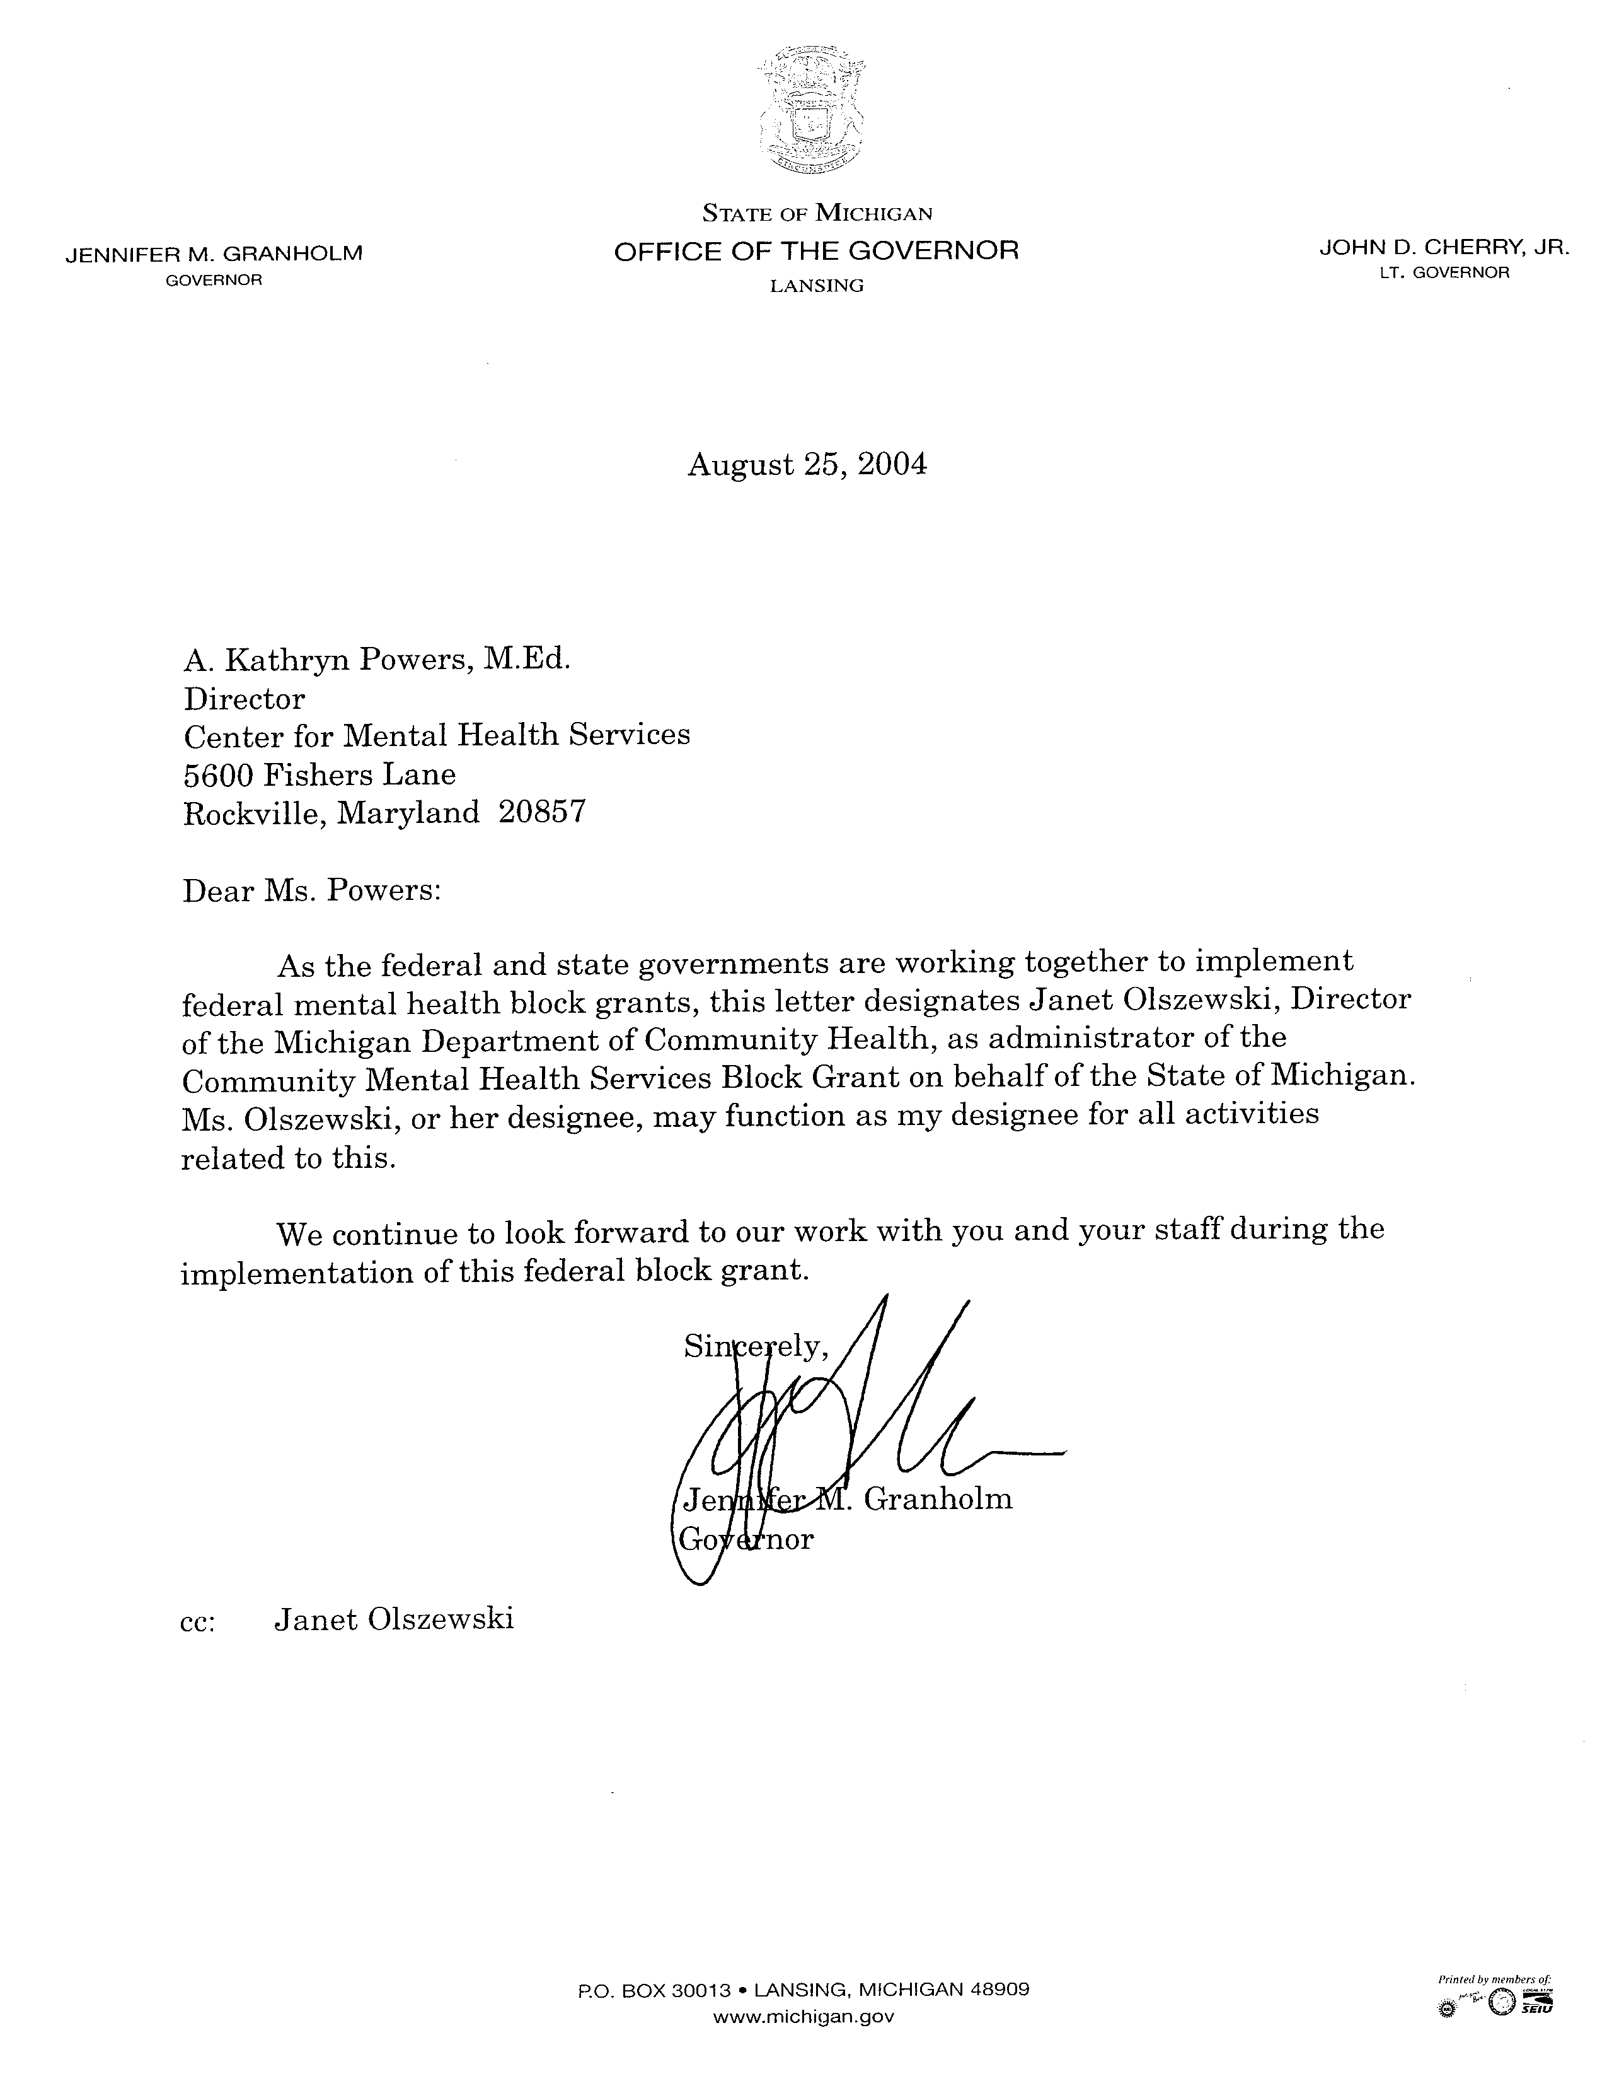

DIRECTOR, DEPTARTMENT OF COMMUNITY HEALTH AUTHORIZATION LETTER
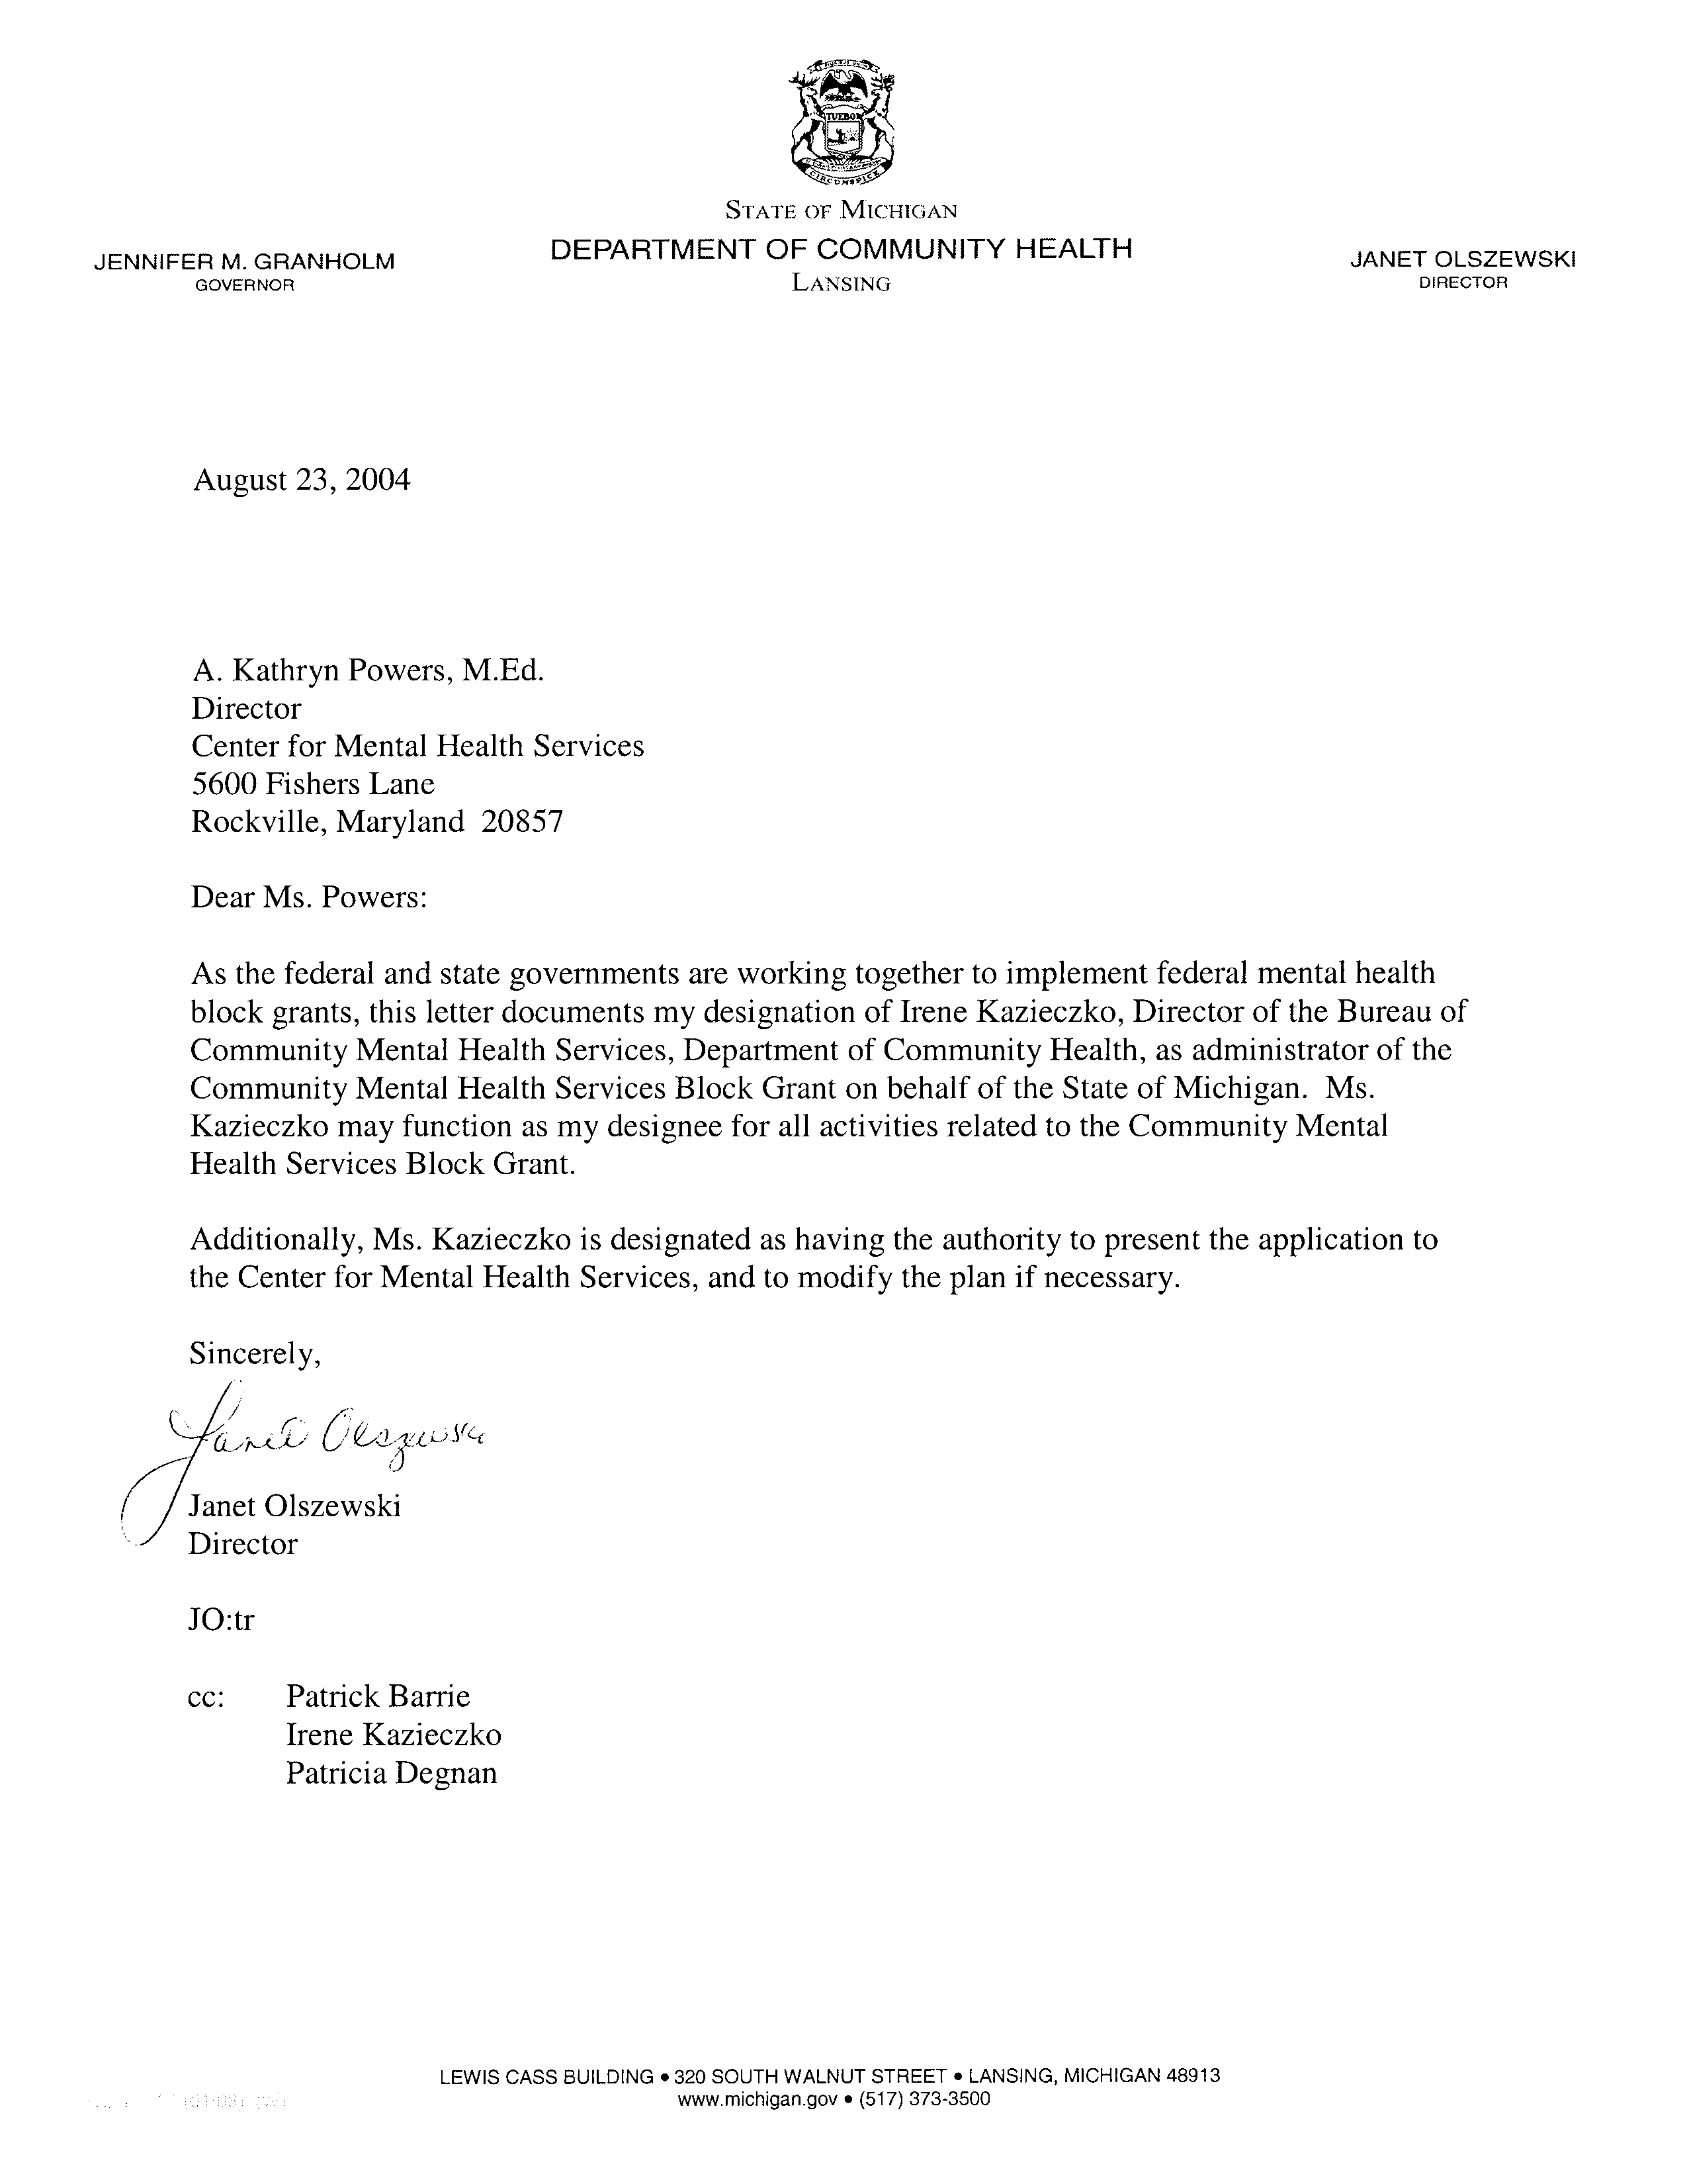

Part B. Administrative Requirements, Fiscal Planning Assumptions, and Special Guidance

- Federal Funding Agreements, Certifications and Assurances

(1) Funding Agreements
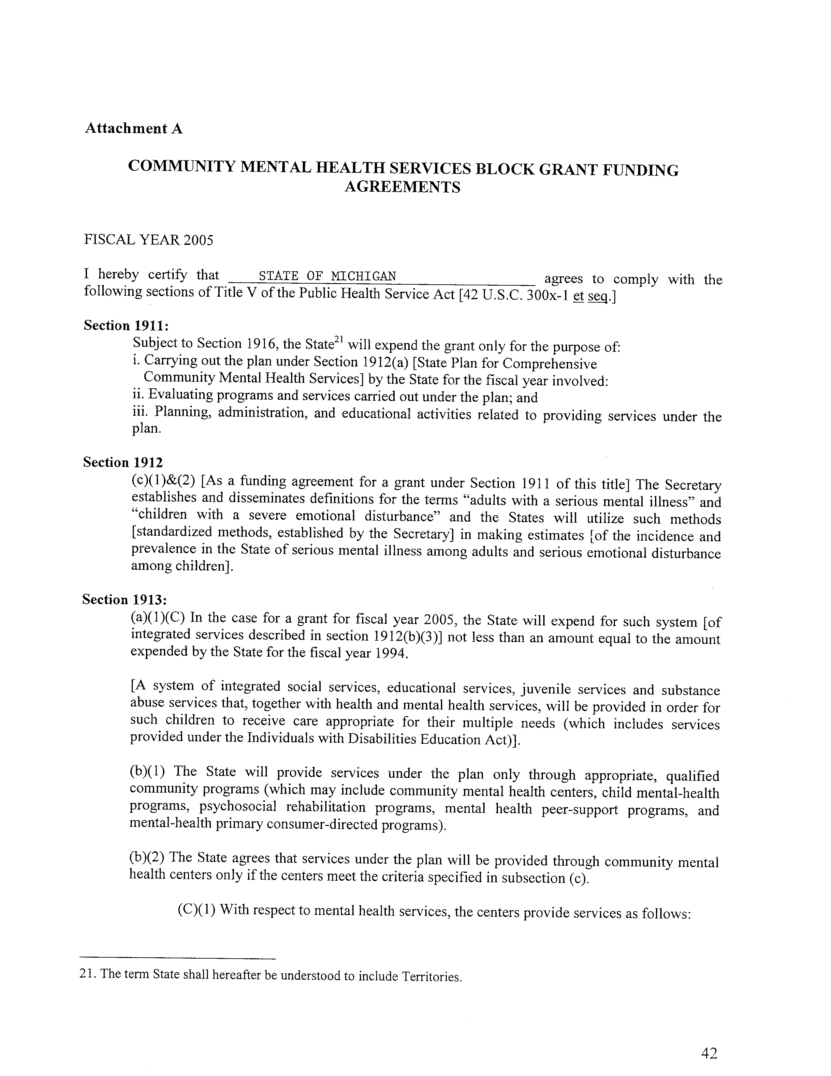
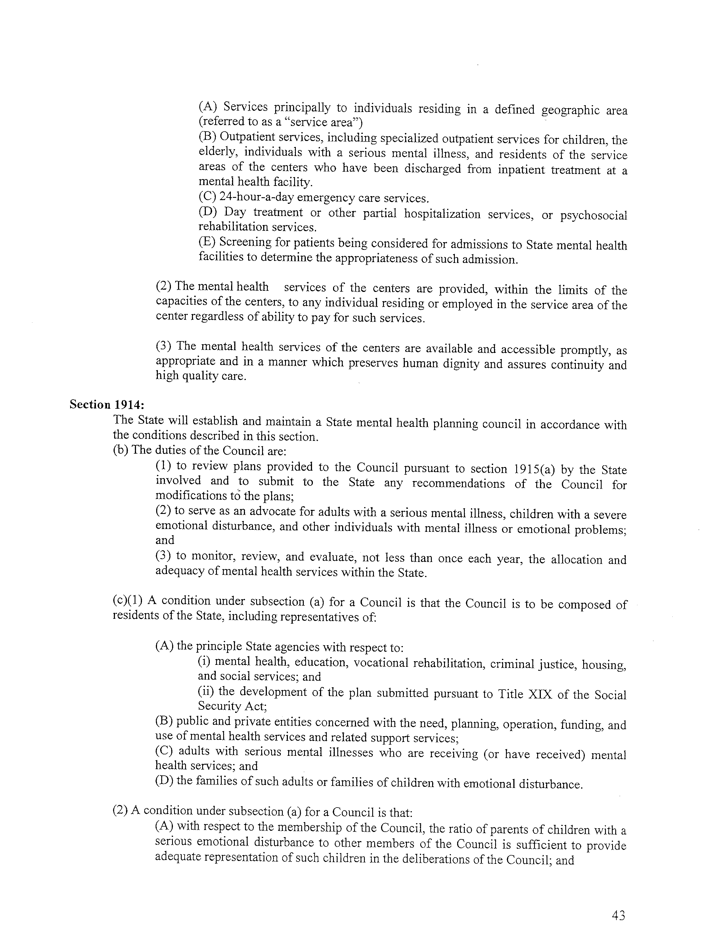
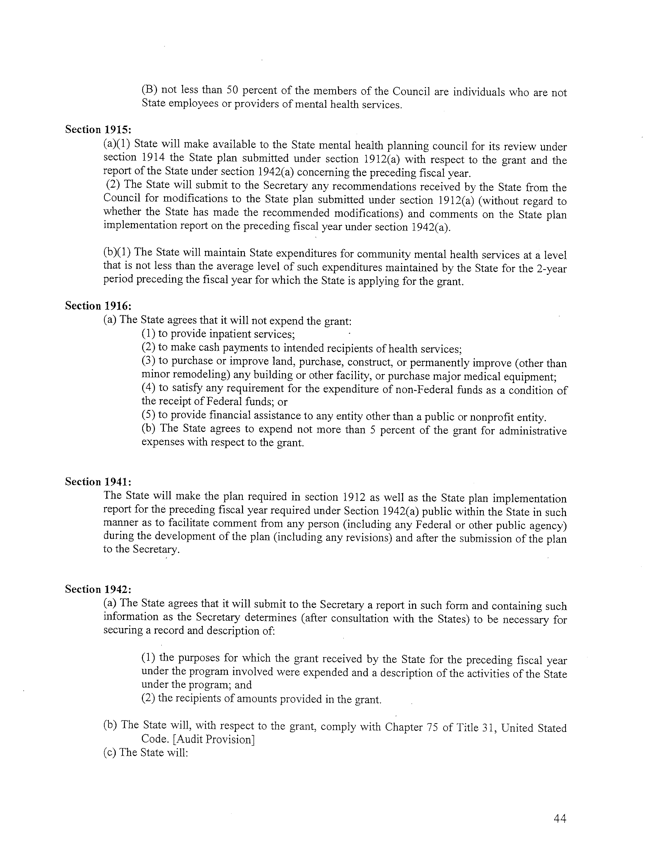
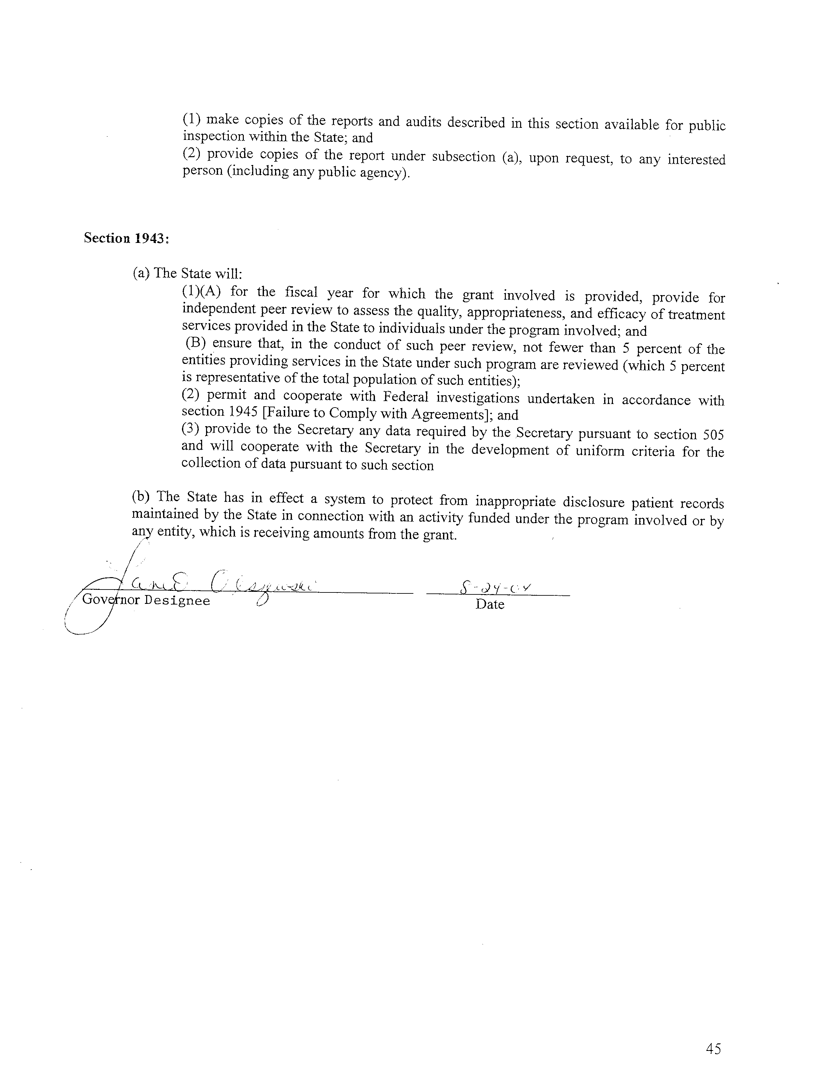

(2) Certifications
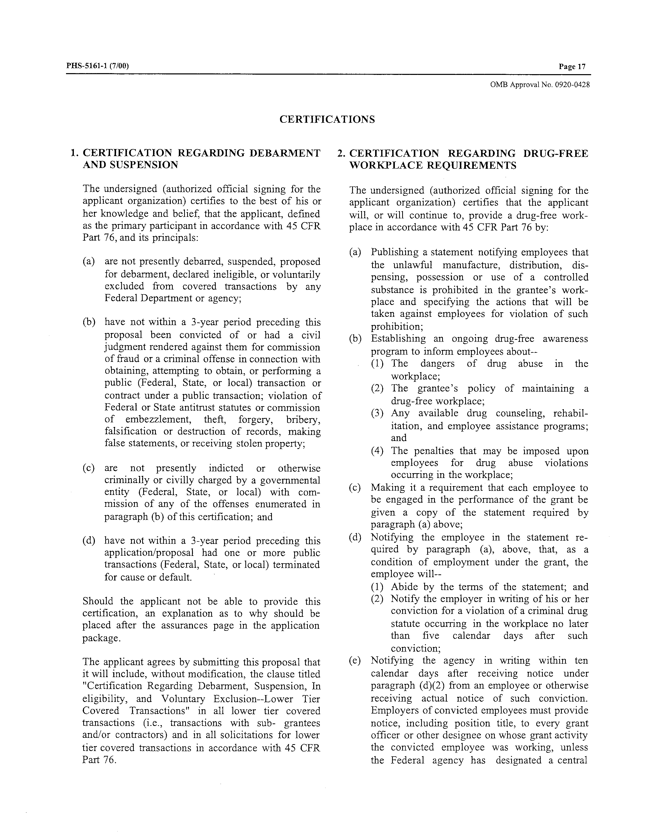

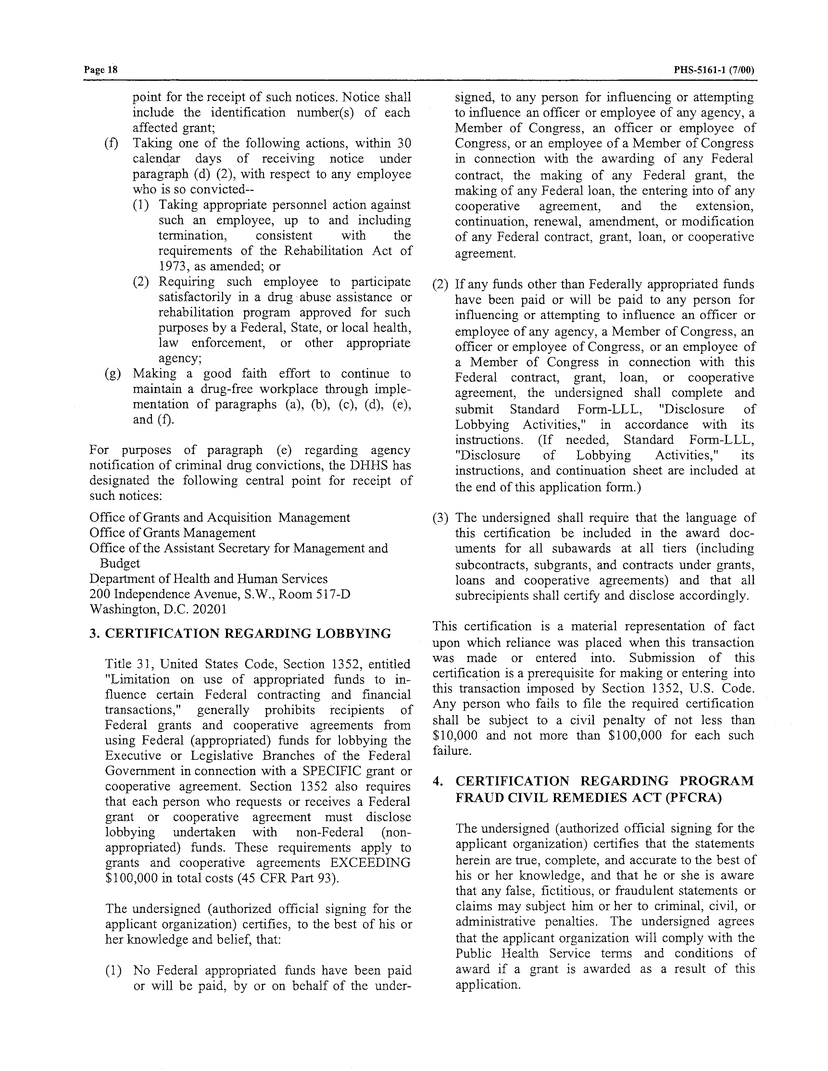

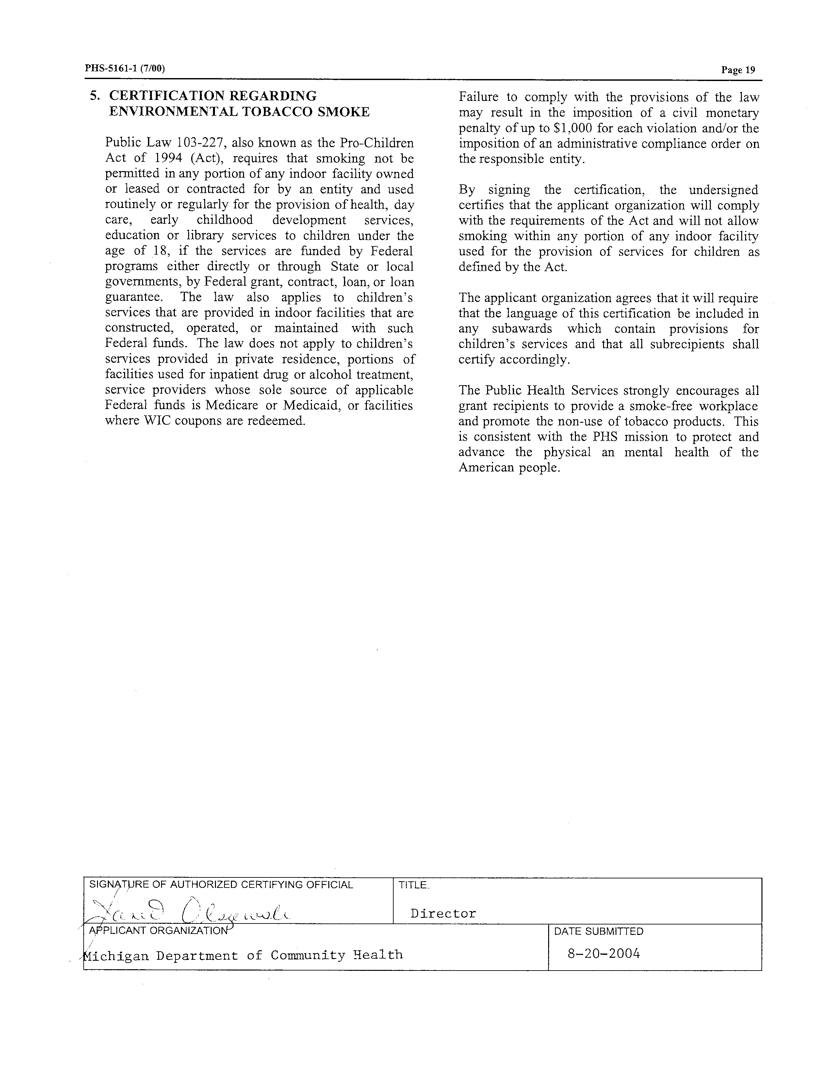

(3) Assurances
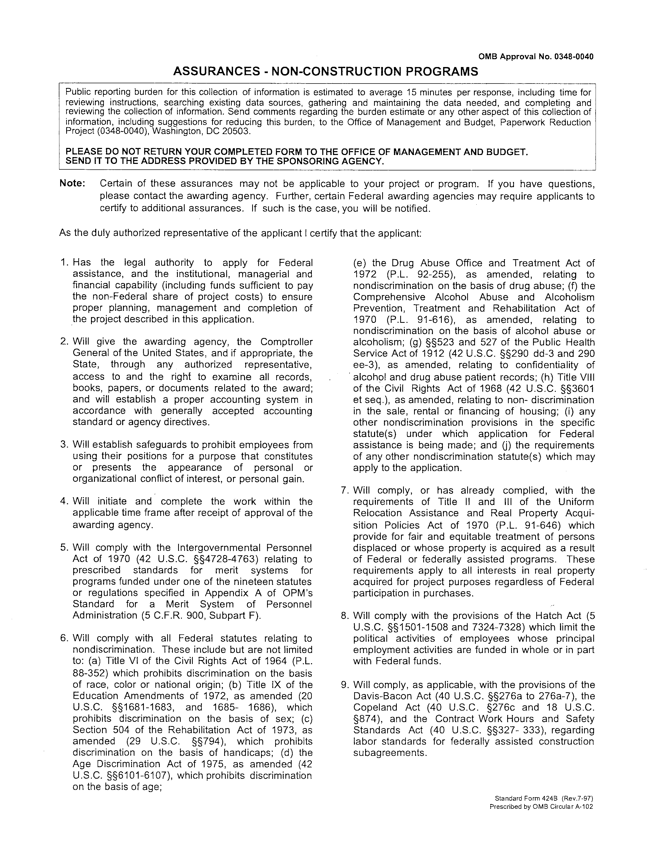
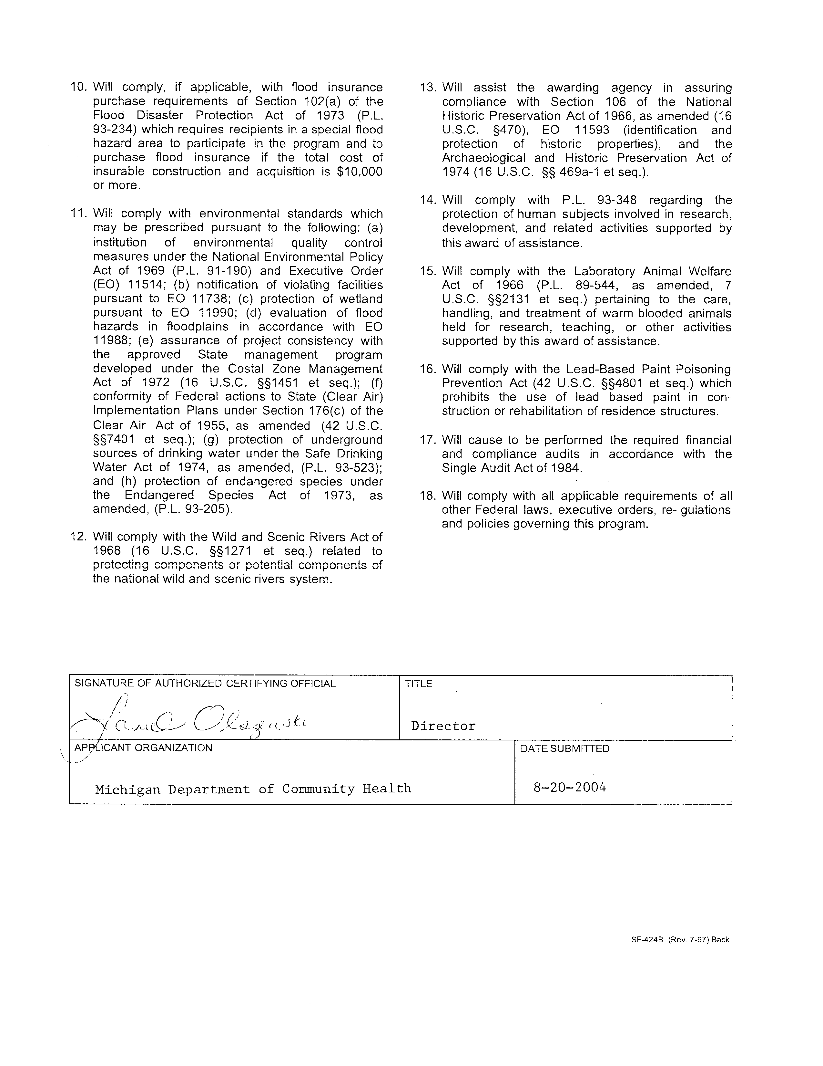

Public Comments on the State Plan

The state’s planning council has reviewed and commented on this application. Public comment is being invited through two methods. The application is currently posted on the MDCH web site, with the invitation for comment. Also the planning council meetings will be posted as open meetings with opportunity for any state resident to provide input into the plan. If changes are indicated as the result of this public comment review, modifications to the plan will be requested.

II. Set-Aside for Children’s Mental Health Services Report

The fiscal year for the State of Michigan is the same as the federal fiscal year.

State Expenditures for Mental Health Services

Calculated  FY 1994 | Actual  FY 2002 | Actual  FY 2003 | Actual/Estimated  FY 2004*
$3,509,106 | $4,587,669 | $4,413,993 | $3,522,544

* Children’s total block grant allocation for FY2004 is $4,574,695.

III. Maintenance of Effort (MOE) Report

The fiscal year for the State of Michigan is the same as the federal fiscal year.

State Expenditures for Mental Health Services

Actual  FY 2002 | Actual  FY 2003 | Actual/Estimated  FY 2004
$502,661,951 | $527,379,896 | $516,760,093

IV. State Mental Health Planning Council Requirements

1. Membership Requirements

The Advisory Council on Mental Illness (ACMI) first functioned as a strategic “Planning Forum” from December 1988 to January 1990. In 1990, the Michigan Department of Community Health Director appointed 20 members. The membership fulfills all requirements of P.L. 102-321. The Director continues to appoint new members as needed and currently there are no membership vacancies.

Section 1914(c) of the PHS Act requires that State Mental Health Planning Councils conform to certain membership requirements. The ACMI meets this requirement, and although each ACMI member is allocated to one principal membership requirement, some members in reality have experience and interest in multiple areas. The membership consists of consumer advocates, primary consumers, family members of adults with SMI, parents of children with SED, mental health advocates, mental health service providers and state agency representatives of housing, vocational rehabilitation, social services, criminal justice, mental health, Medicaid, and education. 65% of the membership are not state employees or providers of mental health services. The number of parents with children experiencing SED is sufficient to provide adequate representation of children.

The Council is active and committed to its charge: to advise the Department of Community Health in its planning and advocacy for persons experiencing mental illness. The Council monitors and evaluates the implementation of the State Plan and advises the Director as to service system needs.

2. State Mental Health Planning Council Membership List and Composition

TABLE 1. List of Planning Council Members

Name | Type of Membership | Agency or Organization Represented | Address, Phone, Fax, Email
Dorothy Byington Boone | State Agency-Housing | MSHDA  State Housing Development Authority | 735 East Michigan  Lansing, MI 48912  Ph: 517-373-9349  Fax: 517-335-6565  Booned@michigan.gov
Roseanne Renauer | State-Agency-Vocational Rehabilitation | Michigan Rehabilitation Services | P.O. Box 30010  Lansing, MI 48909  Ph: 517-373-4056  Fax: 517-373-4479  renauerr@michigan.gov
Jocelyn Vanda | State Agency-Social Services | Michigan Family Independence Agency | Grand Tower Bldg.  Suite 1514  Lansing, MI 48909  Ph: 517-373-7985  Fax: 517-335-6101  VandaJ@michigan.gov
Clayton “Tony” Straseske | State Agency-Criminal Justice | Michigan Dept. of Corrections | P.O. Box 30003  Lansing, MI 48909  Ph: 517-373-3318  Fax: 517_335-8071  straseca@michigan.gov
Patricia Degnan | State Agency-Mental Health & Medicaid | Michigan Dept. of Community Health | 320 S. Walnut  Lansing, MI 48913  Ph: 517-373-2845  Fax: 517-335-6775  degnanp@michigan.gov
Jane E. Reagan | State Education Agency | Michigan Dept. of Education | P.O. Box 30008  Lansing, MI 48909  Ph: 517-335-2250  Fax: 517-373-7504  reaganj@michigan.gov
Kerin Scanlon, Chair | Consumer Advocate |  | 5220 Hedgweood Dr.  Apt. 303  Midland, MI 48640  Ph: 989-832-8714 (h)  Ph: 989-774-3143 (w)  kscanlon@tm.net
Patrick Coyne, Secretary | Consumer Advocate | Drop-In Self Help, Inc. | 120 Grove Street  Battle Creek, MI 49015  Ph: 269-964-8133  Fax: 269-964-8460  pcoyne@ccm.tds.net
Colleen Jasper | Consumer Advocate | Office of Consumer Relations  Department of Community Health | 2529 Limerick  Holt, MI 48842  Ph: 517-373-1255  Fax: 517-335-6775  JASPER@michigan.gov
Brian Wellwood | Consumer Advocate | JIMHO and Project Doors | 421 Seymour  Lansing, MI 48933  Ph: 517-371-2221  Fax: 517-371-5770  brwellwood@aol.com
Jamie Pennell | Parent of Child with SED |  | 211 Butler  Leslie, MI 49251  Ph: 517-589-9074  bnjoo@cablespeed.com
Malisa Pearson | Parent of Child with SED | Association for Children’s Mental Health | 200 B. Butternut  Charlotte, MI 48813  Ph: 517-543-9992  Fax: 517-336-8884  acmhmalisa@acd.net
Chandra Jones | Parent of Child with SED |  | 3931 Sashabaw Rd.  Waterford, MI 48329  Ph: 248-618-8936  Scjones415@yahoo.com
Chris Valentine | Family Member of an Adult with SMI | Alliance for the Mentally Ill of Michigan | 9221 Pointe Charity Drive  Sandpointe, MI 48755  Ph: 989-856-4505
Arlene Naganashe | Family Member of an Adult with SMI | Inter-Tribal Council of Michigan | 34 Bridge Street  Petosky, MI 49770  Ph: 231-347-9093  Fax: 231-487-4673
Ben Robinson | Mental Health Advocate | Lutheran Social Services of Michigan | 8131 East Jefferson  Detroit, MI 48214  Ph: 313-823-7700  Fax: 313-823-9604  brobi@lssm.org
Elmer Cerano | Mental Health Advocate | Michigan Protection and Advocacy | 4095 Legacy Parkway  Ste. 500  Lansing, MI 48911  Ph: 517-487-1755  Fax: 517-487-0827  ecerano@mpas.org
Sally Steiner | Mental Health Advocate | Michigan Office of Services to the Aging | 7109 W. Saginaw  Lansing, MI 8909  Ph: 517-373-8810  Fax: 517-373-4092  steiners@michigan.gov
Mark Reinstein | Mental Health Advocate | Mental Health Association in Michigan | 30233 Southfield Rd.  Ste 220  Southfield, MI 48076  Ph: 248-647-1711  Fax: 248-647-1732  msrmha@aol.com
Elaine R. Thomas | Mental Health Service Provider | Detroit-Wayne CMHS Programs | 640 Temple Avenue  8th Floor  Detroit, MI 48201  Ph: 313-833-2365  Fax: 313-833-2039  ethomas@co.wayne.mis.us

TABLE 2. Planning Council Composition by Type of Member

Type of Membership | Number | Percentage of Total Membership
TOTAL MEMBERSHIP | 20
Consumers/Survivors/Ex-patients (C/S/X) | 4
Family Members of Children with SED | 3
Family Members of Adults with SMI | 2
Vacancies (C/S/X & family members) | 0
Others (not state employees or providers) | 4
Total Primary Consumers, Family Members & Others | 13 | 65%
State Employees | 6
Providers | 1
Vacancies | 0
Total State Employees & Providers | 7 | 35%

3. Planning Council Charge, Role and Activities

A. NAME: ADVISORY COUNCIL ON MENTAL ILLNESS (ACMI)

B. FUNCTION:
1. PURPOSE-To advise the Department of Community Health (DCH) in its planning and advocacy for persons with SMI.
2. RESPONSIBILITIES-As defined in P.L. (102-321).
3. DUTIES:
a. To assist the DCH in planning for community-based programs targeted to persons with serious mental illness (SMI).
b. To advocate for improved services to persons with SMI.
c. To monitor and evaluate the implementation of the "State Comprehensive Mental Health Service Plan for Persons with Serious Mental Illness (P.L. 102-321)."
d. To advise the Director of the Department of Community Health as to service system needs for persons with SMI.

C. ORGANIZATIONAL STRUCTURE
1. MEMBERSHIP:
a. APPOINTMENT: By the Director of the Michigan Department of Community Health.
b. COMPOSITION: As defined in P.L. 102-321.
c. NUMBER: 20 members (11 consumers/advocates and 9 state employees or providers).
d. TERM: Two (2) years.
e. VACANCIES: To be appointed by the Director of the Michigan Department of Community Health (consistent with P.L. 102-321 requirements which state that at least 50% of the membership shall be advocates or consumers).
f. REIMBURSEMENT: Travel expenses to and from meetings may be reimbursed, with prior approval from the director.
g. ATTENDANCE: Resignation shall be assumed after three successive absences from regular meetings.
h. ALTERNATES: A member may designate an alternate to attend a specific meeting. This alternate will be able to vote for the person they represent during the meeting of which they are in attendance.
2. OFFICERS:
a. COMPOSITION: Chair, vice chair, recording secretary
b. SELECTION: By election of the Council.
- TERM: 1 year term (maximum 2 terms).

3. STAFFING:
a. COMPOSITION: 1) Council Coordinator, 2) Advisory staff (as needed)
b. ROLES: 1) The Coordinator will facilitate council meetings and correspond with state and federal officials as required by federal law or as necessary to support the Council's functioning. The membership will be informed of significant developments as soon as possible. 2) Advisory staff will report to the Council on the progress made regarding the "State Comprehensive Mental Health Service Plan for Persons with Serious Mental Illness."
4. STUDY OR WORK GROUPS:
To be established by the council as needed.

D. MEETINGS
1. REGULAR MEETINGS: No less than 4 times per year.
2. SPECIAL MEETINGS: As required, to be called by the council chair or the DCH Director. A special meeting will be established when requested by six (6) members.
3. AD HOC COMMITTEES: May be established by the council chair on a time-limited basis.
4. QUORUM: More than one half (2) of the membership.
5. PROCEDURE: Roberts Rules of Order

E. WRITTEN COMMUNICATION
1. NOTICE OF MEETINGS: Staff Coordinator
2. MINUTES: DCH staff may take the meeting's minutes which shall be reviewed by the secretary and approved by the Council.
3. REPORTING-To the DCH director at least annually.

F. AMENDMENTS TO THE BYLAWS-Require approval by 2/3 of the membership-will be enacted with concurrence of the DCH director.

G. RULES AND REGULATIONS: To be determined.

H. OPERATING EXPENSE: $2,000 annually.*

* Current budget is $2,500

4. State Mental Health Planning Council Comments and Recommendations

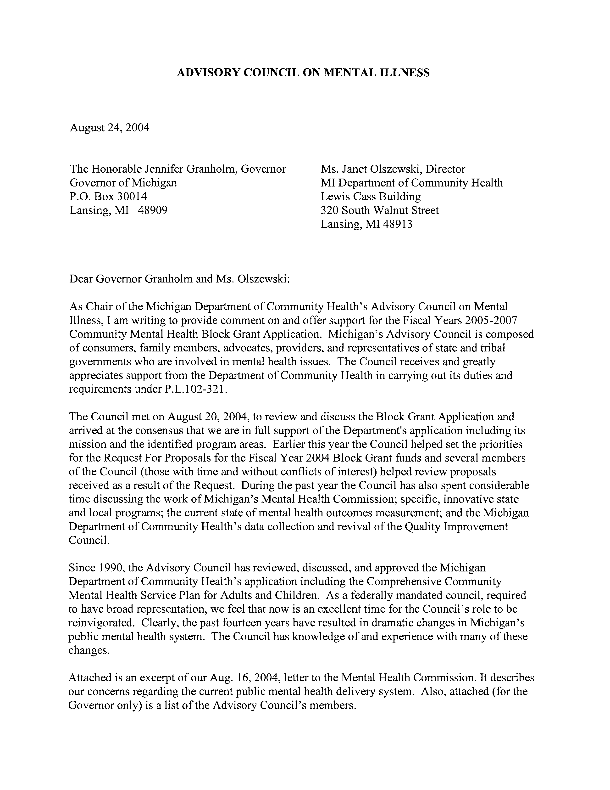

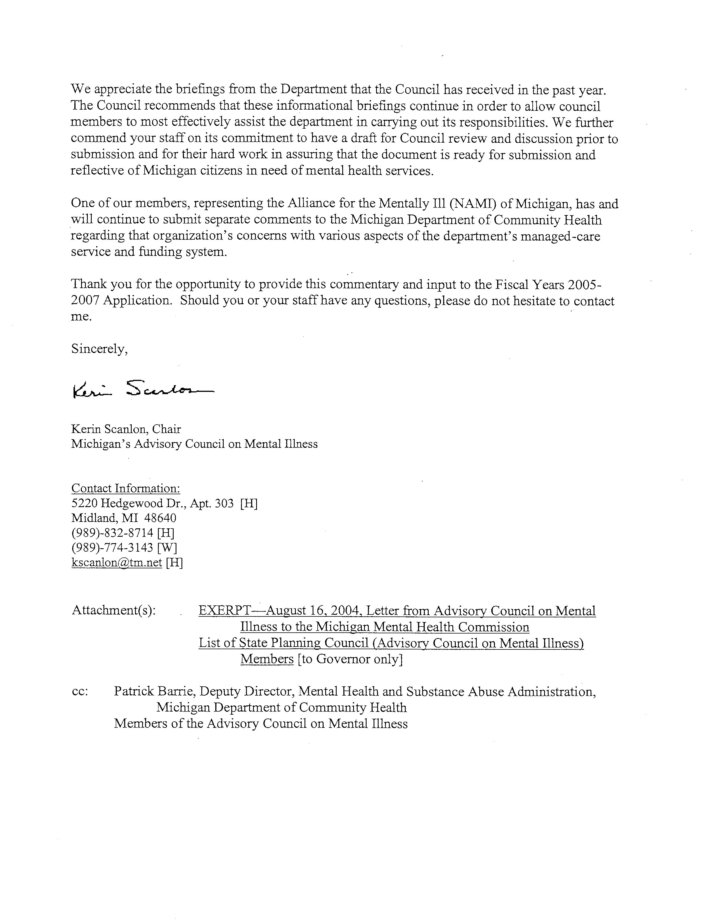
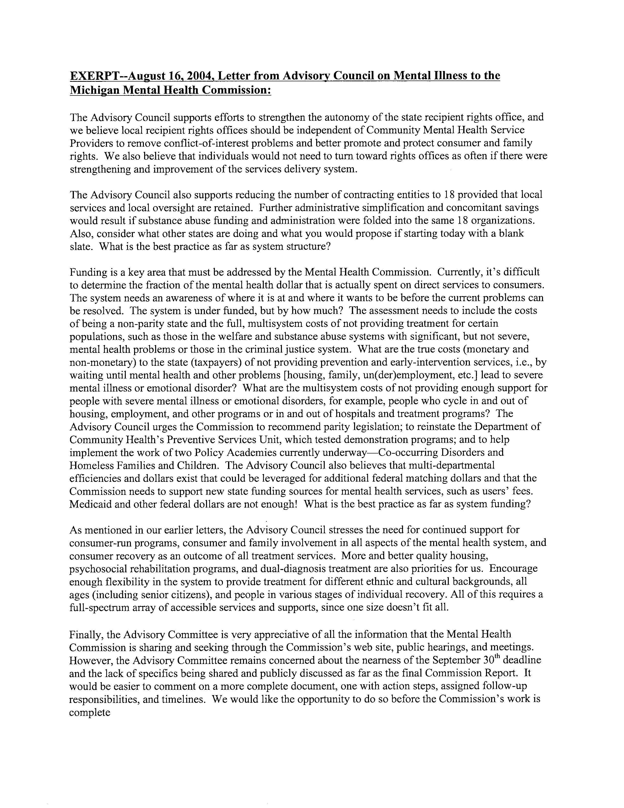
PART C. State Plan

Section I: Description of State Service System

Michigan's public mental health system is administered by the Department of Community Health (MDCH), one of 20 principal departments of state government. MDCH is responsible for Mental Health, Developmental Disability, and Substance Abuse Services, Public Health, and Medicaid. The Office of Services to Aging is a Type 1 agency within MDCH with a director that is appointed by the governor. MDCH is involved in collaborative activities with other state departments including Corrections, Education, Career Development, and the Family Independence Agency.
Mental Health and Substance Abuse Administration within the MDCH contracts with the 46 Community Mental Health Service Programs (CMHSPs) for mental health and developmental services and supports funded by state general funds and for services funded by the Community Mental Health Services Block Grant for services to adults with serious mental illness (SMI) and children with serious emotional disturbance (SED).
The administration contracts with eighteen Community Mental Health Prepaid Inpatient Health Providers (PIHPs) to administer the state’s Concurrent 1915(b)/(c) Medicaid Managed Specialty Supports and Services delivery system. The more populous counties typically serve beneficiaries within a single county geographic service area. Those having fewer than the minimum 20,000 covered lives in their own catchment area have formally affiliated with one or more of the remaining twenty eight smaller Community Mental Health Service Programs (CMHSPs) to ensure that beneficiaries in all 83 counties of Michigan are afforded the requisite covered services. As anticipated, some of these business affiliation arrangements have precipitated mergers of the smaller, more rural county-based community mental health agencies. This has resulted in improved administrative efficiencies and more consistent availability of the required service array.
The purpose of the Concurrent 1915(b)/(c) Medicaid Managed Specialty Supports and Services waiver program is: 1) to manage and provide Medicaid specialty mental health, substance abuse and developmental disabilities supports and services under a prepaid shared risk arrangement, and 2) to provide people in Michigan with mental health needs, substance use disorders, and developmental disabilities an opportunity to receive a wider array of services under a person-centered planning approach than previously permitted under Medicaid fee-for-service. The waiver was formally approved on June 26, 1998, and was implemented on October 1, 1998. The program is subject to a two-year renewal period. The State’s second request for renewal was approved in December 2003.
The original terms and conditions of the 1998 waiver approval required the State to: 1) competitively bid contracts under the waiver program within four years, and 2) submit a transition plan within two years detailing how the State plans to shift from non-competitive, sole source contracting to competitive procurement. This plan was submitted with the renewal application on September 29, 2000. In its transition plan, the State concluded that competitive procurement is impractical and presented a justification for non-competitive procurement with qualified Community Mental Health Services Programs (CMHSPs) for initial consideration to operate as the specialty Prepaid Inpatient Health Plan for a designated area. The MDCH completed an Application for Participation process to identify the 18 CMHSPs that serve as the managers of the Medicaid Specialty Service program (prepaid inpatient health plans or “PIHPs”) in September 2002. Contracts with the 18 PIHPs began on October 1, 2002.
The December 2003 approved waiver renewal allows the state to provide more flexible, non-traditional services under the authority of 1915(b)(3). Under the authority of 1915(b)(3), medically necessary supports and services that promote community inclusion and participation, independence, or productivity are provided when identified in the individual plan of services as one or more goals developed during person-centered planning.
This provides beneficiaries with greater choice and control. It also results in more individualized, cost–effective supports and services that are more in keeping with the beneficiary's needs and requests. 1915(b)(3) services include peer-delivered or peer operated support services, family skill development, respite care, community living training and support, housing assistance, skill building assistance, extended observation beds, wraparound services for children and adolescents, direct prevention service, supported independent housing services and supported employment.
Service gaps identified in the state’s previous plan were crisis planning, recovery, and treatment for persons with co-occurring mental health and substance abuse disorders. Crisis planning has been added to the Person-Centered Planning Guidelines as a required component to be offered to consumers. Crisis Planning is an area for which CMHSPs may apply for block grant funds and awards in this area have been made for two years. Recovery principles are emphasized in all service areas. The Office of Consumer Relations supports recovery training and block grant awards are made in the area of recovery. Michigan is one of the states participating in the National Co-occurring Policy Academy. The work of the academy is being meshed with the development of integrated treatment system development work that has been undertaken with block grant funds. In addition to funding regional initiatives, this fiscal year MDCH has sponsored statewide technical assistance to advance development of integrated co-occurring services. Drs. Kenneth Minkoff and Christy Cline have assisted state and regional teams and work will continue through the five work groups of the academy: Consensus Building/Advisory; Treatment and Outcomes; Policy/Legal; Workforce Development; and Finance, Contracts, and Administration. The identification of these gaps in service and the priority we give them are based upon input received from consumers and advocates, needs assessment surveys completed by CMHSPs annually, and the application of statewide service utilization data.
As has been the case for several years, the State of Michigan, like nearly all other states, is experiencing a period of declining tax revenues and increased unemployment. Michigan has positioned itself to make certain that the residents of the state are appropriately and adequately served. The numbers of state level staff have decreased. However, most of those who provide services directly to beneficiaries are employed by the PIHP or affiliate community mental health agencies. Fortunately, their work force has remained relatively stable. Similarly, as state revenues have declined, the MDCH has made a great effort to implement efficiencies and maximize federal reimbursement efforts. As a result, the funding made available to the PIHPs and affiliates has, for the most part, been maintained at previous levels. Recent economic indicators suggest this economic challenge will continue for the next several years.
The MDCH has a number of mechanisms in place to provide leadership in the coordination of mental health services. For example, each PIHP has a formal contract with the MDCH that describes the PIHPs responsibilities and deliverables. The contract places a heavy emphasis on customer service, uniform data collection and encounter data reporting, fiscal management, quality assessment, and utilization. Before a contact is let, each CMHSP must also meet the state’s certification standards for operating a community mental health program.
Legislation passed in 1995 at the urging of the MDCH assures that consumers serve in a governing capacity on all governing boards of local community mental health agencies and are an integral part of both the state’s and local mental health program’s planning and consumer protection mechanisms. One of many examples of this is the Mental Health Planning Council. This council made up of consumers stakeholders, advocates, and state and local service agency representatives provides valuable input to our department on our program direction, the state’s Mental Health Plan and helps shape the MDCH’s Block Grant application.
Program specialists and consultants also are an important part of the MDCH’s leadership and coordination efforts. The MDCH has published a number of best practice guidelines and offers technical support to local community mental health programs in a number of areas including: Person-Centered Planning, Employment, Recovery, Jail Diversion, School to Community Transition, Inclusion, Stigma, Housing, Self Determination, Grievance and Appeals/Recipient Rights, and Customer Service.

For children’s services, Michigan continues development of a comprehensive system of care to address the needs of children, especially children with significant needs and that meet the criteria for SED. While state agencies, local communities, and parents continue to further develop the system, the current system of care continues to support children to receive services that help maintain them in the community and keep families intact.

Historically, efforts have been made to move children into communities from more restrictive out-of-home placement, while still providing beneficial and helpful treatment interventions. This movement has continued and is supported through the expansion of the system of care. The development and implementation of community-based services have been crucial to moving children into the least restrictive environment without compromising treatment effectiveness. Some research has in fact suggested that residential treatment interventions may be harmful to youth, while others have shown the effectiveness of community-based treatments. A major development in Michigan has been the incorporation of person-centered planning/family-centered practice, which has led to increased consumer choice and treatment interventions that are designed as the child and family desires. With the support of the Mental Health Block Grant, training in family-centered practice and community-based interventions has been occurring to assist in implementation. More focus in FY2004 has been placed on outcomes and data collection and will be continued in FY2005, especially for children’s block grant funded projects. The Wraparound Quality Assurance Project and the Juvenile Justice Screening, Assessment, and Diversion Project are two projects that have begun to collect statewide data on each of these initiatives and FY05 will likely see improved outcomes information being provided.

The Department of Community Health has focused on and been a leader in increasing collaboration with other state agencies, local communities, and families. As can be noted under Criterion III: Children’s Services, DCH participates in many interagency groups and emphasizes collaboration for children’s services. Through these groups, the system of care has improved through the elimination of duplicative efforts and new projects being planned with joint efforts in development, implementation, and evaluation. More work is being planned to further improve the system of care, increase parent leadership development, and increase and maintain youth involvement on interagency committees.

At the community level, interagency administrative groups serve to assure interagency planning and coordination. Of these various local committees, the most pivotal group is the Multi-Purpose Collaborative Body (MPCB), recently renamed Community Collaboratives. All of Michigan’s 83 counties are served by a single county or multi-county local Community Collaborative which functions to oversee children's services planning and development. The local collaborative bodies are comprised of local public agency directors (public health, community mental health, Family Independence Agency [FIA], substance abuse agencies), family court judges, prosecutors, and families, private agencies and community representatives.

The organization of the children’s system of care includes many state agencies, advocacy groups, family members, and local providers of services. State agencies in Michigan are organized in such a way that each agency may provide multiple services. For example, the Department of Community Health is responsible for health and mental health services, some housing services, substance abuse services, medical and dental services, Medicaid and Children’s Special Health Care Services (Title V). The Family Independence Agency is responsible for foster care, children’s protective services, some housing assistance services, case management services, and juvenile justice services. The Department of Education is responsible for educational services and the implementation of the Individuals with Disabilities Education Act. Employment Services and housing services are provided by the Department of Labor and Economic Growth. There has been increased interagency collaboration, especially in recent years, which has led to a more comprehensive system of care for children and in a number of communities, however many barriers remain to the development of a statewide comprehensive system of care and access to mental health services for children who need them. The agencies have cooperated in helping to reduce the duplication of services, especially case management and the provision of services through the use of the wraparound process and person-centered planning. Committees continue to focus on improving the system of care and collaboration.

Michigan Mental Health Commission

The Michigan Mental Health Commission, a temporary body established by Executive Order 2003-24 on December 10, 2003, began meeting in 2004 to re-evaluate the state’s publicly-funded mental health system with the ultimate goal of using its recommendations to transform Michigan’s mental health system into a national model. The commission is comprised of mental health consumers, advocates, providers, representatives from law enforcement and the courts, policymakers, and the public.

In announcing the establishment of the Michigan Mental Health Commission, Governor Jennifer Granholm stated that the public mental health system must:

• provide adequate and appropriate mental health care for adults and children with serious mental illness or serious emotional disturbances;
• involve consumers and families in the decision-making process;
• ensure timely access to care;
• foster quality and excellence in service delivery; and
• provide service in an effective and fiscally accountable manner.

While the Michigan Mental Health Commission is not due to make its final report until October 2004, the six goals that were discussed at the most recent (August 17, 2004) meeting include:

Goal 1: The public knows that mental illness is treatable, recovery is possible, and many people with mental illness lead productive lives.
Goal 2: The mental health of all children and adults is promoted and their mental health needs are met at the earliest opportunity.
Goal 3: No one ends up in the juvenile and criminal justice systems because of inadequate mental health care.
Goal 4: A full array of high-quality mental health treatment, services, and supports is accessible in communities to improve the quality of life for individuals with mental illness and their families.
Goal 5: Michigan’s mental health system is structured and funded to deliver high-quality care effectively and efficiently by accountable providers.
Goal 6: Recovery must be supported by access to integrated mental and physical health care, housing and employment supports, and education to assure that all people have the opportunity to reach their full potential as contributing members of society.

Upon completion of the final report from the Michigan Mental Health Commission, the Department of Community Health will evaluate goals established in the Mental Health Block Grant and make any changes necessary to the application to address implemented recommendations for the public mental health system.

The Advisory Council for Mental Illness has provided input on priority areas and policy changes to the Mental Health Commission. An excerpt from the council’s August 16, 2004 letter to the commission is attached to the letter from the council chair that is included in this application.

Section II. Identification and Analysis of the Service System’s Strengths, Needs, and Priorities

- Adult Mental Health System

Michigan’s has a well-earned reputation of making community-based services and supports to institutional care available to its citizens. Based upon a single point of entry model, forty-six local community mental health agencies, as a matter of law, deliver a full array of services that are fundamentally based upon person-centered planning, inclusion, and choice. All public mental health and substance abuse services including ACT, jail diversion and supports like counseling and consumer run drop-in centers are conveniently locate and available statewide.

The greatest weakness in our system today is one that is shared with most state governments, the economy. Having lost several hundred thousand well paying manufacturing jobs, our state’s unemployment rate is high and revenues are down. While we continue to enjoy the continuing support of the governor and legislature, those programs that rely exclusively upon state funding have either been capped or reduced.

What this means is that Michigan has had to limit general access to state-funded public mental health services based upon severity of condition and urgency of need and within legislation appropriation. Persons with serious mental illness and children with serious emotional disturbances are priority populations as specified in the Michigan Mental Health Code and will as a matter of law continue to be promptly serviced. However, persons with mild condition or less urgent needs can expect to placed for some period on time on waiting lists for services or be referred to private non-profit mental health providers for service.

Evidence-Based Practice
This year the MDCH has formed an Evidence Based Practice workgroup and an Evidence-Based Practice Steering Committee that includes consumer, advocate, CMHSP, provider, and university research representatives. This initiative is included in Governor Jennifer Granholm’s business plan for the state. The steering committee is reviewing the six evidence-based practices for which implementation resource kits are available (or soon to be available) as well as other practices suggested by group members. MDCH has implemented some of the practices including Assertive Community Treatment, Supported Employment, Parent Management Training, and Cognitive Behavioral Therapy. The group will select one or more of the evidence-based practice for concentrated implementation in Michigan. Criteria being considered in the selection process include strong evidence base, large target population that would benefit from the practice, lower cost, less complex in nature, availability of implementation toolkits and treatment manuals, and lower levels of resistance from clinicians and other direct care staff. Implementation will include planning, education, training, and support.

Implementation of these practices will provide additional services from which consumers can choose. As they have been shown to be effective for the people for whom they were designed, it is likely that they will improve consumer outcomes. MDCH will be able to make better use of scare resources with an increased use of evidence-based practices.

b) Children’s Mental Health System

The children’s mental health services system in Michigan has many areas of strengths and several areas in which there are opportunities to improve.

Strengths of the children’s services are:

Managing and developing the system of care

This has been completed through numerous collaborative efforts at the state and local levels. Michigan has had Community Collaboratives established for over twenty years covering every county in the state. The Community Collaborative is an inclusive planning and implementation body of stakeholders at the county of multi-county level. The Community Collaboratives articulate a shared vision and mission to improve outcomes for children and families through sharing risk, making decisions concerning use of funds, facilitating cross-systems arrangements, and making programming and policy decisions. The Community Collaboratives are involved with overseeing implementation of many of the other initiatives described below, such as Wraparound, Great Start, and the Mental Health Juvenile Justice Screening, Assessment, and Diversion Project. The Community Collaboratives will be able to report policy barriers again to a state level interagency group, which is being re-established.

Great Start (Early Childhood Comprehensive System [ECCS] Project) Initiative

The ECCS Project is an initiative that will better coordinate the services the State of Michigan provides for its children. The initiative entails immediate steps to strengthen Michigan’s early childhood efforts and to build an early childhood system of care, birth to five and their families.

Evidence-Based Practice Implementation
Michigan has focused on looking at evidence-based practices in two components: Models of practice and the processes in which these are delivered. The Michigan Level of Functioning Project has led to decisions about which models to utilize, while efforts toward Person-Centered Planning/Family-Centered Practice and Wraparound have been directed to improving the process in which practices are delivered.

Michigan Level of Functioning Project

The Michigan Level of Functioning Project uses the Child and Adolescent Functional Assessment Scale (CAFAS) to gather data about persons receiving services from the children’s public mental health system and then utilizes this data to guide the planning and implementation of evidenced-based practices. Outcome data is utilized to determine which evidence-based practice can be most helpful to Michigan in improving services to children and families. Thus far, Michigan has completed an initial training on Cognitive-Behavioral Therapy for Youth with Depression and is applying for broad training in Parent Management Training. Each of these models were chosen for training using the information generated from Michigan Level of Functioning Project.

Person-Centered Planning/Family-Centered Practice

Person-Centered Planning/Family-Centered Practice is the framework in which services are planned and delivered in Michigan in the public mental health system and by other child-serving systems. This framework is an essential component Person-Centered Planning has been in the Michigan Mental Health Code since 1996. In our guidance on Person-Centered Planning to Community Mental Health Services Programs and Prepaid Inpatient Health Plans, DCH states that “in the case of minors, the child/family is the focus of services planning, and family members are integral to the planning process and its success.” Continued focus on providing services that meet the needs of children and families has led to the development of a Family-Centered Practice training model that can be used for cross-systems training.

Wraparound

Wraparound is a planning process that is used for children and families that are in multiple systems and are determined by the community team to be eligible for wraparound services. Michigan has been a leader in the development and implementation of the wraparound process. Michigan has developed a fidelity evaluation system and provides ongoing training to help ensure fidelity to the process. Further details are provided in the Children’s Section of this application.

Opportunities to improve the system of care include:

Decrease differences in the array of services available at the local level

At present time, communities that have been more innovative and have aggressively sought funding tend to offer more programming and services. Other communities that have taken a “wait and see” approach and are not as collaborative, now are behind and do not have the same array of services available for children. Collaborative groups at the state level continue to work with these communities to expand their local system of care and ameliorate differences in services available to children and families.

Expansion of Current Innovative Projects
At present time, evidence-based practice training and innovative projects such as the Mental Health Juvenile Justice Screening, Assessment, and Diversion Projects and the Michigan Level of Functioning Project cannot be expanded statewide due to limited funding. To resolve this problem, Michigan is seeking outside grants to support evidence-based practice training and is increasing collaboration with state partners to expand projects.

Services to Children in Foster Care
Children in foster care and are excluded from the Medicaid Health Plan benefit, which includes an outpatient mental health benefit. The Medicaid capitated Mental Health Specialty Services provided through CMHSPs serves children with serious emotional disturbance including children in foster care. Children in foster care with mild and moderate mental health conditions have Fee for Services Medicaid which is a very limited benefit. This has reduced access to the public mental health system and led to services being purchased for children in foster care from the private mental health system. These services are often inadequate to meet the needs of the children and their families. Michigan was cited, in the most recent federal Child and Family Services Review by the Department of Health and Human Services, for children not receiving adequate mental health services. To resolve this, there has been a collaborative group addressing this issue and their recommendations have been forwarded to the Michigan Mental Health Commission.

Section III. Performance Goals and Action Plans to Improve the Service System

- Adult Plan

1) Current Activities

i: Comprehensive community-based mental health services

Michigan is operating under a Freedom of Choice waiver approved under the authority of Section 1915(b) of the Social Security Act by the Center for Medicare and Medicaid Services (CMS). The Michigan Department of Community Health (MDCH) uses a capitated, pre-paid managed system of care through contracts with the 18 community mental health services programs (CMHSPs), or affiliations of CMHSPs, which submitted successful Applications for Participation to the MDCH in 2002. Separate contracts with all 46 CMHSPs provide for mental health and developmental disability services for non-Medicaid recipients who are eligible for these services.

Specialty mental health services are a carve-out from MDCH’s contracts for primary health care with Medicaid Health Plans. Contractual provisions require the CMHSPs and Medicaid Health Plans have signed agreements providing for the coordination of care for Medicaid beneficiaries. The Medicaid Health Plans are responsible for providing up to 20 outpatient visits per year to members who meet medical necessity criteria for this level of care.

Oral surgery is a Medicaid primary care coverage through the recipient’s Medicaid Health Plan. For consumers who are not insured, community dental resources for the indigent are utilized.

Michigan’s comprehensive community-based mental health service system provides many opportunities for individuals with serious mental illness to function successfully outside of inpatient or residential institutions to the maximum extent of their capabilities. Inpatient and residential services are available when the individual needs that level of care for a short-term or longer-term duration.

The following community-based state plan services are available to adults and are described in detail in Chapter III of Michigan’s Medicaid manual:

- Applied Behavioral Services
- Assertive Community Treatment
- Assessments
- Case Management
- Clubhouse Psychosocial Rehabilitation Programs
- Crisis Interventions
- Crisis Residential
- Family Therapy
- Health Services
- Home-Based Services
- Individual/Group Therapy
- Intensive Crisis Stabilization Services
- Medication Administration
- Medication Review
- Nursing Facility Mental Health Monitoring
- Occupation Therapy
- Personal Care in Specialized Settings
- Physical Therapy
- Speech, Hearing, and Language
- Substance Abuse Services: Assessment, Outpatient, Intensive Outpatient, and Pharmacological Supports (methadone or LAAM)
- Treatment Planning
- Transportation

The following are additional services for adults with a serious mental illness which are contractually required to be available and for which Medicaid funds may be used under the authority of 1915(b)(3); State General Funds may also be used for these services:

- Peer-Delivered or Peer-Operated Support Services
- Family Skills Development
- Respite Care
- Community Living Training and Support
- Housing Assistance
- Skill Building Assistance
- Extended Observation Beds
- Direct Prevention Service Models
- Supported Independent Housing
- Supported Employment

Substance Abuse Services that may be paid for out of Medicaid substance abuse capitation include Subacute Detoxification and Residential Treatment Services. State General Funds may be used to pay for these services for Medicaid recipients as well as non-Medicaid recipients.

CMHSPs are required by contract to provide or arrange for assessment and treatment services for individuals with co-occurring mental health and substance use disorders. MDCH encourages integrated treatment models.

The development of the county or multi-county based Community Mental Health Services Program network has supported the provision of services and supports in the community to many people who previously would have been hospitalized. The comprehensive array of community-based services has supported the steady decline in inpatient public hospitalization rates in Michigan over the past 25 years. The process of deinstitutionalization started during the 1960s when the census high reached 19,059. The average daily census in state-operated psychiatric hospitals by the end of FY 1989 was 3,162 adults, dropping to 1,148 by end of FY 1997. By the beginning of FY 03, the average daily census was 880. One of the state hospitals, Northville, closed in May 2003 after its residents were transferred to other facilities or placed in the community with needed supports. These transfers were each planned in advance using a person-centered planning process. On August 11, 2004, the total census of all state hospitals was 874, of which 625 were adults with serious mental illness. As the numbers have declined, the severity of the disabilities of patients in institutions has been increasing. It is expected that the census will remain level or rise slightly. Additionally, the department will be dealing with physical plant and fiscal issues in the remaining institutions.

Below is information related to mental health and related services for individuals with serious mental illness. These mental health services are discussed in more detail because they are the ones that are targeted for enhancement with mental health block grant funds.

Person-Centered Planning:

Public mental health services in Michigan are required by law to be provided through an Individual Plan of Service developed using a person-centered planning process. In April, 1996 the Michigan Mental Health Code was updated and rewritten. One significant and fundamental change in the Code was the addition of person-centered planning in the development of the Individual Plan of Service. In Section 712, The Mental Health Code establishes the right for all individuals to have their Individual Plan of Service developed through a person-centered planning process regardless of age, disability or residential setting. In person-centered planning the individual directs the planning process with a focus on what he/she wants and needs. The development of the Individual Plan of Service, including the identification of possible services and supports, is based upon the expressed needs and desires of the individual. Health and safety issues are documented in the plan with supports that will be provided.

MDCH last revised the Person-Centered Planning Practice Guideline in 2003. The guideline is an attachment to the contract between the MDCH and the PIHP. The guideline describes the values and principles of person-centered planning including essential elements. The essential element section is used to develop site review indicators to measure the performance of PIHP/CMHSPs in the area of person-centered process. The site review team includes individuals with disabilities who interview beneficiaries regarding their satisfaction and knowledge of person-centered processes.

Effective October of 2002, individuals have the opportunity to request an independent facilitator for their Individual Plan of Service to ensure it is completed using a person-centered process. A variety of individuals including persons with disabilities from across the state have become facilitators and many persons with serious and persistent mental illness have facilitated their own plan with support of chosen families, friends, allies and paid staff.

A variety of projects have been developed to strengthen person-centered processes. These projects include developing and building natural supports to enhance community inclusion, providing training, guidance and mentoring for people to become independent facilitators, developing peer relationships to build community connections and employing consumers as Peer Support Specialists to assist others in the development and implementation of their plan of service. The manual “Planning for Yourself,” developed in conjunction with national expert Michael Smull, continues to be utilized in a variety of areas across the state. Peer Support Specialists have been instrumental in providing technical assistance and mentoring with the manual.

On September 20 & 21, 2004, Michigan will have the 7th annual person-centered planning conference. The theme of the conference this year is “Dream It, Achieve It!” A variety of past grantees including beneficiaries will attend and present at the conference highlighting innovations that have occurred across the state and nationally. A variety of presenters who have received block grant funding will be leading workshops to share innovations and outcomes. Directors of PIHPs/CMHSPs will attend and present at the conference in partnership with persons with disabilities.

Self-Determination:

Michigan continues to move forward in assisting adults of all disability groups to move toward choices and options involving self-determined arrangements. A Self-Determination Policy and Practice Guideline has been written in partnership with stakeholders and will be a contract requirement with the 18 PIHPs effective October 1, 2004. This contract requirement will offer adults with developmental disabilities and adults with serious mental illness the opportunity to request self-determined arrangements.

The MDCH has supported multiple CMHSPs and PIHPs in implementing self-determined arrangements including the development of individual budgets. The guideline was developed with a large stakeholder input that included executive directors, providers, advocates, families and consumers among others. In July, a training session was provided on the guideline clarifying technical requirements and answering questions from staff, advocates and consumers. A website link specifically designed for self-determination will soon be added to the MDCH home page to provide updated information to the field.

On June 14 & 15, 2004, the 7th annual Self-Determination Conference was held entitled “Just Do It!” with over 500 people attending. A variety of presentations from local, state and national experts were provided.

MDCH continues to request proposals and support PIHPs/CMHSPs to apply innovative techniques with persons with serious and persistent mental illness in the area of self-determination. Education and training have been focused on in a variety of areas in the state. In the past two years counties who were awarded funding have worked toward costing out services to fulfill the request of consumers who choose to separate case management and other supports from psychiatric treatment for additional choices among providers. Several persons with serious and persistent mental illness have developed individual budgets leading to an increase in choice and control. Consumers who have self-determined arrangements that occurred from block grant funding have presented at the person-centered planning and self-determination conferences.

In October of 2003, Michigan received a three-year federal grant from the Centers for Medicare and Medicaid Services entitled Independence Plus. This federal grant will assist MDCH with developing the infrastructure needed to move self-determination forward. The grant has a specific workgroup that will be comprised of mental health consumer, advocates, and providers to discuss how to operationalize self-determination for persons with mental illness.

Case Management:

Case management services, which have been updated in Medicaid Chapter III requirements, assist consumers to design and implement strategies for obtaining services and supports that are goal-oriented and individualized. Services include assessment, planning, linkage, advocacy, coordination and monitoring to assist beneficiaries in gaining access to needed health and dental services, financial assistance, housing, employment, education, social services, and other services and supports developed through the person-centered planning process.

CMHSPs have continued to struggle with caseload sizes and the MDCH has addressed this issue in multiple ways. The MDCH continues to request proposals for consumers with serious and persistent mental illness to become Peer Support Specialists. Effective October 1, 2004, we have included Peer Support Specialists as a b(3) alternative service. Several grantees continue to employ Peer Support Specialists to work directly with consumers in the recovery process including activities such as applying for entitlements, facilitating person-centered plans, assisting with finding new places to live supporting independence, connecting to communities and a variety of life domains. Grantees have understood the benefit and continue to employ consumers after grant funding has ended.

To assist with education and training, including statewide networking, MDCH has requested consultation and training using the Georgia Certified Peer Support Model. Larry Fricke and other qualified individuals will be providing two one-week trainings with Peer Support Specialists who are employed through the federal mental health block grant. The training will be tailored to the needs of Michigan. Two of the trainers from Georgia will be presenting at the person-centered planning conference in September of 2004.

To assure access to needed medical services for persons with serious mental illness, the MDCH’s contracts with the PIHPs require coordination with the Medicaid Health Plans responsible for primary care for Medicaid recipients. CMHSPs must have a documented policy and set of procedures to assure that coordination regarding mutual consumers is occurring between the CMHSP and/or its contracted service providers, and providers of primary health care. This policy must minimally address all consumers of CMHSP services for whom services or supports are expected to be provided for extended periods of time and those receiving psychotropic medications.

Vocational Services:

MDCH continues to support vocational services innovations to move individuals toward gainful employment. We have worked collaboratively with the Michigan Department of Career Development supporting the Ticket to Work initiatives. New developments include supporting consumer-owned business and assisting with Micro-Enterprise Development. The Employment Training Specialist (ETS) Program is offered periodically to job coaches and developers across the state. A specific ETS training will be provided to staff and members of clubhouse programs to address low employment outcomes in a variety of areas in the state and development of Transitional Employment opportunities.

The MDCH staff, in conjunction with national expert Gary Bond will provide a training of evidence-based supported employment services to address unique needs for each CMHSP and to adapt the model to its particular community.

Relationship with the State Vocational Rehabilitation Agency:

At the state level administrative and fiscal issues continue to be addressed. Quarterly meetings occur with administrative staff at both agencies working in collaboration to clarify services for persons receiving mental health services and supports. The contract between the MDCH and the PHIP requires the PHIP to work with the Michigan Jobs Commission-Rehabilitation Services district offices regarding the relative roles and responsibilities of the parties in the provision of rehabilitative services. The PHIP/CMHSP is required to develop a memorandum of understanding specifying responsibilities and methods of communication in the coordination and non-duplication of services between the two agencies.

Clubhouse/Psychosocial Rehabilitation Programs:

Michigan continues to support Clubhouse Programs throughout the state. Funding continues to be provided to support members, including improving employment outcomes and assisting with housing supports. The MDCH has a sole source contract with the Michigan Association of Clubhouses (MAC) to offer training across the state on a variety of topics, including fidelity of the model, employment, self-assessment, developing consumer advocacy, Schizophrenics Anonymous group, developing public speakers in clubhouses, and other related topics. Videotape was produced promoting clubhouse programs to assist clubhouses across the state in public relations and anti-stigma efforts. A copy of the tape was provided to each clubhouse in the state. The MDCH supports members and staff to attend as a training team at national locations certified by the International Center for Clubhouse Development (ICCD).

The first annual Michigan Clubhouse Conference was held this year. A variety of trainings were provided to assist programs in developing a supportive relationship with its auspice agency, ICCD certification, developing and maintaining an array of employment opportunities, and supported education program in the clubhouse. The MAC has been instrumental in sponsoring the trainings and coordinating technical assistance in the state.

In our contract with the MAC next year, the MDCH will provide more tailored employment training with help from Michigan State University to meet the needs of clubhouses focusing on work and social skill, marketing strategies, systemic instructional strategies, developing natural supports, as well as partnering with community employers and job development for all consumers.

Services for Older Adults:

Older Adults with serious mental illness in the public mental health system may have developed the illness earlier in life, may have experienced a late onset, may be at risk of suicide, experience dementia with depressed mood, behavioral disturbances or delusions, or have co-occurring problems with substance use or dependency. Accurate assessment in many older adults is difficult due to multiple medical conditions that may mask as psychiatric conditions, multiple medication interactions, age related changes to physical and mental functioning, and increasing isolation. Family caregivers of isolated older adults with mental illness or progressive disabling medical conditions are also the focus of interventions designed to improve coping skills, mental health needs, reduction of stress, burden, depression and family conflicts. The MDCH is enhancing efforts to improve services to persons with dementia and serious mental illness and improve integration of service between primary, long term and behavioral health care.

Older Adults use fewer public mental health services than younger adults; the reasons include stigma, denial, inadequate outreach services, lack of education about the services and mental illness and lack of staff trained in geriatrics. Specialty Services used by older adults are tracked quarterly. The most appropriate penetration rate has yet to be determined, but attention to the elderly receiving services continues.

It remains a priority to improve identification of older adults in all settings who exhibit significant changes and disturbances in mood, cognition or behavior that may pose a danger to themselves or others. Outreach strategies include traditional and innovative techniques to establish trust, rapport, acceptance and increased use of mental health services by older adults at-risk. Access must continue to be simplified and facilitate appropriate clinical interventions and services to assess, treat and manage emergent or persistent mental illness and co-occurring medical conditions. Often it is someone other than the mentally ill older adult who requests services on their behalf.

Expertise is being developed to provide customized information, education and case consultation to staff who work in health care and community service organizations and 24-hour care facilities, to increase their awareness and knowledge about suicide risk and prevention, serious mental illness and dementia in older adults.

Enhancement of the ability of community mental health clinicians to identify and assess older adults’ disturbances in cognition, mood and behavior by increasing their knowledge and use of assessment tools and protocols used by other service systems to whom they provide consultation is an important initiative of the MDCH.

Initiatives include technical assistance, dementia specific training, train the trainer models, various conferences and workshops and an annual Mental Health and Aging Conference for service providers. Other initiatives such as prevention and outreach respite, guardianship alternatives, Dementia Care Consultation, Gatekeeper Initiatives, Family Training for Members with Dementia, Person-Centered Planning are a part of current efforts.

Assertive Community Treatment:

Assertive Community Treatment (ACT) is a community-based approach to comprehensive assertive team treatment and support for seriously mentally ill adults. ACT uses proactive engagement and provides continuous, rapid, flexible and mobile team based care, twenty-four hours a day, seven days a week, three hundred and sixty-five days a year. The ACT team is the fixed point of responsibility for the development of the consumer’s person-centered plan and for supporting consumers in all aspects of community living. As the fixed point of responsibility, ACT assists consumers to live in the most independent setting possible. ACT is an evidenced-based practice that has a positive effect in using fewer hospital services, increasing housing stability and service satisfaction thus conserving available community resources in the capitated public mental health system.

Approximately 100 ACT teams are functioning in Michigan. Fidelity to program standards or elements is essential in evidence-based practices. Researched since 1972 both in the field and university, the field sometimes looks upon ACT as a “dated” service, and develops “improved” variations of the treatment model. The original model supported former long-term psychiatric patients in the community; the current model supports some aging former long-term psychiatric patients, but supports more consumers who are younger, and have had periodic hospitalizations, no hospitalizations and first episodes. ACT also attends to the aging CMH population; these consumers experience the same aging issues of the general population. Additionally, mental health consumers are more likely to smoke more, exercise less and have a long history of psychotropic medication use. Medical and psychiatric symptoms and issues tend to blur in older consumers, medication usage requires different dosing and medication interactions are a constant concern.

ACT services are available to the consumer for as long as needed, the expectation is that many consumers will improve to the point of using a less intense service. Mental health consumers, often called peers, have been or are being added to many ACT teams. Peers serve as very powerful motivators, as role models and help promote recovery. Many peer initiatives have occurred through block grant initiatives.

Staffs require training, support, and encouragement to develop a recovery expectation mindset that will help consumers believe in and move toward recovery. Training and development for staff in the field is so important that it is included in the current Medicaid guidelines and is provided contractually to ACT teams through the Assertive Community Treatment Association. Teams supporting caseloads of consumers over a long period of time tend to become very stable and function well. Current concerns with ACT provision include too little assistance to consumers on employment and supported employment (SE), substance abuse treatment provided within the team, in vivo service and assistance in developing and maintaining new friends or rebuilding relationships with families. Provision of medication has been observed as a major activity of many of the ACT teams. SE, also an evidenced-based practice, is not often an opportunity for consumers. This was observed in the Application for Participation by the Community Mental Health programs, by the Michigan Public Health Institute, and by site review. Staff turnover is of constant concern; the average member stays about 18 mos. (personal conversation, San Antonio). Service provision issues center around agency support, training, and reasonable technology and resources to complete the job safely such as cell phones, pagers, agency cars, and petty cash.

Agency and Administrative support is challenging at times. Agency requirements, usually developed for clinical “in office” programs are challenging to adapt in a manner that enhances the ACT model; it makes service provision more difficult. All consumers who qualify should have access to an ACT program. A new focus on the efficacy of ACT within the state is shown by the attention to ACT in the current Chapter III Medicaid requirements, updated site review protocols and training.

Consumer-Run and Peer-Operated Services:

Support and maintenance for consumer-run drop-in centers and peer operated community services has been very instrumental in creating a peer-to-peer resource for consumers who attend and participate in consumer activities and ease their transition into long-term community living. Block grant funds again provide a needed resource, which allows consumers to have a comfortable, independent sense of ownership of the drop-in facilities and other consumer-run services delivered by their peers.

Increased attendance within the drop-in centers and the addition of peer case management and project stay services operating out of drop-in centers has created an even greater need for resource support in the areas of furnishings, supplies, transportation support, minor facility repairs, computer purchases, training, and general enhancement of the physical consumer site used to operate and provide consumer services. These consumer-run drop-in sites and consumer services have proven over the years to be instrumental in keeping consumers from relapse, and general need for traditional mental health service interventions to a minimum. High attendance volume has created a strain on furnishings and equipment within the drop-in settings, thus creating the ongoing need for support and maintenance of the buildings.

With the support from the Justice In Mental Health Organization, Inc. (J.I.M.H.O.), an MDCH contracted technical assistance and consultation peer staffed and operated agency, consumers have been afforded a comfortable consumer-led resource to address identified needs by consumers and strategies and solutions developed by consumer. For nearly twenty years J.I.M.H.O has been a rock foundation of peer support from training consumer staff, boards of directors, crisis intervention and assisting CMHSPs in the development of better consumer/CMHSP relations and development of autonomous independent consumer-run services.

Within the last two years J.I.M.H.O. has also helped develop regional drop-in affiliations to allow consumer drop-in centers to convene with other drop-ins in their geographic areas to strategize and discuss mutual problems, provide peer encouragement and share in the development of independence and self-worth in the consumer movement. These regional affiliations have been meeting quarterly and are now beginning to show a positive impact when J.I.M.H.O. is not available. With the support of this consultation agency and the growth of consumer drop-ins and other consumer service delivery options, the support from block grant resources remains an important asset for consumer growth.
Jail Diversion:

As a priority service initiative within MDCH and through the block grant application directives, there continues to be a focus and service delivery activity around pre- and post-booking jail diversion for persons who have contact with the criminal justice system for minor or non-violent felony crimes. In keeping with the Michigan Mental Health Code requirements, block grant resources are used to assist CMHSPs in the development and provision of a jail diversion program (both pre- and post-booking) to individuals with serious mental illness, serious emotional disturbances or developmental disabilities, with the intent to divert them from jail incarceration when appropriate.

Eleven jail diversion programs (both rural and urban) are being funded with block grant resources that provide staffing; promote enhancement of existing programs; strengthen collaborative agreements with law enforcement agencies, courts, prosecutors, and mental health providers; and/or develop better screening and assessment to divert those who meet the criteria for diversion instead of incarceration.

The MDCH has revised and provided for review a jail diversion Policy Practice Guideline draft to be later incorporated into the CMHSP contract. This draft supports and recommends for implementation the commitment to the principle of service to persons with serious mental illness, serious emotional disturbance, or developmental disabilities by providing effective and humane treatment in the mental health system rather than incarceration by the criminal justice system. This practice guideline will serve as a jail diversion policy and resource for CMHSPs in their delivery of jail diversion services as authorized under the Michigan Mental Health Code. It is anticipated that, in conjunction with these practice guidelines, interaction among the current jail diversion programs and assistance from other MDCH identified resources the state will be able to provide a more comprehensive and client appropriate service delivery program. As part of the block grant application, MDCH must report on jail diversion. Therefore, all CMHSPs are being requested to obtain the number of individuals diverted from jail and submit the data to MDCH.

Office of Consumer Relations:

The Office of Consumer Relations, within the Bureau of Community Mental Health Services at MDCH, was organized in 1993 to bring primary consumer representation to the top management level in the form of policy. Headed by a primary consumer, the emphasis is on inclusiveness of primary consumers in all aspects of the office and connected funding. Throughout the state, the office conducts four consumer trainings for administrators, consumers, medical staff, and general staff in the following areas: recovery, anti-stigma, self-esteem, empowerment, crisis planning, employment skills, and in conjunction with the person-centered planning and self-determination areas.

The Office takes the initiative to promote primary consumers’ participation in block grant funding awards. Connected is the recruitment of funding for consumer-run programs, including 50 consumer-run drop-ins, 2 crisis homes, and 3 project stays. A Project Stay offers supports and skills to stay out of hospitals and stay in the community. The annual Consumer Conference, planned and implemented by primary consumers, is partially supported by block grant funding.
Crisis Planning:

Crisis Planning, an on-going initiative connected in the performance of person-centered planning (PCP), is a critical step in meeting the requirements of both PCP and recovery. The promotion of crisis planning is independent and voluntary among primary consumers. Block grant awards will be given to project that emphasize primary consumers in the planning, implementation and review of the initiative. Various formats of crisis planning are acceptable with standardized basic information required. As required by PCP training, there is a provision that advance directives (crisis planning) be discussed with consumers and a plan developed for those desire it.

Anti-Stigma:

Anti-Stigma is a strong initiative encouraged by the MDCH and approved for funding from the block grant. Stigma is considered the number one barrier to receiving and recovering from mental illness. The emphasis for anti-stigma grants is for the involvement, participation, and implementation by primary consumers to dissolve stigma within the system and community. Anti-stigma has the distinction of various approaches including education, acting, and internal training.

Recovery:

Recovery training and participation is the underlying foundation for all consumer-run initiatives including both crisis planning and stigma reduction. Recovery, however, is an initiative funded by the block grant to further promote the principles and concepts for recovery: personal responsibility, support, education, self-advocacy, and hope. The variety of how recovery is created into a project is great, with the primary consumers taking the initiative to create, plan, and implement recovery projects and programs in their own unique areas and needs.

Services for Individuals with Co-occurring Mental Health and Substance Use Disorders:

Michigan has been selected as a member of the Substance Abuse and Mental Health Service Administration’s National Policy Academy on Co-occurring Disorders. Michigan’s team is led by Dr. Michael Ezzo, MDCH Chief Deputy Director, and includes representation from the governor’s office, the legislature, the judiciary, and local mental health and substance abuse providers. The mission of the state Co-occurring Policy Academy is that persons with co-occurring disorders will live productive, quality lives, with dignity, through access to integrated, comprehensive services and supports, regardless of age or circumstances. The Academy has formed the following five work groups: Consensus Building/Advisory; Treatment and Outcomes; Policy/Legal; Workforce Development; and Finance, Contracts, & Administration.

Over the past several years, MDCH has promoted the development of treatment for co-occurring disorders through training, technical assistance, and funding of pilot projects. During the last two years, several projects have been supported by Community Mental Health Block Grant funds to plan and implement a comprehensive, continuous, integrated system of care model for individuals with co-occurring disorders. And this year we have sponsored a statewide technical assistance project, which first brought together the current block grant projects on March 11 and then invited all the CMHSPs to participate, with their local CAs, on June 10. The valuable input MDCH received at the June 10 event is being incorporated into the work of the state Policy Academy. Many participants volunteered to serve on Academy work groups.

In June, MDCH submitted an application for a Co-occurring State Incentive Grant. This federal funding would support us in our development of an improved system of care for individuals with co-occurring disorders. But whether we receive this funding or not, we plan to continue our system development.

ii: Mental Health System Data Epidemiology

Michigan defines an adult with serious mental illness as a person who meets criteria for a set of diagnoses identified by the MDCH. The state does not use one standardized measurement of functional impairment.

State estimates of the number of adults with serious mental illness in each of Michigan’s CMHSP regions in 2000 used a methodology developed by a group of technical experts working under the auspices of CMHS. In order to produce CMHSP-level estimates of the prevalence of adults with serious mental illness, two data sources were employed. First, county-level 2000 Census counts were supplied by Ken Darga, State Demographer, Michigan Information Center, Michigan Department of Management and Budget. These counts of adults 18 years and older were stratified by gender, age groups, and county urbanicity, factors predictive of the number of adults with serious mental illness. Second, adult SMI prevalence rates were supplied by the National Comorbidity Survey completed by Kessler and others in 1994, and reported for each cell of a county-level cross-classification table based on the predictive factors listed previously – gender, age group, and urbanicity.

Estimates of the number of adults with serious mental illness were obtained by multiplying the number of people in each cell of the demographic cross-classification table by the prevalence rate for the appropriate cell. The 24 resulting cell estimates were then combined to obtain countywide estimates. For multi-county CMHSPs, final numbers were obtaining by summing estimates from each county in the CMHSP region. The total number of adults with serious mental illness in Michigan is estimated to be 412,242.

The Center for Mental Health Services has provided the estimated number of adults with serious mental illness in Michigan as 402,930.

A description of the demographic characteristics of individuals receiving publicly funded mental health services in FY 2003 is included as Attachment A to this application. This summary for FY 2003 shows the gender, age groups, race/ethnicity, corrections status, residence, household income, program eligibility, employment, and education status of individuals served. Demographic characteristics are shown for consumers with mental illness, developmental disabilities, substance abuse only (in the mental health system), both mental illness and developmental disabilities, and for unknown disabilities. Demographic information is also collected in a separate data system for individuals receiving substance abuse services in the public substance abuse system. Gender, race, ethnic background, correctional status, living arrangement, and age information is collected. 65,584 individuals were admitted to substance abuse treatment in FY 2003. Of those, 13.8% had an identified mental illness at the time of admission.

Access to services is believed to be more limited to certain sub-populations, including people who are not native English speakers, older adults, and individuals with co-occurring mental health and substance disorders. The MDCH has provided training on requirements for serving people with Limited English Proficiency and handbooks have been made available through the CMHSP association. Outreach and services for older adults and their caregivers continue to be a MDCH priority and are supported by state funds and federal block grant funds. MDCH is supporting planning for and implementing integrated co-occurring treatment in several CMHSP regions currently and plans to increase the availability of these integrated services statewide through the work of the State Co-occurring Policy Academy and its work groups.

iv: Targeted services to rural and homeless populations

Rural Services

The majority of Michigan’s population lives in the 11 counties that are urban. The remaining 72 counties are classified as rural.

Michigan has assured the availability of mental health services to all residents by requiring the full array of services in each CMHSP region. Access standards related to timeliness and geographic availability are required by contract. For office or site-based mental health services, the individual’s primary service providers must be within 30 miles or 30 minutes of the individual’s residence in urban areas, and within 60 miles or 60 minutes in rural areas.

CMHSPs who serve rural areas are encouraged to submit proposals for one-time block grant funding for service areas identified in the MDCH annual Request for Proposals. Innovative proposals developed by CMHSPs in areas not identified by MDCH are also accepted. For fiscal years 2003, 2004, and 2005, all proposals submitted from rural areas that were rated high or medium were approved for funding. Program specialists continue to work with CMHSPs in rural areas to support their successful applications for funding.

Housing and Homelessness Programs/Partnerships:

Supportive Housing Program Partnership: This program is in its 6th year of existence and has facilitated over 800 units of housing. It is estimated that 1500 units of housing will have been generated by this MSHDA/CSH/DCH partnership by 2008. Community coalitions exist in Allegan, Kent, Genesee, Washtenaw, Livingston, Traverse City-Benzie, Out-Wayne and Kalamazoo counties. Additional efforts have been initiated in Detroit, Ottawa County and Sault Ste Marie as the result of training and technical assistance through the partnership. The final number of units will likely far exceed the current estimate.

Long Term Care Housing Workgroup: This group had previously identified goals and a work plan. The CMS Nursing Home Transition Grant is carrying out significant components of this plan. An additional grant for $1 million has been applied for from CMS to carry out plan components.

Homeless Programs: These programs consist largely of the PATH, Shelter Plus Care, and SHP grant programs in addition to a program of training and technical assistance made available to sub-grantees as well as other requesting parties (e.g. HUD-sponsored trainings; HUD-requested special assistance; CMH requests; MSHDA and CSH requests, etc.). In addition DCH participates on the Michigan Interagency Committee on Homelessness (MICH).

PATH: This is a formula grant through SAMHSA intended to link persons w/mental illness and at risk of homelessness with community- based resources and supports (including assistance w/applications for income supports) to avoid becoming homeless. It is delivered through the CMHSPs. One-time financial assistance may also be available to recipients at risk of homelessness to mitigate the identified risk.

HUD Shelter Plus Care: This is an 11.7million dollar program of Section 8-type housing options for homeless persons with disabilities. The targeted disabilities include MI, SA, HIV-AIDS and/or DD. The initial HUD award came in 1992 and was the 4th largest in the nation with this newly established program. We are now in the 2rd renewal grant and are viewed by HUD as one of the best practice examples for running this kind of program. HUD funding is for the housing subsidy. The match requirement is the documentation of equivalent dollar value in supportive services to the participant population.

HUD Supportive Housing Program (SHP) Grant: This program is funded by 1.3 million of the HUD funds made available through the statewide Continuum of Care Planning body. It involves a S+C type program of housing subsidies made available to community-based organizations (CBOs) struggling to respond to individuals/families in need but lack organized community programs to do so. DCH is the grantee and sub-grantees were determined via an RFP process available to any locality covered by MSHDA’s COC Plan. Late in 2003, MDCH was awarded a new HUD SHP grant of over $2 million to provide leasing assistance coordinated with PATH for an additional 93 individuals.

Home Ownership: DCH participates in a homeownership coalition for persons with disabilities (PWD). The goal is to enable PWD or families with a member(s) with disabilities (and typically low or very low income) to qualify for a mortgage and ultimately purchase a permanent home of their own. Mortgage products pursued are those through community lenders willing to absorb the higher than ordinary risk, MSHDA loans, Rural Development Agriculture (RDA) loans, and the Fannie Mae Home Choice program, which Michigan helped to pilot. Coalition members/partners are CBOs assisting potential borrowers, lenders, MSHDA, Rural Development, Fannie Mae, PWD, advocates and DCH supportive housing staff. Down payment assistance is available through MSHDA (up to 10K for qualifying borrowers for down payment assistance and closing costs). More than 80 families have achieved homeownership over the last nine years with total home values of approximately $4 million.
HOPWA: DCH is the grantee for the state funds for Housing Assistance for Persons with AIDS. We administer this program through the AIDS Care Consortia affiliated with the local public health systems of service The FY 04 award was $911,000; of which $342,000 has been used to fund 2yr certificates which can offset the housing related costs incurred by a person living with HIV/AIDS. A total of 964 persons have received housing assistance thru the HOPWA program through 441 units of short-term or emergency assistance and 147 units of rental assistance. Additionally, 88 people received assistance with finding housing and 469 people received supportive services (Some of the people received help in more than one of the categories of assistance).

Michigan Team: The Michigan Team was formed approximately nine years ago. It grew out of the need to form a state delegation to participate in a National Association of State Mental Health Program Directors (NAMHPD)/SAMHSA invitation-only forum on how to address housing needs for persons with SMI and SA. Representatives from MSHDA’s executive and special needs housing sections participated along with representatives from MDCH, a representative from SA, consumer relations, and the private sector. We resolved to pursue ideas generated from this forum, met on a periodic basis, and quickly saw the link to our goals and activities in other arenas. We now are an interagency group, with representatives from several program areas of MSHDA [homeless, community development, tax credits, special needs, etc.], their executive office, FIA, DCH, CSH, and as needed, other areas of the public service systems. Aside from CSH, the private sector gets included using a focused consultation model. Several accomplishments have resulted from this effort:

_ Low Income Housing Tax Credit Program: Special Needs Points. The Tax Credit program has been amended to offer bonus points for development proposals, which commit to house persons with special needs conditions within their projects. This initiative seeks to facilitate integrated housing options for the special needs populations and foster collaborative arrangements with housing developers and human services systems and providers. The most recent allocation round realized 132 units of the total number receiving credit reservations.

_ Section 8 Program expansions and modifications. Several hundred Section 8 certificates/vouchers have been obtained in Michigan through targeted advocacy with housing agencies eligible to request them. Additionally, MSHDA has both requested additional subsidies benefiting the special needs population, and had amended its Administration Plan for its existing portfolio to include such provisions as “preferences”, project-based designations, and reservations for organizations/developments benefiting the special needs populations.

_ CSH/DCH/MSHDA Supportive Housing Program expansion/problems resolution. This previously discussed program is managed and discussed as a Michigan Team project.

_ Plans for the education, training technical assistance and skills building of the essential stakeholders for the programs are planned here. Targeted audiences include CMH, housing developers, housing agencies, case managers/care coordinators, FIA workers, non-profit organizations, other service providers, lenders/funders, property managers, community consortia, the annual Affordable Housing Conference, etc.

_ Other issues as applicable, including additional strategies to close the gap between the supply of affordable/accessible housing and the housing needy funding efficiencies and the prudent use of the available funds for housing. This includes the DCH review and technical assistance provided for HUD Section 811 and 202 proposals for funding received in the Grand Rapids and Detroit offices.

MSHDA has established a goal of closing the housing gap for individuals most in need. This includes all persons who are constituents of DCH. Michigan Team advises MSHDA on issue areas; needs analyses; problems needing resolution, etc., in pursuit of this goal. [One noteworthy example can be found in MSHDA’s Retrofit Program, whereby MSHDA made funds available to owners of MSHDA-financed housing to improve the barrier-free and physical accessibility accommodations available]. Efforts are intended to result in an increase in the number of such units available.

Other: Inspections, costs estimations and advising the Children’s Waiver Program, homeownership efforts and assisting housing-troubled citizens, thereby mitigating the risk of their becoming users of or increasing the utilization of/dependence on the systems of care as the result of housing-related crises are among the other activities of the program. This includes management of the Revolving Consumer Loan Fund (which has loaned approximately $269,000 since 1994) and assuring that housing issues cited by the Dignified Lifestyles Program receive follow-up attention. Additionally, DCH staff provides assistance to approximately 500 families per year to access community resources through our Community Living and Long Term Care Planning Division.

v. Management Systems

Financial Resources, Staffing, and Training

The Michigan Legislature appropriated approximately $9 billion dollars in fiscal year 2004 to the MDCH. This includes revenues from all sources including federal and state Medicaid, state general fund and other revenues. The MDCH uses the funding to administer statewide programs in the areas of mental health, public health and Medicaid. The MDCH contracts with 18 PIHPs (which are single CMHSP or affiliations of CMHSPs) to provide mental health services to Medicaid recipients and with 46 CMHSPs to provide metnal health services using state funds and federal mental health block grant funds. CMHSPs provide some direct service but the majority of services are provided by subcontract service agencies. PIHPs and CMHSPs are required to demonstrate continuous competency and capacity to fulfill administrative responsibilities necessary for the state mental health system. By contract, management of existing resources will continually improve by moving away from high cost, highly structured and regulated service models to more individualized, cost-effective services and supports for consumers. These may include options for consumer-directed or managed services and supports.

Block grant funding is directed to Michigan’s CMHSPs to expand or maintain adult mental health services. These funds are expended adhering to state and federal statutes, principles and guidelines in a manner that best meets the needs of consumers. Approximately $8.5 million of the Block Grant resources are distributed to the CMHSPs for maintaining comprehensive community mental health centers and starting or expanding services and other innovative community support services designed for persons with serious mental illness. The remaining funds are used to support the development and implementation of mental health services or programs that promote innovative or unique methods for adult mental health services.

Two requirements exist with respect to financing of mental health services. First, no person shall be denied services on the basis of inability to pay. However, persons must pay for the cost of services up to their determined ability to pay. Secondly, the county of client residence is liable for 10% of the unreimbursed cost of care. It is the policy of the system to both maximize and optimize third party revenue sources, that is, insurance (including Medicare and Medicaid).

The direction of state funding efforts for mental health services has steadily moved toward a community-based system to parallel service provision advances. By FY 1986 Michigan's mental health funding had shifted so that more funds were directed to community-based than state institution-based services. In FY 1980 community-based services represented 29% of the total budget, while they represent 73.6% of the total in FY 1997. The distribution of expenditures in recent years continues to be approximately 75% to 25%. Service delivery mechanisms are changed to be more responsive to persons with serious mental illness.

MDCH will continue to provide the PIHPs state and federal share of Medicaid funds as capitated payment based on a Per Eligible Per Month (PEPM) methodology for contractually identified and described covered services.

The MDCH will provide the CMHSP full-year State Mental Health General Funds (SMHGF) for individuals meeting the priority service population criteria in need of supports and services for contractually identified and described covered services. These funds will be distributed based upon a formula for state general funds and Medicaid funding.

Data used to construct the funding formula for each CMHSP included: total population; total population under the age of 18 and at the poverty level or below (1990 census data); total population age 18 and older at the poverty level or below (1990 census data); and total population estimate of adults with serious mental health disorder (1994 census data).

To meet its responsibility for statewide mental health services, the state has received an appropriation for approximately 7,500 full-time equivalent employee positions to provide and administer the mental health (both MI and DD), public health and Medicaid services. This total includes staff for the state-operated hospitals and centers. The MDCH estimates that there are over 25,500 persons employed to provide community-based mental health services through CMHSP service providers or other providers under contract to community mental health or the Department of Community Health. Through the provisions of the contract with the MDCH, the local CMHSP is required to provide, maintain and/or enroll and continually evaluate a network of credentialed and competent providers adequate to fulfill the obligations of the contract.
Training for all individuals involved in the mental health system, whether directly employed by the MDCH or CMHSPs, under contract to either organization, or a consumer of the services, is actively promoted. The MDCH works with the Michigan Association of Community Mental Health Boards in planning training events.

CMHSPs are, by contract, required to collaborate and coordinate with other health service providers at their local level. Specifically, they are required to work with the substance abuse coordinating agency in systems planning to identify ways that the respective systems, working together, can bring about appreciable improvements in services, management or both. They are further required to have a documented policy and set of procedures to assure that coordination regarding mutual consumers is occurring.

Training of providers of emergency health services regarding mental health

Community level activities include training of emergency health services providers as well as other first responders on mental health issues. As well as mental health in the general population, some initiatives focus on the special needs of older adults and others who have Alzheimer’s disease. Every CMHSP region has at least one jail diversion program and much is done in this area to educate the health care workers and local police who first come in contact with people with serious mental illness when a crisis occurs. In Detroit, a long-time program educates hospital emergency staff on how to deal with both mental health and substance abuse issues, especially for those who present with co-occurring disorders.

A sample community guide addresses the following: Who are the people with mental illness?; Where do people with mental illness live?; Factors surrounding emergency response; What is mental health?; What is a disability?; What is mental illness?; What causes mental illness?; Description of schizophrenia, mood disorders, anxiety disorders, personality disorders, amnesia; Crisis behavior; Differences between mental retardation and mental illness; Americans with Disabilities Act; Recognizing characteristics and behaviors that are symptomatic of mental illness; Psychiatric medications; and Community referrals.

Description of the manner in which the state intends to expend the grant under Section 1911 for FY 2005 through FY 2007.

Community Mental Health Block Grant funds for FY 05 through FY 07 will be used in Michigan to support and improve services for adults with serious mental illness.

There are some services funded on an ongoing basis, including comprehensive mental health services in Wayne County, and a co-occurring substance abuse and mental health disorder project also in Wayne County. The MDCH will also use block grant funding for additional adult services on a one-time basis to CMHSPs that submitted successful proposals in response to an April 12, 2004 Request for Proposal written by the MDCH. Proposals were requested in the areas of Anti-Stigma, Crisis Planning, Recovery, Case Management, Person-Centered Planning, Self-Determination, Jail Diversion, Consumer-Run Services, Older Adults, Clubhouse, Vocational/Employment, Rural, Homeless, Special Population and other innovative services proposed by CMHSPs. Fifty-four new new projects were recommended for funding as the result of team reviews of proposals. Thirty-six projects approved for two years of funding last year are continuing through FY 05.

Projects will be monitored through quarterly report review, and site visits as indicated. MDCH has convened information-sharing meetings so that staff from all of the projects funded in some of the programmatic areas can share information with each other and with the MDCH. Block grant funds will also be used to provide training of service staff in department priority areas.
2) Goals, Targets and Action Plans

Goal 1: Assure the existence of a quality, comprehensive service array responsive to consumer needs through planning.

Target: To maintain a formal link between the Advisory Council on Mental Illness with other departmental or statewide planning bodies.

Population: Adults with mental illness

Criterion 1: Comprehensive, community-based mental health system

Brief Name: Advisory Council on Mental Illness (ACMI)

Indicator A: ACMI member participation in councils and work groups which inform the department.

Measure: Membership and active participation by ACMI members in other groups designed to inform the department and/or state on issues related to the delivery and quality of mental health services.

Source(s) of
Information: Membership rosters; ACMI meeting minutes and reports

Special Issues: ACMI is represented on the department’s Quality Improvement Council and on the Governor’s Mental Health Commission.

Significance: ACMI membership on the Quality Improvement Council assure that ACMI is informed and has an active role in the evaluation of Michigan’s public mental health system. ACMI participation in the Mental Health Commission allows a forum for input into recommendations for statewide system reform.

Indicator A: Advisory Council on Mental Illness (ACMI) | FY03 Actual | FY04  Projected | FY05  Target | FY06  Target | FY07  Target
Measure: ACMI membership on other departmental or state groups providing input on mental health service composition and quality. | Yes | Yes | Yes | Yes | Yes
Goal 1: Assure the existence of a quality, comprehensive service array responsive to consumer needs through planning.

Target: To provide a comprehensive mental health service array.

Population: Adults with mental illness

Criterion 1: Comprehensive, community-based mental health system

Brief Name: Specialty Service Array

Indicator B: A comprehensive mental health service array is available throughout the state of Michigan.

Measure: Numerator: Number of CMHSPs with full service array

Denominator: Number of CMHSPs

Source(s) of
Information: CMHSP contractual requirements, Site Review Reports and Service Agency Profiles

Significance: A comprehensive service array is necessary to provide a quality public mental health system.

Indicator B: Specialty Service Array | FY03  Actual | FY04  Projected | FY05 Target | FY06  Target | FY07  Target
Value: | 100% | 100% | 100% | 100% | 100%
Numerator: Number of CMHSPs with full service array | 47 | 46 | 46 | 46 | 46
Denominator: Number of CMHSPS | 47 | 46* | 46 | 46 | 46

*The total number of CMHSPs decreased as the result of a merger.
Goal 1: Assure the existence of a quality, comprehensive service array responsive to consumer needs through planning.

Target: To maintain consumer satisfaction with mental health services

Population: Adults with mental illness

Criterion 1: Comprehensive, community-based mental health system

Brief Name: Consumer Satisfaction

Indicator C: Percentage of adults with mental illness who complete the Mental Health Statistics Improvement Programs’ (MHSIP) consumer satisfaction survey who are satisfied with services.

Measure: Numerator: Number of adults with mental illness who complete the MHSIP consumer satisfaction survey who agree with the statements regarding outcomes resulting from services received at PIHP facilities.

Denominator: Number of adults with mental illness who complete the MHSIP survey.

Source(s) of
Information: Michigan 2003 Consumer Satisfaction Survey Report. Full analysis report: Michigan Public Mental Health, Developmental Disability, and Substance Abuse Services, February 2004.

Special Issues: This is a new indicator and a baseline will be established.

Significance: Satisfaction with services is likely to increase adherence with goals established in the individual service plan through the person-centered planning process. Assessed outcome areas include social functioning, family relations, functioning at school or work, symptom improvement, ability to deal with crises and daily problems, housing situation, and a perception of greater control over life circumstances.

Indicator C: Percentage of adults with MI who complete the MHSIP survey who are satisfied with services. | FY03  Actual | FY04  Projected | FY05 Target | FY06  Target | FY07  Target
Value: | 60% | 60% | 60% | 60% | 60%
Numerator: Number of adults with MI who complete the MHSIP survey who agree with the statements regarding outcomes resulting from services. | 172 | 172 | 172 | 172 | 172
Denominator: Number of adults with mental illness who complete the MHSIP survey. | 286 | 286 | 286 | 286 | 286

Goal 2: Increase reliance on community-based alternatives to inpatient care.

Target: To reduce, or maintain, the recidivism rate for people hospitalized within a year.

Population: Adults with mental illness

Criterion 1: Comprehensive, community-based mental health system

Brief Name: Community-based Alternatives

Indicator D: The number of people with serious mental illness who are re-hospitalized within 30 days of discharge

Measure: Numerator: The number of persons discharged within a quarter and re-admitted to inpatient within 30 days of discharge.

Denominator: Total number of persons who are discharged from inpatient care within a quarter.

Source(s) of
Information: Michigan Performance Indicator Report Consultation Draft for the period January 1, 2004 to March 31, 2004, dated June 21, 2004.
(Indicator #5b)

Special Issues: The departmental standard for this measure is 15%. Second quarter draft data for this measure is believed to be inaccurate from the state’s largest CMHSP and corrections have been requested.

Significance: This information is collected one month after the end of each quarter; persons who are admitted during the last month of the quarter are included in the 30-day recidivism count. The public mental health system is funded through pre-paid capitation payments. The use of high cost alternatives such as inpatient care directly impacts the availability of other appropriate community-based services. Rapid readmission may suggest premature discharge, untimely or insufficient follow-up.

Indicator D: Community-Based Alternatives | FY03 Actual | FY04 Projected | FY05 Target | FY06 Target | FY07 Target
Value: | 8.9% | 20.45% | 15% | 15% | 15%
Numerator: Total number of people discharged within a quarter and re-admitted to inpatient within 30 days | 376 | 939 | 689 | 689 | 689
Denominator: Total number of discharges within the quarter (2nd Quarter) | 4,219 | 4,590 | 4,590 | 4,590 | 4,590
Goal 3: Assure access to the comprehensive service array.

Target: To provide pre-admission screening for psychiatric inpatient care withing three hours

Population: Adults with mental illness

Criterion 1: Comprehensive, community-based mental health system

Brief Name: Access-Emergency Referrals

Indicator E: Percentage of persons receiving a pre-admission screening for psychiatric inpatient care for whom the disposition was completed within three hours.

Measure: Numerator: Number of emergency referrals completed within three hours

Denominator: Number of emergency referrals for Medicaid inpatient screening during the time period

Source(s) of
Information: Michigan Performance Indicator Report Consultation Draft for the period January 1, 2004 to March 31, 2004, dated June 21, 2004 (Indicator #1).

Special Issues: The departmental standard for this measure is 95%. Second quarter draft data for this measure is believed to be inaccurate from the state’s largest CMHSP and corrections have been requested.

Significance: Persons who are experiencing symptoms serious enough to warrant evaluation for inpatient care are potentially at risk of danger to themselves or others. Thus, time is of the essence. This indicator assesses whether CMHSPs are meeting the MDCH’s standard that 95% of the inpatient screenings have a final disposition within three hours. This indicator is a standard measure of access to care.

Indicator E: Access-Emergency Referrals | FY03 Actual | FY04 Projected | FY05 Target | FY06 Target | FY07  Target
Value: | 97% | 89% | 95% | 95% | 95%
Numerator: Number of emergency referrals completed within three hours (2nd Quarter) | 5,960 | 5,278 | 5,637 | 5,637 | 5,637
Denominator: Number of emergency referrals for Medicaid inpatient screening during the time period (2nd Quarter) | 6,160 | 5,934 | 5,934 | 5,934 | 5,934
Goal 3: Assure access to the comprehensive service array.

Target: To provide a face-to-face meeting within 14 days of non-emergency request for services.

Population: Adults with mental illness

Criterion 1: Comprehensive, community-based mental health system

Brief Name: Access: Face-to-Face

Indicator F: The percentage of persons receiving a face-to-face meeting with a mental health professional within 14 calendar days of non-emergency request for service

Measure: Numerator: Number of persons receiving an initial assessment within 14 calendar days of first request

Denominator: Number of persons receiving an initial non-emergency professional assessment following a first request

Source(s) of
Information: Michigan Performance Indicator Report Consultation Draft for the period January 1, 2004 to March 31, 2004, dated June 21, 2004 (Indicator #2b).

Special Issues: The MDCH has set a contractual standard for this indicator. It is expected that these assessments will occur within 14 days 95% of the time. Ongoing contractual monitoring will continue to assure compliance.

Significance: Quick, convenient entry into the mental health system is a critical aspect of accessibly of services. Delays can result in appropriate care or exacerbations of distress. The time from scheduling to face-to-face contact with a mental health professional and commencement of services is a critical component of appropriate care.

Indicator F: Access Face-to-Face | FY03 Actual | FY04 Projected | FY05 Target | FY06 Target | FY07 Target
Value | 94.6% | 98% | 95% | 95% | 95%
Numerator: Number receiving initial assessment within 14 calendar days of first request (2nd Quarter) | 7,413 | 7,477 | 7,270 | 7,270 | 7,270
Denominator: Number of persons receiving an initial non-emergency professional assessment following a first request (2nd Quarter) | 7,838 | 7,653 | 7,653 | 7,653 | 7,653

Goal 3: Assure access to the comprehensive service array.

Target: To provide follow-up services within 7 days after discharge.

Population: Adults with Mental Illness

Criterion 1: Comprehensive, community-based mental health system

Brief Name: Access - 7 day follow-up

Indicator G: The percentage of persons discharged from a psychiatric inpatient unit who are seen for follow-up care within 7 days.

Measure: Numerator: Persons seen for follow-up care by CMHSP within 7 days

Denominator: Persons discharged from a psychiatric inpatient unit

Source(s) of
Information: Michigan Performance Indicator Report Consultation Draft for the period January 1, 2004 to March 31, 2004, dated June 21, 2004 (Indicator #8b).

Special Issues: This indicator previously measured follow-up within 30 days of discharge, but was changed in 2002 to assure a timelier follow-up period of 7 days.

Significance: The continuity of care post discharge from a psychiatric inpatient unit is important to the recovery and stabilization processes for consumers. When responsibility for the care of an individual shifts from one organization to another, it is important that services remain continuous. If follow-up contact is not immediately made, there is more likelihood that an individual may not have all supports required to remain living in the community. Lack of community supports could result in additional/recurrent hospitalization. Thus, quality of care and consumer outcomes may suffer.

Indicator G: Access – 7 Day Follow-up | FY03  Actual | FY04  Actual | FY05  Target | FY06 Target | FY07 Target
Value: | 77% | 82% | 82% | 82% | 82%
Numerator: Number of persons seen for follow-up care by CMHSP within 7 days (2nd Quarter) | 2,967 | 2,829 | 2,829 | 2,829 | 2,829
Denominator: Number of persons discharged from a state psychiatric inpatient unit (2nd Quarter) | 3,847 | 3,466 | 3,466 | 3,466 | 3,466

Goal 4: Increase opportunities for persons with serious mental illness to become employed.

Target: To maintain the percentage of persons with a serious mental illness who are in supported employment earning at least minimum wage.

Population: Adults with mental illness

Criterion 1: Comprehensive, community-based mental health system

Brief Name: Employment

Indicator H: Supported employment status of people who have a serious mental illness

Measure: The percentage of persons with mental illness in supported employment earning the federal minimum wage or greater

Numerator: Total number of people with mental illness in supported employment earning minimum wage

Denominator: Total number of people with mental illness in supported employment

Source(s) of
Information: Michigan Performance Indicator Report Consultation Draft for the period January 1, 2004 to March 31, 2004, dated June 21, 2004 (Indicator #35).

Significance: Persons with psychiatric disabilities do not differ from persons without disabilities in their desire to have employment. However, persons with disabilities continue to experience high rates of unemployment, in part due to their needs for services and supports. Supportive employment opportunities including individual placements and transitional employment opportunities with clubhouses are expected parts of Michigan’s service array. A measure of this goal is the number of people in supported employment who are working in jobs in which their income is at or greater than the federally established minimum wage levels.

Indicator H: Employment | FY03  Actual | FY04  Projected | FY05  Target | FY06  Target | FY07  Target
Value: | 93% | 91% | 91% | 91% | 91%
Numerator: Number of persons with mental illness in supported employment earning the federal minimum wage or greater (2nd Quarter) | 2,422 | 2,266 | 2,266 | 2,266 | 2,266
Denominator: Total number of persons with mental illness in supported employment (2nd Quarter) | 2,617 | 2,501 | 2,501 | 2,501 | 2,501

Goal 5: Assure that adults with dementia have access to mental health care.

Target: To maintain the percentage of persons with dementia receiving community mental health services.

Population: Adults with mental illness

Criterion 1: Comprehensive, community-based mental health system

Brief Name: Services to adults with dementia

Indicator I: The percentage of people who have a diagnosis of dementia within the total CMHSP population living in the community.

Measure: Numerator: Number of people with a diagnosis of dementia, residing in the community, who received CMHSP mental health services

Denominator: Estimated total number of persons with a diagnosis of dementia with behavioral disturbances, depression, or delusions residing in the community

Source(s) of
Information: Data submitted by CMHSPs to data warehouse
Michigan Dementia Coalition, 2000 estimate on the prevalence of dementia in Michigan, Archives of Neurology, August 2003, Geriatrics, April 2002, Vol. 57, No. 4.

Special Issues: In 1996, Michigan’s Mental Health Code included dementia with behavioral disturbances, depression, or delusions as a mental illness. CMHSPs are required to provide services to those meeting the definition of mental illness. In 2000, the Michigan Dementia Coalition estimated that there are 200,000 citizens who are experiencing dementia, of that number, 168,000 have Alzheimer's Disease and the remaining 32,000 are experiencing other types of dementia. We estimate that approximately one-third of people with dementia meet clinical criteria as specified in the Mental Health Code.

Significance: The vast majority of dementia occurs in those aged 65 and older. As age increases the percentage of individuals experiencing dementia also increases. For example, in 2000, of people over 65 who had an Alzheimer's Disease diagnosis, 7% were between 65 and 74 yeas of age, 53% were between 75 and 84, and 40% were over 85. Frequently perceived as an older adult issue, dementia is also diagnosed in younger adults and causes unalterable and progressively detrimental life changes to both those diagnosed and to their families.

Indicator I: Services to adults with dementia | FY03  Actual | FY04  Target | FY05  Target | FY06 Target | FY07 Target
Value | 1.9% | 1.9% | 1.9% | 1.9% | 1.9%
Numerator: Number of persons diagnosed with dementia, residing in the community who received CMHSP specialty services | 1,270 | 1,270 | 1,270 | 1,270 | 1,270
Denominator: Estimated number of persons with a diagnosis of dementia with behavioral disturbances, depression, or delusions residing in the community | 66,667 | 66,667 | 66,667 | 66,667 | 66,667

Goal 6: Assure there is a jail diversion program in every CMHSP.

Target: To assure the availability of jail diversion services in every CMHSP region.

Population: Adults with mental illness

Criterion 1: Comprehensive, community-based mental health system

Brief Name: Jail Diversion

Indicator J: Number of CMHSPs with a jail diversion program

Measure: Number of CMHSPs with a jail diversion program

Source(s) of
Information: CMHSPs/CMHSP Site Review Team Reports

Special Issues: Section 207 of the Mental Health Code requires all CMHSPs to provide services designed to divert persons with serious mental illness, serious emotional disturbance, or developmental disability from incarceration when appropriate. Each CMHSP is required to work with law enforcement, collect jail diversion service data and maintain a database. The department’s Jail Diversion Guidelines were revised in July of 2004 and CMHSP comments are being reviewed for incorporation.

Indicator J: Jail Diversion | FY03 Actual | FY04 Projected | FY05 Target | FY06 Target | FY07 Target
Measure: Number of CMHSPs with a jail diversion program | 47 | 46* | 46 | 46 | 46

*The total number of CMHSPs decreased to 46 as the result of a merger.

Goal 7: To implement and provide evidence-based services

Target: To maintain existing services and promote other types of evidence-based practices

Population: Adults with mental illness (for therapeutic foster care and children with serious emotional disturbance)

Criterion 1: Comprehensive, community-based mental health system

Brief Name: Provision of evidence-based services

Indicator K: The eight evidence-based services

Measure: 1. Provision of Standardized Pharmacological Treatment
2. Provision of Supported Housing.
3. Provision of Supported Employment.
4. Provision of Assertive Community Treatment
5. Provision of Therapeutic Foster Care
6. Provision of Family Psychoeducation
7. Provision of Integrated Treatment for Co-occurring Disorders
8. Provision of Illness Management and Recovery Skills

Source(s) of
Information: State Mental Health Data System; Evidence-Based Practice Steering Committee

Special Issues: Some of the practices listed as not being provided are being implemented in some areas of the state. There is not the capacity to collect data on these practices at present. For example, integrated treatment for co-occurring disorders is being provided by several CMHSPs.

Significance: Evidence-based practices are services that have demonstrated positive outcomes for people with mental illness.

Indicator K: The provision of eight evidence-based services | FY03 | FY04 | FY05 | FY06 | FY07
Measure: The following evidence-based practices are being provided:  1. Standardized Pharmacological  Treatment |  | No
2. Supported Housing |  | Yes
3. Supported Employment |  | Yes
4. Assertive Community Treatment |  | Yes
5. Therapeutic Foster Care |  | No
6. Family Psychoeducation |  | No
7. Integrated treatment for co-occurring disorders |  | No
8. Illness management and recovery skills |  | No

Goal 8: To provide assertive community treatment (ACT) to all eligible individuals who request it.

Target: To maintain the level of ACT service provision.

Population: Adults with mental illness

Criterion 1: Comprehensive, community-based mental health system

Brief Name: Persons receiving ACT.

Indicator L: The number of persons receiving ACT services.

Measure: Count of persons receiving ACT services.

Source(s) of
Information: Demographic Data/Encounter data set FY 2003.

Significance: ACT is an evidence-based practice implemented in Michigan. Program fidelity is assessed prior to approval and monitored regularly.

Indicator L: Persons receiving ACT | FY03 Actual | FY04 Estimated | FY05 Target | FY06 Target | FY07  Target
Measure: # receiving ACT services | 6,580 | 6,580 | 6,580 | 6,580 | 6,580

Goal 9: To provide supported employment all eligible individuals who have it as a goal in their individual plan of service.

Target: To maintain the level of supported employment

Population: Adults with mental illness

Criterion 1: Comprehensive, community-based mental health system

Brief Name: Persons receiving supported employment.

Indicator M: The number of persons receiving supported employment.

Measure: Count of persons receiving supported employment.

Source(s) of
Information: Demographic Data/Encounter data set FY 2003.

Significance: Research evidence supports the development of supported employment to meet the needs of persons with serious mental illness.

Indicator M: Persons receiving supported employment | FY03 Actual | FY04 Estimated | FY05 Target | FY06 Target | FY07  Target
Measure: # receiving supported employment | 2,649 | 2,649 | 2,649 | 2,649 | 2,649

Goal 10: To provide supported independent housing to all eligible individuals who have it as a goal in their individual plan of service.

Target: To maintain the level of supported independent housing

Population: Adults with mental illness

Criterion 1: Comprehensive, community-based mental health system

Brief Name: Persons receiving supported independent housing.

Indicator N: The number of persons receiving supported independent housing.

Measure: Count of persons receiving supported independent housing.

Source(s) of
Information: Demographic Data/Encounter data set FY 2003.

Significance: Research evidence supports the development of supported independent housing to meet the needs of persons with serious mental illness.

Indicator N: Persons receiving supported independent housing | FY03 Actual | FY04 Estimated | FY05 Target | FY06 Target | FY07  Target
Measure: # receiving supported independent housing | 1,117 | 1,117 | 1,117 | 1,117 | 1,117

Goal 1: Maintain or increase access to case management services among persons with serious mental illness (SMI).

Target: Maintain case management services for people who have a serious mental illness.

Population: Adults with mental illness

Criterion 2: Mental Health System Data Epidemiology

Brief Name: Percentage Receiving Case Management

Indicator A: Percentage of adults with SMI receiving case management services

Measure: Numerator: The number of adult recipients who are diagnosed with SMI receiving case management services during the FY

Denominator: The number of adults with SMI served by CMSHPs during the FY

Source(s) of
Information: Reports from the CMHSPs: Demographic Data/Encounter data set FY 2003

Special Issues: In Michigan, consumers have choice of services as developed through the person-centered planning process.

Significance: Assuring access to case management services for persons diagnosed with a SMI is a primary goal of the mental health block grant.

Indicator A: Persons Receiving Case Management Services | FY03 Actual | FY04 Projected | FY05 Target | FY06 Target | FY07 Target
Value | 39% | 39% | 39% | 39% | 39%
Numerator: Number of adult recipients diagnosed with SMI receiving case management services during the fiscal year. | 25,017 | 25,017 | 25,017 | 25,017 | 25,017
Denominator: Number of adults diagnosed with SMI served by the CMHSP during the fiscal year. | 64,442 | 64,442 | 64,442 | 64,442 | 64,442

Goal 2: Assure service to persons 65 years of age and older.

Target: To maintain the percentage of people over the age of 65 who receive community mental health services

Population: Adults with mental illness

Criterion 2: Mental Health System Data Epidemiology

Brief Name: Services to the 65+ Population

Indicator B: Ratio of percentage of persons over age 65 in the area population receiving mental health services to the percentage of persons over 65 in the area population.

Measure: Numerator: Percentage of persons 65 and older served

Denominator: Percentage of persons 65 and older in the CMHSP service area

Source(s) of
Information: Michigan Performance Indicator Report Consultation Draft for the period January 1, 2004 to March 31, 2004, dated June 21, 2004 (Indicator #19).

Special Issues: Block grant funds were first targeted to this population in FY 02, and continue to be directed in an effort to assure access to services by this population group.

Significance: This indicator addresses the degree to which adults over the age of 65, typically an underserved population, are receiving mental health services.

Indicator B: Services to the 65+ population | FY03 Actual | FY04 Projected | FY05 Target | FY06 Target | FY07 Target
Value: ratio | 0.6 | 0.6 | 0.6 | 0.6 | 0.6
Numerator: Percentage of people 65+ served by the CMHSP (2nd Quarter) | 7.3% | 7.3% | 7.3% | 7.3% | 7.3%
Denominator: Percentage of people 65+ in the CMHSP service area | 12.3% | 12.3% | 12.3% | 12.3% | 12.3%

Goal 3: Assure service to ethnic minority persons.

Target: To maintain the percentage of people of ethnic minorities served in the community mental health system

Population: Adults with mental illness

Criterion 2: Mental Health System Data Epidemiology

Brief Name: Services to Persons from Ethnic/Minority groups

Indicator C: Ratio of the percentage of ethnic minority persons in the area population receiving mental health services to the percentage of ethnic minority persons in the area.

Measure: Numerator: Percentage of persons of ethnic minorities served

Denominator: Percentage of persons of ethnic minorities in the CMHSP service area

Source(s) of
Information: Michigan Performance Indicator Report Consultation Draft for the period January 1, 2004 to March 31, 2004, dated June 21, 2004 (Indicator #20).

Significance: This indicator addresses the degree to which ethnic minorities, typically an underserved populations are receiving public mental health services. This indicator is a standard measure of access to care.

Indicator C: Services to People from Ethnic/Minority Groups | FY03 Actual | FY04 Actual | FY05 Target | FY06 Target | FY07 Target
Value: Ratio | 0.88 | 0.89 | 0.89 | 0.89 | 0.89
Numerator: Percentage of ethnic/ minorities served (2nd Quarter) | 17.6% | 17.8% | 17.8% | 17.8% | 17.8%
Denominator: Percentage of people of ethnic minorities in the CMHSP service area | 19.9% | 19.9% | 19.9% | 19.9% | 19.9%

Goal 4: Assure Jail Diversion Services to People with Serious Mental Illness.

Target: To maintain the number of people with serious mental illness who are diverted from jail into community mental health services

Population: Adults with SMI

Criterion 2: Mental Health System Data Epidemiology

Brief Name: Jail Diversion

Indicator D: The number of people with serious mental illness who are diverted from jail into mental health services.

Measure: The number of people with mental illness diverted from jail

Source(s) of
Information Special request manual data submission by CMHSPs

Special Issues: The present method of collecting jail diversion data, as part of demographic data, is not effective. Separate reporting has been requested of CMHSPs while the MDCH works to determine the best way to collect this data in the future.

Significance: Many consumers with mental illness who come into contact with local law enforcement are successfully treated in the community. Local programs allow for appropriate information about consumers to be provided to judges and others who make the determination whether to divert individuals from jail or not.

Indicator D: Jail Diversion | FY03 Actual | FY04 Projected | FY05 Target | FY06 Target | FY07 Target
Measure: Number of people with mental illness diverted from jail | 1,273 | 1,273 | 1,273 | 1,273 | 1,273

Goal 1: Increase availability of the service array in rural communities with funds from the Mental Health Block Grant.

Target: To maintain the level of community mental health services to people living in rural areas of the state.

Population: Adults with mental illness

Criterion 4: Services for Homeless Populations and Services for Rural Populations

Brief Name: Rural Services Population

Indicator A: Percentage of rural persons with SMI who receive mental health services.

Measure: Numerator: Number of people with SMI receiving services in rural counties

Denominator: Total number of people with SMI in rural areas

Source(s) of
Information: Demographic Encounter Data; Estimation of the 12 month Prevalence of Serious Mental Illness in Michigan 2000.

Special Issues: Counties with populations greater than 250,000 are considered urban. These counties are Wayne, Oakland, Macomb, Kent, Genesee, Washtenaw, and Ingham. All other counties are considered rural.

Significance: This indicator is being used to determine whether people living in the state’s rural areas are being served at a level representative of the state population. Michigan has a significant portion of the population living in rural areas where they are sparsely distributed and often older, making concentrated services challenging to develop.

Indicator A: Rural Services Population | FY03 Actual | FY04 Projected | FY05 Target | FY06 Target | FY07 Target
Value | 22% | 22% | 22% | 22% | 22%
Numerator: Number of people with SMI receiving services in rural counties | 27,348 | 27,348 | 27,348 | 27,348 | 27,348
Denominator: Total estimated number of people with SMI in rural areas | 127,009 | 127,009 | 127,009 | 127,009 | 127,009
Goal 2: Maintain and increase housing opportunities through Michigan’s PATH projects.

Target: To maintain the number of adults with mental illness service in PATJ projects.

Population: Adults with mental illness

Criterion 4: Targeted Services to Homeless Populations and Targeted Services to Rural Populations.

Brief Name: PATH

Indicator B: The number of individuals served in PATH projects (programs for persons with serious mental illness who may be homeless or at risk of homelessness) in Michigan.

Measure: The number of individuals enrolled in PATH projects

Source(s) of
Information: PATH 2003 Annual Report.

Special Issues: The goal for FY 03 was to maintain the existing level of 3,133. For FY 03, 26 projects were operational. Existing level of support for agencies was maintained. The reported projections for the various years and subsequent reported numbers of PATH served clients show variances that may be a result of data collection efforts. As definitions are more uniformly applied, it will be possible to reflect more precise numbers for this performance indicator. The FY04 estimate is that 2,608 persons will be served.

Indicator B: PATH | FY03 Actual | FY04 Projected | FY05 Target | FY06 Target | FY07 Target
Measure: The number of CMHSP consumers enrolled in PATH projects | 3,133 | 3,133 | 3,133 | 3,133 | 3,133

Goal 3: Increase efforts to identify and develop housing options available to persons with serious mental illness.

Target: Provide information to planning organizations and conferences regarding housing opportunities for people with mental illnesses.

Criterion 4: Targeted Services to Homeless Populations and Targeted Services to Rural Populations.

Brief Name: Housing Options

Indicator C: Presentation and discussion of housing issues and information at the meetings of the Advisory Council on Mental Illness (ACMI), Continuum of Care trainings, and conferences where staff of community mental health agencies are present.

Measures: 1) Focus on housing at ACMI meetings.
2) Number of attendees at above trainings.

Source(s) of
Information: ACMI meeting agendas and sign-in sheets at above trainings.

Significance: Inclusion of this topic at meetings and conferences will provide continued focus and direction on housing issues. This subject will continue to be a topic of discussion for ACMI.

Indicator C: Housing Options | FY03  Actual | FY04 Projected | FY05 Target | FY06  Target | FY07  Target
Measure: Focus on Housing at ACMI meetings | Yes | Yes | Yes | Yes | Yes
Measure: Number of attendees at ACMI meetings which focus on housing, COC trainings, and conferences where staff of CMHSPs are present | Not established | 118 | 118 | 118 | 118

Goal 4: Maintain or increase housing opportunities for people with mental illness in their own homes

Target: To maintain the percentage of adults served living in a residence where the lease, rental agreement, or deed/mortgage of the home, apartment or condominium is in the consumer’s name or that of his/her spouse.

Population: Adults with serious mental illness.

Criterion 4: Targeted Services to Homeless Populations and Targeted Services to Rural Populations

Brief Name: Own Residence

Indicator D: Percentage of adults served living in a residence where the lease, rental agreement, or deed/mortgage of the home, apartment or condominium is in the consumer’s name or that of his/her spouse.

Measure: Numerator: Number of adults with serious mental illness living where the lease, rental agreement, or deed/mortgages of the home, apartment or condominium is in the consumer’s name or that of his/her spouse.

Denominator: Number of adults with SMI served through CMHSPs
Source(s) of
Information: Michigan Performance Indicator Report Consultation Draft for the period January 1, 2004 to March 31, 2004, dated June 21, 2004 (Indicator #36).

Special Issues: Activity for FY03 centered on maintaining or increasing the number of people living in their own residence (as defined above) and in identifying other available housing opportunities. Activity for FY04 centered on increasing permanent supportive housing options. Permanent supportive housing is a statewide priority in the continuum of care and is targeted toward the chronically homeless. The MDCH also manages 401 Shelter Plus Care units, 75 Supportive Housing Program units and supported 964 people with HOPWA resources.

Significance: Use of this indicator is based on the assumption that, in general, the quality of life of adults with mental illness will be higher when they live in their own residence instead of in some other type of residential placement.

Indicator D: Own Residence | FY03 Actual | FY04 Projected | FY05 Target | FY06 Target | FY07 Target
Value | 55.2% | 55% | 55% | 55% | 55%
Numerator: Number of adults with serious mental illness living in their own residence (2nd Quarter). | 37,440 | 35,187 | 35,187 | 35,187 | 35,187
Denominator: Number of adults with serious mental illness served through CMHSPs (2nd Quarter) | 67,822 | 64,442 | 64,442 | 64,442 | 64,442

Goal 5: Increase housing opportunities for people with mental illness

Target: Apply for and obtain federal grants funds to obtain new resources for housing opportunities for people with mental illness

Population: Adults with serious mental illness

Criterion 4: Targeted Services to Homeless Populations and Targeted Services to Rural Populations

Brief Name: Resource development

Indicator E: Additional resources obtained through grant applications

Measure: Total additional resources received through grant applications

Source(s) of
Information: Grant award documentation
For the period January 1, 2004 through March 31, 2004

Special Issues: Activity for FY04 centered on applying for HUD resources through renewals and a new application through the statewide Continuum of Care. MDCH received $5,547,284 through that process in 2004.

Significance: The regular applications for HUD resources enable us to provide resources to persons with mental illness for rental assistance.

Indicator E: Resource Development | FY03  Actual | FY04  Projected | FY05  Target | FY06  Target | FY07  Target
Measure: Total new housing/services resources received through new grant applications | Not established | Not established | $750,000 | $750,000 | $750,000

Goal 1: Allocate block grant funds to support and improve services for people with serious mental illnesses.

Target: Fully expend block grant funds within established time frames.

Population: Adults with SMI, and children with SED.

Criterion 5: Management Systems

Brief Name: Block Grant Spending Plan

Indicator A: Allocations to program innovations through the annual block grant award expenditures.

Measure: The amount of funding provided for services for people with serious mental illness

Source(s) of
Information: Mental Health Block Grant Spending Plan

Special Issues: Uncommitted funding is made available to programs by a competitive grant process that addresses adult needs primarily on a one-time basis. Service initiatives designed to carry out departmental priorities are intended to continue services, foster service innovation and replications, capacity development or evaluation activities to meet the needs of adults with serious mental illness.

Significance: Opportunities to try new initiatives or foster service innovations and replications as well as capacity development and evaluation activities allow the community-based system of care to become more consistent and increase the quality of care.

Indicator A: Block Grant Spending Plan | FY03 Actual | FY04 Projected | FY05  Target | FY06  Target | FY07  Target
Detroit/Wayne Comprehensive | $ 5,578,735 | $ 5,578,735 | $ 5,578,735 | $ 5,578,735 | $ 5,578,735
Other Adult SMI Services | $ 3,795,815 | $ 3,652,744 | $ 3,652,744 | $ 3,652,744 | $ 3,652,744
State Administrative Expenses | $ 497,019 | $ 497,019 | $ 497,019 | $ 497,019 | $ 497,019
Other Children’s SED Services | $ 3,434,543 | $ 3,434,543 | $ 3,434,543 | $ 3,434,543 | $ 3,434,543
Continuation Award | $13,241,980 | $13,163,041 | $13,163,041 | $13,163,041 | $13,163,041

Goal 2: Maintain expenditures for adults with mental illness for community-based care.

Target: To maintain state expenditures for community-based services for people with mental illness.

Population: Adults with mental illness

Criterion 5: Management Systems

Brief Name: Expenditures for Community Care

Measure: Numerator: Total state expenditures for Community Mental Health

Denominator: Total state expenditures for mental health services

Indicator B: Percent of expenditures for persons with mental illness used for community mental health care.

Source(s) of
Information: Department of Community Mental Health, Budget Office Data

Significance: The direction of state funding efforts for mental health services has steadily been moving toward a community-based system from a parallel service provision system. A baseline of 66% was identified in FY 97, and the goal for the state was to maintain that expenditure level. Since then, the MDCH has attempted to make gradual increases to the identified baseline and has provided a higher level of expenditures.

Indicator B: Expenditures for Community Care | FY03  Actual | FY04 Projected | FY05  Target | FY06  Target | FY07  Target
Value | 82% | 84% | 84% | 84% | 84%
Numerator: Total state expenditures for Community Mental Health | $527,379,896 | $516,760,093 | $516,760,093 | $516,760,093 | $516,760,093
Denominator: Total state expenditures for Community Mental Health | $641,323,427 | $609,433,111 | $609,433,111 | $609,433,111 | $609,433,111

Section III. Performance Goals and Action Plans to Improve the Service System

- Children’s Plan

1) Current Activities

i: Comprehensive community-based mental health services

With the initiation of mental health managed care, Michigan continued to focus on developing those services that are intense, family-centered, and community-based alternatives to out-of-home restrictive care. Strength-based models that incorporate an individualized, person-centered planning/family-centered practice concept continued to be supported and encouraged. These models include wraparound services, home-based services, and respite care. The wraparound and home-based services models utilize a multi-agency staffing approach assuring the involvement of representatives of the health, education, and child welfare service arenas. This continues to be emphasized.

The DCH continues its activities to assure a family-centered children’s mental health services system. Federal block grant resources are used to assist the Association for Children’s Mental Health (ACMH) in providing advocacy and parent/family support for children with serious emotional disturbance and their families. The ACMH provides training and support for parents in six regions of Michigan to function as advocates to secure services and to provide mentoring to other parents. The regions targeted for parent advocates are those areas presently under-served or having a high need for advocacy. On-going feedback from parent support groups regarding the impact of intensive home and community-based program development has been a key element in planning and implementation of a family-centered mental health services system. Work to continue efforts to increase family-centered practice will continue in FY05 through individualized services (wraparound) training, and person-centered planning/family-centered practice training with PIHP staff and families.

Highlights of the community-based services for children include the following:

Home-based Services: Michigan requires CMHSPs to provide home-based services. DCH established intensive mental health home-based services as a primary service delivery method for children with serious emotional disturbance and their families. By providing Medicaid coverage for home-based services, access to this intensive, family-centered service was dramatically increased. By including home-based services as a required component of CMHSP service arrays, such access is continued and reduces the potential for reliance on unnecessary and more costly restrictive placements.

Wraparound Services: A services approach that has continued to grow is wraparound. Wraparound was introduced in Michigan in 1993. DCH has made Mental Health Block Grant funding available for this service planning strategy since that time. CMHSP led initiatives are supported by annual federal block grant awards. The Family Independence Agency also is a major funder of wraparound and other funders varyingly include the courts, schools and substance abuse services. There has continued to be focus on entrenchment of the wraparound model and improvement in service proficiency and capacity for wraparound services to children with SED and their families. All wraparound services in Michigan are provided as a collaborative effort targeted to preserve families and reduce reliance on inpatient and residential treatment. Wraparound services initiatives in Michigan must be structured to involve a community team, a resource coordinator, and a child and family team. The initiative must plan and facilitate services based on the principles of strength-based assessments, life domains planning, the philosophy of unconditional care, and 10 other core wraparound values. These fundamental elements are published in an informational advisory and are included as requirements in all DCH/CMHSP wraparound contracts. In addition, a request has been made to the Centers for Medicare and Medicaid Services to include wraparound in the capitated 1915(b) waiver managed special services and supports as a B3 service for children and adolescents. Wraparound is also included in Michigan’s Mental Health Code as a service that CMHSPs must provide to children when appropriate.

Respite Services: Respite services provide an interval of relief to the families of children, who have a serious emotional disturbance, utilizing short-term care to the child within or out of the family's home. Parents of children with serious emotional disturbance have identified respite as a critical support service to families to keep their child within the family home. The provision of respite services to families of children with serious emotional disturbance has been a primary element supporting the successful reduction of reliance on inpatient services and out-of-home placements by allowing the family a break for their child, often reducing frustration for both the parents and the child. This helps to improve the child’s overall functioning. CMHSPs provide respite services as part of their array of services, although a reduction in state funding for respite as part of executive budget cuts in December 2002 did reduce the amount of respite provided and total numbers served.

Case Management Services: By policy, those clients needing case management are those who have multiple service needs and who require access to the continuum of mental health services (i.e. those individuals needing or provided substantial services), and those who have a demonstrated inability to independently access and sustain involvement with needed services. The determination of the need for case management may occur at any time due to changing circumstances. The need for case management services must be documented in the clinical record.

Family-Centered Practice: By policy and under the Mental Health Code, Michigan requires CMHSPs to utilize the Person-Centered Planning (PCP) approach. DCH has developed a curriculum that focuses on the implementation of Family-Centered Practice (FCP). The training curriculum for the Person-Centered Planning/Family-Centered Practice became available to CMHSP staff and families in early FY99. DCH provides PCP/FCP training upon the request of CMHSPs and works with the CMHSPs to design training specific to the needs of that CMHSP. Also, in FY99, with grant support from the National Resource Coalition of America and the Robert Wood Johnson Foundation, four communities were selected to pilot family-centered training across all systems and sectors serving children and families. An additional three communities were selected in FY 2001 to participate, including two large counties in Southeast Michigan (Metropolitan Detroit area). Each community designs its family-centered training with state assistance, based on an assessment of the level of family-centered practice in the community. Additionally, a national consultant, John O'Brien was brought to Michigan for a strategic planning meeting on FCP and how it might be moved forward in Michigan. With continued emphasis on family-centered, community-based interventions and efforts to keep children out of more restrictive, more costly, and often less beneficial out-of-home placements, the CMHSPs continue to be encouraged to focus on providing appropriate care that families and children request and desire. In addition, the DCH Site Review Team monitors family-centered practice in the development of plans of services for children and families as part of their protocols. CMHSPs are cited for this and are referred to DCH for technical assistance and training.

ii: Mental Health System Data Epidemiology

Prevalence Estimation: The literature estimates that from 3 to 21 percent of the general population require mental health services. The Surgeon General’s Report on Mental Health (1999) indicates that the Methodology for Epidemiology of Mental Disorders in Children and Adolescents (MECA) Study estimated that 21 percent of U.S. Children ages 9 to 17 had a diagnosable mental or addictive disorder. Additionally, if significant functional impairment was required, the percentage dropped to 11 percent. This is consistent with the Prevalence of Serious Emotional Disturbance in Children and Adolescents (1998).

Under the federal definition, the Department of Community Health estimates that most children provided public mental health services in Michigan qualify as being SED. All of the children identified as having an emotional illness in Michigan have a diagnosis exclusive of V codes, primary substance abuse, and developmental disorder, and have usually had this condition for six or more months. This would qualify them as having a serious emotional disorder under the federal definition. Based upon the broad federal definition of SED, Michigan has used a prevalence estimate for SED of 11%, which calculates out to 285,534 children. In Prevalence of Serious Emotional Disturbance in Children and Adolescents, the Center for Mental Health Services cites two ranges of prevalence based on severity of impairment. It should be noted that when using the broader range and definition (8% - 12% with significant functional impairment), Michigan’s current prevalence rate for SED, 11%, is slightly higher than the mean of the recommended rate. This figure takes into account recommended adjustments for differing levels of poverty. Michigan’s rate is also less than three percentage points above the extreme functional impairment range cited by CMHS.

SED Definition: Michigan’s Mental Health Code defines serious emotional disturbance in compliance with the federal definition as published in the May 20, 1993 Federal Register Notice, Vol. 58, No. 96. The DCH contract with community mental health service programs (CMHSPs) also defines serious emotional disturbance using the parameters included in the federal definition. In recent years, DCH has made a concerted effort to correct aberrations regarding reported numbers of children with serious emotional disturbance served by CMHSPs. The CMHSP reporting patterns over the last several years indicate disparate application of the federal definition. As CMHSPs apply more consistent criteria for access into services, this disparity will decrease.

Targeted Population: The DCH/CMHSP contract now requires that CMHSPs administer the Child and Adolescent Functional Assessment Scale (CAFAS) at intake (for non-emergent cases) and at closure or annually thereafter. During FY98, the DCH mandated the statewide use of the Child and Adolescent Functional Assessment Scale (CAFAS) by CMHSPs in order to more accurately describe the SED population served by CMHSPs and to begin to equate the functioning level of the population served with the level of service intensity required to meet the child and family’s needs. The subscale scores of the CAFAS are required to be reported to DCH as part of the data set reporting requirements. In addition, the CMHSP Performance Indicator System requires a measure of system access related specifically to children.

Chart #1 illustrates the number of children per CMHSP catchment area in Michigan, the general population per catchment area in Michigan, the percentage of children in the general population for CMHSP catchment areas, the estimated number of children with SED served by CMHSPs in FY03, the percentage of the child population that received services from the identified CMHSPs in FY03, and the calculation of 11% of children per CMHSP catchment area. Chart #1 utilizes 2000 census data.

Chart #1

CMHSP | # OF CHILD 0-18 | # GEN. POP | % OF GEN. POP 0-18 | EST. # OF SED SERVED FY03 | % SERVED OF CHILD POP | 11% OF CHILD 0-18
ALLEGAN | 30,495 | 105,665 | 28.86% | 219 | 0.72% | 3,354
AUSABLE VALLEY | 13,409 | 58,402 | 22.96% | 559 | 4.17% | 1,475
BARRY | 15,433 | 56,755 | 27.19% | 206 | 1.33% | 1,698
BAY-ARENAC | 30,972 | 127,426 | 24.31% | 621 | 2.01% | 3,407
BERRIEN | 42,302 | 162,453 | 26.04% | 772 | 1.82% | 4,653
CENTRAL MI | 64,257 | 267,250 | 24.04% | 1,788 | 2.78% | 7,068
C.E.I. | 110,643 | 447,728 | 24.71% | 1,367 | 1.24% | 12,171
COPPER COUNTRY | 11,969 | 54,881 | 21.81% | 289 | 2.42% | 1,317
DETROIT-WAYNE | 577,680 | 2,061,162 | 28.03% | 7,024 | 1.22% | 63,545
GENESEE | 119,601 | 436,141 | 27.42% | 854 | 0.71% | 13,156
GOGEBIC | 3,548 | 17,370 | 20.43% | 171 | 4.81% | 390
GRATIOT | 10,058 | 42,285 | 23.79% | 272 | 2.70% | 1,106
GREAT LAKES | 24,888 | 98,773 | 25.20% | 536 | 2.15% | 2,738
HIAWATHA | 12,892 | 59,389 | 21.71% | 267 | 2.07% | 1,418
HURON | 8,749 | 36,079 | 24.25% | 155 | 1.77% | 962
IONIA | 16,554 | 61,518 | 26.91% | 273 | 1.65% | 1,821
KALAMAZOO | 57,391 | 238,603 | 24.05% | 820 | 1.43% | 6,313
KENT | 162,259 | 574,335 | 28.25% | 1,895 | 1.17% | 17,848
LAPEER | 24,601 | 87,904 | 27.99% | 168 | 0.68% | 2,706
LENAWEE | 25,658 | 98,890 | 25.95% | 112 | 0.44% | 2,822
LIFEWAYS | 52,840 | 204,949 | 25.78% | 1,352 | 2.56% | 5,812
LIVINGSTON | 45,125 | 156,951 | 28.75% | 278 | 0.62% | 4,964
MACOMB | 189,784 | 788,149 | 24.08% | 897 | 0.47% | 20,876
MANISTEE-BENZIE | 9,294 | 40,525 | 22.93% | 528 | 5.68% | 1,022
MONROE | 39,993 | 145,945 | 27.40% | 420 | 1.05% | 4,399
MONTCALM | 16,580 | 61,266 | 27.06% | 332 | 2.00% | 1,824
MUSKEGON | 46,878 | 170,200 | 27.54% | 440 | 0.94% | 5,157
NEWAYGO | 13,933 | 47,874 | 29.10% | 296 | 2.12% | 1,533
NORTH CENTRAL | 20,681 | 84,704 | 24.42% | 470 | 2.27% | 2,275
NORTHEAST | 14,757 | 67,759 | 21.78% | 389 | 2.63% | 1,623
NORTH COUNTRY | 37,013 | 143,957 | 25.71% | 776 | 2.10% | 4,658
NORTHPOINTE | 15,678 | 65,936 | 23.78% | 281 | 1.79% | 1,725
OAKLAND | 300,760 | 1,194,156 | 25.19% | 840 | 0.28% | 33,084
OTTAWA | 68,396 | 238,314 | 28.70% | 438 | 0.64% | 7,524
PATHWAYS | 26,519 | 120,040 | 22.09% | 580 | 2.19% | 2,917
PINES (BRANCH) | 11,698 | 45,787 | 25.55% | 402 | 3.43% | 1,287
ST. CLAIR | 43,971 | 164,235 | 26.77% | 315 | 0.72% | 4,837
ST. JOSEPH | 17,180 | 62,422 | 27.52% | 275 | 1.60% | 1,890
SAGINAW | 55,890 | 210,039 | 26.61% | 536 | 0.96% | 6,148
SANILAC | 11,992 | 44,547 | 26.92% | 116 | 0.97% | 1,319
SHIAWASSEE | 19,244 | 71,687 | 26.84% | 224 | 1.17% | 2,117
SUMMIT POINTE | 35,854 | 137,985 | 25.98% | 818 | 2.28% | 3,944
TUSCOLA | 15,606 | 58,266 | 26.78% | 280 | 1.80% | 1,717
VAN BUREN | 21,406 | 76,263 | 28.07% | 534 | 2.50% | 2,355
WASHTENAW | 71,288 | 322,895 | 22.08% | 354 | 0.50% | 7,842
WEST MICHIGAN | 16,905 | 66,480 | 25.43% | 319 | 1.89% | 1,860
WOODLANDS | 13,053 | 51,104 | 25.54% | 221 | 1.69% | 1,436
TOTAL | 2,595,767 | 9,938,444 | 26.12% | 31,077 | 1.20% | 285,534

iii. Children’s Services

Children’s Services System: In Michigan, responsibility for coordination of children’s services is delegated to state departments by service area as described below.

Michigan Department of Community Health (MDCH or DCH)
The MDCH is a decentralized state agency responsible for assuring mental health services to individuals in the state. Through its contracts with Community Mental Health Services Programs (CMHSPs), PIHPs for Medicaid Specialty Services, and regional substance abuse agencies, the MDCH assures mental health and substance abuse services to children with serious emotional disturbance and their families. These contracts require services coordination and integration with key local children’s human services providers. Local CMHSP Directors participate as representatives to community human services interagency coordination groups known as Community Collaboratives.

Michigan Family Independence Agency (FIA)
FIA is a centralized state agency responsible for providing child welfare, child protection, and delinquency services in the state. Services are provided through state offices at the county level. Service coordination policies are implemented through community interagency agreements and local office performance contracts. Local FIA directors participate as representatives to Community Collaboratives.

Michigan Family Court System
This court system, a division of the Circuit Court has been phased in to replace the former Probate Court system. Child abuse and neglect and delinquency cases fall under the jurisdiction of the Family Court. Family Court judges or court administrators participate as representatives to Community Collaboratives. The State Court Administrator Office has been a key partner in developing and training for the blended funding initiative.

Michigan Department of Education (MDE)
MDE is a decentralized state agency responsible for assurance of education services in the state. This responsibility includes assurance of special education services as required by the Individuals with Disabilities Education Act. In conjunction with Intermediate School Districts (ISDs), local public school districts are responsible for regular and special education services coordination. Intermediate and local public school superintendents and/or special education directors participate as representatives to Community Collaboratives. Education representatives also serve as members of child and family services planning teams, service level components of interagency individualized services initiatives.

At the state human services systems level, Michigan has incrementally intensified its focus on interdepartmental planning and program development. Under the new Governor, the Children’s Cabinet has been established and is convened by Governor Jennifer M. Granholm to work collaboratively to better support and serve Michigan’s children. The members of the Children’s Cabinet are the Directors of the Departments of Community Health, Labor and Economic Growth, and the Family Independent Agency and the Superintendent of Public Instruction. The Children’s Action Network (CAN) has been appointed by the Children’s Cabinet to focus on universal prevention and early intervention services for children birth to age five. The CAN includes members of the Children’s Cabinet, members of the child advocacy community, and other key state governmental staff. The CAN brings together the Department Directors in human services – to work across state department boundaries to uplift children. Two major initiatives of the Children’s Cabinet and CAN are:

School-based Family Resources Centers: Governor Granholm has responded to the challenge of turning around Michigan schools that are not meeting their academic achievement goals with a two track strategy. The first track emphasizes improved leadership and professional development and better alignment of curriculum to state content guidelines in the “high priority” schools. The second track calls for the creation of School Based Family Resource Centers that will use a collaborative approach to improve human service delivery to school-aged children and their families. These Centers will serve as a “one stop shop” for family services located within or near a neighborhood school. Recognizing that services like health care, nutrition, and family support activities can have significant impact on education achievement, the Centers will help schools achieve their long-term goals of improved reading and math scores be improving services to families. The Centers will also promote greater parental involvement in education by linking human service delivery to the school environment. The Family Independence Agency is leading this effort.

Project Great Start (PGS) is the Governor’s umbrella effort that seeks to coordinate the early childhood work of various public and private entities in Michigan to achieve common targets and measurable results. PGS will seek opportunities for synergy among the many early childhood programs and initiatives that exist in Michigan today and ways to eliminate needless duplication of services and competition for resources. Existing early childhood programs in Michigan that wish to identify themselves with Project Great Start are welcomed and asked to embrace cooperative action. PGS will work to see that more resources, public and private, are devoted to achieving an early childhood vision of “A Great Start for every child in Michigan: safe, healthy, and eager to succeed in school and in life.” and, in particular, will use the Children’s Action Network to maximize the impact to reaching this vision. The Early Childhood Comprehensive System Project, which is funded by a federal Maternal and Child Health grant, is developing a strategic plan to assure a coordinated system of community resources and supports to assure the vision of a “Great Start” for every child. The Early Childhood Core Team, a group of state staff and local community representatives, and parents, is guiding the process.

In addition, several state interagency structures have been established to facilitate planning and coordination in the development and delivery of education, child welfare and children’s mental health services. These interagency administrative committees are steering cross-system activities in the implementation of Part C of IDEA, wraparound services for children and families, and the Blended Funding Workgroup.

Child Care Expulsion Prevention (CCEP) programs provide trained early childhood mental health professionals who consult with children care providers and parents for children under the age of six who are experiencing behavioral and emotional challenges in their child care setting. CCEP aims to reduce expulsions and increase the number of families and child care providers who successfully nurture the social and emotional development of children ages 0-5 in licensed child care programs. These projects are a collaborative effort funded through the Family Independence Agency and the Michigan Department of Community Health and support cooperation with local community mental health agencies and the Michigan Community Coordinated Child Care Association.

At the community level, interagency administrative groups, counterparts to each of the aforementioned structures, serve to assure interagency planning and coordination. Of these various local committees, the most pivotal group is the Community Collaborative. All of Michigan’s 83 counties are served by a single county or multi-county local Community Collaborative which functions to oversee children's services planning and development. The local collaborative bodies are comprised of local public agency directors (public health, community mental health, Family Independence Agency [FIA], substance abuse agencies), family court judges, prosecutors, and families, private agencies and community representatives.

Transition to Adult Services: In late 1997, DCH and FIA began to explore strategies to identify approaches to enhance access to mental health services for youth served by the Michigan Network for Youth and Families. Staff involved in these discussions detailed a significant overlap of homeless and runaway youth issues and service barriers and the focus of transition services models. During FY98, FIA and DCH children’s and adult’s services staff reviewed national youth in transition models and released requests for CMHSP mental health services transition proposals. The request for proposals specifically requested models that:

- target youth with serious emotional disturbance 16 through 22 years of age;

- incorporate the wraparound individualized services planning approach; and

- focus on interagency collaborative development of a seamless array of age appropriate services that provide transition linkages between children’s and adult’s mental health services systems, and provide linkages to education and vocational rehabilitation services.

The mental health youth to adult transition services project has the potential to bring significant revision to the local community mental health services structure. Current adult services eligibility policies do not recognize behavior disorders in individuals over the age of 18. These are frequent diagnoses in the late adolescent population. In addition, at the state and local levels, the pilots will be developed around a strength-based, individualized, person-centered services planning process, emphasizing service integration and collaboration. It is anticipated that blended efforts of the children’s and adult’s services systems will advance Michigan’s effort to develop interagency, integrated and seamless systems of care. In addition, DCH has developed a best practice document on transition services in conjunction with education and rehabilitation services.

Juvenile Justice Diversion: In collaboration with the Family Independence Agency (FIA), the State Court Administrators Office, parents of children with SED, Community Mental Health Service Programs (CMHSPs), and a Circuit Court Family Division Judge, the DCH has created a model for juvenile justice diversion to occur at the local level. The mental health system, in cooperation with the local juvenile justice system, has a role to play at each stage in the adjudication process. Youth with mental health needs may be identified for diversion from the juvenile justice system at any point, including pre-adjudication (before formal charges are brought) or during the disposition process. Pre-adjudication diversion occurs at the point of contact with law enforcement officers and relies heavily on effective interactions between police and community mental health services. During the disposition process, youth may be screened and evaluated for the presence of serious emotional disturbance. After the determination of serious emotional disturbance is made, diversion may include negotiations with prosecutors, defense attorneys, community-based mental health providers, the local Family Independence Agency (FIA), and the courts to produce a community-based disposition in lieu of prosecution or as a condition of a reduction in charges. In the diversion process, youth and families would be linked to an array of community-based services.

Since FY00, the Federal Mental Health Block Grant was made available to CMHSPs for the purpose of providing screening and assessment services for the juvenile justice population served by the local FIA and Circuit Court-Family Division and to provide services to youth who are screened and assessed and determined to be in need of mental health services. For those CMHSPs that were already providing screening and assessment services, funding can be used for wraparound, home based services, or for innovative programming for the juvenile justice population currently served by the local Circuit Court-Family Division or Family Independence Agency.

CMHSPs will partner with the local FIA and the juvenile justice system in diverting youth with serious emotional disturbance from the juvenile justice system. Family and youth input into the development and implementation of these services is required.

iv. Targeted services to rural and homeless populations

Population Description: Michigan commissioned a study called, "The State of Homelessness in Michigan" which is supported by the Michigan Interagency Committee on Homelessness, a federally mandated entity comprised of representatives from all state agencies that provide homeless assistance programs. The 17-month study was released in June of 1995. The study attempted to estimate the numbers of homeless persons and families, and to survey homeless individuals and families presently provided services in order to gather demographic information and descriptive information regarding services involvement, including mental health services, substance abuse history, school involvement (for children), etc., both to identify what services homeless individuals and families are receiving and to identify what services they feel they need. The study was commissioned to provide baseline information to the state for planning purposes. The study estimates that there are 77,000 to 136,000 incidents of homelessness among school age children each year.

Services Provided: The Michigan Department of Education (MDE) was awarded funding to provide approximately 25 special local Intermediate School District projects for outreach and support of homeless children to attend and be successful in school by providing tutorial services, transportation, and other related support services to families (case management).

Since FY95, annual appropriations, through the Family Independence Agency had maintained Michigan's 28 runaway programs and nine (9) homeless youth programs. This past year, 26 runaway programs and 13 homeless youth programs have been established to meet the evolving needs of local communities. Since then, the State of Michigan and the Skillman Foundation have annually renewed their commitment to support the Michigan Network for Youth and Families (MNYF). The programs provide a variety of counseling services, case management, emergency shelter, support services, and 24-hour crisis intervention. Although, data is not available for specific diagnosis, it is assumed that a number of these children are SED and are being served within the MNYF programs on a short-term basis and referred for mental health services. Several MNYF agencies and CMHSPs have established relationships to facilitate services for mutual clients. In these instances, MNYF programs are able to provide emergency crisis intervention and referral for the CMHSP, emergency respite services, or foster care and parent support groups. The CMHSP is able to provide counseling and other services for MNYF clients with mental health needs. DCH continues to encourage the development of these relationships. In late 1997, DCH and FIA began to explore strategies to identify approaches to enhance access to mental health services for youth served by the MNYF Programs. Staff involved in these discussions detailed a significant overlap of issues and service barriers presented by the needs of homeless and runaway youth and the focus of the transition services models. During FY98, FIA and DCH children's as well as adult's services staff reviewed national youth in transition models and released requests for CMHSP mental health services transition proposals.

Policy Academy on Homeless Families and Children

Michigan currently has a Policy Academy on Homeless Families and Children with the vision of “All Michigan children and Families live with dignity and thrive in safe, affordable, and sustainable homes in supportive communities.” Goals of the Policy Academy on Homeless Families and Children are:
- Expanding the supply of and access to affordable and safe housing for homeless families, children, and youth.
- Strengthening and expanding efforts to prevent homelessness among families, children, and youth.
- Increasing awareness and utilization of “mainstream” services and community resources for homeless families, children, and youth.
- Increasing the quality of data and efficacy and impact of collaborative federal, state, and local planning for ending homelessness among families, children, and youth.
- Building a political agenda and public will to end homelessness for families, children, and youth.
As the Policy Academy on Homeless Families and Children continues to plan and develop strategies to end homelessness, this application will be updated and goal will be established to monitor this effort.

Housing and Homelessness Programs/Partnerships:

Rural Services

The majority of Michigan’s population lives in the 11 counties that are urban. The remaining 72 counties are classified as rural.

Michigan has assured the availability of mental health services to all residents by requiring the full array of services in each CMHSP region. Access standards related to timeliness and geographic availability are required by contract. For office or site-based mental health services, the individual’s primary service providers must be within 30 miles or 30 minutes of the individual’s residence in urban areas, and within 60 miles or 60 minutes in rural areas.

CMHSPs who serve rural areas are encouraged to submit proposals for one-time block grant funding for service areas identified in the MDCH annual Request for Proposals. Innovative proposals developed by CMHSPs in areas not identified by MDCH are also accepted. For fiscal years 2003, 2004, and 2005, all proposals submitted from rural areas that were rated high or medium were approved for funding. Program specialists continue to work with CMHSPs in rural areas to support their successful applications for funding.

Housing and Homelessness Programs/Partnerships:

Supportive Housing Program Partnership: This program is in its 6th year of existence and has facilitated over 800 units of housing. It is estimated that 1500 units of housing will have been generated by this MSHDA/CSH/DCH partnership by 2008. Community coalitions exist in Allegan, Kent, Genesee, Washtenaw, Livingston, Traverse City-Benzie, Out-Wayne and Kalamazoo counties. Additional efforts have been initiated in Detroit, Ottawa County and Sault Ste Marie as the result of training and technical assistance through the partnership. The final number of units will likely far exceed the current estimate.

Long Term Care Housing Workgroup: This group had previously identified goals and a work plan. The CMS Nursing Home Transition Grant is carrying out significant components of this plan. An additional grant for $1 million has been applied for from CMS to carry out plan components.

Homeless Programs: These programs consist largely of the PATH, Shelter Plus Care, and SHP grant programs in addition to a program of training and technical assistance made available to sub-grantees as well as other requesting parties (e.g. HUD-sponsored trainings; HUD-requested special assistance; CMH requests; MSHDA and CSH requests, etc.). In addition DCH participates on the Michigan Interagency Committee on Homelessness (MICH).

PATH: This is a formula grant through SAMHSA intended to link persons w/mental illness and at risk of homelessness with community- based resources and supports (including assistance w/applications for income supports) to avoid becoming homeless. It is delivered through the CMHSPs. One-time financial assistance may also be available to recipients at risk of homelessness to mitigate the identified risk.

HUD Shelter Plus Care: This is an 11.7million dollar program of Section 8-type housing options for homeless persons with disabilities. The targeted disabilities include MI, SA, HIV-AIDS and/or DD. The initial HUD award came in 1992 and was the 4th largest in the nation with this newly established program. We are now in the 2rd renewal grant and are viewed by HUD as one of the best practice examples for running this kind of program. HUD funding is for the housing subsidy. The match requirement is the documentation of equivalent dollar value in supportive services to the participant population.

HUD Supportive Housing Program (SHP) Grant: This program is funded by 1.3 million of the HUD funds made available through the statewide Continuum of Care Planning body. It involves a S+C type program of housing subsidies made available to community-based organizations (CBOs) struggling to respond to individuals/families in need but lack organized community programs to do so. DCH is the grantee and sub-grantees were determined via an RFP process available to any locality covered by MSHDA’s COC Plan. Late in 2003, MDCH was awarded a new HUD SHP grant of over $2 million to provide leasing assistance coordinated with PATH for an additional 93 individuals.

Home Ownership: DCH participates in a homeownership coalition for PWD. The goal is to enable PWD or families with a member(s) with disabilities (and typically low or very low income) to qualify for a mortgage and ultimately purchase a permanent home of their own. Mortgage products pursued are those through community lenders willing to absorb the higher than ordinary risk, MSHDA loans, RDA loans, and the Fannie Mae Home Choice program, which Michigan helped to pilot. Coalition members/partners are CBOs assisting potential borrowers, lenders, MSHDA, Rural Development, Fannie Mae, PWD, advocates and DCH supportive housing staff. Down payment assistance is available through MSHDA (up to 10K for qualifying borrowers for DPA and closing costs). More than 80 families have achieved homeownership over the last nine years with total home values of approximately $4 million.

HOPWA: DCH is the grantee for the state funds for Housing Assistance for Persons with AIDS. We administer this program through the AIDS Care Consortia affiliated with the local public health systems of service The FY 04 award was $911,000; of which $342,000 has been used to fund 2yr certificates which can offset the housing related costs incurred by a person living with HIV/AIDS. A total of 964 persons have received housing assistance thru the HOPWA program through 441 units of short-term or emergency assistance and 147 units of rental assistance. Additionally, 88 people received assistance with finding housing and 469 people received supportive services (Some of the people received help in more than one of the categories of assistance).

Michigan Team: The Michigan Team was formed approximately nine years ago. It grew out of the need to form a state delegation to participate in a NAMHPD/SAMHSA invitation-only forum on how to address housing needs for persons with SMI and SA. Representatives from MSHDA’s executive and special needs housing sections participated along with representatives from MDCH, a representative from SA, consumer relations, and the private sector. We resolved to pursue ideas generated from this forum, met on a periodic basis, and quickly saw the link to our goals and activities in other arenas. We now are an interagency group, with representatives from several program areas of MSHDA [homeless, community development, tax credits, special needs, etc.], their executive office, FIA, DCH, CSH, and as needed, other areas of the public service systems. Aside from CSH, the private sector gets included using a focused consultation model. Several accomplishments have resulted from this effort:

_ Low Income Housing Tax Credit Program: Special Needs Points. The Tax Credit program has been amended to offer bonus points for development proposals, which commit to house persons with special needs conditions within their projects. This initiative seeks to facilitate integrated housing options for the special needs populations and foster collaborative arrangements with housing developers and human services systems and providers. The most recent allocation round realized 132 units of the total number receiving credit reservations.
_ Section 8 Program expansions and modifications. Several hundred Section 8 certificates/vouchers have been obtained in Michigan through targeted advocacy with housing agencies eligible to request them. Additionally, MSHDA has both requested additional subsidies benefiting the special needs population, and had amended its Administration Plan for its existing portfolio to include such provisions as “preferences”, project-based designations, and reservations for organizations/developments benefiting the special needs populations.

_ CSH/DCH/MSHDA Supportive Housing Program expansion/problems resolution. This previously discussed program is managed and discussed as a Michigan Team project.

_ Plans for the education, training technical assistance and skills building of the essential stakeholders for the programs are planned here. Targeted audiences include CMH, housing developers, housing agencies, case managers/care coordinators, FIA workers, non-profit organizations, other service providers, lenders/funders, property managers, community consortia, the annual Affordable Housing Conference, etc.

_ Other issues as applicable, including additional strategies to close the gap between the supply of affordable/accessible housing and the housing needy funding efficiencies and the prudent use of the available funds for housing. This includes the DCH review and technical assistance provided for HUD Section 811 and 202 proposals for funding received in the Grand Rapids and Detroit offices.

MSHDA has established a goal of closing the housing gap for individuals most in need. This includes all persons who are constituents of DCH. Michigan Team advises MSHDA on issue areas; needs analyses; problems needing resolution, etc., in pursuit of this goal. [One noteworthy example can be found in MSHDA’s Retrofit Program, whereby MSHDA made funds available to owners of MSHDA-financed housing to improve the barrier-free and physical accessibility accommodations available]. Efforts are intended to result in an increase in the number of such units available.

Other: Inspections, costs estimations and advising the Children’s Waiver Program, homeownership efforts and assisting housing-troubled citizens, thereby mitigating the risk of their becoming users of or increasing the utilization of/dependence on the systems of care as the result of housing-related crises are among the other activities of the program. This includes management of the Revolving Consumer Loan Fund (which has loaned approximately $269,000 since 1994) and assuring that housing issues cited by the Dignified Lifestyles Program receive follow-up attention. Additionally, DCH staff provides assistance to approximately 500 families per year to access community resources through our Community Living and Long Term Care Planning Division.

v. Management systems

During FY05, block grant allocations are planned as identified in the following chart.

FY05 BLOCK GRANT PLANNED ALLOCATIONS
SERVICE PROVISION | AMOUNT | PERCENTAGE
ADMINISTRATIVE EXPENSES | $194,614.00 | 4.40%
CHILDREN'S WRAPAROUND SERVICES | $1,531,167.00 | 34.66%
CHILDREN'S STAFF TRAINING | $310,444.00 | 7.03%
PARENT SUPPORT SERVICES | $159,199.00 | 3.60%
CHILDREN'S RESPITE SERVICES | $414,606.00 | 9.38%
JUVENILE JUSTICE DIVERSION PILOTS | $755,935.00 | 17.11%
TO BE ALLOCATED | $1,052,151.00 | 23.81%
CHILDREN’S SERVICES AWARD | $4,418,116.00 | 100.00%

Funds for FY05 are targeted for continued development of those intensive, community-based services that are alternatives between outpatient and inpatient services. Wraparound services continuation and support is the major area of focus for several reasons: 1) it provides an individually designed set of services responsive to needs; 2) it employs an intersystem/ integrated approach to "wrapping" the services around the child and family, thus it is a means to forge integrated services for children; and 3) this service has been effective in preventing unnecessary psychiatric hospitalization or residential treatment and/or in returning children home from these placements. During FY05, Michigan will continue block grant funding for 26 wraparound services, and support respite services initiatives for all 46 CMHSPs. New collaborative projects addressing juvenile justice diversion of youth with SED began late in FY00, 8 additional projects were funded in FY01, and 3 more were added in FY02 to bring the total to 22 projects covering 25 counties. These are continuing in FY05. The three Transition Services pilots that began in FY99 will continue to be funded in FY04. Block Grant dollars were also directed to training in wraparound and family-centered services. Funds were also used to continue support for six regional parent/support group activities and parent involvement in systems planning. Lastly, one state level staff position is funded to (as it relates to children): 1) coordinate the planning process required by P.L. 102-321; 2) provide oversight of the Mental Health Block Grant, and 3) provide technical assistance to CMH regarding home-based services and respite services.

Staff Development: For the past six years, training on development and delivery of the community-based services has been a major focus, not only for pilot project demonstration site staff but also for other staff of CMHSPs, Family Independence Agency (FIA), juvenile courts, and schools statewide, in order to support continued development of these models in Michigan. A diverse statewide children’s services training agenda has targeted enhancement of community capacity to plan and provide culturally competent wraparound, home-based, and respite services. These trainings focused on strength-based assessments and a family-centered approach. This comprehensive training strategy, continued since FY96, focuses on building on families strengths and working with families in the community. Training of staff to deliver family-centered, culturally sensitive services is a major priority of DCH. Family trainers, parents or family members of children with serious emotional disturbance, are incorporated in trainings provided to staff both as participants and as trainers. Family trainers are past recipients of services and provide a critical perspective in the training sessions.

DCH has continued to convene wraparound roundtable meetings. These regional meetings for wraparound resource coordinators are designed to provide a forum for sharing information and for brainstorming barriers. In the largely urban southeast region of the state, CMHSP respite services program administrators have adopted this roundtable concept. The respite roundtable participants now include parents and family advocates, as well as local and state level children=s services staff. These forums focus on service capacity and skill development in the context of family-centered best practices. The contract with CMHSPs requires contractors to assure that staff receive person/family-centered planning (PCP) training. DCH has contracted for the development of an individualized family-centered services curriculum based on the principles of wraparound services planning. This combined training curriculum has been used to meet the staff development needs of CMHSP staff and at the same time satisfy the PCP training requirements.

An interagency effort to establish a universal family assessment and plan of service model for use by local community level human services systems reached the implementation stage during FY98 with the selection of four communities to pilot intersystem assessment and plans of service processes. In FY00, two of the communities developed and secured agreement from the various partner agencies, to use a common assessment and plan of service. Pilot sites are asked to assure 30% to 50% of the members of site planning committees for the initiative are parents or family members. As part of the state level effort to assist communities in adapting a family-centered model, parent and professional trainers facilitate implementation of a training curriculum across child-serving systems designed by the local planning committees. The curriculum design is based on the results of a self-assessment of training needs based on a survey of staff and consumers familiar with focus of the pilot project. During FY99, each community pilot established the local committee to do the self-assessment of the level of family-centered practice and state level parent and staff coaches have assisted sites with the self-assessment process. During FY00 and FY01, family-centered training occurred at the four pilot sites based on their local assessment and plan. In FY01, three additional pilot sites were selected to participate in the project for FY02 and FY03. One result of the pilot, which ended October 31, 2003, is an effort to develop a parent leadership training institute. Additionally, a national consultant, John O'Brien was brought to Michigan for a strategic planning meeting on FCP and how it might be moved forward in Michigan. The recommendations are now being prioritized for follow-up action.

DCH has used Federal Mental Health Block Grant funds to continue cultural diversity awareness and cultural competence training as an element of the overall home and community-based services support and development effort and expand training to emergency services personnel. Cultural competence is emphasized for the family-centered training being completed in Michigan and has expanded beyond ethnicity and race to respecting a person’s economic status, living situation, and family culture. Some training, such as the wraparound conference has included paramedics. Since the contract between CMHSPs and DCH requires coordination between CMHSPs and a consumer’s physician, communication and education occurs informally about each consumer. Additionally, since CMHSPs are required to provide 24-hour emergency services, including some interventions that occur in the community (such as hospital emergency rooms), education often is being provided by CMHSPs on an informal, and sometimes formal, basis.

2) Goals, Targets and Action Plans

Goal 1: | Maintain or expand access to high quality intensive, community-based services for children with serious emotional disturbance and their families.
Target 1: | To maintain or increase the rate of children with serious emotional disturbance receiving case management services, based upon the FY2004 actual rate.
Population: | Children diagnosed with serious emotional disturbance.
Criterion I: | Comprehensive, Community-Based Mental Health Service Systems.
Brief Name: | Case Management Services.
Indicator 1: | Percentage of children receiving case management services in FY2004.
Measure: | Numerator: Number of children with serious emotional disturbance receiving case management services.  Denominator: Total number of children with serious emotional disturbance served by CMHSPs.
Source of Information: | CMHSP data reports.
Special Issues: | By policy, those clients needing case management are those who have multiple service needs and who require access to the continuum of mental health services (i.e. those individuals needing or provided substantial services), and those who have a demonstrated inability to independently access and sustain involvement with needed services. The determination of the need for case management may occur at intake, at the initiation of the treatment planning process based on the above criteria, or at any other time due to changing circumstances. The need for case management services must be documented in the clinical record.
Significance: | The percentage of children with serious emotional disturbance receiving case management services indicate that community-based services continue to be provided, thus reducing the need for more restrictive out-of-home placements.

Fiscal Year | FY2003  Estimated | FY2004  Projected | FY2005  Target | FY2006  Target | FY2007  Target
% Receiving Case Mgt. | 42% | 45% | 42% | 42% | 42%
Numerator | 13,001 | 13,000 | 13,020 | 13,020 | 13,020
Denominator | 31,077 | 30,952 | 31,000 | 31,000 | 31,000

Goal 2: | The Department of Community Health will monitor the quality, access, timeliness, and outcomes of community based services.
Target 1: | Through FY2007, the percentage of children with serious emotional disturbance who received a face-to-face meeting with a professional within 14 calendar days of a non-emergent request for service will average 95% or above.
Population: | Children diagnosed with serious emotional disturbance.
Criterion I: | Comprehensive, Community-Based Mental Health Service Systems.
Brief Name: | Access to Assessment.
Indicator 1: | Percentage of children with serious emotional disturbance who received a face-to-face meeting with a professional within 14 calendar days.
Measure: | Numerator: Children with serious emotional disturbance who received a face-to-face meeting with a professional within 14 calendar days.  Denominator: Children with serious emotional disturbance who received a face-to-face meeting with a professional.
Source of Information: | CMHSP Performance Indicator Report.
Special Issues: | Quick, convenient entry in the mental health system is a critical aspect of accessibility of services. Delays can result in inappropriate care or exacerbation of symptomatology. It is crucial to families and children to be able to access services in a short time frame to promote follow through with services and decrease the rate of dropout. By measuring and focusing on quick access to services, the DCH is encouraging CMHSPs to be responsive to the needs of children and families.
Significance: | The time it takes to have a face-to-face contact with a mental health professional from the request for service is a critical component.

Fiscal Year | FY2003  Estimated | FY2004  Projected | FY2005  Target | FY2006  Target | FY2007  Target
Access to Assessment | 95% | 97% | 95% | 95% | 95%
Numerator | 14,568 | 12,632 | 12,350 | 12,350 | 12,350
Denominator | 15,335 | 13,084 | 13,000 | 13,000 | 13,000

Goal 2: | The Department of Community Health will monitor the quality, access, timeliness, and outcomes of community based services.
Target 2: | By FY2007, the percentage of children with serious emotional disturbance starting any needed on-going service within 14 days of a non-emergent assessment with a professional will average 95% or above.
Population: | Children diagnosed with serious emotional disturbance.
Criterion I: | Comprehensive, Community-Based Mental Health Service Systems.
Brief Name: | Assessment to Start of Services.
Indicator 2: | Percentage of children with serious emotional disturbance starting any needed on-going service within 14 days of a non-emergent assessment with a professional.
Measure: | Numerator: Children with serious emotional disturbance who started any needed ongoing service within 14 days of a non-emergent face-to-face assessment with a professional.  Denominator: Children with serious emotional disturbance who started an ongoing service.
Source of Information: | CMHSP Performance Indicator Report.
Special Issues: | This is a performance indicator that is utilized by the MDCH on a quarterly basis to monitor entry in the CMHSP system. Quick, convenient entry in the mental health system is a critical aspect of accessibility of services. Delays can result in inappropriate care or exacerbation of symptomatology. It is crucial to families and children to be able to access services in a short time frame to promote follow through with services and decrease the rate of dropout. By measuring and focusing on quick access to services, the DCH is encouraging CMHSPs to be responsive to the needs of children and families.
Significance: | The time it takes from assessment to the start of services with a mental health professional is a critical component of appropriate care.

Fiscal Year | FY2003  Estimated | FY2004  Projected | FY2005  Target | FY2006  Target | FY2007  Target
Access to Assessment | 84% | 93% | 93% | 94% | 95%
Numerator | 10,281 | 9,572 | 9,300 | 9,400 | 9,500
Denominator | 12,325 | 10,320 | 10,000 | 10,000 | 10,000

Goal 2: | The Department of Community Health will monitor the quality, access, timeliness, and outcomes of community based services.
Target 3: | Through FY2007, the percentage of children with serious emotional disturbance with meaningful improvement on the CAFAS will remain consistent.
Population: | Children diagnosed with serious emotional disturbance.
Criterion I: | Comprehensive, Community-Based Mental Health Service Systems.
Brief Name: | >=20 point reduction in CAFAS
Indicator 3: | Percentage of children with serious emotional disturbance that have greater than or equal to 20 reduction on Child and Adolescent Functional Assessment Scale in the Michigan Level of Functioning Project (MLOF).
Measure: | Numerator: Children with serious emotional disturbance that have greater than or equal to 20 reduction on Child and Adolescent Functional Assessment Scale in the MLOF.  Denominator: Children participating in the MLOF that completed treatment.
Source of Information: | Michigan Level of Functioning Project
Special Issues: | This indicator reviews significant and meaningful change in the level of functioning for a child and family. CMHSPs that participate in the MLOF (participation is voluntary) also tend to be those that are interested in outcomes and using information for continuous quality improvement efforts. CMHSPs that are new to the MLOF may bring averages down due to previous lacking organized efforts to improve services. Thus, as new CMHSPs continue to join the project, the average for this indicator may continue to fall slightly until continuous quality improvement process is fully implemented. However, as cognitive behavior therapy use is expanded among current project sites, some individual CMHSPs may see improvements.
Significance: | A 20 point reduction or greater on the CAFAS is an indicator of significant and meaningful change in the life of a child and family.

Fiscal Year | FY2003  Estimated | FY2004  Projected | FY2005  Target | FY2006  Target | FY2007  Target
% with >=20 point reduction in CAFAS | 54% | 54% | 54% | 54% | 54%
Numerator | 1,231 | 1,200 | 1,200 | 1,200 | 1,200
Denominator | 2,270 | 2,222 | 2,222 | 2,222 | 2,222

Goal 2: | The Department of Community Health will monitor the quality, access, timeliness, and outcomes of community based services.
Target 4: | Through FY2007, the percentage of children with serious emotional disturbance who complete treatment with no severe impairments will remain consistent.
Population: | Children diagnosed with serious emotional disturbance.
Criterion I: | Comprehensive, Community-Based Mental Health Service Systems.
Brief Name: | No severe impairments at exit
Indicator 4: | Percentage of children with serious emotional disturbance that complete treatment and have no severe impairments on the Child and Adolescent Functional Assessment Scale in the Michigan Level of Functioning Project (MLOF).
Measure: | Numerator: Children with serious emotional disturbance that complete treatment and have no severe impairments on the Child and Adolescent Functional Assessment Scale in the Michigan Level of Functioning Project (MLOF).  Denominator: Children participating in the MLOF had a severe impairment at intake and that completed treatment.
Source of Information: | Michigan Level of Functioning Project
Special Issues: | This indicator focuses on the success of treatment for children and families exiting services. For CMHSPs that are part of the MLOF, this indicator monitors all children who entered the CMHSP with a severe impairment and who leave treatment with no severe impairments. Thus, as new CMHSPs continue to join the project, the average for this indicator may continue to fall slightly until continuous quality improvement process is fully implemented. However, as cognitive behavior therapy use is expanded among current project sites, some individual CMHSPs may see improvements.
Significance: | A 20 point reduction or greater on the CAFAS is an indicator of significant and meaningful change in the life of a child and family.

Fiscal Year | FY2003  Estimated | FY2004  Projected | FY2005  Target | FY2006  Target | FY2007  Target
% with no severe impairments at exit | 54% | 54% | 54% | 54% | 54%
Numerator | 590 | 600 | 600 | 600 | 600
Denominator | 1,084 | 1,111 | 1,111 | 1,111 | 1,111

Goal 2: | The Department of Community Health will monitor the quality, access, timeliness, and outcomes of community based services.
Target 5: | To establish a baseline for children with serious emotional disturbance and their families who report positively on outcomes by FY06 and maintain this rate in FY07.
Population: | Children diagnosed with serious emotional disturbance.
Criterion I: | Comprehensive, Community-Based Mental Health Service Systems.
Brief Name: | % who report positively on outcomes
Indicator 5: | Percentage of children with serious emotional disturbance and their families surveyed who report positively on outcomes.
Measure: | Numerator: Percentage of children with serious emotional disturbance and their families surveyed who report positively on outcomes.  Denominator: Children with serious emotional disturbance and their families who are surveyed.
Source of Information: | DCH/CMHSP Consumer Surveys, Wraparound Quality Assurance Project
Special Issues: | This indicator focuses on the success of treatment for children and families who have received services and the positive outcomes achieved through this partnership. In FY05, Michigan plans to explore the feasibility of using the Youth Satisfaction Survey for Families and evaluate how this survey can be used in collaboration with local CMHSPs who are currently collecting consumer satisfaction information. In FY06, a baseline will be established and in FY07 the target is to meet this baseline.
Significance: | The percentage of children with serious emotional disturbance and their families surveyed who report positively on outcomes is a significant indicator in helping to establish that treatment is meeting children’s and families’ needs.

Fiscal Year | FY2003  Actual | FY2004  Projected | FY2005  Target | FY2006  Target | FY2007  Target
% who report positively on outcomes | Not established | Not established | Explore using YSSF survey | Establish baseline | Meet or exceed baseline
Numerator
Denominator

Goal 3: | Assure the provision of mental health services to children with serious emotional disturbance through community mental health services programs.
Target 1: | To maintain or increase the rate of children with serious emotional disturbance accessing services, based upon the FY2004 actual rate.
Population: | Children diagnosed with serious emotional disturbance.
Criterion II: | Mental Health System Data Epidemiology.
Brief Name: | Percentage of SED Population Served by Public System.
Indicator 1: | Percentage of SED population served by CMHSPs
Measure: | Numerator: The number of children identified as SED by CMHSPs.  Denominator: Total number of children served by CMHSPs.
Source of Information: | CMHSP Data Report, Michigan Level of Functioning Project.
Special Issues: | The Michigan Mission Based Performance Indicator System requires a measure of system access related specifically to children with SED. The above outcome indicator is based on the percentage of children served by CMHSP that are diagnosed as having SED. This percentage, based on the CAFAS scores, is computed by dividing the number of children reported with CAFAS scores of 50 or more by the number of children reported assessed using the CAFAS.
Significance: | The percentage of children with SED being served by CMHSPs is an important indicator to identify that the public system is serving children with SED.

Fiscal Year | FY2003  Estimated | FY2004  Projected | FY2005  Target | FY2006  Target | FY2007  Target
% of SED Served | 1.20% | 1.19% | 1.19% | 1.19% | 1.19%
Numerator | 31,077 | 31,000 | 31,000 | 31,000 | 31,000
Denominator | 2,595,767 | 2,595,767 | 2,595,767 | 2,595,767 | 2,595,767

Goal 4: | Maintain a statewide integrated children’s services system to provide comprehensive community-based care.
Target 1: | To maintain or decrease the percent of children with serious emotional disturbance readmitted to inpatient psychiatric care within 30 days of discharge.
Population: | Children diagnosed with serious emotional disturbance.
Criterion III: | Children’s Services.
Brief Name: | Percent of children readmitted within 30 days.
Indicator 1: | The percentage of inpatient readmissions at 30 days for children with serious emotional disturbance.
Measure: | Numerator: The number of children with SED readmitted to inpatient psychiatric care within 30 days of discharge.  Denominator: The total number of children with SED who are discharged.
Source of Information: | CMHSP Data Reports, Performance Indicator Reports.
Special Issues: | For some children with serious emotional disturbance, the occasional use of inpatient psychiatric care is necessary. However, a rapid readmission following discharge may suggest that persons were prematurely discharged or that the post discharge follow-up was not timely or sufficient. The department standard for this indicator is 15% or lower.
Significance: | The percent of children with serious emotional disturbance readmitted to inpatient psychiatric care within 30 days of discharge is a significant indicator that helps to determine appropriate discharge and follow-up from restrictive inpatient care.

Fiscal Year | FY2003  Estimated | FY2004  Projected | FY2005  Target | FY2006  Target | FY2007  Target
% children readmitted within 30 days | 5.3% | 6.1% | 6.1% | 6.1% | 6.1%
Numerator | 181 | 156 | 156 | 156 | 156
Denominator | 3,396 | 2,576 | 2,576 | 2,576 | 2,576

Goal 4: | Maintain a statewide integrated children’s services system to provide comprehensive community-based care.
Target 2: | To establish and increase the number of Therapeutic Foster Care (TFC) Programs for children with serious emotional disturbance by FY07.
Population: | Children diagnosed with serious emotional disturbance.
Criterion III: | Children’s Services.
Brief Name: | Number of TFC Programs.
Indicator 2: | The number of Therapeutic Foster Care (TFC) Programs for children with serious emotional disturbance.
Measure: | The number of Therapeutic Foster Care (TFC) Programs for children with serious emotional disturbance.
Source of Information: | CMHSP Data Reports, Performance Indicator Reports.
Special Issues: | Therapeutic Foster Care is an evidence-based practice for children with serious emotional disturbance and Michigan does not provide this service for children with serious emotional disturbance at this time. This evidence-based practice will allow for children to be placed out-of-home in closer proximity to their home and will be less restrictive that congregate care placements.
Significance: | The number of Therapeutic Foster Care (TFC) Programs for children with serious emotional disturbance significant in helping to determine that Michigan is offering a broad array of services for children with serious emotional disturbance that is the least restrictive.

Fiscal Year | FY2003  Actual | FY2004  Projected | FY2005  Target | FY2006  Target | FY2007  Target
Number of TFC Programs | 0 | 0 | Work toward establishment | 2 | 4

Goal 4: | Maintain a statewide integrated children’s services system to provide comprehensive community-based care.
Target 3: | To increase the number of children with serious emotional disturbance who receive Therapeutic Foster Care (TFC) by FY07.
Population: | Children diagnosed with serious emotional disturbance.
Criterion III: | Children’s Services.
Brief Name: | Number of children served by TFC Programs.
Indicator 3: | The number of children with serious emotional disturbance who receive Therapeutic Foster Care (TFC).
Measure: | The number of children with serious emotional disturbance who receive Therapeutic Foster Care (TFC).
Source of Information: | CMHSP Data Reports, Performance Indicator Reports.
Special Issues: | Therapeutic Foster Care is an evidence-based practice for children with serious emotional disturbance and Michigan does not provide this service for children with serious emotional disturbance at this time. This evidence-based practice will allow for children to be placed out-of-home in closer proximity to their home and will be less restrictive that congregate care placements.
Significance: | The number of children with serious emotional disturbance who receive Therapeutic Foster Care (TFC) is significant in helping to determine access to this evidence-based practice..

Fiscal Year | FY2003  Actual | FY2004  Projected | FY2005  Target | FY2006  Target | FY2007  Target
Number of children served by TFC Programs | 0 | 0 | Work toward establishment | 10 | 20

Goal 4: | Maintain a statewide integrated children’s services system to provide comprehensive community-based care.
Target 4: | For children receiving Child Care Expulsion Prevention (CCEP) services, 80% or more will have a successful placement outcome.
Population: | Children diagnosed with serious emotional disturbance.
Criterion III: | Children’s Services.
Brief Name: | CCEP successful placement outcome.
Indicator 4: | Percentage of children receiving child care expulsion prevention who stay in their current setting or move to a new setting by parent choice.
Measure: | Numerator: The number of children receiving child care expulsion prevention who stay in their current setting or move to a new setting by parent choice.  Denominator: The total number of children who are closed from services.
Source of Information: | CCEP Quarterly Reports.
Special Issues: | Child Care Expulsion Prevention (CCEP) programs provide trained childhood mental health professional who consult with child care providers and parents in caring for children under the age of 6 who are experiencing behavioral and emotional challenges in their child care setting. This is a collaborative effort funded by the Family Independence Agency and the Department of Community Health and provided through cooperation of local mental health agencies and the Michigan Community Coordinated Child Care Association. In Michigan, 60.9% of children under the age of six are in child care. Currently there are 12 CCEP projects serving 35 Michigan counties.
Significance: | The percentage of children receiving child care expulsion prevention who stay in their current setting or move to a new setting by parent choice is an important outcome indicator addressing the effectiveness of CCEP services.

Fiscal Year | FY2003  Estimated | FY2004  Projected | FY2005  Target | FY2006  Target | FY2007  Target
CCEP Successful placement outcome | Data not collected in this format. | 82% | 80% | 80% | 80%
Numerator |  | 268 | 320 | 320 | 320
Denominator |  | 328 | 400 | 400 | 400

Goal 5: | Continue to implement programs for runaway and homeless youth.
Target 1: | Through FY2007, the Family Independence Agency will maintain runaway programs and homeless youth initiatives statewide.
Population: | Children diagnosed with serious emotional disturbance.
Criterion IV: | Targeted Services to Rural and Homeless Populations.
Brief Name: | Homeless and Runaway Programs statewide.
Indicator 1: | Programs that exist to meet the needs of youth that run away or are homeless are available statewide.
Measure: | Number of programs to meet the needs of youth that run away or are homeless.
Source of Information: | Family Independence Agency.
Special Issues: | In a 1995 report (the most recent homelessness study in Michigan) on the youth served by Michigan Network for Youth and Families (MNYF) programs, over 2,000 reported depression; 1,318 indicated loss or grief; 992 reported being abandoned; 735 were treated as suicidal; 694 displayed behavioral disorders; 454 had family mental health problems. Although, data is not available for specific diagnosis, it is assumed that a number of these children are SED and are being served within MNYF programs on a short-term basis and referred for mental health services. Because of their transient “homeless” lifestyle, it is difficult to consistently track and document service needs and service outcomes for this population. Several MNYF agencies and CMHSPs have established relationships to facilitate services for mutual clients. DCH continues to encourage the development of these relationships.
Significance: | Runaway and homeless youth programs to address the specific needs of homeless youth are crucial to keeping youth from engaging in delinquent activities and will likely lead to a more stable future.

Fiscal Year | FY2003  Actual | FY2004  Projected | FY2005  Target | FY2006  Target | FY2007  Target
Homeless and Runaway Programs statewide | YES | YES | YES | YES | YES

Goal 5: | Continue to implement programs for runaway and homeless youth.
Target 2: | To maintain or increase the rate of children with serious emotional disturbance receiving case management services in rural settings, based upon the FY2004 actual rate.
Population: | Children diagnosed with serious emotional disturbance.
Criterion IV: | Targeted Services to Rural and Homeless Populations.
Brief Name: | Rural case management.
Indicator 2: | Percentage of children receiving case management services in rural settings.
Measure: | Numerator: The number of children (rural) diagnosed with serious emotional disturbance who received case management services during the fiscal year.  Denominator: The number of children (rural) and their families who received substantial amounts of mental health related public funds or services during the fiscal year.
Source of Information: | CMHSP Budget reports, CMHSP Data reports.
Special Issues: | The managed care contract requires case management services as an essential element in all participating contractors= service arrays. Case management may be provided as a single service through community mental health or may be provided under home-based services as part of a package of treatment services for the child and family, or as part of wraparound services.
Significance: | The percentage of children with serious emotional disturbance receiving case management services indicate that community-based services continue to be provided, thus reducing the need for more restrictive out-of-home placements.

Fiscal Year | FY2003  Estimated | FY2004  Projected | FY2005  Target | FY2006  Target | FY2007  Target
% rec. case mgt. in rural settings | 35% | 35% | 35% | 35% | 35%
Numerator | 5,344 | 5,200 | 5,200 | 5,200 | 5,200
Denominator | 15,234 | 14,857 | 13,000 | 13,000 | 13,000

Goal 6 | Increase the knowledge and skills of children’s services staff and parents regarding coordinated, family-centered, community based services.
Target 1: | To maintain or expand the number of parents and professionals trained in family-centered community-based services.
Population: | Children diagnosed with serious emotional disturbance.
Criterion V: | Management Systems.
Brief Name: | Family-Centered Training.
Indicator 1: | Number of people attending trainings.
Measure: | Count of parents and professionals attending family-centered trainings.
Source of Information: | Attendance lists from training coordinators, counts collected by training coordinators – duplicated count
Special Issues: | Training for parents and professionals in family-centered practice has been essential in moving Michigan forward to meet the need of children and families through a process that allows for partnerships between families and professionals and gives families voice and choice. Michigan has devoted resources to these efforts to help improve the system of care and continue to help all systems use a family-centered approach that is comprehensive and meets all needs of children and families. We would like to move toward a system to better track this data so as to determine an unduplicated count.
Significance: | The number of parents and professionals trained in family-centered practice is an important indicator related to the provision and advocacy of individualized services focused at meeting the needs for children and their families.

Fiscal Year | FY2003  Estimated | FY2004  Projected | FY2005  Target | FY2006  Target | FY2007  Target
# of people attending training | 2,600 | 2,700 | 2,700 | 2,700 | 2,700

Goal 7: | To utilize the Mental Health Block Grant to support family-centered, community-based services.
Target 1: | To allocate 95% of children’s federal Mental Health Block support innovative, family-centered, community-based services and training for children and families.
Population: | Children diagnosed with serious emotional disturbance.
Criterion V: | Management Systems.
Brief Name: | Federal Block Grant Allocation.
Indicator 1: | Percent of allocation of Mental Health Block Grant towards innovative, family-centered, community-based services for children and families.
Measure: | Numerator: Annual total block grant funds used to support innovative, family-centered, community-based services for children and families.  Denominator: Annual total federal mental health block grant allocated for children with serious emotional disturbance.
Source of Information: | Annual Block Grant Spending Plan.
Special Issues: | Mental Health Block Grant Funds for FY05 are targeted for continued development of intensive, community-based services and training. Wraparound services continuation and support is the major area of focus. Funds also were used to continue support for parent/support group activities and parent involvement in systems planning. Lastly, one state level staff position is funded to (as it relates to children): 1) coordinate the planning process required by P.L. 102-321; 2) oversee children’s Mental Health Block Grant, and 3) provide technical assistance to CMH to meet the standards of enrollment to provide home-based services.
Significance: | The Mental Health Block Grant-Children’s portion is intended to support family-centered, community-based services for children and families and this indicator demonstrates that these services are supported.

Fiscal Year | FY2003  Estimated | FY2004  Projected | FY2005  Target | FY2006  Target | FY2007  Target
% of allocation of MHBG | 96% | 96% | 96% | 96% | 96%
Numerator | $4,239,153 | $4,394,412 | $4,234,328 | $4,234,328 | $4,234,328
Denominator | $4,413,993 | $4,574,695 | $4,418,116 | $4,418,116 | $4,418,116

ATTACHMENT A

