Michigan Department of Health and Human Services
Bureau of Laboratories

DCH-0881 Instructions for Collection and Submission of Specimens for Detection of Bordetella pertussis by PCR

Rev 01/01/2026

Collection Kit
  - Unit 15 (IATA Category B).
  - NP swab with transport tube.

Patient Preparation and Sample Collection
- To prevent possible false-positive PCR test results, specimens should NOT be collected in the same area used for pertussis vaccination.
- Immobilize the patient’s head and remove the NP swab from the transport tube.
- Using sterile technique, gently pass through the nostril into the nasopharynx inserting the swab parallel to the palate. DO NOT FORCE THE SWAB! Gently roll the swab and leave in place several seconds to absorb secretions.
- After specimen collection, place the swab back into the transport tube.
- Make sure the cap is completely closed.

Labeling
- Label the tube with the complete patient name and at least one other unique identifier (For example: specimen number, medical record number, DOB, etc.).
- Enter the required information on the test requisition form (DCH-0583). The patient name and unique identifier on the form must be entered exactly the same as the information on the tube.

Packaging and Shipping
- Store and ship at refrigerated temperature (2°C to 8°C). Send specimens to MDHHS immediately after collection. Samples must be received at MDHHS within 4 days of collection.
  - NOTE: If culture is requested, please contact the laboratory at 517-335-8067 for further information.
- Place the swab in the small plastic zipper bag. Seal the zipper bag. Place the zipper bag in the kPa biohazard bag. Place 1 absorbent strip in the kPa biohazard bag. Seal the kPa biohazard bag.
- Place the completed MDHHS test requisition in the outside pocket of the kPa biohazard bag.
- Place 2 frozen ice packs, side-by-side, on the bottom of the Styrofoam cooler. Place the kPa biohazard bag on top of the frozen ice packs. Place 2 more frozen ice packs, side-by-side, on top of the kPa biohazard bag. Place the Styrofoam lid on top of the Styrofoam insert and ensure it is tightly closed. Place the Styrofoam insert and lid inside the corrugated box. Close the box and secure with packing tape.
- Attach the completed address label with UN3733 symbol.
- Send to the Michigan Department of Health and Human Services laboratory as soon as possible (e.g. courier, United Parcel Service (UPS), etc.). Do not send via United States Postal Service (USPS).
- The specimen will not be tested if:
- The specimen is not properly labeled or the test requisition not completed.
- The specimen label does not match the test requisition.

Ensuring packaging and shipping follows all applicable regulations is the responsibility of the shipper
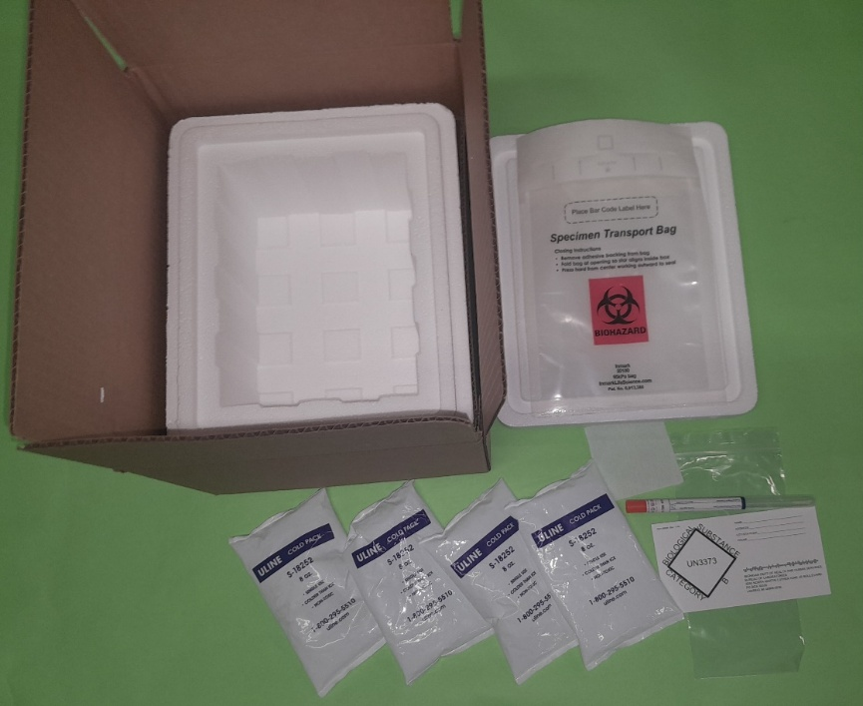
Kit 15: Bordetella pertussis PCR Collection Kit

