Outdoor Burning

Model Ordinance

A Guide for Michigan Counties, Cities, Villages, and Townships
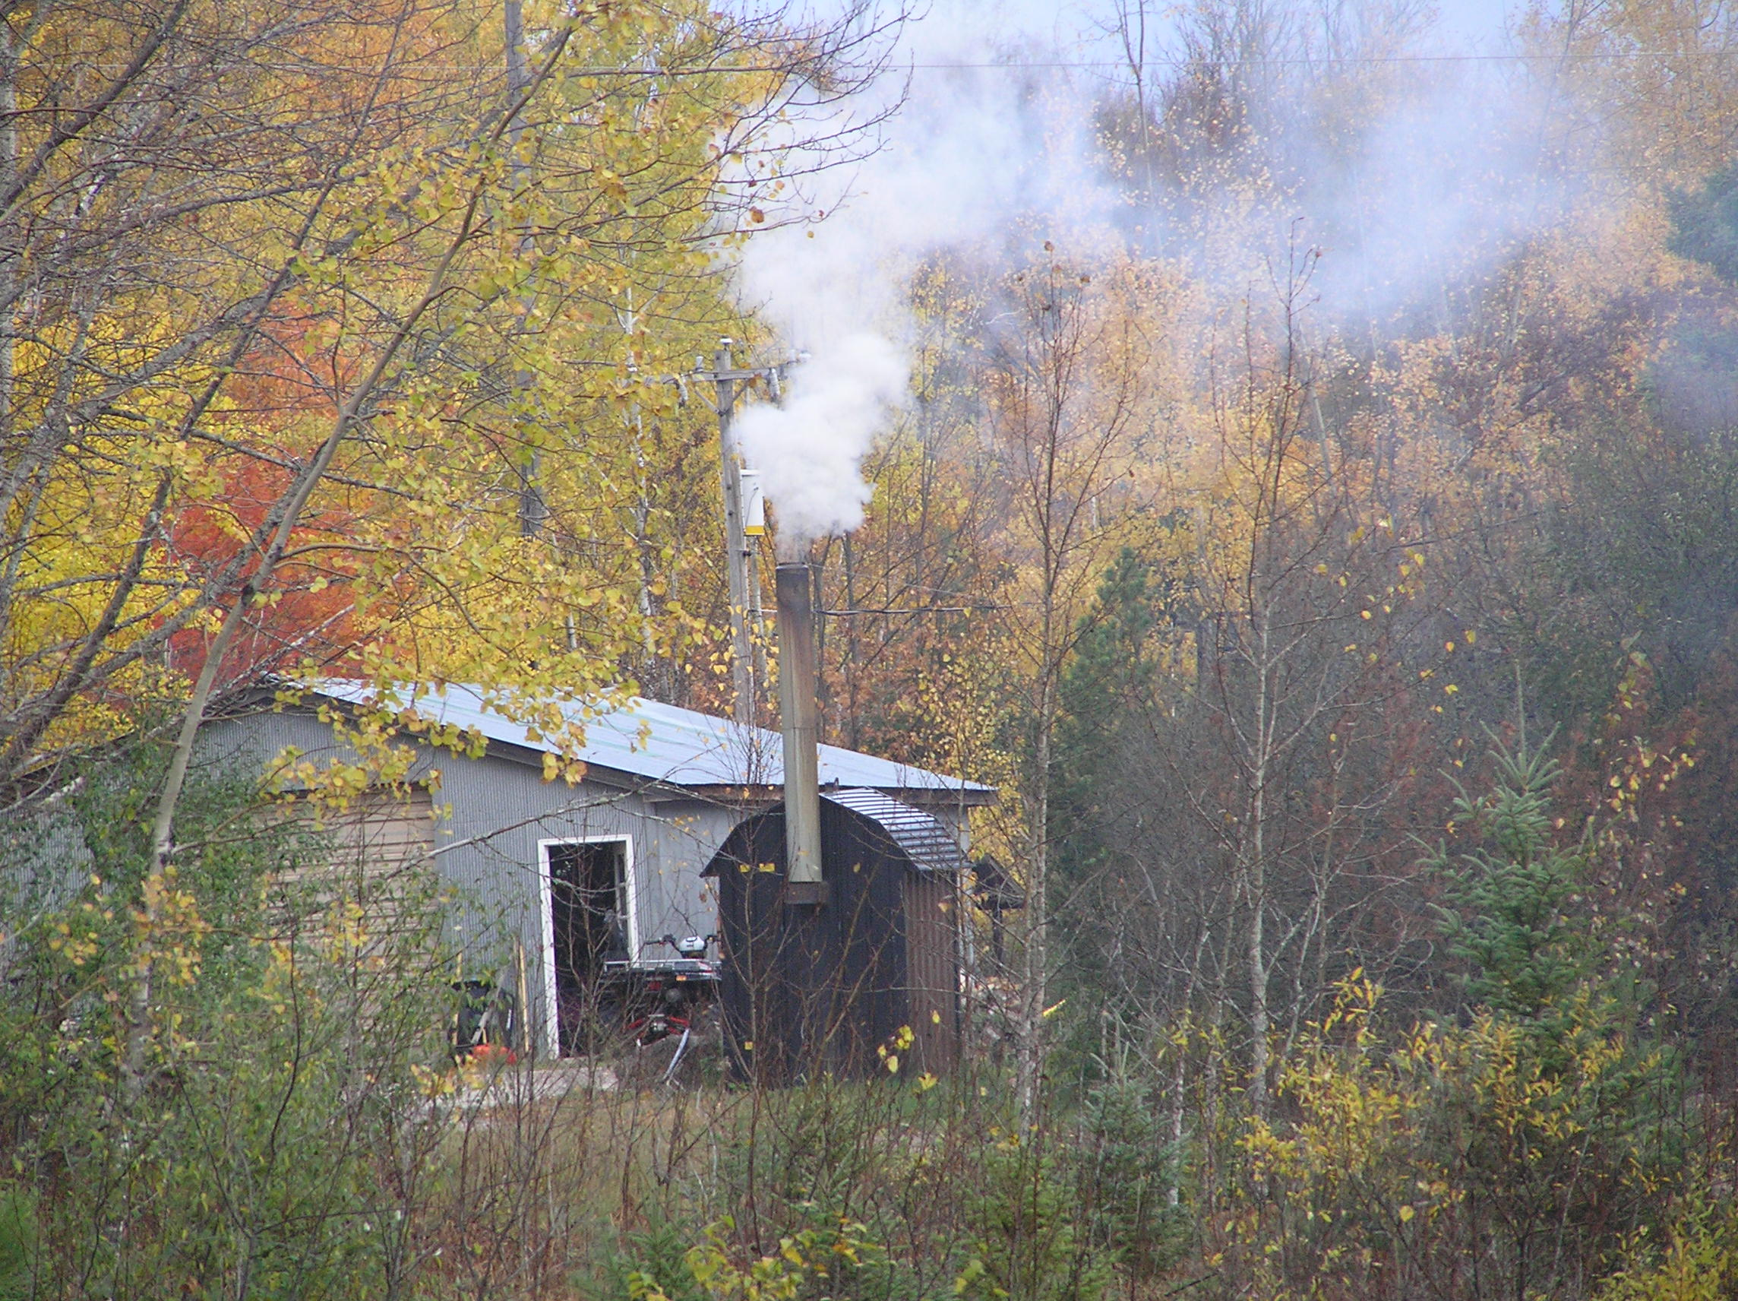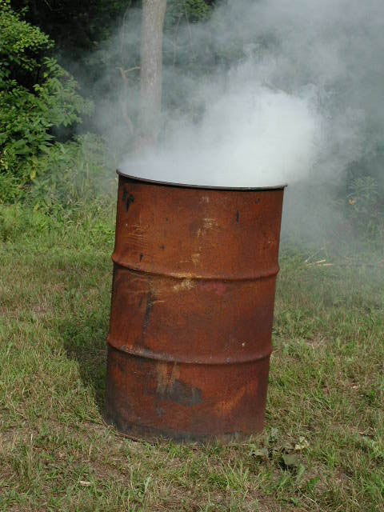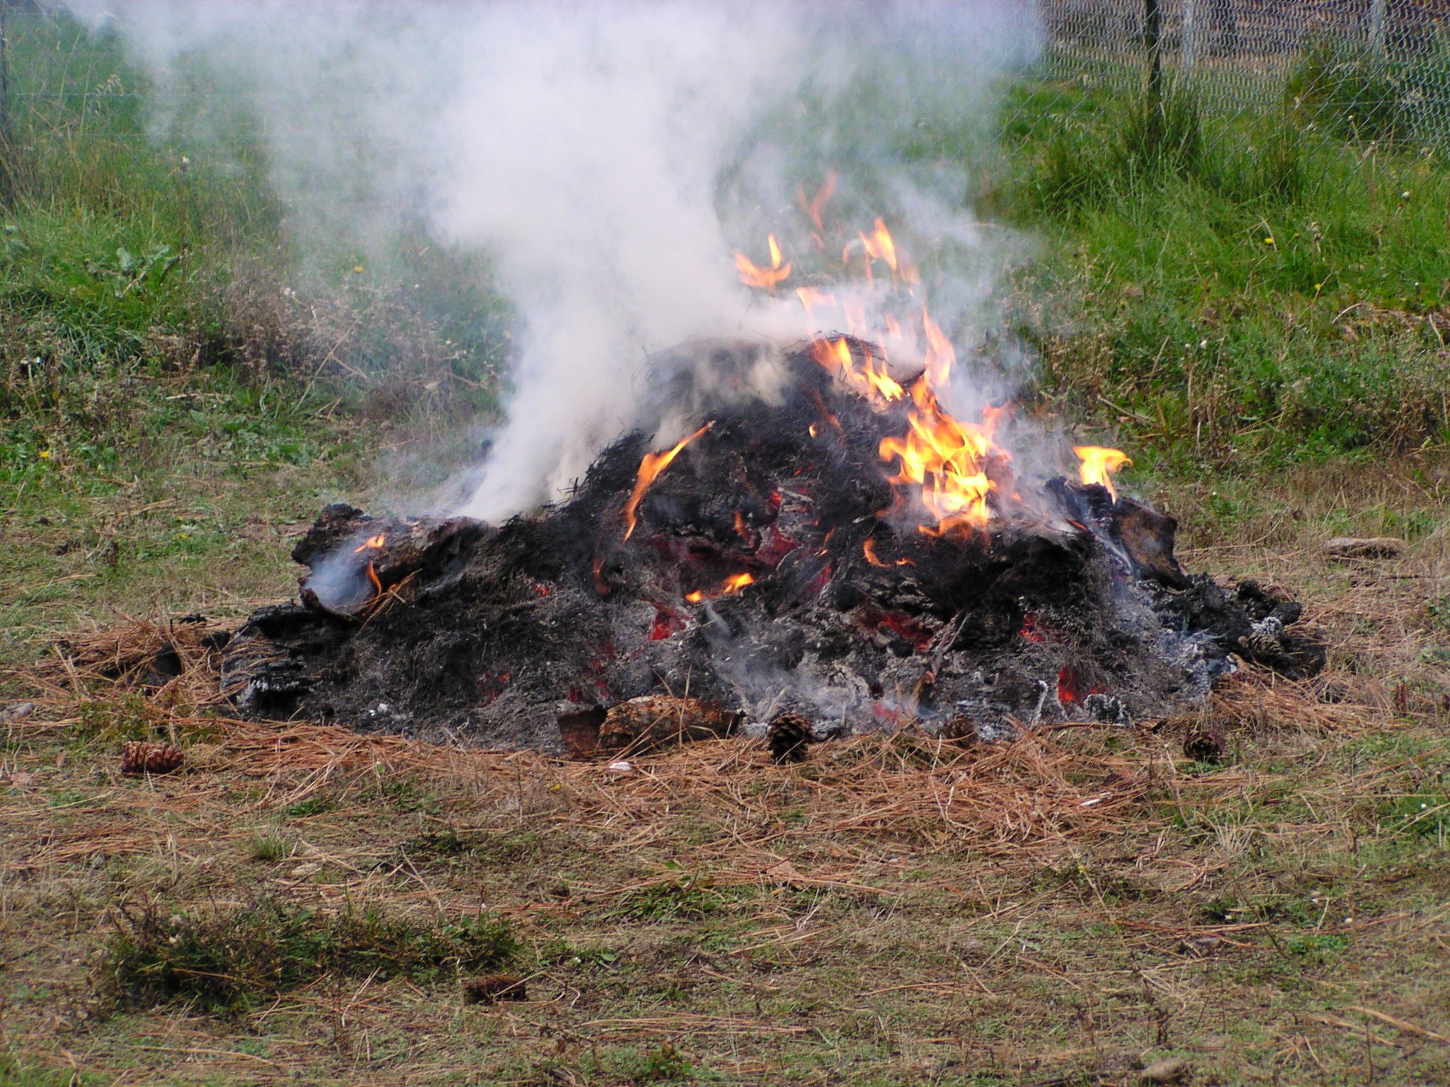



Michigan Department of Environmental Quality

Michigan Townships Association

OUTDOOR BURNING MODEL ORDINANCE
A Guide for Michigan Counties, Cities, Villages, and Townships

INTRODUCTION

While it may seem harmless, outdoor burning generates air pollution, which affects human health and is the source of many odor and nuisance complaints. This model ordinance was developed by the Michigan Department of Environmental Quality (DEQ) in conjunction with the Michigan Townships Association to help Michigan cities, villages, townships, and counties regulate outdoor burning. A municipality may use this ordinance as a model to create its own burning ordinance. The required provisions in this model ordinance meet the state of Michigan open burning restrictions. The suggested optional provisions have been included to allow a municipality to be more restrictive than what the state regulations require. Although not required, these optional provisions are recommended to reduce the amount of air pollution generated by outdoor burning and the adverse health effects associated with it. The model is intended to be advisory only. A municipality is not required to adopt this ordinance or any of the provisions within it; however, a local ordinance cannot be less restrictive than the state requirements outlined in this document.

INSTRUCTIONS

Part I of the Model Ordinance contains numerous alternatives for municipalities to consider and detailed explanations of the various provisions. Each section contains both required provisions and optional provisions that your municipality can "pick and choose" from. All [underlined, bracketed bold] sections require filling in a name, address, governmental body, distance or other information. Shaded and italicized text shows comments or explanations.

Complete each of the fields that require information. If you are using an electronic version of the ordinance, delete any of the notes or grayed out instructions. Many of the provisions in the model are noted as being optional. You can either include these optional provisions or delete them from your ordinance.

Depending on the size and nature of your community, you may want to regulate some of the practices included in model ordinance and leave out others. If a section in the Model Ordinance is omitted, you will need to renumber the remaining sections. You may also have to change any references in previous sections to these renumbered sections. For example, if you omit sections 10 and 11, section 12 will have to be renumbered to section 10 and any references throughout the ordinance to section 12 will also have to be changed.

This model ordinance is available in electronic form on the DEQ open burning web site www.michigan.gov/openburning (select “Model Ordinance”).

You can find additional information about open burning at the following websites:

- Michigan DEQ Open Burning web site: www.michigan.gov/openburning

- Michigan Department of Natural Resources (DNR) Burn Permit web site: www.michigan.gov/burnpermit

- U.S. Environmental Protection Agency (EPA) Backyard Burning web site: www.epa.gov/epawaste/nonhaz/municipal/backyard/index.htm
TABLE OF CONTENTS

Part 1: Model Ordinance 3
Section 1: Purpose 3
Section 2: Applicability 3
Section 3: Severability 3
Section 4: Definitions 3
Section 5: General Prohibition on Outdoor Burning and Open Burning 4
Section 6: Open Burning of Refuse 4
Section 7: Open Burning of Trees, Logs, Brush, Stumps, Leaves,
and Grass Clippings 5
Section 8: Agricultural Burning 7
Section 9: Prescribed Burning 7
Section 10: Outdoor Wood Furnaces 7
Section 11: Patio Wood Burning Units 10
Section 12: Fire Suppression Training 10
Section 13: Burning Permits 11
Section 14: Liability 12
Section 15: Right of Entry and Inspection 12
Section 16: Enforcement and Penalties 12

Part 2: Example Ordinance 15

Appendix A: DEQ, Air Quality Division Priority I and II Areas 21

PART 1: MODEL ORDINANCE

Outdoor Burning Ordinance for the [Pick one: county, city, village or township] of [name], Michigan.

Ordinance No. __________

Note to Those Drafting Ordinances: This model ordinance was drafted to cover "open burning" and "outdoor burning" (outdoor burning includes open burning as well as burning in outdoor wood furnaces and patio burners). If your municipality decides to adopt an ordinance that does not address all of these topics, the title of the ordinance should be changed accordingly.

Section 1: Purpose

1.00 Purpose.
This ordinance is intended to promote the public health, safety and welfare and to safeguard the health, comfort, living conditions, safety and welfare of the citizens of the [Pick one: county, city, village or township] of [name] by regulating the air pollution and fire hazards of outdoor burning.

Section 2: Applicability

2.00 Applicability.
This ordinance applies to all outdoor burning within the [Pick one: county, city, village or township] of [name]. [For county ordinances, insert the following: This county ordinance does not apply to incorporated municipalities. If a provision in a township ordinance in this county covers a similar provision contained in this county ordinance, the township ordinance takes precedence.]

2.1. This ordinance does not apply to grilling or cooking food using charcoal, wood, propane or natural gas in cooking or grilling appliances.

2.2. This ordinance does not apply to burning for the purpose of generating heat in a stove, furnace, fireplace or other heating device within a building used for human or animal habitation.

2.3. This ordinance does not apply to the use of propane, acetylene, natural gas, gasoline or kerosene in a device intended for heating, construction or maintenance activities.

SECTION 3: SEVERABILITY

3.00 Severability.
Should any portion of this ordinance be declared unconstitutional or invalid by a court of competent jurisdiction, the remainder of this ordinance shall not be affected.

SECTION 4: Definitions

4.00 Definitions.

4.1. "Campfire" means a small outdoor fire intended for recreation or cooking but not including a fire intended for disposal of waste wood or refuse.

4.2. "Clean wood" means natural wood which has not been painted, varnished or coated with a similar material; has not been pressure treated with preservatives; and does not contain resins or glues as in plywood or other composite wood products.

4.3. “Construction and demolition waste” means building waste materials, including but not limited to waste shingles, insulation, lumber, treated wood, painted wood, wiring, plastics, packaging, and rubble that results from construction, remodeling, repair, and demolition operations on a house, commercial or industrial building, or other structure.

4.4. "Fire Chief" means the Chief of the [insert name of Fire Department] or other person designated by the Fire Chief. Note: The term “Fire Chief” is used throughout this model ordinance. Municipalities may, at their discretion, designate persons other than those associated with the Fire Department for many of the responsibilities in this ordinance. Also, if a municipality is served by more than one fire department, this definition should be adjusted to include the designated persons from each department.

4.5. “Municipality” means a county, township, city, or village.

4.6. "Open burning" means kindling or maintaining a fire where the products of combustion are emitted directly into the ambient air without passing through a stack or a chimney. This includes burning in a burn barrel.

4.7. "Outdoor burning" means open burning or burning in an outdoor wood furnace or patio wood-burning unit.

4.8. “Outdoor wood furnace” also known as an outdoor wood-fired boiler, outdoor wood-burning appliance, or hydronic heater, means a fuel-burning device that is designed to burn clean wood or other approved solid fuels and is not located within a building intended for habitation by humans or domestic animals; and heats building space and/or water through the distribution, typically through pipes, of a fluid heated in the device, typically water or a mixture of water and antifreeze.

4.9. “Patio wood-burning unit” means a chimnea, patio warmer, or other portable wood-burning device used for outdoor recreation and/or heating.

4.10. “Refuse" means any waste material except trees, logs, brush, stumps, leaves, grass clippings, and other vegetative matter.

SECtion 5: General Prohibition on OPEN Burning

5.00 General prohibition on open burning.
Open burning is prohibited in the [Pick one: county, city, village or township] of [name] unless the burning is specifically permitted by this ordinance.

SECTION 6: Open bURNING of REFUSE
Note to Those Drafting Ordinance: The open burning of refuse (trash) poses a danger to human health and the environment and is frequently a source of citizen complaints. Section 324.11522 of the Natural Resources and Environmental Protection Act (Public Act 451 of 1994) prohibits the open burning of household trash that contains plastic, rubber, foam, chemically treated wood, textiles, electronics, chemicals or hazardous materials. Your municipality will need to decide whether to entirely prohibit the burning of refuse (Alternative 1), prohibit the burning of the items prohibited in the Act, or not regulate the activity under ordinance but rather under the Act which includes specific penalty provisions.

6.00 Open burning of refuse.
(Alternative 1) Open burning of refuse is prohibited.

Or

(Alternative 2)
6.1. Open burning of refuse from a commercial or industrial establishment is prohibited.
6.2. Open burning of refuse from and at a one or two family dwelling is allowed if all of the following conditions are met:
6.2.1. The burning does not create a nuisance. Note: municipalities may want to include language that further defines “nuisance” (e.g., “no materials shall be burned that create a foul or offensive odor or that cause smoke emissions that are reasonably offensive to occupants of surrounding property.”)
6.2.2. The burning is conducted in a container constructed of metal or masonry that has a metal covering device that does not have an opening larger than ¾ inch.
6.2.3. The material being burned is not prohibited under subsection 6.3.
6.2.4. A permit issued in accordance with section 13 of this ordinance has been obtained. Note: This subsection is only required if your municipality chooses to require a permit for this activity under section 13.
6.3. Open burning of the following materials is prohibited.
6.3.1. Household waste that contains plastic, rubber, foam, chemically treated wood, textiles, electronics, chemicals, or hazardous materials
6.3.2. Construction and demolition waste.
6.3.3. Hazardous substances including but not limited to batteries, household chemicals, pesticides, used oil, gasoline, paints, varnishes, and solvents.
6.3.4. Furniture and appliances.
6.3.5. Tires.

Note: Open burning the following items is not prohibited under Section 324.11522 of Public Act 451 of 1994; however, may be prohibited under local ordinance.
6.3.6. Newspaper.
6.3.7. Corrugated cardboard, container board, office paper.

SECTION 7: Open bURNING of Trees, logs, brush, stumps, LEAVES, aND Grass clippings
Note to Those Drafting Ordinance: Your municipality will need to decide whether to entirely prohibit burning of these materials or whether to restrict, but not entirely prohibit, burning of these materials. Based upon that decision, the appropriate provisions from among those suggested in this model may be selected. If Alternative 2 is selected, subsections 7.1 through 7.2.5 should always be included. The provisions in subsection 7.2.6 though 7.2.13 are not required by state air pollution or waste management rules, but are suggestions that a municipality should seriously consider as issues of concern for local regulation in the ordinance. State rules do not allow the burning of trees, logs, brush, and stumps within the limits of an incorporated city or village. Although not required, it is recommended that your municipality at least prohibit the burning of grass clippings and leaves, especially in municipalities with a population greater than 7,500. The burning of these materials generates large amounts of smoke that can be dangerous to those with respiratory problems in the community. If your municipality’s population is larger than 7,500 and you choose to allow the burning of grass clippings and leaves, you must notify the DEQ of this provision.

7.00 Burning trees, logs, brush, stumps, leaves, and grass clippings.
(Alternative 1) Open burning of trees, logs, brush, stumps, leaves, and grass clippings is prohibited.

Or
(Alternative 2)
7.1. Open burning of [trees, logs, brush, stumps, leaves, and grass clippings] is prohibited. Name the particular type of material from the above list that may not be burned such as grass clippings and leaves. If you choose to allow the burning of all these materials with some restrictions, omit this subsection.

7.2. Open burning of [trees, logs, brush, stumps, leaves, and grass clippings] Do not include any material prohibited in 7.1. is allowed only in accordance with all of the following provisions:

7.2.1. Except for campfires, a permit issued in accordance with Section 13 of this ordinance must be obtained prior to open burning under this section when the ground is not snow-covered.

7.2.2. Open burning of trees, logs, brush, and stumps must be conducted at least 1,400 feet from an incorporated city or village limit.

7.2.3. Note: Only include this provision if your municipality contains a priority area as listed in R 336.1331 of the Michigan Air Pollution Control Rules (See Appendix A for a listing of priority areas).Open burning of trees, logs, brush, and stumps is prohibited in the following area [list area from Appendix A], which is designated as a priority area by the Michigan Department of Environmental Quality under R 336.1331 of the Michigan Air Pollution Control Rules.

7.2.4. Except for barbecue, gas, and charcoal grills, no open burning shall be undertaken during periods when the Governor of Michigan has issued a burning ban applicable to the area.

7.2.5. All allowed open burning shall be conducted in a safe, nuisance-free manner, when wind and weather conditions minimize adverse effects and do not create a health hazard or a visibility hazard on roadways, railroads or airfields. Open burning shall be conducted in conformance with all local and state fire protection regulations.

Note: The following additional provisions are optional

7.2.6. Open burning shall be conducted only on the property on which the materials were generated.

7.2.7. Campfires and small bonfires for cooking, ceremonies, or recreation are allowed provided they do not cause a nuisance. Note: Municipalities may want to also include a description of areas where a campfire is allowed or prohibited (e.g., prohibit campfires in residential developments). Municipalities may also consider adding a restriction of the size of campfires to avoid very large bonfires that have the potential to get out of control (e.g. no larger than 4 ft x 4ft).

7.2.8. Open burning under this section shall only be conducted at a location at least [insert a distance appropriate for the municipality.] (such as 100 feet, 250 feet or another greater or lesser distance) from the nearest building which is not on the same property. Note: Municipalities may also want to consider whether different distances should be required for different types of open burning under this section (e.g., campfires vs. brush disposal fires).

7.2.9. Except for campfires, open burning shall only be conducted [insert times of year and/or times of day appropriate for the municipality]. Note: Some municipalities with volunteer fire departments may want to require burning during times of the day when firefighters are more likely to be available. Other municipalities may limit burning to only daylight hours. The municipality may also limit the times of year when open burning is acceptable, such as months with low fire hazard or times when snow cover is present.

7.2.10. Open burning shall be constantly attended and supervised by a competent person of at least eighteen (18) years of age (or use another appropriate age) until the fire is extinguished and is cold. The person shall have readily available for use such fire extinguishing equipment as may be necessary for the total control of the fire.

7.2.11. No materials may be burned upon any street, curb, gutter or sidewalk or on the ice of a lake, pond, stream or waterbody.

7.2.12. Except for barbecue, gas, and charcoal grills, no burning shall be undertaken within [insert distance] (25 feet or other appropriate distance) from any combustible material, combustible wall or partition, exterior window opening, exit access or exit unless authorized by the Fire Chief.

7.2.13. No open burning may be conducted on days when the Department of Environmental Quality has declared an “air quality action day” applicable to the [Pick one: county, city, village or township] of [name]. Note: Those municipalities in areas subject to ozone advisories should consider this subsection.

SECTION 8: aGRICULTURAL BURNING (Omit this section entirely if your municipality chooses not to regulate this activity)

8.00 Agricultural burning.
Open burning of weeds, brush, and crop stubble on agricultural lands is allowed if conducted in accordance with other applicable provisions of this ordinance.

SECTION 9: PRESCRIBED BURNs (Omit this section entirely if your municipality chooses not to regulate this activity)
Note to Those Drafting Ordinances: Prescribed burns are used to manage forest, prairie, or wildlife habitat. Prescribed burns are regulated under Part 515 of the Natural Resources and Environmental Protection Act, MCL 324.51501 et seq. This law is administered by the Michigan Department of Natural Resources (DNR).

9.00 Prescribed burning.
9.1. “Prescribed Burn” means the burning, in compliance with a prescription and to meet planned fire or land management objectives, of a continuous cover of fuels. A "prescription" means a written plan establishing the criteria necessary for starting, controlling, and extinguishing a burn.

9.2. Fires set for forest, prairie, and wildlife habitant management are allowed only if conducted in accordance with Part 515 of the Natural Resources and Environmental Protection Act, MCL 324.51501 et seq.

SECTION 10: OUTDOOR WOOD FURNACES (Omit this section entirely if your municipality chooses not to regulate this activity)
Note to Those Drafting Ordinances: Outdoor wood furnaces (OWFs), stoves, boilers or hydronic heaters, all of which are defined as "outdoor wood furnaces" in this model ordinance, are a leading cause of citizen complaints. They are designed for long burn times between loading and typically have chimney heights less than 10 feet. Restricted airflow, low operating temperatures, and large fuel loads frequently result in excessive smoke. The smoke can cause both acute and chronic health problems if nearby residents are exposed. Your municipality will need to decide whether to entirely ban outdoor wood furnaces, whether to allow outdoor wood furnaces under specified conditions, or not to regulate them at all. Based upon that decision, the appropriate provisions from the four alternatives suggested below may be chosen. The provisions in this section are designed to reduce citizen exposure to smoke from improperly designed, operated, and located units. However, there may be circumstances where a unit complies with the provisions yet emits smoke at levels that generate complaints. In these cases, it may be necessary to require the owner of the unit to implement measures necessary to mitigate smoke exposure (e.g. extending the chimney height, removing/altering the rain cap, relocating the unit, etc). These measures can be implemented as part of the penalty schedule identified in Section 16. You may also choose to add a provision that prohibits the unit from causing a “nuisance.” If a nuisance provision is added, the term “nuisance” should be defined in this ordinance or in another ordinance that is referenced in the provision.

10.00 Outdoor wood furnaces.

(Alternative 1)
After [insert effective date] no person shall install, use, or maintain an outdoor wood furnace in the [Pick one: county, city, village or township] of [name]. Note: If you wish to prohibit only new installations and regulate existing OWFs, consider Alternative 3. If you wish to allow the installation and use of OWFs with certain restrictions, consider Alternative 4.

Or

(Alternative 2)
After [insert effective date] no person shall install an outdoor wood furnace in the [Pick one: county, city, village or township] of [name] until federal or state regulations pertaining to the manufacturing of wood-fired furnaces are adopted by the [Pick one: county, city, village or township] of [name].

Or

(Alternative 3 - This alternative provides language to prohibit new units and regulate existing units.)
10.1. No person shall install an outdoor wood furnace in the [Pick one: county, city, village or township] of [name] on or after [insert effective date].

10.2. The following provisions apply to outdoor wood furnaces installed before [effective date]:

10.2.1. The outdoor wood furnace shall have a permanently attached stack with a minimum stack height of 15 feet above the ground that also extends at least two feet above the highest peak of any residence not served by the outdoor wood furnace located less than [insert a specified distance] from the outdoor wood furnace. (A minimum distance of 200 feet or greater is recommended.)

10.2.2. Fuel burned in the outdoor wood furnace shall be only clean wood, wood pellets made from clean wood, or other listed fuels specifically permitted by the manufacturer’s instructions such as fuel oil, natural gas or propane backup.

10.2.3. The following items are strictly prohibited in outdoor wood furnaces:
- Any material not listed in 10.2.2.
- Wood that has been painted, varnished, or coated with similar material and/or has been pressure treated with preservatives and contains resins or glues as in plywood or other composite wood products.
- Rubbish or garbage, including but not limited to food wastes, food packaging, food wraps.
- Any plastic materials including but not limited to nylon, PVC, ABS, polystyrene or urethane foam, and synthetic fabrics, plastic films and plastic containers.
- Rubber, including tires or other synthetic rubber-like products.
- Newspaper, cardboard, or any paper with ink or dye products.
- Any other items not specifically allowed by the manufacturer or this provision.

10.2.4. The owner of the outdoor wood furnace shall obtain an annual permit from the Fire Chief in accordance with Section 13 of this ordinance if the furnace is located within [insert a specified distance] from property line of the nearest neighbor. Note: If a permit will not be required for outdoor wood furnaces, omit this paragraph entirely. If a permit will be required for all outdoor wood-fired furnaces, end the sentence after the word “ordinance.” If a permit will be required only if there are nearby neighbors, insert an appropriate distance such as 500 or 1,000 feet from property line or from the nearest building which is not on the same property).
Or

(Alternative 4) This alternative provides language to regulate both new and existing units.
An outdoor wood furnace may be installed and used in the [Pick one: county, city, village or township] of [name] only in accordance with the following provisions:

10.1. The outdoor wood furnace shall have a permanently attached stack with a minimum stack height of 15 feet above the ground that also extends at least two feet above the highest peak of any residence not served by the outdoor wood furnace located less than [insert a specified distance] from the outdoor wood furnace. (A minimum distance of 200 feet or greater is recommended.)

10.2. Fuel burned in the outdoor wood furnace shall be only clean wood, wood pellets made from clean wood, or other listed fuels specifically permitted by the manufacturer’s instructions such as fuel oil, natural gas or propane backup.

10.3. The following items are strictly prohibited in outdoor wood furnaces:
- Any material not listed in 10.2.
- Wood that has been painted, varnished, or coated with similar material and/or has been pressure treated with preservatives and contains resins or glues as in plywood or other composite wood products.
- Rubbish or garbage, including but not limited to food wastes, food packaging, food wraps.
- Any plastic materials including but not limited to nylon, PVC, ABS, polystyrene or urethane foam, and synthetic fabrics, plastic films and plastic containers.
- Rubber, including tires or other synthetic rubber-like products.
- Newspaper, cardboard, or any paper with ink or dye products.
- Any other items not specifically allowed by the manufacturer or this provision.

10.4. The owner of the outdoor wood furnace shall obtain an annual permit from the Fire Chief in accordance with Section 13 of this ordinance if the furnace is located within [insert a specified distance] from property line of the nearest neighbor. If a permit will not be required for outdoor wood furnaces, omit this paragraph entirely. If a permit will be required for all outdoor wood-fired furnaces, end the sentence after the word “ordinance.” If a permit will be required only if there are nearby neighbors, insert an appropriate distance such as 500 or 1,000 feet from property line or from the nearest building which is not on the same property.

10.5. Outdoor wood furnaces installed on or after [effective date] must comply with the following provisions:

10.5.1. The outdoor wood furnace shall be installed and used only in an area zoned [insert appropriate zoning designation]. It is recommended that units NOT be installed in residential areas such as subdivisions due to the increased risk for adverse health affects and nuisance complaints. Consider allowing OWFs only in areas with limited population to reduce the exposure risk.

10.5.2. The outdoor wood furnace shall be constructed, established, installed, operated and maintained in conformance with the manufacturer’s instructions and the requirements of this ordinance. In the event of a conflict, the requirements of this ordinance shall apply unless the manufacturer’s instructions are stricter, in which case the manufacturer’s instructions shall apply.

10.5.3. The outdoor wood furnace shall be laboratory tested and listed to appropriate safety standards such as UL, CAN/CSA, ANSI or other applicable safety standards.

10.5.4. The outdoor wood furnace shall be located at least [insert a distance appropriate for the municipality] from the nearest property line. Note: It is recommended that you choose a minimum distance of at least 200 feet. A greater distance may be necessary if the terrain or density of the area is such that would necessitate a further set back to reduce exposure of nearby residents to the emissions.

    - The outdoor wood furnace shall be located on the property in compliance with manufacturer’s recommendations and or testing and listing requirements for clearance to combustible materials.

SECTION 11: PATIO WOOD-BURNING UNITS (Omit this section entirely if your municipality chooses not to regulate this activity)
Note to Those Drafting Ordinances: Chimneas, patio warmers, and other portable wood-burning devices used for recreational purposes, all of which are defined as "patio wood-burning units" in this model ordinance, can be a cause of citizen complaints. The smoke may cause both acute and chronic health problems if nearby residents are exposed. Sparsely populated rural townships will likely not need to regulate patio wood-burning units. However, if your municipality is more developed or has had citizen complaints about patio wood-burning units, you should consider the following alternatives. Your municipality will need to decide whether to entirely ban patio wood-burning units, whether to allow patio wood-burning units under specified conditions, or whether not to regulate them at all. Based upon that decision, the appropriate provisions from those suggested in this model may be chosen.

11.00 Patio wood-burning units.
(Alternative 1) No person shall install, use, or maintain a patio wood-burning unit in the [Pick one: county, city, village or township] of [name].

Or

(Alternative 2) A patio wood-burning unit may be installed and used in the [Pick one: county, city, village or township] of [name] only in accordance with all of the following provisions:

11.1. The patio wood-burning unit shall not be used to burn refuse.
11.2. The patio wood-burning unit shall burn only clean wood.

11.3. The patio wood-burning unit shall be located at least [insert a distance appropriate for the municipality] from the nearest structure which is not on the same property as the patio wood-burning unit. (Choose a minimum distance such as 25 feet, 50 feet or other greater or lesser distance as appropriate for your municipality. For the reasons cited in the introductory note to this section, a substantial minimum distance is recommended.)

11.4. The patio wood-burning unit shall not cause a nuisance to neighbors.

SECTION 12: FIRE SUPPRESSION TRAINING (Omit this section entirely if your municipality chooses not to regulate this activity)
Note to Those Drafting Ordinances: The language suggested in Section 12 regarding fire suppression training is consistent with state administrative rules governing the activity. If a municipality elects not to include this section, practice burns might be prohibited by other provisions of the ordinance (e.g. the prohibitions in sections 5 and 6 of this model). If a section on fire suppression training is included in the ordinance, it must be at least as stringent as state regulations. The DEQ has developed a guidance document for conducting fire suppression training which can be accessed at www.michigan.gov/openburning (click on “Fire Department Fire Suppression Training”).

12.00 Fire suppression training.
Notwithstanding sections 5 and 6 of this ordinance, structures and other materials may be burned for fire prevention training only in accordance with all of the following provisions.

12.1. The burn must be exclusively for fire prevention training. The burning shall not be used as a means to dispose of waste material including tires and other hazardous materials.

12.2. All asbestos must be removed prior to conducting the fire suppression training. If the structure is a residential dwelling, the owner may remove the asbestos or have it removed by a licensed abatement contractor. If it is a commercial building, all asbestos must be removed by a licensed abatement contractor. A listing of accredited individuals and companies licensed by the Department of Licensing and Regulatory Affairs Asbestos Program can be accessed at www.dleg.state.mi.us/asbestos_program.

12.3. A notification of the demolition must be submitted to the Michigan Department of Environmental Quality, Air Quality Division at least 10 business days prior to burning a standing structure. The notification must be submitted using Form EQP 5661 “Notification of Intent to Renovate/Demolish.”

12.4. All ash and demolished materials must be disposed of in an approved landfill or at an alternate location approved by the Michigan Department of Environmental Quality.

Note: The following additional provisions are optional.

12.5. Asphalt shingles and asphalt or plastic siding shall be removed prior to the practice burn unless the Fire Chief determines that they are necessary for the fire practice.

12.6. At least [insert an appropriate number of hours or days] before a planned practice burn, residents within [insert a distance appropriate for the municipality] of the site of the proposed burn shall be notified. (For example, an ordinance could require notification of residents at least 48 hours in advance if they are within 1,000 feet of the proposed burn site.)

12.7. All fire suppression training should conform to the guidelines established by the National Fire Protection Association (NFPA) Standard on Live Fire Training Evolutions (NFPA 1403).

SECTION 13: BURNING PERMITS
Note to Those Drafting Ordinances: The Michigan Department of Natural Resources (DNR) is responsible for issuing burn permits in the Upper Peninsula and Northern Lower Peninsula unless a municipality wishes to do so. Municipalities located in the Southern Lower Peninsula issue burn permits under authority of the state law. Information about where to obtain burn permits can be found at www.michigan.gov/burnpermit. Choose Alternative 1 if you are located in an area where the DNR issues burn permits. Choose Alternative 2 if your municipality issues burn permits. If your municipality wants to require permits for outdoor wood-fired furnaces choose the appropriate language in section 13.4.

13.00 Burning Permits.
(Alternative 1: For municipalities in areas where the DNR will issue burn permits)
At any time the ground is not snow-covered, a person shall not burn any flammable material on or adjacent to forest land, except for domestic purposes, without a permit from the Michigan Department of Natural Resources. “Domestic purposes” means any fire within the curtilage of a dwelling where the material being burned has been properly placed in a debris burner constructed of metal or masonry with metal covering devices with openings no larger than ¾ of an inch, or a campfire, or any fire within a building.

Or

(Alternative 2: For consideration by municipalities that issue burn permits.)
13.1. No person shall start or maintain any open burning covered under this section without a burning permit issued by the [insert "Fire Chief", or name of other office, or title(s) of other person(s) authorized to issue burning permits].

13.2. Any person responsible for burning leaves, brush, clean wood or other vegetative debris under Section 7 of this ordinance shall obtain a one-time burning permit before starting the fire. The fee for each one-time burning permit shall be [insert cost of one-time permit]. Note: Burning permits are commonly issued without a fee. Your municipality will have to decide whether or not to require a fee and how to collect it.

13.3. A campfire does not require a permit provided that the fire complies with all other applicable provisions of this ordinance.

13.4. (Use subsection 13.4 if a permit is required under Section 10) The owner or occupant of the property shall obtain an annual burning permit for each outdoor wood furnace before using the outdoor wood furnace. The fee for each annual burning permit shall be [insert cost of annual permit]. Note: Burning permits are commonly issued without a fee. Your municipality will have to decide whether or not to require a fee and how to collect it. An annual permit expires on [insert annual date of expiration] of each year.

13.5. When weather conditions warrant, the Fire Chief may temporarily suspend issuing burning permits and may temporarily suspend previously issued burning permits for open burning.

13.6. A burning permit issued under this section shall require compliance with all applicable provisions of this ordinance and any additional special restrictions deemed necessary to protect public health and safety.

13.7. Any violation of the conditions of a burning permit shall be deemed a violation of this ordinance. Any violation of this ordinance or the burning permit shall void the permit.

SECTION 14: LIABILITY

14.00 Liability.
A person utilizing or maintaining an outdoor fire shall be responsible for all fire suppression costs and any other liability resulting from damage caused by the fire.

SECTION 15: RIGHT OF ENTRY AND INSPECTION

15.00 Right of entry and inspection.
The Fire Chief or any authorized officer, agent, employee or representative of the [Pick one: county, city, village or township] of [name] who presents credentials may inspect any property for the purpose of ascertaining compliance with the provisions of this ordinance.

SECTION 16: ENFORCEMENT AND PENALTIES
Note to Those Drafting Ordinances: The penalty schedule presented in this section is an example and may be altered to fit the needs of your community. Many officials will provide a written warning in response to a first offense. The warning may include mitigation measures that could be taken to minimize the effects of the outdoor burning or require that the offender cease and desist the activity. This warning may be written into the penalty schedule or applied simply at the discretion of the enforcement official involved per written guidance or policy.

16.00 Enforcement and penalties.

16.1. The Fire Chief and [insert titles of other designated municipal officials] are authorized to enforce the provisions of this ordinance.

16.2. Any person, firm, association, partnership, corporation, or governmental entity who violates any of the provisions of this ordinance or fails to comply with a duly authorized order issued pursuant to this ordinance shall be deemed to be responsible for a municipal civil infraction as defined by Michigan Statute which shall be punishable by civil fine determined in accordance with the following schedule:

 | Minimum Fine | Maximum Fine
1st Offense within 3-year period* | $75.00 | $500.00
2nd Offense within 3-year period* | $150.00 | $500.00
3rd Offense within 3-year period* | $325.00 | $500.00
4th or More offenses within 3-year period* | $500.00 | $500.00

*Determined on the basis of the date of commission of the offense(s)

Note: This penalty schedule is an example, your municipality may choose a different penalty schedule.

16.3. The violator shall pay costs which may include all expenses, direct and indirect, which the [Pick one: county, city, village or township] of [name] has incurred in connection with the municipal infraction. In no case, however, shall costs of less than [insert amount of minimum penalty] nor more than [insert amount of maximum penalty] be ordered. In addition, the [Pick one: county, city, village or township] shall have the right to proceed in any court of competent jurisdiction for the purpose of obtaining an injunction, restraining order, or other appropriate remedy to compel compliance with this ordinance. Each day that a violation of this ordinance exists shall constitute a separate violation of this ordinance.

NOTES

PART 2: EXAMPLE ORDINANCE

The model ordinance in Part 1 was used to create the following ordinance for a rural township in Michigan with a volunteer fire department and a population of 2,600. This is not an actual ordinance. Spartan Township is fictitious. The Model Ordinance contains numerous alternatives for municipalities to consider and detailed explanations of the various provisions and alternatives. As a result, at first glance the Model Ordinance may appear to be overly lengthy and complex. This "Example Ordinance” has been included to show municipalities what a shorter end product might look like. Municipalities are urged not to use this example directly because that would not allow them to consider all the alternatives in Part I Model Ordinance and to select the alternatives that best meet their needs.

Outdoor Burning Ordinance for the Township of Spartan, Michigan.

Ordinance No. 3-A-2010

Section 1: Purpose
1.00 Purpose.
This ordinance is intended to promote the public health, safety and welfare and to safeguard the health, comfort, living conditions, safety and welfare of the citizens of the Township of Spartan due to the air pollution and fire hazards of outdoor burning.

Section 2: Applicability
2.00 Applicability.
This ordinance applies to all outdoor burning within the township of Spartan.
2.1. This ordinance does not apply to grilling or cooking using charcoal, wood, propane or natural gas in cooking or grilling appliances.
2.2. This ordinance does not apply to burning in a stove, furnace, fireplace or other heating device within a building used for human or animal habitation.
2.3. This ordinance does not apply to the use of propane, acetylene, natural gas, gasoline or kerosene in a device intended for heating, construction or maintenance activities.

SECTION 3: SEVERABILITY
3.00 Severability.
Should any portion of this ordinance be declared unconstitutional or invalid by a court of competent jurisdiction, the remainder of this ordinance shall not be affected.

SECTION 4: Definitions
4.00 Definitions.
4.1. "Campfire" means a small outdoor fire intended for recreation or cooking but not including a fire intended for disposal of waste wood or refuse.
4.2. "Clean wood" means natural wood which has not been painted, varnished or coated with a similar material; has not been pressure treated with preservatives; and does not contain resins or glues as in plywood or other composite wood products.
4.3. “Construction and demolition waste” means building waste materials, including but not limited to waste shingles, insulation, lumber, treated wood, painted wood, wiring, plastics, packaging, and rubble that results from construction, remodeling, repair, and demolition operations on a house, commercial or industrial building, or other structure.
4.4. "Fire Chief" means the Chief of the Spartan Township Fire Department or other person designated by the Fire Chief.
4.5. “Municipality” means a county, township, city, or village.
4.6. "Open burning" means kindling or maintaining a fire where the products of combustion are emitted directly into the ambient air without passing through a stack or a chimney. This includes burning in a burn barrel.
4.7. "Outdoor burning" means open burning or burning in an outdoor wood furnace or patio wood-burning unit.
4.8. “Outdoor wood furnace” also known as an outdoor wood-fired boiler, outdoor wood-burning appliance, or hydronic heater, means a fuel-burning device that is designed to burn clean wood or other approved solid fuels and is not located within a building intended for habitation by humans or domestic animals; and heats building space and/or water through the distribution, typically through pipes, of a fluid heated in the device, typically water or a mixture of water and antifreeze.
4.9. “Patio wood-burning unit” means a chimnea, patio warmer, or other portable wood-burning device used for outdoor recreation and/or heating.
4.10. “Refuse" means any waste material except trees, logs, brush, stumps, leaves, grass clippings, and other vegetative matter.

SECtion 5: General Prohibition on open Burning
5.00 General prohibition on open burning.
Open burning is prohibited in the Township of Spartan unless the burning is specifically permitted by this ordinance.

SECTION 6: Open bURNING of REFUSE
6.00 Open burning of refuse.
Open burning of refuse is prohibited.

SECTION 7: Open bURNING of Trees, logs, brush, stumps, LEAVES, aND Grass clippings

7.00 Burning trees, logs, brush, stumps, leaves, and grass clippings.
7.1. Open burning of leaves and grass clippings is prohibited.
7.2. Open burning of trees, logs, brush, and stumps is allowed only in accordance with all of the following provisions:
7.2.1. Except for campfires, a permit issued in accordance with Section 12 of this ordinance must be obtained prior to open burning under this Section when the ground is not snow-covered.
7.2.2. Open burning of trees, logs, brush, and stumps must be conducted at least 1,400 feet from an incorporated city or village limit.
7.2.3. Except for barbecue, gas, and charcoal grills, no open burning shall be undertaken during periods when the Governor of Michigan has issued a burning ban applicable to the area.
7.2.4. All allowed open burning shall be conducted in a safe, nuisance-free manner, when wind and weather conditions minimize adverse effects and do not create a health hazard or a visibility hazard on roadways, railroads or airfields. Open burning shall be conducted in conformance with all local and state fire protection regulations.
7.2.5. Campfires and small bonfires for cooking, ceremonies, or recreation are allowed if the campfire is not located in a residential development.
7.2.6. Open burning under this section shall only be conducted at a location at least 100 feet from the nearest building which is not on the same property for small campfires and 250 feet from the nearest building which is not on the same property for all other fires.
7.2.7. Except for campfires, open burning shall only be conducted between the hours of 10:00 AM and 8:00 PM during the months of January through May and September through December.
7.2.8. Open burning shall be constantly attended and supervised by a competent person of at least eighteen (18) years of age until the fire is extinguished and is cold. The person shall have readily available for use such fire extinguishing equipment as may be necessary for the total control of the fire.
7.2.9. No materials may be burned upon any street, curb, gutter or sidewalk or on the ice of a lake, pond, stream, or water body.
7.2.10. Except for barbecue, gas, and charcoal grills, no burning shall be undertaken within 25 feet from any combustible material, combustible wall or partition, exterior window opening, exit access or exit unless authorized by the Fire Chief.

SECTION 8: aGRICULTURAL BURNING
8.00 Agricultural burning.
Open burning of weeds, brush, and crop stubble on agricultural lands is allowed if conducted in accordance with other applicable provisions of this ordinance.

SECTION 9: OUTDOOR WOOD FURNACES
9.00 Outdoor wood furnaces.
An outdoor wood furnace may be installed and used in the Township of Spartan only in accordance with the following provisions:
9.1. The outdoor wood furnace shall have a permanently attached stack with a minimum stack height of 15 feet above the ground that also extends at least two feet above the highest peak of any residence not served by the outdoor wood furnace located less than 200 feet from the outdoor wood furnace.
9.2. Fuel burned in the outdoor wood furnace shall be only clean wood, wood pellets made from clean wood, or other listed fuels specifically permitted by the manufacturer’s instructions such as fuel oil, natural gas or propane backup.
9.3. The following items are strictly prohibited in outdoor wood furnaces:
- Any material not listed in 9.2.
- Wood that has been painted, varnished, or coated with similar material and/or has been pressure treated with preservatives and contains resins or glues as in plywood or other composite wood products.
- Rubbish or garbage, including but not limited to food wastes, food packaging, food wraps.
- Any plastic materials including but not limited to nylon, PVC, ABS, polystyrene or urethane foam, and synthetic fabrics, plastic films and plastic containers.
- Rubber including tires or other synthetic rubber-like products.
- Newspaper, cardboard, or any paper with ink or dye products.
- Any other items not specifically allowed by the manufacturer or this provision.
9.4. Outdoor wood furnaces installed on or after September 1, 2011 must comply with the following provisions:
9.4.1. The outdoor wood furnace shall be installed and used only in an area zoned agricultural.
9.4.2. The outdoor wood furnace shall be constructed, established, installed, operated and maintained in conformance with the manufacturer’s instructions and the requirements of this ordinance. In the event of a conflict, the requirements of this ordinance shall apply unless the manufacturer’s instructions are stricter, in which case the manufacturer’s instructions shall apply.
9.4.3. The outdoor wood furnace shall be laboratory tested and listed to appropriate safety standards such as UL, CAN/CSA, ANSI or other applicable safety standards.
9.4.4. The outdoor wood furnace shall be located at least 200 feet from the nearest property line.
9.4.5. The outdoor wood furnace shall be located on the property in compliance with manufacturer’s recommendations and or testing and listing requirements for clearance to combustible materials.

SECTION 10: PATIO WOOD-BURNING UNITS
10.00 Patio wood-burning units.
A patio wood-burning unit may be installed and used in the Township of Spartan only in accordance with all of the following provisions:
10.1. The patio wood-burning unit shall not be used to burn refuse.
10.2. The patio wood-burning unit shall burn only clean wood.
10.3. The patio wood-burning unit shall be located at least 100 feet from the nearest structure which is not on the same property as the patio wood burning unit.
10.4. The patio wood-burning unit shall not cause a nuisance to neighbors.

SECTION 11: FIRE SUPPRESSION TRAINING
11.00 Fire suppression training.
Notwithstanding sections 5 and 6 of this ordinance, structures and other materials may be burned for fire prevention training only in accordance with all of the following provisions.
11.1. The burn must be exclusively for fire prevention training. The burning shall not be used as a means to dispose of waste material including tires and other hazardous materials.
11.2. All asbestos must be removed prior to conducting the fire suppression training. If the structure is a residential dwelling, the owner may remove the asbestos or have it removed by a licensed abatement contractor. If it is a commercial building, all asbestos must be removed by a licensed abatement contractor.
11.3. A notification of the demolition must be submitted to the Michigan Department of Environmental Quality, Air Quality Division at least 10 business days prior to burning a standing structure. The notification must be submitted using Form EQP 5661 “Notification of Intent to Renovate/Demolish.”
11.4. All ash and demolished materials must be disposed of in an approved landfill or at an alternate location approved by the Michigan Department of Environmental Quality.
11.5. Asphalt shingles and asphalt or plastic siding shall be removed prior to the practice burn unless the Fire Chief determines that they are necessary for the fire practice.
11.6. At least seven days before a planned practice burn, residents within 2,000 feet of the site of the proposed burn shall be notified.
11.7. All fire suppression training should conform to the guidelines established by the National Fire Protection Association (NFPA) Standard on Live Fire Training Evolutions (NFPA 1403).

SECTION 12: BURNING PERMITS
12.00 Burning Permits.
12.1. No person shall start or maintain any open burning covered under this section without a burning permit issued by the Spartan Township Fire Department.
12.2. Any person responsible for burning leaves, brush, clean wood or other vegetative debris under Section 7 of this ordinance shall obtain a one-time burning permit before starting the fire.
12.3. A campfire does not require a permit provided that the fire complies with all other applicable provisions of this ordinance.
12.4. When weather conditions warrant, the Fire Chief may temporarily suspend issuing burning permits and may temporarily suspend previously issued burning permits for open burning.
12.5. A burning permit issued under this section shall require compliance with all applicable provisions of this ordinance and any additional special restrictions deemed necessary to protect public health and safety.
12.6. Any violation of the conditions of a burning permit shall be deemed a violation of this ordinance. Any violation of this ordinance or the burning permit shall void the permit.

SECTION 13: LIABILITY
13.00 Liability.
A person utilizing or maintaining an outdoor fire shall be responsible for all fire suppression costs and any other liability resulting from damage caused by the fire.

SECTION 14: RIGHT OF ENTRY AND INSPECTION
14.00 Right of entry and inspection.
The Fire Chief or any authorized officer, agent, employee or representative of the township of Spartan who presents credentials may inspect any property for the purpose of ascertaining compliance with the provisions of this ordinance.

SECTION 15: ENFORCEMENT AND PENALTIES
15.00 Enforcement and penalties.
15.1. The Fire Chief and Green County Sheriff Department are authorized to enforce the provisions of this ordinance.
15.2. Any person, firm, association, partnership, corporation, or governmental entity who violates any of the provisions of this ordinance or fails to comply with a duly authorized Order issued pursuant to this ordinance shall be deemed to be responsible for a municipal civil infraction as defined by Michigan Statute which shall be punishable by civil fine determined in accordance with the following schedule:

 | Minimum Fine | Maximum Fine
1st Offense within 3-year period* | $75.00 | $500.00
2nd Offense within 3-year period* | $150.00 | $500.00
3rd Offense within 3-year period* | $325.00 | $500.00
4th or More Offense within 3-year period* | $500.00 | $500.00

*Determined on the basis of the date of commission of the offense(s)

15.3. The violator shall pay costs which may include all expenses, direct and indirect, which the Township of Spartan has incurred in connection with the municipal infraction. In no case, however, shall costs of less than $10.00 nor more than $500.00 be ordered. In addition, the Township shall have the right to proceed in any court of competent jurisdiction for the purpose of obtaining an injunction, restraining order, or other appropriate remedy to compel compliance with this Ordinance. Each day that a violation of this Ordinance exists shall constitute a separate violation of this Ordinance.

APPENDIX A: DEQ, Air Quality Division Priority I and II Areas
(As provide in R 336.1331of the Michigan Air Pollution Control (MAPC) Rules and referenced under R 336.1310(c) of the MAPC Rules)

County | Area
Bay | T14N, R5E, Sections 14 to16 and 21 to 23.
Calhoun | T2S, R4W, Section 34.
Delta | T39N, R22W, Sections 19, 30, south one-half of 17, and south one-half of 18.
Genesee | Starting on Industrial Avenue, north to Pierson Road, east to Dort Highway, south to Hitchcock Street, south to Olive Avenue (extended), south to Robert T. Longway Boulevard, west and southwest to Industrial Avenue.  Starting on Industrial Avenue, north to Stewart Avenue, east to Hitchcock Street, south to Olive Avenue (extended), south to Robert T. Longway Boulevard, west and southwest to Industrial Avenue.
Lapeer | T7N, R12E, that portion of Section 17 which lies south of M-21 and east of Fairground Road.
Macomb | T4N, R14E, Sections 27, 28, 33, and 34.
Manistee | T21N, R16W, Sections 7,18, and 19;  T21N, R17W, Sections 12 and 13.
Midland | T14N, R2E, Sections 14 to 16, 21 to 23, 26 to 28, and 33 to 35.
Monroe | T5S, RIOE, Sections 8, 9, and 15 to 17.  Starting where Sandy Creek empties into Lake Erie, northwest to Maple Avenue (extended north-northeast), southwest to Elm Avenue, west to Herr Road, south to Dunbar Road and east to Plum Creek (which empties into Lake Erie).
Muskegon | T9N, R16W, Sections 5 and 6;  T1ON, R16W, Sections 21, 22, and 27 to 34.
Saginaw | Northeast section: starting on Tittabawassee Road, east to I-75, south to Wadsworth Avenue, west to I-675, west and north to Tittabawassee Road.  Southwest section: T12N, R4E, the eastern half of Section 34 (that which is east of Maple Street) and Section 35.  Starting at Tittabawassee Road, east to I-75, east and south to Washington Avenue, west to 6th Street, north to Carrolton Street, northeast to Zilwaukee Street, north to Westervelt Street, north to Tittabawassee Road.
St. Clair | T6N, R17E, Sections 2 to 4, 9 to 11, 14 to 16, 21, 22, and 28.
Wayne | The area included within the following (counter clockwise): Lake St. Clair to Eight Mile Road to Schaeffer Road to McNichols Road to Greenfield Avenue to Schoolcraft Avenue to Evergreen Road to Joy Road to Telegraph Road to Ford Road to Beech-Daly Road to Cherry Hill Road to Inkster Road to Carlysle Street to Middle Belt Road to VanBorn Road to Wayne Road to Ecorse Road to Haggerty Highway to Tyler Road to Belleville Road to I-94 to Rawsonville Road to Oakville Waltz Road to Will Carleton Road to the Huron River to Lake Erie, except subarea listed in table 33.  Area included within the following (counter clockwise): Lake St. Clair to Moross Road to Seven Mile Road to VanDyke Road to Eight Mile Road to Wyoming Road to Seven Mile Road to Schaeffer Road to Fenkell Road to Greenfield Avenue to Joy Road to Southfield Expressway to Ford Road to Telegraph Road to Cherry Hill Road to Beech-Daly Road (extended) to Michigan Avenue to Inkster Road to Carlysle Street to Middle Belt Road to Vanborn Road to Wayne Road to Pennsylvania Road to Middle Belt Road to Sibley Road to Telegraph Road to King Road to Grange Road to Sibley Road to Jefferson Avenue to Bridge Street (Grosse Ile) extended to Detroit River.

