Module 3.1: | Creating a Requisition with Approval Path(s)
Objective: | This How To focuses on the creation of a requisition and assigning one or more Approval Paths.
Pre-Module Requirements:
- These documents should be received with the request to fill:
- Position Description that has been created or updated
- Approved screening criteria or other documentation, as required
- Justification Memo has been created and attached

Steps:

- Log into Online Hiring Center – Departments using the HR Liaison role username and password. Click on Login button.

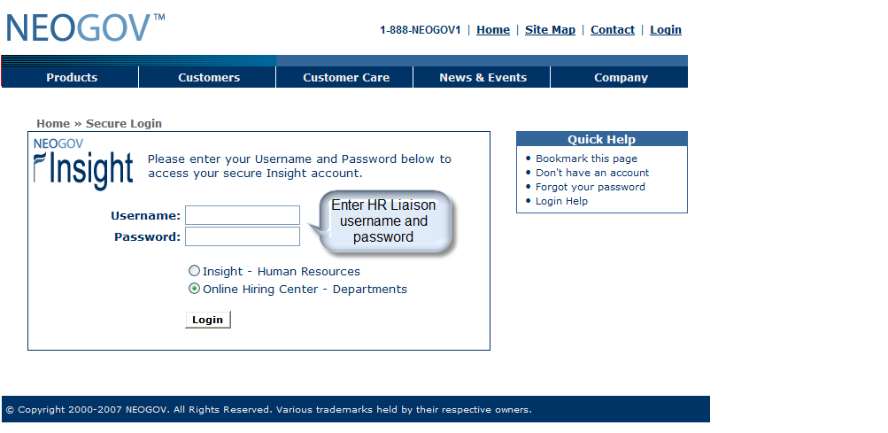

- On the My Requisitions screen, click on the Open New Requisition link.

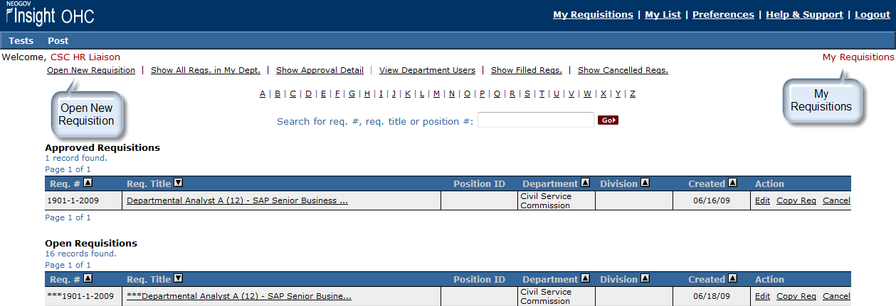

- On the Open New Requisition screen, search for the Class Title by clicking on the appropriate first letter for an alphabetic search, or by entering all or a portion of the class title or class code in Search for class title or class code. Click Go.

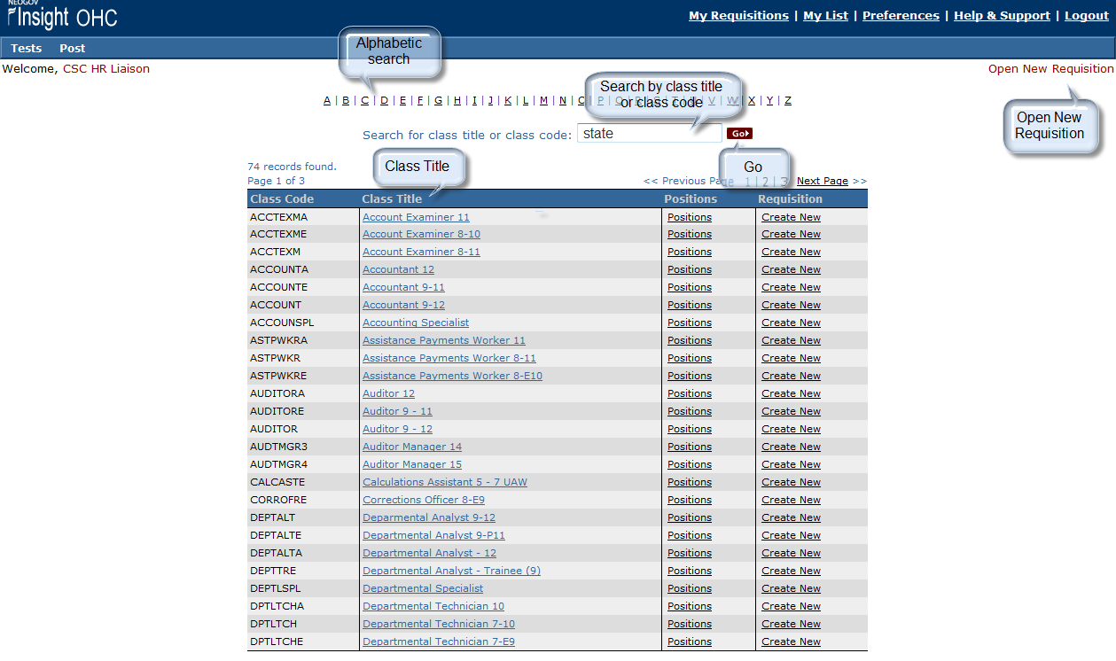

- On the Open New Requisition screen, in the Requisition column, click on the Create New link for the appropriate class title and level.

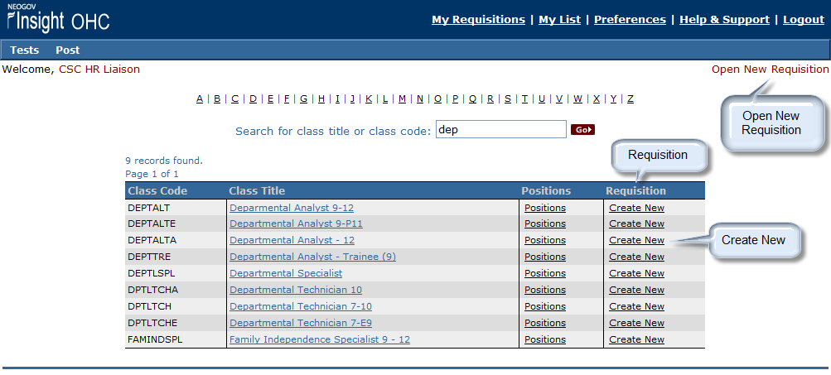

- On the View/Edit Requisition screen, in Desired Start Date, enter the current date in the MM/DD/YYYY format.
- In Requisition #, Leave Blank
- In Working Title, enter the Class Title and Level followed by the Working Title (if different) in upper and lower case (e.g. Departmental Analyst 12 – Senior Business Analyst).
- In Vacancies, at this time a new requisition is required for each vacancy. Always enter 1 in this field.
- In Department, select the LARA from the drop-down.

- Division, Leave Blank.
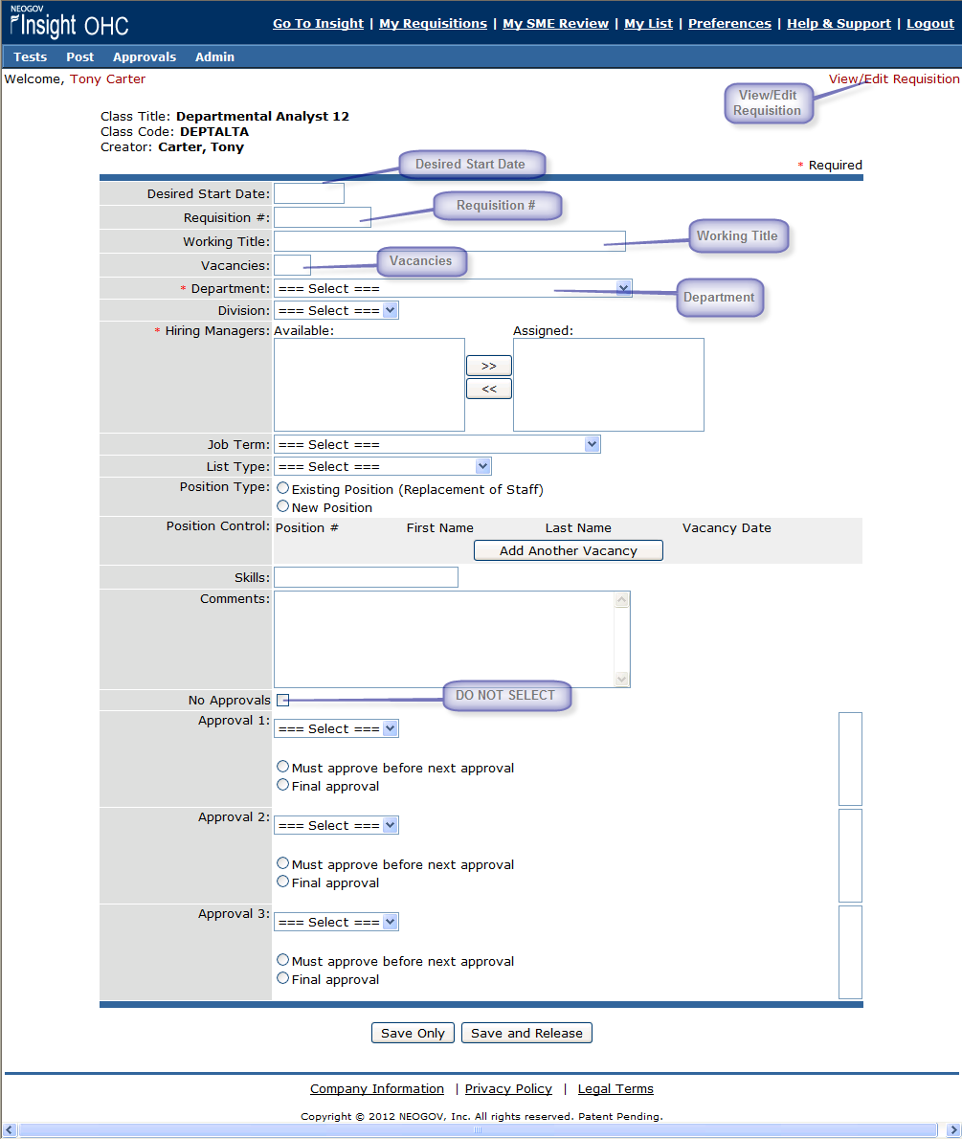

- In Job Term, select the appropriate job term (choices are Limited Term, Non-Career, Permanent Full Time, Permanent Intermittent, Permanent Part Time, Seasonal, and Student Assistant) from the drop-down.

- In List Type, select the appropriate list type (select from Regular, Promotional Only or Departmental Promotional Only) from the drop-down. Choose Regular for postings open to the general public. Choose Promotional Only for postings open to State employees only. Choose Departmental Promotional Only for postings open only to department employees. The other list types will not be used at this time.

- In Position Type, select Existing Position (Replacement of Staff) if the vacancy is for an existing position. Select New Position if the vacancy is for a new position.

- In Position Control, if the vacancy is for an existing Position, click on the Add Another Vacancy button and enter the Position #, previous incumbent First Name, previous incumbent Last Name, and Vacancy Date.

- Skills, Leave Blank.

- Comments are optional. If you enter comments, please initial and date them.

- In No Approvals, do not click in the checkbox.

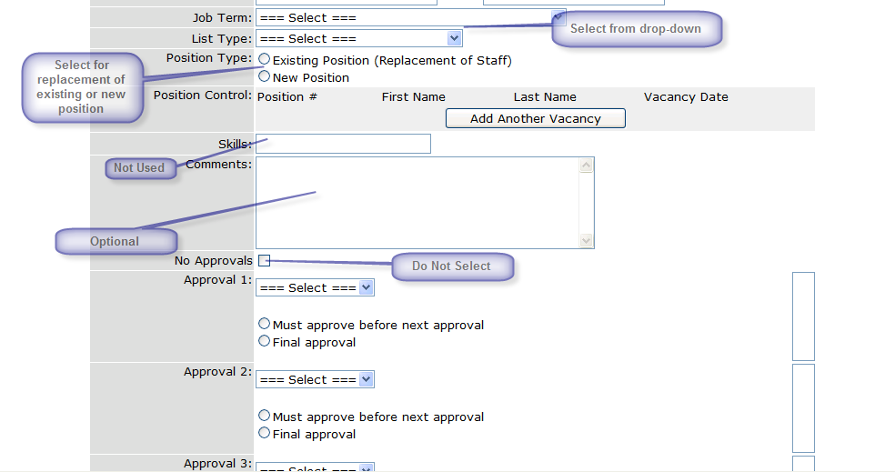

- In Approval 1, 2, 3, select the appropriate approval group(s). See Approval Path document for appropriate paths.

- Once selected, the individual approver(s) must also be selected.

- Select Final Approval for the last level of approvals.

- Click on the Save and Release button. (NOTE: If you want to attach documentation to the request, select Save Only.)

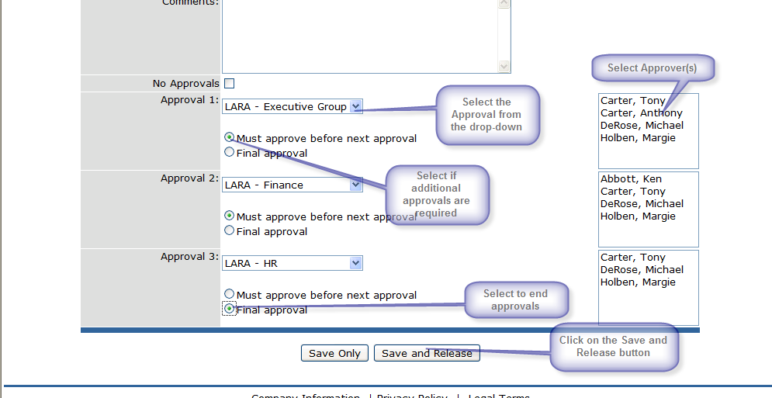

- A completed requisition looks like the screen shot below:

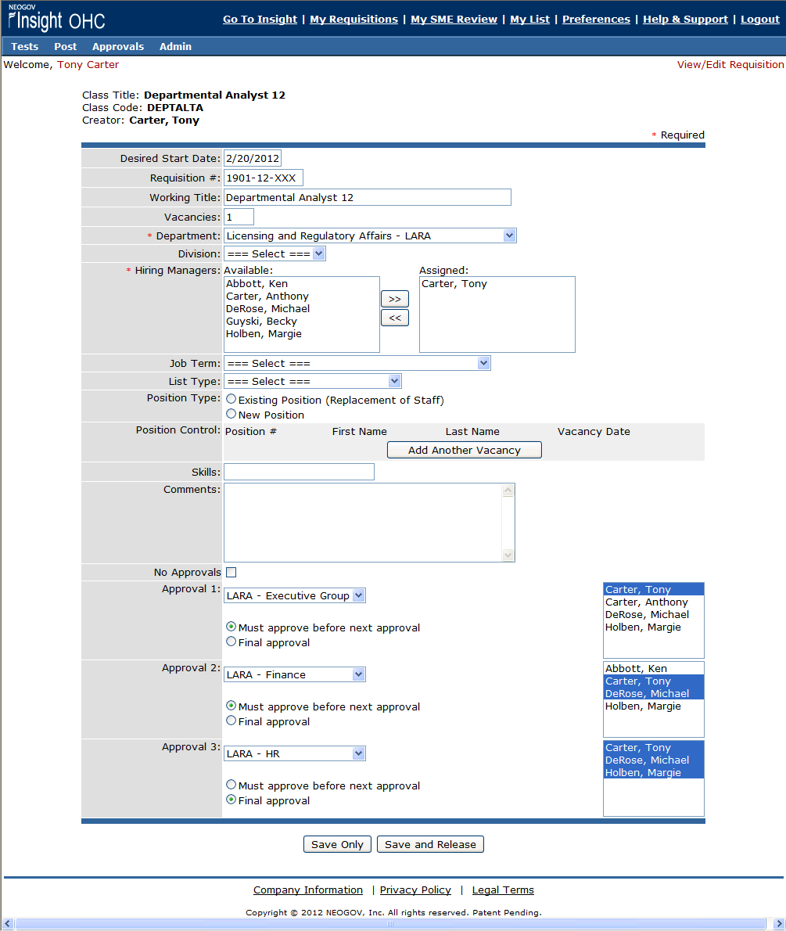

- To Add Attachments, click on Attachments: Add New at the bottom of the requisition. Browse for the file that you want to attach, name the File, and click attach.

- The requisition will now appear on the My Requisitions screen in the In Progress Requisitions section.

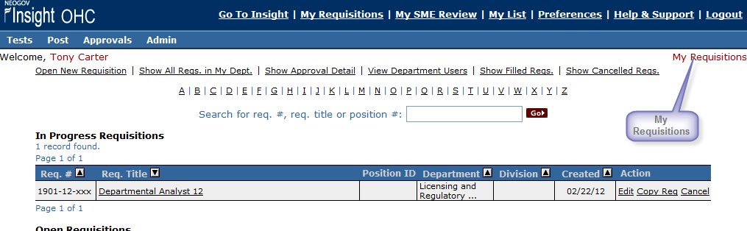

- Click on Logout to exit.

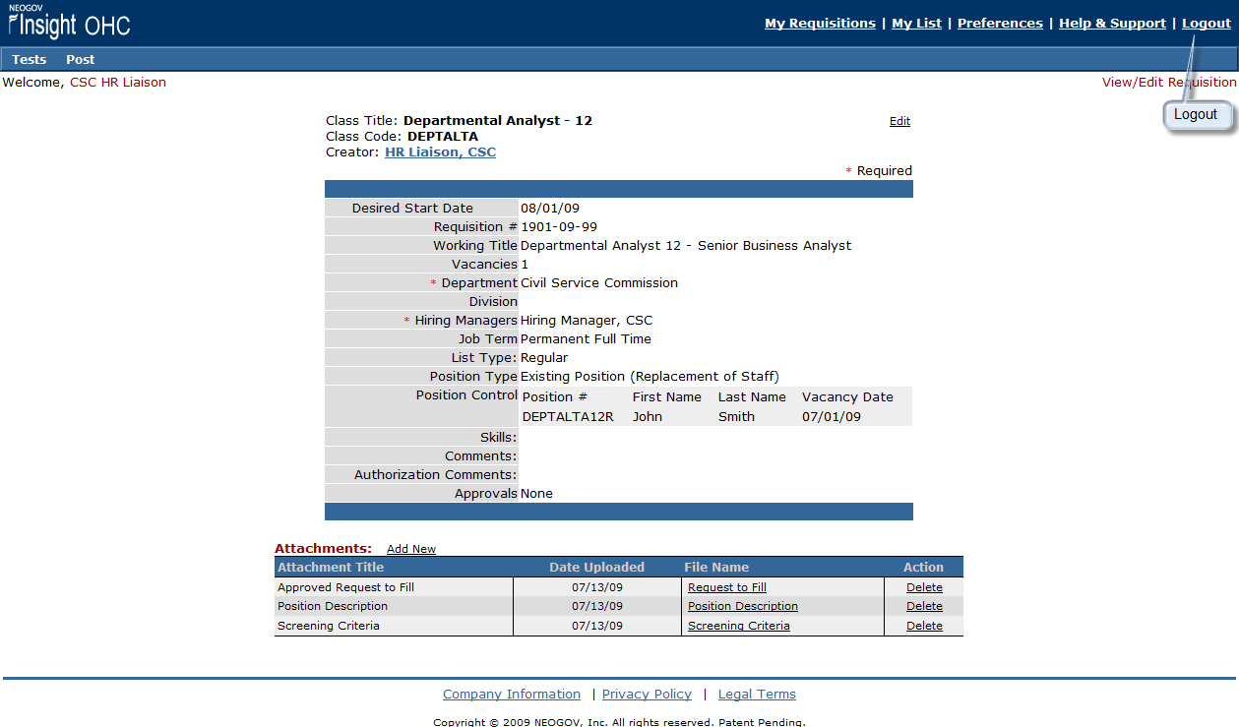

Additional Resources:

Glossary

Insight 111 Create a Requisition/Route for Approvals
Located in Insight – Human Resources, Help & Support, Training; OR,
Located in Online Hiring Center – Departments, Help & Support, Training
Available in HTML or PPT (05:33 minutes)

B, C, E, H Insight Requisition
Insight Enterprise User’s Guide
Located in Insight – Human Resources, Help & Support, User Guide

