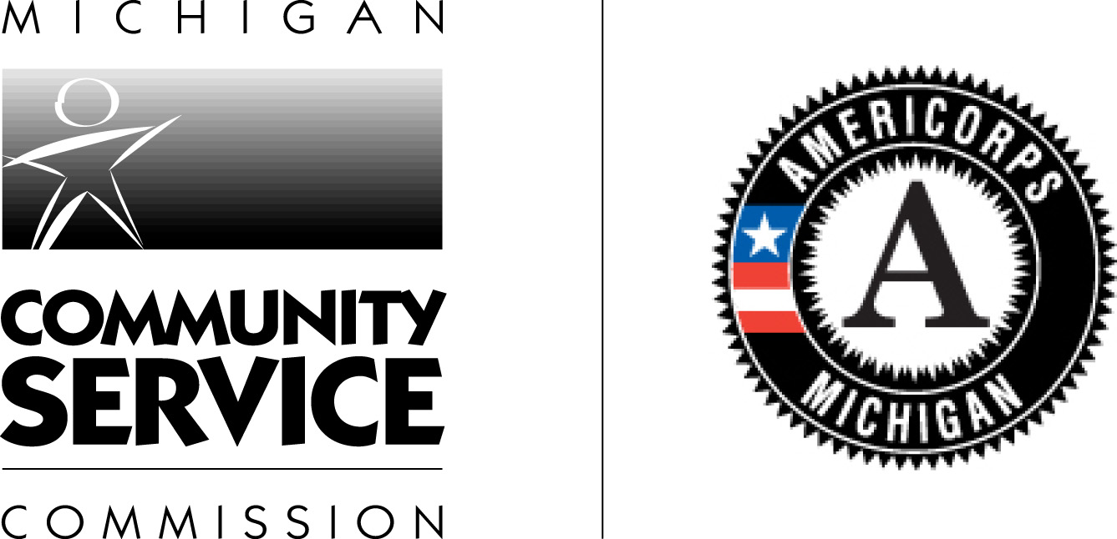
Michigan Community Service Commission
Notice of Funds Available for
My Brother’s Keeper - Michigan

The Michigan Community Service Commission (MCSC) is pleased to announce the availability of federal funds to support innovative collaboration between public and private entities that share volunteerism as the foundation of their initiatives. The funds will be used to assist youth-serving programs and other nonprofits with developing sustainability and improving the quality of volunteer engagement. Grants will be awarded with a start date of January 2015 for an initial 12-month program cycle and based on availability of funds; there is a possibility of an additional two years of funding. Preference will be given to programs operating for a full rather than a partial year.
What is My Brother’s Keeper-Michigan?
The Edward M. Kennedy Serve America Act of 2009 reauthorized and expanded the mission of the Corporation for National and Community Service (CNCS) to include strengthening the nation’s volunteer infrastructure. A new initiative established in this legislation is the Volunteer Generation Fund (VGF). The VGF awards grants to states to recruit, manage, and support volunteers and strengthen the nation’s volunteer infrastructure.
The MCSC requested VGF Funds to support the My Brother’s Keeper-Michigan initiative. It will support a minimum of three programs utilizing a collaborative model to develop innovative approaches to continue to make progress for all youth, including boys and young men of color. Mentoring will be a central component in each grant awarded. Programs will assist youth with success in school and access to college or employment.

Who are we?
This initiative will be administered by the MCSC. The MCSC funds and supports programs that encourage all Michigan residents to volunteer. We work to fulfill this mission through a number of programs, projects, and activities focused on service and volunteerism. These programs include Michigan’s AmeriCorps and Mentor Michigan. Annually, the MCSC distributes nearly $9 million in national service and volunteerism grants.
Who is eligible to apply?
Youth-serving programs and other nonprofits are eligible to apply.

Funds Available and Grant Size

The MCSC has $120,000 available to fund My Brother’s Keeper grants. Grants may range in size up to $30,000. Funds may be available for a second and third year to focus further on implementation, sustainability, and replication.

Match requirement
Applicants will be required to provide a dollar-for-dollar match toward their grant. The match may be non-CNCS cash or in-kind.

My Brother’s Keeper – Michigan: Overview
MCSC will provide opportunities to communities to use a collaborative model to address the challenges facing young boys and men of color, which are addressed in the My Brother’s Keeper Report (http://www.whitehouse.gov/sites/default/files/docs/053014_mbk_report.pdf). Programs will be chosen through a RFP process to receive a grant up to $30,000. Programs will form Collaborative Action Programs, and must have diverse partners engaged in the work. This could include corporations/small businesses, colleges/universities, schools, foundations, governmental programs, and nonprofits. MCSC will provide the support of a staff member to establish these partnerships and leverage the resources of the community, city, and state. The programs will work to develop building blocks for success across youth’s key life stages.
Volunteerism will be central to this initiative. Skills-based volunteers will serve the youth, but in addition, the youth themselves will become volunteers.
Grantee Responsibilities
Grantees will be required to use a volunteer management platform that will increase capacity, manage, track, and report on people, programs, and volunteer opportunities.
Grantees will work to:
-Provide incentives to youth to learn and prepare for the workforce
-Support comprehensive cradle-to-college and career strategies rooted in local communities
-Recognize the importance of parents and other caring adults like mentors
The key connecting element across all of the programs will be a mentoring component which allows the boys and youth to make a connection with one or more caring adults.
Grantees must select at least one from the following list to implement with volunteers and partners.
- Create opportunities for reading and expand knowledge
- Activities that will assist them with graduating from high school ready for college and career
- Complete postsecondary education and training
- Assist with developing skills to enter the workforce
- Establish entry-level job, mentorship and apprenticeship options
- Help grow and improve summer job initiatives
- Engagement in volunteer activities
- Expose youth to different career paths, including STEM careers, that can result in a job and pathway to middle class.
Grantees must engage the youth being mentored as volunteers themselves.
Grantees will also be required to recruit and engage volunteers in National Days of Service such as Martin Luther King, Jr Day of Service, Global Youth Service Day, and 9-11 National Day of Service and Remembrance.

Grantees will report quarterly to the MCSC on targets to date including number of volunteers recruited and number of hours they serve, outcomes, program successes and challenges. Grantees will also report expenditures monthly to the MCSC for reimbursement.

Who do I contact if I have questions?
If you have any questions regarding My Brother’s Keeper – Michigan or the application process, please contact Shannon McCarthy at mccarthys3@michigan.gov or (517) 373-0617

Timeline

October 1, 2014 Request for Proposals released by MCSC

October 15, 2014 Technical assistance webinar
11:30am – 12:30pm

October 28, 2014 Applications will be due to the MCSC

October 31, 2014 Applicants informed of funding decisions

January 1, 2015 Grantee Start Date

Application Guidelines

My Brother’s Keeper - Michigan
2014-2015

Applications Must Be Received By:

5:00 p.m. – October 28, 2014

Please submit an electronic word document to:

Michigan Community Service Commission
Shannon McCarthy
Mccarthys3@michigan.gov

Submission Instructions

Your application, due October 28, 2014, must follow this order and include:
1. Title Page (limited to one page)
Complete the form located in the Appendix (an electronic version of the Title Page is available for your convenience at www.michigan.gov/mcsc. The original copy must have an original signature.
2. Program Narrative (not to exceed 15 double-spaced pages)
The application must be typed and double-spaced in not less than 12-point font size with one-inch margins. One side counts as one page. The narrative should address the statements and questions listed below. In writing the program narrative please refer to the specifics detailed throughout the My Brother’s Keeper Michigan Overview and the Grantee Responsibilities on previous pages.
Your program narrative must be clearly labeled with headings and subheadings. It is important that the information requested is provided in the section within which it is asked, to assure clarity for reviewers. You must number the pages of the narrative section.
- Budget Narrative
A template for creating the budget narrative is available for your convenience at www.michigan.gov/mcsc.
4. Financial Management Survey
An electronic version of this document is available for your convenience at www.michigan.gov/mcsc.
Please be sure to retain an electronic copy of your application. Submit your application as an electronic word document no later than 5:00 p.m. on October 28, 2014
Michigan Community Service Commission
Shannon McCarthy
mccarthys3@michigan.gov
Program Narrative
In evaluating your application for funding, reviewers will consider the evidence of need in your community(s), the capacity of the identified applicant organization to implement the program, your program design and how it addresses the need, and the proposed program’s cost-effectiveness and budget adequacy. The narrative section of the application is your opportunity to outline how your project meets the selection criteria. Below are some general writing suggestions to help you present your project in a way the reviewers will find compelling and persuasive.
- Lead from your program strengths and be explicit. Do not make the mistake of trying to stretch your program description to fit each priority articulated in the regulations or the NOFA. Focus only on the special considerations and priorities that apply to your program.
- Explain how. Do not just state that you will do something; rather state how you will do it.
- Link efforts to outcome. Clearly illustrate how activities will positively impact the identified community needs.
- Be clear and succinct. Reviewers are not interested in jargon, boilerplate, rhetoric, or exaggeration. They are interested in learning precisely what you intend to do, and how your project responds to the selection criteria presented below.
- Don’t make assumptions. Even if you have received funding from the MCSC in the past, do not assume your reviewers know anything about you, your program, your partners, or your beneficiaries.
- Use an impartial proofreader. Before you submit your application, let someone who is completely unfamiliar with your project read and critique the project narrative.

Program Design
Grant awards will cover a one year period of operation. Grants may be renewed for two additional years subject to annual review and availability of federal funds. In developing the program design section, you should only discuss goals, objectives, and program structure for the first year.
1. Rationale and Approach – Organizational and Community Need (25%)
a. Compelling Community Need
- Describe the compelling need for youth programs that provide opportunities for all youth, in particular boys and young men of color.
- Provide current evidence of the need you are describing.
- Evidence of Community Collaboration
- Identify three key collaborative organizations including corporations/small businesses, colleges/universities, schools, foundations, and nonprofits or governmental programs that will take a specific role in providing services or resources to youth to be mentored.
- Describe the current relationship between the applicant and the collaborative partners, or discuss how you will develop or strengthen those relationships.
- Briefly describe how you involved the target community(s) in the planning process. Be specific in explaining which community partners and stakeholders were involved, what roles they played, and what their responsibilities were.
- Please describe the specific role that each partner will play. Examples could include providing internships or corporate mentors, schools as referral sources for mentees, researchers, provision of space or facilities, staff resources for event planning or program support.
- Program Activities Yielding Measurable Outputs and Outcomes
- Describe how you will implement programming that addresses one or more of the following:
    - Create opportunities for reading and expanding knowledge.
    - Activities that will assist youth with graduating from high school ready for college and career.
    - Assist with completing postsecondary education and training.
    - Assist with developing skills to enter the workforce.
    - Establish entry-level job, mentorship and apprenticeship option.
    - Help grow and improve summer job initiatives.
    - Engagement in volunteer activities.
    - Expose youth to different career paths, including STEM careers, that can result in a job and pathway to middle class.
- Describe how increased volunteer participation will positively impact the community need identified.
- Specific objectives have been set by the MCSC. Each community collaborative must strive for the following goals. Please identify specific outputs for each.
Objectives
*Increase number of new volunteers participating in service, including youth recipients
*Increase the number of hours of service delivered by volunteers
*Increase replicable collaborative community models for volunteer mobilization *Organize and recruit volunteers for at least two National Days of Service

2. Collaborative Action (25%)
a. Recruitment and Training
- Describe plans for recruiting adult volunteers and youth, specifically boys and young men of color.
- Provide a plan for providing training to adult volunteers who will serve as mentors.
- Provide a plan for engaging adult and youth volunteers in service.
- Describe clear plans for orienting collaborative partners to the My Brother’s Keeper -Michigan initiative.
b. Sustainability
- Outline your plans for ensuring that the impact of the program is sustainable beyond the presence of federal support. For example, you might describe how your community’s collaborative action program will lead to community investment in volunteer generation efforts, or how the Collaborative Action Program will maintain your project once this initiative is complete. How will the collaborative action team you create continue your work together?
3. Commitment and plan to participate in National Days of Service (10%)
- Describe how the capacity of the applicant organization and partners will accomplish the goal of engaging volunteers in National Days of Service such as, but not limited to, Martin Luther King, Jr., Day, and 9-11 Day of Service and Remembrance. (The applicant must develop a media-driven approach that incorporates universities/colleges, school districts, large employers, and churches into its marketing for engaging people in National Days of Service. The applicant organization will also determine a method for collaborating with other community partners and collect necessary data to track attendance/participation at events associated with National Days of Service.)
4. Organizational Capability – Staff and Organizational Capacity (25%)
  - Sound Organizational Structure
- Ability to Provide Sound Programmatic and Fiscal Oversight:
- Provide a brief history of your work in youth programming and volunteerism, including the year your organization was established.
- Provide specific examples of your organization’s experience and past accomplishments in the proposed areas of activity and your experience operating and overseeing a program comparable to the one proposed.
      - Identify the key program and fiscal positions responsible for your proposed program, and the percent of time dedicated to the program.
- Describe your capacity to manage a federal grant and to provide on-site monitoring of financial and other necessary systems. Provide examples of other federal grants received, including amount and duration.
5. Cost Effectiveness and Budget Adequacy (15%)
The maximum grant size is $30,000 in federal funds. There is a dollar-for-dollar non-CNCS cash or in-kind match required.
- We understand that the amount requested will not be sufficient to cover all costs of your program design. This application may represent program components such as event costs, transportation, curriculum, materials etc. Please describe how the requested funds are adequate and necessary to be effective in supporting the portion of your program design that you describe in this application, including how it is sufficient to support the proposed activities and is linked to your desired outputs and outcomes.
- Demonstrate how your program has or will obtain diverse non-federal or non-CNCS resources for program implementation and sustainability.
- Include a discussion of the non-Corporation resource commitments (in-kind and cash) that you have obtained, the additional commitments you plan to secure, and how you will secure them. In the budget, you must list the sources of your match funds.

Budget Narrative
The budget should be sufficient to perform the tasks described in the proposal narrative. Do not include unexplained amounts for miscellaneous or contingency costs or unallowable expenses such as entertainment costs. Round all figures to the nearest dollar.

An electronic budget worksheet is available at www.michigan.gov/mcsc. The narrative must be completed for funds requested from the CNCS and for all other matching funds. For each line item, a full explanation must be provided in the budget narrative that specifies the purpose, cost basis, and calculation. This form can be printed, and included with each copy of the application. If you should encounter difficulty in downloading the form or for other technical assistance, please contact Shannon McCarthy at mccarthys3@michigan.gov. A copy of the form is also included in the appendix. If you choose to use your own format, it should reflect the same line items, calculations, and order as in the recommended template.

BUDGET INSTRUCTIONS
Before You Begin: Your detailed budget must provide a full explanation of associated costs including their purpose, justification, and the basis of your calculations. Where appropriate, your calculations should be presented in an equation format, identifying the number of persons involved with the event, the per person/unit cost, and/or the annual salary cost.
Summary of statutory budget requirements:
- Equipment costs must not exceed 10% of the total federal share.
- Administrative costs must not exceed 5% of the total grant funds requested.

Operating Costs
A. Personnel Expenses
- Include the portion of principal staff time attributed directly to the operation of the community collaborative project. List each staff position.
B. Personnel Fringe Benefit
- Include costs of benefit(s) for staff listed in Section A. You can identify and calculate each benefit or show cost as a percentage of all salaries. You must include FICA, Worker's Compensation, and Unemployment Insurance for all applicable staff.
C. Travel
- Describe the purposes for staff travel. Costs allowable are transportation, lodging ($65.00 per night limit), subsistence ($31 per day limit), and other related expenses for local and outside-the-project area travel. Calculations must be included; mileage cannot exceed $.50/mile. Example: Staff travel to seven local collaborative meetings – 1 staff x $.50 per mile x 500 miles = $250.00.
D. Equipment
- Equipment is defined as tangible, non-expendable personal property having a useful life of more than one year AND an acquisition cost of $5,000 (five thousand) or more per unit (including accessories, attachments, and modifications). Include items that do not meet this definition in E. Supplies below. Purchases of equipment are limited to 10% of the total grant amount, i.e., the federal share of all budget line items. If applicable, show the unit cost and number of units you are requesting.
E. Supplies
- Include the funds for the purchase of consumable supplies and materials. You must individually list any single item costing $1,000 (one thousand) or more. Example: office supplies: (pens, paper, binders, folders, flash drives) x 2 staff x $200.00 per year = $400.
F. Contractual & Consultant Services
- You may include costs for consultants related to the project’s operations. Consultants used for evaluation should be included in H. Evaluation below. Payments to individuals for consultant services under this grant may not exceed $540 per day (exclusive of any indirect expenses, travel, supplies, etc.). Where applicable, indicate the daily rate for consultants. Example: $540 x 1 consultant x 3 days professional development for consortium members = $1,620.
G. Training
- Include the costs associated with training of staff working directly on the project, especially training that specifically enhances staff project implementation and professional skills. Indicate daily rates of consultants, where applicable. Example: staff training: registration fees $250, lodging $65 x 1 night, $31 for food costs x 2 days = $377.
H. Evaluation
- Include costs for project evaluation activities; including additional staff time or subcontracts you did not budget under Section A. Personnel Expenses, use of evaluation consultants, purchase of instrumentation and other costs specifically for this activity. This does not include the daily/weekly gathering of data to assess progress toward project objectives, but is a larger assessment of the impact your project is having on the community, as well as an assessment of the overall systems and project design. Indicate daily rates of consultants, where applicable.
I. Other Program Operating Costs
- Allowable costs in this category may include volunteer background checks, office space rental (for sites where projects are operating), utilities, and telephone and Internet expenses that are specifically used for community collaboratives. If shared with other projects or activities, you must prorate the costs equitably. List each item and provide a justification in the budget narrative.
J. Administrative
Definitions: Administrative costs are general or centralized expenses of the overall administration of an organization that receives Corporation funds and do not include particular project costs. These costs may include administrative staff positions. For organizations that have an established indirect cost rate for federal awards, administrative costs mean those costs that are included in the organization’s indirect cost rate agreement. Such costs are generally identified with the organization’s overall operation and are further described in Office of Management and Budget Circulars A-21, A-87, and A-122. The Corporation’s share of administrative costs is limited by statute to 5% of the total Corporation funds actually expended under this grant.
K. Source of Match
Describe the grantee match contribution by clearly indicating the source(s), the type of contribution (cash or in-kind), the amount (or estimate), and the intended purpose of the match. You may enter this information in any category in the Purpose-Calculation field.

Selection Criteria and Process

A. Selection Criteria
- Rationale and Approach (25%)
- Collaborative Action (25%)
- Commitment and plan to participate in National Days of Service (10%)
- Organizational Capability (25%)
- Cost Effectiveness and Budget Adequacy (15%)
B. Review and Selection
The review and selection of the My Brother’s Keeper applications is a multiple-step process as described below.
1. Request for proposal released on Wednesday, October 1, 2014.
2. Technical assistance webinar to take place on October 15th, 2014
Register for the webinar through the following link: https://www2.gotomeeting.com/register/532621602
3. Applications will be due to the Michigan Community Service Commission by 5 p.m. on October 28, 2014. Applications will be reviewed for: requirements, adherence to guidelines, and priorities. Other review considerations may include:
  - Geographic diversity
  - Diversity - MCSC seeks to fund a broad range of programs with various approaches to addressing community need.
4. Review and approval of applications
  - Panel of reviewers – October 30, 2014
  - Board review – funding recommendations for all funded applicants will be submitted to the Michigan Community Service Commission Board of Commissioners for approval.
5. Applicants will be informed of funding decisions on or before October 31, 2014.
6. Grantee start date of January 1, 2015.

APPENDIX

Forms and Instructions

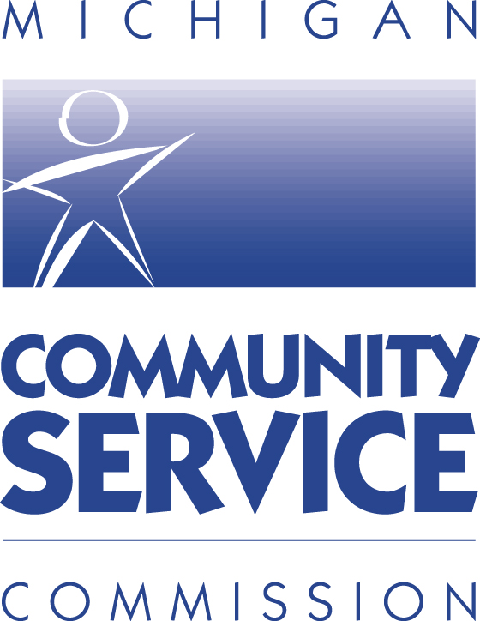

2014 - 2015

My Brother’s Keeper - Michigan

Title Page

Name of Applicant Organization:

Contact Person: Title:

Address:

City: State: Zip:

Phone: Fax: Email:

EIN/Federal Identification Number:

Michigan and US Congressional Districts:

Michigan Senate District of area served:

Michigan House District of area served:

US Congressional District of area served:

Budget:
MCSC Share Requested: Grantee Share:

Total Budget:

Certification: The applicant certifies to the best of his/her knowledge and belief that the data in this application are true and correct and that the filling of the application has been duly authorized by the governing body of the applicant.

Name: Signature:

Title: Date:
Sample Budget Worksheet
2014-2015 My Brother’s Keeper - Michigan Budget Worksheet
Applicant:
Please Note: Calculations resulting in red indicate an error
Program Operating Costs
A. Personnel Expenses
Position/Title | Qty | Annual Salary | % Time | CNCS Share | Grantee Share | Total Amount
 |  |  |  |  |  | $ -
 |  |  |  |  |  | $ -
 |  |  |  |  |  | $ -
 |  |  |  |  |  | $ -
Totals |  |  |  | $ - | $ - | $ -
B. Personnel Fringe Benefit
Purpose | Calculation |  |  | CNCS Share | Grantee Share | Total Amount
Totals |  |  |  | $ - | $ - | $ -
Subtotal--Personnel Expenses |  |  |  | $ - | $ - | $ -
C. Travel
Purpose | Calculation |  |  | CNCS Share | Grantee Share | Total Amount
Totals |  |  |  | $ - | $ - | $ -
D. Equipment
Item/Purpose | Calculation |  |  | CNCS Share | Grantee Share | Total Amount
Totals |  |  |  | $ - | $ - | $ -
E. Supplies
Item | Calculation |  |  | CNCS Share | Grantee Share | Total Amount
Totals |  |  |  | $ - | $ - | $ -
F. Contractual & Consultant Services
Purpose | Daily Rate |  | # of Days | CNCS Share | Grantee Share | Total Amount
 |  |  |  |  |  | $ -
 |  |  |  |  |  | $ -
Totals |  |  |  | $ - | $ - | $ -
G. Training
Purpose | Calculation |  |  | CNCS Share | Grantee Share | Total Amount
Totals |  |  |  | $ - | $ - | $ -
H. Evaluation
Purpose | Calculation |  | Daily Rate | CNCS Share | Grantee Share | Total Amount
Totals |  |  |  | $ - | $ - | $ -
I. Other Program Operating Costs
Purpose | Calculation |  |  | CNCS Share | Grantee Share | Total Amount
Totals |  |  |  | $ - | $ - | $ -
Program Operating Costs |  |  |  | $ - | $ - | $ -
J. Administrative/Indirect
Purpose | Calculation |  |  | CNCS Share | Grantee Share | Total Amount
Totals |  |  |  | $ - | $ - | $ -
 |  | Percentage |  | #DIV/0! | #DIV/0!
K. Source of Match
Source(s), Type, Amount, Intended Purpose
My Brother’s Keeper - Michigan

APPLICATION SUBMISSION REQUIREMENTS CHECKLIST

Please review the following checklist to ensure that your application meets the submission requirements. Each application will be reviewed for compliance. Any application received by MCSC not in compliance with any item on the following checklist will be considered ineligible for review. The application will be returned to the applicant.

Please complete and submit the checklist along with your application.
Applicants must submit one completed application package that includes:

Title Page
Original copy of the Title Page must have an original signature.
Applicants must use the form provided in the Appendix. A single page .pdf of this form is also available at www.michigan.gov/mcsc. The form must be typed.

Program Narrative
Typed
Double-spaced and in not less than 12-point font size
One-inch margins
Must not exceed 15 pages (one side counts as one page)
The narrative must follow the narrative format and include headings / sub-headings for each section
The pages must be numbered

Financial Management Survey
Include one copy of the applicant organization’s most recent independent audit.

Budget Narrative
The budget narrative must follow the order and include all items in the sample worksheet provided. The budget narrative may be single-spaced. An Excel spreadsheet of this form is also available at www.michigan.gov/mcsc .

