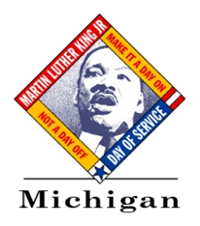 (INSERT ORGANIZATION LOGO)
FOR IMMEDIATE RELEASE
Contact: (Insert contact name)
(Insert contact’s telephone number)
(Insert contact’s email address)
(Insert website – if available)

Volunteers to Recognize MLK Day by (Insert Service Overview – i.e. Renovating School)

WHEN: <Insert Date>
<Insert Time>

WHERE: <Insert Location>
<Insert Address>
<Insert City, State, & ZIP Code>

WHAT: Initiated by Congress in 1994, the Martin Luther King, Jr. (MLK) Day of Service is a nationwide effort to transform the federal holiday honoring Dr. Martin Luther King, Jr. into a day of community service, grounded in Dr. King’s teaching, that help solve social problems. Across the country, thousands of individuals pay tribute to Dr. King’s legacy each year by performing acts of service in his name on this day. The 2013 MLK Day of Service will take place on January 21.

<Insert community organization/school/etc> will become involved in this effort by <insert brief description of service activity/project>.

Through this effort, <insert brief goal you will accomplish through activity/project>.

WHO: More than <insert number of volunteers> from <insert community name>.

Additional Information:
The MLK Day of Service has grown steadily since its inception in 1995 and is celebrated by people in all 50 states who are dedicated to making it a “day on, not a day off.” This project is just one of hundreds of activities being held in cities and states across the country to honor Dr. King.

Michigan’s MLK Day efforts are led by the Michigan Community Service Commission, Michigan Nonprofit Association, Volunteer Centers of Michigan, The LEAGUE Michigan, and Michigan Campus Compact, with support from the Connect Michigan Alliance Endowment Fund, Corporation for National and Community Service, Sara Ballard Volunteer Fund, and Youth Service America. For more information about this national day of service, visit www.MLKDay.gov.

<Insert background/additional information on your organization>

###

