

Michigan’s Assistive Technology (AT) Program 2012 Accomplishments

Alternative Formats are available upon request
Michigan Disability Rights Coalition (MDRC) is pleased to present this Annual Report for The Michigan Assistive Technology Program (MATP). We continue to be impressed with people who use Assistive Technology to achieve their dreams and are excited and proud to share information about our program and their success!
We work in collaboration with other organizations to provide services: the Assistive Technology Loan Fund through UCP of Michigan, and device demonstrations through our network of wonderful community-based subcontractors throughout the state, many of whom also provide training and work to increase public awareness of AT.
MATP is funded through the Assistive Technology Act of 2004. The program has been at MDRC since 1997. Funding comes to Michigan from the Rehabilitation Services Administration through Michigan Rehabilitation Services.

Over the past year, the AT Program:
- Completed 239 device demonstrations of 1,131 devices for 352 people.
- Through 19 exchanges on the ATXchange.org, saved consumers $96,402 compared to the price of buying new devices.
- Approved 37 loans through the Michigan Assistive Technology Loan Fund.
- Completed 54 training sessions for 1,220 people.
- Reached a total of 12,775 people through public awareness activities on the internet, through newsletters, email lists, blogs, social media, and presentations.
- Reached 4,347 people though Information and Assistance, primarily through our partnership with Michigan’s 15 Centers for Independent Living.


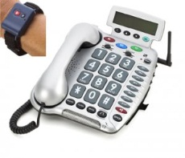
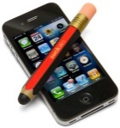

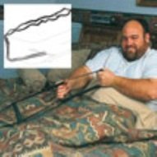
Device Demonstrations

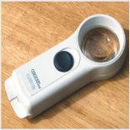

Michigan’s Assistive Technology Program (MATP) subcontracted with nine organizations and three independent contractors to provide hands on device demonstrations throughout the state. The AT Program has an inventory of nearly 1,600 devices available for demonstration (including apps for tablets and smartphones).
Many of the devices are grouped into kits. The program has 5 “small changes, Big Differences” kits, aimed at lower cost AT to help people remain in their communities. There are 3 kits of devices for people who are neurodiverse (i.e. have differences in the ways their brain processes information). There are also 2 kits of devices for people who have low vision. Through the Hearing Loss Association of Michigan, MATP has 10 kits of devices to help people who are hard of hearing. In Wayne, Oakland and Macomb counties, the program has three kits of devices to help people communicate, especially in emergencies. In Michigan’s Upper Peninsula, MATP works with the Superior Alliance for Independent Living to provide device demonstrations with all of the kits and will be expanding to offer demonstrations of devices for outdoor recreation.

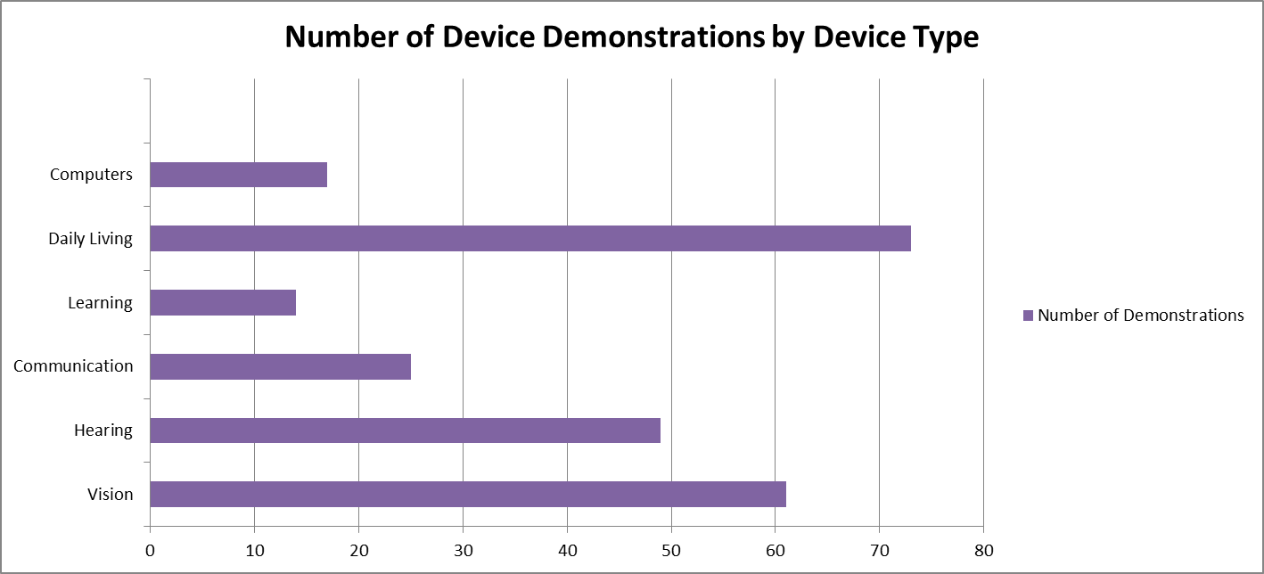

Bar chart showing number of demonstrations by device type. Daily living devices were the most demonstrated, followed by vision, hearing, communication, computers and learning devices.

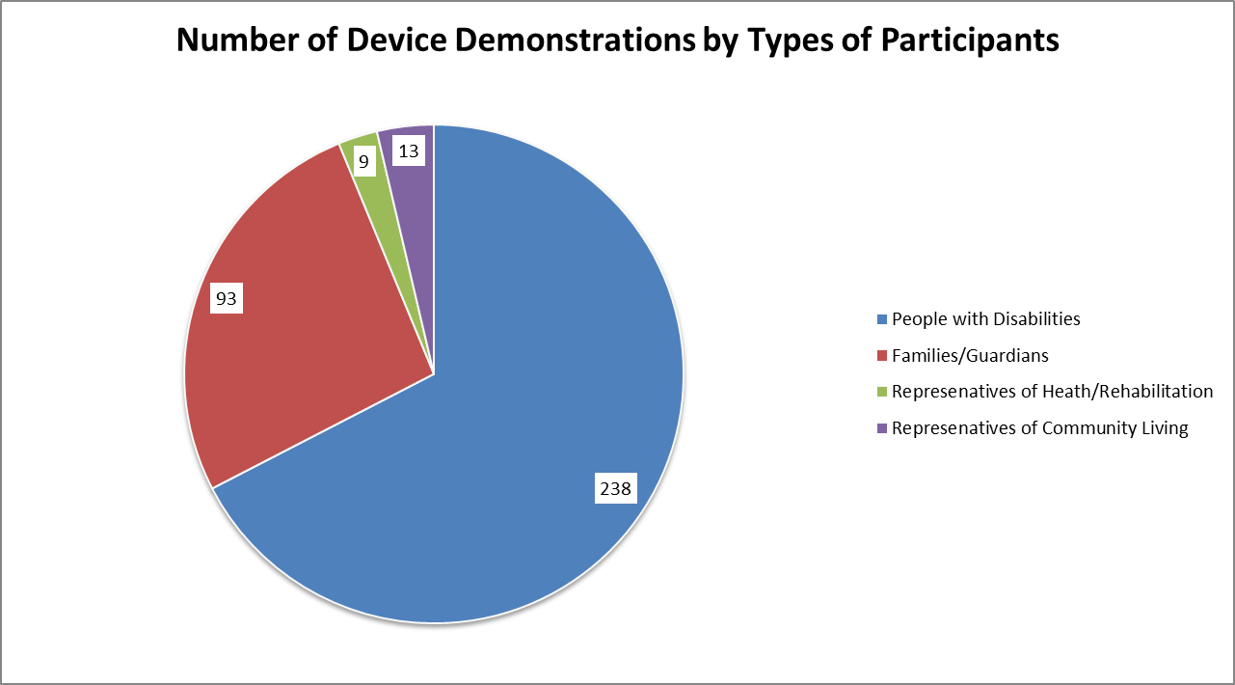
Pie chart showing the number of device demonstrations by types of participants. A majority of device demonstrations were shown to people with disabilities followed by families, representatives of health and rehabilitation, and representatives of community living.

Demonstration Success Stories

Doing the Things She Loves at 92!
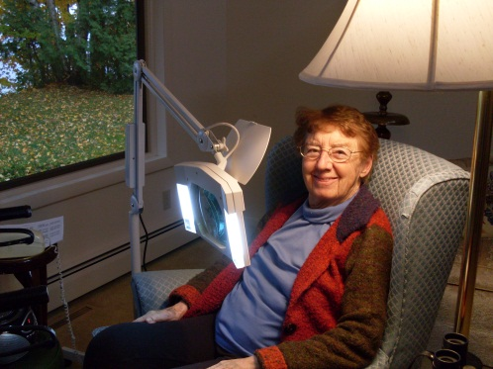
Virginia Grundstrom came to the SAIL office in Marquette for a device demonstration at the suggestion of her eye doctor. He had told Virginia that at age 92 nothing more could be done for her with corrective lenses and that she needed to use a magnifier along with her glasses in order to be able to read and do fine motor tasks.
Several magnifiers were demonstrated at the office and then a floor lamp style magnifier was taken out to Virginia’s home for demonstration. She was able to try it out using the chair where she usually sits to read and knit. It worked perfectly for her needs and the happy expression on her face as she was knitting with the magnifier said it all! She said, “ This is a fantastic program! You really know how to listen to your customers and take care of their needs!” Virginia said she would be ordering perhaps more than one floor lamp magnifier for her home as she felt it would be a great help with reading recipes and labels in her kitchen. Thanks to Michigan’s Assistive Technology Program, Virginia is able to continue to enjoy doing the things she loves.

Not Just an “X”

A person contacted a subcontractor requesting support to find something that would help them write again. They had Parkinson’s Disease and were struggling with a number of daily activities, but particularly frustrated that they could not write and sign checks any longer, and were feeling as if they could no longer manage their finances without assistance. They were shown a variety of devices including the “Pen Again”. The person actually had difficulty stifling the chuckles of joy and surprise and they signed their name over and over again. Hearing that there was a tool to help with something so simple, yet so empowering was not only a relief, but a new lease on life. The person indicated that once they had the device, they would now be able to continue managing their finances independently. Use of this device will improve the their access to community living by providing them an opportunity to legally sign their name; “not just an ‘X’!”

ATXchange.org
Through the ATXchange website, people have been able to exchange used devices at a reduced rate or sometimes even free! Here are just a few examples of the impact.
- In Tecumseh, a man posted an offer for a lift and two slings for $2,000. He was contacted by a family with two children with disabilities in need of such a lift, but unable to obtain coverage for one through insurance. Upon meeting the family, who, drove two hours one way to pick up the equipment, the seller decided to give them the lift system for free. “The lift will be put to good use”, he said. “They were very grateful…It has been a good day”.
- In Midland, one woman’s used accessible van enabled another family to begin traveling together. She was happy she was able to sell her van to a family who would not otherwise be able to afford one, and intends on posting other items.
- We received a thank you from a man in Ann Arbor for our “valuable service and website” that enabled him to receive a Vision Excel Reading Machine from someone wishing to donate it to someone in need rather than sell it.

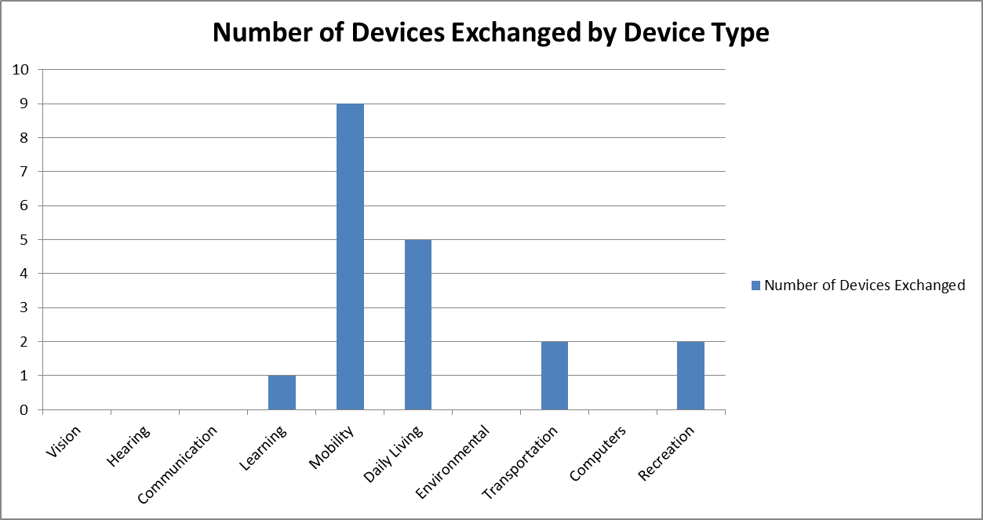
Bar chart showing the number of devices exchanged by device type. Mobility devices were exchanged the most, followed by devices for daily living, transportation, recreation and learning.

Michigan Assistive Technology Loan Fund (MATLF)
MATP provides financial support to UCP Michigan for the Assistive Technology Loan Fund. Examples of the some of the loans made include:
  - An applicant used the MATLF to purchase assistive devices for a hearing impairment, including a bedside fire alarm, clock with bed shaker, and clarity phone totaling $1,588.
  - An applicant purchased a Neuro-prosthetic device with a $10,000 Assistive Technology Loan for her adult daughter to relieve severe spasticity and pain.
  - A family was able to modify a bedroom and bath for their son who has Cerebral Palsy with a $30,000 loan.


AT Loan Fund Success Story: Back to Health and Nature
The Michigan Assistive Technology Loan Program received an application from a previous loan recipient for $2,800 to purchase an adapted recreational device. Living with a neuromuscular disease, her physician strongly recommended biking as an excellent source of exercise. She was approved for the loan and purchased a bike with adapted platform pedals, a change in the braking system that allowed her to use her stronger hand, as well as a small assist motor to help her up hills or when she becomes fatigued. Now she is able to enjoy the outdoors and her community, including many beautiful biking trails in her area. “Being able to go biking with my friends enhances my life in a being part of the group kind of way. It’s a great emotional as well as physical boost.”

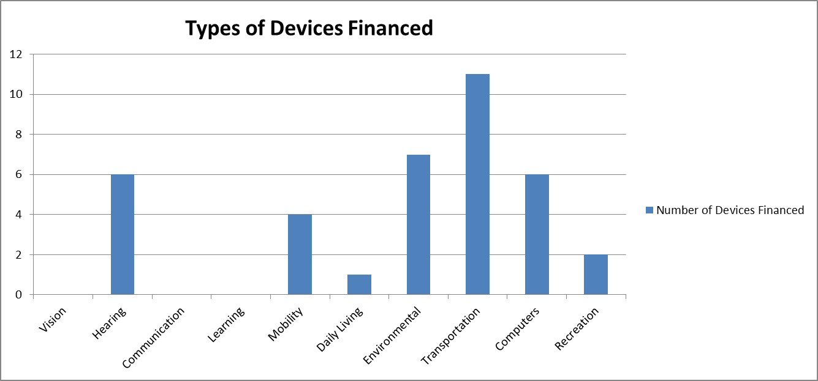
Bar chart showing the number of devices financed through the Assistive Technology Loan Fund. Transportation devices were financed the most, followed by environmental adaptations, hearing devices, computer devices, recreational devices and devices of daily living

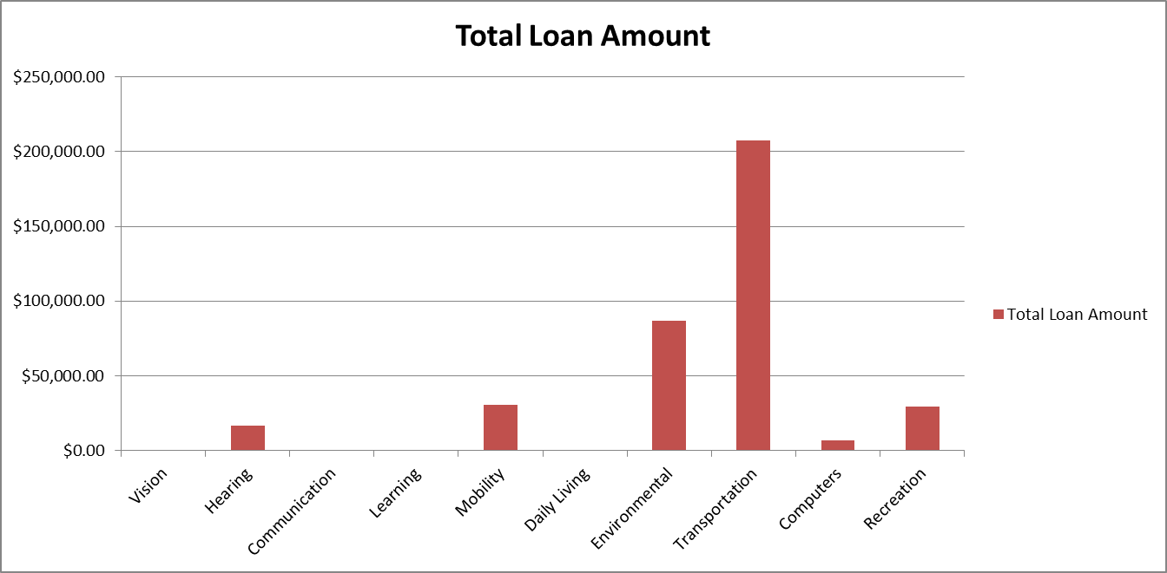
Bar chart depicting the total loan amounts for the year by device type. Loans for transportation totaled the most, followed by environmental adaptations, mobility devices, recreational devices, computers, and daily living devices.

Learning About AT: Training
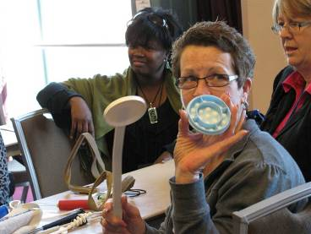
MATP presented trainings directly through MDRC AT Program staff members and also through subcontracts with community organizations throughout the state. “small change, Big Differences” is a popular session in which participants can learn about lower tech, lower cost devices to assist with daily living tasks and recreation. Continuing education credits are offered to social workers and nurses who complete this training session. MATP also presented “Assistive Technology for your Recovery Journey” for people who are in recovery related to mental health issues along with other training for people who are neurodiverse. Through the Hearing Loss Association of Michigan, people learned about the many hearing assistive technology devices and how to access funding and demonstrations of these devices.

Web Conferences (Webinars)
MATP presented 8 webinars this past year, which are archived on our website. Topics included: “Technology for Your Recovery Journey”; “Telephones and Cell Phones for People with Hearing Loss”; “Adapting Email and Access to Social Media for People with Disabilities”; “Customize Your Ride! Adapting Motor Vehicles for People with Disabilities”; ”I-Devices, Android and Apps; Accessible Gardening”; “How to Make PowerPoint Presentations Accessible for All” and “Money Smarts: Rent-to-Own, Payday Lenders, Credit Repair - How to Evaluate the Real Cost and Avoid the Pitfalls”. Many people access the recordings posted on the website afterwards, though they are not included in the data.

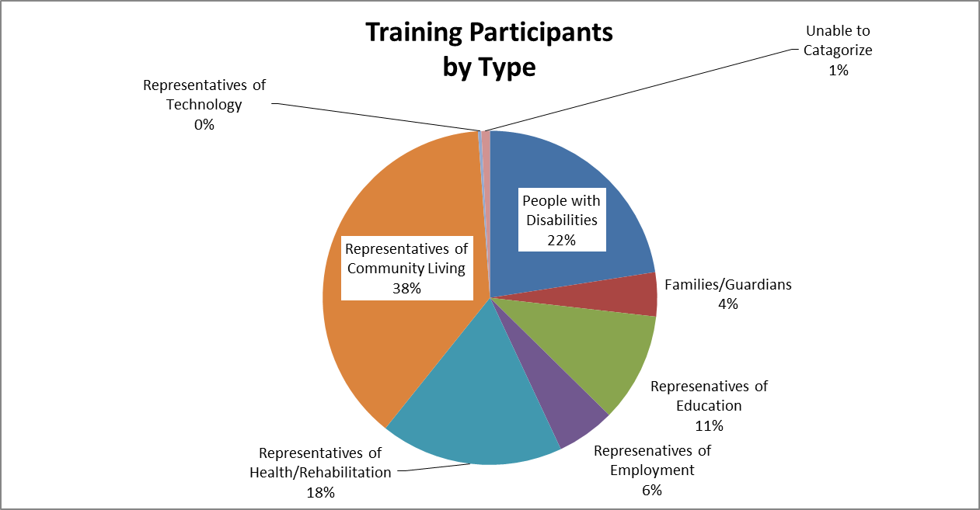
Pie chart illustrating the makeup of training participants. Trainings were most often presented to representatives of daily living, followed by people with disabilities, representatives of health, representatives of education. representatives of employment, families, those we were unable to categorize, and representatives of technology.

Assistive Technology Web Resources
- The Assistive Technology Directory, to help people “Find it Now” has had over 100 new resources added to the listings this past year.
- MATP added the “Assistive Technology Funding Strategy”
- New articles have been added about successes with AT Demonstrations and other topics, for example: preventing falls.

Helping Build Expertise in the Network
The MATP provided $32,000 to the Disability Network in Michigan to increase the capacity of their staff members to provide Information and Assistance about AT. Staff members attended conferences, such as Accessing Higher Ground, RESNA, Visions 2012, the AT Industry Association, the American Occupational Therapy Association, and Closing the Gap. Other staff members received JAWs Certification and Disability Network Northern Michigan sponsored a local event on AT for people who have Autism. The Assistive Technology Program maintains and email list and sends out AT information to the network on a regular basis.

Getting the Word Out!
MATP provided information about AT to 3,200 people through booths and exhibits at a variety of conferences, expos and other community events e published our Assistive Technology Email Newsletter and sent each out to over 200 people. The program has also established a presence on Twitter at http://twitter.com/MIAssistTech.
Information and Assistance about AT
People often call looking for information about resources related to AT. MATP provides information and often connects them with partners who can better serve their needs in their local communities. While the questions vary, here is a sample of how the program has helped.
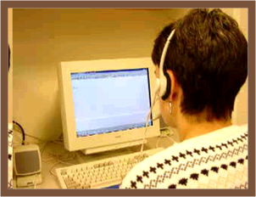
- A mother of a teenager called inquiring about funding sources to purchase Dragon Naturally Speaking and a Livescribe pen for her daughter who had Rheumatoid Arthritis. Noting the teen’s age, MATP’s Information Coordinator asked if assistive technology was provided at school. The mother then said that she was already using Dragon and the Livescribe pen very successfully at school, but was told by administrators that the student would have to return them if another student needed them or wanted to try them. Recognizing that the mother had been misinformed by the school administrator, the MATP staff member referred her to Michigan Alliance for Families for help in understanding her daughter’s rights and the school’s responsibility in providing assistive technology. She was also given the contact information for her local Michigan Rehabilitation Services office as her daughter was nearing transition age.
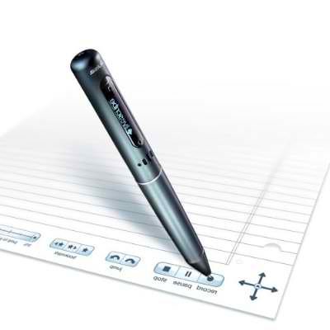

Working with Others to Increase Access to AT
MATP staff members are involved with many organizations, workgroups and collaborations to bring AT to the table and increase access to AT. These include the Lending Hands Loan Closet Collaboration, Michigan Protection and Advocacy Services, After We Are Gone project, ARC of MI, Traumatic Brain Injury LTC work group, Deaf-Blind Center advisory group, Michigan Recovery Council, Work Group to Eliminate Use of Seclusion and Restraint, State Employment Leadership Network, Michigan Brain Injury Association, RESNA Catalyst Project: AT and Employment Work Group, Rehabilitation Services (MRS) Assistive Technology Focus Team, MiChoice Home and Community Based Waiver renewal, the MiChoice Quality Collaborative, workgroups on planning for managed care for people who are dually eligible for Medicare and Medicaid, Person-Centered Planning initiatives, Michigan Health Connect and the Michigan Department of Community Health and Michigan State Housing Development Authority.
Michigan Disability Rights Coalition
(800) 760-4600
www.mymdrc.org

Device Demonstrations: http://www.mymdrc.org/assistive-tech/device-demonstrations.html
ATxchange Website: http://www.atxchange.org
Michigan Assistive Technology Loan Fund: http://ucpmichigan.org/our-programs/the-michigan-loan-funds/michigan-assistive-technology-loan-fund
Find it Now: http://www.mymdrc.org/assistive-tech/find-it-now.html
Funding Strategy: http://mymdrc.org/assistive-tech/funding.html
Preventing Falls: http://www.mymdrc.org/assistive-tech/blog.html

