Understanding by Design (UbD) Template
Capital Area Career Center
Scatterplots in Business and Banking – 2/8/07 Revision

Content Standard (s): What relevant goals will this design address?
S2.1.1, S2.1.2, S2.1.3, S2.1.4

Stage 1: Desired Results

What are the “big ideas”? What specific understandings about them are desired? What misunderstandings are predictable?
Students will understand:

- Scatterplots
- Lines of best fit
- Correlation
- Lurking Variables
- FICO Score
- APR
- Total interest paid

Also, differences between correlation and causation (cause and effect) will be discussed.

Essential Question(s): What arguable, recurring, and thought-provoking questions will guide inquiry and point toward the big ideas of the unit?

How does a scattered set of dots on a graph represent an important relationship in actual data?

Knowledge & Skill
- • What is the key knowledge and skill needed to develop the desired understandings? Students will know …

Formula for Pearson’s correlation coefficient; meaning of FICO scores and APR and their impact on the amount of interest paid on a car loan.

• What knowledge and skill relates to the content standards on which the unit is focused? Students will be able to…

Construct a scatterplot; draw a line of best fit; calculate Pearson’s correlation coefficient; discuss the difference between correlation and causation, lurking variables ...

Stage 2: Assessment Evidence

What evidence will be collected to determine whether or not the understandings have been developed, the knowledge and skill attained, and the state standards met? [Anchor the work in performance tasks that involve application, supplemented as needed by prompted work, quizzes, observations, etc.]

Performance Task Summary:  Summary in G.R.A.S.P.S. form  Students will collect data related to a real-world situation, construct a scatterplot from the data, analyze the scatterplot and prepare a report to an audience appropriate for the situation. | Rubric Titles (Key Criteria)  Scatterplot: Data plotted correctly, axes labeled, etc.  Line of best fit: Appropriate for the data. Slope calculated from the graph and interpreted in the problem context.  Correlation coefficient calculated and discussed in terms of the situation.
Formative Assessment  Presentation, Authentic, Program Contextual | Summative Assessment  End of Unit/Course, Standardized, CACC-wide

Stage 3: Learning Activities

What sequence of learning activities and teaching will enable students to perform well at the understandings in Stage 2 and thus display evidence of the desired results in stage one? Learning Activities: Consider the W.H.E.R.E.T.O elements:

Scatterplot Example of Bivariate Data

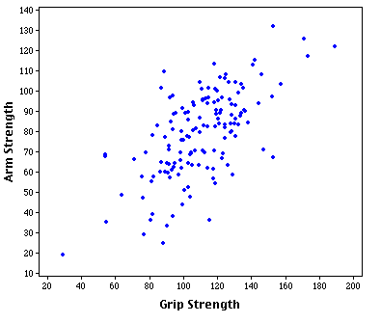

Pearson’s Correlation Coefficient (r)

Measures the linear relationship between variables, ranges from -1 to +1
(the closer to -1 or +1 the stronger the correlation)

Positive correlation – changes in one variable are accompanied by changes in the other variable and in the same direction. (think positive slope)

Negative correlation – changes is one variable are accompanied by changes in the other variable and in the opposite direction. (think negative slope)

Zero correlation – No clear relationship between variables.

Show examples – give estimates of correlation strength

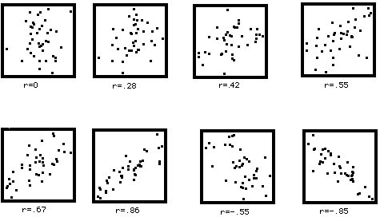

Determine if the following have a positive, negative or zero (0) correlation:

a. Rainfall and attendance at football games. (negative)
b. The age of a car and its value. (negative)
c. Length of education and annual earnings. (positive)
d. Average ACT score and college GPA (positive)
e. Ability to see in the dark and amount of apples eaten. (zero)
f. Miles driven and amount of fuel consumed. (positive)
g. Amount of smoking and incidence of lung cancer (positive)

Activities

Activity 1: Conduct an investigation using a range of FICO scores and APR for a 48-month used car loan. Using a used car valued at $2,500, determine how much total interest will be paid over the life of the loan as it relates to a FICO score.

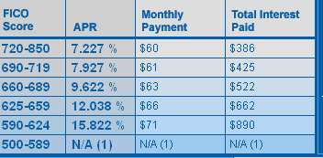

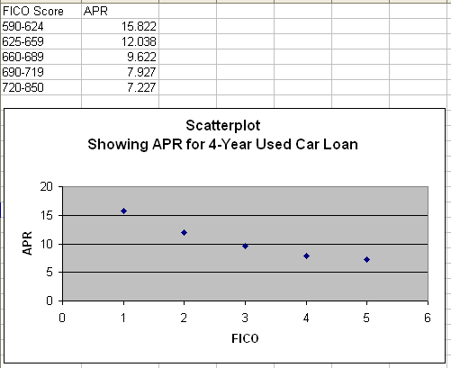

Measure, research, survey, etc. the following data:

Data set 1 | Data set 2
860 | 7.25
800 | 7.5
750 | 7.75
725 | 8
715 | 8.25
710 | 8.5
705 | 8.75
695 | 9.5
690 | 9.75
680 | 10
660 | 12.5
650 | 13
630 | 15
620 | 15.75
450 | 20

a. Plot the data points
b. Identify any patterns, clusters, and outliers.
c. Draw an estimate of the line of best fit through the data.
d. Estimate the correlation coefficient.
e. Use Excel program or graphing calculator to determine correlation
coefficient.

Activity 2: Conduct an investigation ……. This can deepen students’ understanding of correlation.

Activity 2: Conduct an investigation using the “Loan Savings Calculator” on the myFICO website.
a. Open a web browser and enter the address for the myFICO website- http://www.myfico.com/myfico/CreditCentral/LoanRates.asp
b. In the Loan Savings Calculator, select 48-month used auto and Michigan
c. Enter $3,000 in the $ box; select the “calculate” button
d. Study the Monthly Payments and Total Interest Paid to the FICO and APR for each line
e. Compare the information to the Scatterplot created in Activity 1

Lurking Variable

A variable that has an important effect on the relationship among the variables in a study but is not one of the variables being studies. Lurking variables drive the behavior of two other variables creating an apparent association between them.
For example, lemonade consumption and crime rates are highly correlated. Now, does lemonade incite crime or does crime increase the demand for lemonade? Neither: they are joint effects of a common cause or lurking variable, namely, hot weather.
Discuss the following 2 examples:
1. A very strong negative correlation exists between owner’s house size and the age of his or her car(s). What is the third hidden (lurking) variable? __INCOME____________________________

2. Very strong positive correlation between good credit score and lower interest payments. What is the third hidden variable? (Making payments on time each month). (Barb I think this may be a causal relationship – let’s discuss)

Correlation and Causation

High correlation DOES NOT imply causation.

A study of elementary school children ages 6 to 11, finds a high positive correlation between shoe size and scores on a IQ test. Does it make sense to claim that bigger shoe size cause a higher IQ? Or, a higher IQ causes a bigger shoe size? What explains this correlation?
_____________________________________________________________
_____________________________________________________________
_____________________________________________________________

FICO Scores and monthly payments. What is the relationship?
A higher FICO score causes a lower monthly payment and less total interest paid on a loan
If a credit score goes up, a person could save money on interest over the life of a loan
If a credit score goes down, a person could pay more money for interest over the life of a loan

Correlation or Causation?

Each pair of variables shown here is strongly associated. Does I cause II, II cause I or is there a lurking variable responsible for both?

I. Wearing a hearing aid
II. Dying within the next ten years

Lurking variable is person’s age

I. The amount of milk a person drinks
II. The strength of a person’s bones

I causes II, this has been shown experimentally. Exercise and heredity also have causative effect on bone strength.

I. The amount of money a person earns
II. The number of years a person went to school

In general, II causes I, but there are likely lurking variables such as family background and support. There are also other causative variables like vocation choices.

I. A town’s high school basketball gymnasium capacity
II. Number of churches (or bars) in the same town

Lurking variable is the local area population size.

GLOSSARY OF TERMS

Scatterplot
A scatterplot is a graph of paired data in which the data values are plotted as (x, y) points.
Scatterplots are used to examine any general trends in the relationship between two variables. If scores on one variable tend to increase with correspondingly high scores of the second variable, a positive relationship is said to exist. If high scores on one variable are associated with low scores on the other, a negative relationship exists.
The extent to which the dots in a scatterplot cluster together in the form of a line indicates the strength of the relationship. Scatterplots with dots that are spread apart represent a weak relationship.
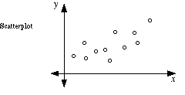

Bivariate

Bivariate data involves two variables, as opposed to many (multivariate), or one univariate.

Pearson’s correlation coefficient

Measures the strength of the linear relationship between two variables.

The correlation between two variables reflects the degree to which the variables are related. The most common measure of correlation is the Pearson Product Moment Correlation (called Pearson's correlation for short). When measured in a population the Pearson Product Moment correlation is designated by the Greek letter rho (ρ). When computed in a sample, it is designated by the letter "r" and is sometimes called "Pearson's r." Pearson's correlation reflects the degree of linear relationship between two variables. It ranges from +1 to -1. A correlation of +1 means that there is a perfect positive linear relationship between variables. The scatterplot shown on this page depicts such a relationship. It is a positive relationship because high scores on the X-axis are associated with high scores on the Y-axis.

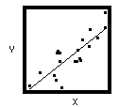

A correlation of -1 means that there is a perfect negative linear relationship between variables. The scatterplot shown below depicts a negative relationship. It is a negative relationship because high scores on the X-axis are associated with low scores on the Y-axis.
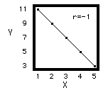
A correlation of 0 means there is no linear relationship between the two variables. The second graph shows a Pearson correlation of 0.

Outlier

Clusters

Data points that cluster together in the form of a line.

Outliers

A data point that is distinctly separate from the rest of the data.

Causation

Causation is the relationship that holds between events, properties, or variables.

Linear association (relationship)

Linear relationship is when 2 variables are perfectly linearly related and the points fall on a straight line.

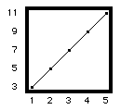

Lurking Variable

A lurking variable is a variable that has an important effect on the relationship among the variables in a study but is not included among the variables studied.
G.R.A.S.P.S. form for performance task:
Goal
Role
Audience
Situation
Product/Performance/Purpose
Standards & Criteria for Success

Consider the W.H.E.R.E.T.O. elements for structuring learning activities:
Where – Help the students know where the unit is going and what is expected. Help the teacher know where the students are coming from (prior knowledge, interests).
Hook – Hook all students and hold their interest.
Equip – Equip students, help them experience the key ideas, and explore the issues.
Provide – Provide opportunities to rethink and revise their understanding and work.
Evaluate – Allow students to evaluate their work and its implications.
Tailored – Tailored (personalized) to the different needs, interests, abilities of learners.
Organized – Organized to maximize initial and sustained engagement as well as effective learning.

