INFORMATION FOR DISTRICT MI-ACCESS COORDINATORS
Worksheet for Fall 2012 MI-Access Grades 3-8
Initial Material Orders
INSTRUCTIONS FOR DISTRICT MI-ACCESS COORDINATORS:
Fall 2012 initial material orders should be entered in the BAA Secure Site from May 14, 2012 to September 11, 2012. This worksheet has been designed to assist District MI-Access Coordinators with collecting initial material order information for the schools in their district. A copy of this worksheet can be printed and distributed to each School MI-Access Coordinator for recording assessment administrator, student, and test administrator manual counts.
This worksheet should be used to collect initial material orders for all of the Fall 2012 MI-Access assessments: Participation, Supported Independence, and Functional Independence assessments in the content areas of English language arts (P/SI), accessing print and expressing ideas (FI), mathematics, and science.
Please establish a deadline for schools in your district to return their completed worksheets to you so that all of your district’s initial material orders may be entered into the BAA Secure Site no later than September 11, 2012. All initial material orders must be submitted using the BAA Secure Site.
INFORMATION FOR SCHOOL MI-ACCESS COORDINATORS
Worksheet for Fall 2012 MI-Access Grades 3-8
Initial Material Orders
INSTRUCTIONS FOR SCHOOL MI-ACCESS COORDINATORS:
- Print your district and school code on the lines provided at the top of the worksheet (see the following page).
- Enter the number of Test Administrator Manuals needed for assessment administrators in your school.
- Enter the number of assessment administrators and students who will be participating in the Fall 2012 MI-Access assessments in the table below. Student counts should be based on IEP Team determinations for students who will be administered the MI-Access Participation, Supported Independence, and Functional Independence assessments in grades 3-8.
Please do not over-estimate your initial material order. An overage is routinely printed and shipped with your shipment.

Worksheet for Fall 2012 MI-Access Grades 3-8
Initial Material Orders
School Name and Code: ___________________________________________
District Name and Code: ___________________________________________

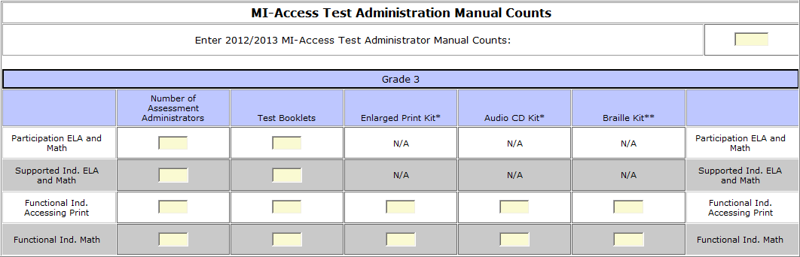
Grade 3 MI-Access Student Counts

Grade 4 MI-Access Student Counts
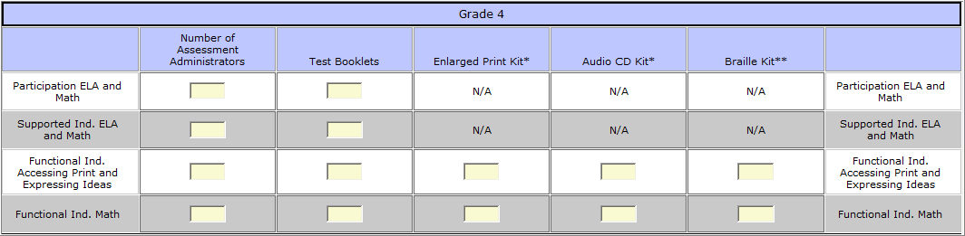

Grade 5 MI-Access Student Counts
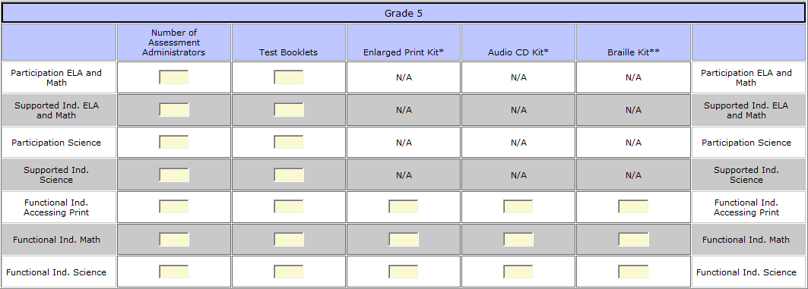

Grade 6 MI-Access Student Counts
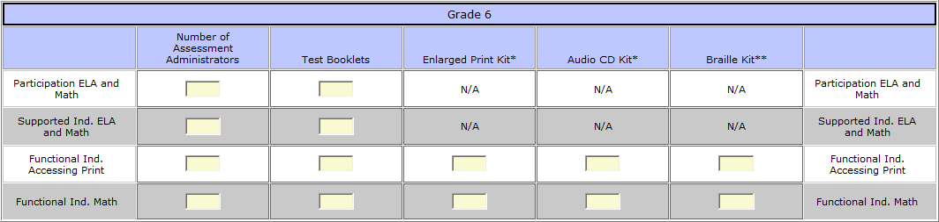

Grade 7 MI-Access Student Counts
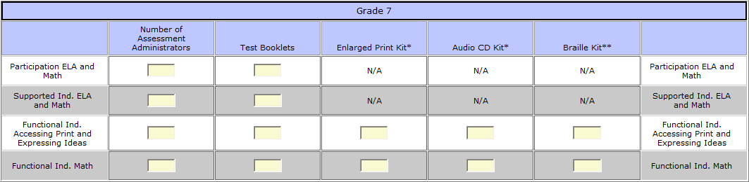

Grade 8 MI-Access Student Counts
