Michigan law requires casino operators, suppliers, and many of their employees to be licensed by the Michigan Gaming Control Board (MGCB) in accordance with the Michigan Gaming Control & Revenue Act, as amended (Public Act 69 of 1997). The following is provided as a general reference, to help you better understand the licensing requirements and procedures.

How do I apply for an Occupational License?

- The first step is to contact the casino or supplier Human Resources Department and inquire about employment opportunities.
- If you are hired, or if the casino or supplier extends to you an invitation for employment, you will be required to complete an application for submission to the MGCB.
- An application fee must accompany your application.
- After receiving the application and fee, the MGCB will conduct a preliminary background investigation to determine if a temporary Occupational License will be issued.
- You will receive notification from the perspective employer when to appear at the MGCB offices for processing, which will include taking your photograph and fingerprints.
- Your temporary Occupational License will be delivered to the casino/supplier and later issued to you.

The MGCB will not process an application for an Occupational License without written documentation from the casino or supplier that you have been hired, or that the casino or supplier intends to hire you.

What kinds of Occupational Licenses are issued? - There are three Levels of Occupational Licenses for persons employed at any of the three Detroit casinos.

- LEVEL One: This is the highest level of an Occupational License and usually includes all managers, supervisors, and other key employees. People included in this category have the authority to develop or administer policy, long-range plans, or to make discretionary decisions regulating gaming operations; and for individuals responsible for major sections within the casino or its property.

- Level Two: This license level is associated with casino employees who operate or maintain casino games; who come in contact with gaming money, chips, tokens, credit slips; functions as a dealer; or acts in a limited supervisory capacity.

- Level Three: Individuals associated with this level of license are casino employees who work in an area where gaming is conducted, or in areas that directly affect gambling, but do not

conduct the games or come in contact with gaming money, chips, tokens, credit slips, etc.

The Level Three Occupational License is usually associated with persons who are employed as beverage servers, wait staff, maintenance and/or housekeeping staff personnel. Persons within this category must be at least 18 years of age.

Is there a fee? - Yes. When submitting an application, the MGCB requires a non-refundable application fee (money order, company check or cashier’s check are accepted). At the conclusion of the background investigation, if a license is granted, a license fee is due. The Occupational License is valid for 2 years, at which time a renewal application and fee will be required. Fees are based on the level of the Occupational License.

Application License &
Fee Renewal
Fee

Level One $500 $250

Level Two $100 $100

Level Three $50 $50

Which jobs DO NOT require a license? Generally, employees who do not work in areas where gaming is conducted are not required to hold a license.

What kind of information in my background would prevent me from being licensed? - The MGCB will deny issuing an Occupational License if you were convicted of a:

- Felony conviction in any state.
- Misdemeanor convictions that involve gambling, theft, dishonesty or fraud, in any state.

The MGCB may also deny issuing a license if the MGCB determines:

- You are not suitable for such license due to your integrity, moral character, reputation, personal probity, financial ability, experience or responsibility, or if you have had a notice filed against you for failure to pay any tax debt, for one or more years.

- There are other factors that may, upon review, adversely affect your ability to be licensed under the provisions as defined within the Michigan Gaming Control & Revenue Act.

The MGCB conducts background investigations on all applicants for licensing.

How long does it take the MGCB to conduct a background check? - The MGCB will make every effort to handle each application in the most expeditious manner possible. However, the MGCB will take whatever time necessary to conduct a thorough background investigation on each person who applies for a gaming license.

Can I get a temporary license? - Temporary licenses enable an employee to begin work with a casino pending completion of the background investigation by the MGCB. The MGCB may issue a temporary license if a preliminary review of the application and a criminal history check do not indicate any discrepancies that could result in denial. Temporary licenses are valid pending the completion of a background investigation at which time an Occupational License may be granted.

If I am denied a license, is there an appeal process? - Yes. Persons denied a license by the MGCB, may appeal the decision.

For more information contact the:

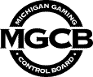

Michigan Gaming Control Board
Licensing Division

Cadillac Place Building
3062 West Grand Blvd., Suite L-700
Detroit, Michigan 48202-6062
Telephone (313)-456-4100
Fax (313)-456-4190

Visit our website at: www.michigan.gov/mgcb

Not printed at public expense
Form # MGCB-B-06
(October 2008)

Michigan Gaming Control Board

Casino Employee Licensing Section

Cadillac Place

3062 West Grand Blvd., Suite L-400
Detroit, MI 48202-6062

How to obtain an
Occupational License
from the

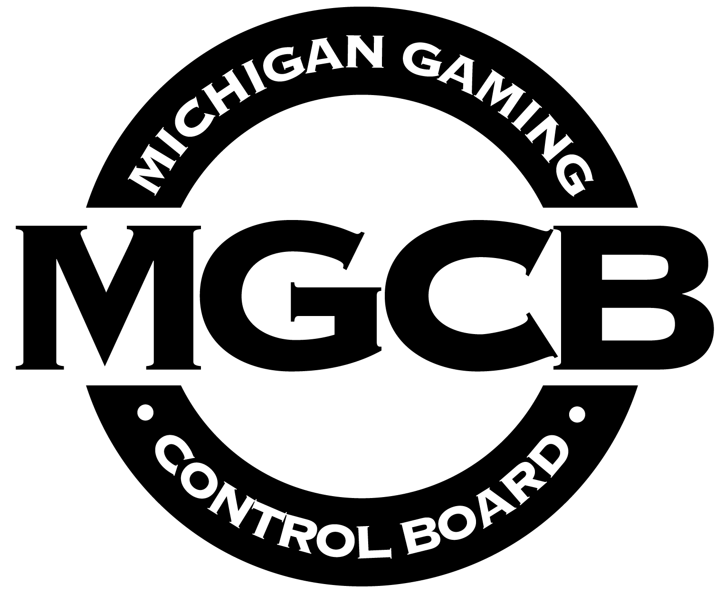

For employment
at a
Detroit casino

