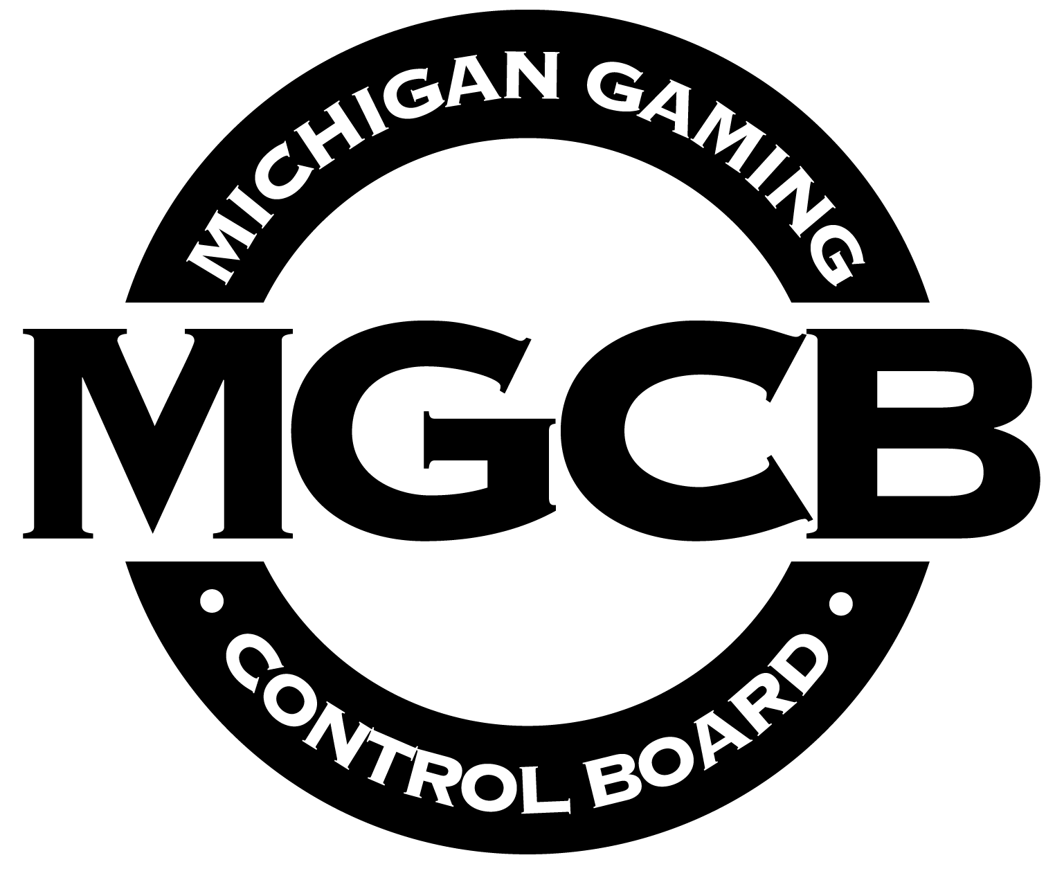  State of Michigan  Michigan Gaming Control Board  Office of the Executive Director  Legal Affairs & Gaming Regulation Division  3062 W. Grand Blvd., L-700  Detroit, MI 48202  Phone: (313) 456-4100  Fax: (313) 456-2864  www.michigan.gov/mgcb |  | RACE MEETING LICENSE APPLICATION  ATTACHMENT I
ATTACHMENT I
INTERSTATE IMPORT SIMULCAST ASSOCIATIONS FORM
(Application - Section II - Simulcasting Information - Question #3b)

(Legal Name of Race Meet Applicant Business Entity)

INTERSTATE SIMULCAST COMPANY INFORMATION

For each out-of-state entity that the applicant plans to contract with or plans to import its live race meet signal to, provide the following information:

Host (alphabetical by name) | City |  | State | Hub | Guest % | Licensed?

Host (alphabetical by name) | City | State | Hub | Guest % | Licensed?

Host (alphabetical by name) | City | State | Hub | Guest % | Licensed?

Host (alphabetical by name) | City | State | Hub | Guest % | Licensed?
(continue if needed)

