 It’s Turkey Time!

The comeback of the wild turkey is one of the greatest wildlife conservation stories. Today, there are more than 7 million wild turkeys in the United States; however, there was a time when the sighting of a wild turkey in this country was rare. Wild turkeys can now be found in parts of every county in Michigan’s Lower Peninsula, plus areas of the Upper Peninsula.

# Did you know?

* Turkeys have excellent eyesight! They can see small movements easily. They can see well in the daylight, but not as well in the dark. Turkeys see distance differently from humans because their eyes are located on the sides of their heads, so they must turn their heads to better judge distance. Turkeys can also see some colors!
* Turkeys have excellent hearing and can locate where a sound is coming from quickly. They can then escape if they see a predator coming.

# **Look Out!**

Do you know what likes to eat turkeys?

Predators of wild turkey eggs and nestlings include raccoons, opossums, skunks, fox, large birds, woodchucks, rodents, bobcats, snakes.

Nesting on the ground is risky business! Turkeys must worry about the weather and other animals threatening their eggs. Hens lay 9 to 13 eggs over a period of two weeks and incubate the eggs by sitting on the nest night and day for about 28 days. All the eggs in the nest hatch on the same day, so that the young turkeys can immediately follow their mother to food, water and safety.

Humans are the primary predator of adult wild turkeys. Other predators include coyotes, bobcats, raccoons, and great horned owls.

## Predator/Prey game

Adapted from Council for Environmental Education’s Growing Up WILD: Exploring Nature with Young Children activity guide Terrific Turkeys lesson.

### You will need:

* hula hoop or string circles for each turkey’s nest.
* Plastic eggs or small balls to represent eggs, 5 per nest.
* Photos or plastic objects to represent food (acorns, plastic insects, frogs, etc.) – minimum of one per child.
* Blue blocks, poker chips, or blue pieces of construction paper to represent water– minimum of one per child.
* Bandanas or predator photos.

### How to Play:

* Prepare by setting up a game area outside or in a large open space.

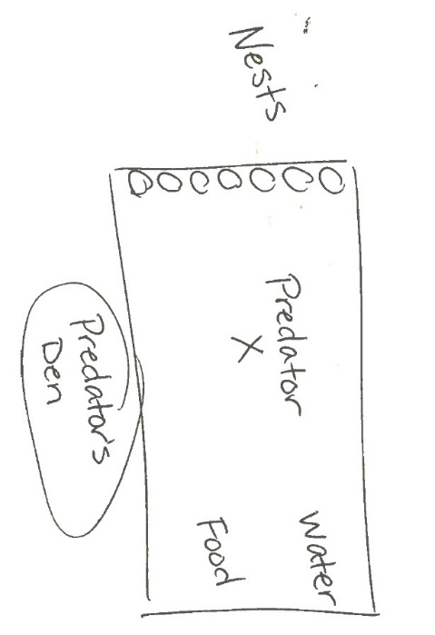

* Children will be a turkey hen in a nest with eggs.
* The game starts when you say “sunup”. Children will move from their nests to the opposite end of the game area and collect 1 food item OR 1 water item and bring it back to their nest. If hens can get 1 food item and 1 water item, they will survive the day. Hens must each get one item and put it in their nest before getting the other. End the game by saying “sundown”. Adjust the amount of time you give each round depending on your students’ abilities and time available to play.
* Who survived the day?

If your students are ready for additional complexity:

* Have 1 to 4 children be predator(s). Predators should wear something to indicate that they are a predator, such as a bandana or a photo of a predator.
* As turkeys try to get 1 food item and 1 water item, predators try to catch them one at a time by touching them on the shoulder.
* Predators must take each turkey to the den (designated spot to the side of the playing field) before catching another. Hens in their nests are safe from predators. How many turkeys survived this round? How many turkeys did the predators catch?
* To add additional complexity for the predators, ask which predators eat turkey eggs. Have 1 or 2 children become egg eating predators. Play the game again with the egg eating predators included; however, egg eating predators do not chase turkeys – they may take one egg at a time from a nest if the hen is not there to protect them. They must take each egg to the den before getting another.
* Who survived this time? How many turkeys did the predators catch? How many eggs?