Pregnancy Test – IM Isbell Marthe’ Diagnostics, Inc.: IM Confirms II hCG

- Purpose:
The IM Confirms ® II hCG Assay is a chromatographic immunoassay (CIA) for the rapid qualitative detection of human chorionic gonadotropin (hCG) in urine specimens. The device is intended for the early detection of pregnancy. Human chorionic gonadotropin (hCG) is a hormone produced by the developing placenta during pregnancy. The test is completed within 4 minutes.

- Specimen:
A. Urine specimens should be collected in a clean, dry container such as a urine collection cup.
B. Specimens may be collected at any time of the day. First morning urine samples will normally contain the highest levels of hCG.
C. If not tested immediately, urine may be stored refrigerated at 36─46ºF (2─8ºC) for up to 72 hours. Samples must be brought to room temperature before testing.
D. Urine samples exhibiting visible precipitates should be filtered, centrifuges, or allowed to settle, to obtain aliquots for testing.
E. Specimen rejection criteria: Samples of unknown age or in unapproved containers should be rejected, and a fresh sample collected.

SAFETY NOTICE: Human specimens may harbor infectious agents. Use universal precautions when working with these materials including gloves and eye protection.

- Materials

A. IM Confirms hCG One-step Pregnancy Test (IM Isbell Marthe’ Diagnostics, Inc., cat. # 6008SD). Materials supplied in kit:

1. Test device: Plastic cassette containing test paper with anti-alpha hCG capture antibody coated membrane and colloidal gold particles coated with mouse anti- BhCG monoclonal antibody.

2. Disposable dropper pipettes

B. Required materials not supplied with kit
    - Specimen collection containers
    - Latex gloves
- External controls. A variety of external controls are commercially available. These include, but are not limited, to.

1. Quidel hCG controls (Quidel Corporation, cat. # 00272)
2. Sacks Medical Corp. (Cat. #S99AO)
3. IM Diagnostics. (Cat. # 6008 C-1001). These controls expire 90 days after opening.
4. Arlington Scientific, Inc (Cat. # 810501)
5. Bio-Rad Quantify urine controls (Cat. # is 975)
6. Bayer Chek-Stix cat. #1364. (Henry Schein, cat. #1470112)
7. Genzyme Diagnostics item # 134 (Henry Schein, cat. # 3276576)

IV. Storage and Stability

The test kit is to be stored either in the refrigerator (35.6 to 46.4⁰ F or 2 to 8⁰ C) or at room temperature up to 86⁰ F (30⁰ C) in its sealed pouch for the stated shelf life of the kit.

V. Quality Control
- External Controls
1. External positive and negative controls are to be performed on a monthly basis.
2. External positive and negative controls are to be performed on each new lot of test kits.
3. If the controls do not yield the expected results, the kit must be removed from service and the action noted in the corrective action section of the QC log sheet.
4. The responsibility for performance of external controls must be rotated among all staff performing testing. The designation of a specific individual to perform all QC activities in the clinic is not permitted.
B. Procedural Control
1. A procedural control is included in the test.
2. A colored band appearing on the control region indicates proper performance and reactive reagents.
3. The result of the procedural control must be documented for the external positive control, the external negative control, and all patient results.
C. Prior to using a new shipment or lot number of IM Confirms hCG, the Positive Control and Negative Control should both be tested and shown to yield the expected results. Upon observing the expected results, the kit is ready for use with patient specimens.
NOTE: The positive and negative controls distributed by IM Diagnostics expire 90 days after opening. After opening, write both the date opened and the open vial expiration of each control vial.
D. The Quality Control Log Sheet should include:
1. Device name and manufacturer
2. Date package, or kit, opened
3. Lot number and expiration date of pregnancy testing device
4. Lot number, closed vial expiration date, and open vial expiration date of each control reagent (if using the IM Positive and Negative controls).
5. Results of:
a. Positive Control
b. Negative Control
c. Procedural Control
6. Initials of staff person conducting quality control tests. The site supervisor and laboratory director must review and sign all QC forms on a quarterly basis.
E. Record the last number and expiration date of the pregnancy test device on the daily test worksheet.
F. Store records for two years.

- Method
  - Review specimen collection instructions.

B. If the test cassette is not at room temperature, allow time to reach room temperature (68to 86⁰ F or 20 to 30⁰ C).

C. Remove the test cassette from its protective pouch after it has reached room temperature. Only open enough that will be used during the clinic since unused cassettes which have been opened can not be stored and used on subsequent days.
  - Label the test cassette with the patient or control identification.
  - Holding the specimen dropper in a straight up and down position, collect about 0.5 ml of urine while avoiding bubbles.
  - Dispense 5 drops (approximately 0.2 ml) of specimen into the sample well.
  - Wait for colored bands to appear. Depending on the concentration of hCG, positive results may be observed in as short as 40 seconds. However, to confirm negative results, the complete reaction time of 4 minutes is required.

NOTE: Add an additional 1-2 drops of urine if a control band does not appear by 3 minutes. However, do not extend the reaction time past 4 minutes if additional sample is added.
  - Be sure to use a separate dropper for each sample and each control to avoid cross contamination.

VII. Results

The Mainline Confirm hCG pregnancy test detects urinary hCG concentrations greater than 20 mU/ml as indicated by the appearance of a colored band in the test region.

A. Negative: Only one colored band appears in the control (C) region. No band is apparent in the test (T) region after 4 minutes.
  - Positive: In addition to the control band, a distinct colored band also appears in the test region within 4 minutes. The colored bands may be any shade of pink. When in doubt, get another sample and repeat the test. Positive results may be interpreted as soon as color develops on the (T) test band and (C) control band.

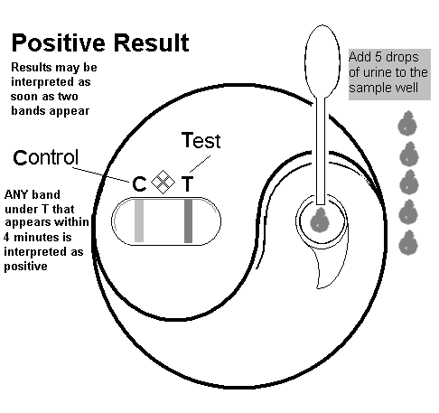
C. Uninterpretable: No colored bands appear or only the test (T) band is colored while the control, (C), band remains clear.

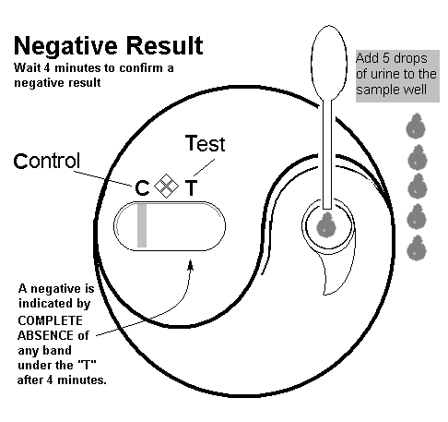
- Procedural Notes

A. When an insufficient amount of urine has been added to the test device, the control band will not appear on the membrane. If a control band has not appeared by 3 minutes, add an additional 1-2 drops of urine. This should correct the problem. If the control band fails to occur by the end of the incubation period, the test should be repeated. If the control band fails to appear on subsequent tests, report the result as indeterminate.

B. Put a new lot of cassettes into use if the control band fails to appear on more than two tests from the same lot number. Deterioration of the test cassette may have occurred.

C. It is important to interpret negative test results at the end of the reaction time (4 minutes). This is because normal, non-pregnant females with low levels of hCG may develop color over time and yield a false positive test.

D. Results may be considered positive as soon as the test band turns color as long as it is within the 4 minute interval.
  - The shade of color which develops on the test band may vary from light pink to dark rose depending upon the amount of hCG present in the sample. However neither the intensity of color nor time of color change can be interpreted as an accurate quantitative measurement of hCG.
  - Weakly reactive positive or negative test results in patients suspected to be pregnant should be confirmed by retesting a fresh early morning urine specimen obtained 42 to 72 hours later or performing a quantitative hCG assay.

- Limitations of the procedure
  - A number of conditions other than pregnancy can result in a false positive test, these include trophoblastic disease and certain non-trophoblastic neoplasms. These diagnoses should be considered if appropriate to the clinical evidence.
  - If a urine specimen is too dilute, (i.e. low specific gravity) it may not contain representative levels of hCG. If pregnancy is still suspected after a negative test, retest with a fresh early morning urine specimen obtained 42 to 72 hours later or performing a quantitative hCG assay.
  - Because of the high degree of sensitivity of the assay, women who test positive during the initial days of pregnancy (i.e. just after conception) may later test negative due to natural termination of the pregnancy. Natural termination occurs in 22% of clinically unrecognized pregnancies and 31% of recognized pregnancies overall.
  - As with all diagnostic tests, a definitive clinical diagnosis should not be based results of a single test, but should only be made by the physician after all clinical and laboratory findings have been evaluated.

- Expected Values:
  - Healthy men and healthy non-pregnant women do not have detectable hCG in urine by the Mainline Confirm hCG test.
  - Mainline Confirm hCG test will detect levels of 20 mU/ml hCG in urine.
  - hCG levels of 100 mU/ml of urine are normally reached by the first day of a missed menstrual period. hCG levels peak about 8-10 weeks after the last menstrual period and decline to lower values for the remainder of the pregnancy. Following delivery, hCG levels rapidly decrease and usually return normal within days after parturition.

- References:
  - IM Confirms Package Insert, Rev 8/08
Technical support: 1-800-427-8557.

***********************************************************************************
This material reviewed and approved for use without modification:

Review Date/Signature: ______________________________________________________________

Review Date/Signature: ______________________________________________________________

Review Date/Signature: ______________________________________________________________

Review Date/Signature: ______________________________________________________________

Review Date/Signature: ______________________________________________________________

Review Date/Signature: ______________________________________________________________

RL.27.02
Rev. 11/2009

