Specimen Collection: Blood Collection by Finger Puncture and Heel Stick RL.04.02
Michigan Regional Laboratory System May 2008

Specimen Collection: Blood Collection by Finger Puncture and Heel Stick

I. Purpose:
To obtain an adequate blood specimen for laboratory tests through a skin puncture from either the finger or the heel. Blood should be collected from the finger on children over one year old or from adults. Blood should be collected from the heel of infants less than one year old or from premature infants over the age of one year who have not yet started walking.

II. Materials and Equipment:
- Disposable latex gloves (Use non-latex, e.g. nitrile or vinyl, if the employee and/or client has a latex allergy).
- 70% isopropyl alcohol
- Cotton balls or gauze
- Blood lancets for finger puncture (capable of making a puncture to the depth of 1.5 mm)
E. Blood lancet designed for heel sticks on infants and premature babies, to a depth of less than 2.0 mm (e.g. BD Quikheel™ Lancet).
F. Puncture resistant sharp’s containers
G. Band Aids (optional)
H. Appropriate microcuvettes or tubes for micro sampling
I. Disinfectant (freshly prepared 10% household bleach) for bench tops
J. Other personal protective equipment, e.g., lab coat or face shield, if appropriate

III. Safety:
- Use standard precautions as outlined in the Bloodborne Pathogen Plan.
NOTE: Standard precautions are guidelines that combine the major features of “universal precautions” and “body substance isolation” practices. Standard precautions cover the transmission of all infectious agents and thus are more comprehensive than universal precautions which are intended to apply only to transmission of blood-borne pathogens.
- Place sharp’s container close to the collection site.
- Wear disposable gloves at all times during the procedure, and lab coat and other appropriate personal protective equipment as indicated.
- Wash hands before putting on gloves and again after removing and discarding gloves. Hand disinfectant gels are acceptable unless your department directives state otherwise or your hands are visibly soiled.
- Change gloves between clients.
- Supplies such as cotton balls, gauze and gloves that are soaked with blood must be disposed of as biohazardous waste. If not soaked with blood, these supplies may be discarded into routine trash containers.
- It is not advisable to apply adhesive over skin puncture sites on children less than two years old. Adhesive bandages can cause irritation to an infant’s skin , and an older infant might remove the bandage, put it in his/her mouth, and aspirate it. Bandages can also be ingested by older children.

Specimen Collection: Blood Collection by Finger Puncture and Heel Stick RL.04.02
Michigan Regional Laboratory System May 2008

- Procedure –
- Fingerstick:
1. Correctly identify and reassure the client. Explain the procedure and verify that the client is free of latex allergies (if latex gloves are used).
    - Position the client in a chair suitable for capillary puncture. If the client is an infant or small child, instruct the parent how best to support the child and restrain excessive movement.
    - Obtain the sample from the third or fourth (middle or ring) finger Choose a site that is on the side of the fingertip, midway between the edge and midpoint of the fingertip. The puncture should be made perpendicular to the fingerprint ridges (shown in figure 1 as the area between the green lines).
    - Thoroughly wash hands with warm soapy water.
NOTE: It may be necessary to warm the skin puncture site to increase blood flow to the site. A warm, moist towl (or other warming devices) at a temperature no higher than 42ºC may be used to cover the site for three to five minutes. This technique increases blood flow to the site up to sevenfold, does not burn the skin, and does not result in significant changes for routinely tested analytes.
5. Thoroughly cleanse the chosen site with 70% isopropanol. Allow the skin to air-dry. Wet alcohol remaining on the skin causes rapid hemolysis, will sting the client and may dilute the sample.

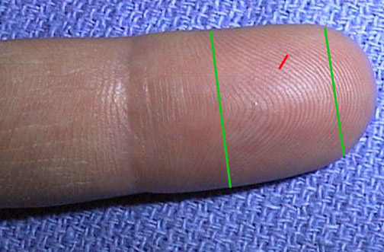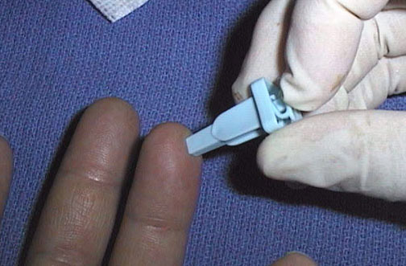
Figure 1 Figure 2
6. Perform finger puncture. Use a sterile, OSHA approved, blood lancet and press firmly. Press the trigger to make a deep puncture (1.5 mm) at the chosen site (figure 2). The blood will form a bead and make collection easier. A puncture parallel to the ridges tends to make the blood run down the ridges and will hamper collection.
NOTE: A deep puncture is no more painful that a superficial one, gives a much better flow, and makes it unnecessary to repeat the procedure.
7. Immediately dispose of contaminated lancet into a sharp’s container.
Specimen Collection: Blood Collection by Finger Puncture and Heel Stick RL.04.02
Michigan Regional Laboratory System May 2008

8. Using a dry gauze, wipe away the first drop of blood, making certain the area is completely dry. The first drop is most likely to contain excess tissue fluid.
9. Apply moderate pressure, approximately 1 cm behind the site of the puncture to obtain a drop of blood. Blood flow from the puncture is enhanced by holding the puncture site downward and gently applying intermittent pressure to the finger. Do not use strong repetitive pressure (milking) on the finger!
10. Release this pressure immediately to allow recirculation of the blood.
11. Collect the blood sample in a collection device appropriate for the test to be performed.
12. Repeat steps 10 & 11 until sufficient blood has been collected.
13. Apply a piece of gauze, (or cotton ball), to the puncture site, using slight pressure until the bleeding has stopped. For older children and adults, offer a band-aid.
B. Heelstick
1. Clean the infant’s heel with 70% isopropyl alcohol (use only rubbing alcohol).
NOTE: Warming the skin-puncture site with a warm moist cloth, or a heel warming device, for 3 minutes can increase blood flow through the site.
  - Allow the heel to air dry.
  - Using a lancet, or heel incision device, and wearing gloves, perform the puncture on the plantar surface of the heel (the shaded area in figure 3). The puncture should be made to a depth of less than 2.0 mm with a sterile lancet or incision device (figure 4).
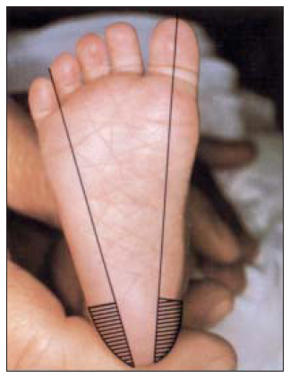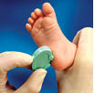
Figure 3 Figure 4

Specimen Collection: Blood Collection by Finger Puncture and Heel Stick RL.04.02
Michigan Regional Laboratory System May 2008

4. Gently wipe off the first drop of blood with sterile lint-free gauze. The initial drop contains tissue fluids that may dilute the sample.
5. Wait for the formation of a large blood droplet; apply gentle pressure with the thumb and ease the pressure intermittently as drops of blood begin to form.
NOTE: Do not use excessive pressure or heavy massaging because the blood may become diluted with tissue fluid or hemolysis of blood cells may occur.
6. Collect blood in the specimen collection device specific for the test being performed.
7. After blood collection is complete, elevate the infant’s foot above the body and apply pressure using sterile gauze until bleeding has stopped. Do not apply adhesive bandages.
V. Procedure Notes
A. Hemolyzed specimens may cause inaccurate results.
B. Hemolsis may occur in skin puncture blood for the following reasons:
1. There is residual alcohol at the skin puncture site.
2. Patients have increased red blood cell fraglity and high packed cell volume (e.g., newborns and infants).
3. Milking of the puncture site.
4. Excessive and aggressive mixing of the specimen in the tube after collection.
C. Skin puncture blood is a mixture of undetermined proportions of blood from arterioles, venules, capillaries, and interstitial and intracellular fluids. The arterial portion can be increased by warming the site prior to collection. This increases the blood flow as much as sevenfold.
D. When heelsticks are performed, take the following precautions:
1. Do not puncture deeper than 2.0 mm.
2. Do not puncture through previous puncture sites.
E. Do not puncture the fingers of infants less than one year old.

VI. References:
- Procedures and Devices for the Collection of Diagnostic Blood Specimens by Skin Puncture;Approved Standard Fifth Edition. NCCLS document H4-A4 [ISBN 1-56238-382-5]. Clinical Laboratory Standards Institute, 940West Valley Road, Suite 1400, Wayne, Pennsylvania 19087 USA, 1999.
B. Blood Collection on Filter Paper for Neonatal Screening Programs. National Committee for Clinical Laboratory Standards, Vol. 23. No. 21 Approved standard – 4th Edition, NCCL Document LA4-A4. Clinical Laboratory Standards Institute, 940West Valley Road, Suite 1400, Wayne, Pennsylvania 19087 USA, 2003.

Specimen Collection: Blood Collection by Finger Puncture and Heel Stick RL.04.02
Michigan Regional Laboratory System May 2008

***********************************************************************************
This material reviewed and approved for use without modification:

Review Date/Signature: ______________________________________________________________

Review Date/Signature: ______________________________________________________________

Review Date/Signature: ______________________________________________________________

Review Date/Signature: ______________________________________________________________

Review Date/Signature: ______________________________________________________________

Review Date/Signature: ______________________________________________________________

RL.04.02
rev. 5/2008

