Center for Educational Performance and Information Security Agreement Instructions for

Nonpublic School Users

Please do not return this instruction page with your security agreement form.
If you are not already an EEM, MSDS or NPSPR authorized user, you must first subscribe to the application through MiLogin for Business. If you do not have a MiLogin for Business account, you may create one at MiLogin for Business (https://milogintp.michigan.gov). Please do not create multiple MiLogin for Business accounts.
- To request access, log in to the MiLogin for Business site and click “Create An Account.”
- Follow through with all steps to create an account. If you need assistance, please see the MiLogin User Guide.
- Once your account has been created, choose “Discover Online Services.”

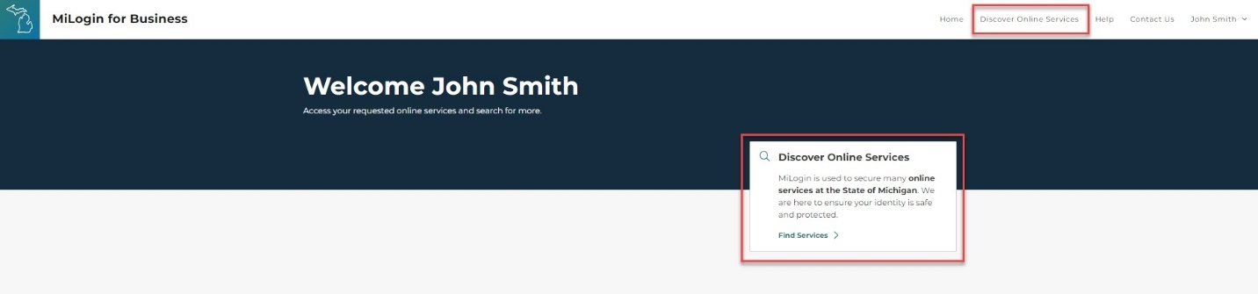
- On the next page, search for an application by keyword, or select an agency (CEPI) to view available applications. Choose the application to subscribe to by clicking the application description.
- Review and agree to the Terms & Conditions.
- Click “Request Service.”

*Application users will receive relevant email updates and reminders.

Security forms must be signed by both the user requesting access to the application(s) and the lead administrator of the entity, as listed in the Educational Entity Master. If the EEM record needs to be updated, that can be done by your entity’s EEM authorized user.
As a nonpublic school user, if extra assistance is needed with updating the EEM record, please contact Wendy Allison at 517-241-5385 or nonpublicschools@michigan.gov.
Please type or print clearly; otherwise, the processing of your form may be delayed. CEPI will email you when your form has been processed (generally within three business days).
NOTE: To remove a former user’s access, submit a User Removal Request Form from the CEPI Security Forms web page.

Application User Roles and Descriptions

Michigan Student Data System (MSDS)
- Quality Reviewer - Edit: Users with this role review submitted data for accuracy and ensure that the data meet the business rules for each field.

- Supplemental Nutrition - Edit: Section 9 of the Richard B. Russell National School Lunch Act establishes requirements and limitations regarding the release of information about children certified for free and reduced-price meals provided under the National School Lunch Program. A child’s eligibility status may only be disclosed to persons directly connected with, and who have a need to know, a child’s free and reduced-price meal eligibility status in order to administer and enforce Title I requirements. This role allows users to view and edit these data.

Registry of Educational Personnel (REP)
- Authorized User: Submit REP data and create new Personnel Identification Codes.

Educational Entity Master (EEM)
- Entity Authorized User: Add, modify and close entities.

Center for Educational Performance and Information Security Agreement for Nonpublic School Users

Step 1. Enter your school information.

Entity Code: Entity Name:
Step 2. Enter the name of the person being authorized by the lead administrator to access the application(s).
Name: Title:
Email: Phone:
MiLogin for Business Account ID (e.g. smithj1234):
Step 3. Select the access this individual will be granted.
Step 4. For the authorized individual: Please sign below.
I agree to abide by the regulations that govern the use of student data within the Family Educational Rights and Privacy Act, as well as the Privacy Act of 1974, governing records maintained about individuals. I agree to protect my user identification and password from unauthorized use. I understand all access under my user ID is my responsibility, and that allowing anyone else to use my ID will result in my account being deleted.

Signature: Date:
Step 5. For the EEM lead administrator: Please sign below.
I attest that the above-named individual is authorized by me to access the applicable applications at the level indicated above, and the data are current and accurate.

Name: Title:

Signature: Date:

Email this form to cepi@michigan.gov *Application users will receive relevant email updates and reminders.

