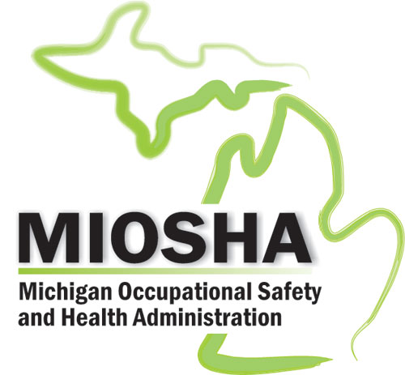

MIOSHA RECORDKEEPING GENERAL GUIDE FOR RECORDING
This summary of major recordkeeping concepts provides general information to aid in keeping records accurately.
- An injury or illness is considered work-related if it results from an event or exposure in the work environment. The work environment is primarily composed of: (1) the establishment and (2) other locations where 1 or more employees are working or are present as a condition of their employment. When an employee is off the employers’ premises, work relationship must be established; when on the premises, relationship is presumed unless an exception specifically applies. In addition to physical locations, equipment or materials used in the course of an employee’s work are also considered part of the employee’s work environment.
2. All work-related fatalities are recordable.
- All work-related injuries and illnesses are recordable if they require: days away from work, restriction of work or transfer to another job, loss of consciousness, medical treatment beyond first aid, or if a significant injury of illness is diagnosed by a physician/licensed health care professional or identified by a positive medical test.

FIRST AID (ALL INCLUSIVE)
- Using nonprescription medications at nonprescription strength (for medications available in both prescription and non-prescription form, a recommendation by a physician or other licensed health care professional to use a non-prescription medication at prescription strength is considered medical treatment for recordkeeping purposes).
- Administering tetanus immunizations (other immunizations, such as Hepatitis B vaccine or rabies vaccine, are considered medical treatment).
- Cleaning, flushing or soaking wounds on the surface of the skin.
- Using wound coverings such as bandages, Band-Aids, gauze pads, butterfly bandages, Steri-Strips, etc. (other wound-closing devices such as sutures, staples, etc., are considered medical treatment).
- Using hot or cold therapy.
- Using any non-rigid means of support such as elastics bandages, wraps, non-rigid back belts, etc. (devices with rigid stays or other systems designed to immobilize parts of the body are considered medical treatment for recordkeeping purposes).
- Using temporary immobilization devices while transporting an accident victim (e.g., splints, slings, neck collars, back boards, etc.).
- Drilling a fingernail or toenail to relieve pressure, or draining fluid from a blister.
- Using eye patches.
- Removing foreign bodies from the eye using only irrigation or a cotton swab.
- Removing splinters or foreign material from areas other than the eyes by irrigation tweezers, cotton swabs or other simple means.
- Using finger guards.
- Using massages (physical therapy or chiropractic treatment are considered medical treatment for recordkeeping purposes).
- Drinking fluids for relief of heat disorders.

MEDICAL TREATMENT
- All treatment that does not fall into first aid as listed above.
- Using prescription medications or use of a non-prescription drug at prescription strength.
- Using wound-closing devices such as surgical glue, sutures, staples, etc.
- Using any devices with rigid stays or other systems designed to immobilize parts of the body.
Reminder: Work-related injuries requiring First Aid Treatment and that do not involve any of the conditions in Item 3 above are not recordable. For further inquiries, contact MIOSHA, Management Information Systems Section
(517) 284-7788.
www.michigan.gov/miosha

www.michigan.gov/miosha Form #: MIOSHA-MISS-1, Effective Date: 08/18/15

