**Delegate Functionality Instructions**

The following instructions are for how to provide another registered user the ability to access and perform activities on behalf of another registered account. Included in these instructions are how to set permissions for the delegate user and how the delegate user accepts the invitation.

NOTE: The person that is going to receive delegate functions will need to have registered for an account in ACA before they can be provided delegate access to another account.

1. Login to the account that wants to Delegate access to someone else to perform functions.

2. After login select Account Management.

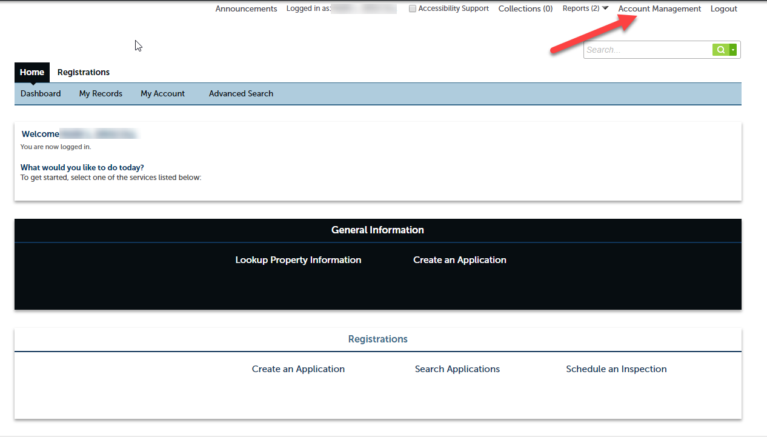

3. In the Account Management screen scroll down to the bottom of the screen and select Add a Delegate button.

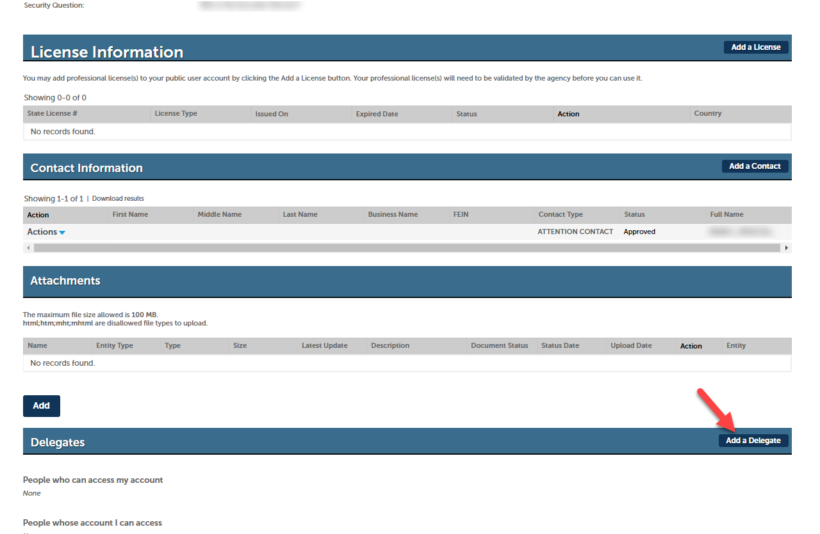

4. Enter the name and email address of the person you wish to delegate functions to. NOTE: The person that is going to receive delegate functions will need to have registered for an account in ACA before they can be provided delegate access to another account.

5. Select the permissions you would like the person to be able to perform on behalf of the account providing delegate access.

6. Place a checkmark in the box next to “I’m not a robot”.

7. Select Invite a Delegate button to send an invitation to the person to become a delegate for the account.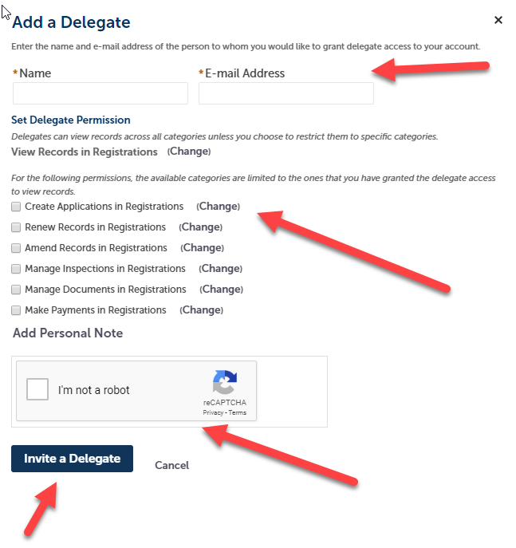

8. The Delegates section will display the users that are delegates for the account and outstanding invitations. This section can be used to manage delegates.

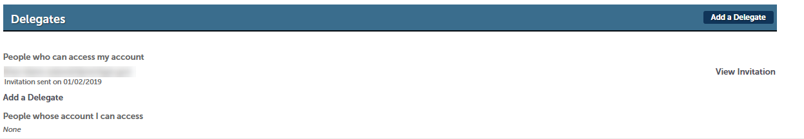

9. If you would like to change the permissions of a delegate that hasn’t accepted the invitation yet, select View Invitation.

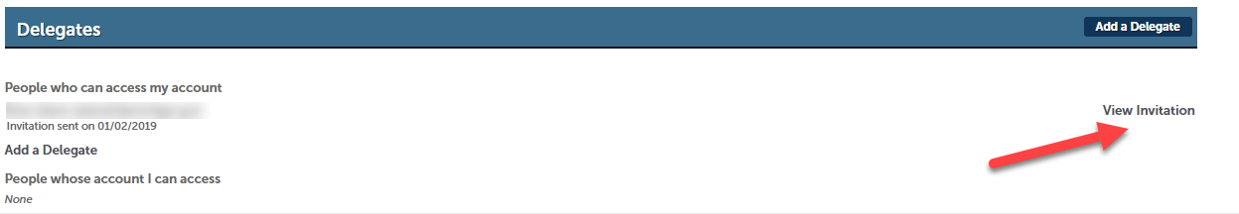

10. Change the permissions as desired and select Save Changes.

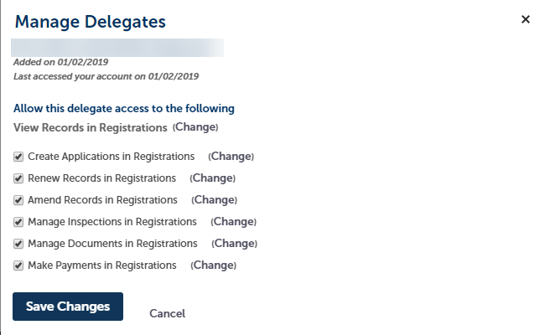

11. If you would like to change the permissions of a delegate that has accepted the invitation, select Actions, then select Edit Permissions.

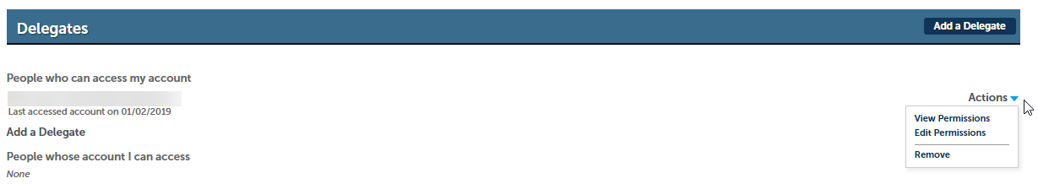

12. Change the permissions as desired and select Save Changes.



13. Example of the invitation sent to the person who is desired to be a delegate.

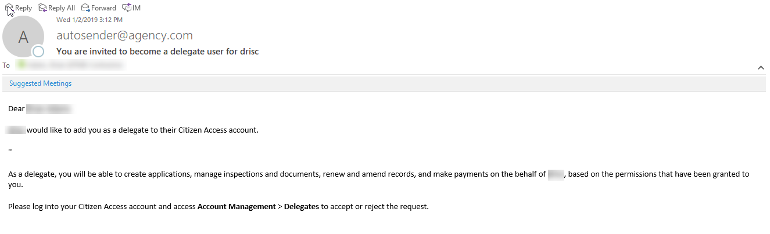

**How to accept the invitation for delegate access.**

1. The person receiving the invitation for delegate access will login to their ACA account.

2. Select Account Management.

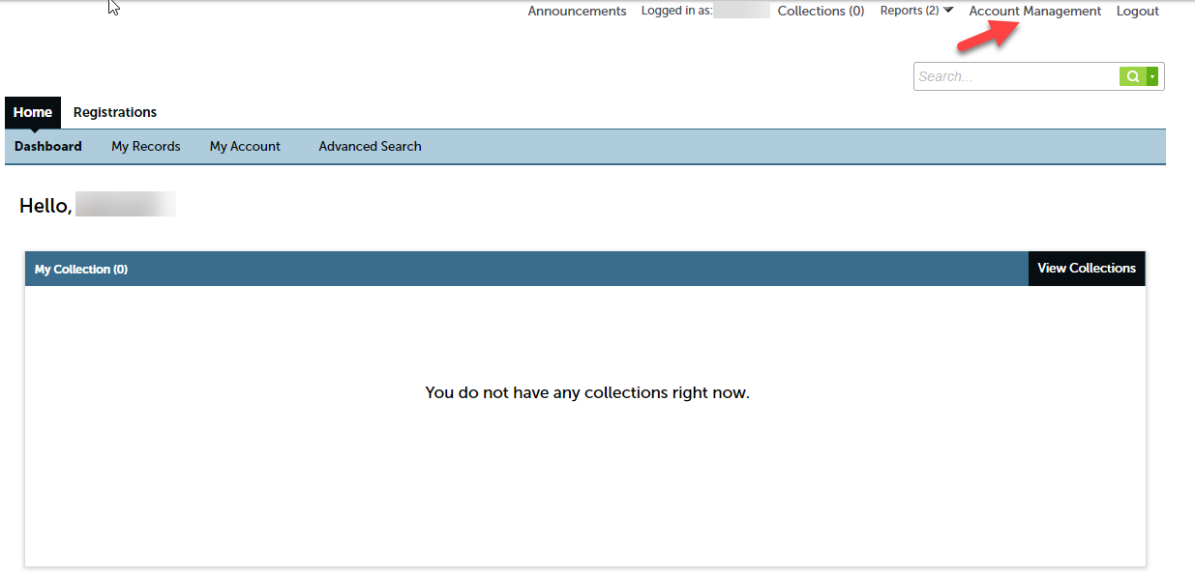

3. In the Account Management screen scroll down to the bottom of the screen and select Accept button to accept the invitation to be a delegate.

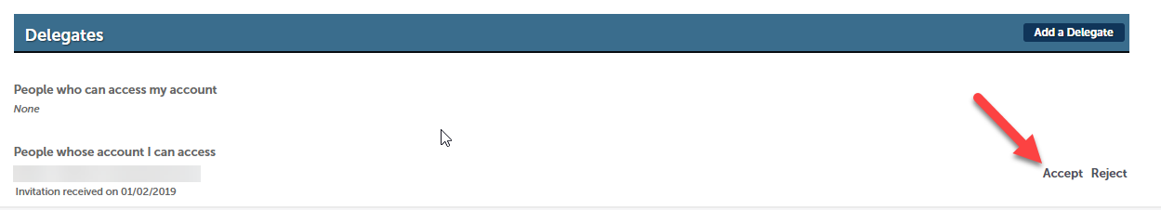

4. When the user provided delegate functionality creates an application or record of any type, they will be asked who they want to create the application as? Either themselves or as another person that has provided them delegate access to their account. This is dependent on the type of permissions the delegate was provided.

