**IMPORTANT REGISTRATION INFORMATION FOR ORGANIZATIONS WITH MULTIPLE FACILITIES**

Organizations with more than one facility: We recommend establishing an organization account and utilizing the delegate functionality. This provides access to others that may perform functions for facilities within the organization, e.g. pay invoices or make changes to the registration certificate, and other activities available in the system.

Directions for the following items available at [www.Michigan.gov/rss](http://www.Michigan.gov/rss)

Records for the organization will need to be PIN Linked from the organization account if they do not appear in the organization account or in search results within the organization account.

See ACA PIN LINK INSTRUCTIONS.

Delegate Functionality: See Delegate Functionality Instructions.

**How to Register an Organization Account:**

1. Go to the system website: aca3.accela.com/MIHS

2. Under the password field select “New Users: Register for an Account”.

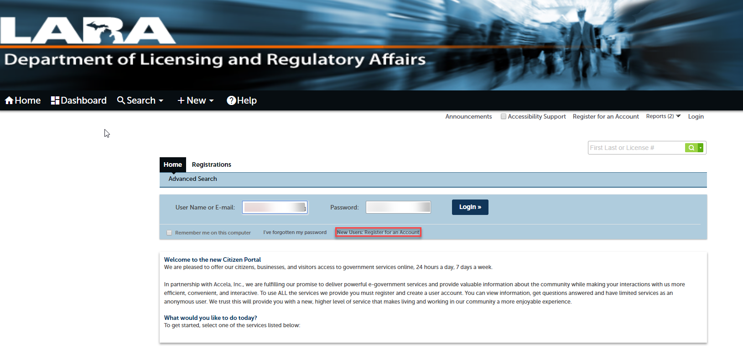

3. After reviewing and accepting the terms select “Continue Registration”.

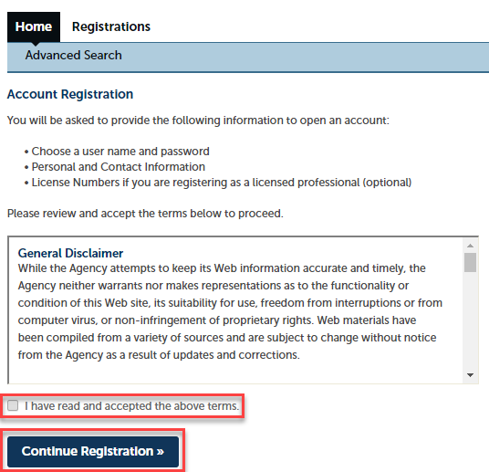

4. On the screen “Enter/Confirm Your Account Information”:

User Name: Enter a user name for the account that reflects the organization.

E-mail Address: Enter the e-mail address of the person that will be responsible for administrating the account on behalf of the organization.

Password: Enter a password and confirm the password in the field “Type Password Again”.

Complete the security question and answer fields.

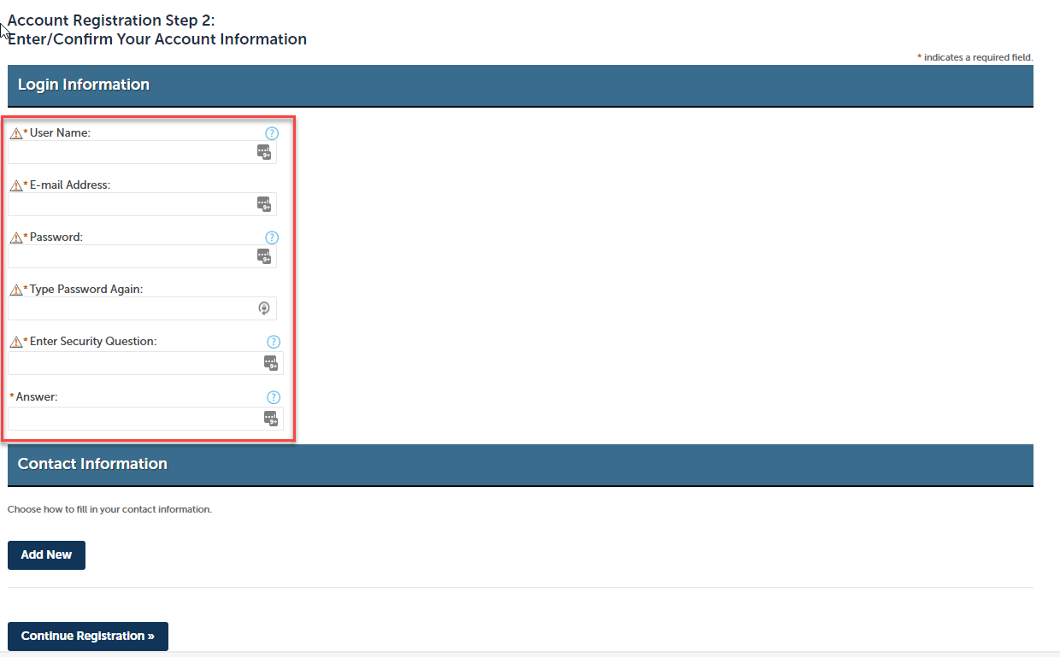

5. Under “Contact Information” on the “Enter/Confirm Your Account Information” screen select “Add New”.

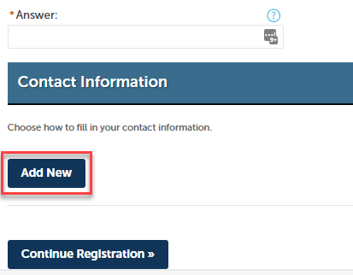

6. Select on the “Select Contact Type” screen under “Type” select “ATTENTION CONTACT”, then select “Continue”.

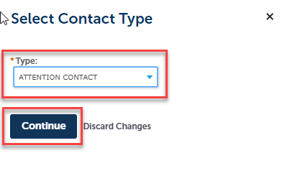

7. Enter the contact information of the person that will be responsible for administrating the account on behalf of the organization on the “Contact Information” screen. In the “E-mail” field enter the same e-mail address that was entered in the “E-mail Address” field on the prior screen.

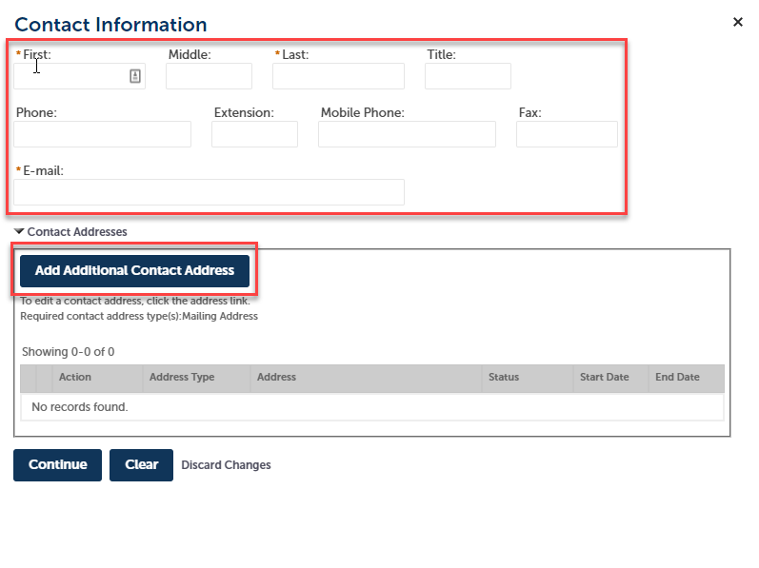

8. Select “Add Additional Contact Address” and enter the mailing address and select “Save and Close”.

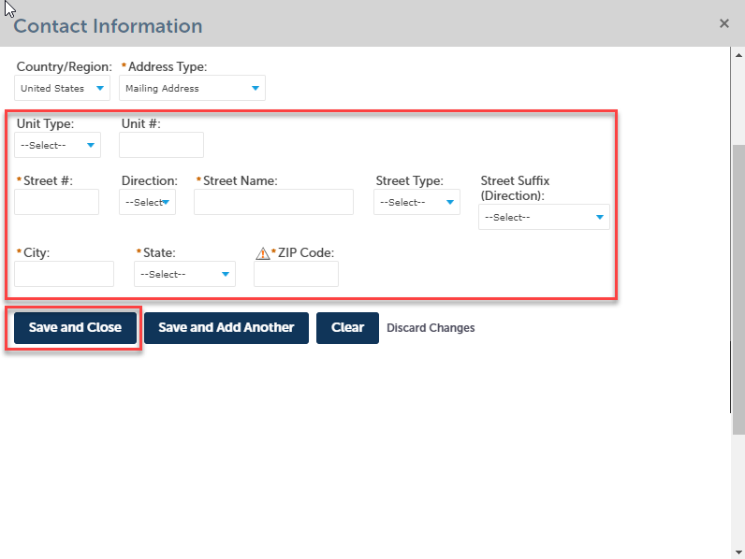

9. On the “Contact Information” screen select “Continue”. There may be a popup that appears that with the message of “The information you entered is not found. Click Continue to create a new account…”, select “Continue”.

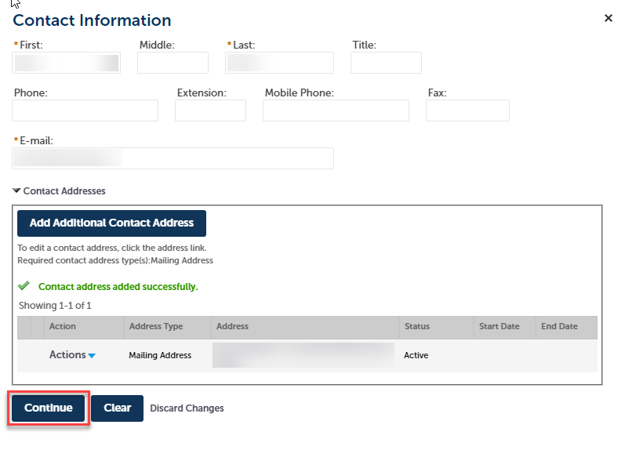

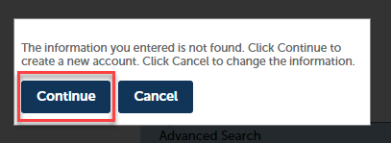

10. Select “Continue Registration”.

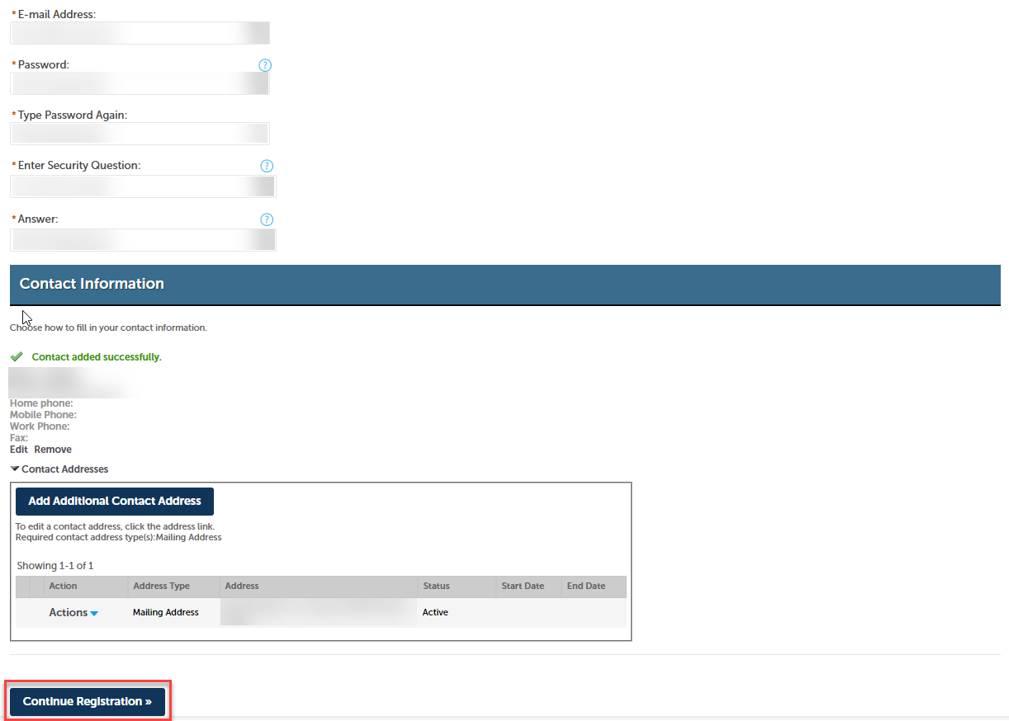

11. The message “Your account has been created successfully. You can login immediately using your User Name and Password.” will appear at the top of the screen. Select “Login” towards the top of the page and this will return you to the login page.

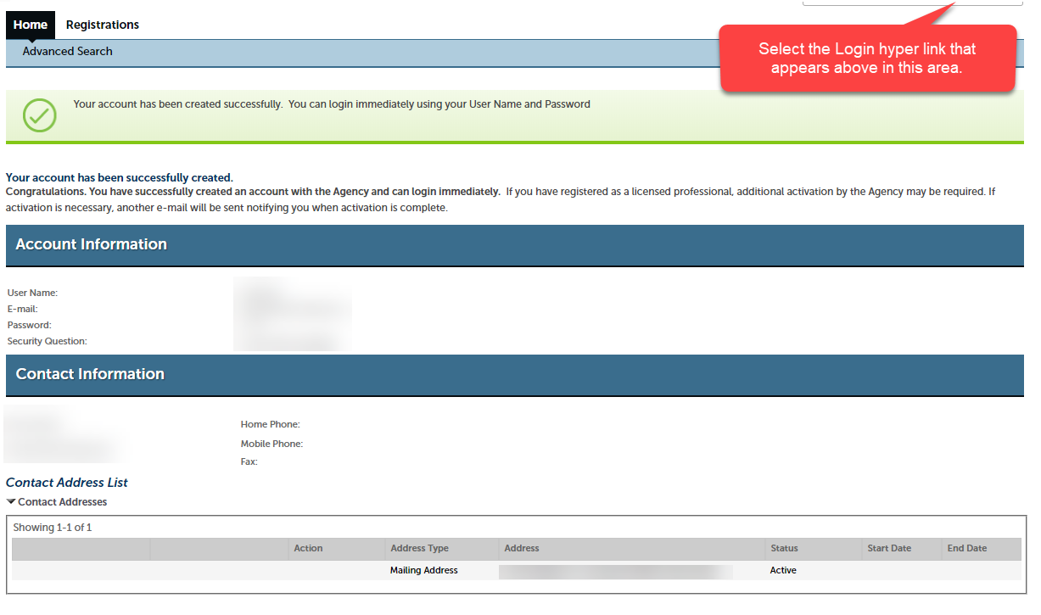

12. Login to the system using the user name and password for the account that was created for the organization.

