State of Michigan

Radiation Safety

ACA Guide

Contents

General Disclaimer 4

Creating a User Account 5

Creating a New Facility 5

Facility Information 6

Machine Information 7

Review 8

Pay Fees 8

Record Issuance 8

Machine Registration 8

Mammography Machine Registration 9

Facility Information 9

Machine Information 9

Additional Information 10

Authorization Information 10

Review 10

Pay Fees 10

Record Issuance 10

Viewing Details of an Existing Facility Registration 11

Plan Review 11

Stand Alone Plan Review 11

Create Application 12

Inspector Requested Plan Review 12

Create Application As 12

Facility Information 12

Plan Specific Information 13

Submittal Information 13

Review 13

Record Issuance 13

Amendments 14

Mammography Machine Amendment 15

Renewals 15

Facility Information 15

Machine Information 16

Machine Information – cont. 16

Review 16

Pay Fees 16

Record Issuance 16

Submitting Payments 17

Electronic Payments 17

Pay by Mail 19

Incident Reporting 19

Facility Information 20

Incident Information 21

Excessive Dose / Medical Event 23

Excessive Dose Information 23

Medical Event Information 25

Review 25

Record Issuance 27

Pin Linking 27

ACA PIN Link Information 28

Review 29

Record Issuance 29

Confirmation 30

Additional PIN Link Notes 30

# General Disclaimer

To complete various functions within the RSS site, you will be presented with a general disclaimer. To use the tools within the site, you must read and accept the terms of the disclaimer as indicated by selection of the provided checkbox.

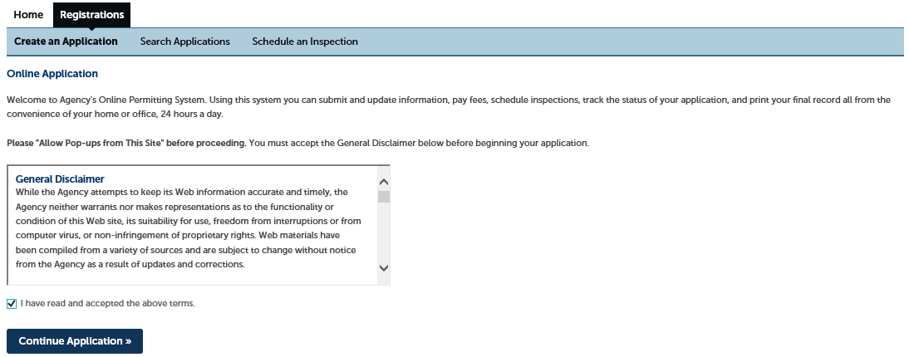

# Creating a User Account

To access the toolset for registering and applying for X-ray machine certification, a user must create an account. This will allow the user to maintain their radiation machine registrations and certifications online. The registration site is found at:

XXX Create Hyperlink Here XXX

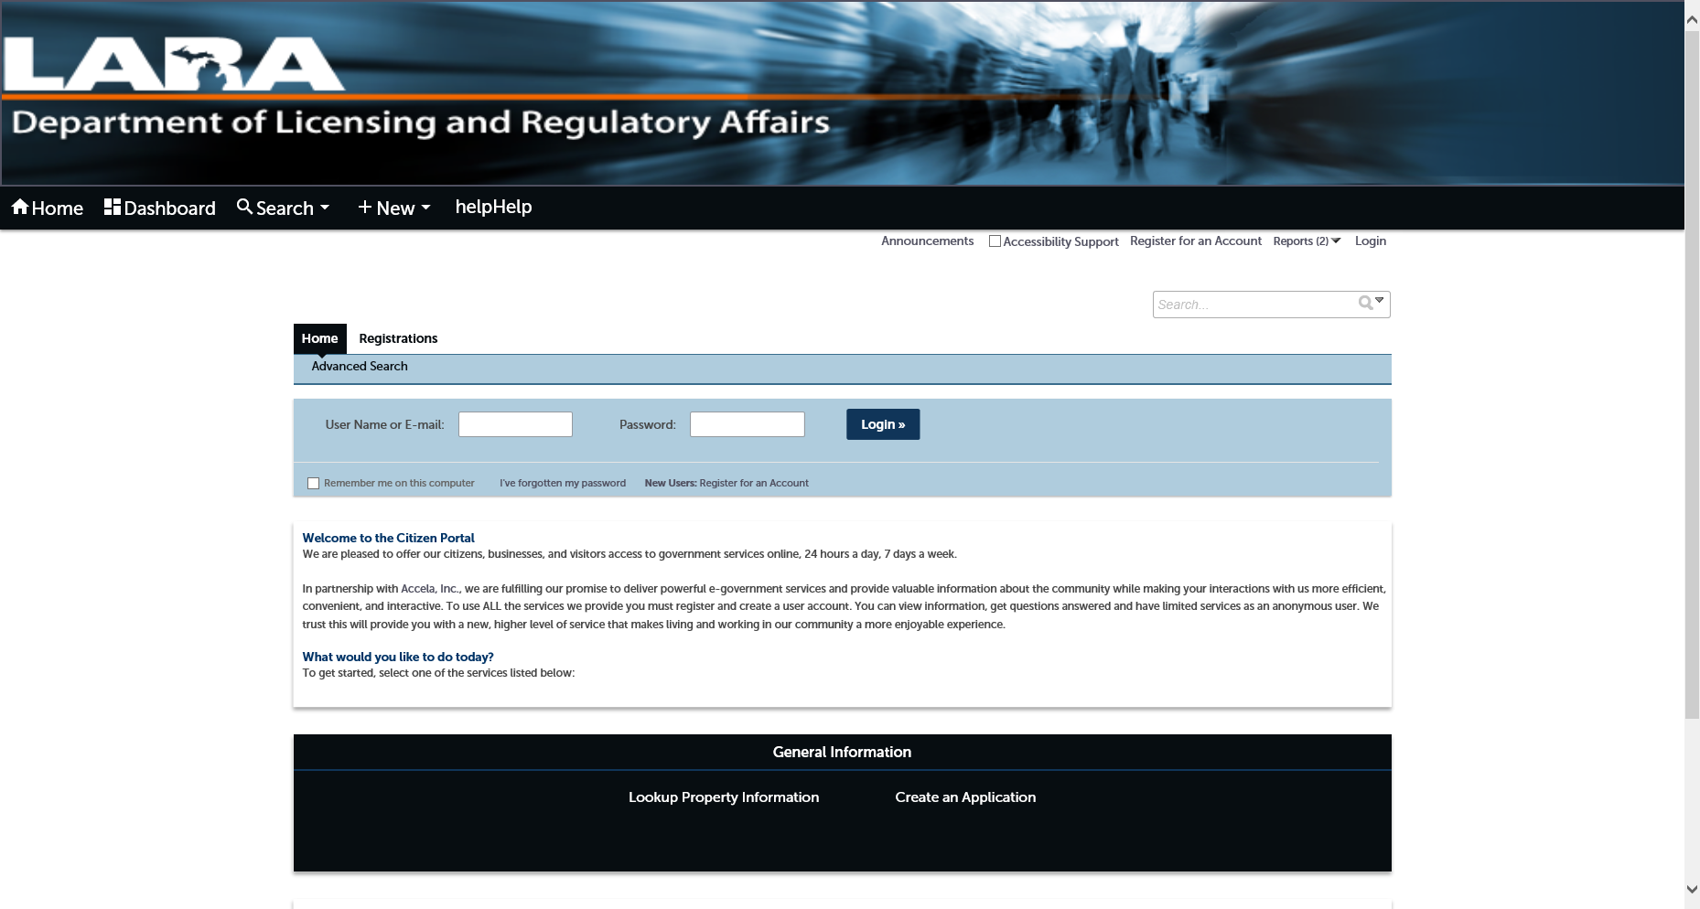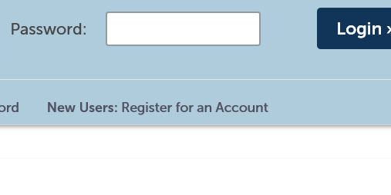

• Existing users can use their User Name and Password to login.

• New Users will have to click on the link depicted above: “New Users: Register for an Account”**.** After following a series of prompts and submitting their information, the new users can simply login as an existing user.

# Creating a New Facility

To create a new facility record, the user must login and proceed to the “Registrations” selector.

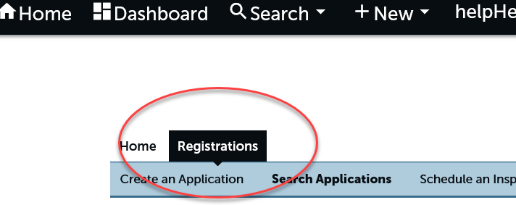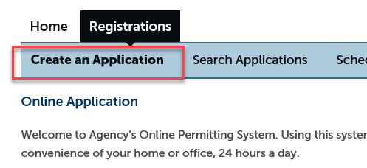

Selecting the “Create an Application” option will advance the user to a “Terms of Use” confirmation page and then presents several options:

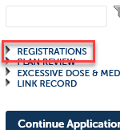Selecting the “REGISTRATIONS” option and then selecting “Facility Application” will present the user with a series of four pages to collect data about their facility, machines and payment information for registration.

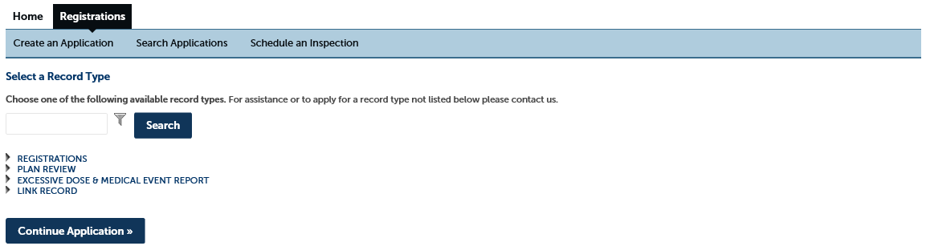

### Facility Information

The first page of registration is the Facility Information page. Here the user will input the facility type and address details, as well as providing contact information for the owner/registrant, the attention contact, and the radiation protection supervisor.

If the user has previously entered facility information, contact information may be selected from their account for ease of completion.

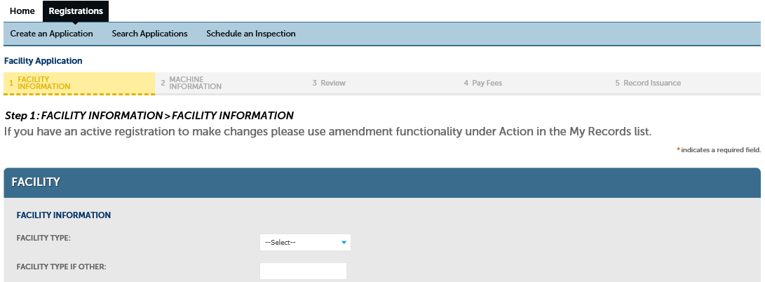

### Machine Information

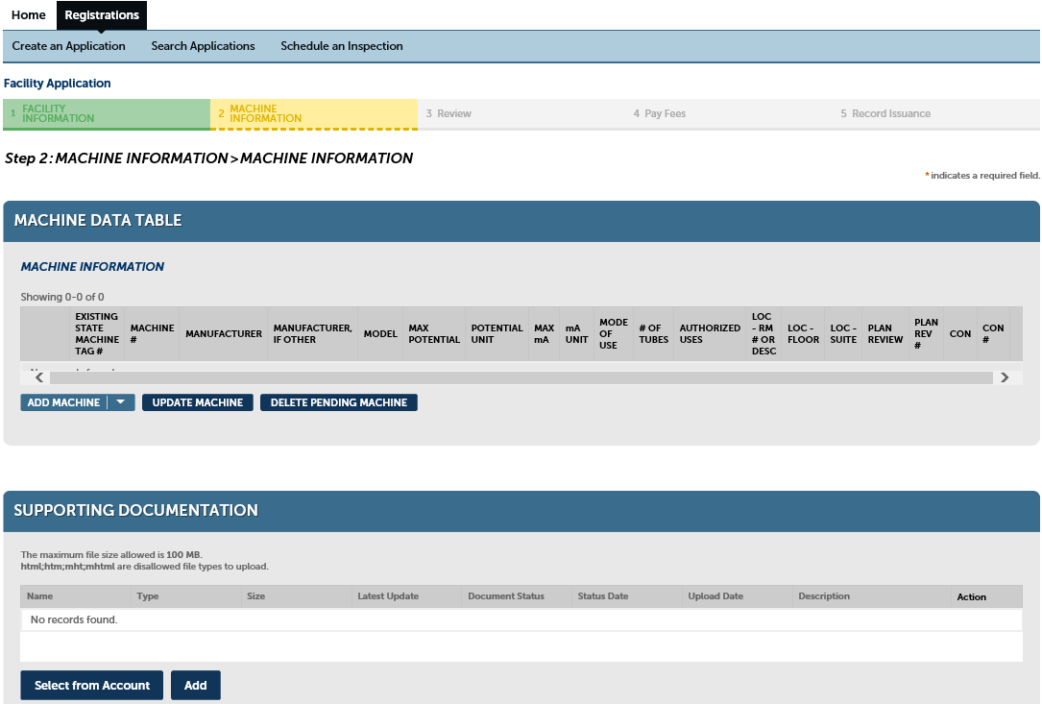The second page of registration is the Machine Information page. Here the user will enter information for each machine that is to be registered at the entered facility. The user is also presented with an optional field to upload supporting documentation.

### Review

The third page of registration is a review of the user-entered information. Edit functions are available for any corrections or additions that may be required.

### Pay Fees

The fourth page of registration is the fee information for the entered machines. The user is presented with the options to pay electronically or to pay by mail.

If the user selects the Continue option, they are redirected to the pay site for electronic payment processing. If the user instead selects the Pay by Mail option, they will be invoiced for the registration fees indicated.

### Record Issuance

Completing the Pay Fees step will advance the process to Record Issuance. This step does not require user input as it is simply the assemblage of the submitted information into a record within the user’s account.

NOTE: If you are unable to complete the registration process for your facility, you can use the “Save and resume later” button in Accela. This allows you to return to your record and to continue entering information where you left off.

The user can then login to their account and view their records. The Action column will offer a link to Resume Application.

# Machine Registration

During the process of Creating a New Facility, the user will be prompted to provide the details of the facility’s X-ray machines for registration. This is the second step of the Facility Application process.

Once the user has submitted the machine data, the record will be populated under the MACHINE INFORMATION header. A machine record will have to be submitted for each machine to be registered to the user’s facility.

## Mammography Machine Registration

If the user is registering a mammography machine or machines, after submitting the registration request they will receive an email notification identifying a mammography authorization record (application). The user must then login to their account and select the identified authorization and complete the application information.

### Facility Information

The first section of the authorization record requires that the user confirms the facility information, including: the facility type and address details, and the provided contact information. Edit links are provided for the user to apply any changes or updates to the provided data. The “Continue Application” button will advance to the next step.

### Machine Information

The second section of the authorization record requires that you provide the facility imaging and material information. The previously entered machine information will appear on the Machine Data Table and can be confirmed here.

Additionally, the user will be required to provide accreditation documentation. This documentation can be uploaded and attached to the authorization record using the provided upload field. Uploaded files will require a Type to be selected from a dropdown list and a Description field must be completed before the user can save the attachment(s).

Evidence must be provided of application for American College of Radiology (ACR) accreditation or a copy of the ACR certificate if the machine is currently accredited. If neither are currently available, evidence of ACR accreditation application must be submitted within 45 days.

NOTE: If opting for State Evaluation process for Stereotactic Breast Biopsy Mammography, a State Evaluation Application packet will be emailed to the attention contact supplied with this authorization application.

### Additional Information

The third step of the authorization application process is to provide a list of Interpreting Physicians and Technologists. A table is provided for both, with check-boxes for the user to indicate the criterion met by everyone listed.

### Authorization Information

Step four of the authorization application process is Authorization Information. The user is presented with three sections: Authorization and Accreditation Information, Medical Physicist Information and Interpreting Physician Information. Each of these sections is required to proceed to the next step: Review.

### Review

Step five: Review presents the user with all the authorization data submitted for the application. The user is presented with each section of the application with edit controls that allow for changes and/or corrections.

### Pay Fees

After reviewing and submitting the authorization information, the user is presented with the Pay Fees information. This section presents a list of any applicable fees and offers payment options if a balance is due. If no balance is due, the user can select “Continue Application” to continue.

### Record Issuance

The final step of the authorization record is a record issuance step that offers a Record Number for reference.

# Viewing Details of an Existing Facility Registration

For an existing user, logging in to ACA will present a list of Registered Facilities among the records available.

Reference the Record Type column to confirm the “Facility Registration” type for review and check the Status column to confirm that the “Certificate Issued” status is present. Left-clicking on the Record Number will take the user to the specific record screen where the details of the facility registration record and any attachments can be viewed (*and downloaded, etc.*).

  To view a specific Machine record, the user can select a Record Type of “Machine Registration”. The Record Number will be a number sequence representing the machine’s registration number (Machine Tag #).

Left-clicking on the Record Number (*machine #*) will take the user to the specific record screen where the details of the machine and any attachments can be viewed (*and downloaded, etc.*).

# Plan Review

The user can submit a standalone Plan Review, or an inspector may initiate a request for Plan Review submittal. This will create a temporary record that will notify the user to follow up with submission of Plan Review.

## Stand Alone Plan Review

Selecting the Plan Review and then “Radiation Shielding Plan Review” will initiate the application process. In Step 1: Facility Information, the submitter must enter their contact information as well as the facility information.

### Create Application

The Plan Review Application process follows these steps:

1. *Create Application As
   * (applies to Inspector Requested Plan Review)
2. Facility Information
3. Plan Specific Information
4. Submittal Information
5. Review
6. Record Issuance

## Inspector Requested Plan Review

This differs from the stand alone plan review as the facility information may exist already, and the submitter must identify who they are creating the application as. The inspector requested plan review may have existing facility and machine information in the record. The process follows the same sequence, but in the case of existing information it must be reviewed/confirmed.

### Create Application As

1. Myself: The user selects this option to indicate that they are completing the application for their own facility/machine.
2. Another Person: The user selects this option to indicate that they are a delegate with authorization to create an account for the facility/machine.

### Facility Information

The Facility Information section of the plan review application requires that the user provides an organization or individual name, with an email address (this can be an existing name selected from the file). Additionally, the facility name, location (address information), and the owner/registrant must be identified. The facility representative is an optional field.

### Plan Specific Information

The first section: Application Information calls for selection of the reason for the plan review. There are four options to select from:

* New X-ray Room (New Construction)
* Renovating an Existing X-ray Room
* New Equipment in an Existing X-ray Room
* New Owner of an Existing X-ray Facility

The submitter can also enter the expected date of project completion. The Facility Information section follows for indicating the Facility Type. And finally, the Machine and Workload information section allows for addition / edits to new or existing machines.

### Submittal Information

A checklist is provided for the user to indicate which document items are included with the submittal. The Submittal Documentation section of the page offers a tool for uploading the indicated documents.

A radiation room drawing is required documentation. The document must be uploaded and the “Type” selected as “Radiation Room Drawing”.

### Review

Step four: Review presents the user with all the plan review data submitted. The user is presented with each section of the application with edit controls that allow for changes and/or corrections.

### Record Issuance

The final step of the plan review application is a record issuance step that offers a confirmation and a Record Number for the user’s reference.

# Amendments

After logging in to a User Account and selecting My Records, the Amendment link will be a selectable option in the Action column of Registered Facility records. Clicking on this link will present the Amendment Selection screen where the user can selection one of many options:

* Change or Update Contact (non-owner)
* New Machine Tag
* Change Machine Location in Existing Facility
* Add Machine to Existing Facility
* Sell Machine from Existing Facility
* Deactivate Machine from Existing Facility
* Add On Stereotactic to Mammography Machine
* Change Address of Transportable Machine
* Change Address of Non-Transportable Machine
* Change Ownership of Facility

Any selection will present a series of details from the existing record that can be altered and submitted for approval. After selecting all appropriate options, the user will be directed through a series of forms to provide the amendment data. This process is like the facility and machine registration processes, except that the data provided will be applied as a submitted change to the existing record. The steps are:

1. Facility Information – A review of existing facility data that can be edited or updated
2. Machine Information – This is presented in two screens.
   1. The first screen is a blank table for adding new machines.
   2. The second screen appears after continuing from the first, and it presents a table that contains the existing registered machines.
3. Additional Information – Allows for the addition of Physicians and Technologists.
4. Authorization Information – This page presents the user with a number of required fields:
   1. Authorization Information
      1. Authorization Type
      2. Stereotactic Breast Biopsy Accreditation Type
   2. Medical Physicist Info
      1. Medical Physicist Name
      2. Date of Last Medical Physicist Evaluation of Machine
   3. Interpreting Physician Info
      1. Stereotactic Breast Biopsy Lead Interpreting Physician Name (Mammography)
5. Review – This page allows the user to review all of the entered information and to make edits if necessary.
6. Pay Fees – Any fees associated with the amendment process will be listed on this page. The user is given the option to continue or to pay by mail. If there is a balance due, selecting “Continue” will advance the user to a credit pay site.
7. Record Issuance – The user is provided a record number for the amendment record and options to view the details of the invoice and record details.

## Mammography Machine Amendment

The mammography machine amendment process follows the same steps as the mammography machine registration, but the information has previously been entered. The user can make changes to the existing data and may also upload additional documentation if necessary.

# Renewals

The registrant will receive a notification email and an announcement will appear on their user login screen indicating when a registration is nearing expiration. This requires the user to proceed through the renewal process. The facility registration number will be provided in both the notification and the announcement.

### Facility Information

The first section of the renewal record requires that the user confirms the facility information, including: the facility type and address details, and the provided contact information. Edit links are provided for the user to apply any changes or updates to the provided data. The “Continue Application” button will advance to the next step.

### Machine Information

The second section of the renewal record requires that you provide any new machine information for the currently registered facility. If the new machine is for mammography, then the required supporting accreditation documentation must be provided as per the machine registration process and can be uploaded on the following screen.

### Machine Information – cont.

The existing machine information for the facility will appear on the Machine Data Table and can be confirmed and/or edited here. Additionally, supporting documentation can be uploaded on this page.

### Review

The third step: Review, presents the user with all the renewal data for the facility. The user is presented with a compilation of each section of the renewal application. This section is for review only and there is no edit function for the user.

### Pay Fees

After reviewing and submitting the renewal information, the user is presented with the Pay Fees information. This section presents a list of any applicable fees and offers payment options if a balance is due. If no balance is due, the user can select “Continue Application” to continue.

### Record Issuance

The final step of the renewal application is a record issuance step that offers a confirmation and a Record Number for the user’s reference.

# Submitting Payments

Each process that involves paying fees will offer two options. The first option will be to pay electronically. The second option is to pay by mail.

### Electronic Payments

On the Pay Fees page, a summary of current fees will be calculated for the user. After reviewing these amounts, the user can simply select “Continue” to proceed with electronic payment submission.

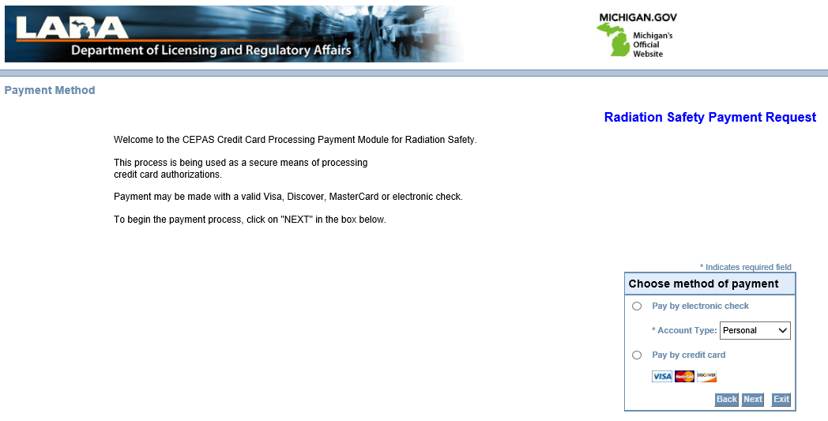

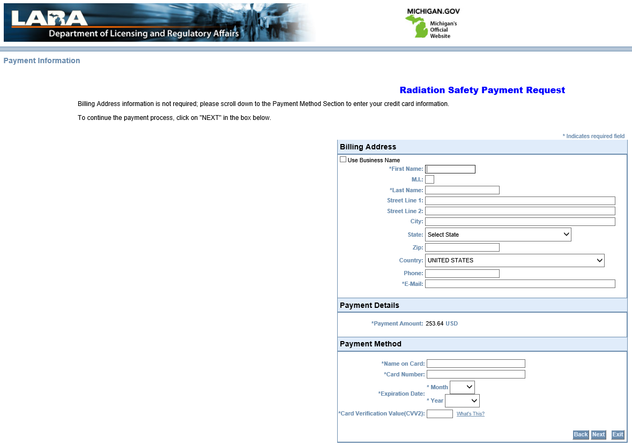

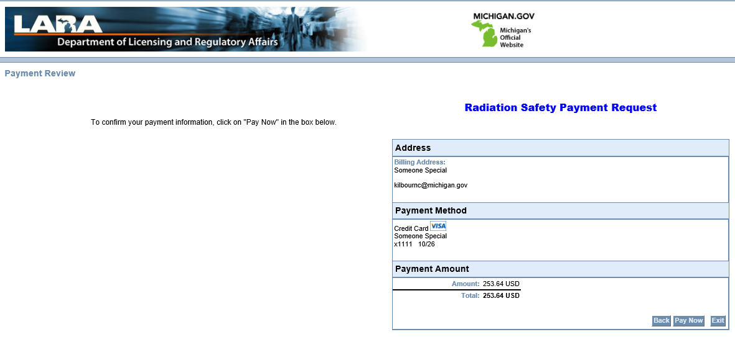

### Pay by Mail

Also, on the Pay Fees page the other option for submitting payment is to “Pay by Mail”. Selecting this button will generate an invoice on the account available for download by the user so that payment can be mailed.

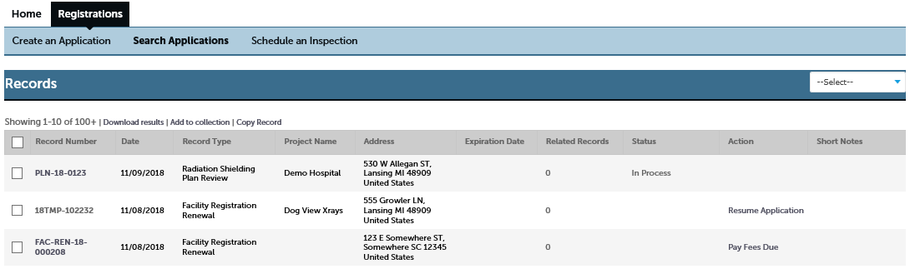

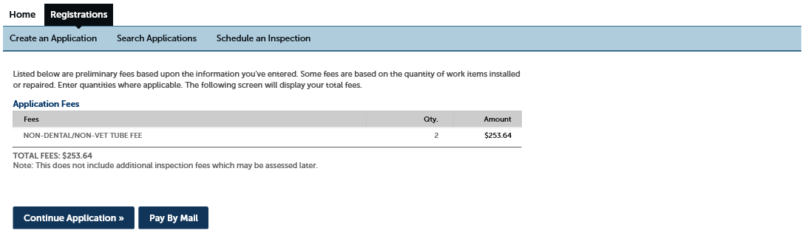

# Incident Reporting

A user can report an incident of radiation exposure excessive dose or medical event. To report an incident, selecting the Registrations tab on the home page and Create an Application. This will open the General Disclaimer and then finally the Record Type selection screen.

By selecting “Excessive Dose & Medical Event Report”, only one option will appear (with the same title). Select the option to proceed with the report.

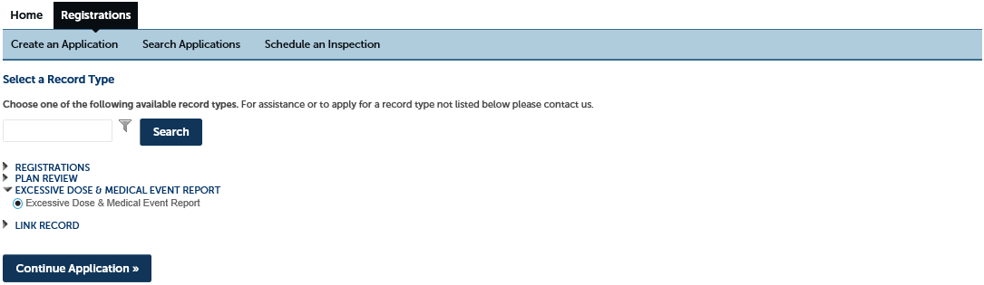

### Facility Information

The first section of the incident record requires that the user provide the facility registration number. Providing this registration information will populate the fields in the next screen.

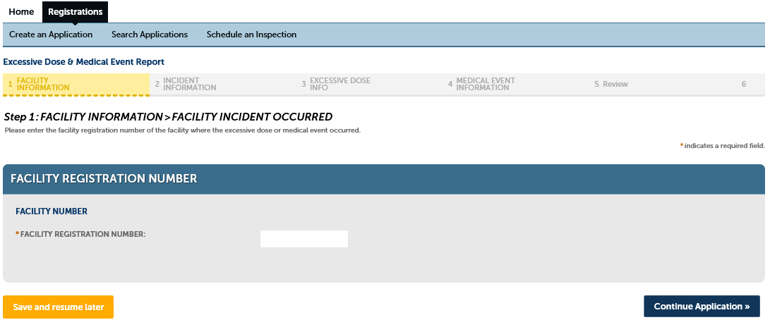

A second page will appear with the existing facility information for the user to confirm. This includes:

* Facility Information
* Facility Name & Contact Information
* Facility Address

This information should be current to the facility, so the user can proceed with the “Continue” button. Any discrepancies can be edited here, but an amendment may be required to update the facility registration. (*see Amendment section*)

### Incident Information

In step 2, the user will confirm the Attention Contact information and indicate the incident type, the date of report, the individual that prepared the facility report, and the individual submitting the incident. The contact information should be pre-filled from the registration information, but the Incident Information must be entered, and each field is required to proceed.

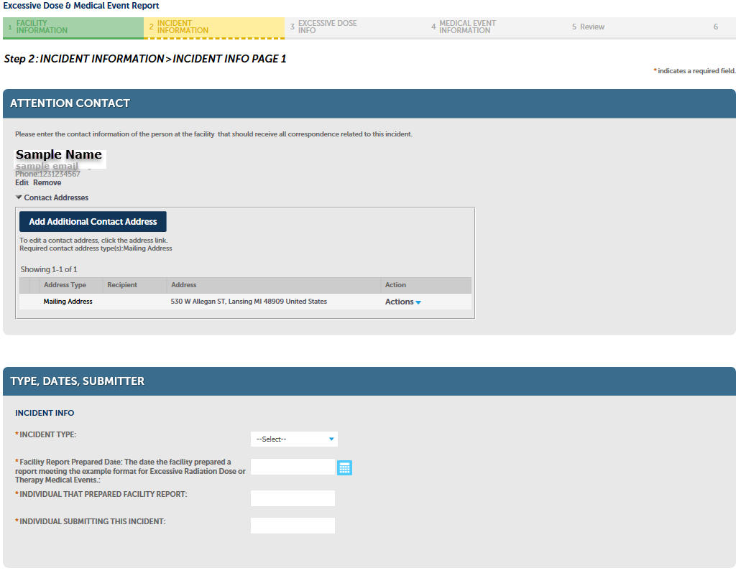

The Incident Type selection will determine what information is required for the report. There are two options available to select:

1. Excessive Dose
2. Medical Event

The next page of the incident information section has three areas for data entry:

1. Discovery and Source (required):
   1. Date of Discovery or Event Occurred
   2. Year Incident Occurred
   3. Quarter of Year Incident Occurred
   4. Radiation Source
2. Narratives (required): there are two narrative fields for entering details of the incident and preventive / corrective actions.
3. Attachments (optional): the attachments area allows the user to upload relevant documentation to the report.

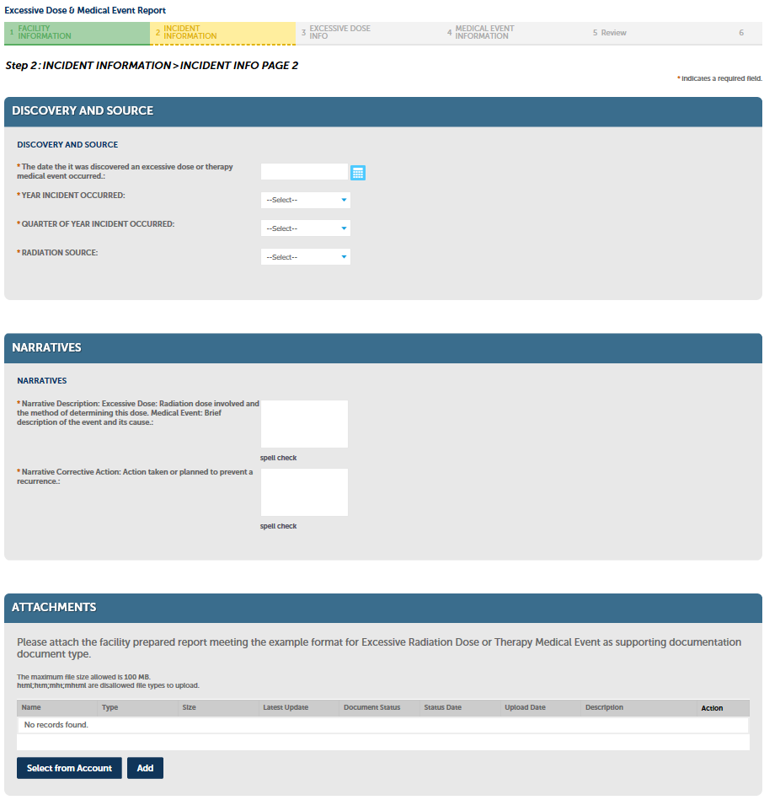

## Excessive Dose / Medical Event

Because the user can select either “Excessive Dose” or “Medical Event” in the incident type field, the required fields will differ based on the selection.

### Excessive Dose Information

If the user has selected Excessive Dose in the incident type field, the step 3 form: Excessive Dose Information presents various fields:

1. Cause and Description (required)
2. Estimate of Extent of Radiation Dose (optional)
3. Date of Birth (optional)
4. Occupation (required): Selectable list
5. Body Part Affected (optional)
6. Dosimeter Identification Data (required)
7. Dosimeter Type (required): Selectable list
8. Period of Exposure (required): Selectable list
9. Dose in MREM (required)
10. Description of Radiation Levels Involved (required)
11. Signature confirmation (required): yes/no
12. Reason for no signature on statement
    1. (narrative required if #11 is “yes”)

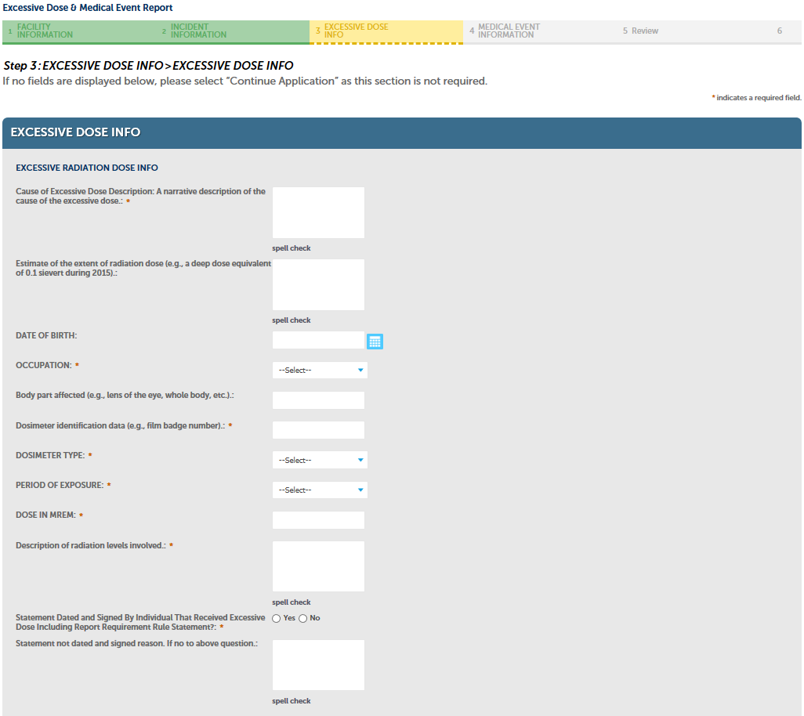When processing excessive dose information, the medical event details are not required for Step 4. The user will be notified to proceed.

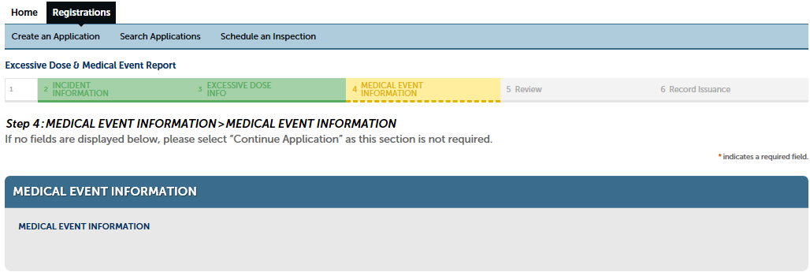

### Medical Event Information

If the user has selected Medical Event in the incident type field, the Step 3 form is not required, and the user can continue past it.

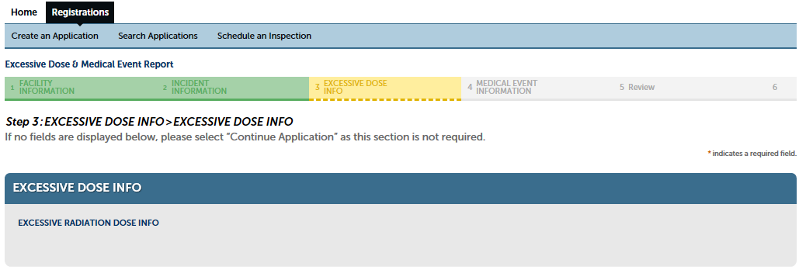

The Step 4 form: Medical Event Information presents various fields that must be filled out with details of the medical event:

1. Date of Occurrence (required)
2. State Issued Machine Tag Number of the Unit Involved (optional)
3. Name of Prescribing Physician (optional)
4. The effect, if any, on the individual(s) who received the administrated dose. (required)
5. Certification that the registrant notified the individual. (required): yes/no
   1. (narrative required if #5 is “no”)

### Review

Step 5: Review presents the user with a summary of the submitted data for the incident report for a final approval and submission.

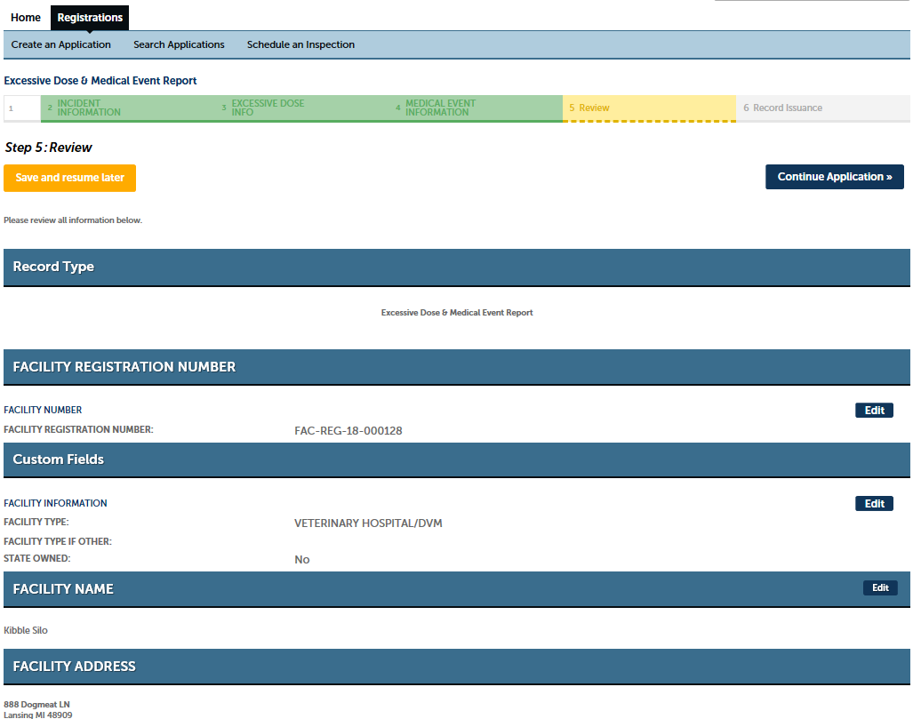

In the last section of this page, the checkbox must be selected to acknowledge and certify the statements provided before proceeding.

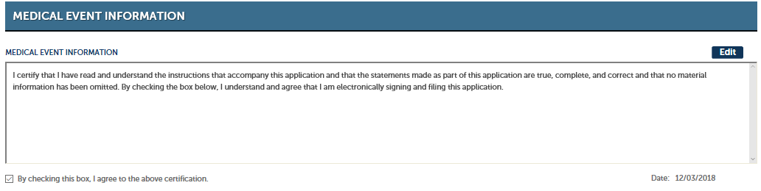

### Record Issuance

And finally, Step 6 is confirmation that the incident record was created to the user’s account. This screen will provide the record number for referencing / reviewing the data.

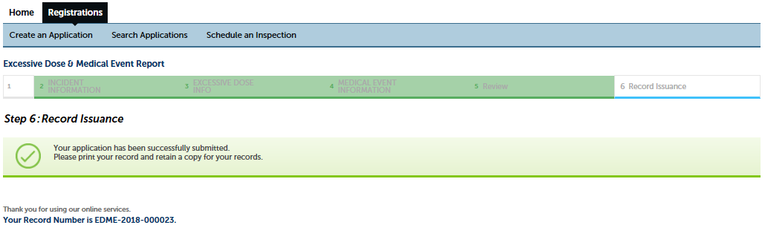

# Pin Linking

When various stages of the records processing are reached, notifications will be sent to the ACA user to indicate that a record has been created. The created record may have to be associated with the user’s account, so the notification will include the record number and a pin number. To associate the file so that it can be viewed from the user’s account, the following steps should be taken:

The user must login or register an account in ACA (see page 5 for creating a new account) and create a Pin Link record. Begin by selecting the “Registrations” tab from the home page and then clicking on the “Create an Application” link.



A list of options will be presented, with one indicating “Link Record”. Selecting this item will expand to allow the user to select “ACA PIN Link”. Select this option and click “Continue Application”.

### ACA PIN Link Information

Step 1: ACA PIN Link Information screen is used to enter the provided Record ID and PIN numbers that have been provided in the notification to the user. The information must be entered to match exactly, and the “Continue Application” link clicked to process the link.

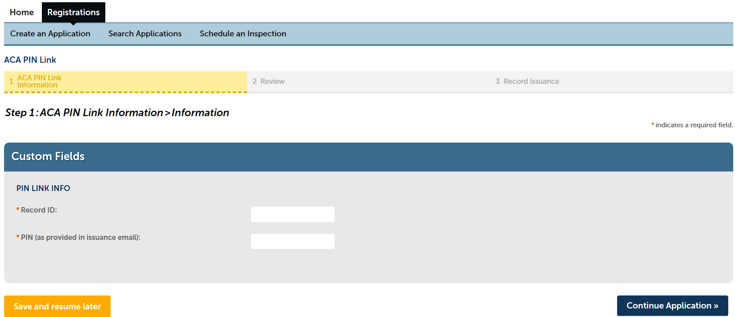

### 

### Review

Step 2: Review will display the record type as an ACA PIN Link with the record information provided displayed in the Custom Fields area.

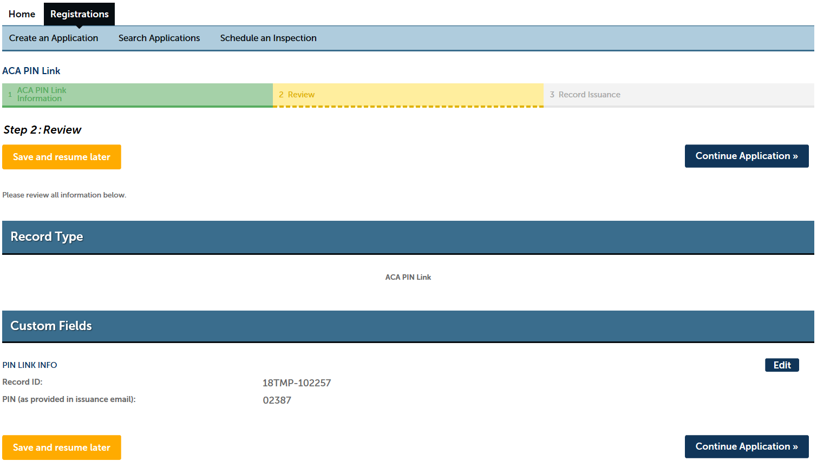

### Record Issuance

Step 3: Record Issuance displays a confirmation notification and provides the record number for the linked data.

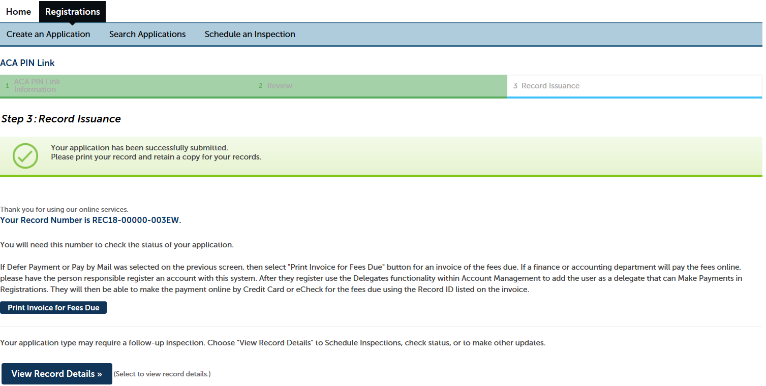

### Confirmation

The user can confirm that the PIN Link was successful by looking at the available records on their home screen under “My Records”.

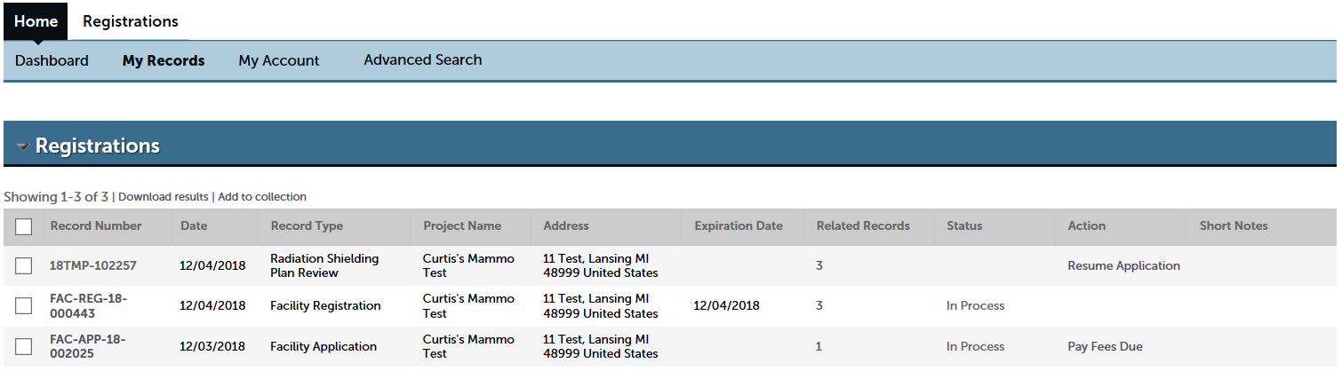

### Additional PIN Link Notes

PIN Link processing can also be used to share access to files. The record ID and PIN can be shared to allow other users to link the file to their own account, allowing them access to that record. When the information is shared, another user will follow this same linking procedure to view the file in “My Records”.