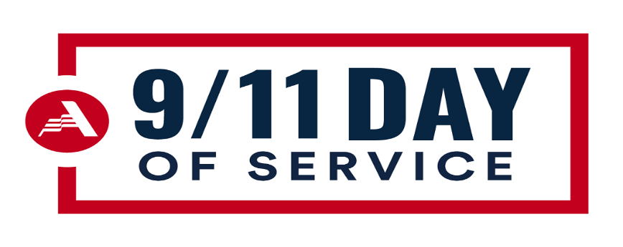
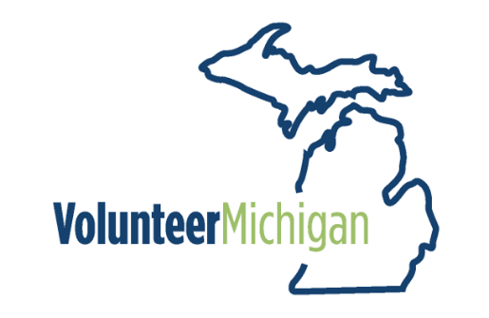
Sample 9/11 20th Anniversary Projects
Please feel free submit projects that respond to your community’s needs or organize a project around one of these ideas.
- Collaborate with the local food bank to host a food distribution event
- Collaborate with Office on Aging and/or Veteran’s Services to help seniors and veterans in your community with landscape clean up or if your group has the appropriate resources help with home improvement projects
- Contact your local fire station and ask if your group can make a homemade meal for the fire fighters. If your community has several stations, recruit others and try to cover every station in your areaf
- Contact the local fire or police station and ask if your group can do a landscape clean up.
- Organize a food collection event and donate for items to a food pantry
- Work with local city officials to do a trash clean up in local parks or tree planting.
- Host a school supply drive. Contact the local district and ask what items are needed.
- Host a weekend food backpack supply event for nonperishable, easy to make items for kids.
- Create quilts with an American Flag theme for veterans in hospice programs.
- Host a personal needs drive that includes socks/underwear and personal hygiene items for local shelters
- Organize an event to help local residents create their personal disaster plan. Offer some items and information from FEMA or in collaboration with local Emergency Managers
- Work with city and fire department to host a smoke detector give away event or help residents improve outdoor lighting and visibility with large, visible house numbers
- Collaborate with local nursing homes or veteran’s organizations and put together care kits for seniors. Consider items such as blankets, cross word books, prepackaged food items (ask first), socks, and create thank you cards with messages of appreciation.
- If vaccinated and allowed, arrange for a visit or host an activity at a facility such as a Hospice, a veteran’s home, or nursing home. This may include playing music, singing, visiting and playing cards or games with residents.
- Clean up 9/11 gardens in your community by weeding, spreading mulch and painting a new sign.
- Contact local health departments, hospitals, Urgent Care Centers and local physician offices and offer to do a landscape spruce up, deliver a homemade meal to staff, deliver thank you cards for caring for our community during the pandemic.
- Work with local Meals on Wheels programs to volunteer to deliver meals and/or make deserts for clients along with a gift and card of thinking of you.
- Work with local officials or churches and do a cemetery clean up.
- Work with Find A Grave and fill requests for virtual photos of graves to help families see their loved ones memorial site.
- Place flags at the cemetery site of veterans in your community.
- Host a blanket making event for those experiencing homelessness or those in foster care
- Work with organizations supporting children in foster care and create birthday packages that include toys, games, socks, underwear and personal needs items.
- Create feminine care packs for local schools to provide maxi pads and other items for schools to discreetly support young women.
- Contact local health care providers and ask if you can arrange a homemade meal for those who have been caring for COVID-19 Patients, doing testing or administering Vaccinations.
- Organize sock drive and personal care items for homeless. Arrange to give the items to local homeless shelters that care for veterans
- Create quilts for hospice programs that feature an American Flag theme for patients who are veterans.
- Host a drive for business-professional clothing for veterans and military families to access for job interviews. Work with a thrift store to offer the items.
- If your community has suffered from flooding in recent times, offer to host a thank you meal for those helping to clean out homes. You may also do a collection for items such as bottled water and nonperishable food items for response center set up to address flooding in SE Michigan
- If you have the resources to host a job fair for new veterans, recruit help to review resumes and assist with interview practice.
- Host a cleaning supply collection for residents recently impacted by flooding in SE Michigan.
- Sew children’s masks for students who cannot be vaccinated.
- Recruit the talent of others to create items of thanks for healthcare workers, fire fighters and veterans. Items can be as simple as cards made by children, keep sake items made by local artists, to recruiting items from local businesses such as a bakery or a restaurant to donate food items.
- Organize a virtual event to support animals being fostered for active military personnel or animal medical needs of veterans. Work with the local Humane Society to ask if they can support such a project.
- Organize a family emergency kit events and help families prepare a disaster plan
- Work with your local emergency managers to host a recruitment event for new volunteers for the Citizens Emergency Response Teams (CERT).
- Stock the refrigerator with drinks such as bottled water, soda, juice or ice tea for a fire station, police station, a healthcare center doing testing, vaccination or caring for COVID-19 patients. Include decorated placemats from local children, signs for the breakroom with appreciation messages that welcome people to help themselves.
- Organize a day of fun for children of active military in your area. Host an outdoor event with fun family friendly activities including a cookout, face-painting, games and give each family a small gift candy, a handmade keepsake and a note of appreciation.

