Running Head: MOTOR VEHICLE SAFETY

Motor Vehicle Safety Intervention for Ypsilanti High School Adolescents

University of Michigan (Student Project)

Executive Summary

**Plan** (Assessment, Diagnosis, Planning). A needs assessment of the 10th and 12th graders at Ypsilanti High School by the Regional Alliance for Healthy Schools (RAHS) showed the students self-reported wearing their seat belts 63% of the time, which is less than the national average of 75%. Observations by trained observers validated the low rate (75%) of use.

From this finding, RAHS decided there was a need to increase seat belt use in this population. The newly-formed Youth Advisory Council (YAC), a peer health education program, decided to select improving seat belt use as their first area of focus. The Plan-Do-Check-Act Model (Wilson, 2011) guided the development of an intervention to increase seat belt use in this student group.

The youth selected social marketing as their main intervention strategy. The social marketing tools developed included a social contract, buttons, and wrist bands with catchy marketing messages.

**Do** (Intervention). The members of YAC talked with their peers about the importance of wearing their seatbelts 100% of the time, and encouraging family members and friends to do the same. The students were encouraged to sign a large display board pledging they would wear their seat belt 100% of the time. Once they agreed to the pledge, they were given a wrist band and button to remind them of their commitment.

**Check (**Evaluation). A post-test was conducted to test the effectiveness of the intervention. The goal of 100% compliance of seat belt use was not met. The post test showed an increase of 14% for the use of seat belts from 74% during the pre-test to 88% during the post test.

**Act (**Recommendations). Due to the importance of seat belt use and the success of the program, YAC is planning to repeat the intervention at the beginning of the 2012 school year.

Motor Vehicle Safety Intervention for Ypsilanti High School Adolescents

Adolescents face many challenges as they grow into adults and begin to discover and learn who they are. Some of the challenges adolescents face includes peer pressure, obesity, drugs and alcohol, sexual behavior and barriers to accessing health care. According to the National Center for Health Statistics, motor vehicle crashes are the leading cause of death for people age 5 to 34 (CDC, 2011). The leading cause of death for the teenage population, unintentional injury, has been at a rate of 48% from 1999-2006. Among the 48%, motor vehicle accidents account for 73% of the deaths (CDC, 2011). In 2009, eight teens ages 16 to 19 died every day from motor vehicle injuries.

Ypsilanti, Michigan is located in Washtenaw County, in the southeastern quadrant of the state. The major industries in or near Ypsilanti Township include Eastern Michigan University, the Ford Rawsonville Plant, and the University of Michigan Health System and academic campus. The median age in the city of Ypsilanti is 23.6 years; 47% are male and 53% are female. The majority of the population is White (61.4%) or African American (31%).

Ypsilanti High School (YHS) and Ypsilanti New Tech High School are the only public high schools in this city of 19,435 persons (USDL, 2011). Inclusive of grades 9 through 12, 1099 students are enrolled. The majority of YHS students are racial minorities (81.9% non-Caucasian). YHS students range in age from 14 to 18 years.

The mission statement of Regional Alliance for Healthy Schools (RAHS) Youth Advisory Council (YAC) is to be advocates for the students of Ypsilanti High School and for the RAHS school-based health center by focusing on teen healthcare issues and policies. The goal follows the mission statement of is to improve the health and well-being of Ypsilanti high school students. The goal of YAC is to educate and improve the health of Ypsilanti high school students. This can be accomplished by developing a strong YAC program with peer health education (RAHS, 2012).

The main objective of YAC is to empower the students to educate the student body on health and safety. Other objectives include building a strong team within the YAC student members and developing protocols and materials which can be utilized by the 2012 to 2013 YAC group.

**Brief Assessment**

Last year, a health needs assessment of YHS was completed by the Regional Alliance for Healthy Schools (RAHS). RAHS is a non-profit voluntary agency funded through the [University of Michigan](http://www.umich.edu) and the [Michigan Departments of Education](http://www.michigan.gov/mde) and [Community Health](http://www.michigan.gov/mdch/). RAHS is a consortium of school-based health centers providing services to the Ann Arbor Public Schools, Ypsilanti Public Schools and the Willow Run Community Schools. The mission is to provide school-based health programs and clinical services that improve the well-being of students, their families, and communities.

Ypsilanti high school is developing a Youth Advisory Council (YAC). The YAC is a group of YHS students who will serve as positive role models for their peers, providing peer to peer guidance and support in health-related topics. The participation goal of YAC is to recruit two representatives from each grade. The students are selected through an application process. All interested students are invited to complete an application and submit it to the RAHS health clinic. At that time the YAC adult leaders which include paid and volunteer school staff, will review the applications and select qualified youth leaders. YAC members will meet at least once every other month for three-hour formal training sessions by the adult leaders. The students will be excused from class by their teachers and must have a permission slip signed by their parent in order to participate.

**Critical Review of the Literature**

Nationally, seat belt use among the population has been steady around 85%. In 2011, seat belt use was estimated at 84 percent with a 1% decrease from 85% in 2010 (United States Department of Transportation, 2012). According to the CDC (2011), the risk of motor vehicle crashes is highest among 16- to 19 year olds with 8 teens dying every day nationally from motor vehicle injuries (CDC, 2011). The National Highway Traffic Safety Administration (NHTSA) reported in 2006 that among passenger vehicle occupants over age 4 years, seat belts saved an estimated 15,383 lives in 2006 (NHTSA, 2011).

Healthy People 2020 included safety and seatbelt use as goals. One of the specific goals is to reduce motor vehicle crash-related deaths. The second goal which relates to the identified intervention being discussed in this paper is to increase the use of safety belts. Healthy People 2020’s goal of increasing seatbelt use is a 10% improvement moving the national average of 84% to a target of 92.4% (U.S. Department of Health and Human Services, 2012).

Research has found when seat belts are used they reduce the risk of fatal injury to the front seat passenger by 45 percent and the risk of moderate to critical injury by 50 percent (NHTSA, 2011).

Peer-led health education has been widely used in many schools and many different topics. Critics of this method suggest that it can be an effective way to educate teens as long as the information if delivered in an accurate and sound method. Another article by Shiner emphasized that peer education provides an alternative approach to standard education with a teacher and students. Peer education is characterized by a placing a focus on learning that is both interactive and participative (Shiner, 1999). A study comparing peer-led and adult-led school health education found that peer leaders were at least as, or more, effective than adults (Mellanby, Rees, & Tripp, 2000).

Implementing an effective intervention is essential when being evaluated. In order to be effective, one must prioritize the possible interventions and assess the needs of the population they are working with. Evidence-based interventions allow you to have a better chance that your intervention will work because it has been shown to be successful in the past. An effective intervention is a key process in order to change the behaviors of the community (Community Tool Box, 2012). It can lead to the possibility of more funding in the future.

According to the Community Tool Box (2012), by having a process in place to implement effective interventions the community may be able to try a combination of interventions, respond to the ecological community needs, avoid common pitfalls and challenges, and tailor interventions at specific at-risk populations. When implementing any intervention it is essential to understand where the population is developmentally. According to a study conducted on adolescents’ intention to use seatbelts, the importance of understanding the beliefs and attitudes about seat belt use with this population was crucial (Thuen & Rise, 1994). The study showed there were major differences between high and low seat belt users. High seat belt users were more likely to believe in the positive outcomes of wearing a seat belt and also viewed the outcomes as more valuable (Thuen & Rise, 1994). Adolescents who were low users were less likely to believe the negative outcomes of not wearing a seat belt and viewed the outcomes as less valuable (Thuen & Rise, 1994).

The study also explained with an adolescent population for seat belt use, it may be more appropriate to influence the adolescent’s behavior and beliefs than try to directly motivate them to comply (Thuen & Rise, 1994). Parents can have a strong influence up until the age of 13-14 years old and tends to decrease as the adolescent grows older (Thuen & Rise, 1994). Adolescents can be heavily influenced by their peers. Peer health education is the goal of the YAC and therefore given the age of the population can be heavily impacted. For the intervention, adolescents will be educating and encouraging other adolescents to wear their seat belt**.**

**Planning Model**

The Plan-Do-Check-Act Model (PDCA) by Wilson (2011) has been selected to guide the development of the intervention. The model is commonly used for continuous quality improvement. The PDCA is a four-step model for implementing and carrying out change (ASQ, 2011). It is used when developing or improving the design of a process, product or service (ASQ, 2011). The model works as a cycle so in order to continually improve the quality of a program. The steps are repeated until program leaders are comfortable with the product.

The main rationale for choosing this model is it can be used by any discipline or area and is easy to understand compared to more complex models which exist. The model can be transferred over to the next topic YAC focuses. During the YAC meetings, we use the model repeatedly when helping the children to think about what they want to do and how they are going to get it done. We help them to critically think about what needs to be in place and in order to have a successful intervention.

**PDCA Step 1: Planning**

The “P” or planning phase of the PDCA model is the most critical phase in making improvements. Before you can develop an intervention, it is crucial that you are able to identify what the problem is and what the needs are of the community you are working with. The problem needs to be studied and brainstormed about finding ways to improve the current practice of your community.

**Problem Identification**

The needs assessment completed last year by RAHS collected data regarding student health from 10th and 12th graders, school staff, and parents. The results from all three groups were very similar. The survey results displayed a perceived need for counseling and education in both safety education which included wearing seatbelts, drinking and driving and carrying weapons. Of the school staff surveyed, 89% stated they felt the adolescents of Ypsilanti high school were in need of safety education. The needs assessment was also completed with the parents, with 72% of the parents either “agreeing” or ‘strongly agreeing” that their teen needed education in safety. The Youth Risk Behavior Survey results showed that the proportion of Ypsilanti High School adolescents wearing their seat belt all of the time is 63% compared to the national average of 85%. The adolescents were also asked, “In the past 12 months have you driven a car drunk or high or ridden in a car with a driver who was drunk or high?” Over a fourth of the adolescents, 31%, who completed the survey, reported they were involved in this risky activity within the last 12 months.

YAC student members expressed a concern that many of their friends and peers did not always “buckle up” in the car. The student members selected this area as a topic for focus for the 2011-12 academic year because they felt education needed to be provided to the student body on why seat belt use is crucial to their safety and well-being. The need was validated by the 2010 needs assessment completed at Ypsilanti high school by students, parents and school staff.

Following up on the attitude survey of school staff, parents, and students conducted during the 2010-’11 academic year, the needs assessment surveyed the students about their habits of seatbelt use. An adult member of the council conducted school-based observations of student seat belt use on selected school days in the school driveways and parking areas. The students did not participate in the observations due to potential safety concerns. However, there would have been potential benefits for the student members to participate to learn the process and take ownership of their intervention.

The needs assessment was conducted on February 17, 2012 at Ypsilanti High School. The student population was observed for seat belt use when arriving at school. Only students who were dropped off by a parent were observed. The observation was limited by the number of children who take the bus to school who were not eligible for inclusion in the assessment. A total of 91 (10%) of the 1000 Ypsilanti High School students riding in personal vehicles were observed for seat belt use. Of the 91 students, 68 (75%) were wearing a seat belt when they arrived at school; 23 (25%) were not buckled up.

According to the observation, only approximately 74% of adolescents at Ypsilanti High School wear their seat belt. This average was higher than the reported seat belt use of 63% from the Youth Risk Behavior Survey completed in 2010. However, this rate is lower than the national average of 85%. A population-focused nursing diagnosis was generated based on the results of the needs assessment, above. This diagnosis is, risk of motor vehicle crash and related injury among Washtenaw County adolescents related to low seat belt use when driving or when riding as a passenger.

**Needs Identification**

The low rate of seat belt use among YHS students and associated risk of personal injury reveals a need for behavioral change, specifically improved seat belt use, among members of this high-risk group. A motor vehicle safety program would be appropriate for the mission and scope of RAHS and the Youth Advisory Council (YAC) and the results of the recent needs assessment.

**Goals and Objectives**

The first goal is for 100% of YHS student population to use seat belts 100% of the time by April 2012. YAC student members will work towards improving the knowledge and awareness of motor vehicle safety among the teens of Ypsilanti high school.

The purpose of this project is to obtain 100% use of seat belts through the use of social marketing. Social marketing will be used to educate the adolescents of Ypsilanti high school on the importance of seat belt use through the use of peer health education. The intervention will be successful if the results of seat belt use improve to 90% in the post-test. The results will be measured by a post-test of observing the number of students who arrive to school wearing their seat belt. Once the intervention has been completed, if the goal has not been met, more education will be required including a second post-test. Seat belt use is the first topic of the motor vehicle safety program. After the seat belt use intervention has been completed, the students may pursue other topics, including drinking and driving, texting, and driving safety. If the seat belt use intervention is not successful the first time, it could be incorporated in each of the other motor vehicle safety topics. A timeline for completion of key project activities is included in Appendix A.

The second goal is to improve the health of Ypsilanti high school students by developing a stronger YAC program. YAC student members will function as a cohesive team by May 31, 2012. All members will contribute to solving the problem, respect each other as they are speaking by not interrupting and will communicate outside of the YAC meetings.

**Planning the Intervention**

The intervention chosen by YAC for improving seat belt use was social marketing. According to Andreason (1994): “Social marketing is the application of commercial marketing technologies to the analysis, planning, execution, and evaluation of programs designed to influence the voluntary behavior of target audiences in order to improve their personal welfare and that of their society” (Storey, Saffitz & Rimon, 2008, p.436). Social marketing has been widely used by the Centers for Disease Control (CDC), the U.S. Department of Agriculture (USDA), the U.S. Department of Health and Human Services (USDHHS), other governmental organization and nonprofit organizations (Grier & Bryant, 2005). Social marketing is often times used for lower economic status, more diverse populations, those in need of social services and harder to reach individuals (Storey, Saffitz, Rimon, 2008). Advantages for social marketing include being able to target the population more directly, high return on investment, does not require a high level of technical skill, and increased visibility which allows the information to be spread quickly and gain popularity (Social Marketing Journal, 2012). All of the above advantages work well for the Ypsilanti high school population.

The YAC student members with the help of adult leadership chose social marketing as the intervention. Some of the reasons for this intervention included limited funding resources, small time frame to develop and implement the intervention and RAHS staff thought this would be a avenue to promote the clinic. The social marketing items chosen were wrist bands and buttons. Both items have the RAHS clinic branded on them. The examples of the social marketing approaches used to increase seat belt use at Ypsilanti high school are displayed in Appendices C, D, E, F and G. These approaches were developed by the YAC student members with the assistance of the adult leadership.

The adult leadership included Elizabeth Loomis, Janice Mitcham and Amanda O’Reilly. Elizabeth Loomis is a Family Nurse Practitioner and oversees the RAHS clinic in her role as the Nurse Supervisor. Elizabeth also works in the clinic during school hours treating adolescents for illnesses. Janice Mitcham is the Clinical Social Worker for the RAHS clinic. Janice has worked with other YAC groups in the past at other schools. The adult leadership aimed to oversee the adolescents and help guide their decision making. However, most of the decisions were left up to the student YAC members including the types of social marketing they wanted to develop to increase seat belt use. The adult leadership routinely met with the YAC student members on a moderately regular timeline. At the beginning of the school year, the group met only once a month. The frequency increased as time went on because the group was having a hard time staying focused and achieving their goals. Since the beginning of the year the group has been meeting every other week, during lunch, in the information office at the school with the guidance of the adult leadership. The role of the adult leadership throughout the process has been to keep the student members focused and guide them through the decision making process.

The intervention chosen to determine a strong YAC program will be team building activities. At the beginning of each meeting, time is allotted for a team ice breaker. The ice breaker encourages students to talk with each other and build relationships within the YAC meetings which can be carried over outside of the YAC meetings. This year limited students applied to be a YAC student member. By creating a close working team, next year YAC will be able to be more effective and implement more activities with the student body earlier in the year. YAC student member cohesiveness is essential in order to continue to meet the mission and vision of YAC which is summarized by student members who communicate, educate and make decisions to problem solve with lawmakers, community people and the school (RAHS, 2012).

**PDCA Step 2: Do**

The next phase of the PDCA model is “Do.” During this phase, the intervention is implemented in the community.

The proposed seat belt use intervention was implemented over a two-day period (March 20 to March 21, 2012) during the lunch period in the school cafeteria. The dosage of the intervention the students received was two days expanding over all 3 lunch periods to target all students. The strength of the intervention consisted of multiple activities to meet the goal including, peer health education and social marketing. The two-part intervention consisted of educational and teambuilding activities, as outlined, below, delivered by at least two students and one adult member of the YAC group.

* YAC members created and presented an informational display consisting of a table and posters and addressed the importance of seat belt use.
* YAC members engaged their peers in discussion of relevant facts related to seat belt use during the information day in the cafeteria, using televisions to educate their classmates and encouraging students to sign a seat belt contract.
* YAC members invited their peers to sign a seat belt use contract (Appendix D). Students signed the contract were awarded a specially designed button and wrist band (Appendix C).
* YAC members will continue to work together on team building activities at the beginning of each YAC meeting. The students will also be traveling to Lansing together for the day to see the Capitol and meet with legislators. The second intervention, building a stronger YAC program, is an ongoing intervention and will continue throughout the end of the school year.

**PDCA Step 3: Check**

“Check” is the third step in the PDCA model. During this phase, the interventionist evaluates if the intervention had the intended effect, and if there were any unintended consequences.

*Goal #1. 100% of the YHS student population will use seat belts on observation by April 2012.* The goal included an increase of 26%, moving from 74% to 100%. During the “check” step of the model, the effectiveness of the social marketing intervention to improve seat belt use was tested. A post-test was completed two days after the intervention was performed. The post-test was performed using the same protocol as the pre-test, that is, observing the number of adolescents who were wearing their seat belt when they arrived at school. Comparison of pre- and post-test results showed an improvement in seat belt use to of 14%, from 74% to 88%. The post-test showed results higher than the national average of 85%. Based on YAC’s goal of 100% compliance at the end of the intervention, results of the post-test showed the intervention was partially successful.

*Goal #2. Improve the health of Ypsilanti high school students by developing a stronger YAC program.* The second intervention of group cohesiveness will also be evaluated during this phase. This evaluation will not take place until the end of the school year because the group has not finished their work. For the evaluation, a survey will be distributed to the YAC student members asking them questions regarding group cohesiveness (see Appendix H). If each YAC member answers each question on the survey as “agree or strongly agree”, then the intervention was successful. If the group members give lower ratings, then we would need to get feedback about why they think the group feels like they are not working as a cohesive team. Obtaining feedback from the members would be very helpful when working with the YAC group during the next school year.

**PDCA Step 4: Act**

The last step of the PDCA model is “Act.” During this phase, the interventionist can reflect on the results and determine the next steps of the project. Quality improvement can take place during this phase by going back to alter the process and make changes where appropriate.

*Goal #1. The evaluation showed that the seat belt use intervention was partially successful*.*.* The goal of 100% compliance was not met with the seat belt intervention. As a result, YAC has potential plans to implement the intervention again at the beginning of the 2012-13 school year using the social marketing tools created during 2011-12. Prior to implementing the intervention during the 2012-13 school year, YAC should evaluate the methods used for the seat belt intervention and decide whether to continue with the same intervention, increase the dose and frequency of the intervention, or try something different. With the knowledge that has been gained through the process, increasing the dose of the intervention along with providing handouts educating the students may help to increase the results of the post-test. A packet has been created for the 2012-2013 YAC group to assist in re-assessment of the tools which were used and how to focus their efforts to re-educate their peers next year.

*Goal #2. An evaluation of the YAC program was not completed.* Although the results of the evaluation of this goal are pending, some implications of evaluation outcomes are suggested here. The evaluation will take place at the end of the school year using a survey to test for group cohesiveness. If the intervention of group cohesiveness is not successful, then investigating and interviewing of YAC members will be need to take place in order to learn more about how to improve the intervention. It will be crucial to find out why the intervention did not have favorable results in order to prevent a failure again. The results may need to be broken down into sub groups which could be done according to the grade of the student.

**Conclusions**

A needs assessment of a public high school revealed low seat belt use and high risk for injury due to vehicle crashes among members of this population. A population-focused intervention guided by the Plan-Do-Check-Act model and focusing on increasing seat belt use was designed. The school-based peer health education model combined with social marketing were novel features of the intervention. The effectiveness of the seatbelt use intervention was reviewed using evaluation strategies designed for this intervention and population. The goal of 100% seatbelt use compliance was not achieved however, there was a 14% improvement. Increasing the dose of the intervention and completing a more extensive literature review would be helpful in learning how to reach the minority, adolescent population of Ypsilanti High School.

In conclusion, things I have learned with this project are to start with clear expectations and goals. It is important to begin any project with a timeline and keep it updated. This provides a tool to work off to make sure you are staying on track and working towards your goal. When developing any project it is important to stay realistic in estimating the amount of time it takes to accomplish each task. By allowing extra time helps the researcher to be less frustrated and less disappointed. Through the process it is important to keep the lines of communication open with the agency you are working with to make sure each group is meeting their expectations and are working together towards the same goals. Lastly, it is important to remember that each project is a learning experience and continues to help you grow as a professional.

References

American Society for Quality (ASQ). *Project Planning and Implementing Tools.* Retrieved December 30, 2011 from <http://asq.org/learn-about-quality/project-planning-tools/overview/pdca-cycle.html>

Grier, S. & Bryant, C.A. (2005). Social marketing in public health. *Annual Review of Public Health, 26,* 319-339.

Mellanby, A. R., Rees, J. B. & Tripp, J. H. (2000). Peer-led and adult-led school health education: a critical review of available comparative research. *Health Education Research, 15 (5),* 533-545.

National Center for Chronic Disease Prevention and Health Promotion (CDC). *Injury Prevention & Control.* Retrieved January 16, 2012 from <http://www.cdc.gov/motorvehiclesafety/teen_drivers/teendrivers_factsheet.html>

National Center for Chronic Disease Prevention and Health Promotion (CDC). *NCHS Data Brief.* Retrieved January 16, 2012 from <http://www.cdc.gov/nchs/data/databriefs/db37.htm>

National Highway Traffic Safety Administration (NHTSA). *Traffic Safety Facts*. Retrieved January 13, 2012 from <http://www-nrd.nhtsa.dot.gov/Pubs/810807.PDF>

Regional Alliance for Healthy Schools (RAHS). *Youth Advisory Councils*. Retrieved February 18, 2012 from <http://www.a2schools.org/rahs/youth_advisory_councils>

Social Marketing Journal. Five Benefits of Social Marketing. Retrieved March 3, 2012 from <http://socialmarketingjournal.com/2008/06/08/benefits-social-marketing/>

Storey, J. D., Saffitz, G.B. & Rimon, J.G. (2008). Social Marketing. In K. Glanz, B.K. Rimer & K. Viswanath (Eds.), *Health behavior and health education; theory, research, and practice* (pp.435-464). San Francisco, CA: Jossey-Bass.

The Community Tool Box. *Overview and Evidence Base- Implementing Effective Interventions*. Retrieved January 26, 2012 from <http://ctb.ku.edu/en/promisingapproach/tools_bp_sub_section_68.aspx>

Thuen, F. & Rise, J. (1994). Young adolescents’ intention to use seat belts: the role of attitudinal and normative beliefs. *Health Education Research, 9 (2),* 215-223.

U.S. Department of Health and Human Services.  *Healthy people 2010: Injury and Violence Prevention.* Retrieved April 15, 2012, from http://healthypeople.gov/2020/topicsobjectives2020/objectiveslist.aspx?topicId=24

Appendix A

Timeline

KEY

|  |  |
| --- | --- |
| Color |  |
| Green | Completed tasks |
| Grey | To allow the reader to view the table easier |

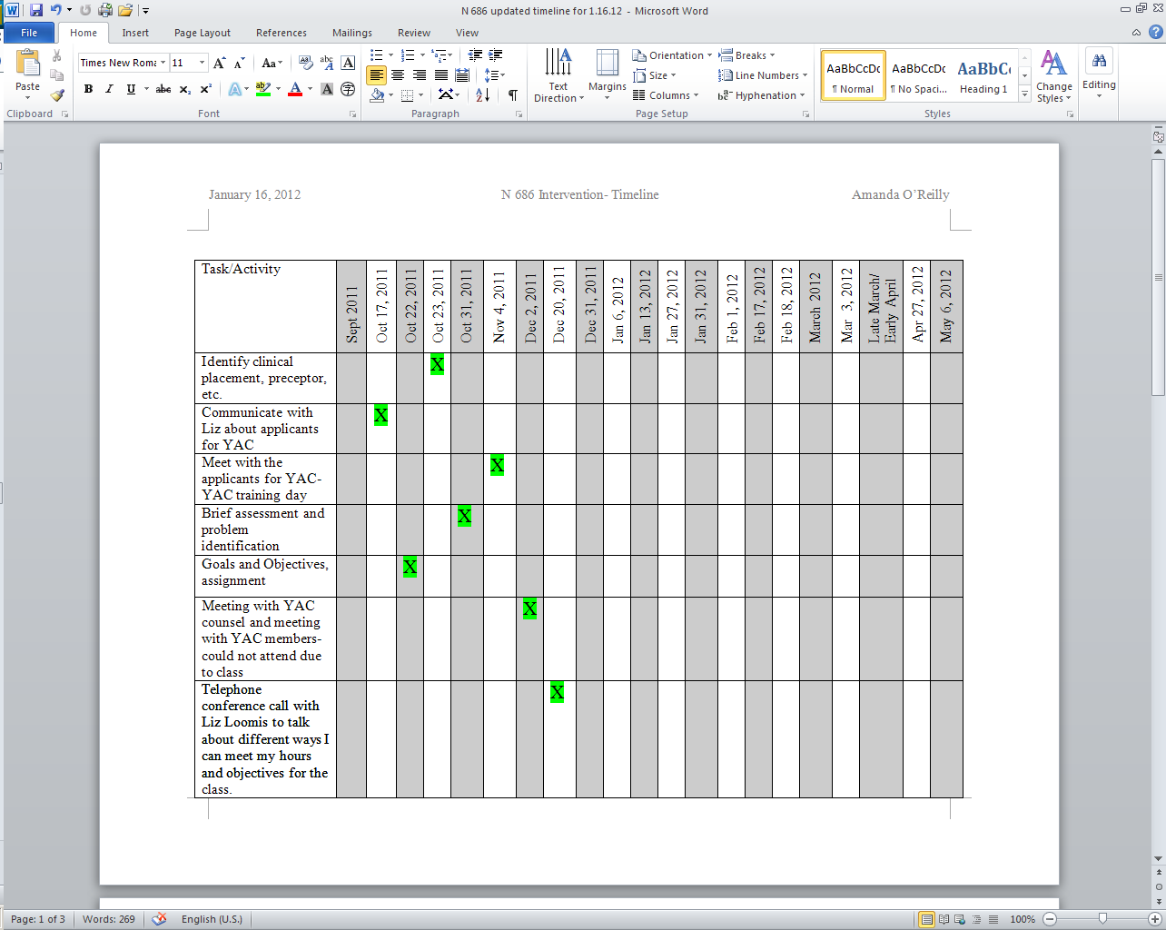

Timeline Continued:

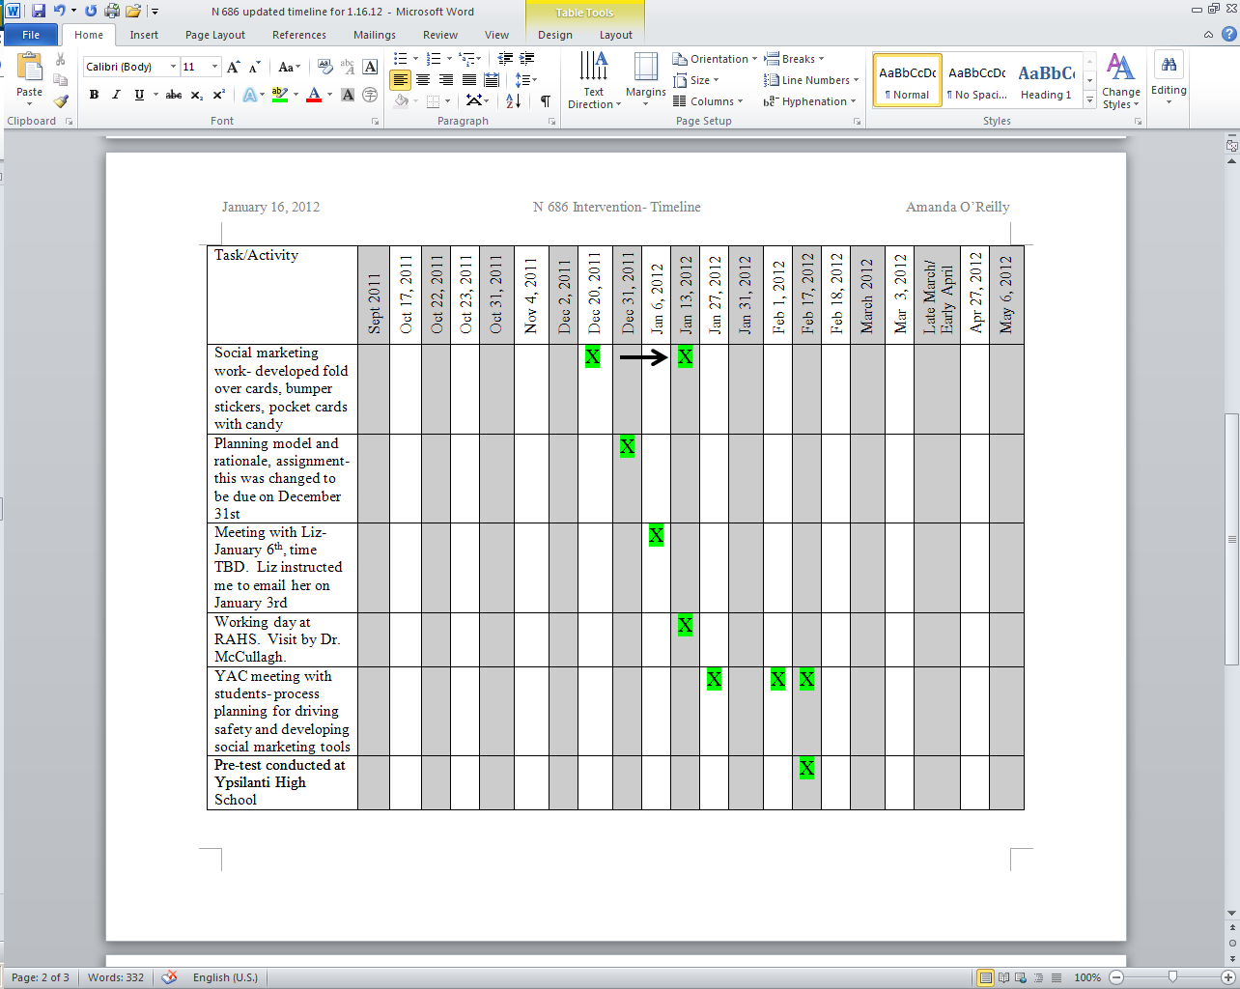

Timeline Continued:

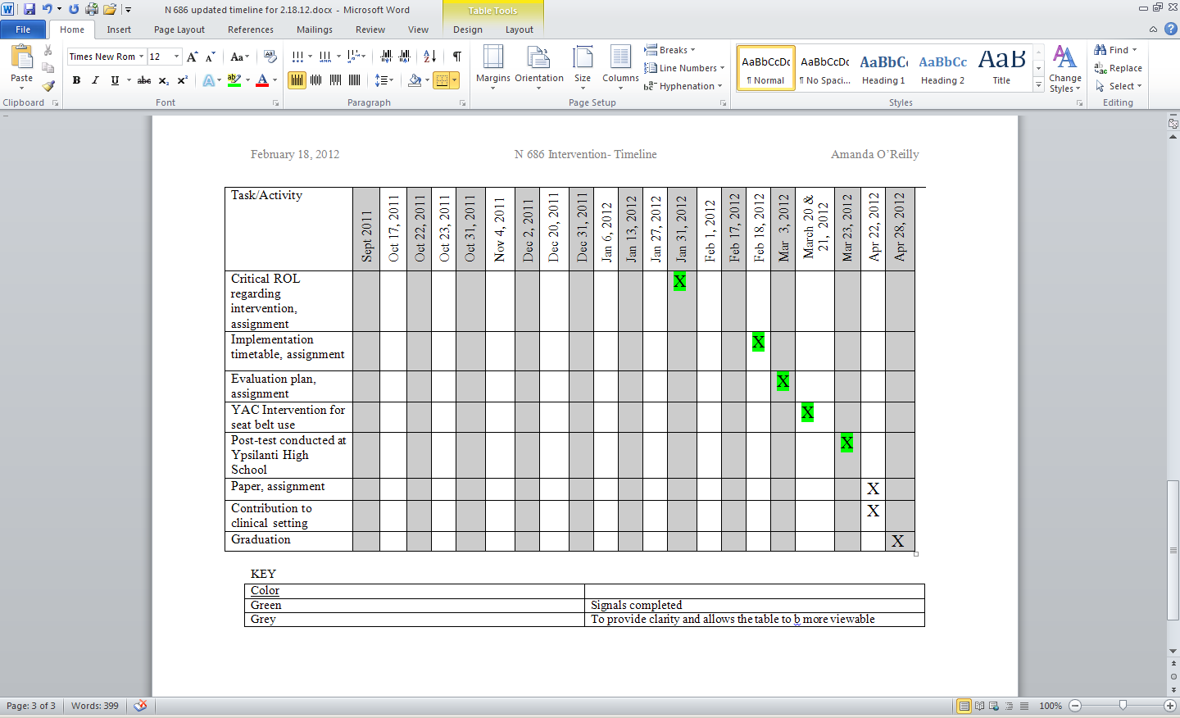

Appendix B

**Example Agenda from Youth Advisory Council Meeting**

[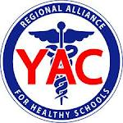](http://www.google.com/imgres?imgurl=http://www.a2schools.org/rahs/files/rahs_yac_logo.jpg&imgrefurl=http://www.a2schools.org/rahs/youth_advisory_councils&usg=__yyOJ-QqYAfLgn1uxqndRtFXYNk0=&h=1545&w=1545&sz=394&hl=en&start=3&zoom=1&tbnid=FPINRFLLk4jZ9M:&tbnh=150&tbnw=150&ei=LJUPT_XLBYb6ggeJhNmABA&prev=/search?q=RAHS+logo&um=1&hl=en&safe=active&sa=N&rlz=1T4SKPB_enUS338US338&tbm=isch&um=1&itbs=1)

**AGENDA**

**January 27, 2012**

|  |  |  |  |
| --- | --- | --- | --- |
| **Time** | **Agenda Item** | **Speaker(s)** | **Handouts?** |
| **11:00am** | Welcome/ Ice breaker | Amanda | No |
| 11:05 | Review the agenda | Amanda | Yes |
| 11:10 | School-based health center month activities | Lindsey |  |
| 11:20 | Discuss expectations of the members for the first project | Liz/Janice | No |
| 11:25 | Discuss calendar and timeline of events for the driving safety project | Janice/Liz/Amanda/ Group | Yes |
| 11:35 | Review task list sign-up sheet and explaining expectations for each item | Liz/Janice/Amanda | Yes |
| 11:55 | Next meeting | Liz/Janice | No |
| **12:00pm** | **Meeting Adjourned** |  |  |

**Next Meeting: February ____, 2012 Time: TBA**

Appendix C

[](http://www.google.com/imgres?imgurl=http://www.a2schools.org/rahs/files/rahs_yac_logo.jpg&imgrefurl=http://www.a2schools.org/rahs/youth_advisory_councils&usg=__yyOJ-QqYAfLgn1uxqndRtFXYNk0=&h=1545&w=1545&sz=394&hl=en&start=3&zoom=1&tbnid=FPINRFLLk4jZ9M:&tbnh=150&tbnw=150&ei=LJUPT_XLBYb6ggeJhNmABA&prev=/search?q=RAHS+logo&um=1&hl=en&safe=active&sa=N&rlz=1T4SKPB_enUS338US338&tbm=isch&um=1&itbs=1)

Button Template

Change “BUCKLE” on top to “SEAT BELTS”.

Change “UP!” on the bottom to “SAVE LIVES!”

[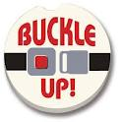](http://www.google.com/imgres?imgurl=http://delhi4cats.files.wordpress.com/2009/09/buckleup.jpg&imgrefurl=http://www.sodahead.com/living/do-you-always-wear-your-seat-belt-when-youre-in-a-car/question-980281/&usg=__gFCnrbLp5Ai7M55ycww3FXjWJcA=&h=399&w=400&sz=23&hl=en&start=540&zoom=1&tbnid=T0yvFds21Ynv5M:&tbnh=124&tbnw=124&ei=MGw-T83tO4j4ggea2MjGCA&prev=/search?q=Seat+Belt&start=525&hl=en&safe=active&sa=N&gbv=2&tbm=isch&itbs=1)

Wrist Band Template

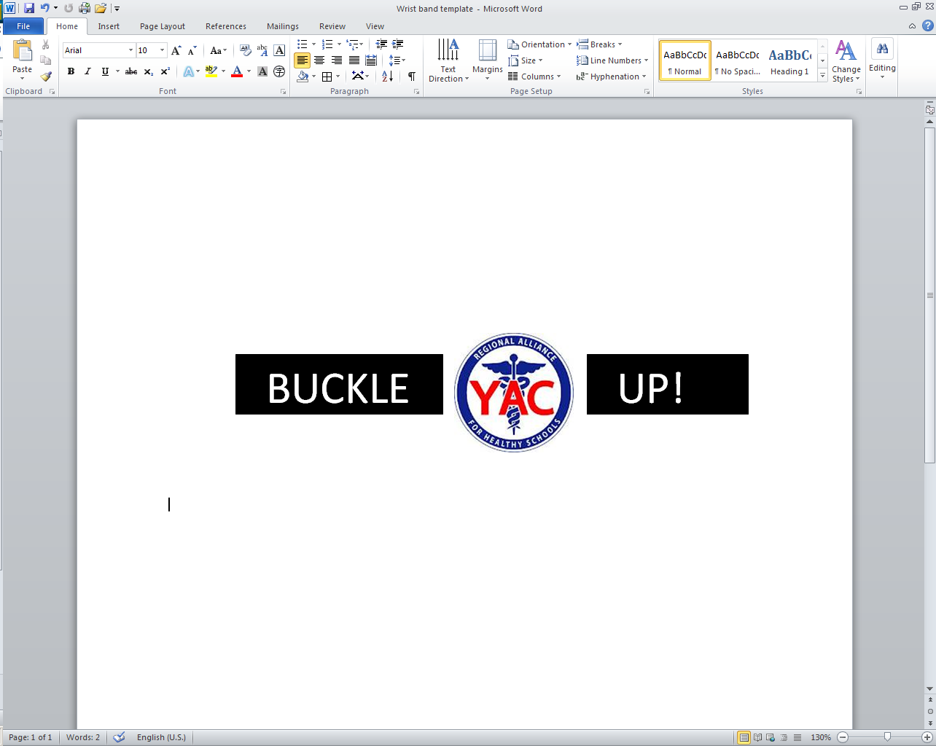

Appendix D

[](http://www.google.com/imgres?imgurl=http://www.a2schools.org/rahs/files/rahs_yac_logo.jpg&imgrefurl=http://www.a2schools.org/rahs/youth_advisory_councils&usg=__yyOJ-QqYAfLgn1uxqndRtFXYNk0=&h=1545&w=1545&sz=394&hl=en&start=3&zoom=1&tbnid=FPINRFLLk4jZ9M:&tbnh=150&tbnw=150&ei=LJUPT_XLBYb6ggeJhNmABA&prev=/search?q=RAHS+logo&um=1&hl=en&safe=active&sa=N&rlz=1T4SKPB_enUS338US338&tbm=isch&um=1&itbs=1)

STUDENT CONTRACT – SEAT BELT USE

*“OPERATION CLICK IT”*

****Using seat belts can reduce the risk of dying in a car crash by 45%. In rollover collisions, the vast majority of unbelted occupants are ejected from the vehicle, dying as a result of the vehicle rolling over them or as a result of sustaining fatal head injuries.

Please initial each line.

___ I agree to wear my seat belt at all times.

____ I agree that I will not start the care until all passengers are buckled up. NO exceptions.

____ I agree that I will not ride in a car as a passenger without buckling up.

____ I agree that I will not ride in a car where the drive and other passengers are not buckled up.

____ I agree that I will be a role model for other students by always wearing my seat belt and enforcing safety seat belt rules with my passengers on every ride.

_____ I agree to remind family and friends of the importance of wearing seat belts should they forget to buckle up.

I understand that these rules are for my safety. If I violate any of these rules, I endanger myself, my passengers and other drivers and I will break the Michigan law.

Name (PRINT) _________________________

Signature: ____________________________ Date: __ / __ / __ __ __ __

Appendix E

Bumper Sticker Examples

Think about the lives you’ll save, and your own!

Buckle up, you’re worth it.

[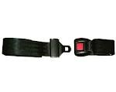](http://www.google.com/imgres?imgurl=http://www.fullcirclepadding.com/displaypages/Admin/Products/SubcategoryImages/FW155.jpg&imgrefurl=http://www.fullcirclepadding.com/index.cfm?event=SubCatDisplay&CategoryID=35&usg=__YQHFQbreiYHQIRcJ-a4zLGJQOac=&h=1205&w=1518&sz=142&hl=en&start=328&zoom=1&tbnid=WGUJduRxjm06DM:&tbnh=119&tbnw=150&ei=fZMPT_ObMs_lggf90rDBAw&prev=/search?q=seat+belts&start=315&hl=en&safe=active&sa=N&gbv=2&tbm=isch&itbs=1)

**A seatbelt a day, keeps the paramedic away**

[](http://www.google.com/imgres?imgurl=http://www.a2schools.org/rahs/files/rahs_yac_logo.jpg&imgrefurl=http://www.a2schools.org/rahs/youth_advisory_councils&usg=__yyOJ-QqYAfLgn1uxqndRtFXYNk0=&h=1545&w=1545&sz=394&hl=en&start=3&zoom=1&tbnid=FPINRFLLk4jZ9M:&tbnh=150&tbnw=150&ei=LJUPT_XLBYb6ggeJhNmABA&prev=/search?q=RAHS+logo&um=1&hl=en&safe=active&sa=N&rlz=1T4SKPB_enUS338US338&tbm=isch&um=1&itbs=1)****

Appendix F

Example of Card Handout

Front:

Think about the lives you’ll save, and your own! Don’t be a sucker, buckle up!!!! RAHS cares!

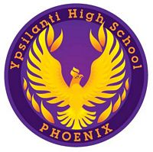  

Back:

[](http://www.google.com/imgres?imgurl=http://www.a2schools.org/rahs/files/rahs_yac_logo.jpg&imgrefurl=http://www.a2schools.org/rahs/youth_advisory_councils&usg=__yyOJ-QqYAfLgn1uxqndRtFXYNk0=&h=1545&w=1545&sz=394&hl=en&start=3&zoom=1&tbnid=FPINRFLLk4jZ9M:&tbnh=150&tbnw=150&ei=LJUPT_XLBYb6ggeJhNmABA&prev=/search?q=RAHS+logo&um=1&hl=en&safe=active&sa=N&rlz=1T4SKPB_enUS338US338&tbm=isch&um=1&itbs=1)

Appendix G

Example of fold over card

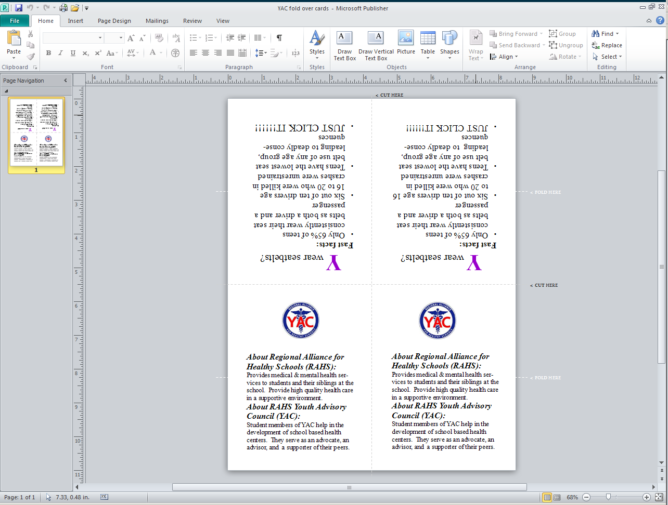

Appendix H

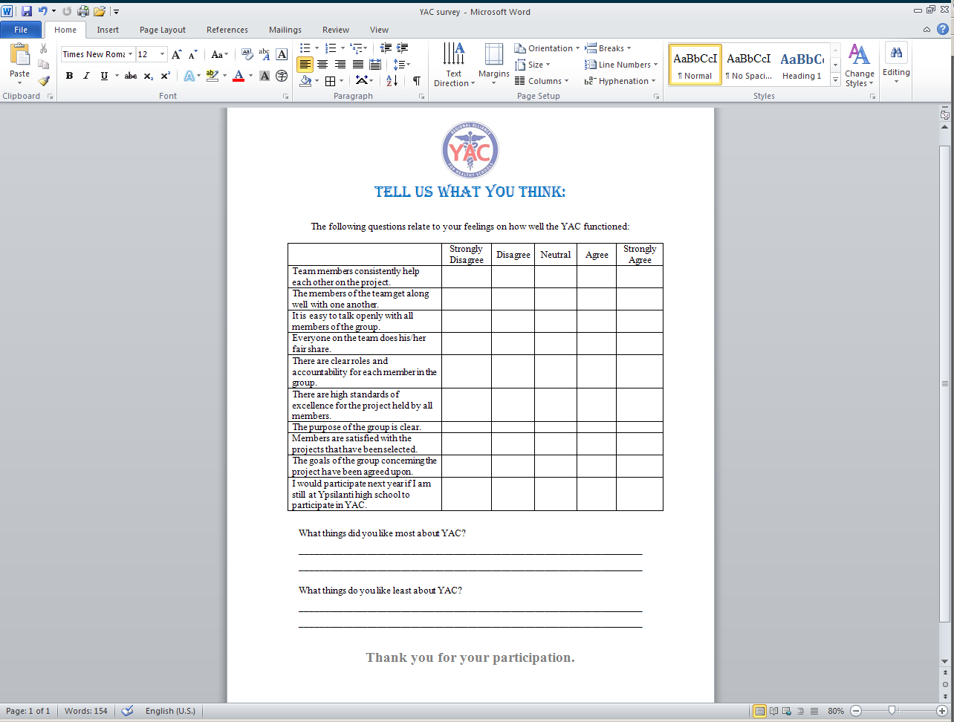YAC Student Member Survey