Minutes from EBP Measurement Workgroup April 10, 2012

Attendees: Nora Barkey, MDCH; Nasr Doss, Detroit-Wayne; Josh Hagedorn, Hope Network; Kathy Haines, MDCH.

On the Phone: Nikki Adkins, Lifeways; Maggie Beckman, network180; Phil Brouwer, Kalamazoo; Sandra Gettel, Access Alliance; Kyleen Gray, Venture; David Johnson, Wayne State; Julie McCulloch, Saginaw; Jon Nigrine, Genesee; Laura Vredeveld, The Standards Group; Jim Wargel, Macomb.

The members introduced themselves.

Kathy Haines let the group know that the minutes for the Measurement Work Group are posted to the MDCH web site below.

http://www.michigan.gov/mdch/0,1607,7-132-2941_4868_38495_38499---,00.html

Update on DD/MI Work Group

Nora Barkey gave an update on the April 5th meeting of the DD/MI Workgroup. During that meeting, Josh Hagadorn reviewed a report on service utilization by disability type (MI, DD, and MI/DD) for key services including residential treatment, behavior plan review, crisis, psychiatric hospitalization, supports coordination, and medication-related services. The graph below from the report compares the use of intensive services across the three disability types. Consumers with both diagnoses (MI/DD) are more likely to use intensive services than are consumers who only have a developmental disability.

Figure 1—Statewide % of Consumers Using Intensive Services by Disability Type
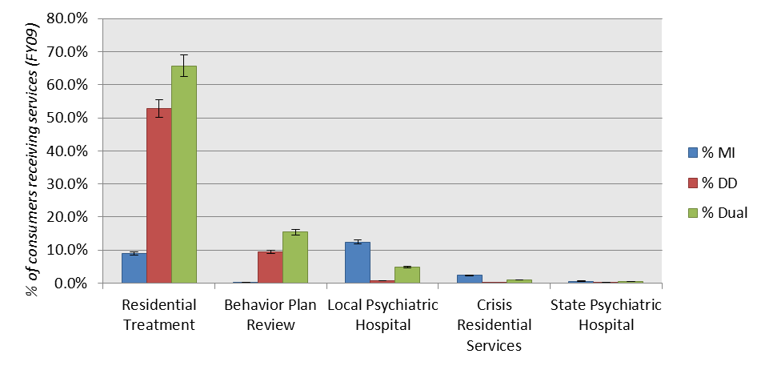
Source: MDCH Data Warehouse, FY2009

The graph below shows that consumers with both diagnoses (MI/DD) are also more likely to use certain outpatient and supports services than are consumers who only have a developmental disability.

Figure 2—Statewide % of Consumers Using Other Selected Services by Disability Type
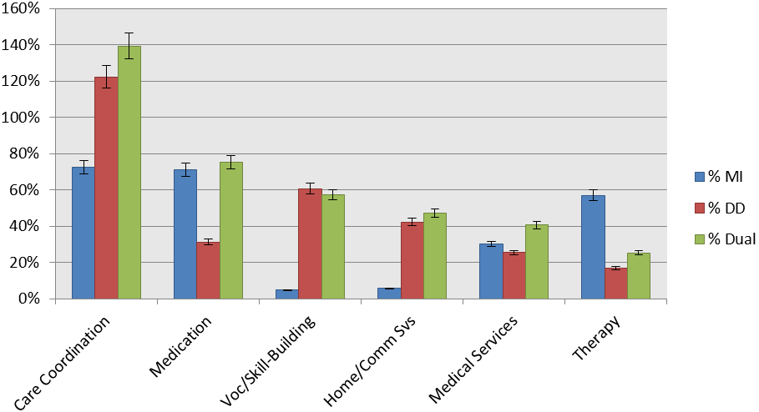Source: MDCH Data Warehouse, FY2009
Note: Each service type is comprised of multiple discrete services and the total percentages may be greater than 100%.

Leslie Mahlmeister had given an overview of her report on research relating to prevalence data for individuals with both a mental illness and a developmental disability. One key finding of the report is that dual diagnosis (MI/DD) may be more common among individuals with moderate ID than more severe ID. Given this, workgroup members discussed whether the prevalence of dual MI/DD might be higher among Medicaid beneficiaries who did not reach the severity level for CMHSP services. This is important as these individuals would come under CMHSP care as part of the dual-eligibles project.

The next MI/DD Work Group meeting will be June 14th.

Update on Work Group Reviewing Disability Designation from the QI and Encounter Diagnoses

At the March meeting the workgroup members asked to explore the feasibility of using service diagnoses as reported on the encounter data to determine a consumer’s disability designation. In the focused study on coordination of care, Health Services Advisory Group (HSAG) had used diagnosis codes to determine disability designation. Also, Judy Webb was considering adding diagnoses as required fields in the QI file in lieu of the disability designation fields. In response to the workgroup’s request, Kathy worked with several workgroup members to create a table showing the number of FY11 encounter lines containing given diagnosis codes like ‘bipolar/mood disorder’, and ‘schizophrenia/psychosis’. The key finding was that mental illness diagnoses were included on many of the encounters for consumers who had a disability designation of developmental disability only (DD only) and were not reported to have a mental illness. Some of the diagnoses included were bipolar disorder, mood disorder, schizophrenia, and other psychoses. To a lesser extent a few encounters for MI-only consumers contained diagnoses related to intellectual disability.

Group members noted that the disability designation field in the QI file is used for numerous purposes including determination of funding streams, screening, and service array. Maggie Beckman recalled that the state used to send lists of reported diagnoses to the CMHSPs for review and confirmation of accuracy. This process was complex as it became clear that there was not a direct correspondence between diagnoses and disability designation.

Several work group members stated that some diagnoses, like Asperger’s or attention deficit disorder can be categorized as MI or DD depending on the consumer’s needs and support system. Members also noted that not all consumers who have an encounter with an MR diagnosis should be categorized as DD or dual MI/DD. Since the mental health code defines ‘developmental disability’ in part by degree of functional limitation, consumer with mild MR along with a mental health diagnosis may be categorized as MI but not DD.

Work group members also noted that there are shortcomings with the Disability Designation information as reported in the QI data. Several noted concern that there is variation in the processes that PIHPs and CMHSPs use to assign disability designation. Agencies may make the determination at various time points, using various criteria. One committee member noted that the MI and DD fields in the QI should have more choices and more clarity like the SA disability designation, which the Measurement work group had reworked several years ago.

Several members noted that it would be useful to report diagnoses in the QI file, even if this could not be used in lieu of the Disability Designation field. These diagnoses would provide a much better clinically summary of the individual than would the diagnoses reported in the encounter records. It was noted that a lot of work would be needed to standardize how clinicians were to report this summary diagnosis information.

Post Note – Since the April Measurement Work Group meeting, the Administration has decided to postpone the reporting of diagnoses in the Quality Improvement file to a future contract year.

Development of Plan for Additional Analyses Relating to Coordination of Care

At the previous meeting the group had reviewed the Health Services Advisory Group’s (HSAG) final version of the focused study on coordination of care. The group discussed that it would be helpful to determine additional demographic characteristics of those consumers who are high utilizers of physical health emergency and inpatient services and determine their patterns of mental health service utilization. The work group also requested similar information for Medicaid beneficiaries not receiving PIHP services in order to compare utilization rates between mental health consumers and other Medicaid beneficiaries.

For the current meeting, Kathy provided a proposed list of additional analyses relating to the coordination of care/medical services utilization. This list included the following analyses:

- How do the service utilization rates for preventive/ambulatory, ER and inpatient care found among the PIHP consumers compare to the rates for other Medicaid consumers? This information would provide insight into whether PIHP consumers use health care services at the same frequency as do other Medicaid consumers.

- The majority of PIHP consumers receiving health care in a FFS arrangement are dual Medicare/Medicaid eligible. Given this, how would service utilization rates between MHP and FFS compare if the Medicare data were included in the analyses? This information would allow us to determine whether dual-eligible consumers make greater use of health care services than do other Medicaid consumers.

- Does the prevalence of the identified chronic health conditions vary across the 18 PIHP? PIHPs could use this information to tailor their trainings and services based on those chronic conditions that are most important for their adult consumers.

- How do the service utilization patterns identified by HSAG relate to other information from the encounter and demographic fields such as age cohort, substance abuse, residential setting, and criminal justice involvement? We could determine whether certain life-style patterns relate to the frequency of use of preventive/ambulatory, emergency or inpatient services. If patterns exist, these would be important factors to take into account for all other analyses of physical health care utilization.

- How do drug prescribing practices relate to the service utilization patterns identified by HSAG and to chronic health conditions? Based on research we would expect to see a relationship between certain medications and health conditions like obesity and diabetes. It will be important to account for these relationships as we examine other patterns and variations in the health care data.

- Do the service utilization patterns or chronic conditions identified by HSAG relate to the cost, amount and type of mental health services? The health care information might provide useful information for utilization management and costing.

The work group supported this list. Kathy noted that she planned to use dollars for the Data Infrastructure Grant to hire a contractor to perform these analyses.

Next Steps

The next meeting of the EBP Measurement Workgroup is Tuesday June 12th 1:00-3:00.
The meeting was adjourned.

