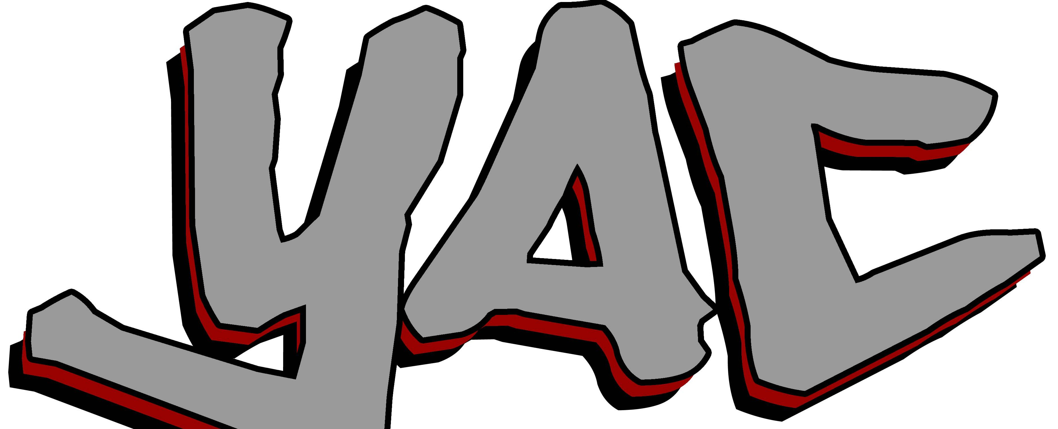
Parent/Guardian Permission Form
RAHS Youth Advisory Council (YAC)

I understand that my child, ______________________________________,
was selected to be a member the University of Michigan, Regional Alliance for Healthy Schools (RAHS) Youth Advisory Council (YAC) at _________ School. He/she has my permission to participate in all YAC activities. This includes meetings before, after, or during his/her school day. I am aware that there will be some trainings or meetings that will be off school premises and will involve transportation provided by the University of Michigan. I give permission to the Regional Alliance for Healthy Schools to use photographs taken of my child during YAC activities and events for advertising, marketing or promotional purposes.

Parent/Guardian Signature:

______________________________________ Date: __________

Printed Name:

____________________________________________________

