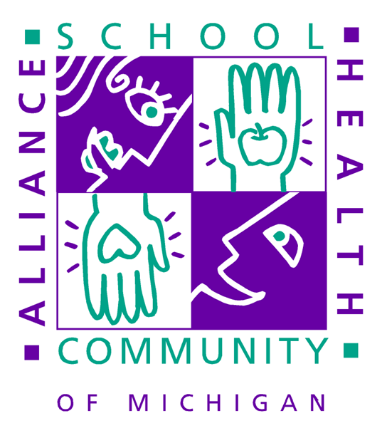

School-Based Health: Why Youth Engagement is Critical

WHY IS ADOLESCENT HEALTH A CRITICAL ISSUE IN MICHIGAN?
Adolescent health problems result in great personal, social, and monetary costs.
- Alcohol is significantly associated with a range of health-compromising behaviors and early onset of alcohol use has been associated with poorer academic functioning and higher rates of school drop out. Yet, nearly half of Michigan high school students report using alcohol, with one-quarter engaging in binge drinking.
- One quarter of all Michigan high school students smoke cigarettes.
- More than 25% of students report experiencing depression; 1 in 10 claims to have attempted suicide; and each year approximately 140 young people in Michigan take their own lives.
- Nearly one third of high school students have engaged in recent sexual intercourse, including 17% of 9th graders.
- Although the rate of teen births is declining, nearly 5,000 babies are born to teenage girls every year in Michigan.

WHAT IS A SCHOOL-BASED HEALTH CENTER?
Michigan's school-based and school-linked health (“SB/SL”) centers have been delivering comprehensive health care and a wide range of support services for more than 15 years. In collaboration with the school district, SB/SL health centers and programs are administered by community based organizations such as hospitals, local health departments and non-profit organizations. Today, there are more than 50 school-based and school-linked health centers and programs in the State of Michigan delivering a range of primary, preventive, and early intervention services to nearly 100,000 children of all grade levels in urban, rural, suburban schools across the state. These centers and programs have emerged as a powerful tool and safety net in meeting the health care needs of children, adolescents, families and other vulnerable populations.

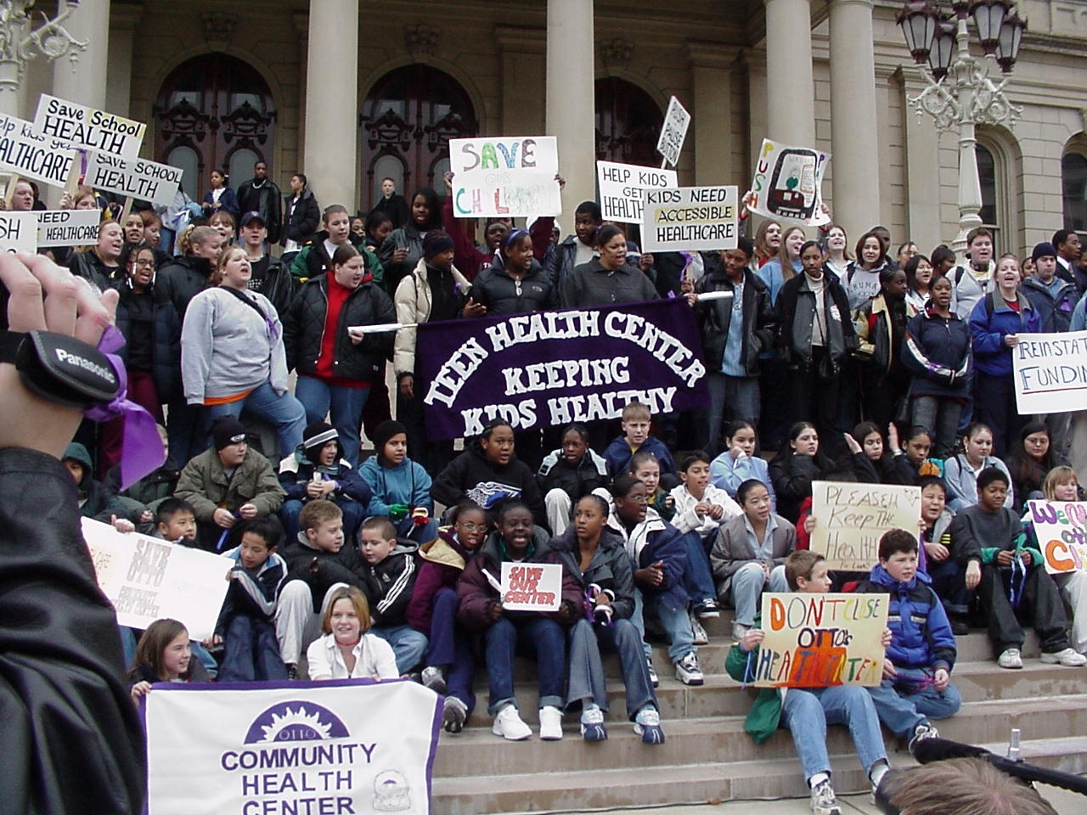
WHAT IS YOUTH ENGAGEMENT?
The elements of youth engagement in child and adolescent health care policy parallel the roles of adults in the policy process. Youth can be involved from within, as participants in policymaking or advisory bodies, or they can exert outside pressure on public systems as advocates. The National 4-H Council refers to these as “participation” and “change” approaches. In addition, training of both youth and adults, is essential to allowing youth to participate fully in policy development.

Here are three approaches to youth participation in child and adolescent health care policy:
- Youth can be participants and advisors;
- Youth can be advocates; and
- Youth can participate in training or peer outreach.

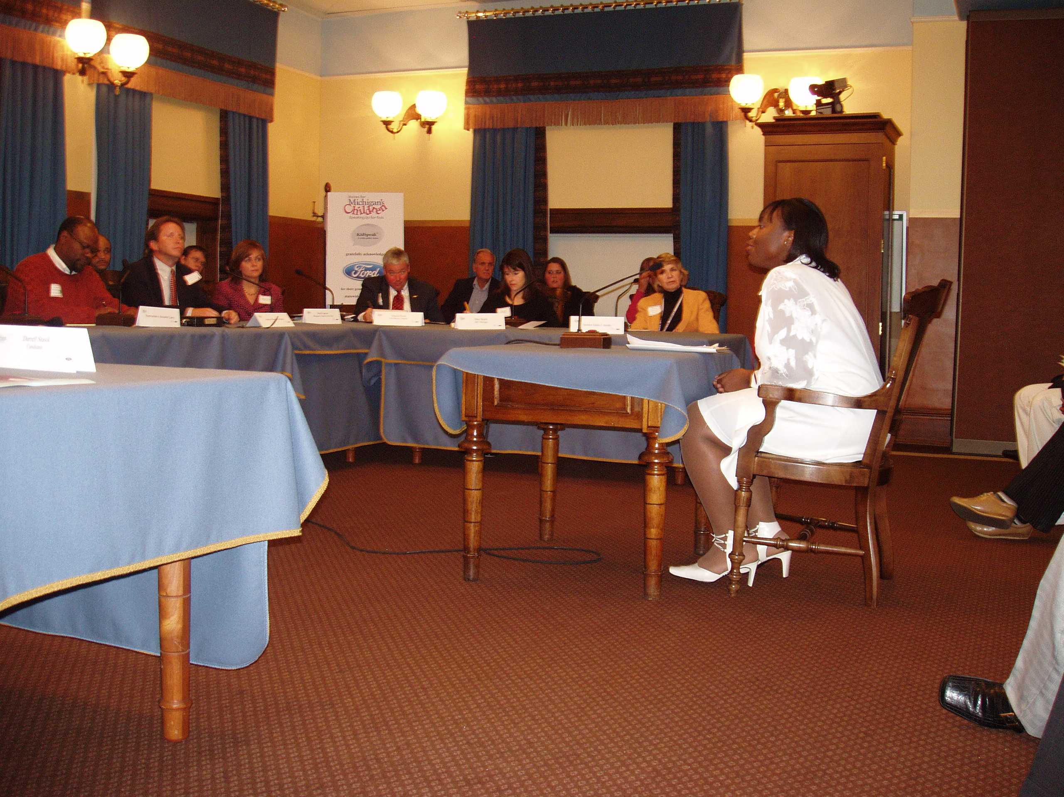
YOUTH ENGAGEMENT IS CRITICAL BECAUSE?
Youth can:
- BRIDGE the gap between younger and older generations;
- EDUCATE community members about the needs of youth, the contributions they can make to the community, and the ways that communities can better support teens;
- PROVIDE input around strategies for adolescents toward the overall prevention of risky behavior;
- ALTER negative images of youth portrayed in the media;
- PUBLICIZE health care options available to youth through peer outreach and education;
- CREATE and open channels for information dissemination to peers;
- SUPPLY firsthand testimony to lawmakers on the value of school-community health centers.

HOW CAN YOUTH GET INVOLVED?
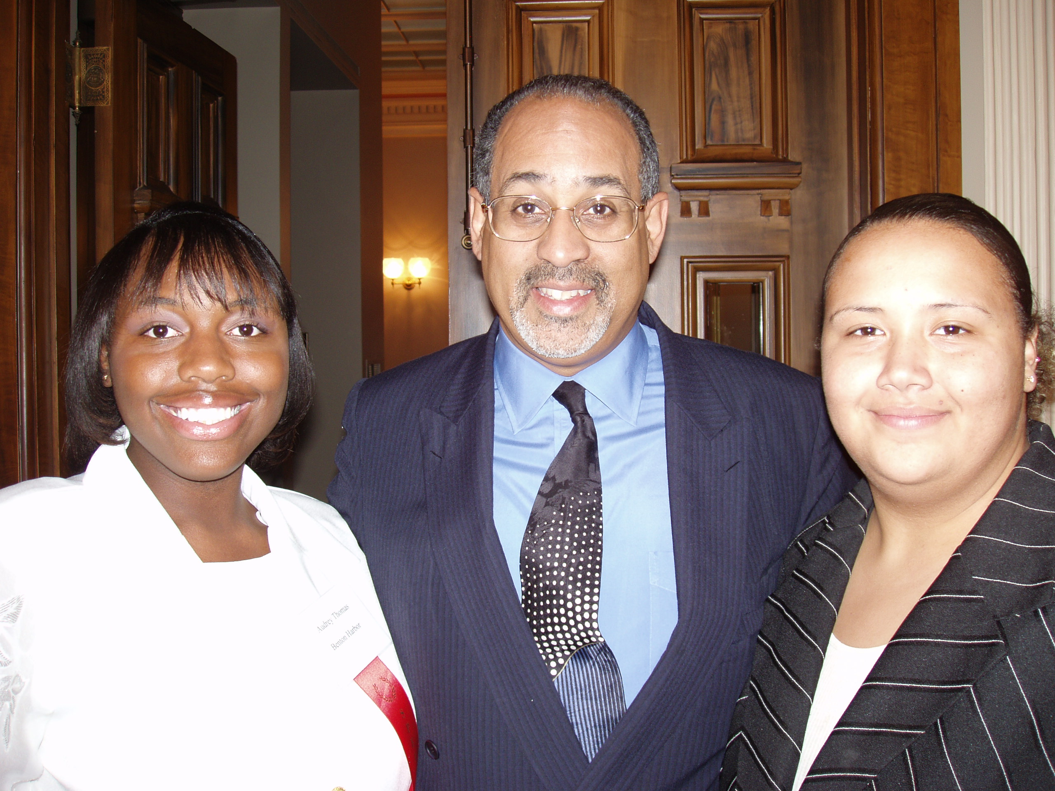
The Policy Process:
- Youth can influence policy . . .
  - Through training in leadership, policy
advocacy, and media relations; and
  - By sharing the podium with adult speakers.

- Youth can shape policy . . .
  - By attending hearings, boards and
commissions at the state and local levels;
and
  - By engaging in asset mapping projects in
their communities to identify community
resources and needs from a youth
perspective.

WHAT CAN PARENTS DO?

Parents should . . .

- BECOME educated on issues concerning child and adolescent health;
- ENGAGE your youth’s SB/SL health center staff in discussions regarding student health care;
- VOLUNTEER to serve on a SB/SL health center community advisory council; Or
- SUPPORT and ENCOURAGE your son or daughter to become a community leader through volunteering to participate in public policy opportunities like the one discussed in this paper.

WHAT SHOULD POLICY MAKERS DO?

- Educate other policymakers about youth by providing them with information, encouraging legislators and agency heads to meet with youth, and conducting regular polling of youth.

- Increase public understanding of and support for teens by working at the community level (for example through faith-based organizations, businesses, and organizations of older adults) to bridge the gap between youth and older generations; and educating community members about the needs of youth, the contributions they can make to the community, and ways that communities can better support teens.

- Use the media to promote balanced images of youth by implementing a statewide media campaign, presenting images of family/community that include adolescents, raising the media’s awareness of their role in creating negative images of youth, encouraging media outlets to form youth advisory councils, and creating media awards and/or report cards for coverage of youth issues.

- Make health care easy and comfortable for all teens to access by publicizing health care options available to youth through outreach and education; promoting point-of-service eligibility and on-site self-enrollment in public programs; eliminating co-payments and premiums for all youth; establishing minor consent for non-emergency, primary medical care; creating health and social services that are welcoming, comfortable, easy for teens to use, and protect the rights of minors; and identifying health plan providers who specialize in serving teens.

- Involve adolescents in the planning and delivery of health services by promoting: adolescent advisory councils, needs assessments, focus groups with teen clients, peer provider programs, funding or youth involvement in program planning, and “report cards” that capture youth evaluations of service providing agencies.

- Fund and support a system of local adolescent health coordinators to promote best practices and coordinated approaches to adolescent health.

- Expand community opportunities for teens by promoting activities for youth during non-school hours, community service and service learning, internships for youth within city and county departments, incentives for employers to employ school-age youth; and encouraging foundations to make one-time grants to establish community youth centers. Additionally, by requiring and funding grantees to involve youth in program planning for state and foundation initiatives.

- Create positive social connections for youth by expanding mentoring programs, developing peer-to-peer mentoring, and fostering mutual understanding between teens and other community sectors.

- Create community conditions that promote safe, healthy choices by facilitating community asset mapping and planning, building social networks, creating channels for information dissemination, decreasing youth access to firearms and alcohol, and increasing transportation safety and opportunities for healthy eating and physical activity.

- Improve the ability of adults in the community to work with and support teens by providing professionals, parents, and other adults with information, training, and referral protocols to help them identify and handle issues that affect adolescent health and development.

- Increase the connection between schools and community by promoting the use of school facilities for youth and community activities during non-school hours, and increasing parent and community involvement in schools.

- Create safe schools and support healthy choices by developing comprehensive school safety plans; creating school climates that support racial, cultural, and other forms of diversity; and increasing opportunities and support for healthy eating and physical activity within schools.

For more information about how you can volunteer to serve on a SBHC community advisory council in your county or for more information about SBHCs, please contact:

Rod Johnson
Director
Community & Program Development
517.381.8000 ext 227
RJohnson@scha-mi.org

Also

Visit us on the Web at:
www.scha-mi.org

Sorenson, Patricia L., and Lower, Richard, (2003). Healthy Youth: An Assessment of State Investments In School-Based/School-Linked Health Services. Michigan’s Children, Lansing, Michigan.
Adapted from Clayton SL, Brindis, CD, Hamor JA, Raiden-Wright H, Fong, C. (2000). Investing in Adolescent Health: A Social Imperative for California’s Future. San Francisco, CA: University of California, San Francisco. National Adolescent Health Information Center.

