Certificate of Achievement

(NAME)
for serving on the RAHS Health Center’s

Youth Advisory Council
20__-20__

You are a leader and we are proud to have you
serve our school and health center!
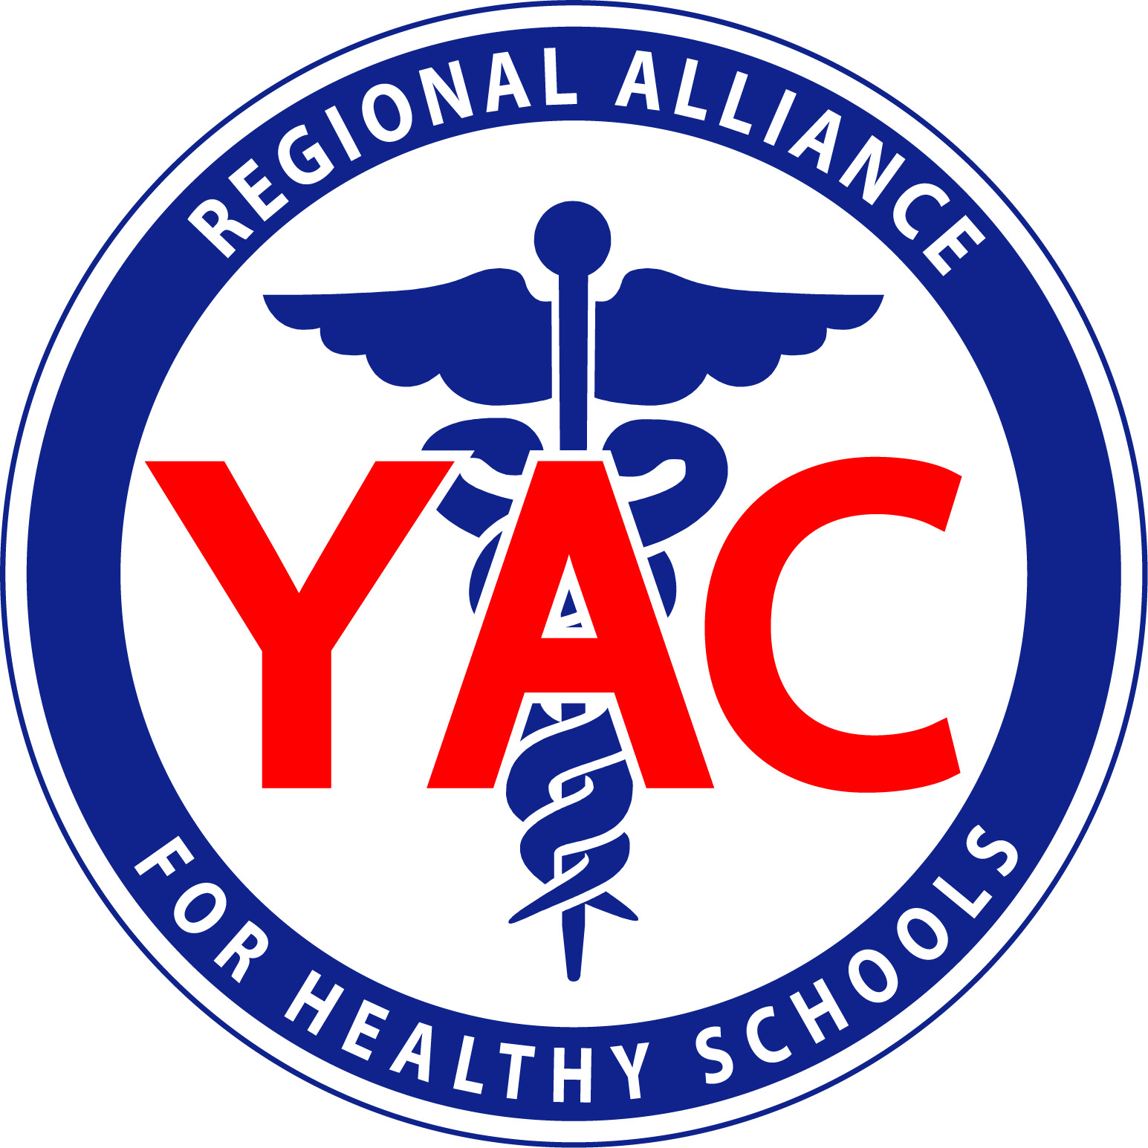
____________________ _________________
Social Worker Nurse Practitioner

