**Introduction**The Willow Health Center Photovoice project has been organized in an effort to address how healthcare and safety intersect in the Lansing community. The goal of this project is to empower you to become active in community change in Lansing and the Ingham County Health Department.   
  
**What is Photovoice?**Photovoice is a process by which youth capture and record their life experiences and community through photos and stories. This project will be related to health and safety in Lansing. Photovoice will include:

1. 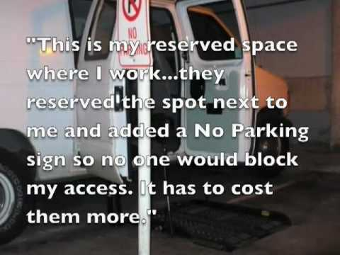 Thinking of questions you want to answer regarding health and safety with your camera.
2. Taking pictures that answer our questions, from your perspective.
3. Reflecting on pictures by yourself and with our photography team.
4. Writing captions for your top choices of photos.

**What is your role?**- Take photos of your life!  
- Be involved in a group discussion to discuss your photographs and personal meaning  
- Share your photos with the community! 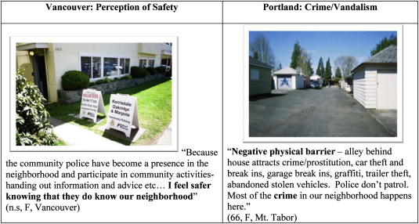

**Getting Started – The Steps We Will Take:**1. Develop questions!  
 You will be taking pictures of a specific topic related to health and safety (for example, a picture of what at the Willow Health Center makes you feel like it is a safe place to receive healthcare).   
 ***Questions may include:***   
 How do you view health and safety in Lansing?   
 What keeps you safe and healthy?  
 What makes it safe for you to get healthcare in Lansing?  
 What makes a doctor’s office or health center safe?   
 How do you stay safe and healthy?  
 What safety issues prevent you from getting healthcare in Lansing?   
  
2. How might you answer your questions using a photo?  
 What pictures would help tell your answer to the question  
  
3. Get a camera. Take pictures!  
 Write down why you took the pic, if you would like  
  
4. Look at your photos when you are done. Is there one that “speaks” to you? What do you see?  
  
5. Do you need to take more pictures?   
  
6. Discuss with your photography team. What other pics were taken? Do you see themes?  
  
7. Write captions for our photos.  
 **The End Goal:** The goal of this project will raise awareness of health and safety from the youth perspective! We can figure out how we want to share our work. We could display them in the waiting room, hold a press conference, present them to the Ingham County Board….you decide!