Creating your MILogin Third Party Account
Linking your existing MEIS Account to MILogin &
Requesting Access to MDE Systems
Creating your MILogin Third-Party Account:

MILogin is the State of Michigan’s single sign on software that will allow users access to State of Michigan systems, to include: CEPI; MICIP; MEGS+; NexSys; etc.

Step one is to follow the Link MILogin.
- Or visit: milogintp.michigan.gov

Using the link above, once you arrive at the MILogin page, it will look like this:
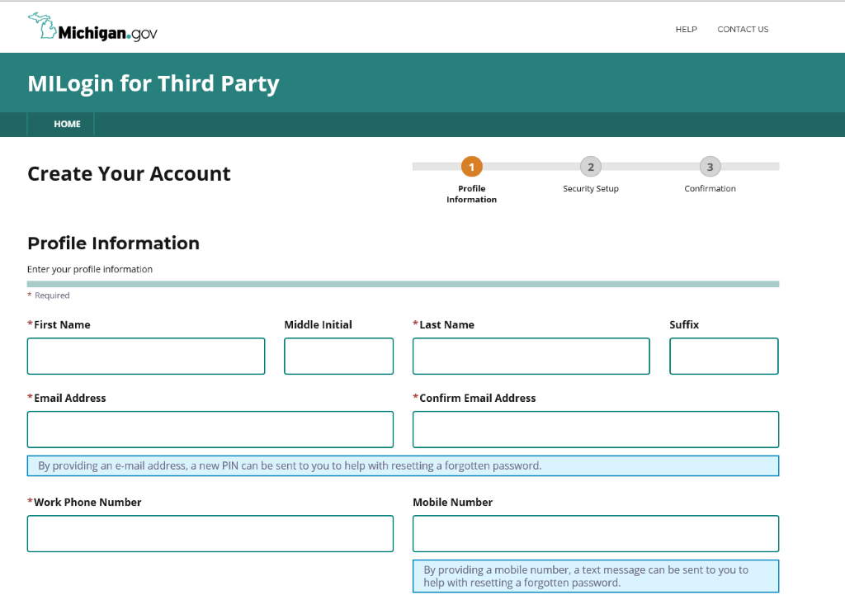

Using your personal information, you will fill out the form. At the end of the form, you will be asked to answer a challenge question:

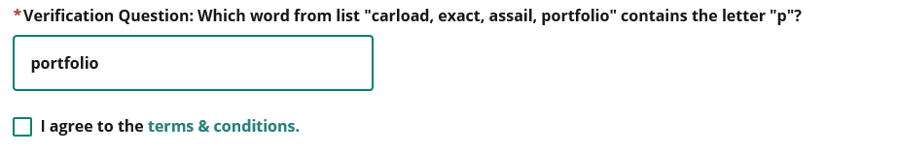
Answer the question. Follow the link to the Terms and Conditions of the MILogin access portal, then check the box indicating agreement (screenshot above).
Then click next.



The next screen will ask you to set up your MILogin User ID and Password to complete your profile.
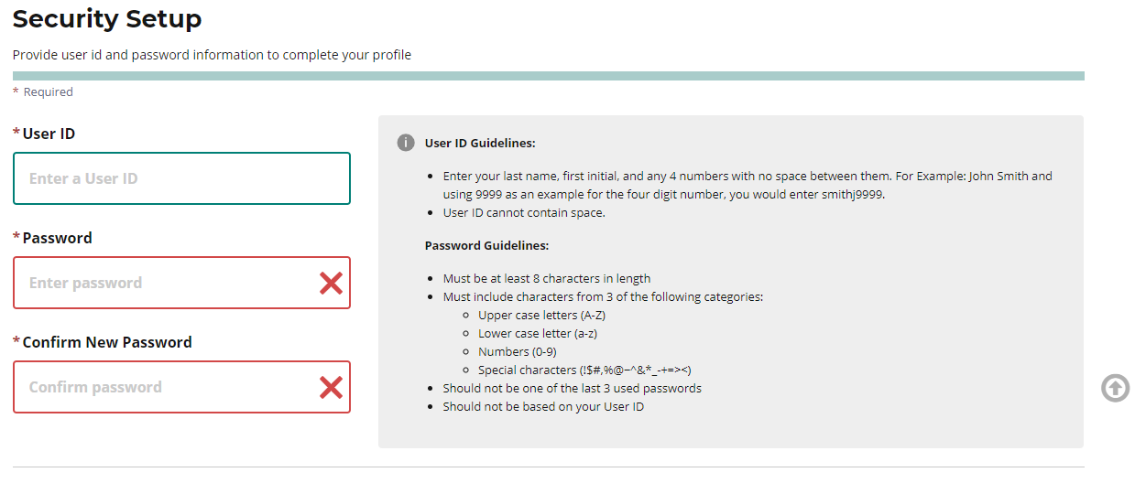

In the gray box to right of the User ID and Password boxes you will see the rules that you need to follow in setting up both the User ID and Password.

After setting your Password and User ID, you will need to choose how to recover your Password through the Security Options.

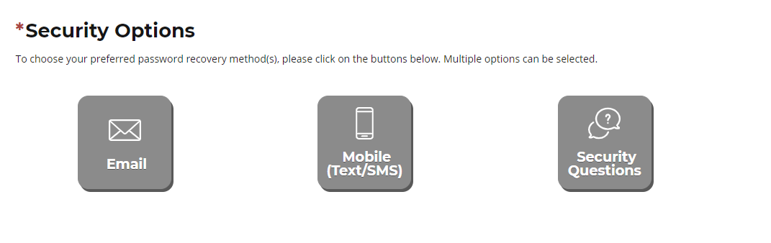
Whichever selection you choose, be sure it will be a good option for you. The information provided via the Profile page will be used as the contact information moving forward (i.e. Email or Mobile).
- If you select email, the email address you entered onto the Profile page will house your password reset.
- If you select the mobile option, the phone number you entered on your Profile page will house your password reset.
- The Security Questions option allows you to choose from a dropdown list of 4 questions to answer. Please be sure the way you answer the questions can be easily remembered. Once you have made your selections, click on the “Create Account” link.
  - If you have selected the “email” option for your Security Option, you will be taken to a page that will give you information about your access.
NOTE: At this point, you do not have access to any State of Michigan systems.
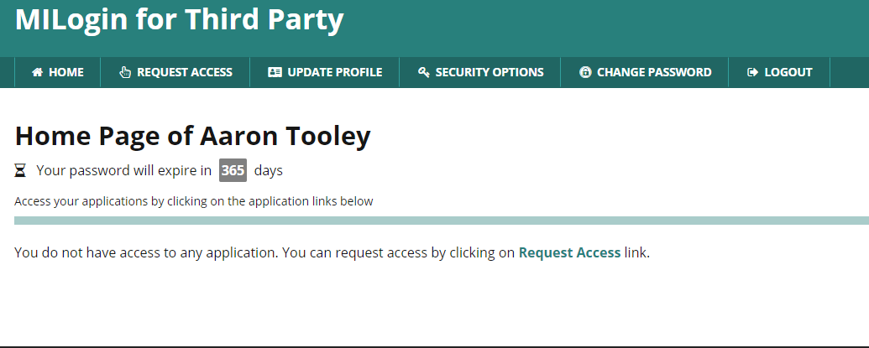
Linking your MEIS account to your MILogin Third Party account:

Go to your MILogin homepage and click on “Request Access”.
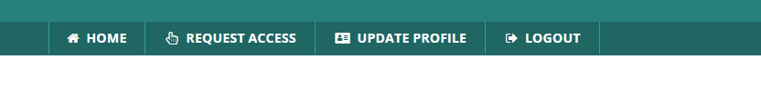
From the –Select Agencies—dropdown, select Michigan Department of Education
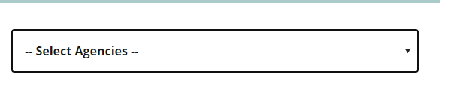
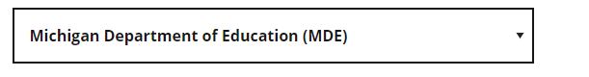
Once you have clicked on the Department name, a list of possible programs will be provided. See the sample below:
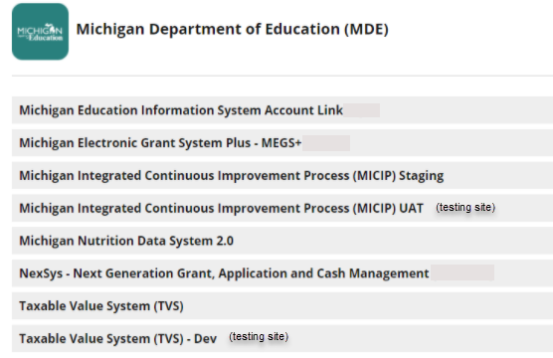
From the program list, select the Michigan Education Information System (MEIS) Account Link.

The next screen will look like this:
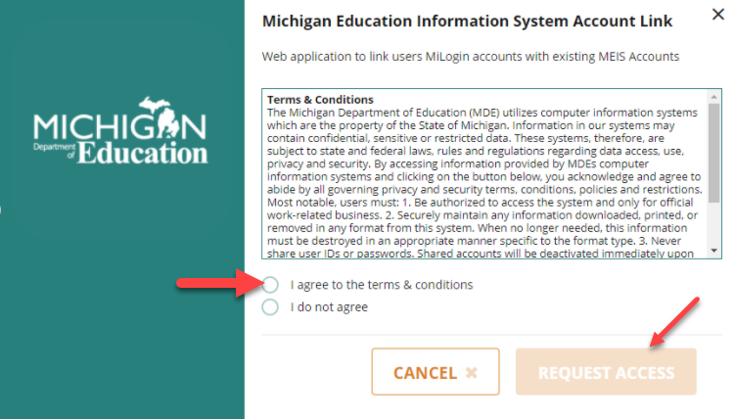
Select the “I agree to the terms & conditions” radio button, then click “Request Access” button.
The next screen will show your email address and work phone as provided in your MILogin account Profile page:
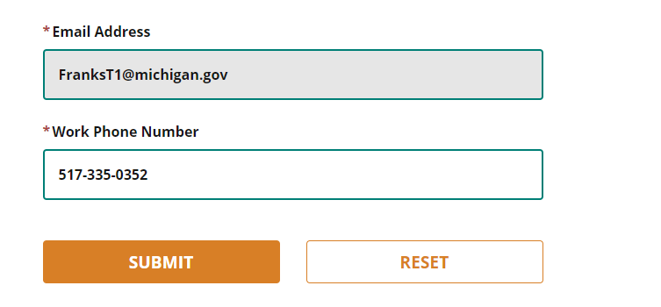
Verify all information is accurate, then click the Submit button.

A successful submission will end in a Confirmation screen that looks similar to this:
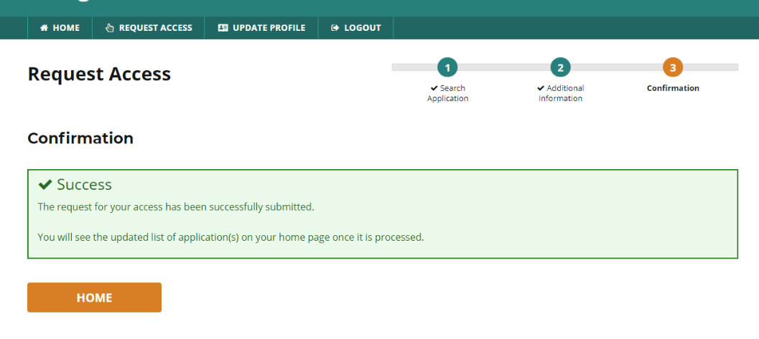
Logout of MILogin and then Log back in. When you return to your MILogin home screen you should see the new system added to your list of MDE systems selections.
Please Note: MILogin can react differently with different browsers. If you logged out and logged back in and do not see the MEIS account link option please close all browser windows and tabs before logging back in to MILogin. If you continue to have difficulties please contact the DTMB Client Service Center: 877-932-6424

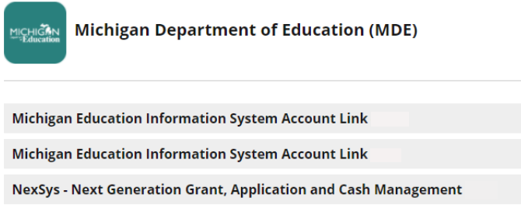
You should receive a system generated email informing you of your access to the MEIS system.
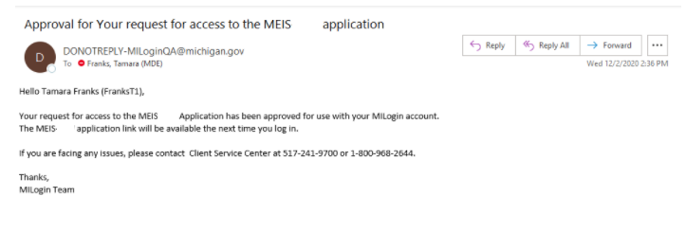
To complete linking your MILogin account with your MEIS account, select the Michigan Education System Account link (sample screenshot below).
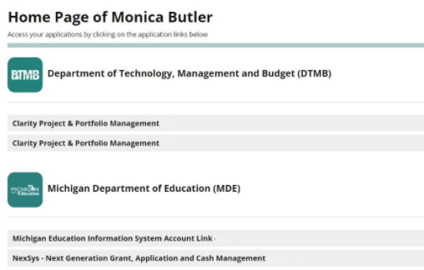

After you select the Michigan Education Information System (MEIS) Account Link, you will land on the Terms and Conditions page. Please see the sample below:

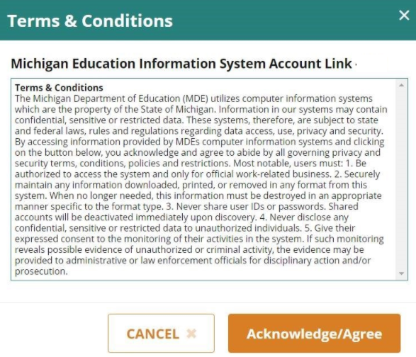
To continue to the MEIS Account Link, click the Acknowledge/Agree button.
You will then be directed to the MEIS Account Link page.
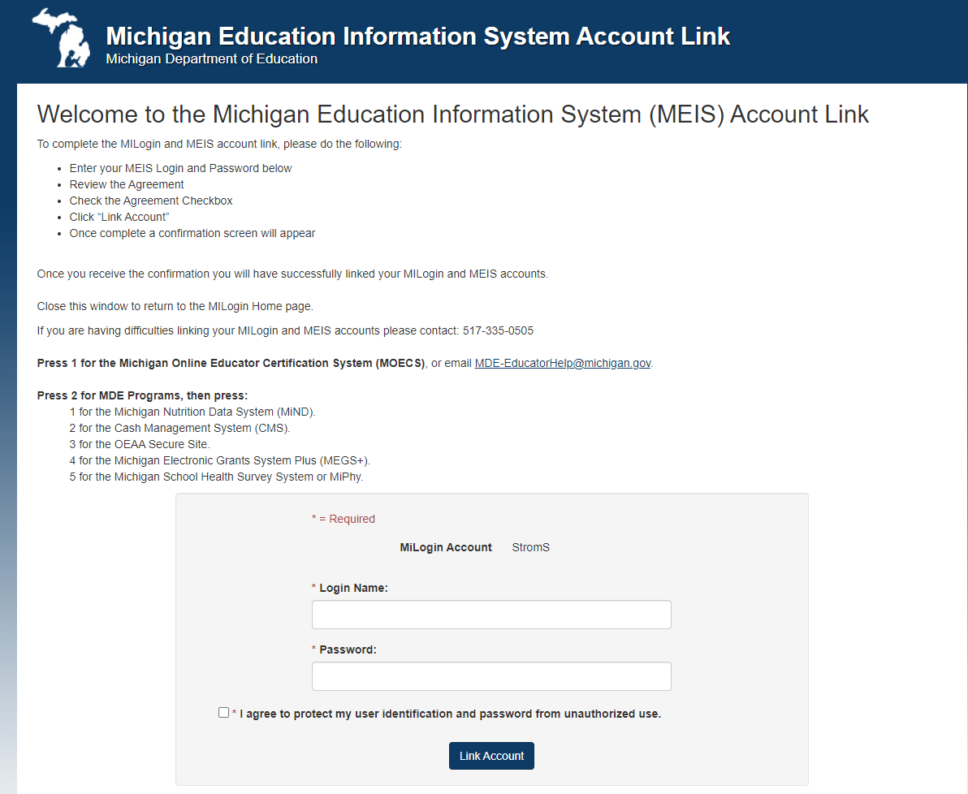
On this page you will need to enter your MEIS account Login Name, your current MEIS password and check the system Agreement checkbox then select the “Link Account” button. Please keep in mind your MEIS Login and Password are the same as the Login and Password you use to access MDE systems such as MEGS+ and CMS.
PLEASE NOTE: If you do not enter the correct MEIS Login and Password after five consecutive tries you will be locked out for 20 minutes. If you are unsure of your MEIS password please visit www.Michigan.gov/MEIS, click the MEIS logo and scroll down to reset your MEIS password.
For additional support with linking your MILogin Third Party Account to your MEIS account please contact the MDE:
Phone: 517-241-5000 or
Email: MDE-EducatorHelp@Michigan.gov
Once you have successfully linked your accounts you will see the Welcome banner/page for your MEIS Account Link. The confirmation will note the MILogin User Name linked to the MEIS account:
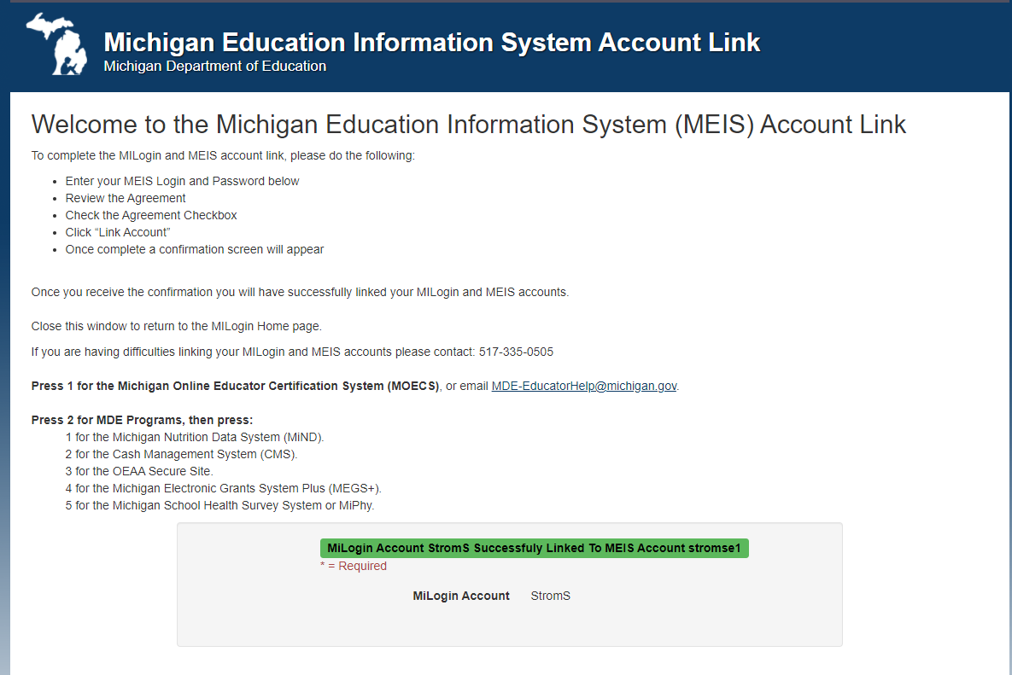

This process needs to be completed once for each unique MEIS number you use. If you linked an account and attempt to link the account again, the System will give you the following message noting the MILogin User ID and MEIS Account:
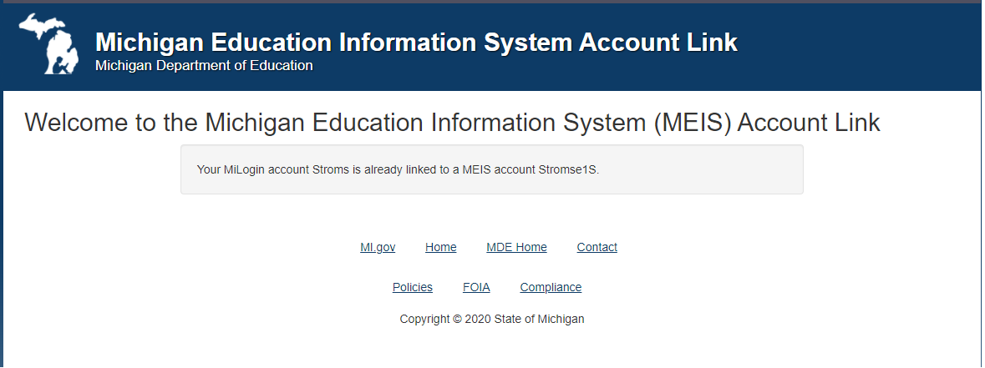

Please Note: If you have multiple MEIS accounts, you will need to create a new MILogin to connect to each MEIS account you utilize by repeating the steps above. You cannot connect multiple MEIS accounts to one MILogin.

Requesting Access to MDE Systems:
Once you have linked your MILogin and MEIS accounts, you can request access to any of the MDE systems that use MEIS as the login portal. From your MILogin homepage click on “Request Access”.
You will be taken to the “Request Access” screen. On this screen, you will need to select MDE from the dropdown list.

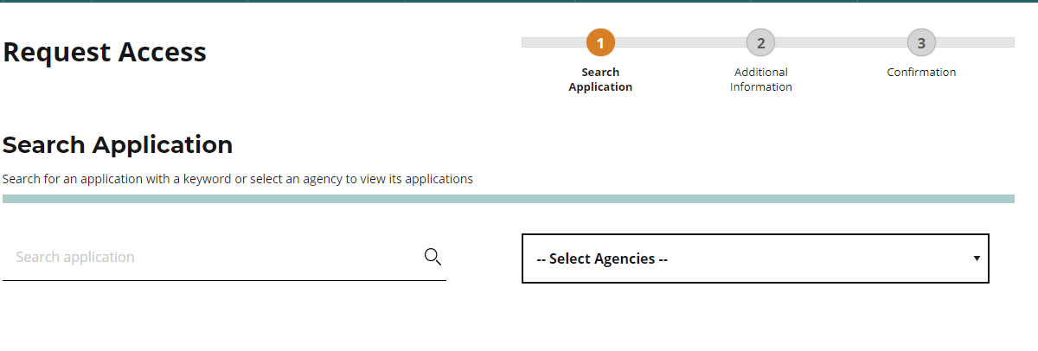

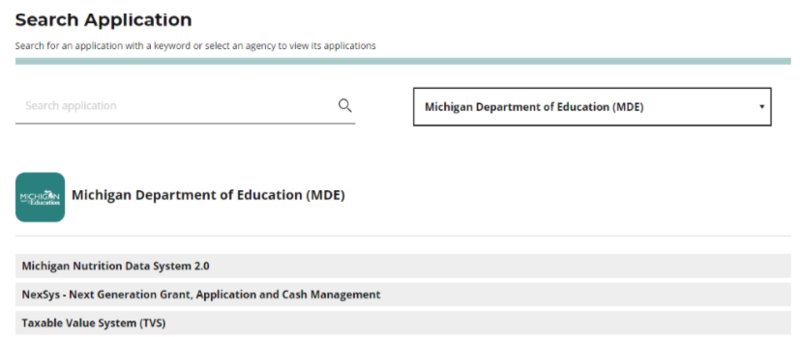

Select the MDE system you want to request access to from the list of available systems.

Once the system refreshes, review the Terms & Conditions page, click the I agree radio button, then click the Request Access button.

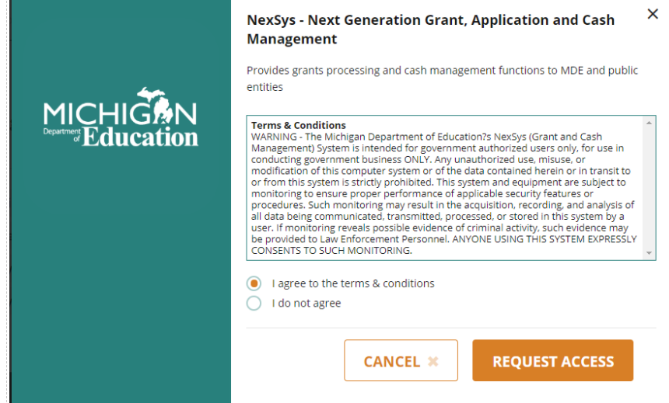

The next page is Additional Information page. The system automatically pre-populates the information from your MILogin Profile page. Please review for accuracy, then click the Submit button.
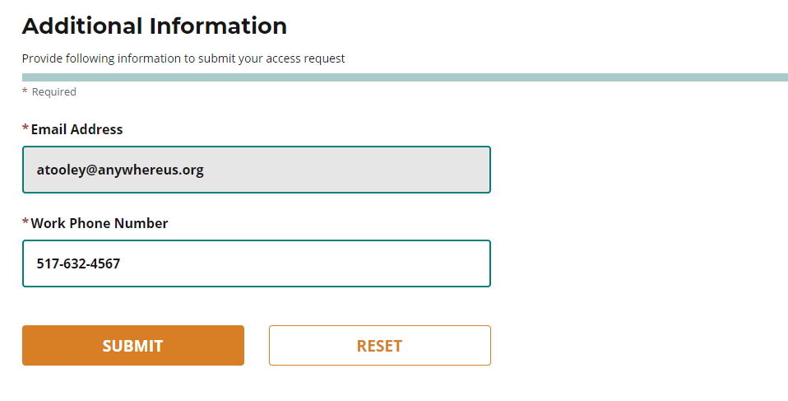

After following the instructions above, a successful submission will end in a Confirmation screen that looks similar to this:

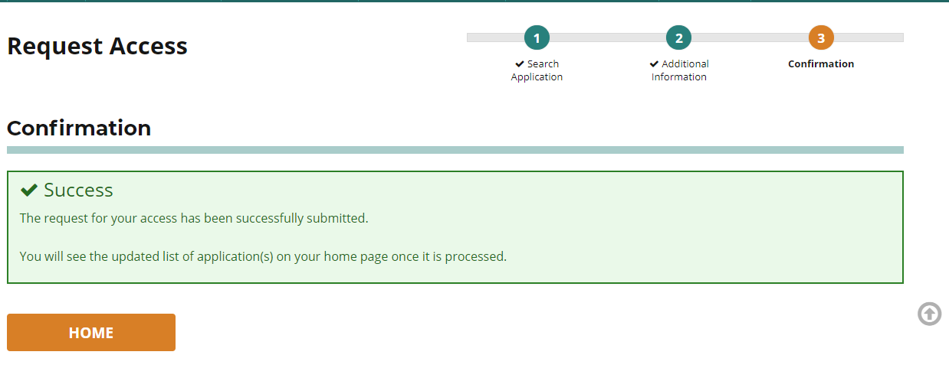
Click on Home button to be taken to the home page of your MILogin account. From this page:
- Logout of MILogin
- Log back in
- Once signed in, you should see the access to Michigan Department of Education (MDE) system you have requested access to.

PLEASE NOTE: MILogin can react differently with different browsers. If you logged out and logged back in and do not see the MEIS account link option please close all browser windows and tabs before logging back in to MILogin.
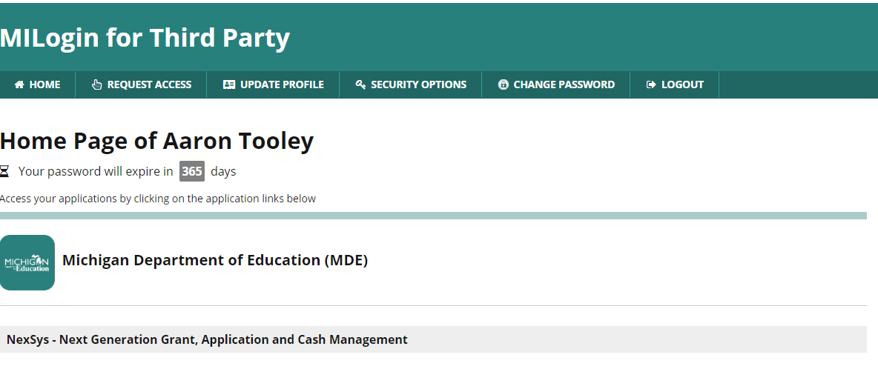
This process is used to Request Access to any MDE system.

