

State Board of Education

Kathleen N. Straus, President
Bloomfield Township

John C. Austin, Vice President
Ann Arbor

Carolyn L. Curtin, Secretary
Evart

Marianne Yared McGuire, Treasurer
Detroit

Nancy Danhof, NASBE Delegate
East Lansing

Elizabeth W. Bauer
Birmingham

Reginald M. Turner
Detroit

Casandra E. Ulbrich
Rochester Hills

Governor Jennifer M. Granholm
Ex Officio

Michael P. Flanagan, Chairman
Superintendent of Public Instruction
Ex Officio

MDE Staff

Sally Vaughn, Ph.D.

Deputy Superintendent and Chief Academic Officer

Betty Underwood, Interim Director

Office of School Improvement

Introduction

The District Comprehensive Needs Assessment (DCNA) was developed to be used as a tool to assist a district staff in determining the strengths and challenges of their district. The DCNA assesses the information, and student data, as well as the system processes and protocols of practice that are in place to support student academic achievement.

Model of Process Cycle for School Improvement

The School Improvement Framework (SIF) establishes a vision for district and school improvement. The Process Cycle for School Improvement has four major components that cycle in continuous praxis around student achievement. They are:

- Gather Data I Where are we now (status) and where do we want to be (goals)?
- Study/Analyze What did the data/information we collected tell us (gap analysis)?
- Plan How do we organize our work so that it aligns to our goals and resources (Plan)?
- Do Staff implements the strategies and action steps outlined in the plan (Implementation and Monitoring).
- Gather Data II Where are we now (status) and did we reach our goals (Evaluation and Revisions)?

Plan
Develop Strategies
And Action Steps
Student
Achievement
Do
Implement Plan
Monitor Plan
Evaluate Plan
Study
Analyze Data
Set Goals and Measurable Objectives
Research Best Practices
Gather Data
Getting Ready
Collect School/student data
Build School Data Profile

While the SIF provides the vision for school improvement, the DCNA is a tool that supports two of the four areas of the School Improvement Process: Gather Data and Study.

The following pages provide sample data charts and probing questions to create dialogue about student and district data. They are designed to facilitate a deeper reflection into a district’s data/information and protocols of practice in order to identify areas of need.

Data/information from the DCNA can be used to write a district improvement plan that includes specific student achievement goals, objectives, and strategies designed by the stakeholders. It is suggested that a DCNA be conducted once every three years, coinciding with the district improvement planning cycle, and revisited annually for evaluation and revisions as needed. Districts that receive any of the federal grant resources are required to complete a comprehensive needs assessment in order to be eligible to receive any of the federal consolidated grant dollars.

Sources of data/information that serve the process of needs identification can include: district self-assessment using the DCNA; evaluation data from the current district improvement plan; information contained in the district report card; district’s annual education report; and student test data from multiple sources.

Web sites that can assist with data collection include: www.michigan.gov/meap , www.michigan.gov/mepr , and www.michigan.gov/cepi, and www.data4ss.org.

The DCNA consists of three sections:

- District Data Profile and Analysis: Assesses current student achievement data and information about the district. The resulting Student Data Analysis Report can be used for district improvement planning purposes. The report includes: 1) identification of student learning goals; 2) gaps between where student achievement is currently and where you want student achievement to be; and 3) identification of contributing causes for gaps in achievement.

- District Processes Analysis and Profile: Assesses the system processes and protocols of practice that are in place to support student academic achievement. The assessment focuses on the Indicators contained in the School Improvement Framework Rubrics. Standard and Strand analysis reports have been included to organize the identified strengths and challenges in system processes and protocols of practice.

- District Comprehensive Summary Report: Provides a format to align identified student achievement challenges with system challenges. This report will provide district staff with useful information for developing the district improvement plan.

Summary of Uses for the DCNA

- Guide the district’s identification of additional resources (grants) to support its goals and objectives.
- Periodically review and/or evaluate district implementation of indicators that are aligned to the School Improvement Framework.
- Serve as the basis for all other needs assessments that may be required of the district.
- Serve as the district’s professional learning plan as required by Public Act 25 (PA25).
- Serve as the district’s technology plan.
- Comply with federal grant requirements of aligning resources with identified needs through a comprehensive needs analysis. (District Comprehensive Analysis Report)

Electronic versions of this document are available at www.michigan.gov/schoolimprovement

District Data Profile

This section provides a model of the types of district information and student data that could be reviewed, and suggested questions that might be asked to probe into the data and information. Completion of this section is recommended, but not required.

Data for the following charts are available on the following websites:
www.mi.gov/MEAP - click on test results
www.data4ss.org

District Profile
District Code:
ISD Code:
District Name:
Superintendent:
Person/Group completing DCNA:
Date:
District and Student Demographic Data/Information
Enrollment
1. What is the current district enrollment?

2. What has been the enrollment trend for the past five (5) years?

______Increasing _______ Stable _______ Decreasing

Total District Enrollment

Year | Year 1: |  | Year 2: |  | Year 3: |  | Year 4: |  | Year 5: |  | Year 6:
Grade | # | % | # | % | # | % | # | % | # | % | # | %
Totals
Sample chart to organize student enrollment trends by grade level

- When looking at sub-group enrollment outlined in the following chart, has the percentage of students from any group changed by more than 5% over the past five years?

If yes, for which sub-group(s)? ______________

Sub Group Enrollment
Years included in the chart:
Group | Total District Enrollment
Group | Year 1 |  | Year 2 |  | Year 3 |  | Year 4 |  | Year 5
Group | # | % | # | % | # | % | # | % | # | %
Economically Disadvantaged
Ethnicity
Students with Disabilities
Limited English Proficient (LEP)
Homeless
Neglected & Delinquent
Migrant
Gender
Male
Female
Total Population
Sample chart to organize sub-group demographics
Summary
4. After reviewing the information on enrollment, what patterns or trends in enrollment can be identified?

5. After reviewing the changes in the district enrollment trends, what implications do the data present for the district in the following areas: staffing, fiscal resource allocations, facility planning, professional development, advertisement, recruitment?

Staff
Using the information from the following charts, discuss the following questions:

1. What is the average number of years teachers in this district have been teaching?

Question | Total # Teachers | 0-3 years | 4-8 years | 9-15 years | >15 years
Indicate how long teachers in the district have been teaching.

2. Indicate the percentage of teachers in the district who meet the federal and state requirements for grade/subject area assignments (Highly Qualified).

Grade Level | Number of Teachers in district | % Currently Meet Criteria | % Do Not Meet Criteria | Waiver Obtained

3. If less than 100% of the classroom instructional staff meets federal and state highly qualified teacher requirements, what action(s) is the district taking to become compliant?

4. How many teachers new to the district (within 3 years) have participated in a new teacher mentor program?

5. What process is in place in the district to ensure new teachers know the curriculum content expectations for their assigned grade?

6. What activities is the district implementing to recruit, maintain, and provide ongoing training to ensure the district instructional staff is/and remains highly qualified?

7. When reviewing teacher tenure in the buildings and comparing student academic achievement data for the building, are any trends noted? Use the chart below or organize data for discussion.

Use the following chart to organize the information for discussion
School in District | Grade | Average # Years Teacher in Building | % of students at grade level

8. For each of the buildings in your district, how long has the administrator been assigned to the building?
Principal: ______
Assistant Principal(s): _______

Use the following chart to organize the information for discussion
School in District | Grade | # Years Principal in Building | % of students at G.L.*
* Grade Level
9. What conclusions can be drawn regarding consistency, training, and qualifications of staffing at the building level?

10. What other conclusions can be made based on this information?

Parent/Community

1. Discuss the types of family/community participation/engagement that are in place to support student achievement.
- What activities generate two-way communications?
- What activities are designed as one-way only?
- What activities are designed to actively engage parents/community in student learning?
- What activities are designed to enrich parent/community skills and ability to be meaningfully involved in student educational programs?
- Do all schools in the district have parent involvement policies as required by section 1118 of NCLB?

2. Does the district have in place, the required policy statement regarding Parent Involvement?

3. Using information contained in the following chart, discuss how has parent/guardian attendance at parent-teacher conferences changed over the last five years?

Years included in the chart:
Group | Parent Conference Attendance
Group | Year 1 |  | Year 2 |  | Year 3 |  | Year 4 |  | Year 5
Group | # | % | # | % | # | % | # | % | # | %
Economically disadvantaged
Ethnicity
Students with Disabilities
Limited English Proficient (LEP)
Homeless
Neglected & Delinquent
Migrant
Gender
Male
Female
Total Population

4. If the district operates a Title III Part C Language Instructional Program, have all of the necessary parental notifications been sent out? When were they sent?

5. Using the following chart, list the partnerships with other agencies and community-based organizations that the district has developed to address nonacademic barriers to learning for students who are low-performing or at risk of dropping out of school.

Name of Organization/Agency | Type of Service they provide
Tab to add additional rows

6. After discussion about the participation rates for parent/community involvement, what factors did the staff identify that impact parent/community involvement?

7. Upon review of the district annual report, are all required elements regarding parent involvement of the report addressed? What elements are missing?

8. Based on a review of the data and information about parent involvement in the district, what strategies could the district use that would increase the level of effective parent involvement?

Summary of District Information: Enrollment, Staffing and Parent/Community Involvement

Use the following chart to summarize challenges/concerns/contributing factors
Area(s) of Concern Noted | Factors identified that contribute to concern | Schools within the district that also noted this concern | Possible Action(s)
Tab to add more lines

Student Achievement Data: All Students

Continuity of Instructional Program
Students who have been in the district since kindergarten
Highest grade level in building | # of students | % of students proficient  ELA | % of students proficient  Math | % of students proficient  Social Studies | % of students proficient  Science
Students who have been in the building since K
Students who moved into the building after K
District should review elementary, middle school and high school levels - copy chart for each level

What additional (multiple) data sources (other than MEAP/MME) were used to inform decision-making about grade level student achievement within the district?

Additional/Multiple Measures of Student Achievement
Name and Type of Measurement Instrument | Grade Level Assessed | Subject Area Assessed
1
2
3
Local Grade Level Data Reports

Grade Level Achievement - District Summary

Year: Sample Data Charts (duplicate for multiple years)
 |  |  | % of Population Demonstrating Proficiency of GLCE/HSCE*
Grade | ACS** | % HQ *** | ELA |  | Math |  | Science |  | Social Studies
 |  |  | # | % | # | % | # | % | # | %
Pre K
K
1
2
3
4
5
6
7
8
9
10
11
12
*GLCE – Grade Level Content Expectations HSCE - High School Content Expectations
** ACS=Average Class Size for the grade *** % of classroom teachers who meet Highly Qualified Status

Grade Level Achievement –School Level Data (Districts are encouraged to analyze individual buildings charts from the School Comprehensive Needs Assessment to determine specific areas of instructional strengths and challenges).

School:

Sample data charts – (see completed individual School Comprehensive Needs Assessment Reports)
 |  |  | % of Population Demonstrating Proficiency of GLCE/HSCE*
Grade | ACS** | % HQ *** | ELA |  | Math |  | Science |  | Social Studies
 |  |  | # | % | # | % | # | % | # | %
Pre K
K
1
2
3
4
5
6
7
8
9
10
11
12
*GLCE – Grade Level Content Expectations HSCE - High School Content Expectations
** ACS=Average Class Size for the grade *** % of classroom teachers who meet Highly Qualified Status

Process to identify eligible attendance areas (Title I)

This is a screen shot of required data in the MEGS application
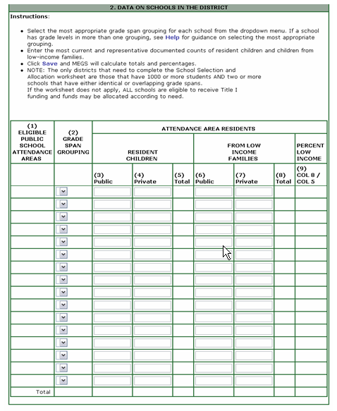

1. Describe the information used to determine free and reduced lunch status of students.

2. Based on the above chart, which schools are at or above 75% of the population eligible for free/reduced lunch?

3. Which schools in the district are above the district average poverty percentage?

4. What process is in place for the district to communicate with Neglected and Delinquent institutions and Non Public schools within the district to determine their eligibility and needs for participation in federal programs?
Michigan AYP Targets

The following table provides the Michigan AYP Targets for the percent of students scoring in the proficient category of the MEAP/MME tests.

 | 2002-04 | 2004-07 | 2007-10 | 2010-11 | 2011-12 | 2012-13 | 2013-14
Elementary
Math | 47% | 56% | 65% | 74% | 82% | 91% | 100%
ELA | 38% | 48% | 59% | 69% | 79% | 90% | 100%
Middle School
Math | 31% | 43% | 54% | 66% | 77% | 89% | 100%
ELA | 31% | 43% | 54% | 66% | 77% | 89% | 100%
High School
Math | 33% | 44% | 55% | 67% | 78% | 89% | 100%
ELA | 42% | 52% | 61% | 71% | 81% | 90% | 100%

Grade Level Achievement – District Aggregate

MEAP/MME Achievement Reports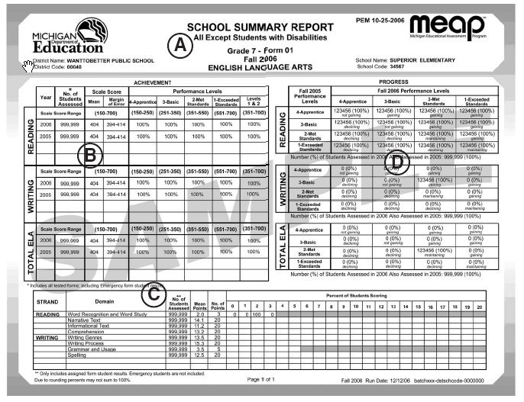
www.michigan.gov/MEAP - click on MEAP test results
MEAP Assessment Test Item Analysis

The following charts are samples of reports that look at how students across the district are scoring on the MEAP/MME test items. These charts can compare schools within the district, and the district to the state. Websites for these charts are listed.

A review of the district overall performance on these test items can assist in determining if there are areas of concern with the district curriculum.

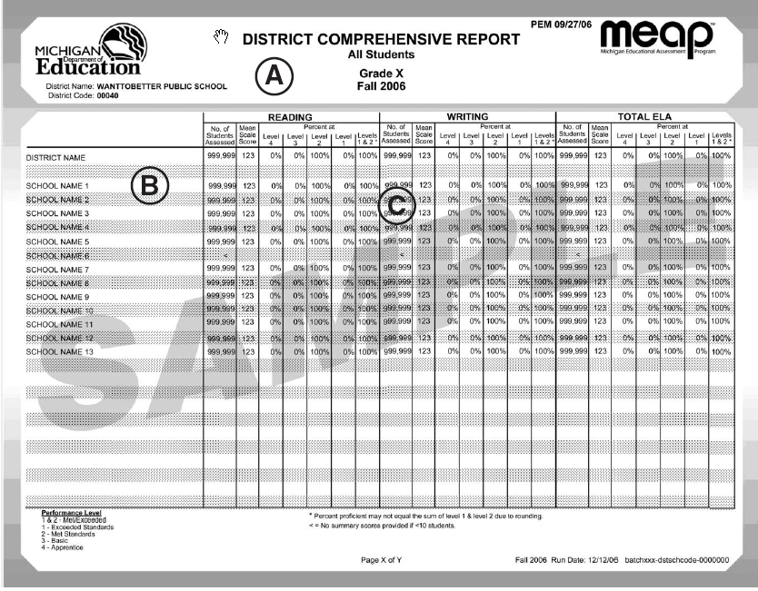
www.michigan.gov/MEAP - click on MEAP Test Results - (you must be an authorized user)

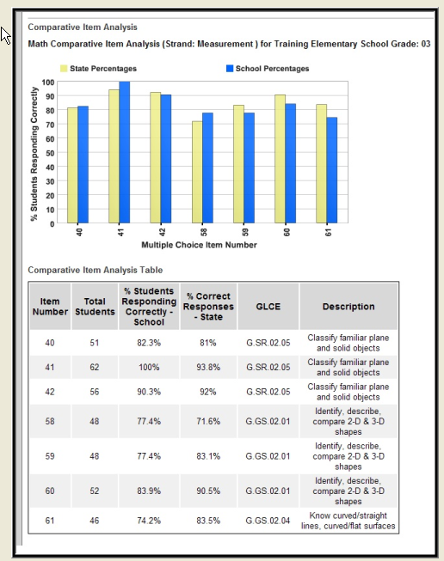
www.data4ss.org
Discussion Questions About District Level Student Data: All Students

Using the information gathered about the district’s overall instructional program, and individual school analysis of grade level achievement data, discuss the following questions.

- What trends have been identified when looking at the three years of MEAP/MME of data for the district?

- What percentage of students moved from basic to proficient, proficient to advanced (MEAP/MME)

- What are the differences in achievement between students who have been in the district for all of their instructional experience and those students who moved into the district from another district?

- What data/information (other than MEAP/MME/GLCE/HSCE) does the district use to measure student achievement at each grade level?

- When looking at additional (multiple) data sources, were there any discrepancies between the sets of data? If so:
- How do additional data sources compare?
- Are the data from the additional data sources congruent with MEAP/MME results?
- What discrepancies were noted?

6. How are these different data sources used for planning purposes?

7. Which of the schools within the district demonstrate consistently high levels of student achievement?

8. What actions has the district taken to identify the strategies being used by these successful schools, for the purpose of possible replication throughout the district?

9. For schools within the district that are demonstrating a pattern of low student achievement, what actions has the district taken to support these schools?

10. What assessment data is used to identify for remediation, individual students who are at risk of not meeting the state student academic achievement standards? How are students identified for participation in any of the federal categorical programs from which the district receives resources?

11. How are buildings within the district identified for participation in federal programs?

12. Based on the data charts for student grade level achievement, were any areas identified as a concern?

13. For any grade level identified as a concern (significant gap in student achievement), after reviewing the data and information, what has the district staff determined to be a leading cause for the gap in student achievement?

- Which grade level(s) presents a concern?
- Based on an individual building grade level analysis of student achievement, which building demonstrates a significant grade level gap in student achievement?
- What contributing cause for the gap did the individual buildings involved identify?

14. After review of the district level MEAP item analysis report, in which skill areas are students performing well?

15. Are there any skill areas where there is a 10% or greater gap between the district and
state scores?

16. What has the district staff determined to be a leading cause for this gap?

17. What process does the district have in place to review and assure curriculum alignment
with the state standards?

18. What process is in place at the district level to assure the curriculum is enacted at all
grade levels/classrooms within the district?

19. How is this process monitored?

20. How does the district use this information to improve teaching and learning practices?

As a result of this review and discussions about student achievement within the district, use the following chart to organize the areas of concern identified during discussions about student data.

Student Achievement Data Summary - All Students
Area(s) of Concern Noted | Factors identified that contribute to Concern | Schools within the district who also noted this Concern | Possible Action(s)

Student Data - District Analysis by Sub-group (full year students)

Group (<30) | % of Students Scoring in Each Category
Group (<30) | Reading |  |  | Writing |  |  | Total ELA |  |  | Math
Group (<30) | B | P | A | B | P | A | B | P | A | B | P | A
Social Economic Status (SES)
Ethnicity
Students with Disabilities

Limited English Proficient (LEP)
Homeless
Neglected & Delinquent
Migrant
Gender - Male

Gender - Female

Aggregate Scores
State

Group (<30) | % of Students by Category
Group (<30) | Science |  |  | Social Studies
Group (<30) | B | P | A | B | P | A
Social Economic Status (SES)
Ethnicity
Students with Disabilities

Limited English Proficient (LEP)
Homeless
Neglected & Delinquent
Migrant
Gender - Male

Gender - Female

Aggregate Scores
State

Discussion Questions About Sub-Group Student Data: (Special Education and LEP will be addressed in the next section)

Using the information gathered about the district’s sub-group achievement data, and individual school analysis of grade level achievement data, discuss the following questions:

- Based on MEAP/MME reports, which of the sub-groups are not at/or above the current state AYP content area targets?

2. Are any of the sub-groups scoring more than 10 percentage points lower than the current state AYP targets?

- What trends have been identified when looking at the three years of MEAP/MME data for these sub-groups?

- Using information from the individual school CNA, review the school data for these same charts and identify any of the schools in the district that would be a concern, based on their sub-group analysis. What trends across schools were noted?

- Does the district have any of these sub-groups with more than 1, but less than 30, students in them? If so, are these students scoring at or above grade level in all content areas? How is this being monitored to ensure all students will be successful?

- How are individual students identified for remediation and/or participation in any of the federal categorical programs from which the district receives resources?

- Which of the schools within the district demonstrate consistently high levels of student achievement in the various (or individual) sub-groups?

- What actions has the district taken to identify the strategies being used by these successful schools for the purpose of possible replication throughout the district?

- For schools within the district that are demonstrating a pattern of low student achievement within particular sub-groups, what actions has the district taken to support these schools?

- What support services are currently being provided for students who are homeless, migrant, reside in institutions for neglected and delinquent or are gender or ethnic based?

Services | Homeless | Migrant | N&D | Gender Based | Ethnic Based

11. How are these programs evaluated? How effective have these programs been in raising the level of student achievement for each of these groups?

Use the following chart to organize the area of concerns, factors, and actions based on the review and discussions around sub-group student academic achievement. (Special Education and Limited English Proficient are discussed separately following this section)

Summary of Sub-Group: Concerns, Factors, and Actions
Area(s) of Concern Noted | Factors identified that contribute to concern | Schools within the district who also noted this concern | Possible Action(s)

Review of Special Education Population
Students taking the MEAP/MME test
Sub-group:  Students with Disabilities (use ed settings data from MI-CIS) | Total # of Students  In Group | % of Total District  Population | % of Students Scoring in Each Category
 | Total # of Students  In Group | % of Total District  Population | ELA |  |  |  | Math
 | Total # of Students  In Group | % of Total District  Population | 1 | 2 | 3 | 4 | 1 | 2 | 3 | 4
Instructed in General Education Setting 80% or more
Instructed in general Education Setting 79-40%
Instructed in general education <40%
Sub-group:  Students with Disabilities (use ed settings data from MI-CIS) | Total # of Students  In Group | % of Total District  Population | % of Students Scoring in Each Category
 | Total # of Students  In Group | % of Total District  Population | Science |  |  |  | Social Studies
 | Total # of Students  In Group | % of Total District  Population | 1 | 2 | 3 | 4 | 1 | 2 | 3 | 4
Instructed in General Education Setting 80% or more
Instructed in general Education Setting 79-40%
Instructed in general education <40%

Students taking MI-Access test
Sub-group:  Students with Disabilities (use ed settings data from MI-CIS) | Total # of Students  In Group | % of Total District  Population | % of Students Scoring in Each Category
 | Total # of Students  In Group | % of Total District  Population | ELA |  |  | Math
 | Total # of Students  In Group | % of Total District  Population | SP | AP | E | SP |  | AP |  | E
Instructed in General Education Setting 80% or more
Instructed in general Education Setting 79-40%
Instructed in general education <40%
Sub-group:  Students with Disabilities (use ed settings data from MI-CIS) | Total # of Students  In Group | % of Total District  Population | % of Students Scoring in Each Category
 | Total # of Students  In Group | % of Total District  Population | Science |  |  | Social Studies
 | Total # of Students  In Group | % of Total District  Population | SP | AP | E
Instructed in General Education Setting 80% or more
Instructed in general Education Setting 79-40%
Instructed in general education <40%
SP=Surpassed the Performance Standard AP=Attained the Performance Standard E= Emerging Toward the Performance Standard

Students with Disabilities Group Demographics
More information on these tests can be found on the MI-Access Web page (www.mi.gov/mi-access) and at the MI-Access Information Center (www.mi-access.info) and (www.michigan.gov/MEAP - click on MEAP Test Results)

MEAP analysis question

- How many students with disabilities in the school participate in the MEAP/MME testing (number enrolled vs. number participating)?

- What percentage of students took MI-Access or other modified test?

- Are there any grade levels, subject areas, or disability groups with significant changes in their MEAP performance over the past x years? If there are significant changes in performance, why?

- Is there a difference in performance between students who receive content instruction in general education settings and those who receive content instruction in special education settings? If there is a difference in performance, why?

Fall 2008 Michigan Educational Assessment Program
Performance Level Descriptors (PLDs)
The following are the Performance Level Descriptors approved by the Michigan State Board of Education.
Level 1: Advanced
The student’s performance exceeds grade level expectations and indicates substantial understanding and application of key concepts defined for Michigan students. The student needs support to continue to excel.
Level 2: Proficient
The student’s performance indicates understanding and application of key grade level expectations defined for Michigan students. The student needs continued support to maintain and improve proficiency.
Level 3: Partially Proficient
The student needs assistance to improve achievement. The student’s performance is not yet proficient, indicating a partial understanding and application of the grade level expectations defined for Michigan students.

Level 4: Not Proficient
The student needs intensive intervention and support to improve achievement. The student’s performance is not yet proficient and indicates minimal understanding and application of the grade level expectations defined for Michigan students.
For more detail, please see the Fall 2008 MEAP Guide to Reports available online at www.michigan.gov/meap

Curriculum/Delivery

- What is your school’s identification rate for students with disabilities? How does this compare to the overall identification rate in your district?
  - How does your school identification rate for any specific disability category differ from your district’s identification rate? (Refer to MI-CIS data)
  - Is there over or under representation of racial/ethnic groups in your school’s special education programs?
  - Are there differences in achievement between racial/ethnic groups for students with disabilities?

- For students not receiving instruction in general education setting, what curriculum is used and how is it aligned with the State Grade Level Content Expectations/High School Content Expectations, and/or Extended Grade-level Content Expectations?

- How are services provided that will help the student become successful in the general education setting? For example:
a. Co-Teaching
b. Differentiated instruction
C. Supplementary aids and services
d. Peer tutoring
e. Additional interventions

- How do you ensure that students with disabilities have access to the full array of intervention programs (Title 1, Title III, Section 31a, credit recovery programs, after-school programs, etc.)?

Summary of Special Education Sub-Group: Concerns, Factors, and Actions

Area(s) of Concern Noted | Factors identified that contribute to concern | Schools within the district who also noted this concern | Possible Action(s)
Limited English Proficient (LEP) Group Demographics

Using these sample charts, list which languages are included in the district’s LEP sub-group.

MEAP/MME
Language* <30 | # Students | #Students  Tested | # of Staff who Speak the Language |  | % of Student’s scoring in each category of MEAP/MME
Language* <30 |  |  | Teachers | Parapro | ELA |  |  | Math |  |  | Science. |  |  | Soc.Stu.
 |  |  |  |  | B | P | A | B | P | A | B | P | A | B | P | A
Total District
*10 or more students within the language group B=Basic, P=Proficient, A=Advanced

English Language Proficiency Assessment (ELPA)
Language* <30 | # Students | #Students  Tested | # of Staff who speak the Language |  | Category Assessment Results
Language* <30 |  |  | Teachers | Paraprofessional | 1 | 2 | 3 | 4 | 5
Total District
(www.michigan.gov/MEAP - click on MEAP Test Results)

Discussion for LEP Sub Group Analysis:

- For each language group, what is the percent of students in the language group who are not at/or above the current state standard for each content area?

- Are any of the LEP sub-groups scoring more than 10 percentage points lower than the state AYP standards?

- If the district has less than 30 students in the LEP sub-group, how is their progress monitored?

- What services are currently being provided?

- If buildings identified concerns within their CNA for the LEP sub-group, what did they identify as contributing causes for the gaps in achievement?

- How are students who are most at risk of failing to meet the current state academic achievement standards identified for support services?

Summary of Limited English Proficient Sub-Group: Concerns, Factors, and Actions
Area(s) of Concern Noted | Factors identified that contribute to concern | Schools within the district who also noted this concern | Possible Action(s)

Non-Academic Student Data: All Students

Mobility Data
Years included in chart:
Mobility
Grade | # of Students |  |  | Number Entering |  |  | Number Leaving
Years | 1 | 2 | 3 | 1 | 2 | 3 | 1 | 2 | 3
K
1
2
3
4
5
6
7
8
9
10
11
12

Discipline Data: All Students

Years included in chart:
Grade | # of  Students |  |  | # of  Suspension* |  |  | # of  Expulsions |  |  | Unduplicated Counts
Years | 1 | 2 | 3 | 1 | 2 | 3 | 1 | 2 | 3 | 1 | 2 | 3
K
1
2
3
4
5
6
7
8
9
10
11
12
*Suspension is any occurrence that results in out of classroom

Enrollment and Graduation Data: All Students
Years included in chart:
Grade | # of  Students |  |  | # Students in Young 5’s  Programs |  |  | # Students in course/grade acceleration |  |  | Early HS graduation |  |  | # of  retentions |  |  | # Promoted to next grade
Years | 1 | 2 | 3 | 1 | 2 | 3 | 1 | 2 | 3 | 1 | 2 | 3 | 1 | 2 | 3 | 1 | 2 | 3
K
1
2
3
4
5
6
7
8
9
10
11
12

Graduation Rate - Total District
 | 2003-2004 | 2004-2005 | 2005-2006 | 2006-2007
Graduation Rate
Drop out Rate
Attendance Rate

Graduation Rate - Sub-Group for years:
Sub Group | Graduation Rate |  |  |  | Drop out Rate |  |  |  | Attendance Rate
Years | 1 | 2 | 3 | 4 | 1 | 2 | 3 | 4 | 1 | 2 | 3 | 4
SES
Ethnicity
Disabilities
LEP
Homeless
Neglected & Delinquent
Migrant
Gender
Male
Female

Number of Students Enrolled in Extended Learning Opportunities: All Students

Years included in chart:
Number of Students in Building by grade | # Enrolled in Advanced Placement Classes | # Enrolled in International Baccalaureate  Courses | # of Students in Dual Enrollment | # of Students in CTE/Vocational Classes | Number of Students who have approved/reviewed EDP on file*
6
7
8
9
10
11
12

* EDP must be developed for all 8th graders, and reviewed annually in grades 9-12 to ensure that course selections align with the plans.
Sub-Group Analysis
Years included in chart:
Group | # Students |  |  | # of  Absences  <10 |  |  | # of  Suspension |  |  | # of  Expulsions |  |  | Unduplicated Counts
Years | 1 | 2 | 3 | 1 | 2 | 3 | 1 | 2 | 3 | 1 | 2 | 3 | 1 | 2 | 3
SES
Ethnicity
Disabilities
LEP
Homeless
Neglect & Delinquent
Migrant
Gender
Male
Female
Totals

Years included in chart:
Group | # of  Students |  |  | # of  Retentions |  |  | # of  Drop  out |  |  | # Participating in extended learning opportunities |  |  |  | # Promoted to next grade |  |  | Mobility
 |  |  |  |  |  |  |  |  |  |  |  |  |  |  |  |  | Entering |  |  | Leaving
Years | 1 | 2 | 3 | 1 | 2 | 3 | 1 | 2 | 3 |  | 1 | 2 | 3 | 1 | 2 | 3 | 1 | 2 | 3 | 1 | 2 | 3
SES
Ethnicity
Disabilities
LEP
Homeless
N & D
Migrant
Gender
Male
Female
Totals

Educational Development Plans
For each grade listed, indicate the number of students who have/had an EDP created in grade 8 and reviewed annually in grades 9-12

Group | Grade 8 | Grade 9 | Grade 10 | Grade 11 | Grade 12
Years
SES
Ethnicity
Disabilities
LEP
Homeless
N & D
Migrant
Gender
Male
Female
Totals
Summary Questions for Discussion:

Using data about the district’s mobility, attendance patterns, suspension, expulsion, retention rates, dropout rates, graduation rates, and extended learning opportunities:

- What are the student mobility rates for the district and for each identified sub-group?

- Has the mobility rate changed over time?

- What is the average student attendance rate? (For whole school and by sub-group).

- What percentage of students missed more that 10 days of school? Is there a high concentration in any of the sub-groups?

- Are there grade level differences in attendance?

- What is the trend of dropouts over the past 3-5 years (whole district and sub-group)?

- Has the dropout rate decreased, increased, or stayed the same?

- What does the dropout pattern look like when disaggregated by sub-group for individual schools? (Review individual school CNA data).

- Is there a grade level that has a higher percentage of students dropping out? Is there a school within the district that demonstrates a higher rate of dropouts?

- What are the achievement levels of students who drop out of school?

- What are the attendance patterns of students who drop out of school?

- What are the discipline patterns of students who drop out of school?

- What percentages of eligible students are participating in extended learning opportunities?

- Are the participation rates increasing in extended learning opportunities?

- What is the district doing to inform students and parents of extended learning opportunities?

Summary of Student Non-Academic Data: Concerns, Factors, and Actions

Area(s) of Concern Noted | Factors identified that contribute to concern | Schools within the district who also noted this concern | Possible Action(s)
Perception Data

Student

- In what ways does the district collect information about student perception in the following areas:

  - How they feel about their school; their teacher; their principal?

  - What they think the teachers and principal(s) feel about them?

  - What they feel the staff expectations are for their learning ability?

Parent/Guardian

- In what ways does the district collect information about parent/guardian perception in the following areas:

- Teacher preparation and ability to prepare their children to be successful learners?

- Principal(s) effectiveness?

Staff

- In what ways does the district collect information about staff perceptions in the following areas:

- High expectations for all students?

- Coherence of instructional program?

- Leadership effectiveness and support?

Community

- In what ways does the district collect information about community perception in the following areas:

- Teacher preparation and ability to prepare all students to be successful learners?
- Principal(s) leadership abilities?

- Staff having high expectations for all students?

Summary Discussion: Perception Data

- In what ways does the district use this perception information to inform decision-making
activities?

- What challenges have been identified as a result of reviewing the data/information collected about stakeholder perceptions?

Professional Development Assessment

In order to incorporate the required state professional development plan into your district improvement plan, discuss the following questions and identify area of needs:

- Based on a review of the professional development needs/activities identified by buildings within the district (review individual building CNA reports) what trends were noted in the needs/activities identified by the buildings?
- What activities have the district provided that will build collaborative decision making skills for administrators and teachers in the district?

- What activities have the district provided that will improve site-based decision making skills for school leaders?

- What activities have the district provided that will improve the school improvement planning process to better meet the teaching and learning needs within the district?

- What activities does the district currently have in place to improve instructional leadership skills for building administrators?

- Describe how professional development activities are collaboratively designed to support building level school improvement efforts. How are they tied to teacher or student identified needs? Who is involved?

- What resources are available to support district professional learning activities?

- What activities has the district identified to support classroom teacher use of student achievement data to guide instruction and remediation activities within the building(s)?

- How does the district currently use professional development as a way to eliminate the achievement gap?

- What policy/practice does the district have in place to support professional learning communities?

- Describe the district plan to provide staff ability to effectively use technology for teaching and learning activities.

- How are professional learning activities that are offered, measured for their impact on teaching and learning?

13. After reviewing the school, staff, parent and community, and student achievement data for the district, and information about professional development needs identified by schools within the district, what did the district identify as areas of need for professional development?

Summary of Professional Development: Concerns, Factors, and Actions
Area(s) of Concern noted | Factors identified that contribute to concern | Schools within the district who also noted this concern | Possible action(s)

Technology Assessment: (Necessary if applying for E-rate funding)

- Describe the District Technology Protection Measure that is/will be in place to block or filter adult and student internet access to inappropriate materials (visual depictions that are obscene, child pornography, or harmful to minors).

- How will the district monitor adult and student use of the internet?

- Does the district have an Internet Safety Policy in place? Does it meet the requirements as outlined in the state Technology Planning and CIPA (Children’s Internet Protection Act) requirements?

- Does the district have a process to provide public notice and hearings about the Internet Safety Policy?

- Based on a district-wide assessment, what telecommunication services, and hardware support teaching and learning within the district?

- What actions has the district taken to identify and promote curriculum and teaching strategies that integrate technology effectively into curriculum and instruction?

- How has the district adjusted its curriculum to include technology literacy of all students?

For more information on these requirements go to: www.siuniversalservice.org/reference/

Summary of Technology Assessment: Concerns, Factors, and Actions

Area(s) of Concern noted | Factors identified that contribute to concern | Schools within the district who also noted this concern | Possible action(s)

Conclusion Summary Discussion

Based on staff review of all the information and data about the district, schools within the district, student academic and non-academic data, sub-group disaggregation, and staffing, (review the summary charts in each area), consider the following questions:

1. How can information about student achievement data be used for curriculum, instruction, and remediation purposes?

2. What implications does this information have on the following:
- District level resource allocation?
- Professional development?
- Staffing?
- Instructional materials?
- Support resources?
- Parent/community involvement?
- Technology integration?
- Data management systems to support data-driven decisions at both district and school levels?

3. In review of all of the tables labeled: “Concerns, Factors, and Actions”, which items would the district identify for inclusion in its district improvement plan?

Area(s) of Concern Noted | Factors identified that contribute to concern | Schools within the district who also noted this concern | Possible Action(s)

4. For any item that the district will address within the district improvement plan, how will district strategies and actions align with and support the strategies and actions outlined in the individual building school improvement plans?

Goldenrod

District
Data
Analysis

This document provides districts with a report on Student Achievement Strengths and Challenges. Also included is a chart that can be used to list the district’s student achievement goals, needs statements, and contributing causes for the gap for inclusion in a District Improvement Plan. The following charts must be completed if you will be using the web site for electronic completion of the CNA.

- Based on a review of the data and the staff discussion around the questions on the preceding pages, state the district’s conclusions regarding the strengths and challenges of student learning need.

Strengths:
Challenges:

2. What content area goals has the district established for student achievement that will be address in the district improvement plan? (Use chart below to list.)

Content Area | Student Achievement Goal | Status*
1. English Language Arts
2. Math
3. Science
4. Social Studies
*() Active goal, () Maintenance goal, or () Revised Goal

3. For the goals listed above, what did the student data identify as the gap between where current student achievement is and where the district would like it to be? (Use the chart below to list.)

Student Achievement Goal | Need: Identified Gap*
1. English Language Arts
2. Math
3. Science
4. Social Studies
* Gap refers to the difference between where students are currently achieving and where the district would like achievement to be.

4. For each of the identified gaps listed above, based on the district’s discussion about current trends in student learning, what has the district determined to be the leading cause(s) for the gap in performance? (Use the following chart to list.)

Student Achievement Goal Statement | Contributing (leading) Cause for Gap
1.
2.
3.
4.

The following chart can be used to summarize content area goals that the district has established. The chart will allow you to identify those goals that reflect a current need (Active Goal) as well as those goals that are not currently identified as a need, but that the district wants to maintain resources to support continued success (Maintenance Goals). The chart will also provide the opportunity to indicate if the goal is being revised (Revised Goal) from its original statement.

The chart below can be copied and used for each of the goals identified.

Goal chart
District: |  | School Year:
Section I: Comprehensive Analysis of Student Achievement
Content Area: | () Active Goal* () Maintenance Goal* () Revised Goal*
Student Goal Statement:
Statement of gap in student achievement (Need Statement):

Contributing Cause for the gap in student achievement:
List the multiple sources of data used to identify this gap in student achievement:

*Active Goals are goals that reflect areas of current challenge
*Maintenance Goals are areas that are not currently a challenge area, but strategies to
maintain/increase current level of achievement are needed, and
*Revised Goals indicate changes from original plan.

Completed goal charts can be copied and pasted into Section I of the District Comprehensive Analysis Report on Student Achievement and System Processes and Protocols of practices at the end of this CNA.
Resource Integration

Federal NCLB law requires districts to coordinate and integrate services provided under this part with other educational services at the local educational agency or individual school level, such as; Even Start, Head Start, Reading First, Early Reading First, and other preschool programs, including plans for the transition of participants in such programs to local elementary school programs; and services for children with limited English proficiency, children with disabilities, migratory children, neglected or delinquent youth, Indian children served under part A of Title VII, homeless children, and immigrant children in order to increase program effectiveness, eliminate duplication, and reduce fragmentation of the instructional program.

For goals that the district has established, discuss how you will utilize all available resources to support those goals.

- What grant related resources have been secured to support student achievement goals in this district?

Grant | Goal Area(s) | Services Provided | Grades Served | School or District Program | Total Amount of Funding
(Tab to add additional lines)

2. How are decisions made about how these resources will be used to support student achievement?

3. Who is involved in this decision making process?

4. Of the grant resources listed above, identify the percentage of each that support district level initiatives and the percentage that supports individual school initiatives.

5. How is the impact of these resources on student achievement evaluated?

6. Based on the evaluation of the use of these support resources, how effective have the strategies been in improving student achievement?

7. What changes in how these resources are used would staff recommend to better support the district and/or school student achievement goals?

8. How many of the buildings within the district operate as Title I Schoolwide buildings?

9. What needs did the Title I Schoolwide buildings identify as a result of their required Comprehensive Needs Assessment for Schoolwide planning?

Schoolwide Buildings in District | Needs Identified | Strategies They developed

10. How will the district provide technical assistance and support for these schools
as they implement their schoolwide strategies?

