**Instructions for Completing**

**The School Food Authority Verification Collection Report**

**Introduction to the SFA-VCR report:**

State agencies must report the information on the School Food Authority Verification Collection Report (SFA-VCR) for each School Food Authority (SFA) with schools operating the National School Lunch Program (NSLP) and/or the School Breakfast Program (SBP) annually to the United States Department of Agriculture.

All School Food Authorities including SFAs with all schools exempt from verification requirements must complete applicable sections of the SFA-VCR report. This includes SFAs participating in the Community Eligibility Provision (CEP) and Residential Child Care Facilities (RCCIs).

**Requirements to complete the report:**

1. An agency user (Level 3) who has a MEIS account and has completed the security access form; and
2. A computer workstation with internet connectivity. Recommended browser is Internet Explorer 6.0 or later versions.

**Steps for accessing the SFA-VCR:**

The SFA-VCR report is accessible on line through the MiND (Michigan Nutrition Data System) under the Child Nutrition Program (CNP) section of the MEIS (Michigan Education Information System) at [www.michigan.gov/meis](http://www.michigan.gov/meis).

**Step I: Login to the MiND System**

1. On your browser, go to [www.michigan.gov/meis](http://www.michigan.gov/meis)
2. Click on the link MiND - Michigan Nutrition Data System in the Child Nutrition Programs (CNP) section.

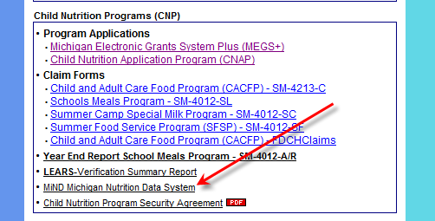

1. Login with a valid MEIS Login and password. Make sure your Child Nutrition Programs- Security Access Form is up to date. If you previously had access to the LEARs report you will be able to login to MiND using the same username and password.

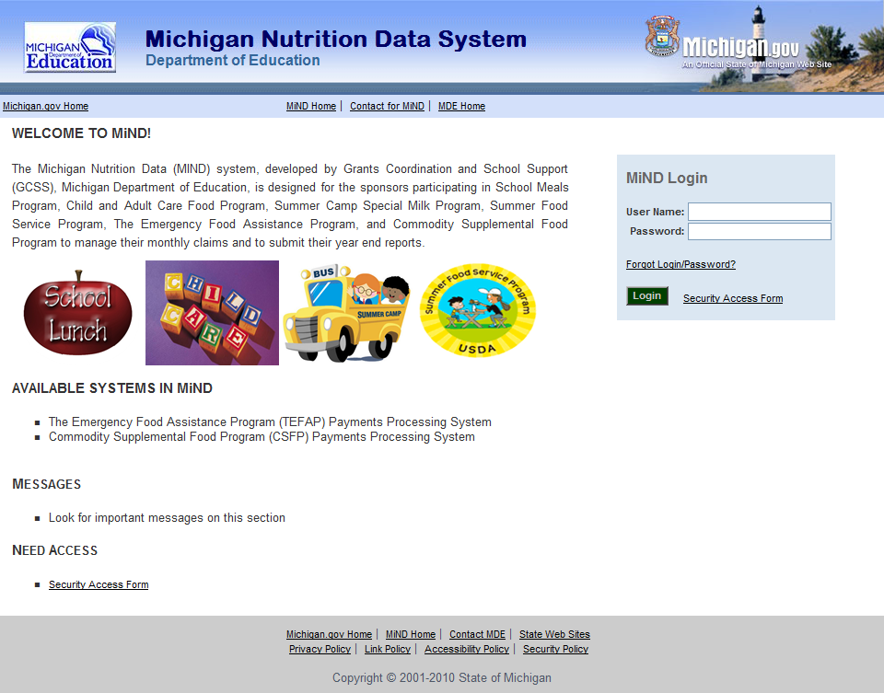

1. Click on Verification Collection Report.

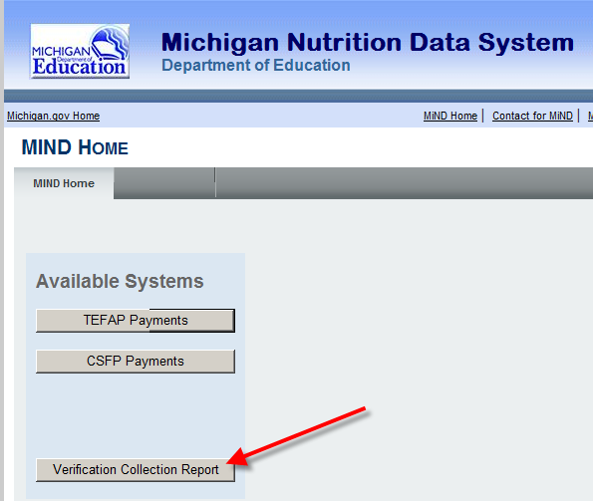

**Reminders before you get started:**

1. If you need to leave the screen at any time while completing the report, click the save button at the bottom of the form. It is a good idea to periodically save the data you have entered.

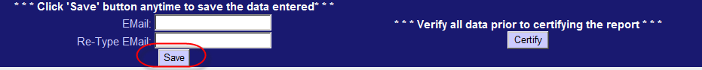

1. Please make sure your current email address is correct in the area provided at the bottom of the form.

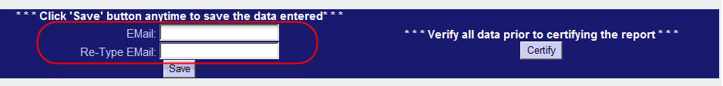

1. If you need more information about the report, **click on the help** **button** located in the upper right hand corner of the form.

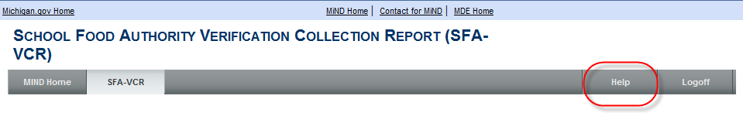

**II. Completing the SFA-VCR:**

The top of the form is prepopulated by MDE and includes the SFA or RCCI sponsor ID, School Food Authority (SFA) name, and school year.

In the next area **you must click on the radio button to choose public or private SFA.**

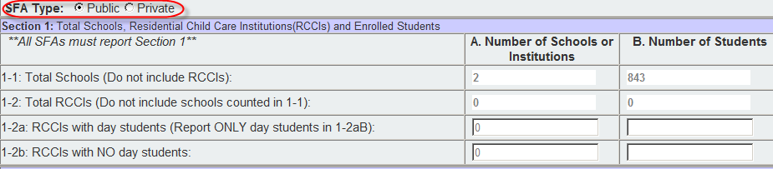

**III: The SFA-VCR is organized into 5 sections:**

**Section 1:**

Sections 1-1 Column A and 1-2 Column B are prepopulated for all SFAs and Residential Child Care Institutions (RCCIs) operating the National School Lunch Program (NSLP) and/or the School Breakfast Program (SBP), including SFAs and RCCIs that are exempt from verification requirements. The information in this section is **reported as of the last operating day in October**. You will not be able to change these numbers, unless you amend your October 2013 claim.

Sections 1-2a and 1-2b Columns A and B must be completed by the SFA and or RCCI as applicable.

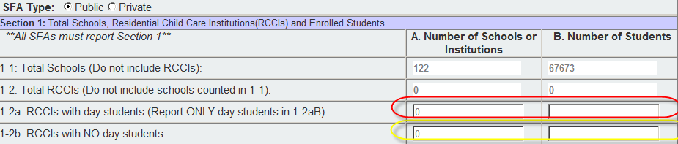

*Helpful tips for Section 1:*

* *Section 1-2a Column A is the number of schools or institutions with day students.*
* *Section 1-2a Column B should only include RCCIs with day students.*
* *Section 1-2b Column A is the number of institutions without day students.*
* *Section 1-2b Column B should only include the number of students that are* ***not*** *day students.*

**Section 2:**

Section 2 is for SFAs operating the Community Eligibility Option. Report the number of CEO schools or Institutions operating the NSLP and/or SBP and the number of enrolled students with access to the NSLP and/or SBP as of the **last operating day in October.** This section is prepopulated and you will not be able to change the numbers.



*Helpful tips for Section 2:*

* *If you are* ***not*** *operating the community eligibility option skip this section.*
* *Section 2-1 Columns A and B are prepopulated and you will not be able to change these numbers.*

**Section 3:**

Section 3 is for reporting students approved as free eligible and not subject to verification. All SFAs must report Section 3 or check box 3-1 if applicable.

**3-1:** Check the box in section 3-1 **only** if all schools and/or RCCIs in the SFA were not required to perform direct certification with Supplemental Nutrition Assistance Program (SNAP).



**3-2 Column A:** This section is prepopulated by CEPI. You will not be able to change this number.

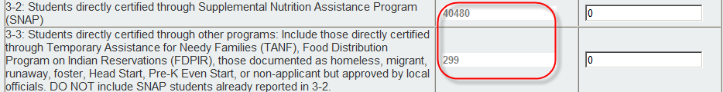

**3-2 Column B:** Include students directly certified with SNAP **as of the last operating day of October.** Also include in this count any student in the SFA deemed eligible based on extended categorical eligibility via an eligible student in the household who has been directly certified with SNAP.

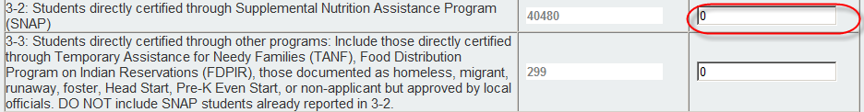

**3-3 Column B:** Include students directly certified through programs other than SNAP. Include those students directly certified through Temporary Assistance for Needy Families (TANF), Food Distribution Program on Indian Reservations (FDPIR); students documented as foster, homeless, runaway, Head Start, Pre-K Even Start, or non-applicant but approved by local officials. Also include any student in the SFA deemed eligible based on extended categorical eligibility via a student in the household that was directly certified through TANF, foster child, or FDPIR. **Do not include SNAP students already reported in 3-2 Column B.**



*Helpful tips for Section 3-2 and 3-3 Column B:*

* SNAP will always be listed first in the direct certification report even if a student is eligible for another program as well as SNAP.
* To determine the number of directly certified SNAP eligible subtract the number of directly certified TANF and Foster listed on the direct certification report.
* The numbers you enter in column 3-2 B do not have to be the same as the prepopulated numbers in 3-2 A.
* Anticipate the numbers you enter in 3-2 B may be greater than the prepopulated numbers in 3-2 A.

**Section 4:**

All SFAs with schools and/or RCCIs collecting individual household applications must report this section.

* Report number of **applications** in column A **approved as of**

**October 1, 2013.**

* Report number of **students** in column B **as of the last operating day in October 2013.**

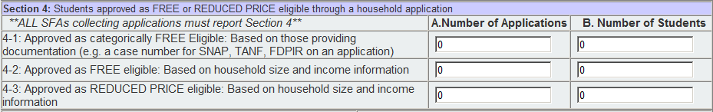

**4-1 Column A**: Report the number of **applications** approved FREE eligible based on documentation submitted on an application (i.e. case number for SNAP, TANF, or FDPIR) on file **as of** **October 1, 2013.**

**4-1 Column B:** Report the number of **students** **as of the** **last operating day in October 2013** approved FREE eligible based on an **application**. The number reported in this column **does not** include students that were directly certified.

Examples of students approved for FREE eligibility on applications that would be reported in 4-1 Column B:

* Students listed on a **household application** with a SNAP, TANF, or FDPIR case number.
* Students that are categorically eligible for FREE eligibility because they reside in the primary household with a student that is FREE eligible from a SNAP, TANF, or FDPIR case number on an **application.**

*Helpful tips for Section 4-1 Columns A and B:*

* *The information reported in Section 4-1 is from applications with case numbers (SNAP, TANF, and FDPIR). Do not report students that are directly certified.*
* *Make sure the students reported in 4-1 Column B are not on the direct certification list. Direct Certification takes precedence over applications.*

**4-2 column A:** Report the number of **applications** approved FREE eligible based on income information submitted by the household on file **as of October 1, 2013.**

**4-2 column B:** Report the number of **students** approved FREE eligible based on income information submitted by the household on file as of **the last operating day of October 2013.**

**4-3 column A:** Report the number of **applications** approved **REDUCED PRICE** **eligible** based on income information submitted by the household on file **as of October 1, 2013.**

**4-3 column B:** Report the number of **students** approved **REDUCED PRICE eligible** based on income information submitted by the household **as of the last operating day of October 2013.**

**T-1:** Total Free eligible students reported (this will be totaled automatically).

**T-2:** Total Reduced Price eligible reported (this will be totaled automatically).



**Section 5:**

All SFAs must report Section 5 or check box 5-1 if applicable.

**5-1:** Check the box if all schools and/or RCCIs in the SFA are exempt from verification activities. No further reporting is required in section 5.



**Verification activities are not required for:**

* Schools/RCCIs in which **all** children have been certified under direct certification procedures including children documented as foster, migrant, runaway or homeless children;
* RCCIs which do not have day students;
* Schools electing the Community Eligibility Provision;
* Schools participating only in the Special Milk Program;
* Schools which do not have any free or reduced price eligible students;
* Other FNS determined exemptions on a case-by-case basis.

**5-2:** Click on the correct radio button to indicate whether verification was performed and completed by the deadline of November 15th. If verification was completed after the deadline, report the remainder of section 5 as applicable.



**5-3:** Click on the radio button next to the type of verification process used.

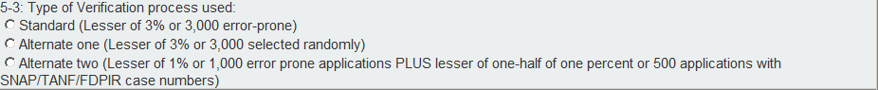

* Standard (Lesser of 3% or 3,000 error prone)
* Alternate one (Lesser of 3% or 3,000 selected randomly)
* Alternate two (Lesser of 1% or 1,000 error prone applications Plus lesser of one-half of one percent or 500 applications with SNAP/TANF/FDPIR case numbers)

*Helpful tips for section 5:*

* *Standard Verification was formerly called Basic Sampling*
* *Alternate One Verification was formerly called Alternative Random Sampling*
* *Alternate Two Verification was formerly called Alternative Focused Sampling*

**5-4:** Report the total number of error prone applications on file as of

October 1, 2013.

**If 1 or 3 is checked in section 5-3, then complete the information for 5-4:**



**If 2 is checked in section 5-3, N/A will be prepopulated in 5-4:**



**5-5:** Report the number of applications selected for the verification sample according to the type of verification process used in 5-3.



**5-6:** This section is where the results of verification from November 15, 2013, are reported. Each category and the outcome from the original benefit are reported in the 3 boxes at the bottom of the form.

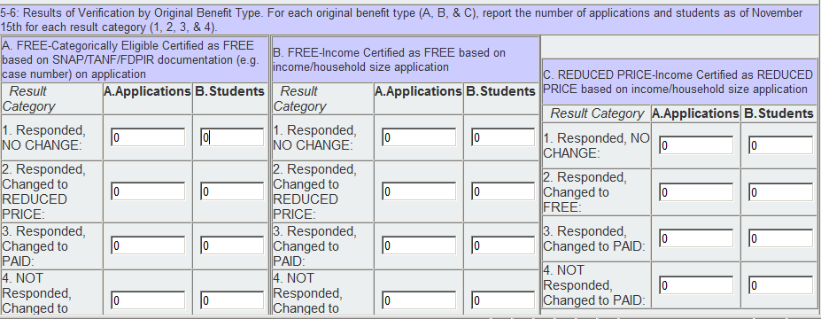

**Categories in Boxes A, B, & C:**

* **Category in box A:** FREE-Categorically Eligible Certified as FREE based on SNAP/TANF/FDPIR documentation (e.g. case number) on application.
* **Category in box B:** FREE-Income Certified as FREE based on income/household size application.
* **Category in box C:** REDUCED PRICE-Income Certified as REDUCED PRICE based on income/household size application.

Each Category has four rows/sections. The first three rows (A-1, 2, 3; B-1, 2, 3; and C-1, 2, 3) are for households that **responded** with appropriate documentation as of **November 15, 2013.**  The last row (A-4, B-4, and C-4) is for households that **did not** respond.

**Row A-1, B-1, and C-1:** Report the number of **applications** with no change in **Column A** and the number of **students** on these applications in **Column B.**

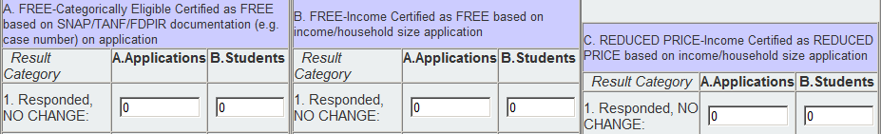

**Row A-2, B-2, and C-2:** Report the number of **applications** that were changed from the original benefit to REDUCED PRICE in **Column A** and the number of **students** on these applications in **Column B**.



**Row A-3, B-3, and C-3:** Report the number of **applications** that were changed from the original benefit to PAID in **Column A** and the number of **students** on these applications in **Column B.**



**Row A-4, B-4, and C-4:** Report the number of applications that were changed from the original benefit to **PAID** due to the household not responding. Report the number of applications changed from the original benefit to **PAID** in **Column A** and the number of **students** on theseapplications in **Column B.**



**VC-1:** If applicable enter the total number of questionable applications verified for cause in addition to the verification requirement as of

November 15, 2013.



Applications that are verified for cause are not considered part of the required sample size. Include the results of verification for cause by original benefit type from the appropriate category and row in section 5-6.