mdhhs-5598, american indian/alaska native (ai/an)
child/parent tribal enrollment/eligibility verification
Michigan Department of Health and Human Services
(Revised 5-22)

ATTN: Indian Child Welfare Matter/ICWA Tribal Agent
INSERT NAME OF AGENT
INSERT ADDRESS OF AGENT
INSERT CITY/STATE/ZIP CODE OF AGENT

Specific Tribe, if known.
If multiple tribes identified, this verification request must be sent to the identified tribe’s ICWA Tribal Agent cited in the Federal Register ICWA Designated Tribal Agent Listing.
Please utilize this form to verify Indian ancestry in appropriate cases. If a court case has been initiated, please also utilize the DHS-120 and attach this form. Pursuant to the Indian Child Welfare Act (ICWA)
25 USC 1901 et seq., Michigan Indian Family Preservation Act (MIFPA) MCL 712B. 1 – 41, 45 CFR 1355 Adoption and Foster Care Analysis and Reporting System (AFCARS) regulations, and Bureau of Indian Affairs (BIA) ICWA Final Rule 25 CFR 23, please be advised that the Michigan Department of Health and Human Services (MDHHS) is seeking enrollment/eligibility verification.
section 1 – indian child (Caseworker completes this section)

Child's Name | Date of Birth

Caseworker's Name | Caseworker's Signature | Date

Caseworker's Email Address | Caseworker's Telephone Number

Supervisor's Name | Supervisor's Signature | Date

Supervisor's Email Address | MDHHS County

MDHHS County Office Mailing Address | City | State | Zip Code

SECTION 2 – TRIBAL CHILDREN'S PROTECTIVE SERVICES (CPS) INFORMATION REQUEST AND/OR MEMBERSHIP/ELIGIBILITY VERIFICATIONS (Tribe completes this section)
Please return verification response to child’s caseworker regarding child, mother, and father’s membership/eligibility status in the tribe. Child’s Biological Family History is attached to assist with determination of membership or eligibility for membership status of the child and parents (see page 3-4).

Representative/Tribe/Agency is (Check all that apply):
Investigating a family [MCL 722.627(2)(a)]
Placing a child [MCL 722.627(2)(d)]
Monitoring active efforts [MCL 722.627(2)(e)]
Providing services to a child or family [MCL 722.627(2)(e)] and

Tribal representative requests copies of the following Children’s Protective Services (CPS) record information:
Complaint Intake
DHS-154, Initial Service Plan (ISP), more commonly referred to as the CPS Investigation Report
DHS-152, Updated Service Plan (USP)
DHS-151, Children’s Protective Services Service Agreement
DHS-1105, Family Team Meeting Report
Risk Assessment
Safety Assessment
Risk Re-assessment
Safety Re-assessment
Closing USP
DHS-259, Family Assessment of Needs and Strengths (FANS)
Child Assessment of Needs and Strengths (CANS)
Trauma Screening Checklist

Child's Name | Date of Birth

Child’s Tribal Affiliation (Verification Required per 25 USC 1901 et seq./MCL 712B. 1 - 41)

Mother's Tribal Affiliation (Verification Required per 45 CFR 1355)

Father's Tribal Affiliation (Verification Required per 45 CFR 1355)

Tribal Representative Name

Tribal Representative Signature (Sign and scan document or create a .pdf document and .pdf signature to submit to MDHHS)

Tribal Representative Email Address | Tribal Representative Telephone Number

The Michigan Department of Health and Human Services will not exclude from participation in, deny benefits of, or discriminate against any individual or group because of race, sex, religion, age, national origin, color, height, weight, marital status, partisan considerations, or a disability or genetic information that is unrelated to the person’s eligibility.

section 3 – CHILD’S BIOLOGICAL FAMILY HISTORY Caseworker and family complete this section. (Please complete as thoroughly as possible.)

Child’s Name | Date of Birth | Place of Birth

Native American?  Yes No Absent Parent/Unknown | Tribe/Enrollment Number

Child’s Father's Name | Date of Birth | Place of Birth

Child's Father's Name (Other Family Name through Marriage Hyphenation, etc.)

Paternal Status Type
Legal Father Biological Father Putative Father

Date of Death | Place of Death | Native American?  Yes No Absent Parent/Unknown

Tribe/Enrollment Number | Former Address

Child’s Mother's Name | Date of Birth | Place of Birth

Child's Mother's Name (Maiden/Former)

Child's Mother's Name (Other Known Family Name)

Is Child’s Mother Adopted?  Yes No | If yes, name of child’s biological maternal grandmother

Date of Death | Place of Death | Native American?  Yes No Absent Parent/Unknown

Tribe/Enrollment Number | Former Address

Paternal Grandfather’s Name | Date of Birth | Place of Birth

Date of Death | Place of Death | Native American?  Yes No Absent Parent/Unknown

Tribe/Enrollment Number | Address

Paternal Grandmother's Name | Date of Birth | Place of Birth

Date of Death | Place of Death | Native American?  Yes No Absent Parent/Unknown

Tribe/Enrollment Number | Address

Maternal Grandfather’s Name | Date of Birth | Place of Birth

Date of Death | Place of Death | Native American?  Yes No Absent Parent/Unknown

Tribe/Enrollment Number | Address

Maternal Grandmother's Name | Date of Birth | Place of Birth

Date of Death | Place of Death | Native American?  Yes No Absent Parent/Unknown

Tribe/Enrollment Number | Address

Paternal Great Grandfather’s Name | Date of Birth | Place of Birth

Date of Death | Place of Death | Native American?  Yes No Absent Parent/Unknown

Tribe/Enrollment Number

Paternal Great Grandmother's Name | Date of Birth | Place of Birth

Date of Death | Place of Death | Native American?  Yes No Absent Parent/Unknown

Tribe/Enrollment Number

Maternal Great Grandfather’s Name | Date of Birth | Place of Birth

Date of Death | Place of Death | Native American?  Yes No Absent Parent/Unknown

Tribe/Enrollment Number

Maternal Great Grandmother's Name | Date of Birth | Place of Birth

Date of Death | Place of Death | Native American?  Yes No Absent Parent/Unknown

Tribe/Enrollment Number

Paternal Great Grandfather’s Name | Date of Birth | Place of Birth

Date of Death | Place of Death | Native American?  Yes No Absent Parent/Unknown

Tribe/Enrollment Number

Paternal Great Grandmother's Name | Date of Birth | Place of Birth

Date of Death | Place of Death | Native American?  Yes No Absent Parent/Unknown

Tribe/Enrollment Number

Maternal Great Grandfather’s Name | Date of Birth | Place of Birth

Date of Death | Place of Death | Native American?  Yes No Absent Parent/Unknown

Tribe/Enrollment Number

Maternal Great Grandmother's Name | Date of Birth | Place of Birth

Date of Death | Place of Death | Native American?  Yes No Absent Parent/Unknown

Tribe/Enrollment Number

mdhhs-5598, american indian/alaska native (ai/an)
child/parent tribal enrollment/eligibility verficiation
instructions: completion/mailing guidance
- All client and caseworker’s contact information must be completed.
- Family History: Fill in as many boxes as possible. Caseworkers should try to complete up to great-grandparent boxes on the MDHHS-5598 form. Some tribal enrollment offices require more than a biological mother and father; many tribes require great-grandparents. Caseworkers may also add other relatives beyond those identified in the boxes on page four to assist tribal enrollment offices with identifying the child’s family and/or familial connections (Ex: Aunt, Uncle, Cousin, Niece, Nephew, etc.).
  - See genogram example on page 6.
- Workers should contact the tribe as soon as possible if there is reason to know the child is an Indian child; see NAA 200 Identification of a Indian Child Policy and 25 CFR 23.107(c). for "reason to know" phrase definition and guidance.
- Caseworkers must obtain verification of child and parent tribal membership/eligibility utilizing this form to complete ICWA/MIFPA and Adoption and Foster Care Analysis Reporting System (AFCARS) requirements in MiSACWIS.
- Native American Affairs (NAA) policy requires verification of an Indian child for putative father cases. Note: If there are multiple alleged fathers in one case, a genogram for each alleged father must be completed.
- Caseworkers should only check the Absent Parent/Unknown box when the whereabouts of the parent is unknown.
- Upon return of the MDHHS-5598 form from a tribe verifying the tribal child's membership/eligibility, the county must directly release the following sections only of the CPS Centralized Intake (CI) report without redaction to an Indian child’s tribe: Reason for service which identifies the complaint date, case name, etc.; Member household information; Allegation comments; Safety comments; Supervisor complaint action comments; Complaint action override comments. Caseworkers must follow SRM 131 Confidentiality requirements for redaction of CPS history on a Centralized Intake (CI) report request. If a MDHHS-5598 is returned with the checkbox(es) selected requesting a tribal youth’s Children’s Protective Services information, caseworkers should complete the PROFESSIONAL CHILD PROTECTIVE SERVICES (CPS) REDACTION REQUEST CHECKLIST and send the request to the Redaction Unit at DHHS-Redaction-Unit@michigan.gov within one business day of receipt for CPS ISP, CPS USP and Closing reports.
a. No CPS information should be sent with the MDHHS-5598 form at initial mailing.
- Caseworkers may fax, email or send the MDHHS-5598 regular mail to the child’s tribe’s ICWA Designated Tribal Agent at the Bureau of Indian Affairs (BIA) ICWA Designated Tribal Agent List at (https://www.bia.gov/bia/ois/dhs/icwa). The MDHHS-5598 may only be sent to tribes/bands listed on the Federal Register.
Caseworkers should contact the respective ICWA Designated Tribal Agent per tribal government for their preference on MDHHS-5598 transmission (mail, email, fax, etc.); see CPS Investigative Flow Chart for Michigan Tribal CPS Protocol at https://www.michigan.gov/documents/mdhhs/CPS_Investigation_Flow_Chart_650666_7.pdf. Caseworkers should utilize the BIA website or Federal Register information if a Michigan tribe does not have CPS protocol cited in the CPS Investigation Flow Chart.
An MDHHS-5598 must be sent for each new child welfare episode; even if the tribal enrollment/eligibility was verified or denied previously.
Genogram Aid

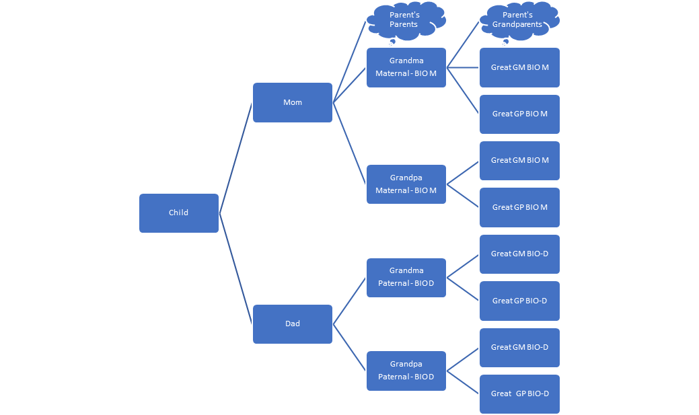

Paternal Grandfather’s Name = BIO Dad’s Father’s Name
Paternal Grandmother’s Name = BIO Dad’s Mother’s Name
Maternal Grandfather’s Name = BIO Mom’s Father’s Name
Material Grandmother’s Name = BIO Mom’s Mother’s Name
Paternal Great Grandfather’s Name = BIO Dad’s Grandfather’s Name (BIO Dad’s Fathers’ Father’s Name)
Paternal Great Grandmother’s Name = BIO Dad’s Grandmother’s Name (BIO Dad’s Fathers’ Mother’s Name)
Paternal Great Grandfather’s Name = BIO Dad’s Grandfather’s Name (BIO Dad’s Mothers’ Father’s Name)
Paternal Great Grandmother’s Name = BIO Dad’s Grandmother’s Name (BIO Dad’s Mothers’ Mother’s Name)
Maternal Great Grandfather’s Name = BIO Mom’s Grandfather’s Name (BIO Mom’s Fathers’ Father’s Name)
Maternal Great Grandmother’s Name = BIO Mom’s Grandmother’s Name (BIO Mom’s Fathers’ Mother’s Name)
Maternal Great Grandfather’s Name = BIO Mom’s Grandfather’s Name (BIO Mom’s Mothers’ Father’s Name)
Maternal Great Grandmother’s Name = BIO Mom’s Grandmother’s Name (BIO Mom’s Mothers’ Mother’s Name)

Midwest Region Indian Child Welfare Act Tribal
Agent Listing for Mailing ICWA Notices to Michigan Tribes
Michigan Department of Health and Human Services
Midwest Regional Director, 5600 West American Blvd., Suite 500, Norman Pointe II Building, Bloomington, MN 55437; Telephone: 612-713-4400; Fax: 612-713-4453
Bay Mills Indian Community, Phyllis Kinney, Tribal Court Administrator, 12140 W. Lakeshore Dr., Brimley, MI 49715; Phone: 906-248-3241, 906-8811; Fax: 906-248-5817; Email: phyllisk@baymills.org
Grand Traverse Band of Ottawa and Chippewa Indians, Maria Guillen, Anishinaabek Family Services Supervisor, 2605 N. West Bayshore Drive, Peshawbestown, MI 49682-9275; Telephone: 231-534-7681; Fax: 231-534-7706; Email: maria.guillen@gtb-nsn.gov
Hannahville Indian Community of Michigan, Wendy Lanaville, ICWA Worker, N15019 Hannahville B1 Road, Wilson, MI 49896; Telephone: 906-723-2512; Fax: 906-466-7397;
Email: wendylanaville@hichealth.org
Keweenaw Bay Indian Community, Corey Pietila, Director Social Service, 16429 Beartown Road, Baraga, MI 49908; Telephone: 906-353-4201; Fax: 906-353-8171; Email: cpietila@kbic-nsn.gov
Lac Vieux Desert, Dee Dee McGeshick, Social Services Director, P.O. Box 249, Watersmeet, MI 49969; Telephone: 906-358-4940; Fax: 906-358-4900; Email: dee.mcgeshick@lvdtribal.com
Little River Band of Ottawa Indians, Marissa Kist, ICWA Designated Tribal Agent, 2608 Government Center Drive; Manistee, MI 49660; Telephone: 231-398-2242; Fax: 231-398-3387;
Email: marissakist@lrboi-nsn.gov
Little Traverse Bay Bands, Heather Boening, Human Services Director, 7500 Odawa Circle, Harbor Springs, MI 49740; Telephone: 231-242-1620; Fax: 231-242-1635
Email: hboening@ltbbodawa-nsn.gov
Match-E-Be-Nash-She-Wish Band of Potawatomi Indians of Michigan (Gun Lake Tribe), Dominique Ambriz, 2880 Mission Drive, Shelbyville, MI 49344; Telephone: 269-397-1760; Fax: 269-397-1761; Email: dominique.ambriz@hhs.glt-nsn.gov
Nottawaseppi Huron Band of the Potawatomi, Meg Fairchild, Social Services Manager, 1485 Mno Bmadzewen Way, Fulton, MI 49052; Telephone: 269-729-5151; Fax: 269-729-5920;
Email: mfairchild@nhbp.org
Pokagon Band of Potawatomi Indians, Mark Pompey, Social Services Director, 58620 Sink Road, Dowagiac, MI 49047; Telephone: 269-782-8998; Fax: 269-782-4295;
Email: mark.pompey@pokagonband-nsn.gov
Saginaw Chippewa Indians Tribe (SCIT), Attn: Patrick Nahgahgwon, ICWA Designated Tribal Agent, 7500 Soaring Eagle Boulevard, Mt. Pleasant, MI 48858; Telephone: 989-775-4909; Fax: 989-775-4912
Email: icwa@sagchip.org; agonzalez@sagchip.org
Sault Ste. Marie Tribe of Chippewa Indians, Melissa VanLuven, ICWA Program Director, 2218 Shunk Rd, Sault Ste. Marie, MI 49783; Telephone: 906-632-5250; Fax: 906-632-5266;
Email: ICWA-MIFPA-Contacts@saulttribe.net
Find a designated tribal agent for service notices for all tribes online at: https://www.bia.gov/bia/ois/dhs/icwa/agents-listing/

