Last Updated: 9/30/20


The #MichiganStudentsVote Campaign was designed to host student voter engagement resources that administrators, students and partners can use to help get out the vote leading up to Election Day.

Together we've learned from past campus democratic engagement efforts, shared strategies to institutionalize civic efforts on campus and strengthened the network of Michigan college campuses working to amplify student voices in our democracy. Now, we use this toolkit and calendar in hopes of mobilizing Michigan students!

Please use the resources in this toolkit to help educate and empower student voters on their rights and options this fall. You can tag the Michigan Department of State or Democracy MVP Poll Worker Recruitment initiative in any of your posts or videos @MichSoS or @DemocracyMVP

Table of Contents:

Introduction

Safe, Secure and Accessible Elections

Key Messages

Important Dates & Deadlines

Important Links

Tools to Take Action

Campus Engagement Calendar

Sample Newsletter

Sample Email

Sample Social Media Posts

Graphics

Voter Information 101

Register to Vote

Same-Day Voter Registration

Absentee Voting
FAQ

Additional Resources

Ballot Guides

Resources from our Partners

INTRODUCTION

Key Messages

As a student or school administrator, you can take action and be a trusted source of information for your campus and peers by providing trusted information to voters across the state regarding the Nov. 3, 2020 election on social media, group texts, websites, newsletters, emails and in other communications.

This toolkit contains the tools you need to help spread the word.

Key messages and goals:
- Register and Vote Early: Encourage students to register and vote early at their local clerk’s office! This is the easiest, fastest way to register and to vote - and it helps keep lines at clerk’s offices and polling locations shorter on Election Day. It is especially important in the Nov. 3, 2020 election because of slowed U.S. postal services and the need for social distancing at in-person polling locations. REGISTER EARLY. VOTE EARLY.
- Make a Plan to Vote: All voters, including students, need to make a plan to vote this year. In Michigan, voters have options, so students can choose what is best for them. They can safely vote from home, or they can vote in person at their polling place, which will follow all social distancing and safety protocols for the protection of voters and workers.
- Plan Ahead: Encourage those voting from home to mail in their ballots at their earliest opportunity (Recommended: at least two weeks before Election Day). Another good option is to deliver them in person to their local clerk’s office or drop box. Voters can find this information at Michigan.gov/Vote.
- Your Right to Register on Election Day: As we approach Election Day, make sure students know that they have a right to register and vote up to and on Election Day. Crucially, after October 19, students can only register at their local clerk’s office.
- Be a Poll Worker! Encourage students to become poll workers! The U.S. is currently experiencing a nationwide poll worker shortage caused by the COVID-19 pandemic. Michigan is counting on lower-risk populations, like students, to step up and fill this poll worker gap. As a poll worker, you will be trained to work elections or count absentee voter ballots, and you will be paid for your time. Learn more at Michigan.gov/DemocracyMVP
- Become a Democracy Fellow! Help your peers get out the vote! Seeking students who are self-starters, democratically engaged, politically interested and willing to help peers register to vote and engage in dialogue around democracy. Learn more at campusvoteproject.org/democracy-fellows

- Use accurate information on social media to get out the word: Feature Secretary of State channels as the go-to source for election information:
  - Michigan.gov/Vote is the go-to source for all voting information and resources.
  - Twitter: @MichSoS
  - Facebook and Instagram: @michigansos
  - The official hashtags are #MIPlan2Vote and #MIStudentsVote

Important Dates & Deadlines

Michigan students, be sure to save the date! If you would like access to the Google calendar to embed on your website, please email Sumaiya Ahmed Sheikh at sahmed@campusvoteproject.org.

September 2020
- September 24: Absentee ballots available
  - Clerks begin to mail ballots to voters who requested to vote from home.
  - In-person absentee voting becomes available in city and township clerk offices.

October 2020
- October 19: General Election Online Voter Registration Deadline!
  - This is the last day to register to vote online or through the mail for the November general election.
- October 19: If voting by mail, place your ballot in the mail
  - Starting approx. 2 weeks from Election Day, we recommend students drop off their ballot at their clerk’s office or drop box. You can find your local clerk’s information, as well as the location of anydrop boxes for your jurisdiction, by visiting Michigan.gov/Vote and selecting “Who is my clerk?”
- October 20-November 3: Register and vote in person at clerk’s office
  - Starting October 20, voters must register to vote in person at your city or township clerk’s office or satellite office and provide additional residency documentation. You can find your local clerk’s information, as well as information on satellite offices by visiting Michigan.gov/Vote and selecting “Who is my clerk?”
  - Good news: You can register and vote early all in one visit!
- October 31-November 1: Clerks’ offices must be open on Saturday or Sunday for at least eight hours for in person voter registration and absentee voting.

If you encounter any issues with your clerk’s open hours, contact the Michigan Department of State at Elections@Michigan.gov.

November 2020
- November 3: Election Day!
  - Polls are open from 7 a.m. to 8 p.m. local time. If you are in line before 8 p.m., you will be able to vote. To find your polling place, visit Michigan.gov/Vote and select “Where’s my polling place?”

  - Students who have not yet registered to vote can register and vote by visiting their local clerk’s office or satellite office. To find your local clerk’s office, visit Michigan.gov/Vote and select “Who is my clerk?”

Important Links

Michigan’s Secretary of State office maintains a “catch-all” website that contains personalized voting information and resources, do yourself a favor and bookmark it > Mmichigan.gov/Vote.

- Am I registered to vote?
- What’s on my ballot?
- Where is my clerk’s office or drop box?
- Where’s my polling location?
- Apply for an absentee ballot
- Register to vote
TOOLS TO TAKE ACTION

Campus Engagement Calendar

Michigan students, be sure to save the dates! Click here to access the public URL to the Michigan Campus Engagement Calendar.
If you’d like the embed code to host the calendar on your campus website and/or if you have an event to add to the calendar, please email Sumaiya Ahmed Sheikh at sahmed@campusvoteproject.org.

Weeks of September 1 - September 24: Register and Request AV Ballot
- Key Dates/Holidays
￮ September 16 - | Constitution Day!
￮ September 18 - | National Black Voter Day!
￮ September 22 - | National Voter Registration Day!
￮ September 24 - | In-person absentee voting is available in city and township clerk’s offices for the Nov. 3 general election.
Suggested Actions
  - Plan National Voter Registration Day outreach and events on your campus! Include absentee ballot request forms at these events, whether virtual or in-person.
  - Encourage early registration and requesting to vote from home by sharing on social media or sending newsletters or emails about voter registration.
  - Spread the word about becoming poll workers by sharing @DemocracyMVP content on Twitter, Facebook and Instagram.

Weeks of September 28 - October 12: Register and Vote Early; Return AV Ballots
- Key Dates/Holidays
￮ September 29 | First presidential debate
￮ October 7 | Vice Presidential Debate
￮ October 15 | Second Presidential Debate

Suggested Actions:
  - Plan a voter registration drive or hand out absentee voter ballot applications for your campus.
  - Plan a “Students Vote Early” day on your campus where students can request their absentee ballots online, or visit their clerk’s office to request an AV ballot and cast their ballot early. Promote this event on social media and tag @MichSoS and @DemocracyMVP for amplified messaging.
  - Plan a presidential debate virtual watch party that includes voter registration and AV ballot requests.
  - Encourage early voting and voter registration by sharing graphics on social media or sending newsletters or emails about voting options.

Weeks of October 19 - October 26: Register and Vote Early; Return AV Ballots

- Key Dates/Holidays:
￮ October 19 | General Election Online & Absentee Voter Registration Deadline!  Starting on October 20 through 8 p.m. on Election Day you must register to vote in person at your city or township clerk’s office and provide “proof of residency.”
￮ October 19 | Recommended deadline to place ballots in the mail to ensure it arrives by 8 p.m. on Election Day. After this date, we recommend students return their absentee ballot by dropping it off at your city or township clerk’s office or ballot drop box. You can find your local clerk’s information, as well as the location of their drop box by visiting Michigan.gov/Vote and selecting “Who is my clerk?”  Note: Absentee ballots must be RECEIVED by your clerk by 8 p.m. on Election Day.
￮ Oct 20 to  Nov 3 | In-Person Voter Registration: Students who are not yet registered to vote must register in person at their city or township clerk’s office. They can register and vote all in one visit. Note: Students must provide additional proof of residency.
￮ October 22 | Third Presidential Debate
￮ October 24 | Vote Early Day!
￮ October 30 | The deadline to request a ballot by mail  Your request must be received by 5 p.m. the Friday before the election (October 30, 2020). However, this close to Election Day, it is highly recommended that voters go their clerk’s office to request, fill out and submit their ballot in person.
￮ Oct 31 to  Nov 1 | Clerks’ offices must be open for at least eight hours for in-person absentee voting.

Suggested Actions:
  - Keep students aware of dates and deadlines. Post social media reminders and send out emails for:
    - Last day to register to vote online
    - Recommended deadline for putting ballots in the mail
    - First day of in-person voter registration
    - Last day to request an AV ballot through the mail
  - Promote registering and voting early at your local clerk’s office or satellite office.
  - Plan a Vote Early Day event and promote on social media and in newsletters
Note: The early voting period runs from Thursday, September 24, 2020 to Monday, November 2, 2020, but dates and hours for your city or township clerk may vary based on where you live.

Week of November 2: Election Week
- Key Dates/Holidays:

￮ November 2 | Last day to vote early in-person. Must visit clerk’s office by 4 p.m.
￮ November 3 | Election Day! Polls are open from 7 a.m. to 8 p.m. local time. Students can register to vote and vote in person at local clerk’s office or satellite office.

Suggested Actions:
  - Post social media reminders and send out emails for the day before Election Day, encouraging students to skip the line and vote early (the last day to do so for registered voters).
  - On Election Day, post social media reminders and send out emails reminding students to vote and about same-day registration.

Michigan’s Secretary of State office maintains a “catch-all” website that contains personalized voting information and resources, do yourself a favor and bookmark it > Mmichigan.gov/Vote.

Sample Newsletters

Newsletter Sample I - Register to Vote

Don’t sit on the sidelines this election - make your voice be heard. Make a plan to register to vote!
Here is the information you need to know to register to vote in November:
- Check your voter registration - Even if you think you know your status. Visit Michigan.gov/Vote to verify your voter information or register to vote.
- REGISTER EARLY – It is easier, faster and requires less documentation. From now until October 19, you can:
  - Register online at Michigan.gov/Vote (if you have a valid Michigan driver’s license or state ID)
  - Fill out this form and return it to your local clerk’s office. You can use this application to register to vote even if you do not have a Michigan ID or driver’s license. You can find your local clerk’s mailing and email address at Michigan.gov/Vote.
  - Register in person at your local Secretary of State office or city/township clerk’s office

Note: in Michigan, you have the right to register up to and on Election Day. After October 19, in order to register to vote, you must visit your local clerk’s office in person and provide additional proof of residency. You can find your local clerk at Michigan.gov/Vote.

- Make a Plan to Vote - In Michigan, you can vote from home by absentee ballot, vote early at your clerk’s office, or vote in person at your polling place on Election Day. To learn more about your options and make a plan, visit Michigan.gov/Vote.

FAQ

Do I need a photo ID or proof of citizenship to vote or to register?
No. You will be asked for a photo ID when you vote or register in person. If you don’t have one or don’t have one with you, you can sign a simple form and then register or vote.

Does registering to vote enter me into jury duty?
No. Jury duty pools are not pulled from voter registration rolls in Michigan.

Do I need to wear a mask to vote?
Wearing a mask is strongly encouraged when voting in person - but it is not required. Polling locations on Election Day will be regularly sanitized, and social distancing will be enforced. You can also vote safely and securely at home using an absent voter ballot! If you are already a registered voter, the deadline to request an AV ballot by mail is October 30, and the deadline to request an AV ballot in person at your clerk’s office is November 2. If you are not already a registered voter, you can register and request an AV ballot at your clerk’s office up to and on Election Day!

Is absentee voting secure?
Yes. Voting by mail, or absentee voting, is very secure and accurate. To learn more about the AV process and security measures, visit Michigan.gov/ElectionSecurity

- Take Action - Get involved. You can do more than registering and voting this election season. Our democracy needs you! You can sign up to be a poll worker and get paid to ensure elections are safe and secure. To be a poll worker, sign up at Michigan.gov/DemocracyMVP You can also make sure your friends and peers are registered to vote by planning a voter registration drive or sharing resources. Visit Michigan.gov/StudentVoting to learn more.

Newsletter Sample II - Vote Early

Don’t sit on the sidelines this election - make your voice be heard. Make a plan to

register to vote!
Here is the information you need to know to register to vote in November:
- Check your voter registration - even if you think you know your status. Visit Michigan.gov/Vote to verify your voter information or register to vote.

- VOTE EARLY – It is easier, safer, more convenient, and it means you won’t have to wait in lines on Election Day! To vote early at home, or in person, you can:
  - Request an Absentee Voter Ballot be mailed to you by filling out an application online at Michigan.gov/Vote.
  - Fill out this form and mail, email, or hand deliver it to your clerk’s office to request an absent voter ballot be mailed to you.
  - From September 24 through November 2, you can visit your clerk’s office to request an absentee voter ballot, vote in person at your clerk’s office, and hand it back to your clerk to cast your ballot - all in one stop!
  - If you are not already a registered voter, or if you need to update your registration address, you can visit your clerk’s office up through 8 p.m. on Election Day to register and cast an absentee voter ballot. You must bring proof of residency documents to register and vote.

Note: If your absentee voter ballot application request form is received by 5 p.m. the Friday before the election (October 30), your clerk will mail you a ballot. However, after October 19, it is highly recommended that you visit your clerk’s office in person to request, fill out, and submit your ballot.

- RETURN YOUR BALLOT - You have until 8 p.m. on Election Day to complete the ballot and return it to the clerk's office. To return your ballot, you can:
  - Take your ballot directly to your clerk’s office to turn it in.
  - Place it in your clerk’s ballot drop box.
  - Mail it to your clerk’s office. Within two weeks of Election Day, due to possible U.S. Postal Service delays, voters are encouraged to apply in person at their local clerk’s office.
To locate your clerk’s office, or your clerk’s ballot drop box, visit Michigan.gov/Vote

To vote in person at the polls on Election Day, you can visit Michigan.gov/Vote to locate your polling location.

FAQ

Do I need a photo ID or proof of citizenship to vote or to register?
No. You will be asked for a photo ID when you vote or register in person. If you don’t have one or don’t have one with you, you can sign a simple form and then register or vote.

Does registering to vote enter me into jury duty?
No. Jury duty pools are not pulled from voter registration rolls in Michigan.

Do I need to wear a mask to vote?
Wearing a mask is strongly encouraged when voting in person - but it is not required. Polling locations on Election Day will be regularly sanitized, and social distancing will be enforced. You can also vote safely and securely at home using an absent voter ballot!

Is absentee voting secure?
Yes. Voting by mail, or absentee voting, is very secure and accurate. To learn more about the AV process and security measures, visit Michigan.gov/ElectionSecurity

- Take Action - Get involved. You can do more than registering and voting this election season. Our democracy needs you! You can sign up to be a poll worker and get paid to ensure elections are safe and secure. To be a poll worker, sign up at Michigan.gov/DemocracyMVP You can also make sure your friends and peers are registered to vote by planning a voter registration drive or sharing resources. Visit Michigan.gov/StudentVoting to learn more.

Sample Emails

Dear [Insert Name],

Are you prepared for the Nov. 3 presidential election? Your voice and your vote matter. To make your voice heard this election season, don’t wait—make a plan to vote today!

This email includes a helpful guide for student voters on voter registration, voting early at home or at the polls on or prior to Election Day.

- Check your voter registration - even if you think you know your status. Visit Michigan.gov/Vote to verify your voter information or register to vote.
- REGISTER EARLY – It is easier, faster and requires less documentation. From now until October 19, you can:
  - Register online at Michigan.gov/Vote (if you have a valid Michigan driver’s license or state ID).
  - Fill out this form and return it to your local clerk’s office. You can use this application to register to vote even if you do not have a Michigan ID or driver’s license. You can find your local clerk’s mailing and email address at Michigan.gov/Vote.
  - Register in person at your local Secretary of State office or city/township clerk’s office.

Note: In Michigan, you have the right to register up to and on Election Day. After October 19, in order to register to vote, you must visit your local clerk’s office in person and provide additional proof of residency. You can find your local clerk at Michigan.gov/Vote.

- VOTE EARLY – It is easier, safer, more convenient, and it means you won’t have to wait in lines on Election Day! To vote early at home, or in person, you can:
  - Request an absentee voter ballot be mailed to you by filling out an application online at Michigan.gov/Vote.
  - Fill out this form and mail, email, or hand deliver it to your clerk’s office to request an absent voter ballot be mailed to you.
  - From September 24 through November 2, you can visit your clerk’s office to request an absentee voter ballot, vote in person at your clerk’s office, and hand it back to your clerk to cast your ballot - all in one stop!
  - If you are not already a registered voter, or if you need to update your registration address, you can visit your clerk’s office on Election Day to register and cast an absentee voter ballot. You must bring proof of residency documents to register and vote.

Note: If your absentee voter ballot application request form is received by 5 p.m. the Friday before the election (October 30), your clerk will mail you a ballot. Due to possible U.S. Postal Service delays, voters are encouraged to request a ballot by mail prior to the deadline or visit your local clerk’s office to request a ballot in person. To find your local clerk’s office, visit Michigan.gov/Vote and select “Who is my clerk?”

- RETURN YOUR BALLOT - You have until 8 p.m. on Election Day to complete the ballot and return it to the clerk's office. To return your ballot, you can:
  - Take your ballot directly to your clerk’s office to turn it in.
  - Place it in your clerk’s ballot drop box.
  - Mail it to your clerk’s office. Within two weeks of Election Day, due to possible U.S. Postal Service delays, voters are encouraged to apply in person at their local clerk’s office.
To locate your clerk’s office, or your clerk’s ballot drop box, visit Michigan.gov/Vote

To vote in person at the polls on Election Day, you can visit Michigan.gov/Vote to locate your polling location.

FAQ

Do I need a photo ID or proof of citizenship to vote or to register?
No. You will be asked for a photo ID when you vote or register in person. If you don’t have one or don’t have one with you, you can sign a simple form and then register or vote.

Does registering to vote enter me into jury duty?
No. Jury duty pools are not pulled from voter registration rolls in Michigan.

Do I need to wear a mask to vote?
Wearing a mask is strongly encouraged when voting in person - but it is not required. Polling locations on Election Day will be regularly sanitized, and social distancing will be enforced. You can also vote safely and securely at home using an absent voter ballot!

Is absentee voting secure?
Yes. Voting by mail, or absentee voting, is very secure and accurate. To learn more about the AV process and security measures, visit Michigan.gov/ElectionSecurity

- Take Action - Get involved. You can do more than registering and voting this election season. Our democracy needs you! You can sign up to be a poll worker and get paid to ensure elections are safe and secure. To be a poll worker, sign up at Michigan.gov/DemocracyMVP. You can also make sure your friends and peers are registered to vote by planning a voter registration drive or sharing resources. Visit Michigan.gov/StudentVoting to learn more.

Sample Social Media Posts

Social media is one of the most powerful tools in getting out the vote, especially in socially distanced times like these. Check out these sample social media posts below that can be used on Facebook, Twitter & Instagram.

- Don’t sit on the sidelines this election. Register to vote! It’s fast and easy. Register online right now, it takes less than two minutes! Michigan.gov/Vote #MIStudentsVote #MIVoting
- Avoid long lines on Election Day by registering early and requesting an absentee voter ballot. Vote Safe. Vote smart. Vote Early. Request your AV ballot online at Michigan.gov/Vote #MIStudentsVote #VoteSafeVoteEarly #MIVoting
- Are you registered to vote? Are you sure? Are you REALLY sure? Check here for peace of mind: Michigan.gov/Vote
- When you don’t vote, you let others speak for you. Make your voice heard. Register to vote and request an absentee voter ballot online today at Michigan.gov/Vote
- Today is Election Day! It’s not too late to register. Visit your local clerk’s office for same-day voter registration! Visit Michigan.gov/Vote to find your local clerk’s office.
- Did you know you can vote early and in person in Michigan? You can visit your local clerk’s office to receive a ballot and cast your vote. Visit Michigan.gov/Vote to find your local clerk. #MIStudentsVote #VoteSafeVoteEarly #MIVoting
- Voting at home (AKA absentee voting) is the safest, quickest and easiest way to vote this November. Visit Michigan.gov/Vote to request an AV ballot online today. #MIStudentsVote #VoteEarly #MIVoting #VoteSafeVoteEarly
- Have an AV ballot you need to turn in? You can find your clerk’s ballot drop box by visiting Michigan.gov/Vote #VoteSafeVoteEarly
- TODAY is the last day to get your AV ballot in the mail to ensure it is received by your clerk on time. After today, take your ballot to your clerk’s office or ballot drop box #VoteEarlyVoteSafe #VoteEarly #MIVoting
- Starting today, you vote early and in person at your clerk’s office! Visit Michigan.gov/Vote to find your clerk’s office #MIStudentsVote #VoteSafeVoteEarly #MIVoting
- It takes less than two minutes to register to vote! Two minutes! That’s less time than it takes to brush your teeth. Do yourself and your community a favor and register to vote. Now! What are you waiting for? Register online at: Michigan.gov/Vote #MIStudentsVote #MIVoting
- Register to vote. It’s easy. It’s fast. It makes a difference: Michigan.gov/Vote #MIStudentsVote #MIVoting
- Here we go, it’s time to vote! Keep yourself and others safe by wearing a mask when you cast your vote on November 3. It’s that simple… Vote. Wear a mask. #MIStudentsVote #MIVoting
- Checklist for social distancing: 1. Be safe, 2. Vote. #MIStudentsVote #MIVoting
- Election Day is coming! Enter your address to see what’s on YOUR ballot: Michigan.gov/Vote #MIStudentsVote #MIVoting
- You know what’s empowering? Voting! Let’s do this: Michigan.gov/Vote #MIStudentsVote #MIVoting

Graphics

Register to vote online or by mail
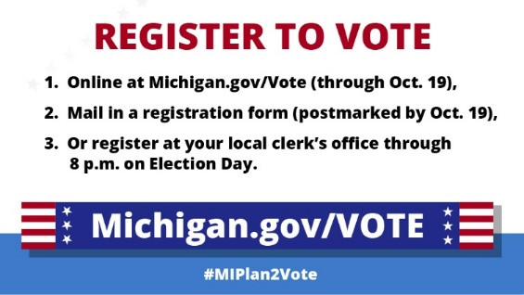

You can register to vote by going to Michigan.gov/Vote and completing the online form (if you have a MI driver’s license or state ID). You can also mail the form it to your clerk or register in person in your clerk’s office. #MIStudentsVote

Register to vote in person at your local clerk’s office until 8 p.m. Election Day. Find their hours and location at Michigan.gov/Vote #MIStudentsVote

After Oct. 19, REGISTRATION must be done IN PERSON in a voter’s local clerk’s office with proof of residency)

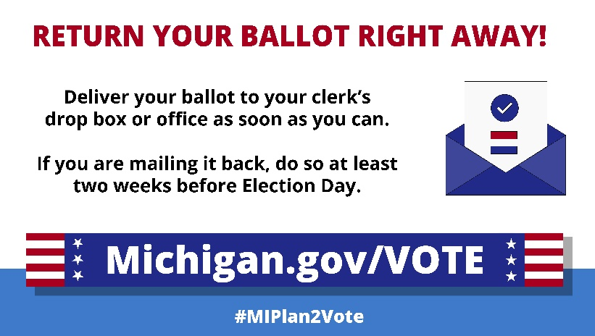
Return your ballot right away

Don’t delay! Return your absent voter ballot right away to your clerk’s drop box or office, or by mailing it by Oct. 19. Find your clerk’s locations and hours at Michigan.gov/Vote. #MIStudentsVote

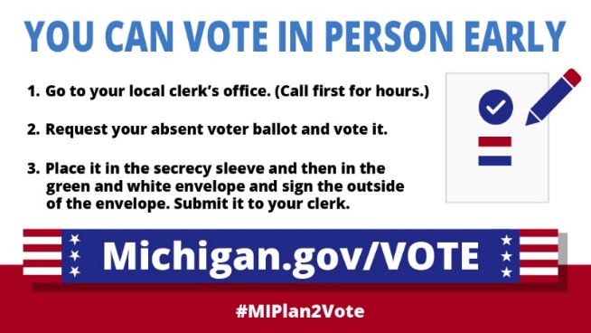
Vote early

IN-PERSON voting can be done in a voter’s clerk’s office up until 4 p.m. on the day before Election Day.)

Did you know you can vote early at your clerk’s office? Find their hours and locations at Michigan.gov/Vote. #MIStudentsVote

Vote from home / Absent voter ballot

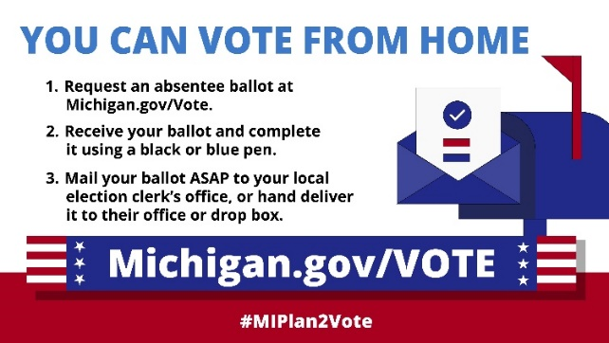

Vote from home. Apply online. Michigan.gov/Vote #MIPlan2Vote

Make sure your vote from home is counted. Sign the back of the envelope. #MIPlan2Vote

Not sure how to fill out your ballot at home? Call your clerk. Find their information at Michigan.gov/Vote. #MIPlan2Vote
8

Click here to access several election-related sample posts and graphics that are available for your use. Contact Sumaiya Ahmed Sheikh at sahmed@campusvoteproject.org if you’re interested in editing them specifically to your campus.
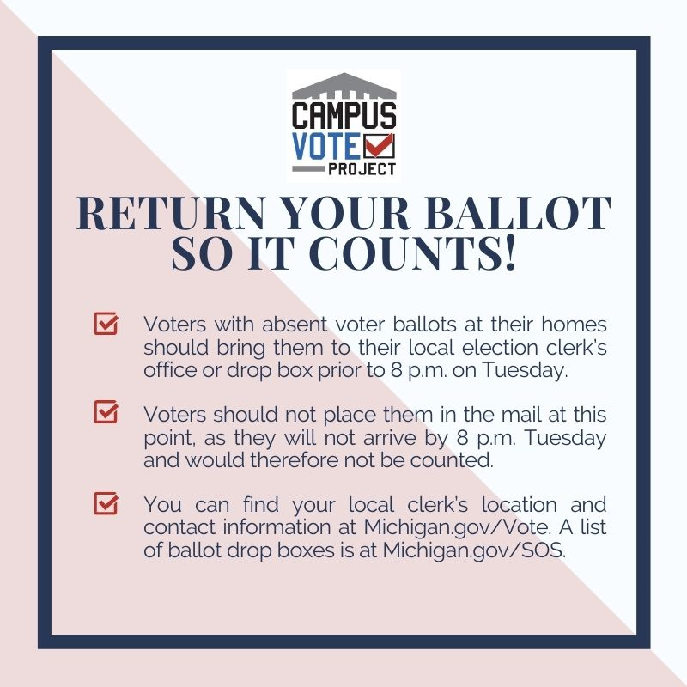
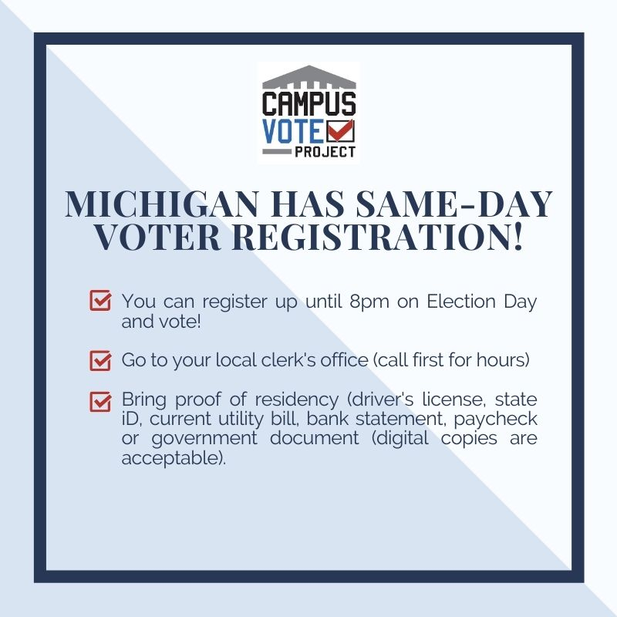
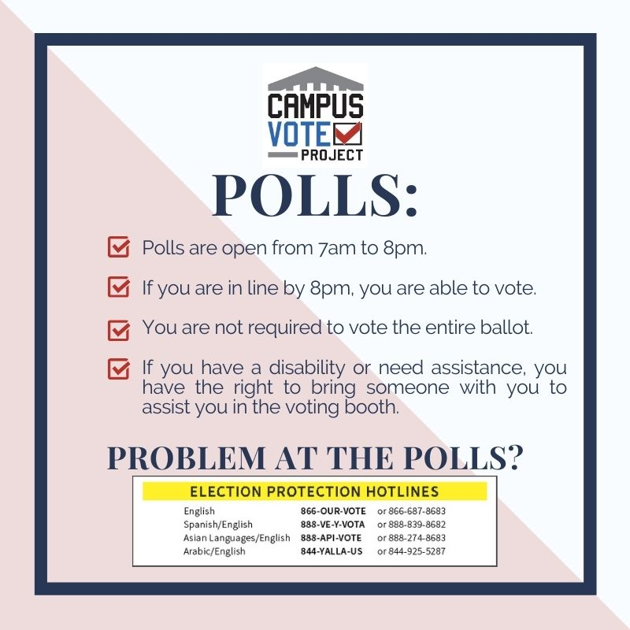

VOTER INFORMATION 101

This section provides all the information you need to be a trusted source of information for students on voter registration and voting.

Voter Registration

Voter Registration
Michigan students can register to vote up to, and on Election Day. Remember, when registering to vote or voting in person:

- Practice social distancing – stay at least 6 feet from others as much as possible.
- Wear a mask.
- Wash your hands for at least 20 seconds.

If you are unsure of your registration status, you can check by clicking here.

In order to register, you must:

- Be 18 years or older when you vote
- Be a U.S. Citizen
- Be a Michigan resident
- Be a resident of your city/township for at least 30 days
- Not be serving a sentence in prison

What if I’m a student?

Students who come from Michigan and attend a school in Michigan can register to vote at their school address or their home address. Students who are from Michigan and who attend school in another state can still register to vote at their home address in Michigan. Students who are from another state but who are attending school in Michigan can register to vote at their school address in Michigan, or in their home state (not both). For questions about registering to vote in other states, look for resources on voting in that state.

If you have a Michigan driver’s license or state ID card, and you are registered to vote in Michigan, your voter registration address and the address on your ID will be the same. If you change the address on one, it will automatically change the other. The Secretary of State will mail you a sticker with your new address to place on your license or ID card.

What documents do I need?

Registering within 14 days of an election, and on Election Day, requires you to present proof of residency documents at your local clerk’s office.

Proof of residency documents can be in paper or electronic form (displayed on your phone, a tablet or a laptop). Your proof of residency MUST have your name on it and display your current address.

- A valid Michigan driver’s license or state ID
- A webpage on your university student portal displaying your name and the address where you want to register (ex. Wolverine Access, StuInfo, Academica, CentralLink, GoWMU)
- Financial aid documents or university registration forms
- Bank statement
- Credit card bill or Utility bill
- Signed and executed lease
- Pay stub

What is NOT a valid form of proof of residency?
- An expired ID or License
- A student ID that does NOT display your current address
- An Amazon package or any non-official piece of mail

Ways to register to vote:

- You can register online by clicking here (Only if you have a valid state of Michigan ID or driver’s license. Must be done at least 15 days before Election Day).
- You can register at your local Secretary of State office. (Must be done 15 days before Election Day).
- You can register at your local clerk’s office up to, and on Election Day. You can find your local clerk by clicking here.
- You can fill out this application (If you do not deliver this form to your clerk’s office, the ballot must be mailed, or emailed, 15 days before Election Day).

Same Day Voter Registration - Register on Election Day

In Michigan, there is no deadline to register to vote. Michigan allows same-day registration.

Students are strongly encouraged to register to vote at least 15 days before Election Day - when it can be done online.

When registering on Election Day, you will need to visit your local clerk’s office and MUST bring proof of residency. At your clerk’s office, you can also request an absentee voter ballot and vote right there!

Absentee Voting

Any registered voter in Michigan can request an absent voter ballot without providing a reason.

To vote safely during the COVID19 pandemic, we are encouraging students to utilize absentee voting. Requesting an AV ballot is easy, quick and secure.

Requesting an absent voter ballot:

Students may request an absent voter ballot or accessible voter ballot in a variety of ways. Students who are registered to vote can complete an online application at Michigan.gov/Vote or submit an application, large print application, letter, or postcard to your local clerk. Click here to find your local clerk. Requests for absent voter ballots may be returned by hand, via postal mail or email, as long as a signature is visible.

- How do I apply for an absentee ballot?
  - Apply online NOW!
  - Apply online for an accessible electronic absent voter ballot **NEW** (Do not complete this form if you want a regular, paper absent voter ballot).

  - Download an absent voter ballot application
  - Download an absent voter ballot application - Fillable version

When is the deadline to apply for an absent voter ballot?

If you are not already registered to vote or need to update your voter registration address and you want to request an AV ballot, you can visit your clerk’s office to register (or update your registration), request an AV ballot and submit your vote - all in one stop - up to and ON Election Day! So long as you are in line at your clerk’s office by 8 p.m. on Election Day, your registration and vote will count.

If your voter registration is already up to date, there are a few AV ballot request deadlines to be aware of, and you cannot request an AV ballot on Election Day.

- To have your AV ballot mailed to you, your request must be received by your township or city clerk no later than 5 p.m. the Friday before the election. Due to possible delays in postal service, we recommend getting your AV ballot in the mail to send back to your clerk at least 14 days prior to Election Day. If you receive your ballot with less than 14 days to go before Election Day, we recommend delivering your ballot by hand to your clerk’s office or to their secure ballot drop box.
- To request an AV ballot in person at your clerk’s office, you must submit an in-person request at your clerk’s office by 4 p.m. on the day prior to the election.

How do I return my absent voter ballot?

There are a few ways to return your AV ballot - make sure to sign the back of your envelope before returning your AV ballot! Ballots must be received by your local clerk BY 8 p.m. on Election Day to be counted.

- Drop it off at your clerk’s office or AV ballot drop-box. You can return your ballot to your local clerk’s office, satellite office, or find your local clerk’s ballot drop box. You can find your clerk’s drop box location by visiting Michigan.gov/Vote.

Note: Ballot drop boxes aren’t like a mailbox where you can drop mail going to any location in the state. You should ONLY drop off your AV ballot at your local clerk’s office drop box.

If you are an out-of-state student attending school in Michigan, and you are voting in your home-state election using an AV ballot, DO NOT place your ballot in a drop box. You will need to mail your ballot to your home state clerk’s office.

- Mail it to your local clerk’s office. To use this option, be sure to mail your ballot at least two weeks before Election Day to make sure it arrives in time. Be sure you are mailing your ballot to the correct clerk’s office! Lookup your clerk by visiting Michigan.gov/Vote and selecting “Your clerk” on the far-left menu.

Did my ballot arrive?
All registered voters can track their ballot by looking up their information in the voter information section of this website.

Spoiling an absent voter ballot (I submitted my ballot. Can I change my vote?):

If a student has already voted absentee and wishes to change their vote, a student can spoil their ballot by submitting a written request to their city or township clerk. The student must sign the request and state if they would like a new absentee ballot mailed to them or if they will vote at the polls. This request must be received by 2 p.m. the Saturday before the election if received by mail. An absentee ballot may be spoiled in person at the clerk’s office until 4 p.m. the Monday prior to the election. The student can obtain a new absentee ballot there or vote at the polls. There is no option on Election Day to spoil an absentee ballot that has been received by the clerk.

FAQ

Do I need a photo ID or proof of citizenship to vote or to register?
No. You will be asked for a photo ID when you vote or register in person. If you don’t have one or don’t have one with you, you can sign a simple form and then register or vote.

Does registering to vote enter me into jury duty?
No. Jury duty pools are not pulled from voter registration rolls in Michigan.

Do I need to wear a mask to vote?
Wearing a mask is strongly encouraged when voting in person - but it is not required. Polling locations on Election Day will be regularly sanitized, and social distancing will be enforced. You can also vote safely and securely at home using an absent voter ballot!

Can I vote before Election Day?
All registered voters in Michigan can vote before Election Day using an “absentee voter ballot”. You don’t need an excuse or a reason. You can vote before Election Day from home, or by going to your city/township clerk’s office.

Is absentee voting secure?
Yes. Voting by mail, or absentee voting, is very secure and accurate. To learn more about the AV process and security measures, visit Michigan.gov/ElectionSecurity

What if I moved to a new address?
You should update your voter registration whenever you move. If you did not update your registration by Election Day, you can register to vote at your city/township clerk’s office, with proof of residency, on Election Day. So long as you are in line at your clerk’s office by 8 p.m., you will be able to register and your vote will be counted.

You can also vote at your old polling place one last time if:
- You moved within the same city or township; or,
- You moved to a different city or township after September 4, 2020.

What if I need assistance voting?
You have the right to vote independently using an accessible voting machine. If you would like to use an accessible voting machine, tell an election official when you arrive to vote.

You have the right to assistance from the election officials. You can ask the election officials for instructions on how to use the voting equipment or assistance at any time, even after you have entered the voting booth.

If you are blind, disabled, or unable to read or write, you have the right to assistance from anyone you choose, except the person cannot be your employer, an agent of your employer or an officer or agent of your labor union.

ADDITIONAL RESOURCES

Ballot Guides

These guides provide unbiased, nonpartisan information about candidates and ballot measures so that students can make informed decisions about who and what they are voting for.

Vote411.org by League of Women Voters: Vote411 has a nonpartisan ballot guide as part of their website that creates personalized ballot information for users. Candidate information is centered around the candidates' responses to questions from the League of Women Voters.

Ballotpedia: Covers an extensive variety of information about elections, policies, voting, and government in the United States. The site includes the BallotReady portal for students to view what's on their ballot.

BallotReady: Allows users to enter their address and access nonpartisan information about everything on their ballot. Users can then fill it out and use it as a reference for when they vote. They can also share their ballot with friends and family.

Resources from Our Partners

Campus Vote Project:

Campus Vote Project works with universities, community colleges, faculty, students and election officials to reduce barriers to student voting. Our goal is to help campuses institutionalize reforms that empower students with the information they need to register and vote. Check out some of our work:

- State Student Guides: CVP has created state-specific guides for students that include Registration Deadlines and Election Dates, Official Election Websites, Register at School or Home, What Type of ID Do I Need to Register, What Type of ID Do I Need to Vote, Where Do I Vote, How Can I Vote and more!
- Student Voter Engagement Handbook: CVP’s handbook includes information about Barriers to Student Registration and Voting, Getting Started: Making Your Campus Voter Friendly, Meeting with College Administrators, Meeting with Local Elections Officials, Strategies to Raise Awareness of Upcoming Elections, Registering Students to Vote, Voter Education Campaigns, Help Students Make a Voting Plan, For Student Organizers: Road to Election Day Timeline, Sustaining Your Student Engagement Efforts and more!
- Youth Voting Rights: CVP is dedicated to supporting increased access to the democratic process, specifically highlighting and tackling the barriers that young people and students face. We work to help young people gain access to the polls in a variety of ways including hosting the Youth Voting Rights Working Group with support from Rock the Vote and CIRCLE.

Student-specific voter registration scenarios:

Guides have been created with the Fair Elections Center's Campus Vote Project to provide guidance to students regarding where to register to vote this year. The information covered is not meant to be comprehensive, as residency laws and other nuances vary state to state. Download the graphics by clicking here.

ALL IN Campus Democracy Challenge

The ALL IN Campus Democracy Challenge strives to change civic culture and institutionalize democratic engagement activities and programs on college campuses, making them a defining feature of campus life. The Challenge, in collaboration with higher education, seeks to:

- Couch Parties: The ALL IN Challenge and Vote for Astra are sharing a peer-to-peer text banking strategy for virtual voter engagement. Volunteers will text contacts in their phones with pre-written scripts, pre-written answers, and links to register to vote, request an absentee ballot, pledge to vote, and make a plan to vote. There is no cost to campuses to access the training resources and technology. The ALL IN Challenge will provide free access to the OutVote app from which text messages will be sent.
- COVID 19 Campus Virtual Democratic Engagement Resources: The ALL IN Challenge has compiled a toolkit for campuses to learn more about strategies and creative ideas for virtual and in-person learning.

Students can also check out When We All Vote’s social media guide that shows how to promote your voter registration work, share best practices, and provide suggested posts.

Creative Campus Voting Project

The Creative Campus Voting Project is an initiative that uses art and design to make voting less confusing and more appealing to college students. Based at the Stamps School of Art & Design at the University of Michigan, they have created a package of voting-themed games is available free of charge to campuses across Michigan.
- The SparkVotes (virtual) Party “package” is a game-night style event. Student hosts gather 6-8 friends on Zoom, divide into two teams, and compete in a series of non-partisan, voting-themed party games via Google Slides. Games include Count My Ballot (Race to find the two signatures that match well enough for an absentee ballot to be verified and counted); Not-so-Trivial Pursuit (“Buzz” to be the first to answer voting-related questions ); Ballot Quest (With 12 minutes, a sample ballot and a set of clues, find five “treasures”); and Step Up Song Challenge (Select from a set of next steps for a range of voting plans and give a hint — through song — to see if others can guess your next step.) Learn more and request party materials at: bit.ly/SVP_Request

