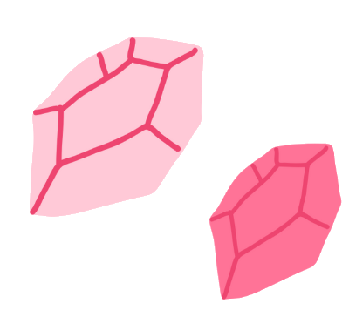
CRYSTALLIZATION
By: Katie Danna, Explore Lab Science
*Parent supervision needed

INTRODUCTION
You might hear the word crystals and think of gems, rocks, icy weather or granite countertops. Crystals can be important in earth science, chemistry, in cooking and for experimental lab designs.

RESEARCH QUESTION
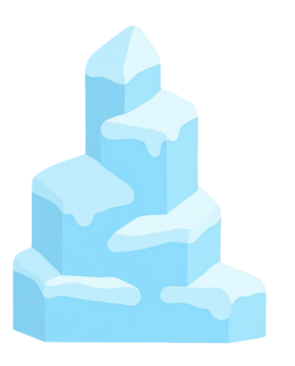
How do different environmental factors affect the growth of crystal formation?

HOW DO CRYSTALS FORM?
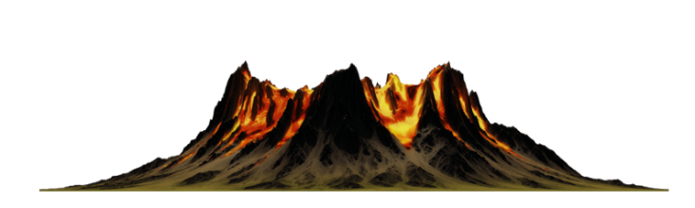
Crystals form through a process called crystallization. One way this process starts is when a liquid begins to cool. In nature this often happens as magma or lava starts to cool. This happens in your kitchen when water is heated to dissolve large amounts of sugar. Once the mixture is allowed to cool, rock candy is created!

TRY IT AT HOME
INGREDIENTS
(MAKES 5)

- 10 cups of granulated sugar
- 4 cups of water
- Food coloring (if you want)
- 5 quart sized glass jars
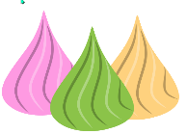
- 5 wooden kabob skewers
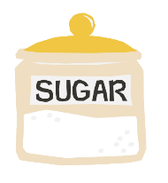
- 5 chip clips

PROPERTIES OF CRYSTALS
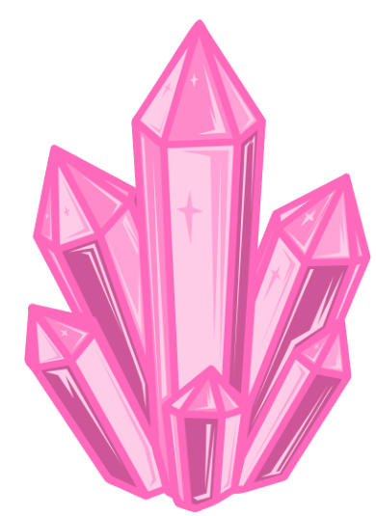
Crystals form when liquids cool and start to harden. They form repeating patterns like triangles and rectangles. An amethyst crystal is purple and has flat sides. These flat sides are called facets. Many crystals have


facets.


PROCEDURE “THE STEPS”

Day 1:
- Put the wooden skewers into water and coat them in sugar.
- Let them dry for at least one hour (recommended to wait one day).
Day 2 (with an adult):
- Clean each glass jar with hot water.
- Attach the chip clip to the skewer and place the skewer dangling into each jar.
DON’T let the skewer touch the bottom!!
- In a pan, bring water to boil. Once boiling, add one cup of granulated sugar at a time and stir with a wooden spoon until sugar dissolves. Keep adding sugar one cup at a time.
- Once all the sugar is mixed in, let simmer for five minutes.
- Rest with heat off for 15 minutes and divide sugar solution into all five jars. You can add food dye.
- Place into different environments, i.e. on the kitchen counter (control), in a cabinet/pantry, in the fridge, on a windowsill and in the microwave. Let sit for six to seven days.
- After six to seven days, remove the skewer from the jar and let out until it is no longer dripping.

OBSERVATIONS

Day | Control | Fridge | Pantry | Microwave | Window
Day 2
Day 3
Day 4
Day 5
Day 6
Day 7
Day 8

From Day 2-8, record what you observe in each environment.
- What did you see happening?
- Size of the crystal?



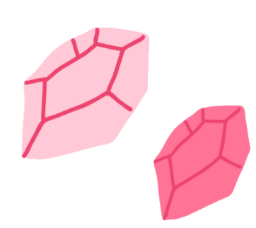

CONCLUSION

- How are the crystals similar and how are they different?
- Which environment had the fastest rate of crystal growth?
- How do you think temperature played a role in the process?

