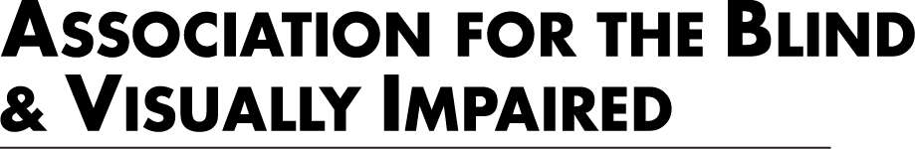

Skills Opportunities and Readiness(SOAR) is a 5-month employment training. The program combines budgeting, exploring transportation options, and leadership development to lay the foundations for future job and volunteer opportunities.

In this 5-week series, students gain employment skills including:

• Resume and cover letter development

• Job seeking skills

• Accommodations and disclosure with employers

• Assistive technology use

• Adaptive communication techniques

• Orientation and mobility

• Transportation options

• Leadership development

For more information, contact Osman Koroma at 616.840.8286 or osman.koroma@maryfreebed.com.

WHERE

Mary Free Bed

350 Lafayette Ave SE, Grand Rapids, MI 49503

SOAR is part of the Transition Works employment program presented by the Association for

The Blind and Visually Impaired and the Bureau of Services of Blind Persons.

Together, they will explore various workplace experiences throughout West Michigan, as well as

enjoy cooking together and recreational activities. There is no cost for students to attend. Lunch

will be provided and transportation is also available.

REGISTER by January 3, 2025, by clicking this link.

<https://lp.constantcontactpages.com/ev/reg/9ncwgde>

WHEN:

SOAR I focus on Basic Independent Living Skills (ILS), basic Assistive Technology (AT) skills, basic Orientation and Mobility (O&M) skills and Work Readiness Training. SOAR I will be the First Saturdays of the month, 10 AM - 2 PM

February 1

March 1

April 5

May 3

June 7

SOAR II focus on Advance Independent Living Skills (ILS), basic Assistive Technology (AT) skills, basic Orientation and Mobility (O&M) skills and Work Readiness Training. SOAR II will be the third Saturdays of the month, 10 AM - 2 PM

February 15

March 15

April 19

May 17

June 21