
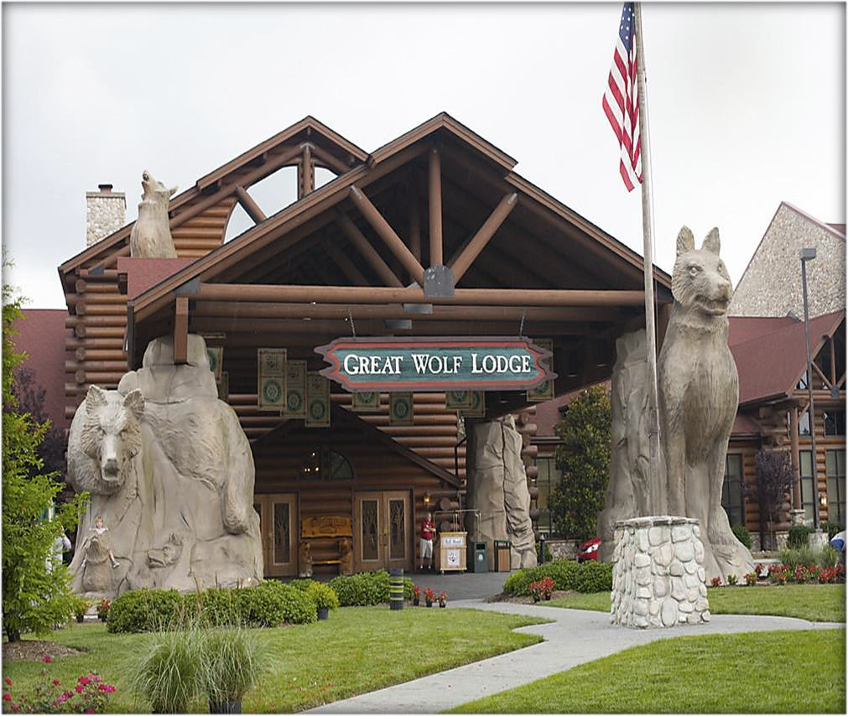
Who:
High School Students (ages 14-26) with an interest in hospitality and their families.

Where:
Great Wolf Lodge 3575 U.S. 31 North S,
Traverse City, MI 49684

When:
May 29 – May 31

What:
- Job readiness activities
- Family engagement
  - Parent networking

Questions?
Brittany Hamilton-Reed
HamiltonReedB@michigan.gov


Visit the Great Wolf Lodge to enjoy a weekend exploring hospitality and a little family fun. Students will observe the behind-the-scenes operation of a resort, learn about various jobs, and gain a better understanding of the hospitality industry.
Students will participate in a variety of activities to build skills necessary for employment success. Families will benefit from programming specifically catered to them including family engagement activities, benefits discussion and networking opportunities.
Register by April 10th via the link below:

https://bit.ly/BSBPGWL26

