So You Want To Go To College:
Virtual classes and In-Person college tours
Have you thought about attending college and would like to learn more about what colleges have to offer and how to be successful in finding a program that meets your goals?
This program is designed to explore what college has to offer academically, socially, and towards your future career goals.
Virtual classes will be held on Monday evenings from 6:30 to 7:30 on October 12, 19, and 26, with a final wrap-up class on December 7.
- October 12: Review your college goals, your career interests, and start to build more knowledge to be ready for college.
- October 19: Learn more about your career pathways and possible job outcomes in those fields.
- October 26: Learn what is expected on a campus tour and key topics to consider, including asking about accommodations and disability disclosure.
Free Campus Tours for students and their families are offered at three area colleges. Lunch is provided for free! All future college students should tour colleges in-person to be able to make the best choice for their goals.
- Ferris State University, Big Rapids, MI. Thursday, November 5, 10:00 am – 2:00 pm.
- Western Michigan University, Kalamazoo, MI. Thursday, November 12, 1:00 pm – 3:30 pm.
- Grand Rapids Community College, Grand Rapids, MI. Tuesday, November 17, 11:45 am – 2:45 pm.
Students who are interested in participating in any of the virtual or in-person tours should submit an Interest Form through this link or the QR code.
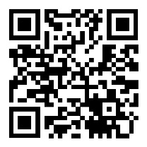 Contact your BSBP counselor for more information or questions.

