SCHOOLOGY SET-UP (Please note: If you have used Schoology for MDARD training prior to October 1st, 2023, the website address has changed and you will now need to carefully follow the directions below. If you have used Schoology after October 1st, 2023, you may log in using your existing username and password and skip to #7 below.)

- Go to: https://mdard.schoology.com

- Enter your username (firstname.lastname) and password (MDARD-NewUser).

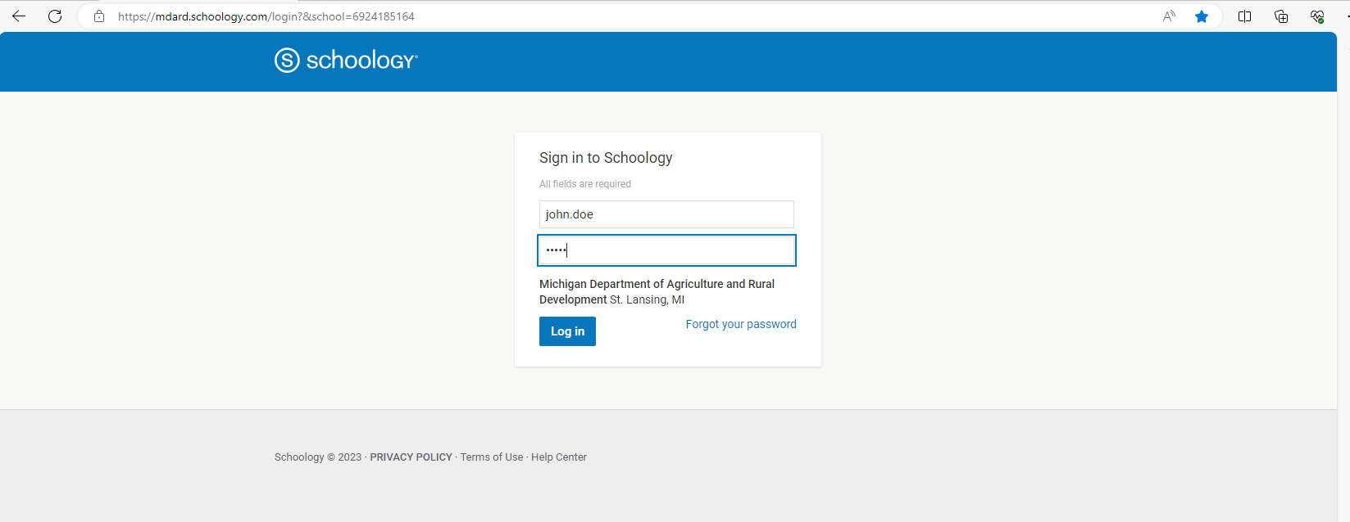
MDARD-NewUser

- Click on the down arrow next to your name in the upper right corner. And then click on “SETTINGS.”
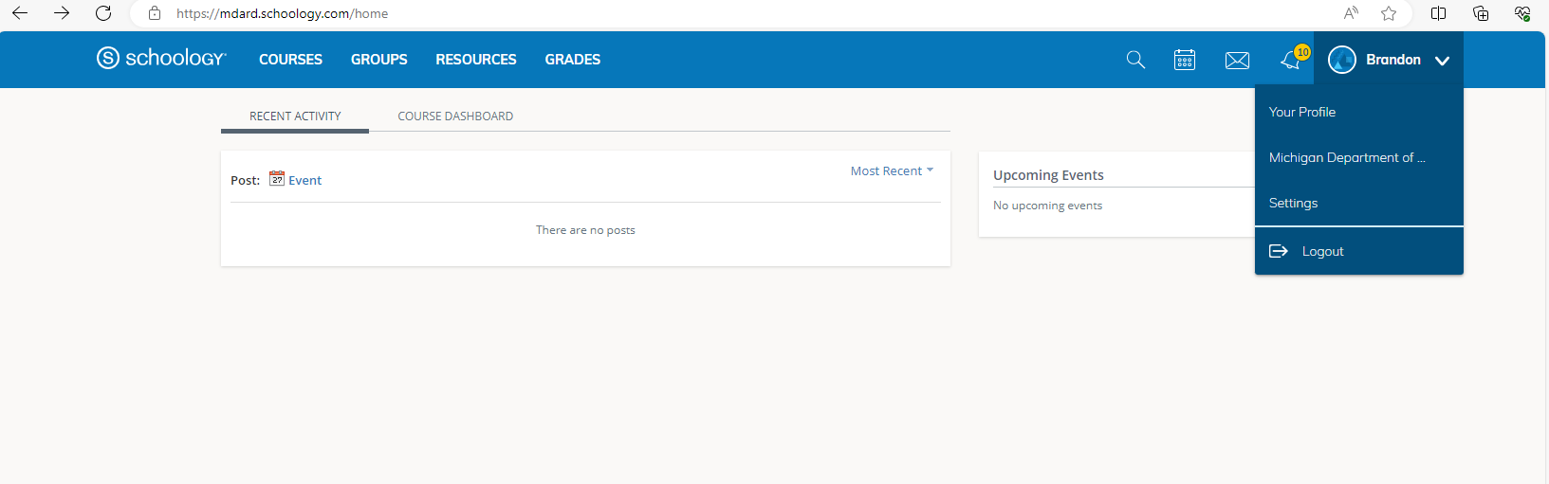

- Click on “Change your Password”.
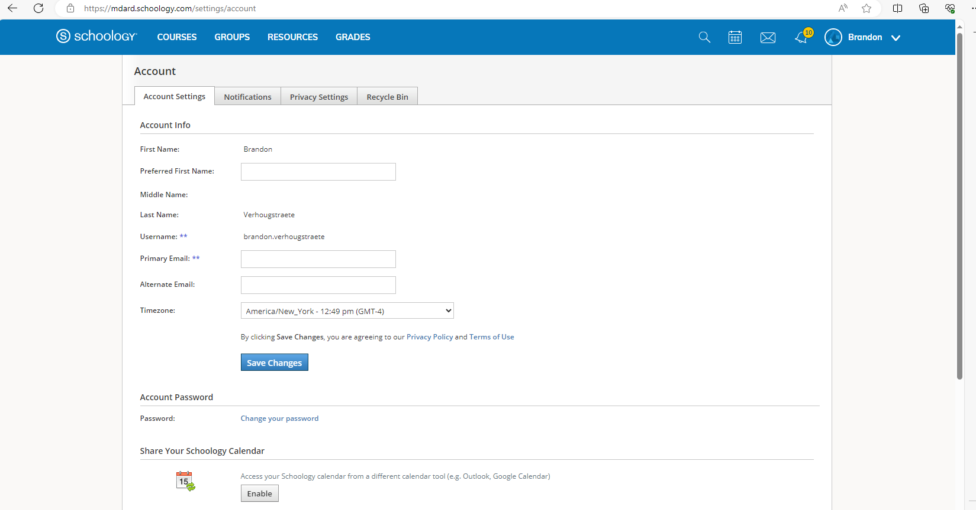

- Change your password from your current password (MDARD-NewUser) to something you will remember. You will need this password for all future MDARD trainings through the Schoology website so keep it somewhere safe.

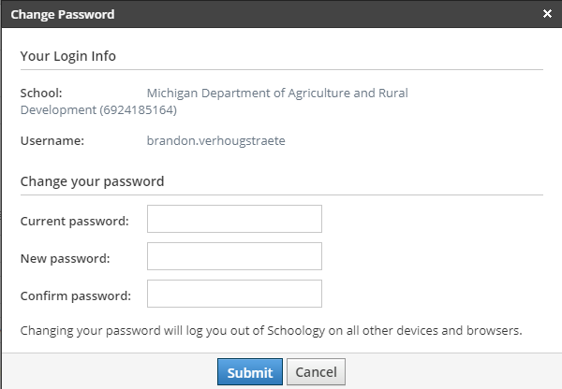
MDARD-NewUser
Change from “MDARD-NewUser” to your own password.

- Click the “SUMBIT” button.

- Click on the “COURSES” tab at the top of the page.

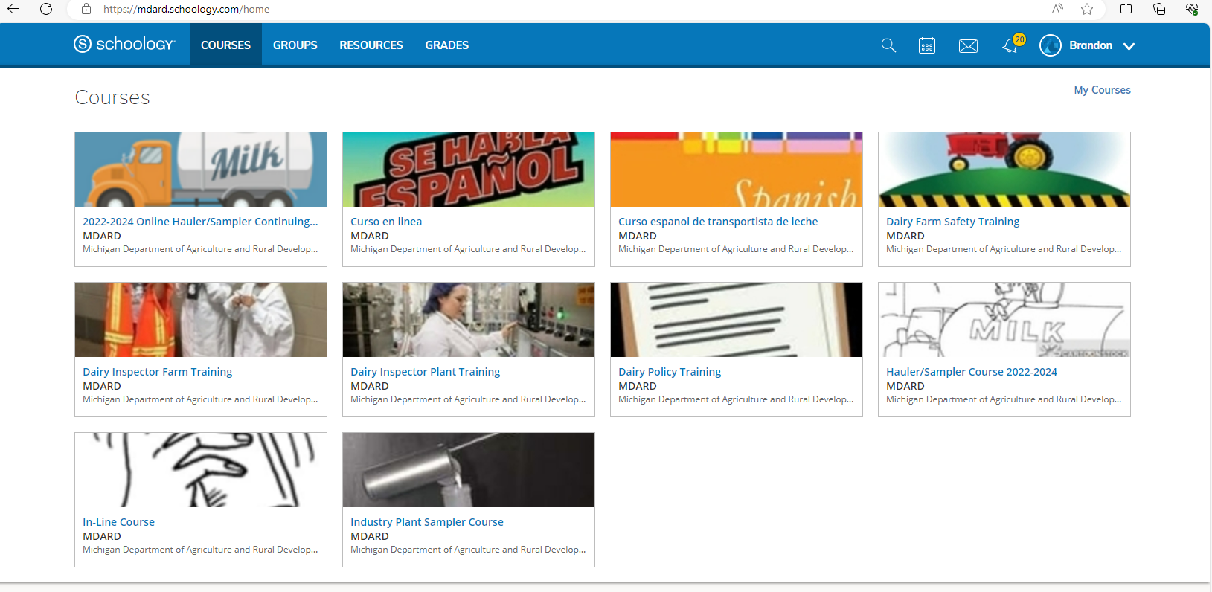

- Click on the course you wish to complete (ex. Curso en linea)

CLICK ON YOUR COURSE

- Click on and COMPLETE EACH ASSIGNMENT for the course you selected.

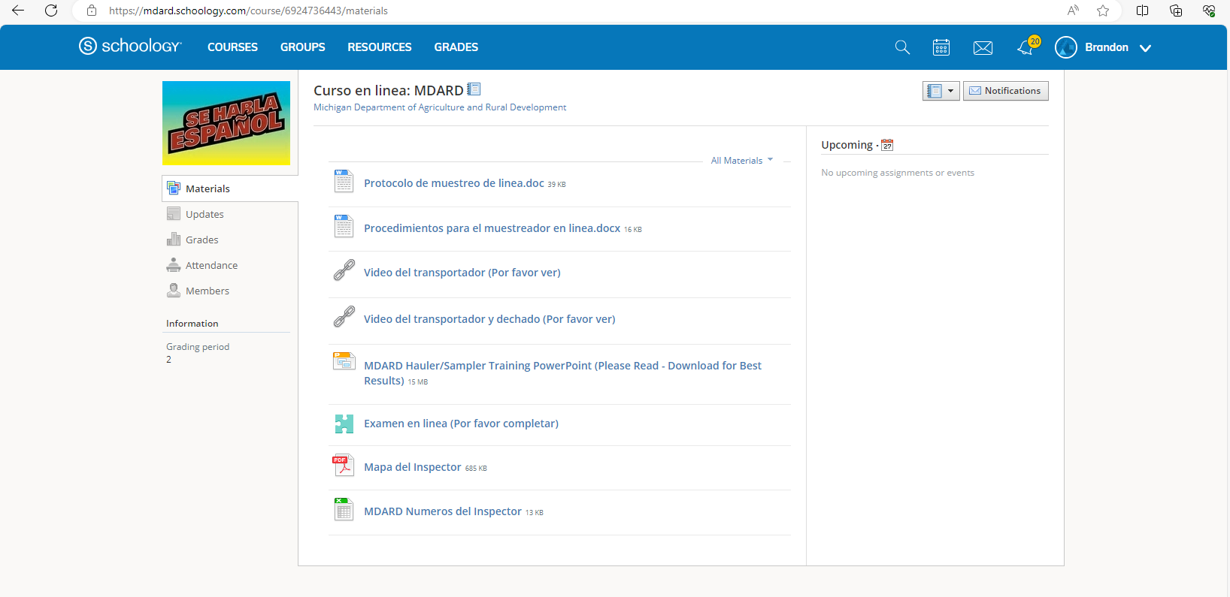

You did it! If you scored 85% or higher on the exam, your local inspector will contact you to schedule the practical portion of the licensing process.

