## Collection kit

# Instructions for Submission of Isolates for Bacterial, Fungal, and Mycobacterial Identification

(Category “A” guidelines included)

* 1. Unit 42B (IATA Category B)
  2. **Unit 42A (IATA Category A)-Shipped only by certified Category A trained personal**. **Please contact our DASH unit at 517-335-8059 if assistance is needed.**

## Acceptable Isolates

### Aerobic bacterial isolates submitted on enriched medium suitable for growth.

**NOTE: Potential Select Agents (*B. anthracis, Brucella sp., Burkholderia mallei/pseudomallei*, *Clostridium botulinum, Francisella tularensis,* and *Yersinia pestis)* and known isolates of Shiga-toxin producing *E. coli* must be shipped Category A.**

### Fungal and yeast isolates submitted on agar slants.

**NOTE: Known isolates of *Coccidioides immitis* must be shipped Category A**

### Mycobacterial isolates in broth or slanted media.

### NOTE: Known isolates of *Mycobacterium tuberculosis* must be shipped Category A

### Broth cultures for Bacterial and Fungal identification are accepted only by prior notification.

### Petri plates for Bacterial and Fungal identification are accepted only by prior notification.

## Labeling

1. Label the specimen with the complete patient’s name and at least 1 unique identifier (specimen number, medical record number, etc.)
2. Enter the required information on the test requisition form (DCH-0583). The patient’s name and unique identifier on the form must be entered **exactly** as the information on the tube.
3. If there are multiple specimens from the same patient, please label each specimen tube with the correct specimen number. A separate test requisition is needed for each specimen.

## Packaging and Shipping-Category B

1. Make sure the cap on the tube is seated tightly and evenly to prevent leaking. Para-film® or tape the cap to secure.
2. Wrap the isolate with paper toweling and insert the isolate with the absorbent pad into the small plastic bag provided. Seal the bag.
3. Place the small bag in the larger Category B secondary container (plastic bag with the biohazard symbol that comes with the Category B shipping materials supplied by MDHHS Bio-Bag). Seal the bag by removing the white strip and folding over the adhesive flap of the bag.

**NOTE: If multiple samples will be shipped in the same canister, all samples must be individually wrapped and separated to prevent contact between them.**

1. Place the completed MDHHS test requisition in the outside pocket of the Bio-Bag.
2. Insert the Bio-Bag diagonally into the provided Category B box so it is suspended in the middle. If necessary, add extra cushioning such as paper toweling or bubble wrap).
3. Close the box and secure with sealing tape on both sides of the flap.
4. Attach completed address label and the UN3373 label if not stamped on the box.
5. Send to the Michigan Dept. of Health and Human Services as soon as possible (e.g., courier, 1st class mail (USPS), United Parcel Service (UPS), etc.)
6. Instructions are also available by visiting, <http://www.Michigan.gov/mdhhslab>
7. The specimen will not be tested if:
8. The specimen is received leaking or broken.
9. The specimen is not properly labeled, or the test requisition not completed.
10. The specimen label does not match the test requisition.

## Packaging and Shipping-Category A

A. Make sure the cap on the tube is seated tightly and evenly to prevent leaking. Para-film® or tape the cap to secure.

B. Wrap an absorbent pad such as paper toweling around the isolate slant and insert the specimen with absorbent pad into the small bubble wrap pockets provided. Seal the flap.

C. Wrap the small bag with extra cushioning material (padding) to avoid specimen jostling and insert in the Category A secondary container (white with red lid) MDHHS. Rotate the lid until locked in place.

**NOTE: If multiple samples will be shipped in the same canister, all samples must be individually wrapped and separated to prevent contact between them. (50ml maximum per canister).**

D. Place the completed MDHHS test requisition around the outside of the canister and insert in the foam holder located inside the Category A box.

E. Close the box and secure with sealing tape around the sides of the flap.

F. Complete the Dangerous Goods Form (DGF)

**NOTE: Make 4 copies of the DGF (3 are kept with the specimen for the carriers use and the 4th copy is retained at your facility for 2 years based on DOT regulations).**

G. Fold the dangerous good forms in half and insert in the clear adhesive pocket. Affix to the side of the box.

H. Attach completed address label, the Class 6 label and UN 2814 label if not stamped on the box or already attached.

I. Record the volume of the sample on the outside of the box

J. Record the name and telephone number of the responsible person on the outside of the package

K. Send to the Michigan Department of Health and Human Services as soon as possible (e.g. courier, Fed-Ex, UPS) **CATEGORY A CANNOT BE SENT BY USPS**

L. Instructions are also available by visiting, <http://www.Michigan.gov/mdhhslab>

M. The specimen will not be tested if:

1. The specimen is received leaking or broken.

2. The specimen is not properly labeled, or the test requisition not completed.

3. The specimen label does not match the test requisition.

## Packaging and shipping are the responsibility of the shipper. Please be sure to follow shipping regulations.

**Unit 42B**-Bacterial, Fungal, and Mycobacterial Isolate Identification

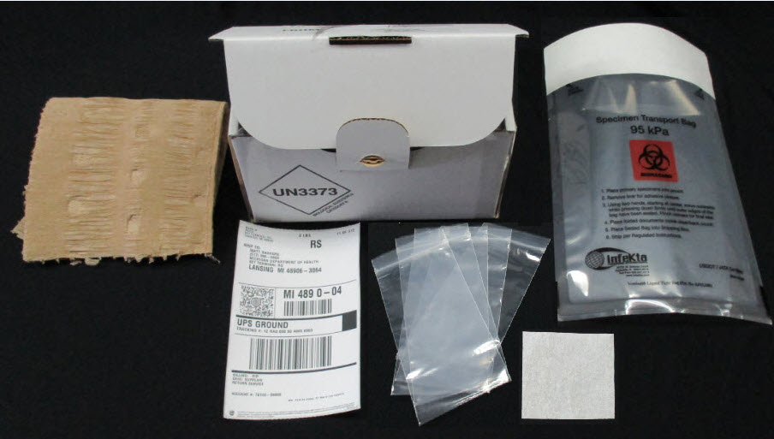

**Unit 42A**-Bacterial, Fungal, and Mycobacterial Isolate Identification-Shipped only by certified Category A trained personal