MICHIGAN’S MISSION-BASED PERFORMANCE INDICATOR SYSTEM
VERSION 6.0

CMHSP Reporting Codebooks

April 2020
*Codebook Version 1/31/2020*

Michigan Department of Health and Human Services
Behavioral Health & Developmental Disabilities Administration

Revision Legend: New for FY2020

FOR CMHSPS

ACCESS
1. The percent of all adults and children receiving a pre-admission screening for psychiatric inpatient care for whom the disposition was completed within three hours.
  - Standard = 95% in three hours
  - Quarterly report
  - PIHP for all Medicaid beneficiaries
  - CMHSP for all consumers

- The percentage of new persons during the quarter receiving a completed biopsychosocical assessment within 14 calendar days of a non-emergency request for service.
  - No standard for 1st year of implementation – will use information to determine baseline.
  - Quarterly report
  - PIHP for all Medicaid beneficiaries
  - CMHSP for all consumers
  - Scope: MI adults, MI children, I/DD adults, and I/DD children

- Percentage of new persons during the quarter starting any medically necessary on-going covered service within 14 days of completing a non-emergent biopsychosocial assessment.
  - No Standard for 1st year of implementation – will use information to determine baseline.
  - Quarterly report
  - PIHP for all Medicaid beneficiaries
  - CMHSP for all consumers
Scope: MI adults, MI children, I/DD adults, and I/DD children

4. The percent of discharges from a psychiatric inpatient unit who are seen for follow-up care within seven days. (All children and all adults -MI, DD).
- Standard = 95%
- Quarterly report
- PIHP for all Medicaid beneficiaries
- CMHSP for all consumers
Scope: All children and all adults (MI, DD) - Do not include dual eligibles (Medicare/Medicaid) in these counts.

5. The percent of face-to-face assessments with professionals that result in decisions to deny CMHSP services. (MI and DD) (Old Indicator #6)
  - Quarterly report
  - CMHSP
  - Scope: all MI/DD consumers

6. The percent of Section 705 second opinions that result in services. (MI and DD) (Old Indicator #7)
- Quarterly report
- CMHSP
- Scope: all MI/DD consumers

EFFICIENCY
*7. The percent of total expenditures spent on administrative functions for CMHSPs. (Old Indicator #9)
  - Annual report (MDHHS calculates from cost reports)
  - PIHP for Medicaid administrative expenditures
  - CMHSP for all administrative expenditures

OUTCOMES
*8. The percent of adults with mental illness, the percent of adults with developmental disabilities, and the percent of dual MI/DD adults served by CMHSP who are in competitive employment. (Old Indicator #10)
- Annual report (MDHHS calculates from BH TEDS data)
- PIHP for Medicaid adult beneficiaries
- CMHSP for all adults
- Scope: MI only, DD only, dual MI/DD consumers

*9. The percent of adults with mental illness, the percent of adults with developmental disabilities, and the percent of dual MI/DD adults served by the CMHSP who earn minimum wage or more from employment activities (competitive, supported or self employment, or sheltered workshop). (Old Indicator #11)
a. Annual report (MDHHS calculates from BH TEDS data)
- PIHP for Medicaid adult beneficiaries
- CMHSP for all adults
- Scope: MI only, DD only, dual MI/DD consumers

10. The percent of MI and DD children and adults readmitted to an inpatient psychiatric unit within 30 days of discharge. (Old Indicator #12)
  - Standard = 15% or less within 30 days
  - Quarterly report
  - PIHP for all Medicaid beneficiaries
c. CMHSP
d. Scope: All MI and DD children and adults - Do not include dual eligibles (Medicare/Medicaid) in these counts.

11. The annual number of substantiated recipient rights complaints per thousand persons served with MI and with DD served, in the categories of Abuse I and II, and Neglect I and II. (Old Indicator #13)

*13. The percent of adults with developmental disabilities served, who live in a private residence alone, with spouse, or non-relative(s).
- Annual report (MDHHS calculates from BH TEDS data)
- PIHP for Medicaid beneficiaries
- CMHSP for all adults
- Scope: DD adults only

*14. The percent of adults with serious mental illness served, who live in a private residence alone, with spouse, or non-relative(s).
- Annual report (MDHHS calculates from BH TEDS data)
- PIHP for Medicaid beneficiaries
- CMHSP for all adults
- Scope: DD adults only

CMHSP PERFORMANCE INDICATOR REPORTING DUE DATES

FY 2020 Due Dates
Indicator Title | Period | Due | Period | Due | Period | Due | Period | Due | From
1. Pre-admission screening | 10/01 to 12/31 | 3/31/20 | 1/01 to  3/31 | 6/30/20 | 4/01 to 6/30 | 9/30/20 | 7/01 to 9/30 | 12/31/20 | CMHSPs
2. 1st request | 10/01 to 12/31 | 3/31/20 | 1/01 to  3/31 | 6/30/20 | 4/01 to 6/30 | 9/30/20 | 7/01 to 9/30 | 12/31/20 | CMHSPs
3. 1st service | 10/01 to 12/31 | 3/31/20 | 1/01 to  3/31 | 6/30/20 | 4/01 to 6/30 | 9/30/20 | 7/01 to 9/30 | 12/31/20 | CMHSPs
4. Follow-up | 10/01 to 12/31 | 3/31/20 | 1/01 to  3/31 | 6/30/20 | 4/01 to 6/30 | 9/30/20 | 7/01 to 9/30 | 12/31/20 | CMHSPs
5. Denials | 10/01 to 12/31 | 3/31/20 | 1/01 to  3/31 | 6/30/20 | 4/01 to 6/30 | 9/30/20 | 7/01 to 9/30 | 12/31/20 | CMHSPs
6. 2nd Opinions | 10/01 to 12/31 | 3/31/20 | 1/01to  3/31 | 6/30/20 | 4/01 to 6/30 | 9/30/20 | 7/01 to 9/30 | 12/31/20 | CMHSPs
7. Admin Costs* | 10/01 to 9/30 | 2/27/21 |  |  |  |  |  |  | CMHSPs
8. Competitive employment* | 10/01 to 9/30 | N/A |  |  |  |  |  |  | MDHHS
9. Minimum wage* | 10/01 to 9/30 | N/A |  |  |  |  |  |  | MDHHS
10. Readmissions | 10/01 to 12/31 | 3/31/20 | 1/01 to  3/31 | 6/30/20 | 4-01 to 6-30 | 9/30/20 | 7/01 to 9/30 | 12/31/20 | CMHSPs
11. RR complaints | 10/01 to 9/30 | 12/31/20 |  |  |  |  |  |  | CMHSPs
13. Residence (DD)* | 10/01 to 9/30 | N/A |  |  |  |  |  |  | MDHHS
14. Residence (MI)* | 10/01 to 9/30 | N/A |  |  |  |  |  |  | MDHHS
15. DD Children Services* | 10/01 to 12/31 | N/A | 1/01to  3/31 | N/A | 4/01 to 6/30 | N/A | 7/01 to 9/30 | N/A | MDHHS
*Indicators with *: MDHHS collects data from encounters, BH-TEDS data or cost reports and calculates performance indicators

PERFORMANCE INDICATOR CODEBOOK

General Rules for Reporting Performance Indicators

1. Due dates
All data are due 90 days following the end of the reporting period (Note: reporting periods are 90 days, six months, or 12 months).
Consultation drafts will be issued for editing purposes approximately two weeks after the due date.
Final report will be posted on the MDHHS web site approximately 30 days following the due date.

2. Children
Children are counted as such who are less than age 18 on the last day of the reporting period.

3. Dual Eligible
Do not include those individuals who are Medicare/Medicaid dual eligible in indicators number 4a & 4b (Follow-up Care) and number 10 (Readmissions).

- Emergency and urgent requests for services
Used here as defined in the Mental Health Code. 330.1100 (18 & 29)

4. Medicaid
Count as Medicaid eligible any person who qualified as a Medicaid beneficiary during at least one month of the reporting period. This includes both traditional Medicaid and Healthy Michigan. Individuals covered under the autism benefit are included. Indicators # 1, 2, 3, 4, 10, and 11 are to be reported by the CMHSPs for all their consumers, and by the PIHPs for all their Medicaid beneficiaries. If a PIHP is an affiliation, the PIHP reports these indicators for all the Medicaid beneficiaries in their region. The PIHPs who are also a single CMHSP will submit two reports: One, as a CMHSP for all its consumers, and one as the PIHP for all its Medicaid beneficiaries.

- Intellectual Disability and Developmental Disability (I/DD)
As defined in the Mental Health Code 330.1100 (12 & 25)

- Mental Illness/Serious Emotional Disturbance (MI/SED)
The individual has an MI DSM Diagnosis.

7. Substance abuse beneficiaries
Indicators 2b and 4b include persons receiving Medicaid substance abuse services managed by the PIHP (this is not applicable to CMHSPs). Managed by the PIHP means any substance abuse services that the PIHP may deliver directly or may subcontract directly with a substance abuse provider.

- Rules for categorizing individuals who have both mental illness and an intellectual or developmental disability (MI/SED & I/DD)

  - If a biopsychosocial (BPS) has been completed for the person:
    - Assign person to either MI or I/DD category based on primary diagnosis.
    - If person has both MI and I/DD primary diagnoses:
- Assign a person as either MI or I/DD based on the primary diagnosis related to the greatest level of impairment

And
- the services they are being referred to or being treated for.
    - If can’t determine whether MI or I/DD category is predominant, categorize the person as I/DD.

  - If BPS has not yet been completed for the person:
- Assign person to either the MI or I/DD category based on the services the person requests.
- If the person requests both MH and I/DD services, categorize the person as I/DD.
- If it can’t be determined what type of services are being requested, categorize the person as MI.

6. Documentation
It is expected that CMHSPs and PIHPs will maintain documentation of:
a) persons counted in the “exception” columns on the applicable indicators – who, why, and source documents; and
b) start and stop times for timeliness indicators.
Documentation may be requested and reviewed during external quality reviews.
ACCESS -TIMELINESS/INPATIENT SCREENING (CMHSP & PIHP)

Indicator #1
The percentage of persons during the quarter receiving a pre-admission screening for psychiatric inpatient care for whom the disposition was completed within three hours (by two sub-populations: Children and Adults). Standard = 95%

Rationale for Use
People who are experiencing symptoms serious enough to warrant evaluation for inpatient care are potentially at risk of danger to themselves or others. Thus, time is of the essence. This indicator assesses whether CMHSPs and PIHPs are meeting the Department’s standard that 95% of the inpatient screenings have a final disposition within three hours. This indicator is a standard measure of access to care.

Table 1 - Indicator #1
1.  Population | 2.  Number (#) of Emergency Referrals for Inpatient Screening During the Time Period | 3.  Number (#) of Dispositions about Emergency Referrals Completed within Three Hours or Less | 4.  Percent (%) of Emergency Referrals Completed within the Time Standard
1. # Children | B2 | C2 | F2 - Calculated
2. # Adults | D2 | E2 | G2 - Calculated

Definitions and Instructions
“Disposition” means the decision was made to refer, or not refer, to inpatient psychiatric care.

- If screening is not possible due to intoxication or sedation, do not start the clock.
- Start time: When the person is clinically, medically and physically available to the CMHSP/PIHP.
  - When emergency room or jail staff informs CMHSP/PIHP that individual needs, and is ready, to be assessed; or
  - When an individual presents at an access center and then is clinically cleared (as needed).
- Stop time: Clinician (in access center or emergency room) who has the authority, or utilization management unit that has the authority, makes the decision whether or not to admit.
- After the decision is made, the clock stops but other activities will continue (screening, transportation, arranging for bed, crisis intervention).
- Documentation of start/stop times needs to be maintained by the PIHP/CMHSPS.

ACCESS-TIMELINESS/FIRST REQUEST (CMHSP)
Mental Health and Intellectual and Developmental Disabilities

Indicator #new 2

The percentage of new persons during the quarter receiving a completed biopsychosocical assessment within 14 calendar days of a non-emergency request for service (by four sub-populations: MI-adults, MI-children, IDD-adults, IDD-children.

- No Standard for 1st year of implementation – will use information to determine baseline.

Rationale for Use
Quick, convenient entry into the public behavioral health system is a critical aspect of accessibility of services. Delays may lead to exacerbation of symptoms and distress, disengagement from the system and poorer role functioning. The amount of time between a request for service and the delivery of needed treatments and supports is one measure of access to care. The assessment process is especially important for individuals seeking services for mental illness or intellectual and developmental disability and the completed assessment is critical for person-centered planning. In addition, timely assessment is critical to the engagement process and connecting the consumer to necessary services and supports while the person is motivated towards treatment.

Receiving a Biopsychosocial Assessment within 14 Calendar Days of First Request

Table 2a – Indicator #2a
1.  Population | 2  # of New Persons Who Requested Mental Health or I/DD Services and Supports and are Referred for a Biopsychosocial Assessment  A | 3.  # of Persons Completing the Biopsychosocial Assessment within 14 Calendar Days of First Request for Service  B | 4.  % of Persons Requesting a Service Who Received a Completed BPS Assessment within 14 Calendar Days  B/A X 100
1. MI-C | H2 | I2 | R2 – Calculated
2. MI-A | J2 | K2 | S2 – Calculated
3. IDD-C | L2 | M2 | T2 – Calculated
4. IDD-A | N2 | O2 | U2 – Calculated
5. Total Population | P2 | Q2 | V2 – Calculated

Column 1 – Population

See General Rules for definitions of children, Medicaid, Mental illness (MI/SED) and intellectual and developmental disability (I/DD).
For Indicator #2a:
- Medicaid includes people who have both Medicaid and Medicare coverage, except Mild to Moderate beneficiaries covered under MI Health Link who are excluded from this indicator.
- Consumers covered under OBRA should be excluded from this indicator.

Column 2- Selection Methodology

- Cases selected for inclusion in Column 2 are those new persons who made a non-emergency request for specialty mental health (MH) or intellectual and developmental disability (IDD) services and supports and were referred for a biopsychosocial assessment during the quarter.

- “First request” is the initial telephone or walk-in request for non-emergency services by the individual, parent of minor child, legal guardian or referral source. In the case of a referral from an outside organization the request date is the date the referring agency makes a request for services on behalf of the person. If the person is referred from an inpatient psychiatric facility, the request date is the date that the person is discharged from the facility. For the request to be included in this indicator, the individual must consent to treatment.

TIP: Reporting inpatient discharges for indicator #2a and #4
Those people who are discharged from an inpatient psychiatric facility and reported in indicator #4 will also be reported in this indicator #2a if they are new to the CMHSP.

- Emergent and urgent requests for MH and IDD services are excluded from this indicator.

- To be “new” for this indicator the person cannot be active in the CMHSP’s mental health system. “New” is defined as either never seen by the CMHSP for mental health services or for services for intellectual and developmental disabilities, or it has been 90 days or more since the individual has received any MH or IDD service from the CMHSP.

- If a person is new to “CMHSP A” but not to the PIHP because they were seen at another CMHSP within that PIHP, the person will be included in indicator #2 for “CMHSP A” but the PIHP will not report this person as the person is not new to the PIHP.

  - If a new consumer did not receive any subsequent services following an initial request (for example due to cancelled appointments), the consumer is re-counted as “new” for the current quarter if it has been 60 days or more since the last access screening, either in-person or non-face-to-face. (See Figure 2.1).

  - Consumers who come in with a crisis and are stabilized are counted as "new" for indicator #2 when they subsequently make a non-emergency request for MH or IDD services. The indicator will be tracked from the point of the non-emergent request forward. (See Figure 2.2).

- If over the past 90 days the person has only received crisis services, the person is new or reportable for indicator 2.

- Crisis services are defined by the following codes:
  - Crisis intervention, Intensive Crisis Stabilization for Children or for Adults, H2011
  - Intensive Crisis Stabilization, S9484
  - Screening for Inpatient Program, T1023
  - Psychotherapy for Crisis, 90839 & 90840
  - Crisis Residential, H0018
  - Any service from a psychiatric inpatient stay
  - Partial Hospitalization if T1023 reported, 0912, 0913

Column 3 – Numerator Methodology

- Cases selected for inclusion in Column 3 are those in Column 2 for which the biopsychosocial assessment was completed within 14 calendar days following the first request.

- Count forward from the date of the first request to the completion date of the biopsychosocial assessment for mental health or IDD treatment or support, even if this spans across two quarters. (Example: if the initial request is made on 3-20-2020 and the person does not complete a BPS assessment by the end of the day 4-3-2020 (14 days) then for 2nd quarter 2020 the person is counted in column #2 and not counted in column #3). (See Figure 2.3).

- For this indicator, a biopsychosocial assessment is considered completed once the professional has submitted an encounter for the assessment and a qualified professional has determined a qualifying diagnosis for the individual. If the biopsychosocial assessment and the determination of the diagnosis occur on different dates, use the latter date when calculating the time from the initial request to the completion of the biopsychosocial assessment.

- The reporting quarter is based on the date of the request for service. (See Figure 2.4) If date of request and referral date are not on the same day, the reporting quarter is based on the request date. (Example: If the request is 3/31/2021 and the referral is 4/1/2021, the reporting quarter is the 2nd quarter 2021 (Jan-March 2021)).

- The request date is the date the person makes their first request in which they include their name and contact information. The 14-day count starts at this first request, even if multiple attempts are needed to contact the person to set up a referral. (Example: On 1/1/2021 the person calls for the first time and leaves a message, with name and call-back information, requesting services. On 1/1/2021 the access center calls the person back, is unable to reach the person but leaves a message. On 1/15/2021 the person calls back to request services and receives a referral for a BPS. The request date is 1/1/2021.)

TIP: A call to cancel or reschedule an appointment is not counted as a request for this indicator and is not the request date. (See Figure 2.5).

TIP: Only use the initial request date in the calculation (See Figure 2.6).

Column 4 – Calculation Methodology
Calculate the percentage of persons who made a request for services who received a completed assessment within 14 days of the initial request date. Only use the initial request date in this calculation. For example, if the person does not show for first scheduled appointment and reschedules, calculate the number of days between the initial request and the rescheduled appointment. Do not calculate the number of days between the request for a reschedule and the new appointment date.

Documentation

The CMHSP must maintain documentation available for state review on the date of the first request as well as the date the biopsychosocial assessment is completed even if this spans two quarters or multiple quarters. The CMHSP must also maintain documentation on the dates offered to the individual as well as scheduled dates for which the individual did not show up or rescheduled.

Figure 2.1

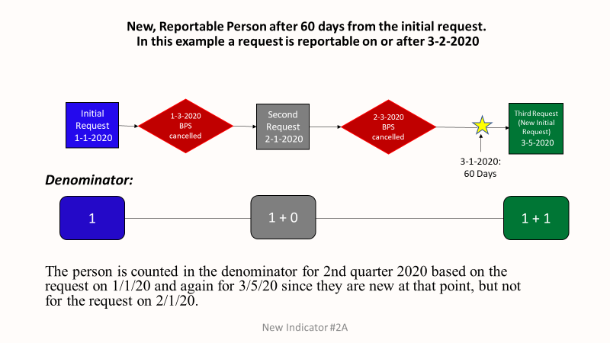Back to Text

Figure 2.2

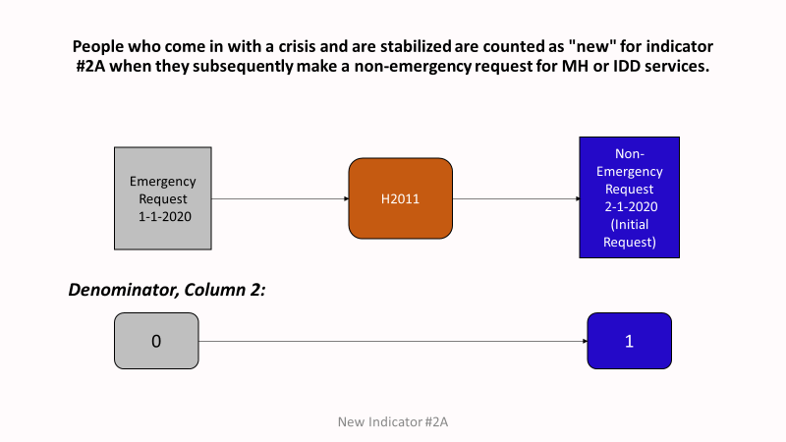Back to Text
Important to Note: A person can be counted no more than twice in the denominator during a quarter.

Figure 2.3

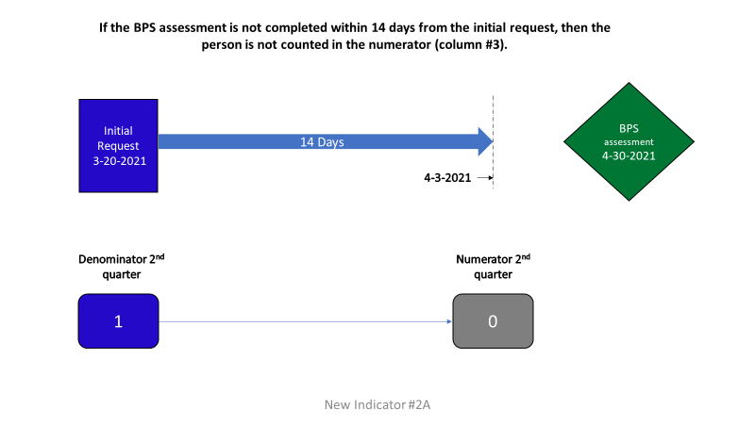Back to text

Figure 2.4

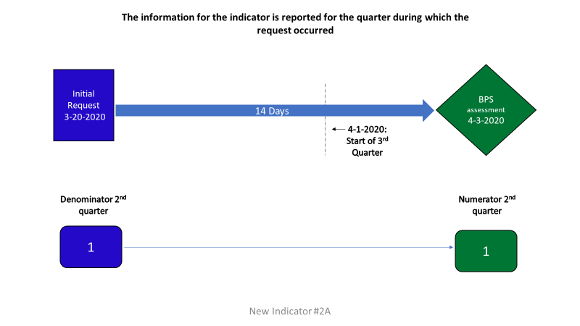Back to text

Figure 2.5

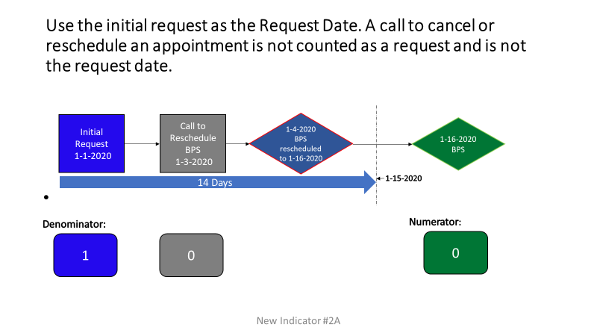Back to text

Figure 2.6

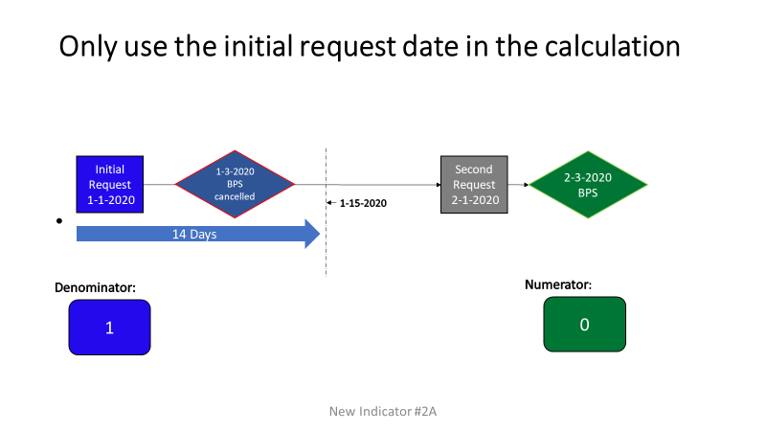Back to text

ACCESS-TIMELINESS/FIRST SERVICE (CMHSP)
Final Draft

Indicator new #3

Percentage of new persons during the quarter starting any needed on-going service within 14 days of completing a non-emergent biopsychosocial assessment (by four sub-populations: MI-adults, MI-children, IDD-adults, and IDD-children).

Rationale for Use
The amount of time between the professional assessment and the delivery of needed treatments and supports addresses a different aspect of access to care than Indicator #2. Delay in the delivery of needed services and supports may lead to exacerbation of symptoms and distress and poorer role functioning and disengagement from the system. The timely start of on-going services is critical to the engagement process and connecting the consumer to services and supports while the person is motivated towards treatment.

Table 3 - Indicator #3
1.  Population | 2.  # of New Persons Who Completed a Biopsychosocial Assessment within the Quarter | 3.  # of Persons from Col 2 Who Started a Face-to-Face Service Within 14 Calendar Days of the Completion of the Biopsychosocial Assessment | 4.  % of Persons Who Started Service within 14 days of Biopsychosocial Assessment
1. MI-C | W2 | X2 | AG2
2. MI-A | Y2 | Z2 | AH2
3. DD -C | AA2 | AB2 | AI2
4. DD-A | AC2 | AD2 | AJ2
5. Total Population | AE2 | AF2 | AK2

Column 2 - Selection Methodology
- Cases selected are those persons who have been reported in Column 2 of indicator #2 either during the current quarter or during previous quarters and for whom a biopsychosocial assessment was completed during the current quarter. The person was determined eligible for mental health or intellectual and developmental disability services.

- See General Rules for definitions of children, Medicaid, Mental illness (MI/SED) and intellectual and developmental disability (I/DD).
TIP: Selection Methodology

  - Those few people who are referred for a biopsychosocial assessment (BPS) and found not eligible for specialty services will be reported in Indicator #2 but not in Indicator #3.

- For this indicator, a biopsychosocial assessment is considered completed once the professional has submitted an encounter for the assessment and a qualified professional has determined a qualifying diagnosis for the individual. If the biopsychosocial assessment and the determination of the diagnosis occur on different dates, use the latter date when calculating the time from the initial request to the completion of the biopsychosocial assessment.

Column 3 – Numerator Methodology

- Cases selected for inclusion in Column 3 are those in Column 2 for which a planned service was received within 14 calendar days of the completion of the biopsychosocial assessment.

- “Service” means any non-emergent face-to-face CMHSP service that is included the person’s plan of service or moves a person toward development of their plan of service. Do not include pre-admission screening for, and receipt of, psychiatric in-patient care or crisis contacts. (See Figure 3.1)

TIP: Definition of Ongoing Services

For this indicator, as long as the service is face-to-face and is not a crisis contact, pre-admission inpatient screening or inpatient care, any encounterable service for specialty mental health (MH) or intellectual and developmental disability (IDD) services and supports can be used to satisfy the requirement that the service is in the person’s IPOS or moves them toward development of their IPOS. For list of crisis services see Indicator #2.

- Count forward from the date of the completed BPS assessment to the date of the first service for ongoing treatment and supports, even if it crosses multiple quarters, in order to calculate the number of calendar days from the completion of the BPS assessment to the start of ongoing services. (See Figure 3.1)

- If a person has an urgent need at some point following the BPS assessment and as a result is not able to receive a non-emergent face-to-face service within the 14-day window, this person should be counted in column #2 and not counted in column #3.

- Consumers covered under OBRA should be excluded from the count.

Documentation
The CMHSP must maintain documentation available for state review on the date the biopsychosocial assessment is completed as well as the date of the first face-to-face service even if this spans two quarters or multiple quarters. The CMHSP must also maintain documentation on the dates offered to the individual as well as scheduled dates that the individual rescheduled or for which the individual did not show up.

ACCESS-CONTINUITY OF CARE (CMHSP & PIHP)

Indicator #4a (CMHSP & PIHP) & 4b (PIHP Only)
The percentage of discharges from a psychiatric inpatient unit during the quarter that were seen for follow-up care within 7 days. Standard = 95%

Rationale for Use
When responsibility for the care of an individual shifts from one organization to another, it is important that services remain relatively uninterrupted and continuous. Otherwise, the quality of care and consumer outcomes may suffer. This is an indicator required by the federal Substance Abuse and Mental Health Services Administration.

Table 4a – Indicator #4a
1.  Population | 2.  # of Discharges from a Psychiatric Inpatient Unit | 3.  # of Discharges from Col 2 that are Exceptions | 4.  # Net Discharges  (Col 2 minus Col 3) | 5.  # of Discharges from Col 4 Followed up by CMHSP/PIHP within 7days | 6.  % of Persons discharged seen within 7 days
1. # of Children | AL2 | AM2 | AN2 - Calculated | AO2 | AT2 -Calculated
2. # of Adults | AP2 | AQ2 | AR2 - Calculated | AS2 | AU2 -Calculated
Column 2 – Selection Methodology
- “Discharges” are the events involving people who are discharged from a Psychiatric Inpatient Unit (community, IMD or state hospital) who meet the criteria for specialty mental health services and are the responsibility of the CMHSP/PIHP for follow-up services. In the event of multiple discharges of one person during the reporting period, count the number of discharges.
- Pre-admission screening for psychiatric in-patient care; and the psychiatric in-patient care should not be counted here.
- Do not include dual eligibles (Medicare/Medicaid) in these counts.

Column 3 – Exception Methodology
- Consumers who request an appointment outside the seven-day period or refuse an appointment offered that would have occurred within the seven calendar day period, or do not show for an appointment or reschedule it.
- Consumers who choose not to use CMHSP/PIHP services.

CMHSP/PIHP must maintain documentation available for state review of the reasons for all exclusions. In the case of refused appointments, the dates offered to the individual must be documented.

Column 4- Calculation of denominator
Subtract the number of discharges in column 3 from the number of discharges in column 2 and enter the number.

Column 5- Numerator Methodology
- Enter the number of discharges from column 4 (net) who were seen for follow-up care by the CMHSP/PIHP within seven days.
- “Seen for follow-up care,” means a face-to-face service (not screening for inpatient service, or the inpatient service) with a professional (not exclusively psychiatrists).
- “Days” mean calendar days.

Table 4b – Indicator #4b Do not use the following fields (BP-BT). This Indiciator is PIHP only.
1.  Population | 2.  # of Discharges from a Substance Abuse Detox Unit | 3.  # of Discharges from Col 2 that are Exceptions | 4.  # Net Discharges  (Col 2 minus Col 3) | 5.  # of Discharges from Col 4 Followed up by CA/CMHSP/  PIHP within 7days | 6.  % of Persons discharged seen within 7 days
# of Consumers | AV2 | AW2 | AX - Calculated | AY2 | AZ2- Calculated

Column 2 – Selection Methodology
- “Discharges” are the events involving consumers with substance use disorders who were discharged from a sub-acute detoxification unit, who meet the criteria for specialty mental health services and are the responsibility of the CA/PIHP or CMHSP/PIHP for follow-up services. In the event of multiple discharges of one person during the reporting period, count the number of discharges.
- Do not include dual eligibles (Medicare/Medicaid) in these counts.

Column 3 – Exception Methodology
- Consumers who request an appointment outside the seven-day period or refuse an appointment offered that would have occurred within the seven calendar day period, or do not show for an appointment or reschedule it.
- Consumers who choose not to use CA/CMHSP/PIHP services.

CA/PIHP or CMHSP/PIHP must maintain documentation available for state review of the reasons for all exclusions. In the case of refused appointments, the dates offered to the individual must be documented.

Column 4- Calculation of denominator
Subtract the number of discharges in column 3 from the number of discharges in column 2 and enter the number.

Column 5- Numerator Methodology
- Enter the number of discharges from column 4 (net) who were seen for follow-up care by the CA/PIHP or CMHSP/PIHP within seven days.

2. Seen for follow-up care,” means a face-to-face service with a substance abuse professional.
- “Days” mean calendar days.

ACCESS-DENIAL/APPEAL (CMHSP Only)

Indicator #5 (old indicator #6)

Percentage of face-to-face assessments with professionals during the quarter that result in denials.

Indicator #6 (old indicator #7)
Percentage of Section 705 second opinions that result in services.

Rationale for Use
As managed care organizations, CMHSPs are responsible for exercising appropriate control of entry into the public mental health system. The professional assessment represents one of the first opportunities for a CMHSP to control access to its non-emergent services and supports.

Table 5 – Indicator #5 & #6
1.  Total # of New Persons Receiving an Initial Non-Emergent Face-to-Face Professional Assessment | 2.  Total # of Persons Assessed but Denied CMHSP Service | 3.  Total # of Persons Requesting Second Opinion | 4.  Total # of Persons Receiving Mental Health Service Following a Second Opinion
BA2 | BB2 | BC2 | BD2

Note: Do not include in any column in Table 5 individuals who only received telephone screens or access center screens performed by non-professionals. Table 5 excludes those cases in which the individual refused CMHSP services that were authorized.

Definitions
Section 330.1705 of Public Act 1974 as revised, was intended to capture requests for initial entry into the CMHSP. Requests for changes in the levels of care received are governed by other sections of the Code.
“Professional Assessment” is that face-to-face meeting with a professional that results in an admission to ongoing CMHSP service or a denial of CMHSP service.

Methodology
Column 1: Enter the number of those people who received an initial face-to-face professional assessment during the time period (from Indicator #2, Column #2).
Column 2: Enter the number of people who were denied CMHSP services.
Column 3: Enter the number of people who were denied who requested a second opinion.
Column 4: Enter the number of people who received a mental health service as a result of the second opinion.

EFFICIENCY

Indicator #7 (old indicator #9)
The percent of total expenditures spent on managed care administrative functions annually by CMHSPs and PIHPs.

Rationale for Use
There is public interest in knowing what portion of an agency’s total expenditures are spent on operating the agency relative to the cost of providing services. Combined with other indicators of performance, information on percentage spent on administrative costs can be used as an indication of the agency’s overall efficiency.

Method of Calculation
MDHHS will calculate this indicator using CMHSP Total Sub-Element Cost Report and the PIHP Medicaid Utilization and Net Cost Report.
Numerator: the amount of expenditures for managed care administration as defined in the cost reports for the functions as defined in the document: “Establishing Managed Care Administrative Costs” Revised June 20, 2005.
Denominator: the amount of total expenditures from all funding sources for CMHSPs; and the amount of total Medicaid expenditures for PIHPs.

OUTCOMES: EMPLOYMENT

Indicator #8a,b (old indicator #10a,b)
The percent of (a) adults with mental illness, the percent of (b) adults with developmental disabilities, and the percent of (c) adults dually diagnosed with mental illness/developmental disability served by the CMHSPs and PIHPs who are employed competitively.

Rationale for Use
A positive outcome of improved functioning and recovery is the ability to work in a job obtained through competition with candidates who may not have disabilities. While there are variables, like unemployment rates, that the CMHSP and PIHPs cannot control, it is expected that through treatment and/or support they will enable and empower individuals who want jobs to secure them.

Method of Calculation

MDHHS will calculate this indicator after the end of the fiscal year using employment data from the individual’s most recent BH TEDS record.

CMHSP Indicator
Numerator: the total number of (a) adults with mental illness, the total number of (b) adults with developmental disabilities, and the total number of (c) adults dually diagnosed with mental illness/developmental disability who are employed competitively.
Denominator: the total number of (a) adults with mental illness, the total number of (b) adults with developmental disabilities, and the total number of (c) adults dually diagnosed with mental illness/developmental disability served by the CMHSP.

PIHP Indicator
Numerator: the total number of (a) adult Medicaid beneficiaries with mental illness, the total number of (b) adult Medicaid beneficiaries with developmental disabilities, and the total number of (c) adult Medicaid beneficiaries dually diagnosed with mental illness/developmental disability who are employed competitively.
Denominator: the total number of (a) adult Medicaid beneficiaries with mental illness, the total number of (b) adult Medicaid beneficiaries with developmental disabilities, and the total number of (c) adult Medicaid beneficiaries dually diagnosed with mental illness/developmental disability served by the PIHP.

OUTCOMES: EMPLOYMENT

Indicator #9a,b (old indicator #11a,b)
The percent of (a) adults with mental illness, the percent of (b) adults with developmental disabilities, and the percent of (c) adults dually diagnosed with mental illness/developmental disability served by the CMHSPs and PIHPs who earned minimum wage or more from any employment activities.

Rationale for Use
A positive outcome of improved functioning and recovery is the ability to earn an income that enables individuals the independence to purchase goods and services and pay for housing.

Method of Calculation

MDHHS will calculate this indicator after the end of the fiscal year using employment data from

the individual’s most recent BH TEDS record. A new minimum wage data element will be added to the

FY ’06 reporting requirements.

CMHSP Indicator
Numerator: the total number of (a) adults with mental illness, the total number of (b) adults with developmental disabilities, and the total number of (c) adults dually diagnosed with mental illness/developmental disability, who received Michigan’s minimum wage or more from employment activities (competitive, supported or self-employment, or sheltered workshop).
Denominator: the total number of (a) adults with mental illness, the total number of (b) adults with developmental disabilities, and the total number of (c) adults dually diagnosed with mental illness/developmental disability served by the CMHSP.

PIHP Indicator
Numerator: the total number of (a) adult Medicaid beneficiaries with mental illness, the total number of (b) adult Medicaid beneficiaries with developmental disabilities, and the total number of (c) adult Medicaid beneficiaries dually diagnosed with mental illness/developmental disability, who received Michigan’s minimum wage or more from employment activities (competitive, supported or self-employment, or sheltered workshop).
Denominator: the total number of (a) adult Medicaid beneficiaries with mental illness, the total number of (b) adult Medicaid beneficiaries with developmental disabilities, and the total number of (c) adult Medicaid beneficiaries dually diagnosed with mental illness/developmental disability served by the PIHP.

OUTCOME: INPATIENT RECIDIVISM (CMHSP & PIHP)

Indicator #10 (old indicator #12):
The percentage of readmissions of children and adults during the quarter to an inpatient psychiatric unit within 30 days of discharge. Standard = 15% or less

Rationale for Use
For some people with mental illness, the occasional use of psychiatric inpatient care is essential. However, rapid readmission following discharge may suggest that people were prematurely discharged or that the post discharge follow-up was not timely or sufficient. This indicator assessed whether CMHSPs are meeting the Department’s standard of no more than 15 percent of people discharged from inpatient units are being readmitted within 30 days.

Table 6 – Indicator #10
1.  Population | 2.  # of Discharges from Psychiatric Inpatient Care during the Reporting Period | 3.  # of Discharges in Col 2 that are Exceptions | 4.  # Net Discharges  (Col 2 minus Col 3) | 5.  # of Discharges (from Net Col. 4) Readmitted to Inpatient Care within 30 Days of Discharge | 6.  % of Discharges Readmitted to Inpatient Care within 30 days of Discharge
1. # of Children | BE2 | BF2 | BG2 - Calculated | BH2 | BM2 -Calculated
2. # of Adults | BI2 | BJ2 | BK2 - Calculated | BL2 | BN2 -Calculated

NOTE: This information is intended to capture Admissions and Readmissions, not transfers to another psychiatric unit, or transfers to a medical inpatient unit. Do not include transfers or dual-eligibles (Medicare/Medicaid) in the counts in any column on this table.

Column 2 – Selection Methodology
  - Discharges” are the events involving all people (for the CMHSPs) and Medicaid eligibles only (for the PIHPs) who are discharged from a Psychiatric Inpatient Unit (community, IMD or state hospital), who meet the criteria for specialty mental health services and are the responsibility of the CMHSP for follow-up services. In the event of multiple discharges of one person during the reporting period, count the total number of discharges.
  - Do not include dual eligibles (Medicare/Medicaid) in these counts.

Column 3 – Exception Methodology
Enter the discharges who chose not to use CMHSP/PIHP services

CMHSP/PIHP must maintain documentation available for state review of the reasons for exceptions in
column 3.

Column 4 – Calculation of Denominator
Subtract the number of discharges in column 3 from the number of discharges in column 2 and enter the number.

Column 5 – Numerator Methodology
- Enter the number of persons from column 4 who were readmitted to a psychiatric inpatient unit within 30 days of discharge from a psychiatric inpatient unit.
- In order to obtain correct counts for column 5, you must look 30 days into the next quarter for possible readmissions of persons discharged toward the end of the current reporting period.
- “Days” mean calendar days.

Attachment I:

CMHSP Annual
Recipient Rights Report
Codebook

Period: | 10/01/13-9/30/20
Due: | December 31, 2014

OUTCOMES: RECIPIENT RIGHTS COMPLAINTS

Indicator #11
The annual number of substantiated recipient rights complaints in the categories of Abuse I and II, and Neglect I and II per 1,000 persons served by CMHSPs and by PIHPs.

Rationale for Use
Substantiated rights complaints are a measure of the quality of care provided by CMHSPs and managed by PIHPs. Since Abuse and Neglect complaints must be investigated, it is believed that these four categories represent the most serious allegations filed on behalf of people served.

Table 7b. Recipient Rights Complaints from All Consumers Served by the CMHSP (reported by CMHSPs)

A = CMHSP Name

RR Complaints | 1.  # of Complaints from All Consumers | 2.  # of Complaints Substantiated by ORR | 3.  # of Complaints Substantiated Per Thousand CMHSP Consumers Served
Abuse I | B | C
Abuse II | D | E
Neglect I | F | G
Neglect II | H | I

Instructions:
Column 1: Enter the number of complaints from all consumers in each of the above categories that were filed at the local Office(s) of Recipient Rights during the year.
Column 2: Enter the number of those complaints that were substantiated by the local ORRs.
Column 3: MDHHS will calculate the number of complaints per thousand persons served.

Tips and Reminders

Indicator 2A

Definition of New Persons

Tip 2a.1
  - If the person has received SUD services in the last 90 days, but no MH/IDD services the person is reportable for indicator 2a.
  - If a new person is requesting services for both mental health/intellectual and developmental disability as well as substance use disorder,
    - include the person in this current indicator (#2a) if referred for services to a CMHSP.
    - Also include the person in the substance use disorder indicator (#2b) if the person is admitted to a licensed and accredited SUD provider. §
Tip 2a.2
- Person can be new to the CMHSP but not the PIHP because they were seen at another CMHSP within that PIHP. CMHSP indicator would report individual as ‘new’.
- PIHP would go through all of the ‘new’ persons reported by the various CMHSPs and determine if they are ‘new’ to the PIHP. For this indicator, the PIHP will only report those people who are new to the PIHP. §

Figure 2a.1

Important to Note: A person can be counted no more than twice in the denominator during a quarter.

Figure 2a.2

Tip 2a.3
If over the past 90 days the person has only received ‘crisis’ services, they are new or reportable for indicator 2a. Crisis services are defined by the following codes:

      - Any service from a psychiatric inpatient stay
      - H2011 – Crisis intervention, Intensive Crisis Stabilization for Children or for Adults
      - S9484 – Intensive Crisis Stabilization
      - T1023 – Screening for Inpatient Program
      - 90839 – Psychotherapy for Crisis
      - 90840 – Psychotherapy for Crisis
      - H0018 – Crisis Residential
      - 0912, 0913 – Partial Hospitalization if T1023 reported. §

Tip 2a.4 (reporting inpatient discharges for indicator #2a and #4)

If the person is referred from an inpatient psychiatric facility:
- If the person is new to the PIHP, include them in this indicator (#2a) as well as indicator #4.
- Indicator #2a is a subset of the people reported in indicator #4.
- Indicator 2 is looking at ‘request to assessment’ while Indicator #4 is looking at access to services after the hospitalization. §

Figure 2a.3
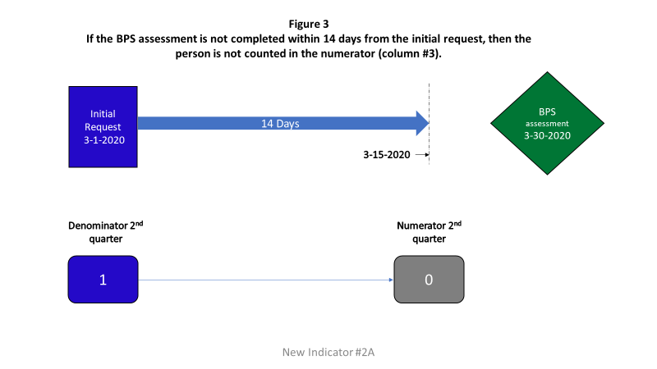

Figure 2a.4
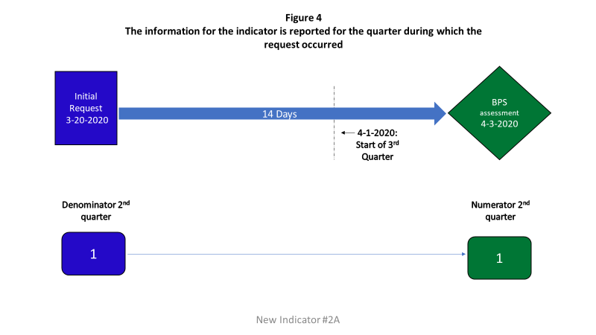

Determining Date of Request

Tip 2a.5
If a person is difficult to reach after leaving initial request, the date of the person’s first request is the request date. The request starts once the person provides their name and contact information.

Example:
- 1/1/2020 The person calls for the first time and leaves a message, with name and call-back information, requesting services.
- 1/1/2020 The access center calls the person back, is unable to reach the person but leaves a message.
- 1/15/2020 the person calls back to request services and receives a referral for a BPS.
- The request date is 1/1/2020. §

Figure 2a.5
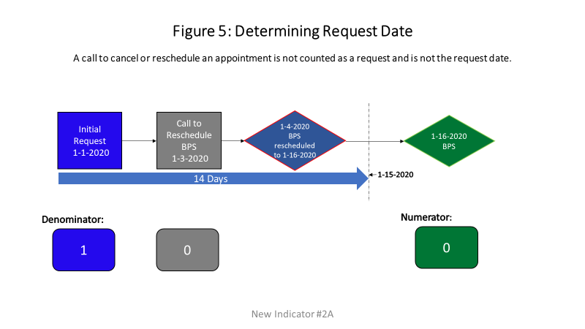
Figure 2a.6
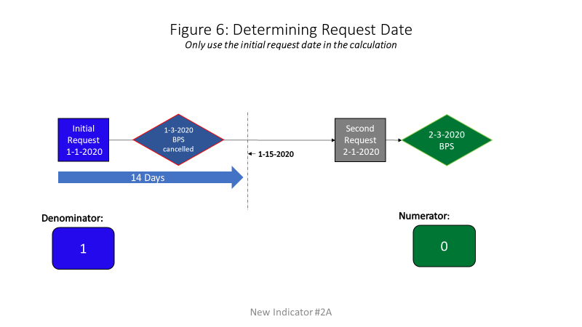

Tips and Reminders
Indicator 3

Selection Methodology

Tip 3.1.
  - Those few people who are referred for a biopsychosocial assessment (BPS) and found not eligible will be reported in Indicator #2A but not in Indicator #3.

Medicaid persons
  - If at the time the PIHP submits the indicators it is determined that the person was retroactively eligible for Medicaid during the reporting quarter then the person should be included in the Medicaid version of the indicator.
Important to note
  - A person can be non-Medicaid for indicator #2A but become Medicaid for indicator #3, or the reverse.

Figure 3.1
Definition of Ongoing Services

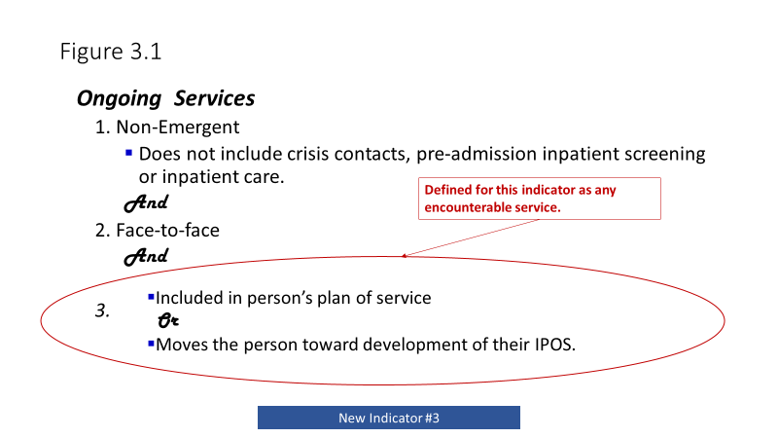

Figure 3.2

