**Michigan Department of Health and Human Services**

**Critical Congenital Heart Disease Screening**

**Guide for Hospitals**

**December 2023**

# TABLE OF CONTENTS

Introduction

Overview of Screening for Critical Congenital Heart Disease in Michigan

Conducting the Screen

Guidance for Screeners

NICU Protocol

Common Algorithm Errors

Submitting Results to the Newborn Screening Program

CCHD Follow-up Procedure (Data elements collected, failed, no information and missed screen faxes)

Pulse Oximetry Reporting Rate

Reporting Pulse Oximetry Results to the Newborn Screening Program

Parent Refusal of the Blood Spot Screen

Quality Assurance

Best Practices

Resources

Contact Information

Appendix A

Appendix B

# PROGRAM CONTACTS

**NBS Follow-up Program**

**Michigan Department of Health and Human Services**

**Newborn Screening Follow-up**

333. S. Grand Ave., 2nd floor

PO Box 30195

Lansing, MI 48909

**Toll-free:** 866-673-9939

**Telephone:** 517-335-4181

**Fax:** 517-335-9419 or 517-335-9739

**Email:** [newbornscreening@michigan.gov](mailto:newbornscreening@michigan.gov)

**Website:** www.michigan.gov/newbornscreening

**Kristen Thompson, MPH**

Newborn Screening Program Coordinator

517-284-4992

[Thompsonk23@michigan.gov](mailto:Thompsonk23@michigan.gov)

**Amy Rakowski, M.S.**

Pediatric Genomics Epidemiologist

517-284-4233

[Rakowskia@michigan.gov](mailto:Rakowskia@michigan.gov)

**Shelby Heppe, MPH**

Newborn Screening Follow-up Section Manager

517-285-0382

[Heppes@michigan.gov](mailto:Heppes@michigan.gov)

# INTRODUCTION

Every Michigan newborn is screened shortly after birth for over 50 different disorders. In addition to the blood spot screen, two point of care screens are completed at the hospital before the baby is discharged: the critical congenital heart disease (CCHD) screen and the hearing screen. This hospital guide will focus on the CCHD screening. The guide is intended for hospital staff conducting the screen, the newborn screening coordinator, and the information technology staff involved in reporting these results to Michigan Department of Health and Human Services (MDHHS).

Congenital heart defects (CHDs) are the most common group of birth defects, nearly 1% of births per year in the United States. About 1 in 4 babies with a CHD have a critical CHD. CCHDs require surgery or catheter intervention in the first year of life. CCHDs remain one of the most significant causes of infant death in the United States (Newborn Screening: Critical Congenital Heart Defects, 2020).

Effective April 1, 2014, MDHHS implemented statewide pulse oximetry screening of all Michigan newborns prior to hospital discharge (enabling legislation available in Appendix A). The Newborn Screening Program recommends that newborns be screened prior to hospital discharge, as close to 24 hours of age as possible, using the approved MDHHS CCHD Screening Algorithm.

It is vital that every newborn receives a pulse oximetry screen for CCHD and those results are sent to the Newborn Screening Program. Each year in Michigan over 90,000 babies are screened, an average of 4 babies are diagnosed with a CCHD, and an average of 7 babies are diagnosed with a secondary condition through screening. We appreciate your staff and all of your efforts in ensuring this program is a success.

# OVERVIEW OF SCREENING FOR CRITICAL CONGENITAL HEART DISEASE IN MICHIGAN

Pulse oximetry has been shown to detect some forms of CHDs in the newborn based on low oxygen levels in the blood. This screening targets twelve specific anomalies classified as CCHD (Table 1). Failure to detect such heart defects while in the hospital puts the baby at risk for serious complications within the first few days or weeks of life. Frequent emergency room care, potential permanent disability and even death may be the result of delayed treatment.

In 2011, pulse oximetry was recommended by the U.S. Department of Health and Human Services Secretary's Advisory Committee on Heritable Disorders in Newborns and Children as an important screening tool for detection of CCHD in asymptomatic newborns (Beekman, 2012). This recommendation was subsequently endorsed by the American Academy of Pediatrics (AAP) as a standard of care.

Effective April 1, 2014, screening for CCHD using pulse oximetry was mandated for all Michigan newborns prior to hospital discharge.

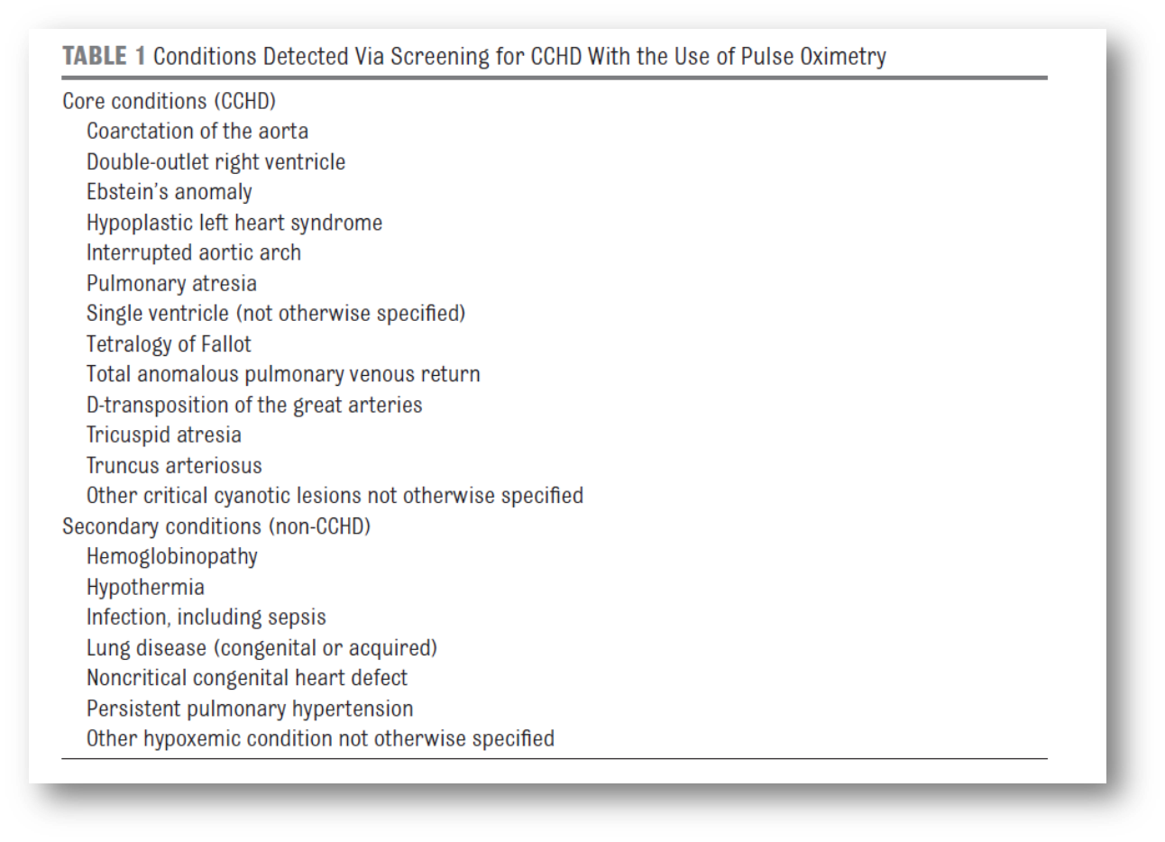

# CONDUCTING THE SCREEN

The [Michigan algorithms for CCHD screening](https://www.michigan.gov/mdhhs/-/media/Project/Websites/mdhhs/Adult-and-Childrens-Services/Children-and-Families/Hereditary-Disorders/Newborn-Screening/CCHD/MI-algorithm-11-6-13.pdf?rev=b75eeca3590745ce80c9f8874666c2bc&hash=0FA3B558787B5251DF755F40A526CF45) using pulse oximetry were developed by the Michigan CCHD Advisory Committee based on AAP recommendations.

Screening should be done at or as close to 24 hours of life when the infant is comfortable and quiet.

**Guidance for Screeners**

* 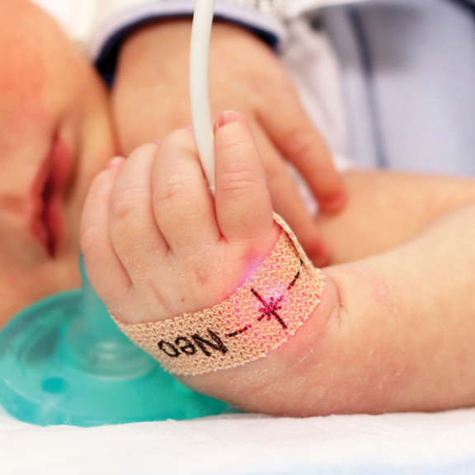The screen is for asymptomatic infants. Infants showing signs of cyanosis, tachypnea, increased work of breathing, swelling, tiring easily during feeds, sweating, or poor weight gain prior to the screen at 24 hours should be evaluated as soon as possible.
* Select site: right hand; either foot.
* Place photodetector on outer aspect of hand/foot (under 4th-5th finger/toe).
* Wrap sensor tape around extremity.
* Ensure light emitter is directly opposite the photodetector.
* If using a reusable sensor, secure the sensor using wrap recommended by vendor; do not use tape or use hand to secure sensor to site.
* For the best results, conduct a pulse oximetry screening as close to 24 hours of life as possible prior to discharge.
* 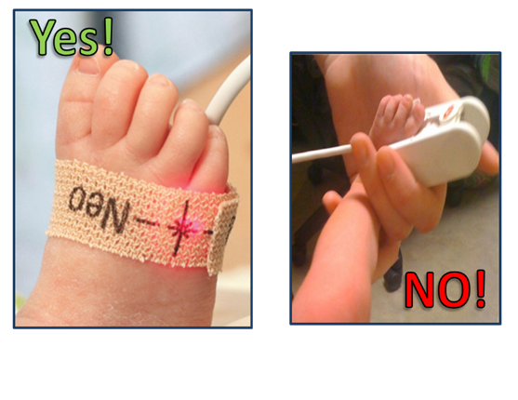The infant should not be distressed or be in cardiovascular distress.
* Make sure that the infant is awake, comfortable, and quiet. The parent may hold the baby and infants can also be swaddled if it helps them stay calm. Any movement, shivering, or crying can affect the accuracy of reading.
* Use a pulse oximeter that has been approved by the Food and Drug Administration for use in neonates.

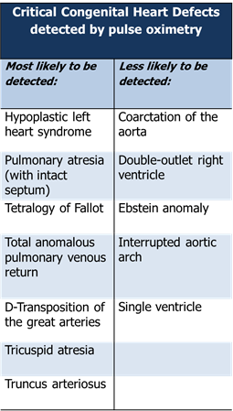Unlike other conditions on the newborn screening panel, we expect that some babies with a CCHD will pass their screen, so clinical vigilance is extremely important. The table on the left identifies which core conditions most likely and least likely to be detected through screening.

Even prior to or after a pulse oximetry screen is taken, it is important to monitor the infant for these signs and symptoms to identify a potential CCHD: **cyanosis, tachypnea, increased work of breathing, swelling, tires easily during feeds, sweating, or poor weight gain**.

# NEONATAL INTENSIVE CARE (NICU) UNIT PROTOCOL

NICU infants should be screened when medically appropriate following the MDHHS NICU algorithm. The NICU algorithm for CCHD screening is below.

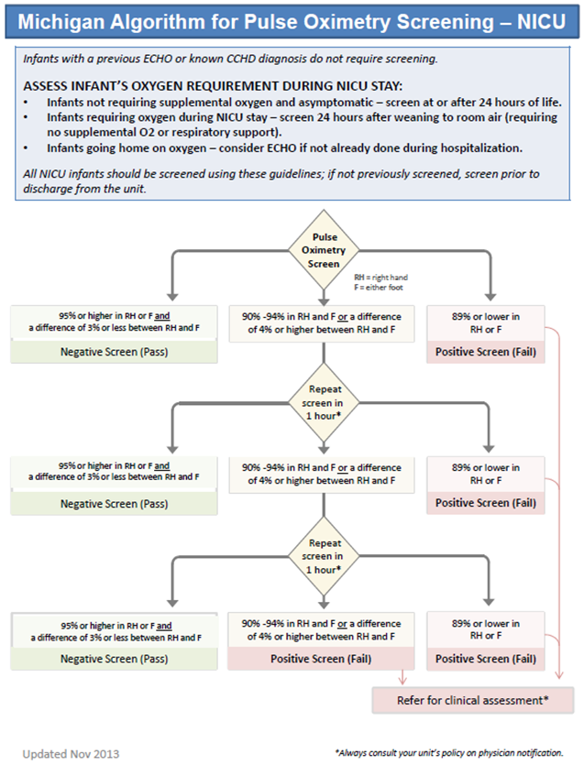

# COMMON ALGORITHM ERRORS

The most common reason for improperly following the pulse oximetry screening algorithm is giving an unnecessary rescreen after passing or failing the first screen. Rescreening after an initial passed screen causes more work for hospital staff.

Of most concern are errors where babies receive a rescreen after failing their initial screen and babies who do not receive a needed rescreen. These babies are discharged from the hospital before a CCHD could be ruled out.

Please follow the key points of the algorithm:

* 95% or higher in the RH or F AND a difference of less than 3% is a pass.
* Any result between 90-94% OR a difference of greater than or equal to 4% is a repeat. Repeats require one hour between screens.
* Anything 89% or lower is a fail. These babies should be referred for clinical assessment. Another pulse oximetry screen is not enough to rule out a CCHD.

Examples:

* Right hand: 93 Foot: 95 is a pass. There only needs to be a reading of 95% or higher in either the right hand or foot.
* Right hand: 100 Foot: 96 is a rescreen. Though these numbers look high, the difference of 4% requires that a rescreen be taken.
* Right hand: 89 Foot: 92 is a fail. Anything 89% or lower is a failing result and this baby should not be rescreened.

# SUBMITTING RESULTS TO THE NEWBORN SCREENING PROGRAM

As of April 1, 2014 hospitals are required to electronically submit CCHD screening data to the Michigan Newborn Screening Program.

**Reporting Pulse Oximetry Results to the Newborn Screening Program**

Michigan has three options for hospitals to utilize to securely report CCHD data electronically to the state:

* eReports
* File Transfer Protocol (FTP)
* Health Level 7 (HL7) messaging

For more specific instructions on how to set up any of these reporting methods, please contact Kristen Thompson at [thompsonk23@michigan.gov](mailto:thompsonk23@michigan.gov).



**Flow of Data for CCHD Screening**

1. The blood spot card demographic information is filled out.
2. The CCHD screen is conducted at the hospital.
3. The CCHD screen is recorded in the patient’s electronic medical record (EMR).
4. The CCHD screen is reported to the NBS Program using one of the three reporting methods (FTP, HL7, or eReports.)
5. The CCHD screen links with the MDHHS NBS Laboratory Information Management System (LIMS).
6. The NBS Program conducts follow-up on failed screens, screen reported to the program as missed, and screens the program did not receive any information on.

A mistake at any step of this process can cause major downstream effects.

The first step to success is accurately filling out the demographic information on the blood spot card. This is important because this information is used by the NBS Program to link the CCHD results being sent by your hospital with the correct patient. A mistake in filling out any of the demographic information will prevent the CCHD results from linking with the patient record in our system. This makes it appear that your hospital never submitted any CCHD screening data for this patient.

Things to keep in mind when filling out the demographic information on the blood spot card:

* Leave out dashes, hyphens, and spaces.
* Spell mother’s first and last names accurately.
* Birth date and medical record number must be accurate.
* Use mother’s full legal name on the blood spot card.

Things to keep in mind when recording CCHD screening results into a patient’s EMR:

* Enter the results into the patient’s EMR as soon as possible. Any delays in entering this data can lead to forgetting entirely, forgetting the observed pulse ox values for the right hand and foot, or entering the wrong time that the screen was taken.
* Make sure the time recorded is the time you took the screen and not the time you are entering the screen into the EMR.
* Check for accuracy.
* Make sure you enter both the foot and right-hand results. Results without values, or results with one value will not be accepted.
* Results with just pass/fail are not accepted.
* Don’t miss a value or leave it blank.
* Check that you haven’t typed 0 versus 100 or 9 versus 96.

**CCHD Follow-up Procedure**

The Newborn Screening Program uses a standardized process for follow-up.

Hospitals will receive an email from the Newborn Screening Program office for the following reasons:

* An infant failed the CCHD screening
* Birth hospital reported that CCHD screening was missed for an infant
* No CCHD screening information has been received for an infant

MDHHS collects CCHD screening data for follow-up and quality assurance purposes. MDHHS uses the collected CCHD data to:

* Alert hospitals of potentially missed screens
* Determine the outcome of failed screens
* Evaluate the CCHD screening algorithm
* Link to the birth defects registry to determine the pulse oximetry screening results of infants reported to the registry with a CCHD

Data Elements Collected:

* + Demographics
  + Dates and times
  + Foot oxygen saturation
  + Right hand oxygen saturation
  + Perfusion index (if available)
  + Pulse oximetry not complete
    - Distress
    - Transfer
    - Infant died
    - Prior postnatal CCHD dx
    - Referred
    - Parent Refusal
    - Echocardiogram
    - Missing

The Newborn Screening Program will reach out to the birth hospital and request additional information via email. The email will include the information needed to identify the infant. The form can be emailed or faxed back to the Newborn Screening Program office or entered in eReports.

If the Newborn Screening Program did not receive any information on an infant or if the pulse oximetry screen for the infant was reported as missed an email will be sent to the birth hospital. The email will include the information needed to identify the infant(s). If a pulse oximetry screen has been completed, results should be submitted to the State NBS Program using the recommended method of eReports or your hospital’s usual reporting method. If a pulse oximetry screen has not been completed, the primary care provider should be notified as soon as possible. ***Do not fax or email results back to the NBS Program***.

For images of the form, please see Appendix B.

**Reporting Errors**

Every month you will receive a list of patients that we did not receive CCHD screening results on. The reason that we did not receive them could be that your hospital never submitted the information to us, or it could be because it was submitted with errors that prevented the CCHD screening results to link with the patient record in our LIMS. It is recommended that all hospitals, regardless of how they report initially, report errors using eReports, our online reporting module for CCHD.

To get registered, contact Kristen Thompson at [ThompsonK23@Michigan.gov](mailto:ThompsonK23@Michigan.gov).

When using eReports to report errors, it is recommended that you search by the kit number provided in the emailed list of patients we do not have information on. CCHD screening results must be linked to the initial kit number, so searching by any other demographic information can result in results being linked to a subsequent blood spot screen and will still appear as missing.

**Pulse Oximetry Reporting Rate**

On a monthly basis, the Newborn Screening Program determines the pulse oximetry screening reporting rate for each hospital. It is vital that every newborn receives a pulse oximetry screen and those results are sent to the Newborn Screening Program. The Newborn Screening Program’s goal is for each hospital to have a reporting rate of 95% or greater. Technical assistance is offered to all hospitals with a reporting rate of less than 90%.

**Parent Refusal of the Blood Spot Screen**

If a parent refuses to permit collection of a blood spot screen but allows a pulse oximetry screen these results can be reported via email to Kristen Thompson at <Thompsonk23@Michigan.gov>. These results are unable to be reported using your normal reporting methods.

# QUALITY ASSURANCE

The NBS Program evaluates each hospital’s CCHD screening performance and provides a quarterly report to each hospital with the following metrics:

* All newborns with a right hand and foot pulse oximetry screen reported to the state divided
* by the total number of newborns with a bloodspot screen (Target = 95%).
* All newborns with a right hand and foot pulse oximetry screen reported to the state less
* than 10 days after screen date divided by the total number of newborns with a bloodspot screen. (Target = 90%).
* All newborns with a right hand and foot pulse oximetry screen completed between 20 and 28 hours after birth divided by the total number of newborns with a pulse oximetry screen. (Target = 90%). An example of a CCHD Quarterly Quality Assurance Report appears below:

# BEST PRACTICES

**General tips for all hospitals:**

* Take the CCHD screen at 24 hours with the bundle of 24-hour tasks (hep B, weighing, etc.)
* Have a pulse oximeter in room available for nurse at any time, but also for taking the screen
* Consult with IT to see if adding parameters in the electronic medical record for pass/rescreen/fail is possible
* Have nurses enter results quickly after screen (that minute, or just outside the room)
* Make sure submission of data is within ten days of screen
* In discharge summary, change from values only to include pass, fail, and rescreen
* Nurse informatics specialists are very helpful
* Develop a form to fax to primary care provider offices if follow-up care is needed
* Train new staff and retrain veteran staff on CCHD best practices
* In the flow sheet where the staff enter data, add a pop out with the CCHD algorithm
* Set up EMR to alert staff if the screen was entered in wrong (ex; 9 versus 99)
* Hospitals reporting using FTP: Enter errors in using eReports and use eReports to enter in information if there was an echo or a change in the results
* Utilize the electronic medical record (EMR) system

After staff enter the pulse oximetry screening values, request that IT program the EMR to auto calculate the CCHD screen outcome (see example below). This has shown improved accuracy of the screening results while reducing the time staff spend in the patient’s EMR.

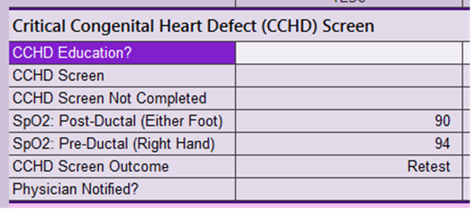

**Newborn Screening Online Training for Critical Congenital Heart Disease**

The Newborn Screening Program has an online training for pulse oximetry screening for CCHD. The purpose of this training is to enhance the knowledge and skills of staff taking pulse oximetry readings for newborn screening. This module provides a brief overview of CCHD and CCHD screening using pulse oximetry. It reviews national and state recommendations on pulse oximetry screening for CCHD. It includes discussion and identification of CCHDs and their public health impact and detection. The training will also give examples of recommended equipment, protocol, and best practices for CCHD screening using pulse oximetry.

Upon successful completion of the course and all other requirements, the following continuing education opportunities are available: 1.00 Nursing Contact Hours.

[**Michigan Newborn Screening for Critical Congenital Heart Disease**](http://www.newbornscreening.com/cchd)

[**Critical Congenital Heart Disease Screening Online Course**](https://courses.mihealth.org/PUBLIC/home.html)

# References

Beekman, R., Mahle, W., Martin, G., Minich, L., Mital, S., Morrow, R., Rosenthal, G., Snyder, C., Towbin, J., and Tweddell, J. (2012). Endorsement of Health and Human Services Recommendation for Pulse Oximetry Screening for Critical Congenital Heart Disease. *Pediatrics*, 129(1), 190-192. <https://doi.org/10.1542/peds.2011-3211>

Congenital Heart Defects (CHDs): Data and Statistics on Congenital Heart Defects. (2023). Retrieved from <https://www.cdc.gov/ncbddd/heartdefects/data.html>

Cooley, W., Glidewell, J., Grosse, S., Howell, R., Kelm, K., Kemper, A., Kumar, P., Mahle, W., Martin, G., Morrow, R., and Pearson, G. (2011). Strategies for Implementing Screening for Critical Congenital Heart Disease. *Pediatrics*, 128 (5) e1259-e1267. <https://doi.org/10.1542/peds.2011-1317>

Newborn Screening: Critical Congenital Heart Defects. (2020). Retrieved from <https://www.aap.org/en-us/advocacy-and-policy/aap-health-initiatives/PEHDIC/Pages/Newborn-Screening-for-CCHD.aspx>

# APPENDIX A – LEGISLATIVE MANDATES

## **Public Health Code Act 368 of 1978**

The NBS Program applies to all newborns in the State of Michigan by law. You can find the law in its entirety online on the [Public Health Code Act 368 of 1978](http://www.legislature.mi.gov/(S(fg310mqdkkiecyxuaanjvbxc))/mileg.aspx?page=getobject&objectname=mcl-333-5431) website.

Some highlights are:

* Health professional in charge of the care of a newborn infant or, if none, the health professional in charge at the birth of an infant must collect the newborn screen
* Informed consent of the parent is not required
* Positive results shall be reported to the infant’s parents, guardian or person in loco parentis
* NBS fee and adjustment
* Hardship waiver of the fee is authorized
* Retention and disposal schedule are established

## **Act No. 31, Public Acts of 2006 to amend 1978 PA 368**

This amendment can be found in its entirety on the [Act No. 31, Public Acts of 2006 to amend 1978 PA 368](http://www.legislature.mi.gov/(li5g3jafe4e5ad55oo2kgxym)/documents/2005-2006/publicact/pdf/2006-PA-0031.pdf) website.

Some highlights are:

* Creation of the newborn screening quality assurance advisory committee
  + Committee members
  + Review disorders screened and recommend new disorders for addition to the screening panel
  + Financial review of the NBS Program with recommendation to adjust the amount charged
* Addition of screening for hearing loss

# APPENDIX B –FAX FORMS

Failed Screen Fax Form:

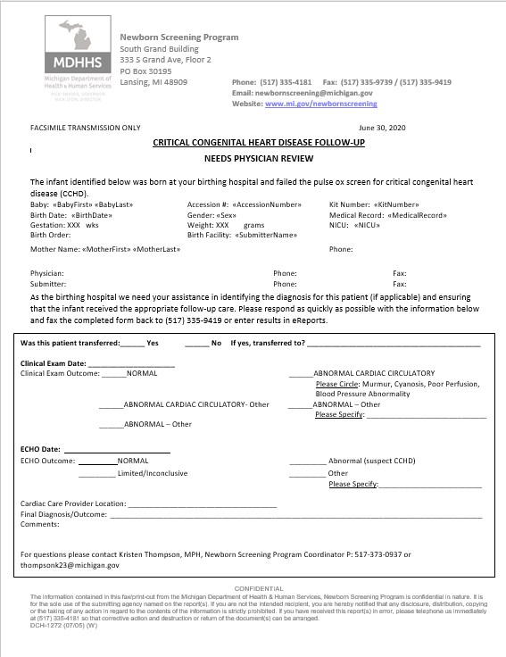

Closed Case Fax Form:

