MICHIGAN DEPARTMENT OF TRANSPORTATION

2026-2027 Statewide Technical Training Course Request Form

Instructions
- Single course attendee: Complete the required fields (boxes).
- To add multiple attendees: Right click anywhere on the last line to add a line, click ‘Insert’, select ‘Insert Rows Below’; then, complete the required fields (boxes).
- Submit the completed form in Microsoft Word format to MDOT-TechTraining@Michigan.gov. Please put “Technical Training” in the Subject line.
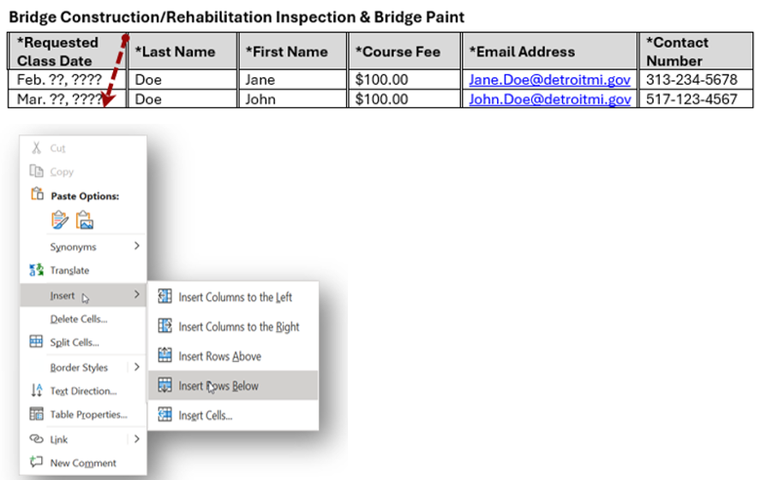

2026-2027 Statewide Technical Training Course Request Form
Local Agencies
Note: Reference the 2026-27 Statewide Technical Training Course Schedule for assistance with special notes, guidelines, and information for each course you plan to attend.

Your registration depends on completing the following process:
- Submit this form.
- We will confirm via email if a seat is available.
- Pay only after your seat is confirmed.
- Your seat is secured once we receive both your registration form and payment.
- Payment is non‑refundable and due by the day registration closes.
Fields marked with * are required.

Courses

Bridge Construction/Rehabilitation Inspection & Bridge Paint
*Requested class date | *Last name | *First name | *Course fee | *Email address | *Contact number

Computerized Office Technician (COT)
*Requested class date | *Last name | *First name | *Course fee | *Email address | *Contact number

Computerized Office Technician-Recertification (COT-Recert) Exam

Note: Submit a copy of your non-expired COT certification, along with this Request Form.
*Requested class date | *Last name | *First name | *Course fee | *Email address | *Contact number

Concrete Paving Inspection Training
*Requested class date | *Last name | *First name | *Course fee | *Email address | *Contact number

Density Certification Training: Visit Ferris State University’s website to register.

Concrete Paving Inspection Training
*Requested class date | *Last name | *First name | *Course fee | *Email address | *Contact number

Drilled Shaft Training
*Requested class date | *Last name | *First name | *Course fee | *Email address | *Contact number

Hot Mix Asphalt Paving Operations: Visit Ferris State University’s website to register.

Hot Mix Asphalt Paving Operations - Recertification: Visit Ferris State University’s website to register.

MDOT Superpave Asphalt Mix Designers Certification Training
*Requested class date | *Last name | *First name | *Course fee | *Email address | *Contact number

Prevailing Wage Training
*Requested class date | *Last name | *First name | *Course fee | *Email address | *Contact number
If you require assistance accessing this information or require it in an alternative format, contact the Michigan Department of Transportation’s (MDOT) Americans with Disabilities Act (ADA) coordinator at Michigan.gov/MDOT-ADA.

