# Instructions

1. Requestor Contact Information: Double click on this box. [*Fill in the Last Name, First Name, Location, E-mail Address and Contact Number fields]. Then click the Esc key to continue.
2. Complete the form for each attendee, as shown in the following example. [*Complete the required fields]
3. For attendees requiring multiple course enrollments, follow item #2 steps for each course.
4. To add additional attendees to a specific course: Right click on the Course Title, click on Insert, then select Insert Rows Below.
5. Submit the completed form in the **Microsoft Word** format to [MDOT-TechTraining@Michigan.gov](mailto:MDOT-TechTraining@Michigan.gov). Please put “Technical Training” in the Subject line.

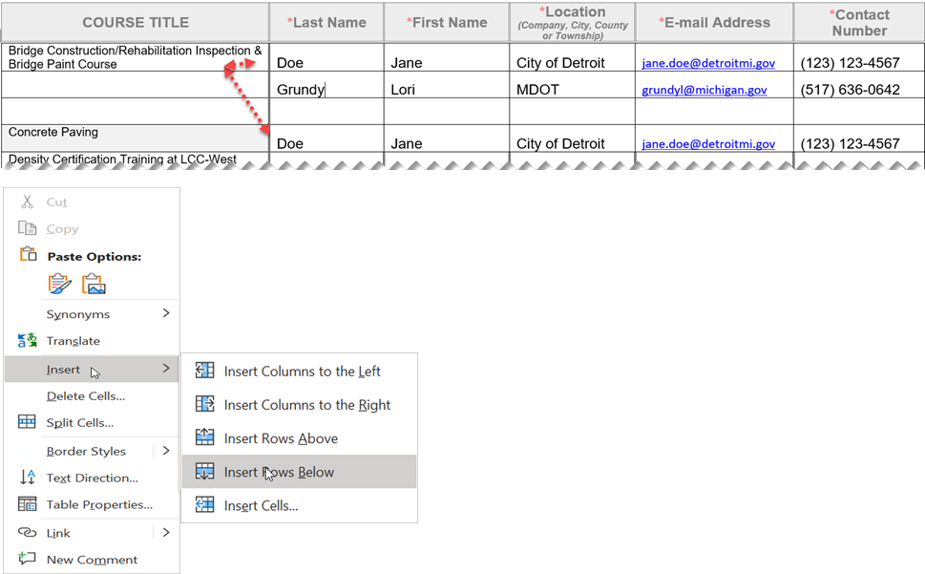

|  |  |  |  |  |  |
| --- | --- | --- | --- | --- | --- |
| Bridge Construction/Rehabilitation/Paint Inspection Course and Structural Steel Bolting/Welding Training |  |  |  |  |  |
| Computerized Office Technician (COT)  (The MDOT [2020 Spec book](https://www.michigan.gov/mdot/-/media/Project/Websites/MDOT/Business/Construction/Standard-Specifications-Construction/2020-Standard-Specifications-Construction.pdf?rev=b944f71da7fb4f9c879f74659f64795b&hash=572ED32A1FC18C8D164C30D646450900) a laptop with laptop power cord, and a calculator will be required for use.)  **Note:**MDOT expects full commitment to attendance and participation in this class/course. Certifications and certificates of completion will not be issued for participants that fail to attend and/or participate. If the student does not pass the exam, the full course must be retaken. There will be no retests.  **\***Registration for North and Marquette classes is limited to attendees only from the North & Superior region, respectively. Registrations from other regions for these classes will be confirmed subject to availability though it is not guaranteed. |  |  |  |  |  |
| Computerized Office Technician-Recertification Exam (Must have previously passed the Computerized Office Technician course. A laptop with laptop power cord, and a calculator will be required for use.)  **Note:**Proof of non-expired Computerized Office Technician certification is required prior to registering for this exam. If the student does not pass the exam, the full course must be retaken. There will be no retests.  **\***Registration for North and Marquette classes is limited to attendees only from the North & Superior region, respectively. Registrations from other regions for these classes will be confirmed subject to availability though it is not guaranteed. |  |  |  |  |  |
| Concrete Paving Inspection Training  (This course is strongly encouraged for Technicians inspecting Concrete Paving and Concrete Pavement Restoration Projects, and for Quality Control and Quality Assurance Concrete Testing Technicians.) |  |  |  |  |  |
| Density Certification Training at FSU  (Local Agencies go to Ferris State University’s website to register at: [Ferris.edu/ICET](https://ebill.ferris.edu/C20079_ustores/web/store_main.jsp?STOREID=22&SINGLESTORE=true).) |  |  |  |  |  |
| Geotechnical Construction Inspection Training  **Note:** To receive a certificate the attendee must attend both days. A straightedge and calculator will be required for use. |  |  |  |  |  |
| Hot Mix Asphalt Paving Operations  **Note:** All classes are in-person. Participants must, first, register on the Ferris State University’s (FSU’s) website at [Ferris.edu/ICET](https://ebill.ferris.edu/C20079_ustores/web/store_main.jsp?STOREID=22&SINGLESTORE=true), as there are some required online prework (quizzes) that you must complete before the in-person class dates.  **Pre-Coursework:** You cannot attend the in-person class if you do not register on the Ferris website, first, at [Ferris.edu/ICET](https://ebill.ferris.edu/C20079_ustores/web/store_main.jsp?STOREID=22&SINGLESTORE=true). Once registered, all participants will be emailed with further instructions needed to complete the required online prework on the FSU’s E-Learning system. We recommend you register at least two weeks in advance to allow time to complete this process.  **Questions:** Direct them to [ICET@ferris.edu](mailto:ICET@ferris.edu) |  |  |  |  |  |
| Hot Mix Asphalt Paving Operations-Recertification  **Note:** All classes are in-person. Participants must, first, register on the Ferris State University’s (FSU’s) website at [Ferris.edu/ICET](https://ebill.ferris.edu/C20079_ustores/web/store_main.jsp?STOREID=22&SINGLESTORE=true), as there are some required online prework (quizzes) that you must complete before the in-person class dates.  **Pre-Coursework:** You cannot attend the in-person class if you do not register on the Ferris website, first, at [Ferris.edu/ICET](https://ebill.ferris.edu/C20079_ustores/web/store_main.jsp?STOREID=22&SINGLESTORE=true). Once registered, all participants will be emailed with further instructions needed to complete the required online prework on the FSU’s E-Learning system. We recommend you register at least two weeks in advance to allow time to complete this process.  **Questions:** Direct them to [ICET@ferris.edu](mailto:ICET@ferris.edu) |  |  |  |  |  |
| MDOT Superpave Asphalt Mix Designers Certification Training  **Note:** Local Agencies email: [tmurphy@murphypavetech.com](mailto:tmurphy@murphypavetech.comt) to register. |  |  |  |  |  |
| Prevailing Wage Training  **Note:** To receive a certificate of completion for this course, you must attend both half-day training sessions, consecutively [attend the afternoon virtual session first, followed by the morning session]. |  |  |  |  |  |

If you require assistance accessing this information or require it in an alternative format, contact the Michigan Department of Transportation’s (MDOT) Americans with Disabilities Act (ADA) coordinator at [Michigan.gov/MDOT-ADA](https://www.michigan.gov/MDOT-ADA).