

Request for Quote:
Public Relations Services



Prepared for:
Edward Woods III
Executive Director

SITUATION ANALYSIS
U.S. District Court Western District of Michigan ruled that the recently redrawn maps violate the Equal Protection Clause of the U.S. Constitution. The Michigan Independent Citizens Redistricting Commission (MICRC) is under a federal court order to reconfigure maps for the Michigan House of Representatives in Districts 1, 7, 8, 10, 11, 12, and 14. The Commission’s goals are to educate residents on redistricting, share why their input is needed in reconfiguring these seven districts, and the opportunities available to provide feedback.

These districts include:
- House District 1: Rep. Tyrone Carter, D-Detroit
- House District 7: Rep. Helena Scott, D-Detroit
- House District 8: Rep. Mike McFall, D-Hazel Park
- House District 10: House Speaker Rep. Joe Tate, D-Detroit
- House District 11: Rep. Veronica Paiz, D-Harper Woods
- House District 12: Rep. Kimberly Edwards, D-Eastpointe
- House District 14: Rep. Donavan McKinney, D-Detroit

ABOUT 98fORWARD
Detroit-based 98Forward is Michigan's largest Black-owned full-service, MBE- and WBE-certified public relations and communications agency. Since 1998, our agency has delivered award-winning results by building a full partnership with each client and customizing our strategies to suit your communications, engagement, and storytelling needs. We develop highly tailored, individualized tactics for results-driven communications solutions. We have worked with more than 200 clients in a wide range of industries. We have provided an array of targeted communications services, including:

Our proven ability to achieve success begins with the experience and expertise of our associates. Led by Marilyn Horn and built on the foundation established by its founders, Georgella Muirhead and Bob Berg, 98Forward has an over 25-year track record, earning respect for our skill, integrity, and dedication to our clients and community.

98Forward’s greatest asset is its diverse team of associates. Our firm is comprised of highly skilled professionals dedicated to understanding our client’s industries and providing creative, results-driven communications, public relations, and stakeholder engagement solutions for nonprofit organizations, educational institutions, government, cultural, corporations, and real estate development, and 98Forward executes integrated and strategic campaigns that resonate with our clients’ targeted audiences and stakeholders.

SCOPE OF WORK
98Forward has a track record of successfully executing educational and engagement strategies in Detroit. We are dedicated to executing communications and engagement initiatives in multicultural communities. Our agency has built its legacy on finding ways to ensure that each target audience is addressed thoughtfully and respectfully regardless of age, ethnicity, gender identity, language, or literacy barriers.

98Forward understands the demographics of the City of Detroit residents and how to best reach them for meaningful engagement in providing feedback for proposed maps. Our experience gives us a head start as we develop your strategies, frame your conversations, and engage your communities.

98forward is prepared to begin work on Monday, Feb. 5, and continue the campaign through Friday, Feb. 23. We will execute the following tasks and publicize critical dates and activities as outlined by the MICRC. Tasks and activities include:

- MICRC Virtual Town Hall Meetings
Thursday, February 15, 2024
- 9:00 a.m.-12:00 p.m.
- 1:00-4:00 p.m.
- 5:00-8:00 p.m.

- MICRC Public Hearing
Wednesday, February. 21, 2024
- In-person meeting on the East or West side of Detroit

- MICRC Public Hearing
February 22, 2024
- In-person meeting on the East or West side of Detroit

- Community Engagement
- Identify opportunities to collaborate with organizations to speak with City of Detroit residents in any of the city’s seven neighborhood districts.

- Media Relations
Interviews and promotional materials to drive attendance and engagement at the meetings referenced above.

Paid Advertising

Develop a paid advertising campaign to inform and motivate Detroit residents to participate in reconfiguring Michigan's house district process. We will use the following techniques and platforms:
- Social Media. Additionally, we recommend reaching your audience using Facebook/Instagram, TikTok, and YouTube. These platforms have strong user bases that perfectly fit your audience's characteristics and, when used in combination, will reach residents and key community members.
- Digital: Enhanced Email. We recommend using print media databases to send tailored messages to a specific set of subscribers.
- Video Production. We will write and produce videos for social media content.
- Text Advertising. We will also engage in targeted text messaging.
- Gas Station Television. GSTV is a national network of video displays on fuel pumps that show advertising, news, and other content.

REQUIREMENTS

  - Share their years of experience and summarize their campaigns in targeting the various demographics aged 18 or older (including the city’s seven neighborhood
districts) in the City of Detroit. In addition, please identify the campaign measurements of success and whether they were met, and the lessons learned.

Our agency’s work is built around our commitment to executing communications initiatives that reflect our cultural competency around community engagement work in Detroit and communities with similar populations and communications challenges. Whether it requires connecting block-by-block with city neighborhoods regarding their new city streetlights, engaging targeted areas about the construction of new water lines, or even soliciting the opinions of DDOT bus riders about the future of Detroit transit. We have successfully found ways to ensure everyone is informed thoughtfully and respectfully regardless of age, ethnicity, language or literacy barriers.

The founding principle of this agency is that we never wanted to be a PR firm that just had an office in the city of Detroit; we wanted an agency that was a part of the city. We have lived up to our commitment. For 25 years, 98Forward has been engaged in the most critical communication issues of Detroit and its region. While tackling these tasks, we have learned valuable lessons that could only be gained through on-the-ground experience.

We are proud that our agency has done community engagement work in every single Detroit neighborhood multiple times. We know and understand Detroit audiences and the primary entities that serve its residents. We are currently doing similar work for the Detroit Water and Sewerage Department (DWSD), the Public Lighting Authority (PLA), and the Detroit Public School Community District (DPSCD).

There is no easy, fail-proof way to engage Detroit residents. However, the lessons 98Forward has learned over the last 25 years are invaluable. This experience has helped us develop strategies that are more likely to succeed.

  - Identify and provide their experience in working with traditional and non-traditional media personalities and influencers who could assist to educate, explain, and engage residents to provide feedback for the reconfiguration of the Michigan House of Representatives in Districts #1, 7, 8, 10, 11, 12, and 14.
98Forward has strong, authentic, and reciprocal relationships with all local and regional media outlets from print, television, radio, and digital. Our client stories have landed not only in the local markets but also on affiliate stations. Our top outlets with intimate relationships—which means we have consistent communication, cell phone numbers, and speak consistently include:

  - WXYZ (ABC)
  - WDIV (NBC)
  - FOX 2
  - HOUR Magazine
  - dBusiness
  - The Detroit News
  - The Detroit Free Press
  - The Michigan Chronicle
  - Outlier Media
  - DetroitIsIt
  - WDET
  - NPR
  - Visit Detroit
  - Metro Times
  - Crain’s Detroit Business
  - MLive
  - HuffPost
  - Forbes
  - CNN
  - Reuters

Additionally, we understand the power of influence, and sometimes the messenger is not an atypical TV or radio station; it’s a niche podcast such as Authentically Detroit or TinBridge, a social influencer such as Amber Lewis (@SocialInTheCity) or GMac Cash (@GMacCash), or media personality like Andre Ash. We’ve worked with and have authentic reciprocal relationships with them and others to help further amplify and influence the messaging.

  - How it will develop and execute a multimedia public relations plan to increase engagement from the City of Detroit residents that addresses the scope of work. This should include a targeted social media plan.
All of our work is rooted in the strategy. Based on the specific objectives established by MICRC, 98Forward will develop a comprehensive communications and social media strategy to accomplish those objectives. This strategy will reflect our philosophy to meet the community where they are.

We will develop a multiple-tiered engagement plan that considers access to information. It’s important to note that because this plan will be developed and executed at a record pace, there will not be time to execute some communications tactics. Therefore, the recommended plan will also be heavily guided by what can be accomplished quickly. The plan will include:
- Strategic Communications Planning
- Media Relations
- Content and Material Development
- Social Media and Digital Marketing
- Custom visual assets, including video assets
- Crisis Management

  - Identify the principal and their resume for the project.
98Forward has assembled a team of practitioners, all experienced with communicating with Detroit audiences, to implement this project. The team will be led by agency Vice President Antonice Strickland, and its chief strategist will be agency co-founder Georgella Muirhead. Team members include:

MICRC Project Team:

Antonice Strickland, Vice President, Public Relations & Business Development, Project Lead

Antonice is an award-winning public relations professional with over 12 years of experience that spans across the nonprofit, Fortune-500, government and the music and entertainment industries. She is a highly enthusiastic and self-motivated practitioner as well as a creative and well-connected storyteller with a proven record in implementing strategies that increase positive brand awareness to respective target audiences through written and visual storytelling, digital media, and strategic public and community relations. She has developed and managed local and national campaigns, organized internal processes for small and mid-level organizations and has landed coverage in print and broadcast outlets, including FOX, ABC, MSNBC, Huff Post, Crain’s Detroit Business, NPR, The Detroit News, and more.

Her work with organizations like the Boys & Girls Clubs of Southeastern Michigan, the Black Women’s Health Imperative makes her an unmatched resource for stakeholder and outreach efforts in the nonprofit sector. ​

She holds a Master of Professional Studies in Public Relations and Corporate Communications from Georgetown University and a Bachelor of Arts in Journalism from Michigan State University. She is a board member of Public Relations Society of America Detroit Chapter and formerly served as chapter president of the National Black Public Relations Society Washington D.C.

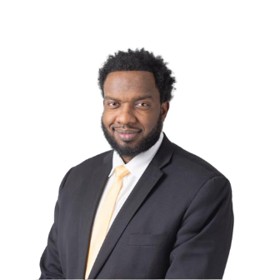
Jeremy Thomas
Senior Director

Jeremy has more than 15 years of experience in public relations, strategic planning, and project management. Before 98Forward, Thomas led communications for the City of Detroit General Services Department. He fuses traditional strategies with new media to provide impactful solutions for clients. He has experience in events, crisis communications, marketing, and branding.

Jeremy is the most recent addition to the 98Forward team. His recent work in government along with alignment in the community, allows him to pursue resources for clients at every level.

He holds a dual Bachelor of Science in Marketing and Business Administration from Tuskegee University. Jeremy also serves as a board advisor for the National Black Public Relations Society – Detroit Chapter.

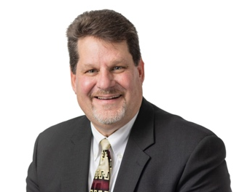
Mark Lane
Senior Director

Mark Lane is an award-winning communications and marketing specialist with more than 25 years of experience generating and creating engagement opportunities. As a results-driven expert in building relationships, leading communication teams, and creating and implementing communication and outreach strategies, Lane has extensive PR agency experience providing account management oversight and execution for local and global clients. He offers a wealth of experience in creating internal and external static and video content having worked with the General Motors Marketing & Communications Division & Customer Care & Aftersales, Community Foundation, Detroit Water and Sewerage Department, and the American Rental Association.
Before his agency tenure, Lane served as the director of PR and special events for Goodwill Industries of Greater Detroit for more than nine years, where he planned and managed PR and special events across all the organization’s programs, retail stores, business services, social ventures, advertising, and all other media. Lane’s expertise is in developing and executing strategic marketing and engagement plans, media relations, community engagement, internal and external communications, video production, social media development, and event management.

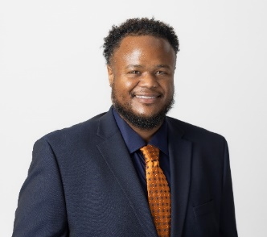
Kevin Hardges
Manager

Kevin Hardges is a communication professional and researcher with a decade of experience in communication research, strategic communication, and social media management. Kevin received his Bachelor’s in Speech Communication and a master's in public relations and organizational communication, both from Wayne State University. Professionally, Kevin has applied his scholarly experience working as an intern for 98Forward, and later as a community liaison and social media coordinator for Detroit Future City, a nonprofit based in Detroit. Additionally, Kevin worked as a Communications Fellow/Social Media Content Creator for a political nonprofit called For Our Future Michigan. Currently, he is a Manager at 98Forward, and pursuing his doctoral degree in communication at Wayne State University.

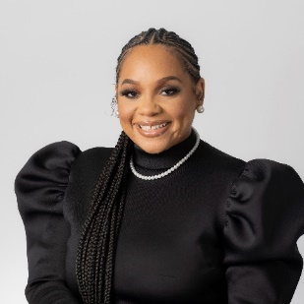
Courtney Mathis
Manager

Courtney Mathis is the manager of 98Forward. Over 10 years of experience in the arts, fashion, entertainment, political, non-profit and culinary industries. In addition to digital strategies, production, and event coordination. Courtney has helped develop careers and establish brands for Grammy nominated artists, Emmy nominated actors and clients who worked with President Barack Obama. In her previous roles, she secured placements in Vogue, Essence, People Magazine, GMA3, StyleMagazine, Newsweek, BET, BRAVO, Dr. Phil, Jimmy Fallon Late Show, The Real, Nationally Syndicated Radio Shows and many more.

She holds a Bachelor of Arts in public relations and Spanish from Western Michigan University. Board member National Black Public Relations Society of Detroit.

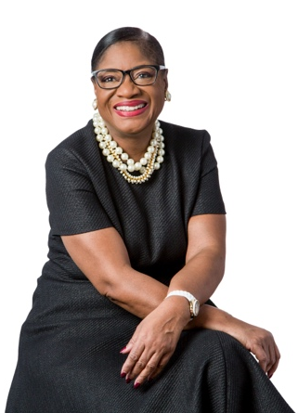
Georgella Muirhead, APR
CEO/Founder

Georgella Muirhead brings more than 40 years of communications experience and community engagement expertise to the 98Forward team. She began her career in the public sector as communications director for the cities of Ann Arbor, East Lansing and Southfield. She also directed the City of Detroit communications department for eight years.

She founded Berg Muirhead & Associates, now 98Forward, with longtime colleague and business partner Bob Berg in 1998. Under her leadership, 98Forward has established a legacy built on their ability to reach, engage, and motivate to action multicultural hard-to-reach audiences.
An industry veteran and an accredited member of the Public Relations Society of America (PRSA), Muirhead’s celebrated career includes 24 years as a government public relations administrator in the cities of Ann Arbor, East Lansing, Southfield, and Detroit. She has been recognized with over two dozen national, state, and local awards for outstanding work in the field of public relations and communications.

In 2021, PRSA Detroit honored Muirhead’s extensive career and significant impact on the profession, inducting her to the PRSA Detroit Hall of Fame. Georgella is based at our Detroit office.

5. Share three references and their contact information that can attest to your experience relevant to this request for quote.

Public Lighting Authority of Detroit (PLA)
98Forward has worked with the PLA since its inception in 2013. Our agency’s team developed a comprehensive communication strategy to announce the authority’s formation, the plan to relight all 139 square miles of the city, and the initial streetlight installation, as well as handling the crisis communications when it was determined that nearly 20,000 of the newly installed lights were defective and had to be replaced. The PLA community engagement plan included every single Detroit neighborhood. We continue to support the PLA today with media relations, crisis communications, social media, and the development of its annual report.
Contact Information: Lorna Thomas, M.D., Chair, Public Lighting Authority, drlornathomas@gmail.com, (313) 324-8290

Detroit Water and Sewerage Department (DWSD)
98Forward has worked with the Detroit Water and Sewerage Department and AECOM, its engineering partner, since 2017 to develop and implement a communications and stakeholder engagement plan for the department’s first city-wide capital improvement project. We have led the strategy for community and contractor engagement, which includes planning and executing forums and community meetings, developing all branded outreach materials, and developing creative opportunities to keep the community engaged.
Contact Information: Bryan Peckinpaugh, Public Affairs Director, Detroit Water and Sewerage Department, 313.410.2954, bryan.peckinpaugh@detroitmi.gov

2023 Detroit Public Schools Community District Facilities Master Plan (FMP)
In 2023, 98Forward was tasked to support Detroit Public Schools Community District (DPSCD) in developing and implementing a city-wide community engagement and strategic communications plan to amplify their 20-year vision for the District's facilities, along with a range of investments aimed at realizing the newly renovated schools within the District. The agency continues to lead the strategy for community engagement, which includes planning and executing community meetings, developing branded outreach materials, writing articles, parent letters, and social media content to continue storytelling around the Facility Master Plan. The agency also performed a similar role for the 2009 DPS School Construction Project.
Chrystal Wilson, APR, Assistant Superintendent, Detroit Public Schools Community District, 313.212.3039, chrystal.wilson@detroitk12.org.

- Hourly for everyone (writer, graphic designer, strategist, videographer, project manager, etc.) working on the project.

HOURLY RATES
CEO | $315
Vice President | $235
Senior Directors | $200
Manager | $185
Producer/Scriptwriter | $200
Speechwriter | $200
Senior Associates | $175
Associates | $150
Administration/Support | $100
Graphic Design | $100

- Provide an estimated budget based on the staff hours working on this project and that identifies the promotional costs (radio, print, television, social media, influencers, etc.) associated with this project that will be paid by the Commission. The Commission understands that these are estimates and subject to change.

Monday, Feb. 5, and continue the campaign through Friday, Feb. 23.
Team Member | Billing Rate | Week of  2-9 | Week of  12-16 | Week of  19-23 | Week of  26- Mar 1 | # OF hours | TOTAL
CEO | 315 | 3 | 1 | 0 | 0 | 4 | 1,260
Vice President | 235 | 8 | 5 | 6 | 1 | 20 | 4,700
Senior Directors | 200 | 8 | 4 | 5 | 1 | 18 | 3,600
Producer/Scriptwriter | 200 | 15 | 0 | 0 | 0 | 15 | 3,000
Manager | 185 | 2 | 7 | 6 | 0 | 15 | 2,775
Senior Associate | 175 | 11 | 10 | 4 | 1 | 26 | 4,550
Associate | 150 | 3 | 2 | 1 | 1 | 7 | 1,050
Graphic Design | 100 | 6 | 1 | 0 | 0 | 7 | 700
Adm. Support | 90 | 1 | 0 | 0 | 0 | 1 | 90
TOTALS |  |  |  |  |  | 116 | 21,725
*Includes 27 hours for attending meetings

Media Advertising Expenses
Gas Station Television  (10 gas stations per district) | $7,833
Radio Advertising (3) Stations  (Praise, Kiss & Mix) | $12,000
Video Production  (For Social Media Advertising  (3) :30 Commercials) | $2,500
Text Advertising  (40,000 per district) | $2,800
Email Campaign  (98Forward Influencer Database) | $210
Digital: Enhanced Email Blasts  (MI Chronicle) | $1,260
Social Media Advertising  (Facebook/Instagram, TikTok and YouTube) | $3,800
Social Issues Influencers  (TikTok) | $1,500
Print Advertisements  (Latino Press, Arab News) | $6,000
TOTAL | $37,903

Touch base Meetings & Lessons Learned
To ensure ongoing coordination alignment in our communications efforts, we will schedule ongoing monthly touch base meetings. These meetings may be in person or virtual depending on need and availability. At the completion of the project, we will do a wrap-up report including lessons learned.

98Forward | Fees & Billing
This proposal's robust communications strategy and implementation demands considerable engagement between the Michigan Independent Citizens Redistricting Commission (MICRC) team and our agency. To successfully implement and execute the extensive strategy outlined above and align it with the budget provided, 98Forward suggests the pricing schedule below.

98Forward | Terms & Conditions

Out-of-Pocket Expenses
Agency’s routine out-of-pocket expenses—for items such as photocopies, incidental postage, faxes, telephone calls, and the like—will be covered as part of professional service fees.
Significant out-of-pocket expenses, including but not limited to: PR Newswire and media, copying costs (in excess of 10 pieces @ $.59 per copy), postage charges (in excess of 10 pieces), telephone charges and mileage ($.50 per mile), travel and lodging are reimbursable expenses and will be billed in addition to professional fees. Expenses in excess of $250.00 will be submitted to the client as an “expense authorization” for prior approval. All billable expenditures will include a 15 percent handling fee. Any large items ordered by our agency under your direction and authorization will be billed directly to you.

Production Costs
Professional service fees do not cover production costs, such as graphic design and artwork charges, photography, audio-visual, printing, catering charges, purchasing advertising time or space, film and video production and entertainment. Production costs are reimbursable expenses and will be described in an “expense authorization” submitted to you for prior approval and billed in addition to the professional fees.

Conditions
98Forward has devised many successful communication and media strategies for our clients, and we will strive to devise the most effective campaign for your organization; however, with the uncertainty of media response, we cannot guarantee results.

98Forward agrees to respond quickly to client inquiries, whether by telephone, in person, by fax, or by email. 98Forward recognizes the need to maintain the confidentiality of information, work papers, and reports if and when they are provided to our agency by the client and agrees to take steps as necessary to preserve all confidentiality.

Insurance Requirements
98Forward shall acquire and maintain insurance in the following amounts during the terms of this agreement:

- Commercial General Liability: $1,000,000 per occurrence/$1,000,000 aggregate
- Automobile Liability: $500,000 each accident (including non-owned and operated vehicles and hired automobile coverage.
- Worker's Compensation: State of hire statutory limits
- Employers Liability: $1,000,000
- Umbrella/Excess Liability: $2,000,000 per occurrence and aggregate

Indemnification
98Forward hereby agrees to indemnify, defend and hold the client harmless, including the respective officers, directors and employees of the indemnified party and their agents, from and against any and all claims, demands, losses, liabilities, actions, liens, lawsuits, and other proceedings of whatever nature which may arise as a result of or in connection with the indemnifying party’s performance under this agreement. However, neither party shall be obligated to indemnify the other to the extent that such claim, damages, action, cost, loss or liability is the result of the other party’s negligent and/or wrongful acts or omissions.

Choice of Law
In the event of a dispute arising under this agreement, the parties agree that they, unless otherwise required by law, will be subject to a court of competent jurisdiction within the state of Michigan, whose laws shall be controlling.

Modifications of Agreement
This document is intended to be a full and complete agreement between both parties. This agreement can be modified only in writing and signed by both parties.

Services Agency Will Not Provide
98Forward will not participate in any activities we determine to be immoral, illegal or in violation of the Public Relations Society of America’s code of professional standards. ______________________________________________________________________________
The 98Forward Team is ready to begin work immediately. We are grateful for the opportunity to submit our proposal for this important and impactful work, and we look forward to beginning a long-term relationship with you, bringing our collective strengths together. We are confident that we can meet the challenges ahead, and we stand ready to partner with you in delivering effective communications solutions.

Your signature below will authorize our relationship.

Date: ___________
Edward Woods III
Executive Director
Michigan Independent Citizens Redistricting Commission (MICRC)
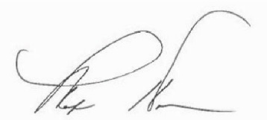
Date: February 1, 2024
Marilyn Horn
Owner
President & Chief Financial Officer
98Forward

If you have any questions on this proposal, feel free to contact Antonice Strickland, Vice President of Public Relations and Business Development, by email at antonice@98forward.com or by phone at (734) 812-4423.

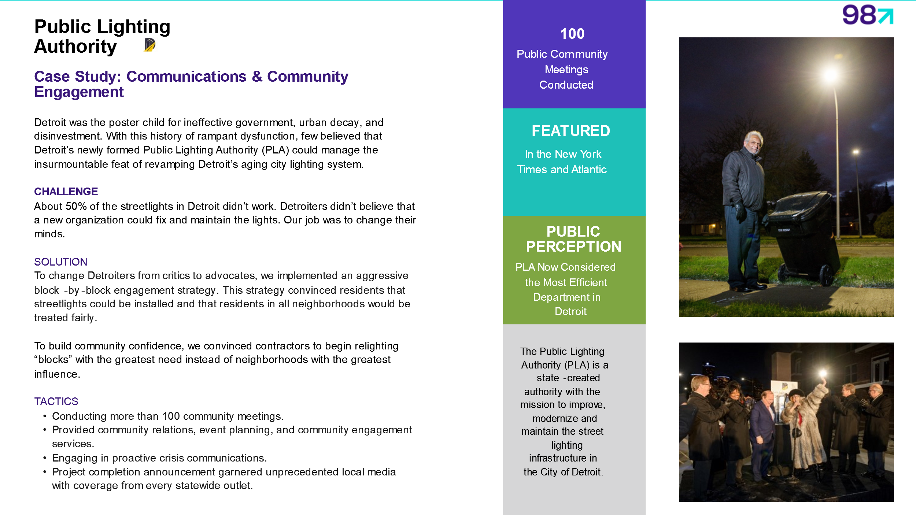
CASE STUDIES

