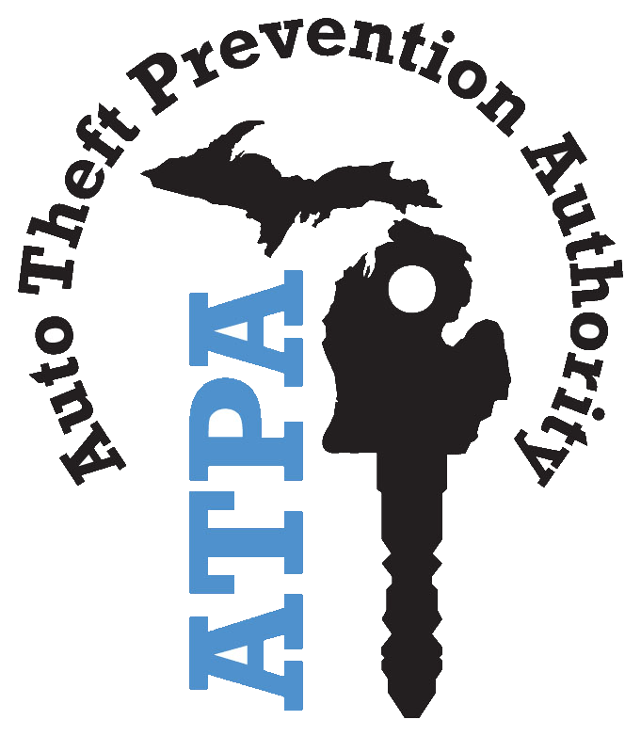  Auto Theft Prevention Authority (ATPA) PROJECT MODIFICATION REQUEST  AUTHORITY: MCL 500.6105; COMPLIANCE: Voluntary, but modification will not be approved unless form is submitted.  Approval is required prior to modification. Attach additional pages if necessary. |  |  |  | Please Check One:  Grant Official Change - Authorized Official  Grant Official Change - Project Director  Grant Official Change - Financial Contact  Personnel Change  Financial Change  Program Change  Other:
I. Grantee’s Information
Grantee’s Name |  |  |  | Project Title/Acronym |  |  | Project Number
Mailing Address

City, State, ZIP Code |  |  |  | Effective Date of Change
II. Authorized Official’s Information
Authorized Official’s Name |  |  |  | Title
Phone Number |  | Email Address
III. Modification Information
Personnel Modification Details
Note: Please indicate the person’s name, his/her role in the grant, title, mailing address, phone number, and email address.

Other Modification Details
IV. Budget Information |  |  |  |  |  |  |  | ATPA USE ONLY
Budget or Modification Requested | Current Approved Budget Amount |  | Amount of Change Requested (+ or -) |  | Revised Budget Amount |  |  | Approved Budget Amount
Sworn Employees | $ |  | $ |  | $0.00 |  |  | $
Other Employees | $ |  | $ |  | $0.00 |  |  | $
Vehicles | $ |  | $ |  | $0.00 |  |  | $
Field Operations | $ |  | $ |  | $0.00 |  |  | $
Office Operations | $ |  | $ |  | $0.00 |  |  | $
Contractual Services/Other | $ |  | $ |  | $0.00 |  |  | $
Total | $ |  | $ |  | $ |  |  | $
V. Signatures
Signature of Authorized Official |  |  |  |  |  | Date
Approval of ATPA Executive Director |  |  |  |  |  | Date
Sign completed form and email a scanned copy to the ATPA at MSPATPA@michigan.gov. Do not send paper copies.

