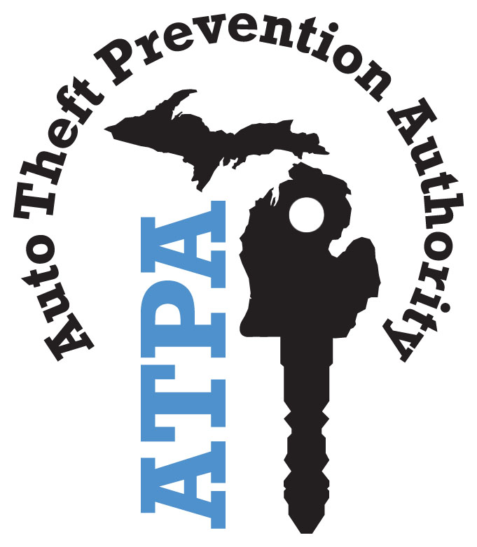

PLAN OF OPERATION

Revised November 2017

TABLE OF CONTENTS

PAGE NUMBER

INTRODUCTION 1

OBJECTIVES 1

SECTION I - ELIGIBILITY FOR GRANTS 2

SECTION II - GRANT POLICY STATEMENTS 6

SECTION III – IMPLEMENTING THE PLAN OF OPERATION 8

APPENDIX A 10

APPENDIX B 12

APPENDIX C 13

This document represents the Plan of Operation for the ATPA, originally required by Public Act 10 of 1986. It was adopted on December 3, 1986 and amended in June 1988; June 1990; June 1991; July 1998; May 2012; and November 2017. It presents a general plan for the disbursement of the funds collected from annual assessments. This plan is a “living” document which may be revised by the ATPA board of directors at any time.

Pursuant to Public Act 174 of 1992, copies of the Plan of Operation may be obtained electronically at: www.michigan.gov/atpa.

INTRODUCTION

The Automobile Theft Prevention Authority (ATPA) was established with a five-year “sunset” provision by Public Act 10 of 1986, to reduce motor vehicle theft in the state of Michigan. During 1992, the Legislature removed the “sunset” provision and made the ATPA a permanent program with Public Act 174 of 1992. Further amendments were made by Public Act 143 of 1993.

The ATPA is directed by a seven-member board of directors appointed by the Governor with advice and consent of the Senate. This seven-member board consists of two representatives of automobile insurance purchasers, two representatives from Michigan insurance companies, two representatives from law enforcement agencies, and the Director of the Michigan State Police. The board of directors meets quarterly at various locations around the state of Michigan, in accordance with the Open Meetings Act.

OBJECTIVES

The ATPA is funded by an annual assessment on automobile insurance companies at a rate of $1 per motor vehicle including private passenger and commercial motor vehicles. Those funds are awarded to various projects which help to accomplish the ATPA’s mission with reducing motor vehicle theft. The ATPA’s list of objectives clearly indicates the types of projects the ATPA is seeking to fund:

- Providing financial support to the Michigan State Police and local law enforcement agencies for motor vehicle theft enforcement teams.

- Providing financial support to state or local law enforcement agencies for programs designed to reduce the incidence of motor vehicle theft.

- Providing financial support to local prosecutors for programs designed to reduce the incidence of motor vehicle theft.

- Providing financial support to judicial agencies for programs designed to reduce the incidence of motor vehicle theft.

- Providing financial support for neighborhood, community, or business organizations for programs designed to reduce the incidence of motor vehicle theft.

- Conducting educational programs designed to inform motor vehicle owners of methods of preventing theft and to provide equipment to enable motor vehicle owners to prevent motor vehicle theft.

- To approve motor vehicle theft prevention devices, which qualify the insured for a premium discount on their comprehensive coverage.

SECTION I

ELIGIBILITY FOR GRANTS

A. Eligible Organizations

Law enforcement agencies, prosecutors, and judicial agencies are eligible to apply for ATPA grants. In addition, non-profit organizations under Internal Revenue Service (IRS) code section 501(c)(3), (e.g., neighborhood organizations, community organizations, and business organizations) are eligible to apply for an ATPA grant. Grants will be awarded to enhance motor vehicle theft prevention efforts.

B. Eligible Programs

The ATPA has established the following categories of programs eligible for funding and recognizes that some overlap of effort may exist among these program categories:

- Law enforcement/Detection/Apprehension
- Prosecution/Adjudication/Conviction
- Prevention
- Anti-Theft Devices

1. Law Enforcement/Detection/Apprehension

Funds may be allocated for the establishment of motor vehicle theft enforcement teams and other detection/apprehension programs. Funding may be provided for state, county, municipal, and township enforcement efforts that target areas of the state which have large motor vehicle theft problems.

Motor vehicle theft often transcends jurisdictional boundaries, and for that reason, enforcement efforts covering multiple jurisdictional boundaries may receive priority for funding. These multiple jurisdictional efforts may include, but are not limited to, several municipalities, counties, or regions.

Detection and apprehension of motor vehicle theft programs may include community involvement programs, detection training programs, and enhancements to information gathering programs. Community involvement with law enforcement has proven effective in combating motor vehicle thefts.

Detection training programs may include training in inspection procedures, identifying fraudulent titles, investigation of suspicious claims and development of fraud profiles, and investigative methods unique to the crime of motor vehicle theft.

Accurate data compiled by information gathering systems is required to properly assess motor vehicle theft programs and measure the effectiveness of programs that combat it. Programs addressing enhancements to these systems may also be considered for funding.
Examples of enforcement/detection/apprehension programs that are eligible for funding include:

- Enforcement programs utilizing law enforcement personnel, either alone or in conjunction with personnel from other fields concerned with motor vehicle theft.
- Statewide training for patrol officers in the proper techniques of identifying and recovering stolen motor vehicles.
- Programs to combat motor vehicle theft at the street level.
- Programs to reduce the incidence of insurance fraud.
- Programs designed to reduce chop shop operations through covert surveillance, undercover operations, and sting operations.
- Programs for information gathering systems to target repeat offenders and high-theft areas.
- Programs for information gathering systems to assist in measuring program effectiveness.
- Programs to improve inspection and regulation of repair facilities and automobile dealers (e.g., parts dealer, distress vehicle transporter, scrap metal processor, and salvage pool operator).
- Programs to assist the insurance industry in identifying fraudulent claims.

2. Prosecution/Adjudication/Conviction

Funding may be provided for prosecution and judicial programs designed to assist with the prosecution of persons charged with motor vehicle theft offenses. Under this category, funding may be provided for efforts to implement legislative change that assist in the prosecution of motor vehicle thieves and the forfeiture of their property.

At present, the prosecution of vehicle theft cases has a relatively low priority at local and state levels. This is due to: 1) motor vehicle theft being classified as a property crime, as opposed to a personal crime; 2) the judiciary view of the seriousness of the crime; 3) the victim receives insurance compensation; and, 4) vehicle theft prosecutions are often complex and expensive.

Despite these constraints, prosecution and conviction of motor vehicle thieves is one of the most important means of breaking motor vehicle theft rings and reducing the economic incentives for motor vehicle theft. Having a designated prosecutor handle motor vehicle theft cases vertically (through both district and circuit courts) has proven very effective in achieving convictions.

The following programs provide examples of prosecution/adjudication programs that may be funded:

- Additional prosecution staff to concentrate on motor vehicle theft cases.
- Workshops designed to train assistant prosecuting attorneys who specialize in motor vehicle theft prosecution.
- Programs to introduce and support legislative changes in statutes pertinent to the prosecution of motor vehicle thieves and the forfeiture of their property.
- Workshops designed to educate the Michigan judiciary about the serious nature of motor vehicle theft.
- Programs to monitor judicial results of motor vehicle theft cases.
- Programs to support better employment of habitual criminal statutes.

3. Prevention

The ATPA has established this category to include programs that promote public awareness, provide public training in motor vehicle theft prevention measures, and support prevention programs.

Without prevention efforts and support from the public, law enforcement alone cannot effectively reduce motor vehicle thefts in Michigan. Far too often thefts occur because the vehicle is left unlocked and the key or fob is left inside. Public education campaigns and prevention training programs can increase individual awareness of the costs of motor vehicle theft, provide tips for the owners to assist in the prevention effort, and demonstrate the savings that preventive measures can yield.

In an effort to assure maximum effectiveness and statewide coverage of prevention campaigns, the ATPA may give preference to applications covering multiple jurisdictions over applications from individual organizations.

Examples of prevention programs that may be funded are:

- Programs that inform and educate the community about motor vehicle theft through block club organizations, neighborhood watch programs, and schools.
- Programs to increase public awareness.
- Programs to inform and encourage public participation in motor vehicle theft prevention and enforcement efforts.

4. Anti-Theft Devices

Public Act 10 of 1986 charged the ATPA with the responsibility of approving motor vehicle theft prevention devices. On March 23, 1987, the ATPA approved interim standards for motor vehicle theft prevention devices. Installation of those devices may qualify for a reduction in the owner’s comprehensive insurance. The amount of the reduction is determined by each company.

Those interim standards were revised by the ATPA Board of Directors on June 22, 1994, to include devices which assist in the recovery of the vehicle. These standards are included as Appendix A of this document.

C. Annual Application Period

ATPA grants are awarded competitively for a specific fiscal year (October 1 through September 30) and applications must be submitted annually. Current grantees are notified of the open grant application period no later than April 1. The announcement that the ATPA is accepting applications is also posted on the ATPA website, located at: www.michigan.gov/atpa.

The deadline for all grant applications is the first Monday in June.

D. Grant Objectives

Standardized performance objectives unique to law enforcement grantees, prosecutor grantees, and prevention grantees were established by a committee of the affected groups reaching a consensus with the ATPA staff on the elements necessary to conduct a successful program. The objects were originally included in the July 1998 Plan of Operation and are updated as needed. The updated objectives can be found in the grant application and grant contract.

E. Eligible Expenditures

Eligible expenditures are updated as needed and can be found in the grant application and grant contract.

F. Ineligible Expenditures

Ineligible expenditures are updated as needed and can be found in the grant application and grant contract.

G. Law Enforcement Grant Evaluation

In order to ensure ATPA, funded teams were focused on the types of arrests that have the greatest impact on reducing vehicle thefts; an arrest ranking formula was developed.

The formula is based upon two factors: 1) how difficult it is to investigate and prove that particular charge; and 2) the impact the conviction of a subject on that charge would have on area vehicle thefts. At the end of a grant year, ATPA staff multiplies the number of arrests in each category by the assigned point’s value and arrive at an average point per arrest for the grantee. A copy of the arrest ranking formula can be reviewed in Appendix B.

SECTION II

GRANT POLICY STATEMENTS

A. Distribution of Funds

ATPA funds shall be expended in the following manner:

- Administration of the ATPA:
- Board expenses.
- Staff expenses.

- Law Enforcement Projects:
- Theft prevention training programs.
- Programs designed to reduce the incidence of motor vehicle theft crimes, to apprehend the criminals, or to recover stolen vehicles.
- Programs to increase recovery rate of stolen motor vehicles through equipment purchases.

- Prosecution Projects:
- Programs designed to vertically prosecute motor vehicle theft-related crimes and increase convictions.

- Prevention and Educational Programs:
- Programs to train citizens, crime prevention patrols, or neighborhood watch programs.
- Programs to educate neighborhood groups regarding motor vehicle theft prevention tactics.
- Programs to etch vehicle windows.

- Training:
- Training for ATPA funded positions.
- Conference expenses.

The ATPA reserves the right to make all final decisions regarding the award of funds. It may also actively solicit applications for new programs. The ATPA analyzes many factors before allocating grant funds, including:

- The severity of motor vehicle theft problem in grant coverage area.
- Motor vehicle theft trends in grant coverage area.
- Performance history of grantee (e.g., arrests, recovery, vehicles etched, etc.).
- The concentration of registered motor vehicles in the grant area (e.g., estimated ATPA revenues generated).
- Motor vehicle theft arrests reported in the grant area.
- Amount of ATPA funding provided in the grant area.
- Percentage of state motor vehicle thefts in the grant area.

Utilizing these factors, the ATPA Board of Directors strives to position resources into grants that will provide the greatest return on investment. Ideally, an area which had ten percent of Michigan’s thefts and registered vehicles would be awarded ten percent of the ATPA funds (see Appendix C for Michigan map of motor vehicle thefts in 2016).

B. Grant Period

Grants are awarded for one fiscal year (October 1 through September 30). Approval of applications may be based on the prior year’s accomplishments.

The ATPA holds public hearings regarding the grants in August and announces its decision in September of each year by award or denial letters to applicants.

C. Grant Payments

Grant payment to grantees is based on quarterly reimbursement. Grantees must submit quarterly financial and progress reports to ATPA staff as detailed in the grant contract. Reimbursement will only be paid on receipt of financial report, in accordance with ATPA requirements.

Advance payments are permitted to non-profit 501(c)(3) organizations for up to 90 percent of the grant award.

D. Matching Funds

Law enforcement and prosecutors’ offices have a required 50 percent local hard cash match.

Non-profit neighborhood and community 501(c)(3) organizations are exempt from this requirement.

E. Reporting Requirements

All grantees must submit quarterly performance, financial and progress reports 30 days after each reporting period as detailed in the grant contract.

F. Monitoring Policy

The ATPA’s staff will conduct monitoring of quarterly financial and progress reports to:

- Ensure the grant money has been spent in accordance with Public Act 174 of 1992, ATPA policies, and the grant contract.

- Determine if the project is making adequate progress, as stated in its goals and objectives.

On-site monitoring may be conducted at the discretion of the ATPA on any grant, both during the grant period and/or at the end of the grant period.

G. Grant Modification

Approved grant project programs or budgets may not be modified without prior written approval of the ATPA. Project revision requests must be submitted to the ATPA in advance of the need.

H. Forfeiture Policy

Any funds received or generated as a result of motor vehicle theft activities shall be used to enhance currently funded and/or future motor vehicle theft programs. Funds received include forfeiture of cash and receipts from sale of property.

I. Additional Grant Requirements

Eligible criminal justice agencies applying for funds for training programs are required to have sought and been denied Justice Training funds (Public Act 302 of 1982) prior to application for an ATPA grant.

J. Executive Directors Authority

The Executive Director of the ATPA has the authority to approve budget modifications up to 50 percent or $100,000, whichever is less, of the grantee's total approved budget amount for the grant year. The approved modification will include 50 percent ATPA reimbursement and 50 percent team cash match.

Any budget modification submitted by a grantee that is represented on the board of directors will be exempt from this provision and the budget modification will be reviewed by the board members.

Budget modifications that need board approval will be discussed via conference call within 15 business days of receipt.

SECTION III

IMPLEMENTING THE PLAN OF OPERATION

Currently, ATPA revenues are based upon the number of motor vehicles that are insured in Michigan. In 2015, an Attorney General’s Opinion (Opinion 7284 rendered June 1, 2015) allowed the ATPA to start collecting the $1 assessment during the 2016 calendar year on all motor vehicles, including commercial motor vehicles, which was a change from previous years.

Although revenue has increased, so have the personnel costs of grantees. The ATPA examines requests closely each grant cycle and adjusts funding levels accordingly. From the inception of the ATPA in 1986 to 1994, grantees were funded at 100 percent, from 1995-2008 grantees were funded at 75 percent, 2009 the funding amount to grantees decreased to 60 percent and from 2010-current grantees were funded at 50 percent; excluding non-profit grantees which have remained funded at 100 percent.

Regardless of the level of revenue, the ATPA will continue to make program adjustments to ensure the effective and efficient distribution of resources and direct the efforts of the many cooperative task forces to areas where the problem is greatest.

APPENDIX A

STANDARDS FOR MOTOR VEHICLE THEFT PREVENTION
AND RECOVERY DEVICES
Approved by the Michigan Automobile Theft Prevention Authority (ATPA),
June 22, 1994

Effective January 1, 1995

The following motor vehicle theft prevention and recovery devices have been approved by the ATPA, in accordance with Public Act 143 of 1993. Any motor vehicles which are equipped with or contain these devices will qualify for a reduction in the vehicle's comprehensive insurance premium. The amount of the specific reduction for each category will be determined by each insurance company and insurers may choose to provide a greater discount to vehicles which have devices from two or more categories.

Two categories of effectiveness in preventing motor vehicle theft have been identified, as well as one category for systems which assist in the recovery of the motor vehicle if it is stolen. Proper use of the systems described in Categories One and Two will respectively provide an optimum level and a minimum level of theft deterrence. A motor vehicle properly equipped with a recovery device will enhance efforts to recover the motor vehicle.

- CATEGORY ONE –

PASSIVE SYSTEMS PROVIDING OPTIMUM LEVEL OF SECURITY

The systems in this category will provide the optimum level of deterrence. To qualify for this discount, the motor vehicle must be equipped with at least one passive device (device is activated automatically when the vehicle's ignition key is removed).

- A passive alarm system which has a back-up battery and meets or exceeds criteria established in Category Two.
- Passive disabling devices which prevent the motor vehicle's steering, fuel, transmission/transaxle, ignition, or starting systems from operating, and devices which prevent the motor vehicle's braking system from releasing.
- A passive time-delay ignition system which allows the motor vehicle to be started only after a preset delay or delayed ignition cut-off system, which disables the motor vehicle at a preset engine speed.
- A passive motor vehicle entry or ignition key system.

- CATEGORY TWO –

ACTIVE SYSTEMS PROVIDING A MINIMUM LEVEL OF SECURITY

Any of the systems in this category will provide at least a minimum level of deterrence. To qualify for a discount, the motor vehicle must be equipped with at least one of these listed devices (which must be manually activated by the motor vehicle owner prior to leaving the motor vehicle). An insurer may choose to offer an increased discount, if the motor vehicle has two or more of these devices.

- Alarm only devices-activated by a door, hood, or trunk being opened or by motion inside the motor vehicle which sound an audible alarm that can be heard at a distance of at least 300 feet for a minimum of three minutes; or,
- Manually activated disabling devices which prevent the motor vehicle's steering, fuel, transmission/transaxle, ignition or starting systems from operating, and devices which prevent the motor vehicle's braking system from releasing.
- Etching of 17 digit vehicle identification number (VIN) on windshield, rear window glass, and both front door windows.

- CATEGORY THREE –

SYSTEMS WHICH ASSIST IN VEHICLE RECOVERY

The systems in this category enhance the effort to recover the motor vehicle after it is stolen.

- A device which, when activated, emits an electronic signal that can be tracked by either a law enforcement agency or by a private monitoring station, which relays the information on the motor vehicle's location to law enforcement officers.

APPENDIX B

ARREST RANKING FORMULA
FELONY CHARGES | MCL | ARREST POINTS
Altering VIN With Intent To Mislead | 750.415 | 10
Arson-Owner Involved | 750.75 | 14
Car-Jacking | 750.529a | 8
Chop Shop | 750.535a | 14
Continuing Criminal Enterprise | 750.159i | 14
Counterfeit Insurance Certificates | 257.222 | 6
Embezzlement | 750.174 | 6
Failure to Return Rental Vehicle | 750.362 | 6
False Certification | 257.903 | 12
False Police Report | 750.411a | 8
False Pretenses | 750.218 | 12
False Statement In Application For Title | 257.254 | 12
Forged License Documents/License Plates | 257.257 | 6
Insurance Fraud-Owner Staged Arson/Larceny/Theft | 500.4511 | 14
Interstate Transportation Of Stolen Motor Vehicle | 750.535 | 14
Larceny By Conversion | 750.362 | 6
Larceny From Motor Vehicle | 750.356a | 4
Obtain Personal Identification (ID) Without Permission | 257.324 | 6
Odometer Fraud | 257.233a | 12
Operating License Forged, Altered Or False | 257.324 | 6
Possess Or Sell Rosette Rivets | 750.415 | 4
Possess Stolen Vehicle With Intent To Pass Title | 257.254 | 10
Repair-Salvage Facility Violation | 257.217 | 4
Receiving And Concealing Stolen Property | 750.535 | 8
Unlawfully Drive Away Automobile | 750.413 | 6
Unlawful Use | 750.414 | 4
Use Fraudulent ID To Lease Or Purchase Vehicle | 750.415 | 12
All Other Charges |  | 2

NOTES:

- Project takes credit for most serious charge against subject and ignores others.
- Project takes credit for original arrest charge, even if reduced later by prosecutor.
- If subject is arrested on three separate warrants, project may count as three arrests.
- Attempted crimes, or conspiracy to commit crime, earn same points as listed.
APPENDIX C

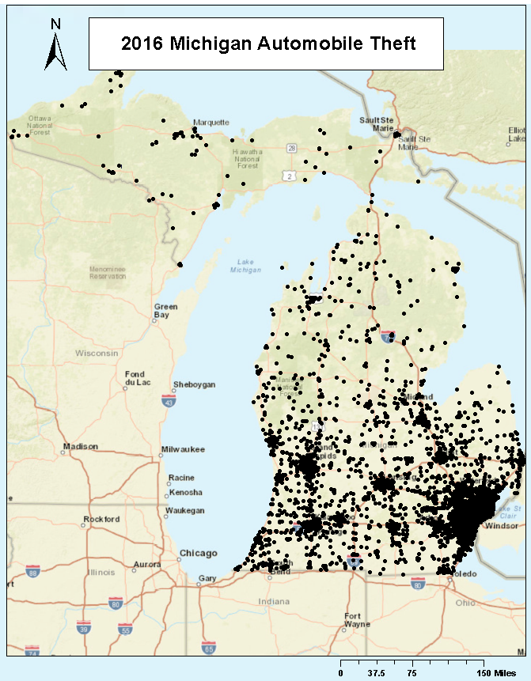

MAILING ADDRESS:

AUTOMOBILE THEFT PREVENTION AUTHORITY
P.O. Box 30634
Lansing, Michigan 48909-0634

Phone: 517-284-3193

