EX-201 (01/2024)

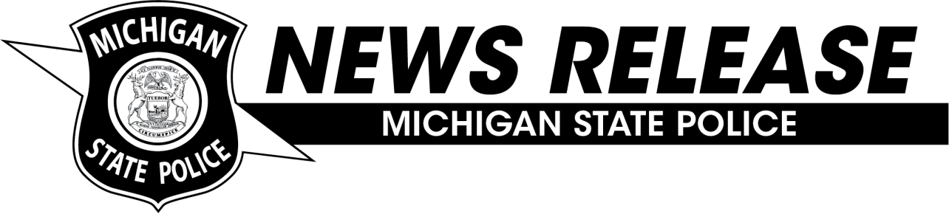Michigan State Police

**Application Process to Open in April for Byrne Justice Assistance Grant and Residential Substance Abuse Treatment Funds**

**FOR IMMEDIATE RELEASE:** **April 10, 2025**

**LANSING, MICH.** The Michigan State Police (MSP) Grants and Community Services Division (GCSD) will soon be accepting applications for fiscal year (FY) 2026 Byrne Justice Assistance Grant (JAG) funds and Residential Substance Abuse Treatment (RSAT).

The Byrne JAG in Michigan provides grant awards to units of government for different program areas in criminal justice, including community relations, indigent defense, multijurisdictional drug task forces, priority population drug courts, and victim services. The RSAT grant in Michigan funds prison and jail-based programming to assist in the reduction of substance use.

Detailed grant information and the application will be available on the [MSP Byrne JAG & RSAT website](https://www.michigan.gov/msp/divisions/grantscommunityservices/byrne-jag-and-rsat) beginning May 1, 2025. The completed grant application must be submitted to the GCSD through the MAGIC+ system on or before June 13, 2025. The FY 2026 grant period begins on October 1, 2025, and ends on September 30, 2026.

The MSP will be hosting an informational Byrne JAG webinar on April 29, 2025, which potential applicants are strongly encouraged to watch. A link to register for the webinar can be found on the [MSP Byrne JAG & RSAT website](https://www.michigan.gov/msp/divisions/grantscommunityservices/byrne-jag-and-rsat).

**###**

**MEDIA CONTACT:**

Ms. Lindsey Holden, MSP Grants and Community Services Division, 517-282-6413, [HoldenL@michigan.gov](mailto:HoldenL@michigan.gov)