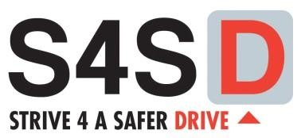

**S4SD Sample Proposal**

# Project Summary

Our campaign name will be The Spartan Standard and will play off the idea that as Spartans we hold ourselves and our peers to a higher standard of acknowledging Vulnerable Road Users. Our team will promote how to share the road with cyclists and educate on cyclist safety.

## **Proposed Timeline**

* November: Register for Canvas, Design posters (contest), develop 60-second public service announcement creation (PSA), and draft banner for pledge signing.
* December: Prepare guidelines for raffle poster design contest, prepare/order promotional items (t-shirts, wrist bands, water bottles, candy, hand sanitizer), administer pre-tests, conduct seat-belt observational survey, continue creating 60-second PSA, and finalize and print banner.
* January: Hold Event #1- poster contest with prizes
* February: Hold Event 2: PSA on morning announcements and share video on social media pages
* March: Lunch event 3: pledge to share the road with bicycles and motorcycles
* April: Post-test and post seatbelt survey. Create presentation and submit on Canvas with supporting documents.

## **Event #1**

Students will design posters that will be displayed throughout the school and community. The posters will be designed to promote sharing with road with bicycles and motorcycles AND promote safe riding with helmets. S4SD and Ford Philanthropy will be displayed on the posters created by students. Students will create posters and the student body will vote on the most creative messages. The top 8 posters will receive a $25 gift card (not exceeding the $200 gift card limit).

## **Event #2**

Students will develop, record, and film a public service announcement (PSA) to share the campaign goal of sharing the road and riding safely while wearing S4SD student t-shirts. The PSA will be done in two formats; an audio recording which will be played by the school during morning announcements and in a video format which will be posted on social media and emailed for parent announcements. The PSA will also be shared with local news outlets to involve the community.

## **Event #3**

A banner with our slogan “The Spartan Standard” bwill be displayed during lunches for a week in April so students can pledge to share the road and ride safely. There will be swag items for student such as wrist bands, water bottles, candy, and hand sanitizers.

## **Campaign Success Evaluation**

Student knowledge will be evaluated with a pre/post-test system. The pre and post-test will be administered electronically via Survey Monkey from the S4SD team. The results of the post-test will be compared to the pre-test to determine the effectiveness of the campaign. Student involvement will be measured by the number of pre and post-tests completed, the number of students in attendance in the school where public service announcements are administered, the video web series shared, and finally by the number of students who take the pledge by signing the banner.

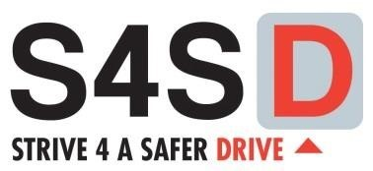

# Proposed Budget

School: Spartan Academy

Date: November 10, 2024

|  |  |  |  |
| --- | --- | --- | --- |
| **Date** | **Paid To** | **Describe Purchase** | **Estimated Amount** |
|  | (fill in vendor) | S4SD t-shirts (20) | $200.00 |
|  |  | S4SD Water bottles (75) | $150.00 |
|  |  | Posters (25) | $150.00 |
|  |  | S4SD Wristbands (75) | $100.00 |
|  |  | Candy | $50.00 |
|  |  | Hand Sanitizer (90) | $75.00 |
|  |  | Hand Sanitizer labels (90) | $75.00 |
|  |  | Gas gift cards @ $25.00 each | $200.00 |
|  |  |  |  |
|  |  |  |  |
|  |  |  |  |
|  |  |  |  |
|  |  |  |  |
|  |  |  |  |
|  |  |  |  |
|  |  |  |  |
|  |  |  |  |
|  |  |  |  |
|  |  |  |  |
|  |  |  |  |
|  |  |  | **$1,000.00** |

# 